[This is the final author version of the abstract, as accepted for presentation at the conference]

Please refer to this publication with: De Jans, S., & Beuckels, E. (2022). I’ve got it from my mommy : how mom influencers affect other mothers’ healthy food choice behavior of their children. *Etmaal van de Communicatiewetenschap 2022, Abstracts*. Presented at the Etmaal van de Communicatiewetenschap 2022 : Diversity, democracy & communication, Brussels, Belgium (online).

# I’ve got it from my mommy. How mom influencers affect other mothers’ healthy food choice behavior of their children

The numbers of obesity among children are rapidly growing worldwide (Raziani & Raziani, 2020), which has a significant impact on children’s quality of life and longevity, but also on the prevalence of transgenerational obesity and population health (Cheng, 2020). While an increasing body of research has been focusing on how advertising directed to children affects their food habits (e.g. Naderer, 2021; Naderer, Matthes, & Spielvogel, 2019), it is argued that parents are the biggest gatekeepers of their children’s food intake (Birch & Fisher, 1998; Pedersen, Grønhøj, & Thøgersen, 2015).

It is suggested that parental attitudes, behaviors and food choices for their children are highly affected by other parents within their social networks (Cochran & Niego, 2002; Hogreve, Matta, Hettich, & Reczek, 2021). Besides, more and more parents are finding their ways to social network sites on the lookout for guidance and parenting advice (Moon, Mathews, Oden, & Carlin, 2019), which they often find on the social media profiles of mom influencers. These niche influencers are mothers with kids who accumulated a large following base on their social network profiles by sharing information about their lives, children and family, and often engage in sponsored partnerships with brands (Abidin & Ots, 2015; Archer, 2019). As influencers are often considered as highly credible among their followers (Hudders et al., 2020), the current paper aims to investigate whether a sponsored post about food for children coming from a mom influencer has a greater impact on other mothers, compared to a sponsored post coming from a brand. Furthermore, it was investigated whether a mom influencer is more or less efficient in promoting food low versus high in nutritional value, compared to a nutrition specialist (i.e. expert influencer) on social media.

Therefore, two experiments were conducted. First, a 2-level between-subjects experiment (source of sponsored post: brand post versus mom influencer post) was conducted among 81 mothers (*Mage*= 30.6, *SD* = 6.10). One group of respondents was exposed to a sponsored Instagram post (promoting a snack low in nutritional value) posted by a brand, while the other group was exposed to the same sponsored post posted by a mom influencer. Using serial mediation analyses by Process Macro (Hayes, 2019; model 6), the results show that mothers like the sponsored post more when it is posted by a mom influencer compared to a brand, which positively affects source credibility. Source credibility further increases post engagement, purchase intention and child appropriateness of the food. See figure 1 for the conceptual model and table 1 for the results of experiment 1.

For the second experiment, we conducted a 2 (influencer type: mom influencer versus expert influencer) by 2 (food type: low versus high in nutritional value) between-subjects experimental design among 169 mothers (*Mage* = 30.77, *SD* = 6.95). The participants were first exposed to an Instagram profile of either a mom influencer or an expert influencer (nutrition specialist) and were then exposed to a sponsored Instagram post for either a product high (carrots) versus low (candy) in nutritional value of that same influencer. The results, using Process Macro (Hayes, 2019; model 4 and model 7 with 2 parallel mediators; cf. conceptual model in figure 2 and results in table 2) show that a mom influencer is perceived less credible but more congruent with the brand compared to the expert influencer. Both source credibility and influencer-brand congruence positively affect purchase intention and child appropriateness. Source credibility, but not influencer-brand congruence, also enhances post engagement. While there is no interaction effect of influencer type and food type on source credibility, there is an interaction effect on influencer-brand congruence. The conditional effects indicate that the mom influencer is only perceived as more congruent with the brand when a snack low in nutritional value is promoted and not when a snack high in nutritional value is promoted.

Thus, a mom influencer shows to be more effective in promoting food compared to a brand, as this resulted in more post engagement, purchase intention and child appropriateness of the food through post liking and source credibility. However, it should be noted that this was the promotion of a product low in nutritional value. In addition, while a mom influencer is perceived as less effective in promoting food compared to an expert influencer through source credibility, a mom influencer is more efficient in promoting foods low in nutritional value through influencer-brand congruence. Hence, our results show that mom influencers are mainly effective in promoting foods low in nutritional value. Therefore, future research should investigate how mom influencers can be deployed to promote healthy food choice behavior.

**Keywords**: Mom influencers; Influencer marketing; Healthy food; Brand post; Expert influencer

**References**

Abidin, C., & Ots, M. (2015). *The Influencer’s dilemma: The shaping of new brand professions between credibility and commerce.* Paper presented at the AEJMC 2015, Annual Conference, San Fransisco, CA, August 6-9.

Archer, C. (2019). How influencer ‘mumpreneur’bloggers and ‘everyday’mums frame presenting their children online. *Media International Australia, 170*(1), 47-56.

Birch, L. L., & Fisher, J. O. (1998). Development of eating behaviors among children and adolescents. *Pediatrics, 101*(Supplement 2), 539-549.

Cheng, K. (2020). Health Oriented Lifelong Nutrition Controls: Pre-venting Cardiovascular Diseases Caused by Obesity. *SM J Nutr Metab, 6*(5).

Cochran, M., & Niego, S. (2002). Parenting and social networks. *Handbook of parenting volume 4 social conditions and applied parenting, 122*.

Hogreve, J., Matta, S., Hettich, A. S., & Reczek, R. W. (2021). How Do Social Norms Influence Parents’ Food Choices for Their Children? The Role of Social Comparison and Implicit Self-Theories. *Journal of retailing, 97*(2), 173-190.

Hudders, L., De Jans, S., & De Veirman, M. (2021). The commercialization of social media stars: a literature review and conceptual framework on the strategic use of social media influencers. *International Journal of Advertising, 40*(3), 327-375.

Moon, R. Y., Mathews, A., Oden, R., & Carlin, R. (2019). Mothers’ perceptions of the Internet and social media as sources of parenting and health information: Qualitative study. *Journal of medical Internet research, 21*(7), e14289.

Naderer, B. (2021). Advertising Unhealthy Food to Children: on the Importance of Regulations, Parenting Styles, and Media Literacy. *Current Addiction Reports, 8*(1), 12-18.

Naderer, B., Matthes, J., & Spielvogel, I. (2019). How brands appear in children's movies. A systematic content analysis of the past 25 Years. *International Journal of Advertising, 38*(2), 237-257.

Pedersen, S., Grønhøj, A., & Thøgersen, J. (2015). Following family or friends. Social norms in adolescent healthy eating. *Appetite, 86*, 54-60.

Raziani, Y., & Raziani, S. (2020). Investigating the predictors of overweight and obesity in children. *International Journal of Advanced Studies in Humanities and Social Science, 9*(4), 262-280.

**Figures**

Figure 1. Conceptual model experiment 1

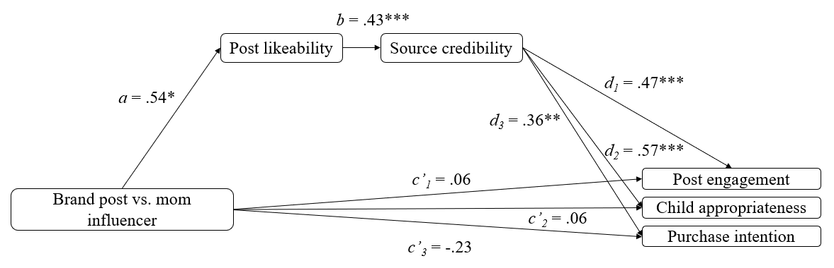  
Note: * = *p* < .05, ** = *p* < .01, *** = *p* < .001

Figure 2. Conceptual model experiment 2

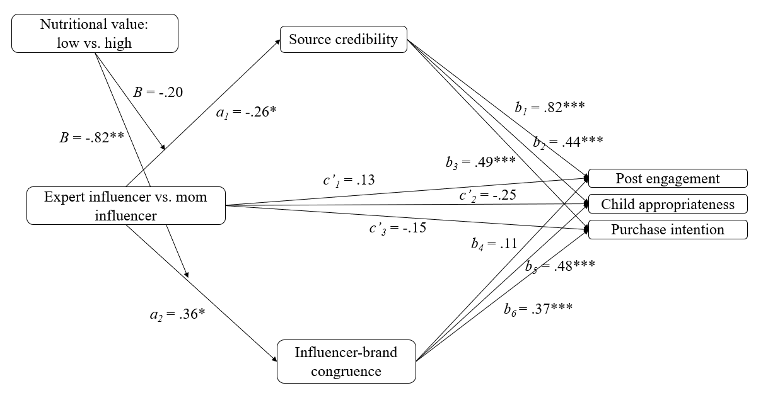

Note: * = *p* < .05, ** = *p* < .01, *** = *p* < .001

**Tables**

Table 1. Results experiment 1

|  |  |  |  |
| --- | --- | --- | --- |
| **IV** | **Mediator 1** | **Mediator 2** | **DV’s** |
| Brand post vs. mom influencer | *Post likeability*  *a* = .54, *SE* = .21, *t* = 2.57, *p* = .012  Brand post: *M* = 3.02, *SD* = 1.05  Mom influencer: *M* = 3.56, *SD* = .82 | *Source credibility*  *b* = .43, *SE* = .08, *t* = 5.51, *p* < .001 | *Post engagement*  *d1* = .47, *SE* = .11, *t* = 4.10, *p* < .001 |
| *Child appropriateness*  *d2* = .57, *SE* = .14, *t* = 4.12, *p* < .001 |
| *Purchase intention*  *d3* = .36, *SE* = .13, *t* = 2.72, *p* = .008 |

Table 2. Results experiment 2

|  |  |  |  |
| --- | --- | --- | --- |
| **IV** | **Moderator** | **Mediators** | **DV’s** |
| Expert influencer vs. mom influencer | *Nutritional value*  *B* = -.20, *SE* = .24, *t* = -.84, *p* = .403 | *Source credibility*  *a1* = -.26, *SE* = .12, *t* = -2.22, *p* = .028  Expert influencer: *M* = 3.98, *SD* = .78  Mom influencer: *M* = 3.72, *SD* = .74 | *Post engagement*  *b1* = .82, *SE* = .09, *t* = 8.90, *p* < .001 |
| *Child appropriateness*  *b2* = .44, *SE* = .10, *t* = 4.35, *p* < .001 |
| *Purchase intention*  *b3* = .49, *SE* = .11, *t* = 4.45, *p* < .001 |
| *Nutritional value*  *B* = -.82, *SE* = .30, *t* = -2.70, *p* = .008  *Low: B* = .76, *SE* = .21, *t* = 3.57, *p* = .001  *High: B* = -.06, *SE* = .21, *t* = -.26, *p* = .796 | *Influencer-brand congruence*  *a2* = .36, *SE* = .16, *t* = 2.31, *p* = .022  Expert influencer: *M* = 4.04, *SD* = 1.17  Mom influencer: *M* = 4.40, *SD* = .83 | *Post engagement*  *b4* = .11, *SE* = .07, *t* = 1.54, *p* = .126 |
| *Child appropriateness*  *b5* = .48, *SE* = .08, *t* = 6.25, *p* < .001 |
| *Purchase intention*  *b6*= .37, *SE* = .08, *t* = 4.45, *p* < .001 |