**Supplemental Protocol: Golden Gate assembly for CRISPR-TSKO**

**Introduction**

This cloning protocol makes use of the GreenGate cloning system (Lampropoulos et al., 2013), that is based on the Golden Gate method (Engler et al., 2008). Six DNA elements in entry vectors are assembled into a destination vector using a Golden Gate reaction with the type II restriction enzyme BsaI and T4 DNA ligase. This assembly is fast, efficient an inexpensive.

CRISPR-TSKO is a technique to efficiently mutate genes in specific cell types, tissues, or organs, using a tissue-specific promoter controlling Cas9 expression. We use two Golden Gate cloning steps to generate new CRISPR-TSKO destination vectors. In the first step (as described in **I**), a new cloning vector is assembled by combining a promoter, Cas9, N- and C-tags, and a terminator entry vectors. Different F-G entry vectors allow the creation of two types of destination vectors that can accept either one or two gRNAs or multiple gRNAs (up to 12). The addition of one or two gRNAs requires a single Golden Gate reaction and is detailed in section **II**. The cloning of multiple or multiple gRNAs requires two Golden Gate steps and is described in **III**.

1. **Golden Gate Assembly of New TSKO Destination Vectors**
2. *Golden Gate*

In the first step, six Golden Gate entry vectors are combined into a destination vector. There are various Golden Gate destination vectors containing different plant selectable and/or visual markers that can be used (see Golden Gate destination vector (*ccdB+*) in **Supplemental Data Set 1**). The first entry vector (AB) contains the promoter for tissue specific expression. The third entry vector (CD) contains the nuclease and can be combined with N-terminal (BC) or C-terminal tags (DE). Alternatively, linker sequences are used if no tag is desired. The fifth entry vector (EF) contains the plant terminator. The sixth Golden entry vector (FG) chosen depends on the final goal. For cloning a vector compatible with one or two gRNAs, make use of the unarmed gRNA entry vector pGG-F-AtU6-26-AarI-AarI-G (see Unarmed gRNA entry vectors in **Supplemental Data Set 1**). For cloning a vector compatible with multiple gRNAs, make use of the variable linker pGG-F-A-AarI-SacB-AarI-G-G (see Variable Linkers in **Supplemental Data Set 1**). As our cloning strategy uses the restriction enzymes BsaI and AarI, there is the requirement that all vectors need to be BsaI- and AarI-free (apart from the cloning sites).

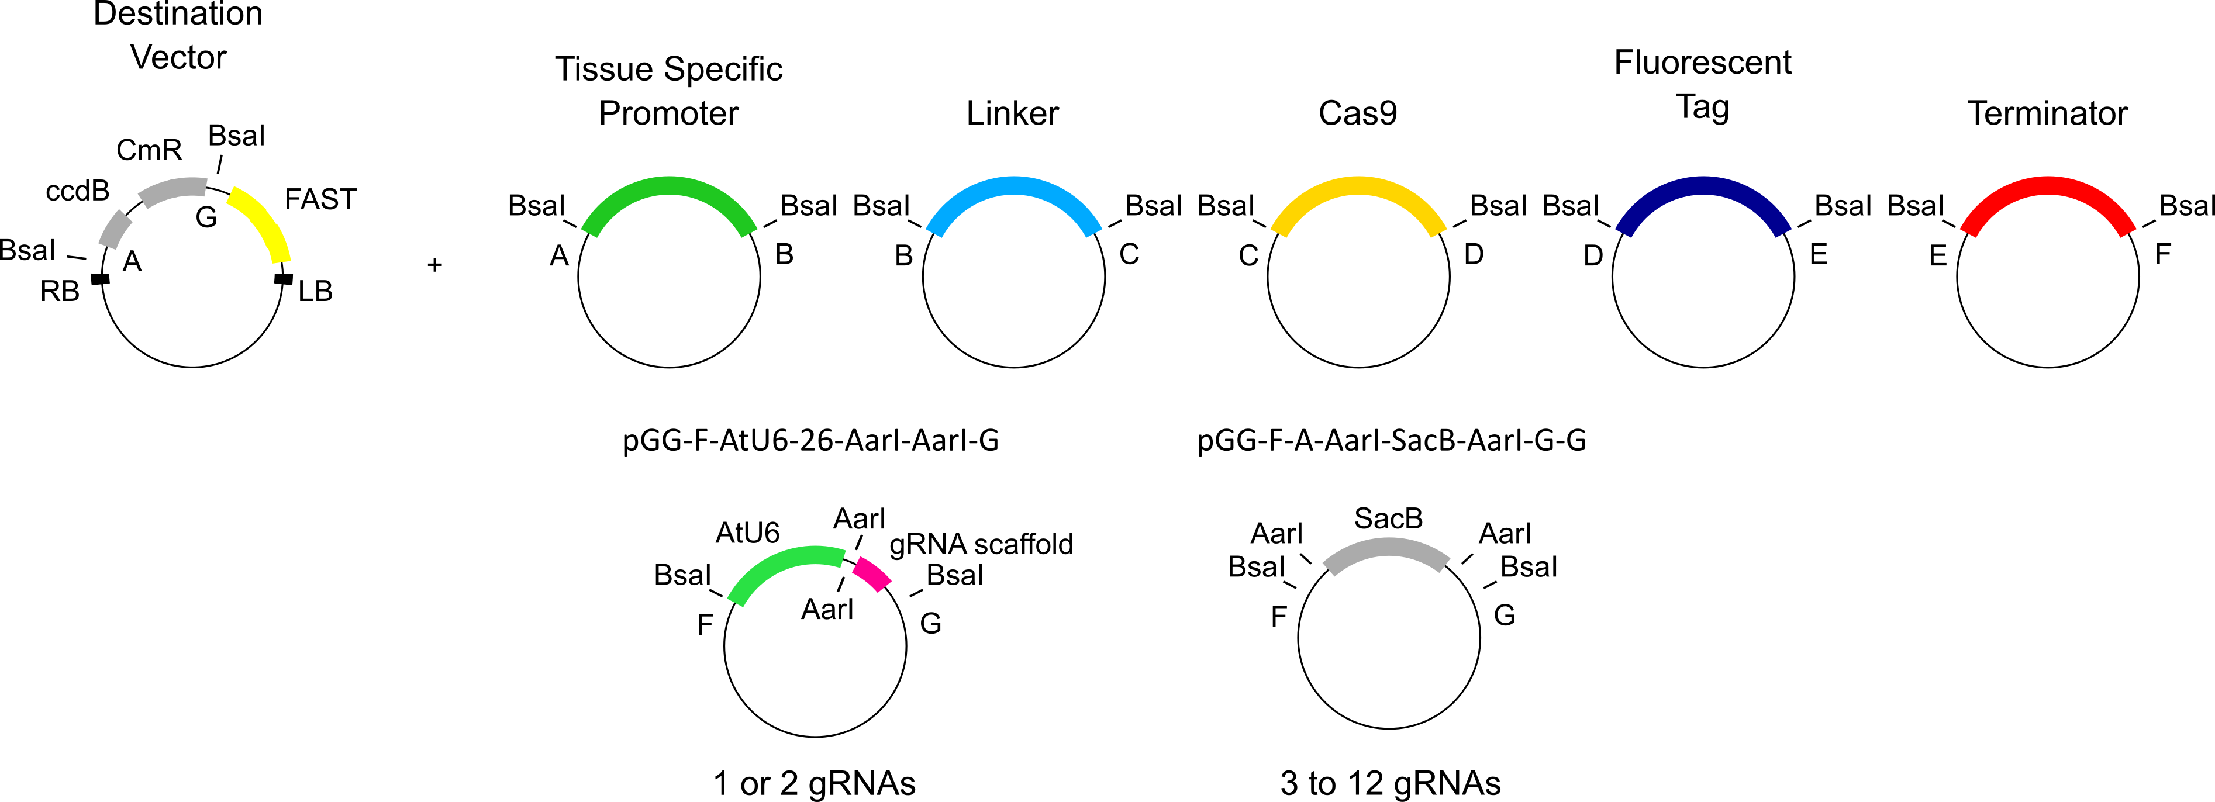

The following components are mixed in a PCR tube:

|  |  |  |  |
| --- | --- | --- | --- |
| **Component** |  | **Amount** | **Volume (µL)** |
| A-B entry vector | (Tissue-specific) Promotor | 100 ng | 1 |
| B-C entry vector | N-tag or Linker | 100 ng | 1 |
| C-D entry vector | Nuclease | 100 ng | 1 |
| D-E entry vector | C-tag or Linker | 100 ng | 1 |
| E-F entry vector | Terminator | 100 ng | 1 |
| F-G entry vector | **Variable** | 100 ng | 1 |
| Destination vector |  | 100 ng | 1 |
| 10X CutSmart Buffer |  | 1X | 1.5 |
| 10 mM ATP |  | 1 mM | 1.5 |
| T4 DNA ligase |  | 200 U | 0.5 |
| BsaI-HF®v2 |  | 10 U | 0.5 |
| MQ water |  |  | 4 |
|  |  |  | 15 |

Golden Gate reaction conditions:

|  |  |  |
| --- | --- | --- |
| 37°C | 3 min | 30 x |
| 16°C | 3 min |
| 50°C | 5 min |  |
| 80°C | 5 min |  |
| 16°C | ∞ |  |

Golden Gate reaction conditions are flexible. We regularly use 2 minute steps for the 37°C and 16°C steps with 20 cycles. This reduces the reaction time to ca. 1 hour and 45 minutes. For difficult reactions, the step time and number of cycles can be increased.

Five µL of the reaction mixture is transformed into 50 µL DH5α *E. coli* cells via heat shock. The transformed cells are plated on LB medium containing 100 µg mL-1 spectinomycin. The vector should be validated using colony PCR and restriction digest. Primers and enzyme(s) vary depending on destination vector used.

Note: The TSKO Destination Vectors for multiple gRNAs contain the *SacB* gene. This gene encodes an enzyme that converts sucrose to levans, which accumulates in the periplasm and is toxic to *E. coli* (Gay et al., 1985). This allows for counter selection in subsequent cloning on LB medium containing 10% sucrose.

1. *AarI restriction digest*

The TSKO destination vectors made in step **I.A,** or those available from our collection (**Supplemental Data Set 1**), have two AarI restriction sites. Upon digestion with AarI, these vectors contain four base pair overhangs that are used to directly load one or two gRNAs (as described in **II**) or multiple gRNAs (as described in **III**). More conveniently however, we replace the two AarI sites with two BsaI sites flanking *ccd*B and *Cm*R expression cassettes (as described in **I.C**).

AarI digestion is performed according to the manufacturer’s recommendations.

|  |  |  |
| --- | --- | --- |
| **Component** | **Amount** | **Volume (µL)** |
| Plasmid DNA (100 ng/µL) | 1 µg | 10.0 |
| MQ water |  | 7.1 |
| Buffer AarI | 1x | 2.0 |
| Oligonucleotides | 0.5 µM | 0.4 |
| AarI | 1 U | 0.5 |
|  |  | 20.0 |

Mix gently and spin down for a few seconds. Incubate at 37°C for 1-16 hours. Heat inactivate the AarI enzyme for 20 min at 65°C and confirm digestion by running ~100-200 ng on a 0,8% agarose gel. Alternatively, the digest can be gel purified. Include the undigested vector as a control and excise the digested fragment when it has separated from the uncut band.

Expected bands:

* The TSKO destination vectors compatible with cloning one or two gRNAs generates two fragments. The smallest fragment (32 bp) is too small to be visualized. The largest fragment is shifted upwards compared to the undigested vector.
* The TSKO destination vectors compatible with cloning multiple gRNAs generates two fragments. The fragment containing the *SacB* selectable marker has a size of 1,898 base pairs. The largest fragment has a size of > 10 kb.

1. *Replacement of AarI restriction sites for BsaI restriction sites*

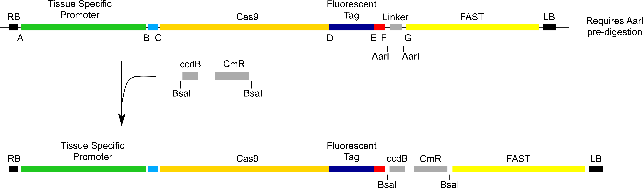

A fragment containing the *ccdB* and *CmR* selectable markers flanked by BsaI sites is PCR amplified with Q5® High-Fidelity DNA Polymerase from the vector pEN-L4-A-G-R1. The primers for this reaction depend on the vector that you are cloning.

* For cloning a one-step vector compatible with 1 or 2 gRNAs, the PCR reaction is performed with oligos 1436 & 1437 (resulting in a fragment of 1451 bp). Following BsaI digestion, this fragment will have the ATTG and AAAC overlaps corresponding to the AtU6-26 promoter and SpCas9 scaffold sequences, respectively.
* For cloning a vector compatible with multiple gRNAs, the PCR reaction is performed with oligo 23 & 24 (resulting in a fragment of 1834 bp). Following BsaI digestion, this fragment will have the ACCT and ATAC overhangs corresponding to the A and G sites in the GreenGate cloning system.

Mix the following components in a PCR tube:

|  |  |  |
| --- | --- | --- |
| **Component** | **Amount** | **Volume (µL)** |
| pEN-L4-A-G-R1 (100 ng/µL) | 50 ng | 0.5 |
| FW primer (10 µM) | 0.5 µM | 2.5 |
| REV primer (10 µM) | 0.5 µM | 2.5 |
| dNTPs | 200 µM | 1 |
| Q5® Reaction Buffer | 1X | 10 |
| Q5® High-Fidelity DNA Polymerase | 1U | 0.5 |
| MQ water |  | 33 |
|  |  | 50* |

Reaction conditions:

|  |  |  |
| --- | --- | --- |
| 98°C | 30 sec |  |
| 98°C | 10 sec | 34 x |
| Ta** | 30 sec |
| 72°C | 1 min |
| 72°C | 2 min |  |
| 16°C | ∞ |  |

* The manufacturer’s recommended final volume is 50 µL. This can however, be reduced to 10 µL.

** 1436 + 1437 (Ta = 67°C) and 23 + 24 (Ta= 57°C), as calculated by the NEB Tm Calculator (<http://tmcalculator.neb.com/#!/main>)

Purify from gel and digest with BsaI

|  |  |  |
| --- | --- | --- |
| **Component** | **Amount** | **Volume (µL)** |
| PCR product | 1 µg |  |
| 10X CutSmart buffer | 1X | 5 |
| BsaI-HF®v2 | 10 U | 0.5 |
| MQ water |  |  |
|  |  | 50 |

Mix gently and spin down for a few seconds. Incubate at 37°C for at least 1 hour, and heat inactivate the BsaI-HF®v2 enzyme for 20 min at 80°C.

The following components are mixed in a microcentrifuge tube:

|  |  |  |
| --- | --- | --- |
| **Component** | **Amount** | **Volume (µL)** |
| AarI digested vector |  | 1 |
| BsaI digested PCR product |  | 1 |
| T4 DNA Ligase | 400 U | 1 |
| 10X T4 DNA Ligase buffer | 1X | 1 |
| MQ water |  | 6 |
|  |  | 10 |

Gently mix the reaction and microfuge briefly. According to the manufacturer’s recommendation, incubate at 16°C overnight or at room temperature for 10 minutes. We however, generally incubate at least for one hour (at room temperature). Heat inactivate at 65°C for 10 minutes. Chill on ice and transform 1-5 µL of the reaction mixture into 50 µL One Shot™ *ccd*B Survival™ 2 T1R Competent Cells via heat shock. Transformed cells are selected on LB medium containing 25 µg µL-1 chloramphenicol. Alternatively, for destination vectors containing a SacB selectable marker, negative selection can be performed on LB medium containing 10% sucrose. The inserted fragment is verified via Sanger sequencing, and the vector should be validated by colony PCR and restriction digest (NheI is recommended).

1. **Vectors compatible with cloning one or two gRNAs**

The TSKO destination vectors compatible with cloning one or two gRNAs are loaded with either annealed oligos for a single gRNA (as described in **II.A**) or with a PCR product for two gRNAs (as described in **II.B**).

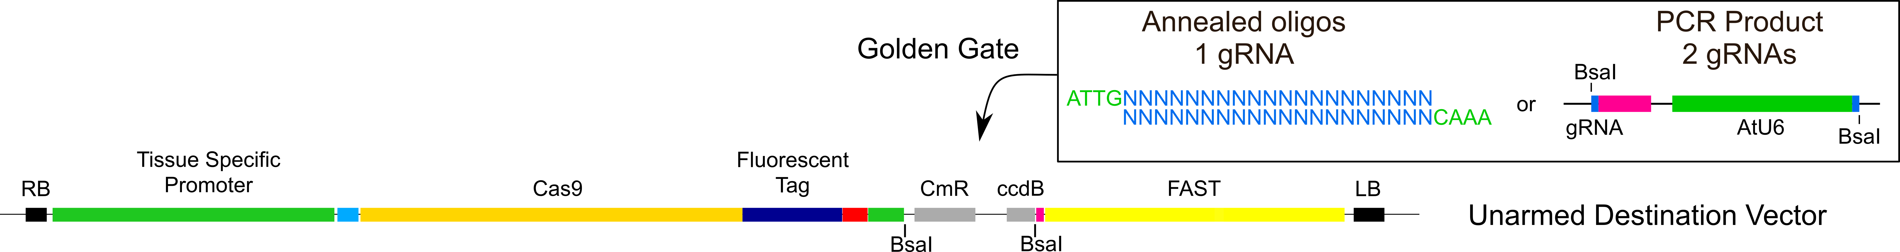

1. Single gRNA: Annealed Oligos

* FW: 5’-ATTG-N20 with N20 being the protospacer of the gRNA
* REV: 5’-AAAC-N20 with N20 being the ***reverse complement*** of the protospacer

5’- ATTGNNNNNNNNNNNNNNNNNNNN

NNNNNNNNNNNNNNNNNNNNCAAA -5’

Protocol:

* Add 1 µL of each 100 µM oligo to 48 µL of MQ water
* Incubate with a slow-cooling program on the thermal cycler e.g.: 5 minutes at 95°C; 95-85°C, -2°C/second; 85-25°C, -0.1°C/second
* The annealed oligos are cloned in the destination vector via a Golden Gate reaction

|  |  |  |
| --- | --- | --- |
| **Component** | **Amount** | **Volume (µL)** |
| Annealed oligos |  | 1 |
| Destination vector | 100 ng | 1 |
| 10X CutSmart Buffer | 1X | 1.5 |
| 10 mM ATP | 1 mM | 1.5 |
| T4 DNA ligase | 200 U | 0.5 |
| BsaI-HF®v2 | 5 U | 0.5 |
| MQ water |  | 9 |
|  |  | 15 |

|  |  |  |
| --- | --- | --- |
| 37°C | 3 min | 30 x |
| 16°C | 3 min |
| 50°C | 5 min |  |
| 80°C | 5 min |  |
| 16°C | ∞ |  |

Transform 5 µL of the reaction mixture via heat shock into 50 µLDH5α *E. coli* cells, and plate on LB medium containing 100 µg/mL Spectinomycin. The vectors should be validated by Sanger sequencing and restriction digest with NheI. Primers and enzyme(s) vary depending on destination vector used.

1. Two gRNAs: PCR product

For cloning two gRNAs in the destination vector we used the following approach as described by (Xing et al., 2014) with some modifications. **BsaI sites** in bold.

* FW: 5’-TTTT**GGTCTC**AATTG-N20-GTTTTAGAGCTAGAAATAGC with N20 being the protospacer of the first gRNA
* REV: 5’-TTTT**GGTCTC**AAAAC-N20-CAATCACTACTTCGACTC with N20 being the reverse complement of the protospacer of the second gRNA

|  |  |  |
| --- | --- | --- |
| **Component** | **Amount** | **Volume (µL)** |
| pEN-2xAtU6 template | 50 ng* | 0.5 |
| 10 µM FW primer | 0.5 µM | 2.5 |
| 10 µM REV primer | 0.5 µM | 2.5 |
| 10 mM dNTPs | 200 µM | 1 |
| 5X Q5® Reaction Buffer | 1X | 10 |
| Q5® High-Fidelity DNA Polymerase | 0.02 U/µl | 0.5 |
| MQ water |  | 33 |
|  |  | 50** |

|  |  |  |
| --- | --- | --- |
| 98°C | 30 sec |  |
| 98°C | 10 sec | 34 x |
| 55°C*** | 15 sec |
| 72°C | 15 sec |
| 72°C | 2 min |  |
| 16°C | ∞ |  |

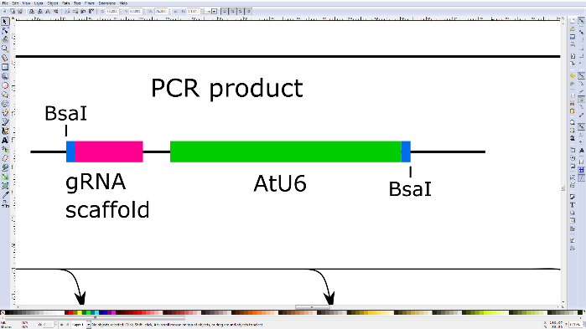

* This is the amount of plasmid used for this report. We routinely use less (≤1ng).

** The manufacturer’s recommended final volume is 50 µL. However, we routinely scale this down to 10 µL.

*** As calculated by the NEB Tm Calculator (<http://tmcalculator.neb.com/#!/main>) using the invariable 3’ sequence of the primer.

The products are run on an 0,8% agarose gel and the 575 bp band is gel purified. Gel purification is highly recommended to ensure no primer dimers are incorporated.

The following components are mixed in a PCR tube:

|  |  |  |
| --- | --- | --- |
| **Component** | **Amount** | **Volume (µL)** |
| PCR product (575 bp band) | ~10 ng | 1 |
| Destination vector | 100 ng | 1 |
| 10X CutSmart Buffer | 1X | 1.5 |
| 10 mM ATP | 1 mM | 1.5 |
| T4 DNA ligase | 200 U | 0.5 |
| BsaI-HF®v2 | 5 U | 0.5 |
| MQ water |  | 9 |
|  |  | 15 |

|  |  |  |
| --- | --- | --- |
| 37°C | 3 min | 30 x |
| 16°C | 3 min |
| 50°C | 5 min |  |
| 80°C | 5 min |  |
| 16°C | ∞ |  |

Five µL of the reaction mixture is transformed via heat shock into 50 µL DH5α *E. coli* cells. The cells are plated on LB medium containing 100 µg mL-1 spectinomycin. Plasmids are validated with a restriction digest and the inserted fragment verified via Sanger sequencing. Primers and enzyme(s) vary depending on destination vector used.

1. **Multiple gRNA vectors**

Cloning >2 gRNAs requires two Golden Gate reactions. In step one, the unarmed gRNA entry vectors (see unarmed gRNA vectors (*ccdB+*) in **Supplemental Data Set 1**) are loaded with either one or two gRNAs. In step two, the armed gRNA vectors are assembled into the TSKO destination vector.

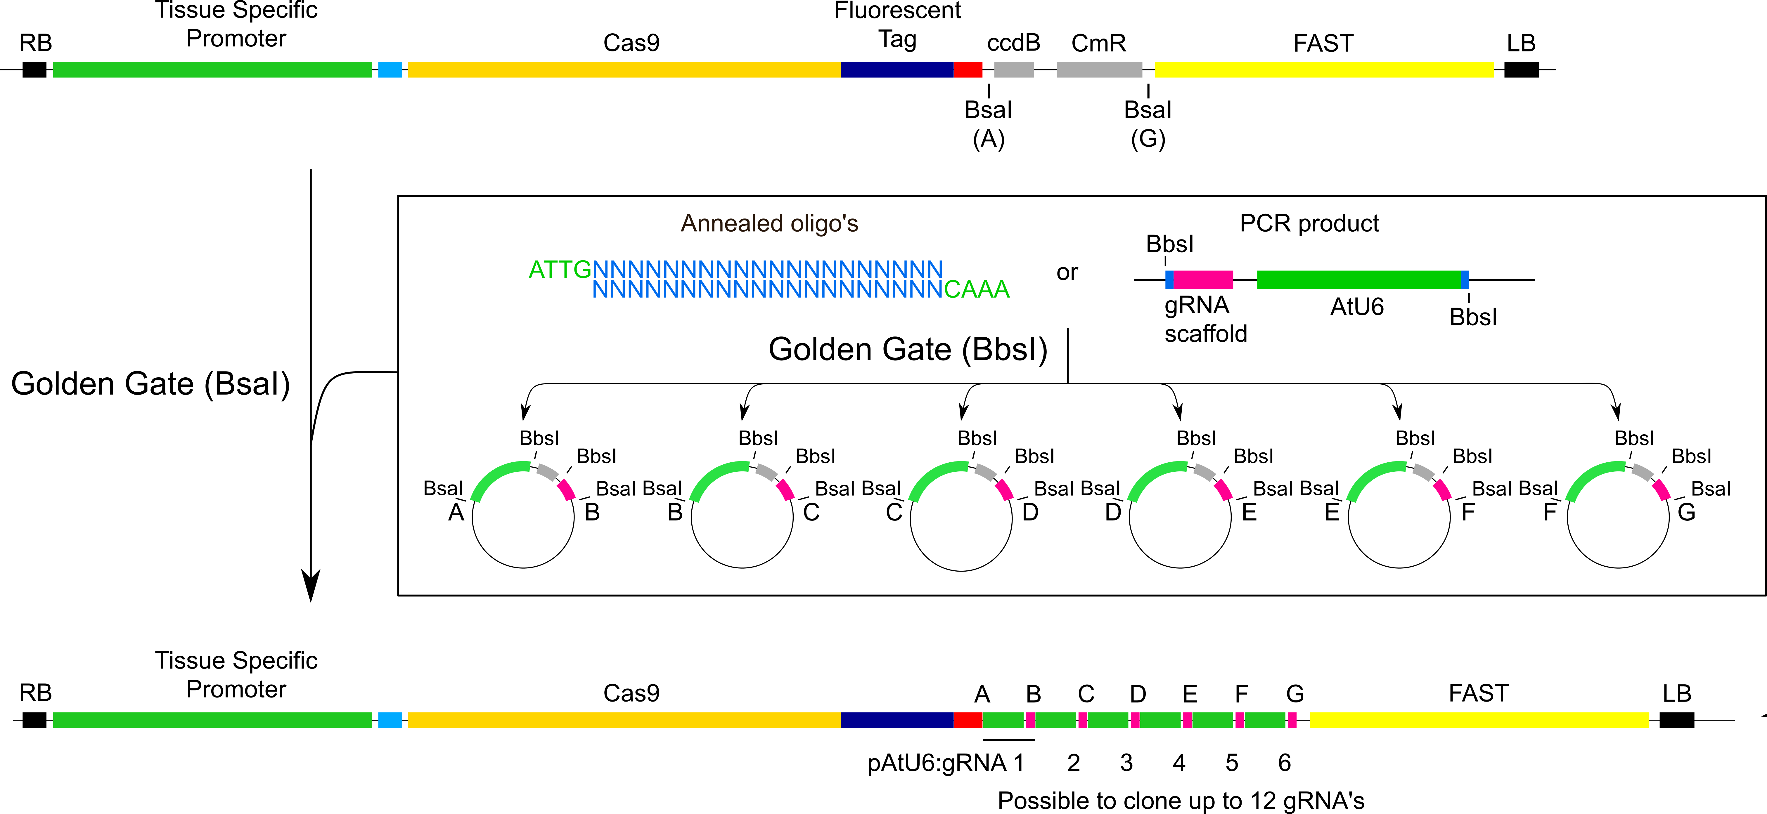

The loading of a single gRNA is done as described in **II. A**, with some modifications. BbsI-HF is used instead of BsaI for the Golden Gate assembly of the annealed oligos. The reaction is transformed into DH5α *E. coli* cells and plated on LB medium containing 100 µg mL-1 Carbenicillin.

For cloning two gRNAs in the unarmed gRNA entry vectors, the loading of two gRNAs is done essentially as described in **II.B**, with the following modifications. Use the following primer sequences, **BbsI sites** in bold.

* FW: 5’- TTTT**GAAGAC**ATATTG-N20-GTTTTAGAGCTAGAAATAGC with N20 being the protospacer of the first gRNA
* REV: 5’- TTTT**GAAGAC**TTAAAC-N20- CAATCACTACTTCGACTC with N20 being the reverse complement of the protospacer of the second gRNA

The products are run on an 0,8% agarose gel and the 575 bp band is gel purified. Gel purification is highly recommended to ensure no primer dimers are incorporated. Golden Gate assembly is done with BbsI-HF, transformed into DH5α *E. coli* cells and plated on LB medium containing 100 µg mL-1 Carbenicillin.

Confirm gRNA clones by Sanger sequencing with oligo 62.

The armed gRNA entry vectors are combined in a destination vector via a Golden Gate reaction. One or more linkers (see Linkers in **Supplemental Data Set 1**) can be used to span the unused positions. The following components are mixed in a PCR tube:

|  |  |  |
| --- | --- | --- |
| **Component** | **Amount** | **Volume (µL)** |
| A-B armed gRNA | 100 ng | 1 |
| B-C armed gRNA | 100 ng | 1 |
| C-D armed gRNA | 100 ng | 1 |
| D-E armed gRNA | 100 ng | 1 |
| E-F armed gRNA | 100 ng | 1 |
| F-G armed gRNA | 100 ng | 1 |
| Destination vector | 100 ng | 1 |
| 10X CutSmart Buffer | 1x | 1.5 |
| 10 mM ATP | 1 mM | 1.5 |
| T4 DNA ligase | 200 U | 0.5 |
| BsaI-HF®v2 | 10 U | 0.5 |
| MQ water |  | 4 |
|  |  | 15 |

|  |  |  |
| --- | --- | --- |
| 37°C | 3 min | 30 x |
| 16°C | 3 min |
| 50°C | 5 min |  |
| 80°C | 5 min |  |
| 16°C | ∞ |  |

Five µL of the reaction mixture are transformed into 50 µLDH5α *E. coli* cells via heat shock. The transformed cells are plated on LB medium containing 100 µg mL-1 spectinomycin. The vector should be validated using colony PCR and restriction digest. Sanger sequencing is not recommended as the repetitive arrays of gRNAs usually cause the reactions to fail.

**Materials**

Product Concentration Provider

CutSmart Buffer 10X New England Biolabs

T4 DNA ligase 400,000 U/mL New England Biolabs

BsaI-HF®v2 20,000 U/mL New England Biolabs

BbsI-HF 20,000 U/mL New England Biolabs

ATP 10 mM ThermoFisher Scientific

NheI 10 U/mL Promega Corporation

Buffer B 10X Promega Corporation

Acetylated BSA 10 µg/µL Promega Corporation

AarI 2 U/mL ThermoFisher Scientific

Buffer AarI 10X ThermoFisher Scientific

Oligonucleotides 50X (0.025 mM) ThermoFisher Scientific

Q5® High-Fidelity DNA Polymerase 2,000 U/mL New England Biolabs

Q5® Reaction Buffer 5X New England Biolabs

10 mM dNTPs 10 mM New England Biolabs

One Shot™ ccdB Survival™ 2 T1R Competent Cells ThermoFisher Scientific

ZymocleanTM Gel DNA Recovery Kit Zymo Research

**Primers**

Oligo 23 GTAAAACGACGGCCAG

Oligo 24 CAGGAAACAGCTATGAC

Oligo 1436 TTTTATTGTGAGACCGCGGCCGCATTAG

Oligo 1437 TTTTAAACTGAGACCGTCGACTTATATTCCC  
Oligo 62 CGACGGCCAGGTAATACGACT

**References**

**Engler, C., Kandzia, R., and Marillonnet, S.** (2008). A one pot, one step, precision cloning method with high throughput capability. Plos One **3,** e3647.

**Gay, P., Le Coq, D., Steinmetz, M., Berkelman, T., and Kado, C.I.** (1985). Positive selection procedure for entrapment of insertion sequence elements in gram-negative bacteria. J Bacteriol **164,** 918-921.

**Lampropoulos, A., Sutikovic, Z., Wenzl, C., Maegele, I., Lohmann, J.U., and Forner, J.** (2013). GreenGate---a novel, versatile, and efficient cloning system for plant transgenesis. Plos One **8,** e83043.

**Xing, H.L., Dong, L., Wang, Z.P., Zhang, H.Y., Han, C.Y., Liu, B., Wang, X.C., and Chen, Q.J.** (2014). A CRISPR/Cas9 toolkit for multiplex genome editing in plants. Bmc Plant Biology **14,** 12.