**Global buffering of forest understory temperatures**

Pieter De Frenne1*†, Florian Zellweger2,3†, Francisco Rodríguez-Sánchez4, Brett Scheffers5, Kristoffer Hylander6, Miska Luoto7, Mark Vellend8, Kris Verheyen1, Jonathan Lenoir9†

1Forest & Nature Lab, Department of Environment, Ghent University, Geraardsbergsesteenweg 267, Gontrode-Melle BE-9090, Belgium.

2Forest Ecology and Conservation Group, Department of Plant Sciences, University of Cambridge, Downing Street, Cambridge CB2 3EA, United Kingdom.

3Swiss Federal Research Institute WSL, Landscape Dynamics and Remote Sensing, Switzerland.

4Department of Integrative Ecology, Estación Biológica de Doñana (EBD-CSIC), Avda. Américo Vespucio 26, Sevilla E-41092, Spain.

5Department of Wildlife Ecology and Conservation, University of Florida, Gainesville, FL, 32611, USA.

6Department of Ecology, Environment and Plant Sciences, Stockholm University, SE-106 91 Stockholm, Sweden.

7Department of Geosciences and Geography, Gustaf Hällströmin katu 2a, University of Helsinki, Finland.

8Département de Biologie, Université de Sherbrooke, 2500 boulevard de l’Université, Sherbrooke, Quebec J1K 2R1, Canada.

9Unité de Recherche “Ecologie et Dynamique des Systèmes Anthropisés” (EDYSAN, UMR 7058 CNRS-UPJV), Université de Picardie Jules Verne, Amiens, France.

*email: [Pieter.DeFrenne@UGent.be](mailto:Pieter.DeFrenne@UGent.be)

†Equally contributing authors

**Abstract**

Macroclimate warming is affecting ecosystems worldwide and is frequently assumed to also manifest under forest canopies despite the potential for tree cover to modify microclimates. Using paired measurements (under the canopy vs. in the open) at 98 sites across five continents, we show that forests globally function as a thermal insulator and that their buffering capacity is of greater magnitude than the warming of land temperatures over the past century. The buffering effect of tree canopies is magnified as temperatures become more extreme and will thus reduce the severity of the impacts of climate change on forest biodiversity and functioning.

**Main text**

Biological impacts of macroclimate warming are increasingly evident across a wide array of ecosystems1-5. Many responses of biological communities and ecosystem processes, however, are lagging behind warming of the macroclimate6-11. Such time lags may be the inevitable consequence of slow dispersal and demography3, 7, 8, but may also be due to the buffering of localized microclimates by vegetation and topography, such that organisms do not necessarily experience the same degree of warming as measured at weather stations12-18. Biotic and abiotic features near the ground create heterogeneous microclimates, mostly via effects on radiation, air mixing, evapotranspiration and soil properties, all of which can influence biodiversity and ecosystem functioning17, 18.

To better predict the biotic consequences of climate change, we need to further our understanding of how the local temperature experienced by living organisms (referred to as the ‘microclimate’) changes in space and time. Macroclimates (also referred to as ‘free-air temperatures’) are characterized by an extensive global network of weather stations established in the well-mixed air of open areas (e.g. short grasslands) *c*. 2 m above the soil surface19, 20 — habitat conditions that are not representative of the conditions experienced by the majority of terrestrial species on Earth21, 22. The study of microclimates is not new, since microclimatological measurements began more than a century ago, but most climate-change studies exactly rely on weather station data that are specifically designed to cancel out these microclimatic effects15-20. Hence, future projections of climate change relying on macroclimate solely ignore the potential impact of microclimates on biodiversity and ecosystem functioning1, 2, 5.

Microclimates are particularly evident in forests, where the large majority of species live underneath the canopy of trees that strongly influences local thermal conditions10-13. This is of major concern for global-change science because forests cover 27 % of the Earth’s land surface and harbor two-thirds of all terrestrial biodiversity20-23, and some studies have already shown that microclimatic buffering can mediate the response of forest communities to climate change8-11.

Here we report a systematic, global meta-analysis quantifying the thermal buffering capacity of the Earth’s dominant forested ecosystems (tropical to boreal forests) across five continents (Fig. 1). Drawing on empirical studies with a strictly paired design (i.e. comparing microclimate with macroclimate), we assess the average buffering capacity of forests and also how the magnitude of buffering depends on macroclimatic context (i.e. free-air temperatures). From a total of 98 sites and 74 studies, we retrieved paired temperature time series and/or summary statistics (i.e. minimum, mean or maximum temperatures) for exactly the same time period in (i) understory conditions in forests (i.e. microclimate) and (ii) an adjacent open habitat without shade (i.e. macroclimate).

In our global analysis of 714 paired temperature data, we found that tree canopies buffer forest floors against both high and low macroclimatic temperatures. Mean and maximum understory temperatures were, on average, cooler by 1.7 ± 0.3 and 4.1 ± 0.5 °C (mean ± S.E., mixed-effects models: both *P* < 0.001) than outside temperatures, respectively. Conversely, minimum temperatures of the forest understory were 1.1 ± 0.2 °C warmer than outside the forest (mixed-effects model: *P* < 0.001; Fig. 1, Supplementary Figs. 1-2).

Across the globe, the thermal buffering capacity of forests was always negatively correlated with the free-air temperature outside forests. Thermal buffering became more negative (i.e. lower temperatures in forests) as free-air temperature increased, and more positive (i.e. higher temperatures in forests) as free-air temperatures decreased (Fig. 2a, Supplementary Figs. 3-4). As a result, the cooling of mean and maximum temperatures was highest in tropical forests while minimum temperatures were enhanced most in boreal forests, relative to the free-air temperature (Fig. 2b).

To specifically test for the effect of spatiotemporal changes in free-air temperatures (e.g. sampling of tropical *vs*. boreal forests, low *vs*. high elevations or warm *vs*. cold years) on the magnitude of buffering, we computed free-air temperature anomalies relative to the average conditions over the period 1970-2000 for each of the 98 study sites, and subsequently used it as a predictor variable instead of actual temperatures outside the forest reported in the original studies. The results are in line with those using raw temperature values rather than anomalies: the cooling effect on maximum and mean temperatures, as well as the warming effect on minimum temperatures, are consistent along the gradient of temperature anomalies, with very similar slope estimates compared to the models with actual free-air temperatures (Supplementary Fig. 5). Together, these results indicate that the thermal buffering capacity of forests across the globe may translate into lower warming in the forest understory compared to warming trends using weather-station data from non-forested areas. Forests across the globe are thus effectively serving as thermal insulator, with strong evidence that buffering can reduce the severity of climate change impacts on forest ecosystems.

In addition to spatiotemporal variability, we also tested for additional factors that might explain some of the variation among studies in the magnitude of temperature buffering, such as forest density and composition (evergreen, mixed or deciduous) or the height of the temperature sensors (e.g. aboveground or belowground) (Supplementary Figs. 6-9). Sensor height and forest structure indeed impacted the degree of buffering. Higher forest density (quantified by canopy cover, basal area, leaf area index or stem density) resulted in stronger buffering of maximal temperatures but not of minimum nor mean temperatures, although the effect was weak and most pronounced for temperatures recorded during the growing season (Supplementary Fig. 8). This is expected given that denser forests reduce air mixing and radiation reaching the forest floor. Surprisingly, the type of dominant tree species (evergreen, deciduous or mixed) did not affect the magnitude of buffering.

Paleoecological records show that temperature changes of greater magnitude and rate have stronger biological consequences5, 24. Here we have shown that microclimate buffering in forests has the potential to partly offset the warming due to anthropogenic climate change, effectively reducing the severity of impacts due to heating of the atmosphere. As such, closed forest canopies might provide a line of defense against the impacts of current and future warming on the ecological processes that influence forest ecosystems (e.g. demography and community reshuffling, tree regeneration, litter decomposition and soil water and nutrient cycling). For example, advanced timing of tree leaf-out due to warming may enhance microclimate cooling of the forest understory which, in turn, influences spring-developing, thermophilous species such as butterflies25.

Our results underpin a neglected function of forests: they demonstrate a buffering of within-forest temperatures by tree canopies that is of greater magnitude than the global warming of land and ocean temperatures over the past century (~0.85 °C, ref. 4) and also the warming of regional surface temperatures following deforestation (usually < 1 °C, ref. 26). Forest canopies serve as thermal insulating layer, likely offsetting the impacts of anthropogenic climate change in the understory, where a large share of forest biodiversity resides and key ecosystem processes take place21, 22. It is thus essential to incorporate microclimates into biodiversity and climate science as well as into forest management and policy. As forest loss, degradation and conversion to monoculture crops continues27, 28, human land use might undermine ecosystems’ natural capacity to mediate climate warming (a positive feedback). Such feedbacks to climate systems may be further exacerbated via effects of microclimates on soil CO2 and CH4 fluxesand sub-canopy evapotranspiration rates29.

Advances in studies of micro- vs. macroclimate change have thus far been limited by the availability of suitable spatial data to model and map small-scale heterogeneity of microclimate conditions10-17. Our global analysis shows the importance of forests in moderating climate warming, and the next step will be to incorporate fine-grained thermal variability into bioclimatic modeling of future species demography and distributions14-17. Our findings underpin that well-quantified microclimates are key to improving predictions and assist management decisions. Forest managers and policy makers alike can potentially exploit microclimate buffering as a regulating service when developing mitigation and adaptation plans to safeguard forest biodiversity and functioning as well as human well-being in a future, warmer climate.

Methods

Literature search and data extraction

We performed a literature search on ISI Web of Science to compile suitable published studies assessing the thermal buffering capacity of forest ecosystems. This search was updated until 15 June 2017 and performed by each of three authors (PDF, FZ, JL) independently, using keywords such as microclimat*, microrefug*, microhabitat*, forest*, temperature* and buffer*. The combined number of potentially suitable papers found by these three independent searches was 706. We then screened the titles and abstracts to find studies that potentially met our requirements for data extraction (see the next paragraph). We considered forest microclimates to represent the suite of climatic conditions measured in localized areas near the ground and within the forest understory (below tree canopies). Microclimatic conditions include temperature, precipitation, wind and humidity, but the focus here was on the temperature of the air layer below tree canopies and the temperature of the topsoil due to their importance for the responses of forest organisms and ecosystem functioning to macroclimate warming. The macroclimate was considered as the climate in free-air conditions, representative of a large geographic region without direct canopy effects. This definition follows the definition used by meteorologists who record synoptic or free-air conditions from standardized weather stations19-20.

Our criteria for study inclusion were the following: studies had to report temperature values (time series or summary statistics such as minimum, mean or maximum values) according to a strictly paired design comparing microclimate below trees (inside forests) with temperatures recorded from a reference neighbouring site outside the forest without any influence of trees (i.e. macroclimate in free-air conditions). Reference sites were either a nearby open site equipped with the same type of (shielded) temperature loggers, a nearby weather station (as long as the distance did not confound with the temperature buffering of the canopy, e.g. due to significant topographic differences), or a logger placed above the upper canopy surface. Constancy of the location of temperature sensors within a pair of observations (e.g. forest soil temperatures were only compared with control soil temperatures) was a requirement. Temperature data presented in tables or text were entered directly into our database (see Supplementary Dataset 1). Temperature data presented in figures in the original papers were extracted using the digitalization software *WebPlotDigitizer* ([https://automeris.io/WebPlotDigitizer/)](http://arohatgi.info/-WebPlotDigitizer/)). We did not set any limit on the study duration, i.e. we extracted data from studies that quantified paired temperature time series during single days up to several years. If studies were performed along an edge-to-core transect, we only considered the measurements outside the forest farthest away from the edge versus the measurement closest to the core of the forest (as far away from the edge as possible). We screened the titles and abstracts of all above-mentioned 706 publications. In addition, we included a formal process of scanning references lists of relevant papers and further added potentially relevant papers extracted from these reference lists. In total, we identified 74 studies published between 1939 and 2017 that met our above-mentioned requirements for data extraction. The majority of the studies were reported in peer reviewed journal articles, but also 2 PhD theses, 1 book and 2 institutional reports were included.

When raw temperature data were available, we computed three summary statistics: maximum, mean and minimum temperatures across time. If available, we extracted temperatures outside and inside the forest and then calculated the magnitude of buffering as understory temperature minus temperature outside the forest; negative values thus reflect cooler temperatures below tree canopies while positive values reflect warmer understory temperatures. A third of the studies (34 % of buffering values) only reported the outside vs. understory temperature difference (and not the forest and free-air temperatures separately). In these instances, only the buffering value itself was directly entered in our database. Replicate forest sites (at least several kilometers apart), seasons (meteorological seasons, later aggregated to growing vs. non-growing season) and temperature metrics (maximum, mean, minimum, air or soil temperatures) within the same study were entered on different rows into the database (Supplementary Dataset 1). Temperature values of longer time series were always aggregated per season and/or year.

All authors contributed to the data extraction from the original papers. After the first data extraction, however, all entries into the database were thoroughly double-checked by four authors (PDF, FZ, FRS, JL), working together closely to resolve any discrepancies or ambiguities and to ensure a standardized protocol across all papers. We used the following R packages for data management, cleaning and visualization: readxl31, dplyr32, CoordinateCleaner33, knitr34, rmarkdown35, ggplot236, and cowplot37, as well as custom R code38.

In total, our final database consisted of 714 paired temperature buffering data points from 74 independent studies spread across five continents. Our full database with all variables used in the analyses, as well as all source code, is reported in Supplementary Information.

Predictor variables

Apart from the temperature variables, we also extracted the following attributes for each buffering value and/or study, if available in the original source article:

* *Location*: Latitude, longitude and elevation (meters above sea level).
* *Biome*: Based on the geographical coordinates, we classified each site into one of the following three biomes: tropical (latitude was between 23.5°S and 23.5°N); temperate (latitude was between 23.5° and 55°); or boreal (latitude was higher than 55°).
* *Vegetation type:* Based on the original source article, or, if needed, additional sources (e.g. other papers from the same study site and/or authors), the forest type was classified into each of three categories: deciduous (if dominant tree species was deciduous; 1 in Supplementary Dataset 1); evergreen (if dominant tree species was evergreen; 2 in Supplementary Dataset 1); or mixed (3 in Supplementary Dataset 1).
* *Forest density*: We extracted for each study site, if available, any of the following variables relating to forest density: canopy cover (%), tree basal area (m2 ha-1), tree density (number ha-1) and leaf area index (LAI). Due to the inconsistent reporting of proxies for forest density in the different studies (i.e. most often only one of these variables was reported), we combined these four measures into one synthetic forest density index, following the procedures described by Van der Veken et al.39 for plant performance based on different trait measurements. Each of the above-described variables was available for a minority of buffering values: 16 % for canopy cover, 23 % for basal area, 7 % for tree density and 8 % for LAI. The synthetic index of forest density was calculated by first dividing each forest density variable by the maximum value for that particular variable across all studies. Then, the mean across all available standardized values was calculated per study site, with values ranging theoretically from 0 (very open forests) to 1 (very dense forests). Note that even this synthetic index was calculable for only 37 % of buffering observations.
* *Season* of sampling: Temperature measurements were classified as having taken place during the growing season, the non-growing season, or whether the whole year was sampled (annual). This was aggregated based on reported meteorological seasons and/or climate information in the original study. The dry and winter season were classified as the non-growing season in tropical and temperate biomes, respectively.
* *Height of the sensor* (in meters above or below the soil surface): positive for aboveground, negative for belowground sensors. While soil temperatures obviously do not reflect free-air temperatures, they still allow for a comparison of forests’ thermal buffering capacity on soil organisms and processes. The effects of outside temperatures on the buffering were similar when only considering sensors placed > 0 cm above the soil surface.
* *Free-air temperature anomalies*: We calculated the difference between each free-air temperature and the long-term average (1970-2000) temperature for a given site. This was done in order to test if the increase in temperature buffering with warmer free-air temperatures was due in part to temporal variation in macroclimate, rather than only spatial variation. Using these temperature anomalies, we asked how the magnitude of the thermal buffering capacity of forests varies along a gradient of deviations from long-term temperature averages, analogous to IPCC definitions of climate change4. Location-specific long-term averages (1970-2000) of mean annual temperatures were extracted from WorldClim version 2 at 30 arc-second spatial resolution (approximately equivalent to 0.86 km² at the equator) for each study site40.

Data analyses

To report summary statistics of the thermal buffering capacity of forests globally (Supplementary Table 1), two contrasting approaches were adopted. First, the raw mean, median and quantiles were calculated. Then, we carried out a multilevel modeling framework using intercept-only linear mixed-effects models (LMMs) without fixed predictor variables but with ‘*study*’ as a random intercept term to account for pseudo-replication in some of the 74 selected studies. The intercept of intercept-only models represents the average magnitude of the thermal buffering capacity of forests while accounting for the non-independence among replicates from the same study. When fitting our intercept-only LMMs, we used the restricted maximum likelihood method in the *lmer* function from the *lme4*-package41 as recommended by Zuur et al.42.

Applying a conventional meta-analytical model *sensu stricto* with weighting of different observations by means of variance estimates43 was not possible here: an estimate of uncertainty (standard error, deviation or confidence intervals) of the buffering values was reported for only a small minority (13.6 %) of buffering values included in our database.

Next, we assessed how free-air temperatures and free-air temperature anomalies predicted variation in the magnitude of the buffering capacity of forests globally. As above, we fitted LMMs with free-air temperatures and free-air temperature anomalies as fixed effects and ‘*study*’ as a random effect using restricted maximum likelihood in the *lmer* function from the *lme4*-package41. We also performed χ²-tests by comparing the univariate LMM including a single predictor with the baseline intercept-only model42. Goodness-of-fit was determined by calculating marginal and conditional R² values following ref. 44 using the *r.squaredGLMM* function in the *MuMIn*-package45.

We also determined how variables such as absolute latitude, biome, elevation, vegetation type, forest density, season, and sensor height influenced variation in the magnitude of the buffering capacity of forests, and how they interacted with free-air temperatures. We first ran seven separate univariate LMMs, one per predictor variable as a fixed effect in our LMMs. As earlier, we again fitted LMMs with a random effect term ‘*study*’ using restricted maximum likelihood in the *lmer* function from the *lme4*-package41. In order to test interactions, we finally also ran LMMs with two predictor variables each: the free-air temperature and each of these seven other predictors (i.e. one-by-one of these seven variables * free air-temperature); for the sake of simplicity, higher level interactions were not considered (Supplementary Table 7).

Finally, the linearity of the relationship between buffering and free-air temperatures was tested with General Additive Mixed Models with the *gamm*-function in the *mgcv*-package46 and again *study* was added as random term (Supplementary Fig. 4). Our main findings were robust to the decisions to (i) analyze understory temperatures as the response variable against free-air temperature as a fixed effect in LMMs, instead of intercept-only LMMs based on buffering values (Supplementary Fig. 3), and (ii) add random intercepts into LMMs, instead of random slopes (Supplementary Table 7). Omitting a few outlier values from a single study121 from the analyses also did not affect our conclusions (Supplementary Table 8).

All analyses were performed in R version 3.4.4 (ref. 47) and all retained papers are in the reference list48-121. All raw data and code are available in Supplementary Dataset 1, Code 1 and Code 2 in Supplementary Information.

**Acknowledgements**

PDF received funding from the European Research Council (ERC) under the European Union’s Horizon 2020 research and innovation programme (ERC Starting Grant FORMICA 757833), KV through ERC Consolidator Grant PASTFORWARD 614839, FRS by a postdoctoral fellowship from the Spanish Ministry of Economy and Competitiveness (FPD-2013-16756), FZ by the Swiss National Science Foundation (project 172198) and MV by the Natural Sciences and Engineering Research Council, Canada.

**Author contributions**

PDF, FZ and JL conceived and designed research. PDF, FZ, JL and FRS assembled and revised the database, and analyzed the data. All authors compiled data and wrote the manuscript.

**Competing interests**

The authors declare no competing interests.

**Materials and Correspondence**

Correspondence and requests for materials should be addressed to P.D.F.

**Data availability**

Data and code will be archived in an online repository such as Dryad upon publication [during peer review, the data and code are uploaded as Supplementary Information].

**References**

1. Willis, K.J. & Bhagwat S.A. Biodiversity and climate change. *Science* **326**, 806-807 (2009).
2. Scheffers, B.R.et al. The broad footprint of climate change from genes to biomes to people. *Science* **354**, aaf7671 (2016).
3. Lenoir, J. & Svenning, J.C. Climate‐related range shifts – a global multidimensional synthesis and new research directions. *Ecography* **38**, 15-28 (2015).
4. IPCC. *Climate Change 2013: The Physical Science Basis* (Cambridge University Press, Cambridge, 2013).
5. Moritz, C. & Agudo, R. The future of species under climate change: resilience or decline? *Science* **341**, 504-508 (2013).
6. Devictor, V.et al. Differences in the climatic debts of birds and butterflies at a continental scale. *Nat. Clim. Change* **2**, 121-124 (2012).
7. Dullinger, S.et al. Extinction debt of high-mountain plants under twenty-first-century climate change. *Nat. Clim. Change* **2**, 619-622 (2012).
8. Bertrand, R.et al. Changes in plant community composition lag behind climate warming in lowland forests. *Nature* **479**, 517-520 (2011).
9. Ash, J.D., Givnish, T.J. & Waller, D.M. Tracking lags in historical plant species’ shifts in relation to regional climate change. *Glob. Change Biol.* **23**, 1305-1315 (2017).
10. De Frenne, P.et al. Microclimate moderates plant responses to macroclimate warming. *Proc. Natl. Acad. Sci. U.S.A.* **110**, 18561-18565 (2013).
11. Scheffers, B.R. et al. Microhabitats reduce animal's exposure to climate extremes. *Glob. Change Biol.* **20**, 495–503 (2013).
12. Senior R.A. et al. Tropical forests are thermally buffered despite intensive selective logging. *Glob. Change Biol.* **24**, 1267-1278 (2018).
13. Frey, S.J.K.et al. Spatial models reveal the microclimatic buffering capacity of old-growth forests. *Science Adv.* **2**, e1501392 (2016).
14. Dobrowski, S.Z. A climatic basis for microrefugia: the influence of terrain on climate. *Glob. Change Biol.* **17**, 1022-1035 (2011).
15. Potter, K.A., Arthur, W.H. & Pincebourde, S. Microclimatic challenges in global change biology. *Glob. Change Biol.* **19**, 2932-2939 (2013).
16. Lenoir, J., Hattab, T. & Pierre, G. Climatic microrefugia under anthropogenic climate change: implications for species redistribution. *Ecography* **40,** 253-266 (2017).
17. Bramer, I.et al. “Advances in Monitoring and Modelling Climate at Ecologically Relevant Scales” in *Adv. Ecol. Res.,* Bohan, D.A. et al., Eds. (Elsevier, 2018), vol. 58, pp. 101-161.
18. Geiger, R. Aron, R.H. & Todhunter, P. *The climate near the ground* (Rowman & Littlefield, Plymouth, ed. 7, 2009).
19. World Meteorological Organization. *Guide to Meteorological Instruments and Methods of Observation* (WMO-No. 8, Geneva, 2008).
20. De Frenne, P. & Verheyen, K. Weather stations lack forest data. *Science* **351**, 234-234 (2016).
21. Jenkins, C.N., Pimm, S.L. & Joppa, L.N. Global patterns of terrestrial vertebrate diversity and conservation. *Proc. Natl. Acad. Sci. U.S.A.* **110**, E2602-E2610 (2013).
22. Millennium Ecosystem Assessment. *Ecosystems and Human Well-being: Biodiversity Synthesis* (World Resources Institute, Washington, DC, 2005).
23. Food and Agriculture Organization of the United Nations. *Global Forest Resources Assessment* (FAO, Rome, 2015).
24. Mayhew, P.J., Jenkins, G.B. & Benton, T.G. A long-term association between global temperature and biodiversity, origination and extinction in the fossil record. *Proc. Roy. Soc. Lond. B.: Bio.* **275**, 47-53 (2008).
25. Wallisdevries, M.F. & Van Swaay, C.A.M. Global warming and excess nitrogen may induce butterfly decline by microclimatic cooling. *Glob. Change Biol.* **12**, 1620-1626 (2006).
26. Lejeune, Q. et al. Historical deforestation locally increased the intensity of hot days in northern mid-latitudes. *Nat. Clim. Change* **8**, 386-390 (2018).
27. Hansen,M.C. et al. High-resolution global maps of 21st-century forest cover change. *Science* **342**, 850-853 (2013).
28. Watson, J.E.M.et al. The exceptional value of intact forest ecosystems. *Nat. Ecol. Evol.* **2**, 599-610 (2018).
29. Good, S.P., Noone, D. & Bowen, G. Hydrologic connectivity constrains partitioning of global terrestrial water fluxes. *Science* **349**, 175-177 (2015).
30. United Nations Environment Programme – World Conservation Monitoring Centre (UNEP-WCMC). *Global Generalised 'Current' Forest dataset (V 3.0)* (1998; <https://www.unep-wcmc.org/resources-and-data/generalised-original-and-current-forest>

**Additional references Methods section**

1. Wickham, H. & Bryan, J. *Readxl: Read Excel Files* (2017; https://CRAN.R-project.org/package=readxl).
2. Wickham, H. et al. *Dplyr: A Grammar of Data Manipulation* (2017; https://CRAN.R-project.org/package=dplyr).
3. Zizka, A. *CoordinateCleaner: Automated Cleaning of Occurrence Records from Biological Collections* (2018; https://CRAN.R-project.org/package=CoordinateCleaner).
4. Xie, Y. *Knitr: A General-Purpose Package for Dynamic Report Generation in R* (2018; https://yihui.name/knitr/).
5. Allaire, J.J. et al. *Rmarkdown: Dynamic Documents for R* (2018; https://CRAN.R-project.org/package=rmarkdown).
6. H. Wickham, *Ggplot2: Elegant Graphics for Data Analysis* (Springer-Verlag, New York, 2009; http://ggplot2.org).
7. Wilke, C. *Cowplot: Streamlined Plot Theme and Plot Annotations for ’Ggplot2*’ (2017; https://CRAN.R-project.org/package=cowplot).
8. Rodríguez-Sánchez, F. & De Frenne, P. *Microclim.forest: Meta-Analysis of Forest Microclimates* (2018, https://github.com/Pakillo). [will be released upon publication, now in Supplementary Information]
9. Van der Veken, S. et al. Experimental assessment of the survival and performance of forest herbs transplanted beyond their range limit. *Basic Appl. Ecol.* **13**, 10-19 (2012).
10. Fick, S.E. & Hijmans, R.J. Worldclim 2: New 1-km spatial resolution climate surfaces for global land areas. *Int. J. Clim.* **37**, 4302-4315 (2017)
11. Bates, D. Fitting Linear Mixed-Effects Models Using lme4. *J. Stat. Softw.* **67**, 1-48 (2015).
12. Zuur, A.F. et al. *Mixed Effects Models and Extensions in Ecology with R* (Springer, New York, 2009).
13. Gurevitch, J. et al. Meta-analysis and the science of research synthesis. *Nature* **555**, 175 (2018).
14. Nakagawa, S. & Schielzeth, H. A general and simple method for obtaining R² from generalized linear mixed‐effects models. *Methods Ecol. Evol.* **4**, 133-142 (2013).
15. Barton, K. *MuMIn: Multi-Model Inference. R package version 1.40.4* (2018; <https://CRAN.R-project.org/package=MuMIn>).
16. Wood, S.N. *Generalized Additive Models: An Introduction with R* (Chapman and Hall/CRC, ed. 2, 2017).
17. R Core Team. *R: A language and environment for statistical computing* (R Foundation for Statistical Computing, Vienna, Austria, 2018; <https://www.R-project.org/>).
18. André, M.F. et al. Contrasting weathering and climate regimes in forested and cleared sandstone temples of the Angkor region. *Earth Surf. Process. Landforms*. **37**, 519–532 (2012).
19. A. Arunachalam, K. Arunachalam, Influence of gap size and soil properties on microbial biomass in a subtropical humid forest of north-east India. *Plant Soil*. **223**, 187–195 (2000).
20. H. Asbjornsen, M. S. Ashton, D. J. Vogt, S. Palacios, Effects of habitat fragmentation on the buffering capacity of edge environments in a seasonally dry tropical oak forest ecosystem in Oaxaca, Mexico. *Agric. Ecosyst. Environ.* **103**, 481–495 (2004).
21. A. K. Barg, R. L. Edmonds, Influence of partial cutting on site microclimate, soil nitrogen dynamics, and microbial biomass in Douglas-fir stands in western Washington. *Can. J. For. Res.* **29**, 705–713 (1999).
22. A. J. Belsky et al. The Effects of Trees on Their Physical, Chemical and Biological Environments in a Semi-Arid Savanna in Kenya. *J. Appl. Ecol.* **26**, 1005 (1989).
23. K. Blennow, Modelling minimum air temperature in partially and clear felled forests. *Agric. For. Meteorol.* **91**, 223–235 (1998).
24. L. P. Brower et al. Oyamel fir forest trunks provide thermal advantages for overwintering monarch butterflies in Mexico. *Insect Conserv. Divers.* **2**, 163–175 (2009).
25. P. Cachan, Signification écologique des variations microclimatiques verticales dans la foret sempervirente de basse Cote d’Ivoire. *Ann. Fac. Sci. Dakar*. **8**, 89–155 (1963).
26. D. W. Carlson, A. Groot, Microclimate of clear-cut, forest interior, and small openings in trembling aspen forest. *Agric. For. Meteorol.* **87**, 313–329 (1997).
27. J. Chen, J. F. Franklin, T. A. Spies, Contrasting microclimates among clearcut, edge, and interior of old-growth Douglas-fir forest. *Agric. For. Meteorol.* **63**, 219–237 (1993).
28. J. Chen et al. Microclimate in forest ecosystem and landscape ecology. *Bioscience*. **49**, 288–297 (1999).
29. S. W. Childs, L. E. Flint, Effect of shadecards, shelterwoods, and clearcuts on temperature and moisture environments. *For. Ecol. Manage.* **18**, 205–217 (1987).
30. A. F. Currylow, B. J. MacGowan, R. N. Williams, Short-term forest management effects on a long-lived ectotherm. *PLoS One*. **7** (2012).
31. G. C. Daily, P. R. Ehrlich, Nocturnality and species survival. *Proc. Natl. Acad. Sci.* **93**, 11709–11712 (1996).
32. R. J. Davies-Colley, G. W. Payne, M. van Elswijk, Microforest gradients across a forest edge. *N. Z. J. Ecol.* **24**, 111–121 (2000).
33. J. S. Denslow, Gap partitioning among tropical rainforest trees. *Biotropica*. **12**, 47–55 (1980).
34. R. K. Didham, R. M. Ewers, Edge effects disrupt vertical stratification of microclimate in a temperate forest canopy. *Pacific Sci.* **68**, 493–508 (2014).
35. M. Dovčiak, J. Brown, Secondary edge effects in regenerating forest landscapes: Vegetation and microclimate patterns and their implications for management and conservation. *New For.* **45**, 733–744 (2014).
36. G. C. Evans, Ecological studies on the rain forest of southern Nigeria. II. The atmospheric environmental conditions. *J. Ecol.* **27**, 437–482 (1939).
37. N. Fetcher, S. F. Oberbauer, B. R. Strain, Vegetation effects on microclimate in lowland tropical forest in Costa Rica. *Int. J. Biometeorol.* **29**, 145–155 (1985).
38. S. J. K. Frey et al. Spatial models reveal the microclimatic buffering capacity of old-growth forests. *Sci. Adv.* **2** (2016).
39. J. D. Fridley, Downscaling climate over complex terrain: high finescale (<1000 m) spatial variation of near-ground temperatures in a montane forested landscape (Great Smoky Mountains). *J. Appl. Meteorol. Climatol.* **48**, 1033–1049 (2009).
40. N. Gaudio, X. Gendre, M. Saudreau, V. Seigner, P. Balandier, Impact of tree canopy on thermal and radiative microclimates in a mixed temperate forest: A new statistical method to analyse hourly temporal dynamics. *Agric. For. Meteorol.* **237**–**238**, 71–79 (2017).
41. B. S. Ghuman, R. Lal, Effects of partial clearing on microclimate in a humid tropical forest. *Agri*. **40**, 17–29 (1987).
42. B. J. Graae et al. On the use of weather data in ecological studies along altitudinal and latitudinal gradients. *Oikos*. **121**, 3–19 (2012).
43. H. B. Granberg, M. Ottosson-Löfvenius, H. Odin, Radiative and aerodynamic effects of an open pine shelterwood on calm, clear nights. *Agric. For. Meteorol.* **63**, 171–188 (1993).
44. A. Groot, D. W. Carlson, Influence of shelter on night temperatures, frost damage, and bud break of white spruce seedlings. *Can. J. For. Res.* **26**, 1531–1538 (1996).
45. P. J. Grubb, T. C. Whitmore, A comparison of montane and lowland rain forest in Ecuador: II. The climate and its effects on the distribution and physiognomy of the forests. *J. Ecol.* **54**, 303–333 (1966).
46. T. D. Heithecker, C. B. Halpern, Edge-related gradients in microclimate in forest aggregates following structural retention harvests in western Washington. *For. Ecol. Manage.* **248**, 163–173 (2007).
47. K. D. Holl, Factors limiting tropical rain forest regeneration in abandoned pasture: Seed rain, seed germination, microclimate and soil. *Biotropica*. **31**, 229–242 (1999).
48. O. Honnay, K. Verheyen, M. Hermy, Permeability of ancient forest edges for weedy plant species invasion. *For. Ecol. Manage.* **161**, 109–122 (2002).
49. B. Hopkins, Vegetation of the Olokemeji Forest Reserve, Nigeria: III. The microclimates with special reference to their seasonal changes. *J. Ecol.* **53**, 125–138 (1965).
50. T. Ibanez, C. Hély, C. Gaucherel, Sharp transitions in microclimatic conditions between savanna and forest in New Caledonia: insights into the vulnerability of forest edges to fire. *Austral Ecol.* **38**, 680–687 (2013).
51. C. Jiménez, M. Tejedor, M. Rodríguez, Influence of land use changes on the soil temperature regime of Andosols on Tenerife, Canary Islands, Spain. *Eur. J. Soil Sci.* **58**, 445–449 (2007).
52. D. Johansson, Ecology of vascular epiphytes in West African rain forest. *Acta Phytogeogr Suec.* **59**, 1–136 (1974).
53. D. Joly, Etude comparative de la température en forêt et en espace ouvert dans le parc naturel régional du haut-jura. *Climatologie*. **11**, 19–33 (2014).
54. U. Karki, M. S. Goodman, Microclimatic differences between mature loblolly-pine silvopasture and open-pasture. *Agrofor. Syst.* **89**, 319–325 (2015).
55. J. Korb, K. E. Linsenmair, The effects of temperature on the architecture and distribution of Macrotermes bellicosus (isoptera, macrotermitinae) mounds in different habitats of a West African Guinea savanna. *Insectes Soc.* **45**, 51–65 (1998).
56. E. Kubin, L. Kemppainen, Effect of clearcutting of boreal spruce forest on air and soil temperature conditions. *Acta For. Fenn.* **225** (1991).
57. R. Lal, D. J. Cummings, Clearing a tropical forest I. Effects on soil and micro-climate. *F. Crop. Res.* **2**, 91–107 (1979).
58. O. Langvall, M. Ottosson Löfvenius, Effect of shelterwood density on nocturnal near-ground temperature, frost injury risk and budburst date of Norway spruce. *For. Ecol. Manage.* **168**, 149–161 (2002).
59. C. E. Latimer, B. Zuckerberg, Forest fragmentation alters winter microclimates and microrefugia in human-modified landscapes. *Ecography* **40**, 158–170 (2017).
60. G. W. Lawson, K. O. Armstrong-Mensah, J. B. Hall, A catena in tropical moist semi-deciduous forest near Kade, Ghana. *J. Ecol.* **58**, 371–398 (1970).
61. G. M. Locosselli, R. H. Cardim, G. Ceccantini, Rock outcrops reduce temperature-induced stress for tropical conifer by decoupling regional climate in the semiarid environment. *Int. J. Biometeorol.* **60**, 639–649 (2016).
62. M. O. Lofvenius, PhD Thesis, Swedish University of Agricultural Sciences, Umeå, Sweden (1993).
63. W. Lüdi, H. Zoller, Über den Einfluss der Waldnähe auf das Lokalklima: Untersuchungen im Gebiete des Hardwaldes bei Muttenz (Basel) (in German). *Bericht über das Geobot. Forschungsinstitut Rübel Zürich* (2018) (available at <http://doi.org/10.5169/seals-377520)>.
64. M. S. Luskin, M. D. Potts, Microclimate and habitat heterogeneity through the oil palm lifecycle. *Basic Appl. Ecol.* **12**, 540–551 (2011).
65. G. R. Matlack, Microenvironment variation within and among forest edge sites in the Eastern United States. **66**, 185–194 (1993).
66. M. A. Meleason, J. M. Quinn, Influence of riparian buffer width on air temperature at Whangapoua Forest, Coromandel Peninsula, New Zealand. *For. Ecol. Manage.* **191**, 365–371 (2004).
67. M. D. Morecroft, M. E. Taylor, H. R. Oliver, Air and soil microclimates of deciduous woodland compared to an open site. *Agric. For. Meteorol.* **90**, 141–156 (1998).
68. M. Nunez, D. M. J. S. Bowman, Nocturnal cooling in a high altitude stand of Eucalyptus delegatensis as related to stand density. *Aust. For. Res.* **16**, 185–197 (1986).
69. H. Odin, B. Magnusson, P.-O. Bäckström, in *Ecology and Management of Forest Biomass Production Systems*, K. Perttu, Ed. (Swedish University of Agricultural Sciences, Department of Ecology and Environmental Research, Report 15, 1984), pp. 77–99.
70. A. Porté, F. Huard, P. Dreyfus, Microclimate beneath pine plantation, semi-mature pine plantation and mixed broadleaved-pine forest. *Agric. For. Meteorol.* **126**, 175–182 (2004).
71. B. E. Potter, R. M. Teclaw, J. C. Zasada, The impact of forest structure on near-ground temperatures during two years of contrasting temperature extremes. *Agric. For. Meteorol.* **106**, 331–336 (2001).
72. V. Renaud, J. L. Innes, M. Dobbertin, M. Rebetez, Comparison between open-site and below-canopy climatic conditions in Switzerland for different types of forests over 10 years (1998-2007). *Theor. Appl. Climatol.* **105**, 119–127 (2011).
73. F. Rodríguez-Sánchez, R. Pérez-Barrales, F. Ojeda, P. Vargas, J. Arroyo, The Strait of Gibraltar as a melting pot for plant biodiversity. *Quat. Sci. Rev.* **27**, 2100–2117 (2008).
74. B. R. Scheffers et al. Increasing arboreality with altitude: a novel biogeographic dimension. *Proc. R. Soc. B Biol. Sci.* **280**, 20131581–20131581 (2013).
75. J. P. Schulz, Ecological studies on rain forest in Northern Suriname. *Meded. Bot. Museum en Herb. R.U.U.* **163**, 1–267 (1960).
76. F. Seebacher, R. A. Alfrod, Color pattern asymmetry as a correlated of habitat disturbance in spotted salamanders (*Ambystoma maculatum*). *J. Herpetol.* **36**, 95–98 (2002).
77. R. E. Shanks, F. H. Norris, Microclimatic variation in a small valley in Eastern Tennessee. *Ecology*. **31**, 532–539 (1950).
78. L. P. Shoo, C. Storlie, Y. M. Williams, S. E. Williams, Potential for mountaintop boulder fields to buffer species against extreme heat stress under climate change. *Int. J. Biometeorol.* **54**, 475–478 (2010).
79. S. G. Sporn, M. M. Bos, M. Kessler, S. R. Gradstein, Vertical distribution of epiphytic bryophytes in an Indonesian rainforest. *Biodivers. Conserv.* **19**, 745–760 (2010).
80. A. J. Suggitt et al. Habitat microclimates drive fine-scale variation in extreme temperatures. *Oikos*. **120**, 1–8 (2011).
81. A. Vajda, A. Venäläinen, Feedback processes between climate, surface and vegetation at the northern climatological tree-line (Finnish Lapland). *Boreal Environ. Res.* **10**, 299–314 (2005).
82. R. A. Valigura, Modification of Texas clear-cut environments with Loblolly pine shelterwoods. *J. Environ. Manage.* **40**, 283–295 (1994).
83. O. van Dam, Thesis, Utrecht University, Utrecht (2001).
84. J. Varner, M. D. Dearing, The importance of biologically relevant microclimates in habitat suitability assessments. *PLoS One*. **9**, e104648 (2014).
85. L. Vitt, T. Avila‐Pires, The impact of individual tree harvesting on thermal environments of lizards in Amazonian rain forest. *Conserv. Biol.* **12**, 654–664 (1998).
86. G. Williams-Linera, Vegetation structure and environmental conditions of forest edges in panama. *J. Ecol.* **78**, 356–373 (1990).
87. M. Xu, Y. Qi, J. Chen, B. Song, Scale-dependent relationships between landscape structure and microclimate. *Plant Ecol.* **173**, 39–57 (2004).
88. M. Yan, Z. Zhong, J. Liu, Habitat fragmentation impacts on biodiversity of evergreen broadleaved forests in Jinyun Mountains, China. *Front. Biol. China*. **2**, 62–68 (2007).
89. S. P. Yanoviak, Community structure in water-filled tree holes of panama: Effects of hole height and size. *Selbyana*. **20**, 106–115 (1999).
90. A. Young, N. Mitchell, Microclimate and vegetation edge effects in a fragmented podocarp-broadleaf forest in New Zealand. **67**, 63–72 (1994).
91. H. Zhu, Z. F. Xu, H. Wang, B. G. Li, Tropical rain forest fragmentation and its ecological and species diversity changes in Southern Yunnan. *Biodivers. Conserv.* **13**, 1355–1372 (2004).

**Figures**

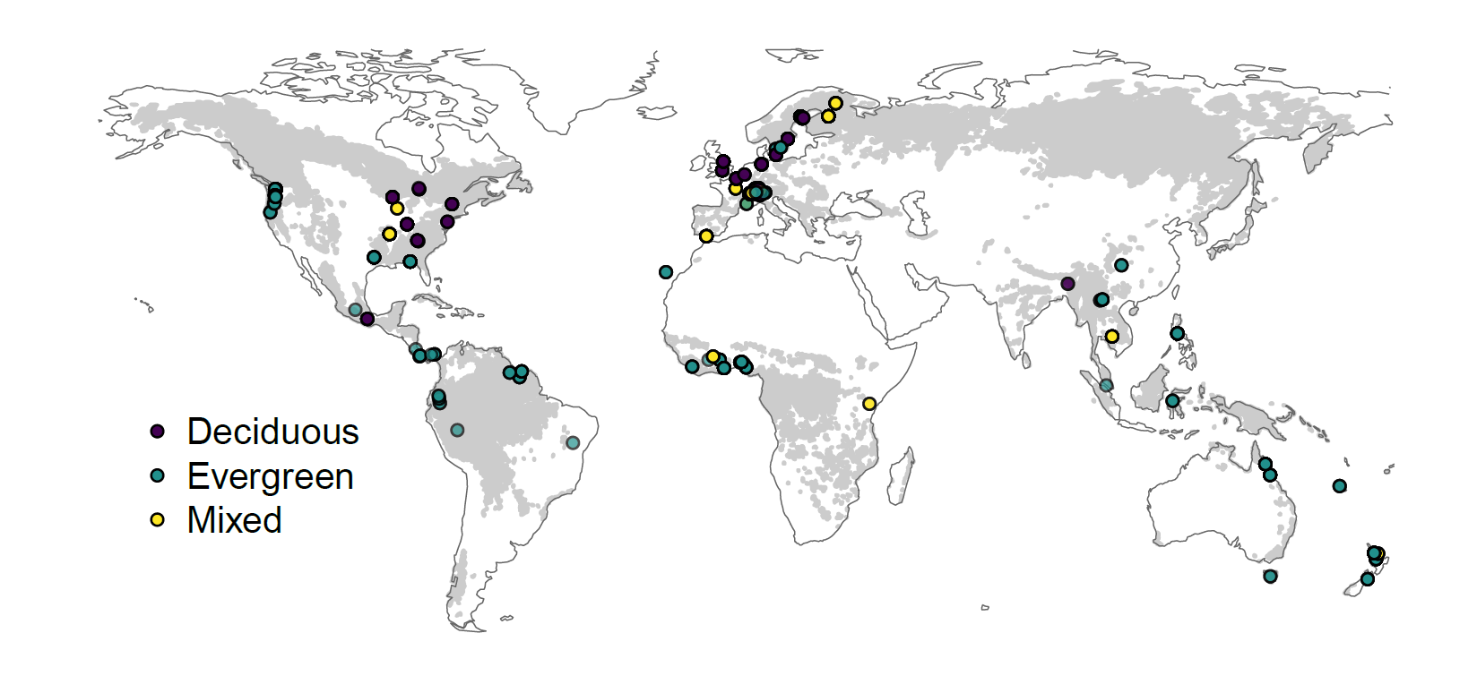

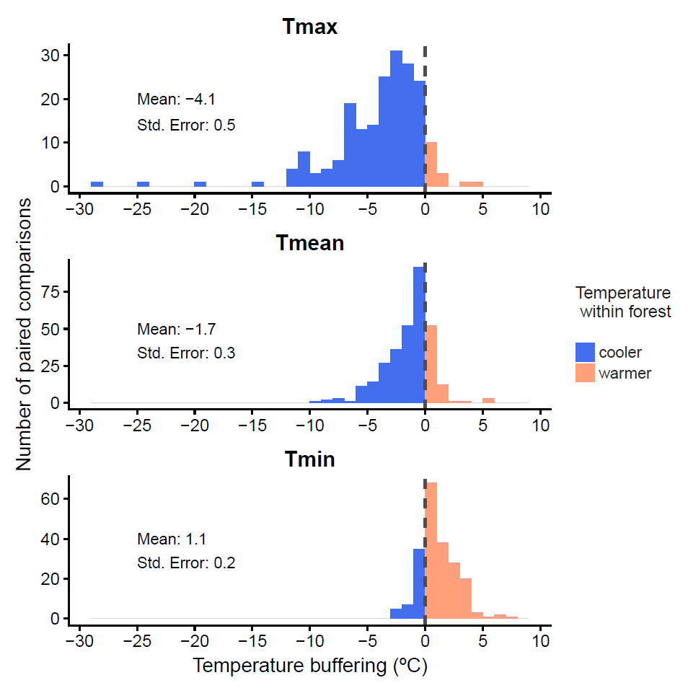

**Fig. 1 | Forest microclimate buffering is globally widespread**. **a,** Distribution of the 98 study sites and their vegetation type (deciduous, evergreen or mixed forests).Grey map background shows the global distribution of forests30. **b,** Histograms display the 714 paired temperature buffering values for maximum (Tmax), mean (Tmean) and minimum (Tmin) temperatures. Maximum and mean temperatures are consistently cooler, and minimum temperatures consistently warmer, within forests compared to free-air temperatures. Buffering was always calculated as temperatures inside minus temperatures outside the forest such that negative (positive) values reflect cooler (warmer) forest temperatures. Buffering means and standard errors are based on mixed-effects models with study as a random-effect term. Full statistical analyses, data and code are reported in Supplementary Information.

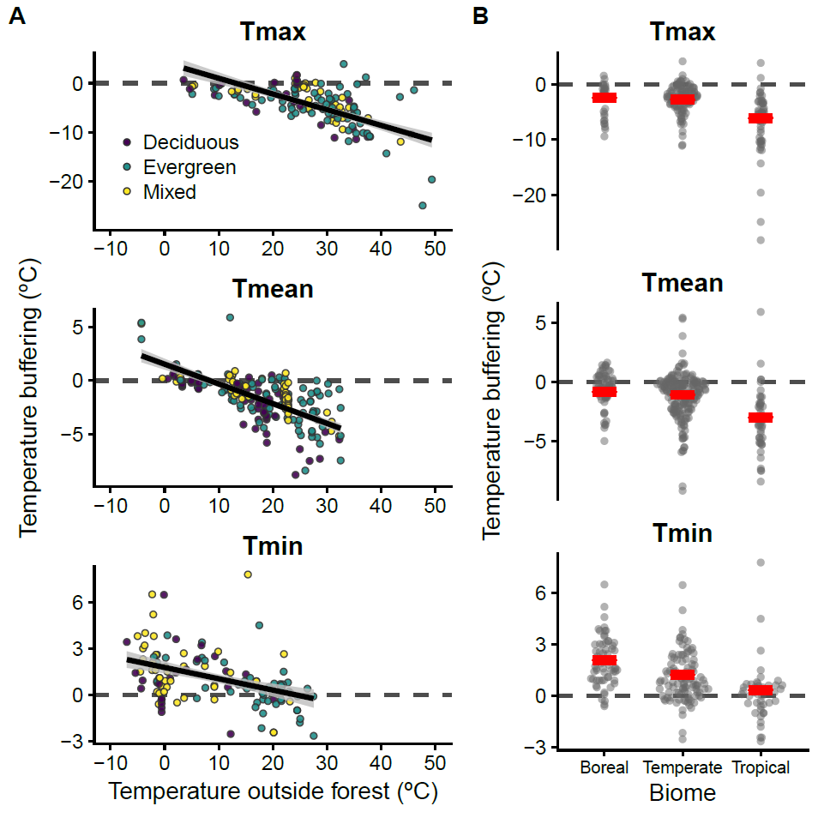

**Fig. 2 | Forest microclimate buffering is negatively related to warming air temperatures and dependent on the biome.** **a,** The magnitude of temperature buffering within forests depends on ambient free-air temperature: the higher the warming, the more buffering of temperatures (Tmax and Tmean). For minimum temperatures, positive buffering increases with colder temperatures. **b,** Study sites were classified into boreal, temperate or tropical, based on their latitude. Buffering was always calculated as temperatures inside minus temperatures outside the forest such that negative (positive) values reflect cooler (warmer) forest temperatures. Regression slopes, 95% confidence intervals (grey shading), and buffering means (red lines), are based on mixed-effects models with study as a random-effect term. Full statistical analyses, data and code are reported in Supplementary Information.