Supplementary information
- Additional information on O. dioscoreae culture conditions
Liquid cultures of O. dioscoreae were grown in AB minimal medium supplemented with 0.05% yeast extract and 10 mM sodium citrate at 28°C with shaking unless otherwise indicated. Cultures for RNA-Seq and RT-PCR experiments were harvested at OD_{590nm} = 0.2 – 0.3, or mid-exponential phase. Yeast extract alone does not support growth of O. dioscoreae (Figure SI 1B), indicating that citrate is the main carbon source utilized by O. dioscoreae when grown on AB medium supplemented with yeast extract and citrate.
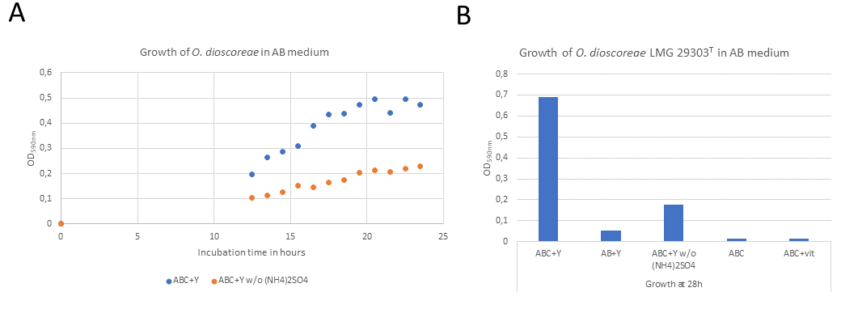
Figure SI 1. A. Representative growth curves of O. dioscoreae LMG 29303^{T} in standard AB minimal medium supplemented with 10 mM citrate and 0.05% yeast extract (ABC + Y) or AB minimal medium without ammonium sulfate supplemented with 10 mM citrate and 0.05% yeast extract (ABC + Y w/o (NH₄)₂SO₄). B. OD_{590nm} at 28h of cultures of O. dioscoreae LMG 29303^{T} in the media listed above as well as AB medium supplemented with 0.05% yeast extract as sole carbon source (AB + Y); AB medium supplemented with 10 mM citrate but without yeast extract (ABC) ; ABC medium supplemented with Wolfe’s vitamin solution (ABC + vit). Bacteria were cultured in 100 mL of medium at 28°C with shaking. For the transcriptomics experiments, cultures were harvested between OD_{590nm} = 0.2-0.3 or mid-exponential phase.

- DNA extraction and PCR
Silica-dried samples were processed using a combination of bead beating (Retsch MM400, Haan, Germany) and the Maxwell® 16 DNA Purification Kit (Promega, Madison, WI, USA). Briefly, a single dehydrated sample, 567 µL TE buffer and one 6 mm glass bead (280 mg) were added to a 2 ml microcentrifuge tube and processed twice in a tissue lyser for 1 min 15 s at a frequency of 30 Hz. Homogenized samples were stored on ice for 2 minutes between each run to prevent overheating. A lysis solution (30 µL of 10% SDS, 3 μL of 20 mg/mL proteinase K) was added and incubated at 37°C for 1h. Following incubation, samples were centrifuged briefly at 14 000 rpm, and the supernatant was transferred into Maxwell® 16 DNA Purification Kit cartridges. The remainder of the DNA extraction protocol was carried out in the Maxwell® 16 Instrument according to the manufacturer’s instructions (Promega). Afterwards, RNA was removed from the gDNA with 1 μg/mL RNase A for 1h at room temperature. Species-specific primers for nrdA were used to confirm the presence of Orrella dioscoreae. For plant species identification, PCR analysis was done using primers specific for the chloroplastic markers matK, rbcL and rpl32-trnL. Sequences were aligned using Muscle [1] and manually trimmed using CLC Main Workbench v7.7.2. (Qiagen) and compared to reference sequences obtained from a vouchered D. sansibarensis specimen from the live collection of the botanical garden of Ghent University (accession 19001189). All specific oligos used in this study are listed in Table S3.
- Reference genome assembly and annotation
The previously reported draft genome of O. dioscoreae strain LMG 29303^{T} was closed using PacBio long read sequencing. Genomic DNA was isolated as described previously [2] and long read libraries were constructed and sequenced using a Pacific Biosciences RSII instrument and P6/C4 chemistry on one SMRT cell (Pacific Biosciences). The sequencing run yielded 47 969 reads, with an N50 of 26 386 bp and an average read length of 19 782 bp. The reads were assembled de novo using the HGAPv2 program of the PacBio SMRT portal software suite with default settings, yielding 9 contigs for a total polished assembly size of 4 839 294 bp and an N50 of 2.69 Mb. Previous PFGE analysis indicated that the genome of LMG 29303T consists of a single chromosome without plasmids [2]. Contigs were further assembled into scaffolds using the SSPACE-LongRead v1-1 software [3], yielding a single scaffold with several sequence gaps. Gaps were further closed by combining scaffolded contigs, contigs obtained previously using Illumina MiSeq technology, and 2x250 bp paired-end Illumina MiSeq reads (total estimated coverage of 155.5x), using GMcloser [4]. Overlapping scaffold ends were trimmed in CLC Main Workbench v7.7.2 and the final chromosome assembly was circularized, yielding a final assembly of 4 848 101 bp. Finally, the chromosome sequence was polished using Pilon [5] and the 2x250 bp Illumina MiSeq reads used to generate the draft genome assembly. Genome sequence annotations were automatically transferred from the draft genome using the RATT tool, part of the PAGIT toolkit [6]. Annotation curation was done in Artemis [7]. The completed genome sequence of O. dioscoreae LMG 29303^{T} is deposited in the European Nucleotide Archive under accession number GCA_900089455.2.
- Chloroplast genome assembly
Fresh leaf nodules of a specimen of D. sansibarensis (from which strain R-67088 was isolated) were ground with a mortar and pestle and DNA was extracted and sequenced as described above. A total of 4.7M Illumina 2x150 bp read pairs were assembled with SPAdes 3.0 in metagenome mode. Contigs were binned according to %G+C, average coverage and taxonomic assignment. Sequencing reads corresponding to the binned contigs were extracted and reassembled using SPAdes 3.0 in single genome mode with –k 21, 33, 55, 77, 99, resulting in a total assembly length of 459 173 bp distributed over 68 contigs and an average coverage of 24.7x. Individual contigs were searched against the NCBI RefSeq database (accessed Feb. 2017) using the Blastn program [8] with an e-value cut-off of 0.001. Only contigs with hits against plastid genome sequences were kept, resulting in a draft assembly of the D. sansibarensis chloroplast of 128 321 bp in 6 contigs. Average sequence coverage was 25.3x, except for a 33.5 kb contig displaying an average coverage of 55.9x corresponding to unresolved copies of the large inverted repeat common in chloroplast genomes [9]. The Dioscorea sansibarensis chloroplast sequence was deposited in the European Nucleotide Archive under project accession PRJEB30106.
- Detection of horizontal gene transfer
Presence of horizontal gene transfer was investigated using two methods. In the first method, CDS sequences of all single-copy core genes were aligned using Muscle [1], trimmed using Trimal [10], and a phylogenetic tree was created using FastTree [11]. The resulting trees were rooted using Achromobacter xyloxidans as an outgroup, or by midpoint rooting if no ortholog was present in A. xyloxidans. Trees resulting from alignments with only few divergent sequences (< 11) were discarded. The presence of incongruencies between gene and species trees was tested using the ETE3 package in Python [12]. Incongruent trees and alignment were further manually checked for possible confounding factors. The second method involved the detection of gene conversion by PhiPack [13]. P-values resulting from the phi-test for gene conversion were corrected using the Bonferroni correction for multiple testing.
- Measurement of free oxygen concentration
Fresh mature leaves of D. sansibarensis were collected in the greenhouse immediately before the experiment. Oxygen concentration was measured 1 mm below the abaxial surface of one of the leaf gland channels closest to the mid-rib using an O₂ microsensor (100 μm tip size, Unisense). The sensor was connected to a OXY Meter microsensor amplifier (Unisense) and the data collected and analysed using Unisense SensorTrace Logger software. The sensor was calibrated using 2-point calibration with aerated tap water and an alkaline 0.1M ascorbate solution according to manufacturer’s recommendations. Analyses were performed in triplicate.
- RNA sequencing and analysis
For RNA isolation, samples were transferred into separate tubes containing RNAlater®-ICE Frozen Tissue Transition Solution (Ambion, Carlsbad, CA, USA) and ground immediately using a pestle. Samples were stored on ice prior to RNA isolation. Three biological replicates were examined for each sample condition. Bacteria were grown to mid-exponential phase (OD₆₀₀ of 0.2 to 0.3) in AB minimal medium supplemented with 10mM citrate and 0.05% yeast extract. Cultures were mixed with two volumes of RNAlater reagent and centrifuged at 8500 rpm for 10 min. The ground plant samples were centrifuged briefly at maximum speed. Total RNA was extracted using the AurumTM Total RNA Mini Kit (BioRad, USA) according to the manufacturer’s recommendations. Contaminating DNA was removed using the TURBO DNA-freeTM Kit (Ambion, USA). Additional RNA quality and integrity were checked by using the Pico 6000 RNA Kit (Agilent) and an Agilent 2100 Bioanalyzer instrument. Ribodepletion was done using the Ribo-Zero bacterial rRNA removal kit (Illumina), cDNA library preparation and sequencing on an Illumina HiSeq4000 system with a 75-bp paired-end read length were done at the Wellcome Trust Centre for Human Genetics (Oxford, UK). First strand cDNA synthesis incorporated dUTP. The cDNA was end-repaired, A-tailed and adapter-ligated. Prior to amplification, samples underwent uridine digestion. Libraries were prepared using Illumina TruSeq Stranded Total RNA Library Prep kit (Illumina, San Diego, CA, USA). Sequencing reads were trimmed using Trimmomatic [14] and mapped to the finished genome of O. dioscoreae LMG 29303^{T} using the EDGE-pro pipeline [15]. Read sets originating from axenic culture samples were rarefied in order to give a similar number of mapped reads across all samples. The final read mapping statistics are given in Table SI 1.

Table SI 1. RNA-Seq read mapping statistics
Condition | Total reads | # reads uniquely mapped | % reads mapped
culture 1 | 4077067 | 3277602 | 95.66
culture 2 | 4242135 | 3333339 | 89.81
culture 3 | 4242135 | 3155582 | 95.42
day1 | 33682326 | 1897309 | 6.14
day2 | 29564328 | 2327709 | 8.72
day3 | 34429472 | 2790981 | 8.63
night1 | 36563741 | 3609722 | 10.55
night2 | 37677860 | 2885702 | 7.93
night3 | 36713200 | 3015743 | 9.1

The resulting count matrix was analysed using the DESeq2 software [16]. PCA-analysis of the samples based on the normalized gene counts was performed to asses reproducibility of the replicates. We observe that technical replicates cluster closely together, and the main source of variance can be explained by the differences in planta and in culture, and between day and night (Figure SI 2). Genes mapped by three or more reads and with Benjamini-Hochberg adjusted p-value < 0.05 were considered differentially expressed (DE). Because the DEseq analysis yielded a very high proportion of differentially expressed genes (DEGs), additional analyses were performed using methods which are less prone to artefacts during library normalization. Specifically, we used Quantro [17] for quantile normalization of the dataset (p > 0.05), followed by qsmooth [18]. Final data matrices were analysed separately making use of both limma-voom and limma-trend packages [19]. Both limma (voom/trend) and DESeq2 pipelines are equally suitable and give similar results. Confirmation of differential regulation was done on genes of interest by RT-PCR (Figure SI 3). RNA-sequencing reads are deposited in the European Nucleotide Archive under study accession number PRJEB30089.

Figure SI 2: Principal component analysis (PCA) plot constructed from the normalized O. dioscoreae gene counts from cultured LMG29303^{T} and in planta samples at both time points (day and night). Each dot represents an individual culture/nodule sample, in a given condition (Red: cultured LMG29303^{T}; Blue: Leaf nodule collected during daytime; Green: Leaf nodule collected during night-time)
- Post-hoc validation of RNA-Seq experiments
We verified the degree of genetic divergence between nodule bacteria and cultured isolates by SNP analysis of the cDNA reads using Snippy with default settings (https://github.com/tseemann/snippy). Sampled nodule bacteria differed from strain LMG 29303^{T} by only 15 SNPs. However, we detected a cluster of 42 genes, which was present in strain LMG 29303^{T} but not in the nodule bacteria. This cluster of genes (ODI_R1825 – ODI_R1866) corresponds to a putative lysogenic bacteriophage, possibly acquired during isolation or passaging. The putative bacteriophage genes are only weakly expressed in strain LMG 29303^{T} (0.4% of all reads) and may have a minimal effect on global gene expression patterns. In order to control for possible artefacts, all confirmatory RT-PCR experiments were conducted using both strain LMG 29303^{T} and strain R-67088, which has been shown by whole genome sequencing to differ from leaf nodule bacteria used in the experiment by only 6 SNPs and not to harbor the putative bacteriophage (data not shown).
- Quantitative Reverse Transcription-Polymerase Chain Reaction (RT-qPCR)
First-strand cDNA synthesis was accomplished using the GoTaq® 2-Step RT-qPCR System (Promega, Madison, WI, USA), according to the manufacturer’s recommendations. Separate reactions containing no-RT and no-template were included as negative controls. qPCR was carried out on the LightCycler® 480 Real-Time PCR System (Roche Diagnostics) using gene-specific primers (Table S3). All oligonucleotides were designed using the CLC Genomics Main Workbench software. The primers were designed to be specific for O. dioscoreae genes (GenBank accession no. LT907988). The specificity of primers was tested by PCR, using gDNA of O. dioscoreae and Dioscorea sansibarensis nodules as the template in separate reactions. The total mRNA levels of genes of interest were normalized to those of the housekeeping gene rpoD, shown not to be differentially regulated in RNA-Seq experiments. An identical expression profile, for all 5 genes, was observed between samples analysed through RT-qPCR and RNA sequencing (Figure SI 3). All experiments were performed in triplicate.
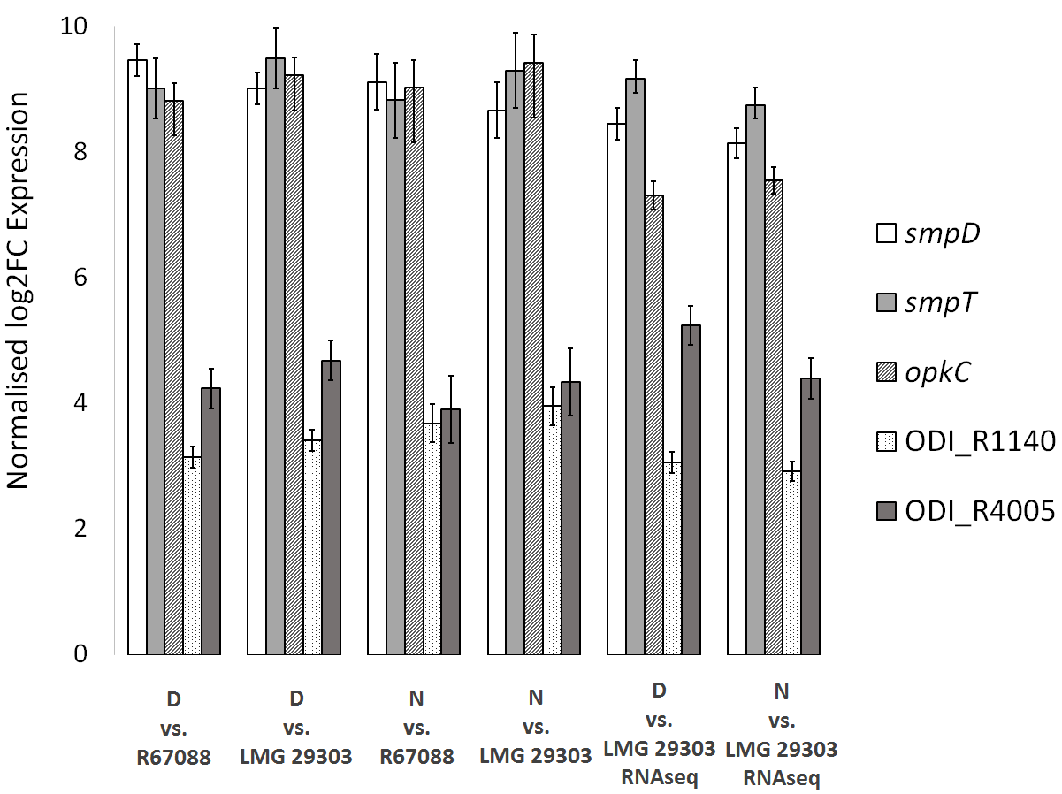
Figure SI 3: Validation of differential regulation of select genes by quantitative RT-PCR. D: leaf nodule RNA samples collected during the day. N: Leaf nodule RNA samples collected at night. Strain numbers represent cultures in AB medium supplemented with 0.2% sodium citrate and 0.05% yeast extract. For reference, log2 fold change values derived from RNA-Seq experiments for each gene are given in the fifth and sixth fields (labelled RNAseq).
- Phylogenetic analyses
A core genome phylogeny of all O. dioscoreae samples was constructed by aligning the protein sequences of all single-copy core genome orthologs, back-translating them to their nucleotide sequences, and concatenating them as described previously [20]. The resulting alignment, containing 3 555 045 positions divided over 3505 genes, was used to create a maximum-likelihood phylogenetic tree using RaxML v8.2.9 [21]. RaxML was run in rapid bootstrapping and best-scoring ML mode (-f a), performing 100 bootstrapping replicates, using the GTRGAMMA nucleotide substitution model. The position of the root was determined by repeating the analysis including Achromobacter xylosoxidans (NCBI accession nr. LSMI01000001) as an outgroup. Chloroplast genome alignments were constructed by mapping WGS reads to the draft genome of the D. sansibarensis chloroplast using REALPHY v 1.12 [22]. To avoid confusion due to sequencing errors in SNP-based phylogenies, samples for which estimated average coverage was below 20x were not included in the analysis, and the following REALPHY parameters were set: -readLength 150 –polyThreshold 0.9 to exclude ambiguous SNPs in repeat regions. The alignment generated had 125 175 positions, including 133 distinct patterns. The maximum likelihood model with the lowest Bayesian information criterion was selected using the model testing tool of CLC Main Workbench v.7.7.2. Chloroplast phylogenies were then reconstructed using the RAxML v8.2 program [21], using the GTRGAMMA substitution model, rapid bootstrap analysis and search for best scoring ML tree (-f a parameter setting) and 1000 bootstrap replicates. The same analysis was repeated by including the draft genome of the D. elephantipes chloroplast (NCBI RefSeq accession number NC_009601.1) to inform the root placement of the phylogenetic tree. Phylogenies of host and symbiont were visually compared and investigated using the TreeMap v. 3.0β program [23] by loading pruned species tree displaying only branches with support values > 70%. Statistical significance of congruence between host and symbiont tress was tested using the implemented randomization test. Reconciliation analysis was performed using the Jane v4 software [24] with default cost settings (co-speciation = 0, duplication = 1, duplication and host-switch = 2, loss = 1, failure to diverge = 1).
- Estimation of symbiosis age
To determine lower bound for the age of the symbiosis, a dating analysis was performed to determine the approximate divergence time of our Dioscorea sansibarensis samples. Divergence time was estimated based on three plastid marker genes (atpB, matK, rbcL) and the trnL intron-trnL exon-trnL/trnF spacer, as described in Viruel et al. [25]. In short, Beast v.1.8.4. [26] was used with a Bayesian relaxed-clock approach, using the GTR+I+G substitution model, a Yule tree prior, and an uncorrelated lognormal molecular clock were used, allowing the rate of mutation to vary among partitions. Two MCMC chains were run for 100 million generations, sampling parameters every 10 000 generations. The same calibration points were used as in Viruel et al. [28], assigning lognormal prior distributions to fossil calibration points, and normal prior distributions for secondary calibration points.
Estimation of the age of divergence of the symbiont was performed by comparing the observed fixed mutation rate in the symbionts of one host lineage over a timespan of two years. This was combined with the estimated branch length of that branch in the core genome phylogeny to obtain an estimate of the divergence time. To increase representation of O. dioscoreae sequences, we included in our analysis whole genome sequences of strain LMG 29303^{T}, isolated from a plant likely sampled in the Democratic Republic of Congo, although exact origin is uncertain, and strain R-67584 sampled from a plant of the live collection of the Botanic Garden Meise (accession CD-0-BR-1960001) also sampled in the DRC. Whole genome phylogeny of all genome sequences using RealPhy as described above placed the African isolates within clades of Malagasy genomes (Figure SI 4), and were not taken into account for divergence age calculation.
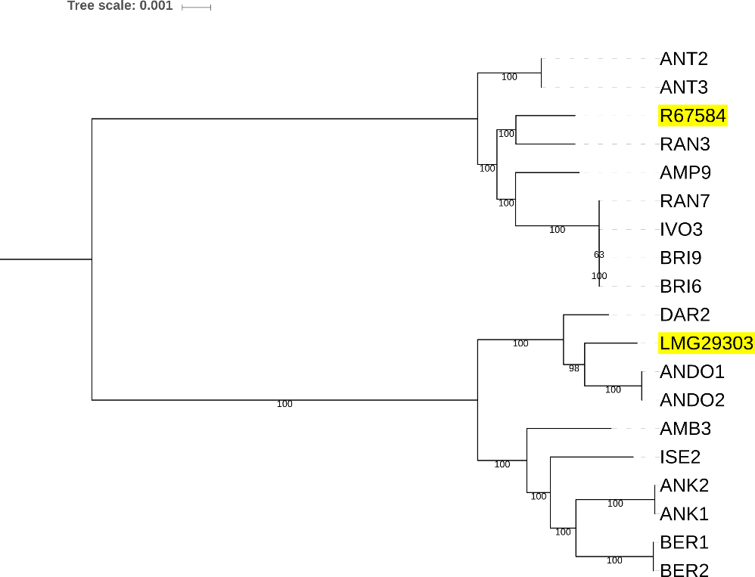
Figure SI 4. SNP-based phylogeny of O. dioscoreae genomes. The phylogeny was generated using the Realphy v1.12 with default alignment parameters and RAxML v8.2 with –GTRGAMMA and 100 bootstrap replicates (-f a -#100). Labels highlighted in yellow indicate stains isolated from plants collected in the DRC.
- Calculation of substitution rates
Non-synonymous to synonymous substitution ratios (d_{N}/d_{S} or ω) ratios were calculated using the yn00 program of codeML, on the single copy core genome (1020 genes) of O. dioscorea (all strains) and several Achromobacter species (ASM23678v2, ASM21974v1, GCS2v1, ASM118959v1, ASM163968v1, ASM16583v1, Achr_xylo_C54_V2, ASM105105v1) d_{N}/d_{S} were averaged over all combinations within the same genus, discarding data with d_{S} < 0.1 or > 2. To estimate the genome wide d_{N}/d_{S} of O. dioscoreae, this analysis was repeated a core genome of all O. dioscoreae genomes available consisting of 3563 genes. To identify genes under positive selection, site-specific d_{N}/d_{S} were calculated for all single-copy core genes of O. dioscoreae using codeml. Sites under positive selection were identified using the BEB (Bayes empirical Bayes) test comparing the M1a (neutral) and M2a (positive selection) models.
- Bacterial genetics
To generate O. dioscoreae strain FID1, regions of homology flanking smpD (ODI_R1490) and a kanamycin resistance cassette from plasmid pKD4 [27] were amplified by PCR using primers listed in Table S3. PCR amplicons were gel-purified using E-Gel Clonewell 0.8% SYBR Safe (Invitrogen) and assembled in an overlap PCR reaction. The final PCR fragment was cloned into a Gateway cloning vector E. coli pDONRpEX18 [28] using the BP Clonase™ II kit (Invitrogen, Carlsbad, CA, USA). The construct was transferred to E.coli Top 10 electro-competent cells for plasmid delivery using electroporation. The resulting plasmids were introduced to O. dioscoreae LF01, a spontaneous mutant resistant to nalidixic acid derived from strain LMG 29303^{T} by biparental mating, using E. coli S17-1 as donor and transconjugants were selected by plating on TSA medium containing kanamycin (50μg/ml) and nalidixic acid (30μg/ml). Counter-selection of merodiploid clones was done by plating on medium containing 5% sucrose. Double cross-over events were verified by PCR.
- Chrome Azurol S (CAS) Assay
Solid medium for the siderophore assay was prepared as described by Schwyn and Neilands [29]. Bacterial strains were grown as previously described, washed and suspended in sterile 0.4% NaCl to an OD₆₀₀ of 0.01. Five µl from each of suspension of strains was spotted on CAS plates and incubated at 28°C for 48h. Halo formation was measured after incubation. Strains LMG 29303^{T}, O. dioscoreae FID1, and LF01 all gave weak positive reactions, manifested as small, clear halos around the colonies . The smpD null mutant FID1 did not display significantly lower iron chelating activity than the parental strain, ruling out participation of the smp genes in siderophore production (data not shown).
- Growth on potassium galactonate as a sole carbon source
Potassium D-galactonate was prepared by mixing a solution of 0.2M calcium galactonate (Sigma) and equimolar amounts of potassium oxalate (Sigma) in boiling water. After cooling, the calcium oxalate precipitate was removed by passing the solution through a 0.2 μm syringe filter. The solution was cooled and pH adjusted with potassium hydroxide prior to supplementation of culture medium.
Pre-cultures of O. dioscoreae strains LMG 29303^{T} and R-67584 were grown on TSA for 48h, washed in sterile 0.4% NaCl and resuspended in AB base medium without carbon source to an OD_{590nm} = 1. Fifty μL of cell suspensions were diluted in 5 mL of AB medium supplemented with 10 mM D-Galactonate or 10 mM sodium citrate and 0.05 g/L of yeast extract and incubated at 28°C with shaking for 48h. Final OD_{600nm} of cultures grown on D-galactonate were 0.16 ±0.5 for strain LMG 29303T and 0.25 ±0.1 for strain R-67584. Final OD_{590nm} of cultures grown on sodium citrate were 0.13 ±0.2 for strain LMG 29303T and 0.175 ±0.2 for strain R-67584. Note: stationary phase cultures of O. dioscoreae tend to form aggregates, which skew optical density measurements. Homogenization of cultures by aspiring twice through a 28G needle leads to average OD_{590nm} measurements for strain LMG 29303^{T} of 0.85 (AB citrate) and 0.71 (AB gluclonate) after 48h.
- Sequence analysis of the smp and opk gene clusters
The central and largest gene of the operon, smpD, encodes a stand-alone module of a non-ribosomal peptide synthase (NRPS) (Figure SI 5). SmpD consists of a condensation domain, an adenylation domain and a phosphopantetheine-binding or thiolation domain, showing 29% identity to a module of bacitracin synthase 1 originated from Bacillus licheniformis. Substrate predictions of the adenylation domain are consistent with loading of a cysteine residue. Phylogenetic analysis and examination of the conserved catalytic residues place SmpD within the family of NRPS cyclization (Cy) domains (Figure SI 6). SmpD may thus be involved in heterocyclization of a loaded cysteine to yield a thiazoline ring. The resulting heterocycle may be further oxidized to thiazole by the product of smpF, which encodes a putative flavin mononucleotide-dependent oxidoreductase. Unusually, SmpD lacks a thioesterase (TE) domain and release of the modified amino acid may occur through the action of a putative stand-alone TE encoded by smpG. Finally, SmpE is a hypothetical protein containing a heme oxygenase domain, possibly involved in redox tailoring reactions. At the 5’-end of the smp1 operon, SmpA, SmpB and SmpC are likely also involved in tailoring reactions using acyl-CoA substrates.

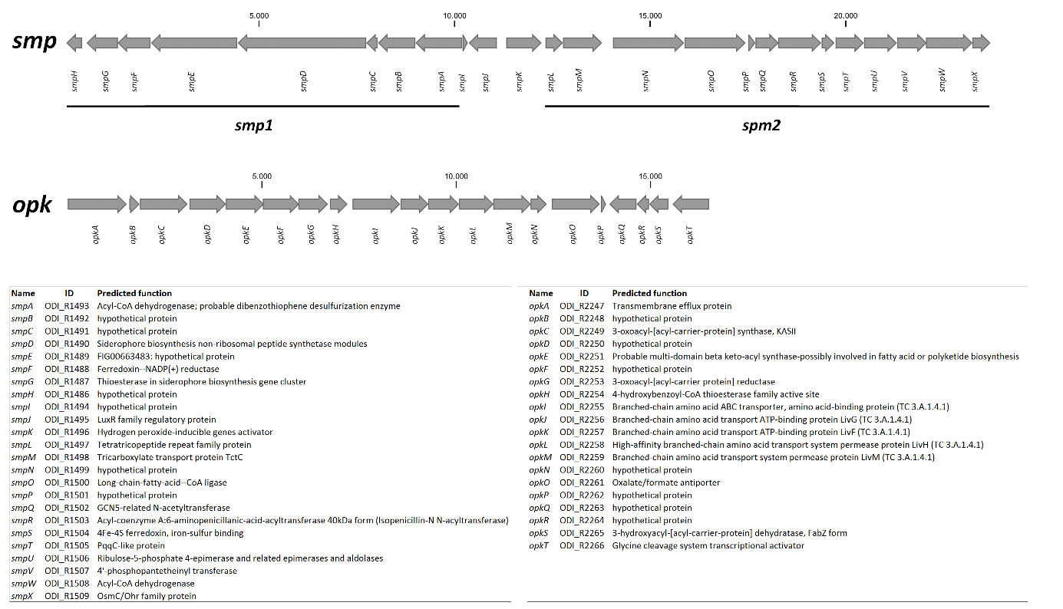
Figure SI 5: O. dioscoreae gene clusters putatively involved in the synthesis of novel secondary metabolites. Upper: Schematic overview of the opk and smp gene clusters, showing the unusual arrangement of biosynthetic operons (smp1 and smp2) surrounding the regulatory region. Table: Predicted function and locus tag identifier of the smp and opk genes.

The second operon of the cluster, smp2, is a highly unusual assemblage of redox enzymes and enzymes related to fatty acid biosynthesis. SmpL, SmpN and SmpP are hypothetical proteins with homologs of unknown function in Burkholderiales. SmpM shows homology (53.5% similarity) to the TctC periplasmic component of the Tct tricarboxylic acid transporter of Comamonas testosteronii but, homologs of TctA and TctB, the remaining components of the Tct ABC transporter are not encoded in the smp cluster or elsewhere in the vicinity. SmpO shows homology to long chain acyl-CoA ligase, and also has homologs in Burkholderiales. SmpR is a predicted peptidase of the C45 family, which includes acyl-CoA transferases. SmpV and SmpW are putative acyl-carrier protein and acyl-CoA dehydrogenase. SmpS and SmpT contain iron-sulfur binding and heme oxygenase domains, respectively, and are possibly involved in redox reactions. SmpU contains an aldolase domain, but also shows significant homology (35% identity) to NovR, an enzyme catalysing oxidative decarboxylation in the biosynthesis of novobiocin [30]. The biosynthetic product of smp2 may thus be an acyl chain, which may possibly serve as substrate for the NRPS tailoring enzymes of smp1. The smp1 and smp2 operons are separated by two transcriptional regulators: a “solo” LuxR-family regulator containing an HTH and an acyl-homoserine lactone binding domain, possibly responding to an exogenous signal or endogenous acyl homoserine lactone quorum-sensing signal synthesized by the AHL-synthase of the LuxI/LuxR pair encoded just downstream of the smp cluster (ODI_R11512-1513). SmpK is a putative LysR family regulator.
The opk operon likely codes for enzymes linked to polyketide biosynthesis (Figure SI 5). OpkA is a putative transmembrane efflux protein from the Major Facilitator superfamily MFS-1 and shows high similarity (36% similarity) to a probable transporter of actinorhodin, a polyketide antibiotic produced by Streptomyces coelicolor [31]. OpkB and OpkQ are both putative acyl carrier proteins (ACP). A polyketide elongation module is comprised of two putative ketoacyl synthases OpkC and OpkD. OpkF, OpkG and OpkS are likely to be involved in further acyl chain modifications: OpkF is a putative AurF-family enzyme functioning as non-heme di-iron monooxygenase [32], OpkG is a putative 3-oxo-acyl-ACP reductase and OpkS is a putative 3-hydroxy-acyl-ACP dehydratase commonly found in polyketide biosynthetic clusters [33]. Finally, OpkH shows homology to a 4-hydroxybenzoyl-CoA thioesterase, possibly involved in releasing the polyketide chain from the acyl carrier. The opk cluster also codes for a highly upregulated putative ABC-transporter with homology to branched-chain amino acid transporters. OpkH shows limited homology (25% similarity) to the Leu/Ile/Val-binding protein of Brucella melitensis, but contains a well-conserved periplasmic binding protein (PBP) domain and a signal peptide, suggesting that the transporter is involved in uptake of a small molecule substrate rather than efflux.

Figure SI 6. Alignment of NRPS C and NRPS Cy domains. Catalytic residues of NRPS C-domains are shown in bold, and catalytic or conserved residues of NRPS Cy domains are in bold and underlined. The protein sequence identifiers correspond to the identifiers in the NaPDoS database (http://napdos.ucsd.edu/, accessed November 2018).

Q9RCF7_VIBCH ----------------MLLAQKPFWQRHLAYPHINLDTVAHSLRLTG---PLDTTLLLRA
TubCc GGSLLAP-VARNGRLALSFAQQRLWFQEQLHPEAPANNLTGAVVFTG---PLHVAALLGA
epoBcy -ESIVPAPAERHVPFPLTDIQGSYWLGRTGAFTVPS-GIHAYREYDCT--DLDVARLSRA
yersi1_C1_cyc ----------------LTPVQHAYLTGRMPGQTLGGVGCHLYQEFEGH--CLTASQLEQA
yersi2_C1_cyc ----------------LTPIQHAYWLGRTHLIGYGGVACHVLFEWDKRHDEFDLAILEKA
pyoch3_C1_cyc ----------------LTPVQAAYVLGRQAAFDYGGNACQLYAEYDWP-ADTDPARLEAA
bleom9_C2_cyc ----------------LTDVQRAYYVGREGGFALGGVSTHAYLEIEAP--RIDVARFTGA
pyoch2_C1_cyc ----------------LSSVQQAYWLGRGAGEVLGNVSCHAFLEFRTR--DVDPQRLAAA
BACA_BACLIcy LVTRAADPENIHEIFPLTGIQLAYLVGRDETFEIGGVATNLTVEFEA---DVDLNRFQLT
bleom9_C3_cyc ----------------LTDIQRAYWLGRHRSLSLGGVATHTYLELDVE--DLDPGRLQTA
SmpD PAHAAPPHAQAGPWFPLSAMQAAYLVGRGDTLALGRVSSHVYHEILME--GCDPDRLEAS
: * . : :

Q9RCF7_VIBCH LHLTVSEIDLFRARFSAQGELYWHPF--SP--PIDYQDLSIHLEAEP-LAWRQIEQDLQ-
TubCc VAALVRRHEALRTTLGEEGGVPYSLIGEPWQPALEVEALPGATVGERLEQAREVALAESR
epoBcy FRKVVARHDMLRAHTLPDMMQVIEPK--VD-ADIEIIDLRGLDRSTREARLVSLRDAMSH
yersi1_C1_cyc ITTLLQRHPMLHIAFRPDGQQVWLPQ--PYWNGVTVHDLRHNDAESRQAYLDALRQRLSH
yersi2_C1_cyc WNQLIARHDMLRMVVDADGQQRILAT--TPEYHIPRDDLRALSPEEQRIALEKRRHELSY
pyoch3_C1_cyc WNAMVERHPMLRAVIEDNAWQRVLPE--VPWQRLTVHACAGLDEAAFQAHLERVRERLDH
bleom9_C2_cyc LRGVIARHPMLRAVIRPDGLQQVLTD--VPPYDVAVHDLRDLDEPARQRRRAALREEMSH
pyoch2_C1_cyc AECVRQRHPMLRARFF-DGRQQILPT--PPLSCFDLQDWRTLQVDEAERDWQALRDWRAH
BACA_BACLIcy LQKLIDRHPILRTIVFENGTQKILEA--TQRYTIETQDLRGFTEEEINVRILEQREKMTS
bleom9_C3_cyc LRRLIDRHDALRLVVLPDGRQQILGD--VPPYLLAHTDLRGRADAE--AELARVREHMSH
SmpD LCAVVARHEALRTIIDPEGRQAILPMQDVPTPLMTRHDHGRDDELAAQAAIHALRRRLSA
. :: : .

Q9RCF7_VIBCH RSSTLIDAPITSHQVYRLSHSEHLIYTRAHHIVLDGYGMMLFEQRLSQHYQSLLSGQTPT
TubCc RRFALETEPHLRVRLLRLAEQQHVLVLSLHHIAADGVGLQVLEQELAALYGALSAGAEPR
epoBcy RIYDTERPPLYHVVAVRLDEQQTRLVLSIDLINVDLGSLSIIFKDWLSFYE----DPETS
yersi1_C1_cyc RLLRVEIGETFDFQLTLLPDNRHRLHVNIDLLIMDASSFTLFFDELNALLA----GESLP
yersi2_C1_cyc RVLPADQWPLFELVVSEIDDCHYRLHMNLDLLQFDVQSFKVMMDDLAQVWR----GE--T
pyoch3_C1_cyc ACAALDQWPVLRPELS-IGRDDCVLHCSVDFTLVDYASLQLLLGEWRRRYL----DPQWT
bleom9_C2_cyc QVVPADLWPLFDVRVS-LGPTDALVHVGVDALICDAHSFGLVLAELAARYA----DPARR
pyoch2_C1_cyc ECLAVERGQVFLLGLVRMPGGEDRLWLSLDLLAADVESLRLLLAELGVAYL----APERL
BACA_BACLIcy KIIDPSVWPLFELKTFMLPGEKKYFFLNVDPLICDDSSMKRLIREFKQLYE----NPGLQ
bleom9_C3_cyc EVRDASRWPLFDVRTHRLDDVRTRLHLSLDLLIADAHSVHVLTGDLLTFYA----DPDAA
SmpD QVAPLARPCALEAVLVALPAGRHMLLVSHEGLHIDGLSMQILFADWAAAYA----RPDAT
: . . * .. .

Q9RCF7_VIBCH AAF--KPYQSYLEEEAAYLTSHRYWQDKQFWQGYLREA----PDLTLTSATYDPQLSHA-
TubCc LPPLPLQVADLADWQRRWVEGEEYQVQLAYWRRQLAGLTPL--EVPGDHPRPRIPSMRGA
epoBcy LPVLELSYRDYVLALESRKKSEAHQRSMDYWKRRVAEL-PPPPMLPMKADPSTLREIRF-
yersi1_C1_cyc AIDTRYDFRSYLLHQQKINQ-PLRDDARAYWLAKASTL-PPAPVLPLACEPATLREVRN-
yersi2_C1_cyc LAPLAITFRDYVMAEQARRQTSAWHDAWDYWQEKLPQL-PLAPELPVVETPPE--TPHF-
pyoch3_C1_cyc AEPLEATFRDYVGVEQRRRQSPAWQRDRDWWLARLDAL-PGRPDLPLRAQPDTR-STRF-
bleom9_C2_cyc FPPLTADFRDHVLHQEALRGTAEYAAAERYWRERLPEL-PPGPELPLAVAPETLGTPRF-
pyoch2_C1_cyc AEPPALHFADYLARRAAQR-AEAAARARDYWLERLPRL-PDAPALPLACAPESIRQPRT-
BACA_BACLIcy LPSLEYSFRDYVLASINFKQTSRYQKDQQYWLDKLDHF-PSAPELPLKSDPAHVAKPSF-
bleom9_C3_cyc LPPLGCSFRDYVLAVRAHAEGEPRRRALDHWRARLADL-PGPPGLPLRCRPEELTAPRF-
SmpD LKALAPCVAPYVAAEQREREGPGWRQSRDRWLSRQARDGLHPPRLPLATDPDKLAQGLT-
* :.

Q9RCF7_VIBCH VSLSYTLNSQLNHLLLKLANANQIGWPDALVALCALYLESAEPDAPWLWLPFMNRWGSVA
TubCc EVRAPLLSAPQAQVLRALGQ--GEGATLYMT-LLAALG------------VLLQRWTGQH
epoBcy RHTEQWLPSDSWSRLKQRVG--ERGLTPTGV-ILAAFS------------EVIGRWSASP
yersi1_C1_cyc TRRRMIVPATRWHAFSNRAG--EYGVTPTMA-LATCFS------------AVLARWGGLT
yersi2_C1_cyc TTFKSTIGKTEWQAVKQRWQ--QQGVTPSAA-LLTLFA------------ATLERWSRTT
pyoch3_C1_cyc RHFHARLDEAAWQALGARAG--EHGLSAAGV-ALAAFA------------ETIGRWSQAP
bleom9_C2_cyc TRRSGRLDAASWTAVKDRAR--RAGLSPSGV-LLAAFA------------EVITAWSGRP
pyoch2_C1_cyc RRLAFQLSAGESRRLERLAA--QHGVTLSSV-FGCAFA------------LVLARWSESA
BACA_BACLIcy KKFSTFLDGHTWNELKKKAR--HHHLTPTSV-LCAAYA------------YILAYWSRQN
bleom9_C3_cyc ARLTTGLGPDAWARLRRAAA--AAELTPAAL-ICAAFC------------DVLAQWSDTP
SmpD ERFEASLDAQAWTRFQAHAG--AAGVTPAAA-VFAAYC------------DVLSRWDGTH
: . . : *

Q9RCF7_VIBCH ANVPGLMV-----------------NSLPLLRLFAQQ--TSLGNYLKQSGQAIRSLYLHG
TubCc DMAVGSAAANRN--RPGLEGILGFLLNIVLLRLDLRGR-PRFRELLRQARRVCVEAYAHQ
epoBcy RFTLNITLFNRLPVHPRVNDITGDFTSMVLLDIDTTRD-KSFEQRAKRIQEQLWEAMDHC
yersi1_C1_cyc RLLLNITLFDRQPLHPAVGAMLADFTNILLLDTACD-G-DTVSNLARKNQLTFTEDWEHR
yersi2_C1_cyc TFTLNLTFFNRQPIHPQINQLIGDFTSVTLVDFNFSAP-VTLQEQMQQTQQRLWQNMAHS
pyoch3_C1_cyc AFCLNLTVLNRPPLHPQLAQVLGDFTALSLLAVDSRHG-DSFVERARRIGEQMFDDLDHP
bleom9_C2_cyc RYSLMLTVFDRPPLHPDLGRIVGDFTSLSLLEVDHSRP-GDFTDRARALQRRLWQDLDHL
pyoch2_C1_cyc EFLLNVPLFDRHADDPRIGEVIADFTTLLLLECRMQAG-VSFAEAVKSFQRNLHGAIDHA
BACA_BACLIcy HFAINLTVFNRIPFHPDVKNMIGDFTSLMLLDIHAEENMSSFWRFALNVQDTLLEALEHR
bleom9_C3_cyc RFTLNLTTFHRPALLPGVDDLVGDFTTTTLLGVDGE-G-DTFRDRARRLQDRIWEDLEHR
SmpD AKTLNVTLAYRPPVSPDIDAAIGNFTRPVLATVTGTQP--RFDLRAKAAQAALMEALDLR
* .

Q9RCF7_VIBCH RYRI----EQIEQDQGLNAEQ--SYFMSPFIN----------------ILPFESPHFADC
TubCc ELPFEHLVEALQPGSE--RGDSSLYRVALAVSDTPWMPGHGLKLEGVQAQPLDFPR----
epoBcy DVSGIEVQREAARVLGIQRGALFPVVLTSALNQQVVGVTS--------LQRLGTPVYT--
yersi1_C1_cyc HWSGVELLRELKRQQRYP--HGAPVVFTSNLGRSLYSSRA--------ESPLGEPEWG--
yersi2_C1_cyc EMNGVEVIRELGRLRGSQRQPLMPVVFTSMLGMTLEGMTI----DQAMSHLFGEPCYV--
pyoch3_C1_cyc TFSGVDLLRELARRRGR-GADLMPVVFTSGIGSVQRLLGD--------GEAPRAPRYM--
bleom9_C2_cyc AVGGVTVTRERALRHDARPGLLTPVVFTSDLPVGETAAED---ADGGEGWALGEPVYG--
pyoch2_C1_cyc AFPALEVLREARRQGQP---RSAPVVFASNLGEEGFVPAA-------FRDAFGDLHDM--
BACA_BACLIcy HYDGVDVIRNIAKKNGMNKKAVMPIVFTSVLSENPDDSFD-------SLVDFDNIHFF--
bleom9_C3_cyc VVSGVEVLRMLRRERGTHDAVRMPVVFTSTLRAAGPAPRT-----APPAWRV-RPGYA--
SmpD HFTALDAARHLASASPGQATLIVPYTFNFALADAPGHGP------LQGVETLGTHVHG--
. . :

Q9RCF7_VIBCH QTELKVLASGSAEGINFTFRGSPQHELCLDITADLASYPQSHWQSHCERFPR-FFEQLLA
TubCc --------------------GVLDLDLHLWVYDT-GEGLTGRLEYAVDLYEEPTARRLLE
epoBcy ------------------STQTPQLLLDHQLYEH-DGDLVLAWDIVDGVFPPDLLDDMLE
yersi1_C1_cyc ------------------ISQTPQVWIDHLAFEH-HGEVWLQWDSNDALFPPALVETLFD
yersi2_C1_cyc ------------------FTQTPQVWLDHQVMES-DGELMFSWYCMDNVLEPGAAEAMFN
pyoch3_C1_cyc ------------------ISQTPQVWLDCQVTDQ-FGGLEIGWDVRLGLFPEGQAEAMFD
bleom9_C2_cyc ------------------VSQTPQVHLDHQVAED-RGELVFNWDAVEDLFAPGALDAMFA
pyoch2_C1_cyc ------------------LSQTPQVWLDHQLYRV-GDGILLAWDSVVGLFPEGLPETMFE
BACA_BACLIcy ------------------STRTSQVYIDNQVYEI-NGGLYITWDYVEQIFEHEVIESMFD
bleom9_C3_cyc ------------------ISQTPQVLLDHQVSES-DGRLVCTWDYVADAYPPGLIEAMFG
SmpD ------------------VSQTPQVWLNLFVMRQ-RGGIVLQLDAVTGLFAPGVPACVAD
: : :

Q9RCF7_VIBCH RFQQVEQDVARLLAEPAALAATTST----------RAIAS--------------------
TubCc GFRQV---LEAVVEAPDRPVPELPV----LGEQERHQVLSGWNRTQRPYPREASVHGLFQ
epoBcy AYVAF---LRRLTEEP--WSEQ--------------------------------------
yersi1_C1_cyc AYCQL---INQLCDDESAWQKPFAD----MMPASQRA-----------------------
yersi2_C1_cyc DYCAI---LQAVIAAPESLKTLASG----IAG----------------------------
pyoch3_C1_cyc DFVGL---LRRLAQSPRAWTDGDAT-----------------------------------
bleom9_C2_cyc AYTAS---LTRLARSPEAWRRPGTP----PLPTAQAA-----------------------
pyoch2_C1_cyc AYVGL---LQRLCDST--WEQPADL----PLPWAQQAR----------------------
BACA_BACLIcy QYIAV---IQKAVSGEDVSTIQMNEKSRQMISAYNDTDQS--------FDA-KPLHELFT
bleom9_C3_cyc AFEAL---LASLAGHDDDAGHDDDA-----------------------------------
SmpD SLGRL---LGRLADSPQAWQEAEFD----LLPATQRQARERANRTDKPVPV-ESLHAGFL
:

References
1. Edgar RC. MUSCLE: multiple sequence alignment with high accuracy and high throughput. Nucleic Acids Res 2004; 32: 1792–7.
2. Carlier A, Cnockaert M, Fehr L, Vandamme P, Eberl L. Draft genome and description of Orrella dioscoreae gen. nov. sp. nov., a new species of Alcaligenaceae isolated from leaf acumens of Dioscorea sansibarensis. Syst Appl Microbiol 2017; 40: 11–21.
3. Boetzer M, Pirovano W. SSPACE-LongRead: scaffolding bacterial draft genomes using long read sequence information. BMC Bioinformatics 2014; 15: 211.
4. Kosugi S, Hirakawa H, Tabata S. GMcloser: closing gaps in assemblies accurately with a likelihood-based selection of contig or long-read alignments. Bioinformatics 2015; 31: btv465.
5. Walker BJ, Abeel T, Shea T, Priest M, Abouelliel A, Sakthikumar S, et al. Pilon: An Integrated Tool for Comprehensive Microbial Variant Detection and Genome Assembly Improvement. PLoS One 2014; 9: e112963.
6. Otto TD, Dillon GP, Degrave WS, Berriman M. RATT: Rapid Annotation Transfer Tool. Nucleic Acids Res 2011; 39: e57–e57.
7. Carver T, Berriman M, Tivey A, Patel C, Böhme U, Barrell BG, et al. Artemis and ACT: viewing, annotating and comparing sequences stored in a relational database. Bioinformatics 2008; 24: 2672–6.
8. Camacho C, Coulouris G, Avagyan V, Ma N, Papadopoulos J, Bealer K, et al. BLAST+: architecture and applications. BMC Bioinformatics 2009; 10: 421.
9. Jansen RK, Raubeson LA, Boore JL, dePamphilis CW, Chumley TW, Haberle RC, et al. Methods for Obtaining and Analyzing Whole Chloroplast Genome Sequences. Methods Enzymol 2005; 395: 348–384.
10. Capella-Gutiérrez S, Silla-Martínez JM, Gabaldón T. trimAl: A tool for automated alignment trimming in large-scale phylogenetic analyses. Bioinformatics 2009; 25: 1972–1973.
11. Price MN, Dehal PS, Arkin AP. FastTree: Computing large minimum evolution trees with profiles instead of a distance matrix. Mol Biol Evol 2009; 26: 1641–1650.
12. Huerta-Cepas J, Serra F, Bork P. ETE 3: Reconstruction, Analysis, and Visualization of Phylogenomic Data. Mol Biol Evol 2016; 33: 1635–1638.
13. Bruen T. PhiPack: PHI test and other tests of recombination. 2005.
14. Bolger AM, Lohse M, Usadel B. Trimmomatic: a flexible trimmer for Illumina sequence data. Bioinformatics 2014; 30: 2114–20.
15. Magoc T, Wood D, Salzberg SL. EDGE-pro: Estimated Degree of Gene Expression in Prokaryotic Genomes. Evol Bioinform Online 2013; 9: 127–36.
16. Love MI, Huber W, Anders S. Moderated estimation of fold change and dispersion for RNA-seq data with DESeq2. Genome Biol 2014; 15: 550.
17. Hicks SC, Irizarry RA. quantro: A data-driven approach to guide the choice of an appropriate normalization method. Genome Biol 2015.
18. Hicks SC, Okrah K, Paulson JN, Quackenbush J, Irizarry RA, Bravo HC. Smooth quantile normalization. Biostatistics 2018.
19. Law CW, Chen Y, Shi W, Smyth GK. Voom: Precision weights unlock linear model analysis tools for RNA-seq read counts. Genome Biol 2014.
20. Pinto-Carbó M, Sieber S, Dessein S, Wicker T, Verstraete B, Gademann K, et al. Evidence of horizontal gene transfer between obligate leaf nodule symbionts. ISME J 2016; 10: 2092–2105.
21. Stamatakis A. RAxML version 8: a tool for phylogenetic analysis and post-analysis of large phylogenies. Bioinformatics 2014; 30: 1312–1313.
22. Bertels F, Silander OK, Pachkov M, Rainey PB, Van Nimwegen E. Automated reconstruction of whole-genome phylogenies from short-sequence reads. Mol Biol Evol 2014; 31: 1077–1088.
23. Charleston M, Page R. TreeMap. 2011.
24. Conow C, Fielder D, Ovadia Y, Libeskind-Hadas R. Jane: a new tool for the cophylogeny reconstruction problem. Algorithms Mol Biol 2010; 5: 16.
25. Viruel J, Segarra-Moragues JG, Raz L, Forest F, Wilkin P, Sanmartín I, et al. Late Cretaceous-Early Eocene origin of yams (Dioscorea, Dioscoreaceae) in the Laurasian Palaearctic and their subsequent Oligocene-Miocene diversification. J Biogeogr 2016; 43: 750–762.
26. Suchard MA, Lemey P, Baele G, Ayres DL, Drummond AJ, Rambaut A. Bayesian phylogenetic and phylodynamic data integration using BEAST 1.10. Virus Evol 2018; 4.
27. Datsenko KA, Wanner BL. One-step inactivation of chromosomal genes in Escherichia coli K-12 using PCR products. Proc Natl Acad Sci 2000.
28. Hmelo LR, Borlee BR, Almblad H, Love ME, Randall TE, Tseng BS, et al. Precision-engineering the Pseudomonas aeruginosa genome with two-step allelic exchange. Nat Protoc 2015; 10: 1820–1841.
29. Schwyn B, Neilands JB. Universal chemical assay for the detection and determination of siderophores. Anal Biochem 1987; 160: 47–56.
30. Keller S, Pojer F, Heide L, Lawson DM. Molecular replacement in the `twilight zone’: structure determination of the non-haem iron oxygenase NovR from Streptomyces spheroides through repeated density modification of a poor molecular-replacement solution. Acta Crystallogr Sect D Biol Crystallogr 2006; 62: 1564–1570.
31. Magnolo SK, Leenutaphong DL, DeModena JA, Curtis JE, Bailey JE, Galazzo JL, et al. Actinorhodin production by Streptomyces coelicolor and growth of Streptomyces lividans are improved by the expression of a bacterial hemoglobin. Nat Biotechnol 1991.
32. Chanco E, Choi YS, Sun N, Vu M, Zhao H. Characterization of the N-oxygenase AurF from Streptomyces thioletus. Bioorganic Med Chem 2014.
33. Helfrich EJN, Piel J. Biosynthesis of polyketides by trans-AT polyketide synthases. Nat Prod Rep 2016; 33: 231–316.

