Fast healing of polyurethane thermosets using reversible triazolinedione chemistry and shape-memory

Niels Van Herck and Filip E. Du Prez*
Polymer Chemistry Research Group, Centre of Macromolecular Chemistry, Department of Organic and Macromolecular Chemistry, Ghent University, Krijgslaan 281 S4-bis, B-9000 Ghent, Belgium

Keywords

Reversible exchange, dynamic chemistry, self-healing, rheology

Abstract

Healable and remoldable polyurethane networks having poly($ε$-caprolactone) soft segments were prepared in a one-pot procedure using a thermoreversible crosslinker based on triazolinedione (TAD) chemistry. A single heating step triggers both shape-recovery and reversible TAD chemistry, which allows fast shape-memory assisted healing from large scale damage up to 1 mm. The network compositions were optimized to maximize healing efficiency. The thermomechanical properties of the materials were studied in-depth by thermal analysis, tensile measurements and rheology. This work validates reversible TAD chemistry as a novel, highly effective chemistry for fast intrinsic healing of high-modulus thermosets without loss of structural integrity.
Introduction
Although the first reports on self-healing materials emerged in the 1970s¹, research in this field significantly increased after the introduction of a truly autonomous self-healing polymer composite, approximately 15 years ago.^{2,3} Since then, numerous repair systems have been reported, which are classified according to either their necessity for an external stimulus (autonomous and non-autonomous healing) or the presence of healing agents (intrinsic and extrinsic healing).⁴⁻⁸
The development of an ‘ideal’ self-healing system, that can repeatedly restore the properties of a damaged material, has been attempted by many researchers in the field of material science. Thus far, self-healing materials that come close to such an ideal system are typically based on hydrogels. Indeed, the increased mobility in these swollen systems aids the restoration of the initial material properties. The most promising intrinsic self-healing systems, however, typically lack mechanical robustness as a result of the increased mobility.⁹ A remarkable solution to this observation was presented by Guan and coworkers, who combined stiffness and spontaneous healing in phase-separated thermoplastic elastomers.¹⁰
Considering the (macroscopic) healing of high-modulus polymer materials, such as thermosets and composites, challenges concerning their limited internal mobility and damage volume reduction remain. The extrinsic healing of materials, which have healing agents embedded, is inherently limited by the volume of healing agents that is released upon damage. Indeed, full repair can only occur when the damage volume is smaller than the volume of the released healing agents.⁷ Moreover, newly formed voids in the (micro)container should not diminish the material properties. These issues are solved when using external reservoirs, as proposed by White et al.¹¹ By combining this technology with a two-stage polymerization procedure, large voids left by damage could be filled with a new strong material. However, because of the large complexity of this system, practical applications are limited.
Alternatively, intrinsic healing of materials does not depend on the delivery of healing agents. However, as this healing mechanism depends on the reversible exchange of bonds or diffusion of polymer chains, healing is limited to local repair within reach of the reversible bonds. This inhibits the formation of gap-bridging connections when the created damage site becomes too large. Rodriguez et al. introduced the concept of shape-memory assisted healing (i.e. SMASH), in which a poly($ε$-caprolactone) (PCL) network with semi-interpenetrating linear PCL chains is able to close and heal crack damage upon a thermal trigger.¹² The thermal energy is used to activate the shape-memory and to restore the mechanical properties by creating new chain entanglements between the diffusing linear chains. A similar system was very recently described by Farhan et al.¹³
Previous work by our group reported on the use of the SMASH concept in polyurethanes (PU) that contain a thermoreversible chemistry.¹⁴ Besides the closure of the damage site as a result of the shape-memory effect, this design also ensured structural healing by formation of new covalent bonds across the interface of the damage site. To achieve this, furan-maleimide chemistry was used to introduce a thermoreversible covalent bond in the crosslinker. In combination with a PCL soft segment in the PU matrix, this resulted in the development of a furan-based shape-memory PU. Upon scratch damage with a razor blade, heating to 50 °C favors scratch closure as a result of the shape-memory effect. Moreover, this heating triggers the reformation of the reversible bonds, that were mechanically broken during the damage event. Although the shape-memory effect is completed within minutes, the reformation of reversible bonds took up to 24 hours and is thus susceptible for improvement to increase the application potential. Furthermore, undesirable oxidation of furan moieties and homopolymerization of maleimide moieties after prolonged exposure above 100 °C, could result in irreversible crosslinking and loss of the dynamic property.^{15,16} The SMASH concept has not only been reported in combination with Diels-Alder (DA) chemistry^{14,17-21}, but also using other reversible chemistries, such as disulfide exchange²², ionic^{23,24} and supramolecular interactions^{25,26}.
Recently, our group described a versatile click-chemistry platform based on the reactivity of 1,2,4-triazoline-3,5-dione (TAD) components.^{27,28} TAD-based molecules are very reactive towards electron-rich π-systems and irreversibly react ultrafast with dienes and enes to form stable adducts through Diels-Alder and Alder-Ene mechanisms respectively. For our research, the most interesting reaction partners are 2,3-substituted indole derivatives as these compounds add a dynamic aspect to the TAD toolbox, since they allow thermoreversible bond exchange. Moreover, TAD-indole adduct formation proceeds very fast at ambient temperatures, whereas reversible exchange occurs between 40 and 140 °C. It has been shown very recently by us that the onset reversibility temperature can be varied by using different substituents on the indole scaffold.²⁹ This reversible TAD chemistry was already successfully used for the design of reprocessable shape-memory materials.³⁰
In this contribution, the development of thermoreversible, high-modulus PU thermosets is discussed using reversible TAD chemistry to allow for fast (30-60 min), shape-memory assisted intrinsic healing of damage up to 1 mm in width. The healable, rigid PU networks were created by the addition of isocyanate and polyol components to a TAD-indole-based crosslinker (Scheme 1). PCL was chosen as soft segment polyol in order to add the desired shape-memory property. The healing of this system was optimized by variation of the polyol length, hard segment content, crosslink density and amount of free indole. Thermal and mechanical characterization were used to evaluate the material properties and to quantify healing efficiency. Reversible TAD chemistry, with its fast kinetics, was validated as a useful tool in a self-healing context.
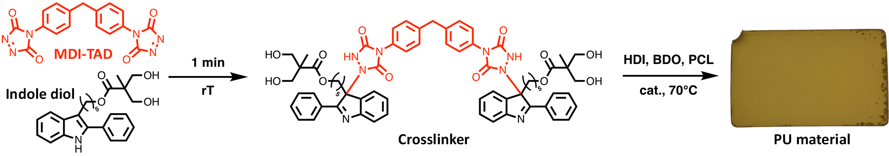
Scheme 1: Reaction of a bisfunctional TAD-compound (MDI-based) with indole diol readily leads to a thermoreversible TAD-indole tetrafunctional crosslinker, which is mixed with hexamethylene diisocyanate (HDI), butanediol (BDO), poly($ε$-caprolactone) diol (PCL) in the presence of a zirconium(IV) acetylacetonate catalyst to produce the envisaged PU material.

Experimental section
Materials. 2,2-bis-(hydroxymethyl)-propionic acid, 1,4-butanediol (BDO), chloroform (CHCl₃), dichloromethane (DCM), N,N’-dicyclohexylcarbodiimide (DCC), 3,4-dihydro-2H-pyran, 4-(dimethylamino)pyridine (DMAP), ethyl carbazate, hexamethylene diisocyanate (HDI), trans,trans-2,4-hexadien-1-ol (HDEO), methanesulfonyl chloride, methanol (MeOH), 4,4’-methylenebis(phenyl isocyanate) (MDI), palladium 5 wt% on carbon (Pd/C), poly($ε$-caprolactone) diol 2000 g/mol (PCL2000), poly(ethylene oxide) 2000 g/mol, sodium iodide (NaI), trans-2-[3-(4-tert-butylphenyl)-2-methyl-2-propenylidene]malononitrile (DCTB), tetrahydrofuran (THF), p-toluenesulfonic acid monohydrate, tin(II) 2-ethylhexanoate (SnOct₂) and zirconium(IV) acetylacetonate (ZrAc₄) were purchased from Sigma-Aldrich. Ammonia in methanol (7 N), bromine, 2,2-dimethoxypropane, dimethylformamide (DMF) and triethylamine (Et₃N) were purchased from Acros Organics. 2-phenyl-1H-indole and trifluoroacetic acid were purchased from Alfa Aesar. Magnesium sulfate (MgSO₄), potassium carbonate (K₂CO₃) and potassium hydroxide (KOH) were purchased from Carl Roth. Hydrochloric acid (HCl, 36%) was purchased from Chem-lab. Chloroform-d (CDCl₃) and dimethyl sulfoxide-d₆ (DMSO-d₆) were purchased from Euriso-top. Ethyl acetate (EtOAc, technical grade) and hexane (technical grade) were purchased from Univar. Acetone (HPLC grade) and toluene (HPLC grade) were purchased from VWR Chemicals. $ε$-caprolactone ($ε$-CL) and 1,4-diazabicyclo[2.2.2]octane (DABCO) were purchased from TCI. DMF was stored on dried molecular sieves (4 Å). $ε$-CL was distilled before use and stored on dried molecular sieves (4 Å). All other products were used as received. 5-(2-phenyl-1H-indol-3-yl)pentan-1-ol (2-Ph-indole-OH)³¹, 5-(2-phenyl-1H-indol-3-yl)pentyl methanesulfonate (2-Ph-indole-OMs)³¹, 4,4’-(4,4’-diphenylmethylene)-bis-(1,2,4- triazoline-3,5-dione) (MDI-TAD)²⁷, 2,2,5-trimethyl-1,3-dioxane-5-carboxylic acid³², (2E,4E)-hexa-2,4-dien-1-yl 2,2,5-trimethyl-1,3-dioxane-5-carboxylate (HDEO ketal)³³ and (2E,4E)-hexa-2,4-dien-1-yl 2,2-bis-(hydroxymethyl)-propanoate (HDEO diol)³³ were synthesized according to known literature procedures and described in the Supporting Information.
Synthesis of 5-(2-phenyl-1H-indol-3-yl)pentyl 2,2-bis-(hydroxymethyl)-propanoate (2-Ph-indole diol). 2,2-bis-(hydroxymethyl)-propionic acid (17.86 g, 133 mmol, 1 eq), K₂CO₃ (20.24 g, 146 mmol, 1.1 eq) and dry DMF (400 mL) were added to a round-bottom 2-neck flask and cooled in an ice bath under inert atmosphere. To this mixture, a solution of 2-Ph-indole-OMs (47.59 g, 133 mmol, 1 eq) in dry DMF (400 mL) was added. The mixture was stirred vigorously overnight at 80 °C and the complete conversion was checked by thin layer chromatography (EtOAc:hexane 50:50). The mixture was allowed to cool down to room temperature and the salts were filtered off and washed with DMF, after which the filtrate was concentrated in vacuo. To the acquired orange-brown oil 5 vol% Et₃N in EtOAc was added to a dilution of 10 m%. This mixture was placed in an ultrasonic bath for 10 min. The salts were filtered off and washed with 5 vol% Et₃N in EtOAc, followed by concentration in vacuo. The crude product is purified via column chromatography (gradient EtOAc:hexane 20:80 to 50:50) to yield the pure product as a light brown oil. Yield = 90% (47.4 g). $M_{w}$ = 395.50 g/mol. LC-MS (m/z) = 396.1 [M+H⁺]. ¹H-NMR (400 MHz, CDCl₃): δ (ppm) = 8.05 (br.s, 1H), 7.62 (d, 1H), 7.55 (d, 2H), 7.47 (t, 2H), 7.38 (m, 2H), 7.21 (td, 1H), 7.14 (td, 1H), 4.12 (t, 2H), 3.77 (ddd, 4H), 2.91 (t, 2H), 2.75 (t, 2H), 1.76 (m, 2H), 1.63 (m, 2H), 1.42 (m, 2H), 1.01 (s, 3H). ¹³C-NMR (100 MHz, CDCl₃): δ (ppm) = 176.12 (C), 136.04 (C), 134.39 (C), 133.55 (C), 129.31 (C), 128.98 (CH), 128.11 (CH), 127.71 (CH), 122.35 (CH), 119.64 (CH), 119.33 (CH), 113.60 (C), 110.94 (CH), 68.66 (CH₂), 65.20 (CH₂), 49.16 (C), 30.55 (CH₂), 28.52 (CH₂), 25.99 (CH₂), 24.47 (CH₂), 17.23 (CH₃). IR (solid, ATR): 3320 (O-H and N-H stretch), 3054, 2932, 2858, 1710, 1649 (C=C stretch), 1603, 1488, 1456, 1386, 1306, 1227, 1138, 1099, 1036, 765, 741, 698, 664 cm⁻¹.
Synthesis of poly($ε$-caprolactone) diol 4000 (PCL4000). $ε$-CL (70.00 g, 613 mmol, 35 eq), BDO (1.58 g, 17.5 mmol, 1 eq) and SnOct₂ (0.36 g, 0.876 mmol, 0.05 eq) were added to a flame-dried round-bottom 2-neck flask. The mixture was brought under inert atmosphere and stirred 2 hours in an oil bath at 120 °C. The obtained polymer was dissolved in DCM and precipitated 3 times in cold MeOH to yield PCL4000 as a white powder. Yield = 93% (66.7 g). ¹H-NMR (400 MHz, CDCl₃) $δ$ = 4.05 (t, 70H), 3.63 (t, 4H), 2.29 (t, 70H), 1.64 (m, 146H), 1.37 (m, 70H). $M_{n}$(NMR) = 4060 g/mol. MALDI-TOF $M_{w}$[PCL+Na⁺]: 3993 Da. SEC (THF, PS standards): $M_{n}$ = 10000 g/mol, Đ = 1.38.
Synthesis of poly($ε$-caprolactone) diol 6000 (PCL6000). Similar to procedure of PCL4000, but using 52 eq of $ε$-CL to yield PCL6000 as a white powder. Yield = 84% (102 g). ¹H-NMR (400 MHz, CDCl₃) $δ$ = 4.03 (t, 104H), 3.61 (t, 4H), 2.28 (t, 104H), 1.62 (m, 214H), 1.35 (m, 104H). $M_{n}$(NMR) = 5989 g/mol. MALDI-TOF $M_{w}$[PCL+Na⁺]: 6047 Da. SEC (THF, PS standards): $M_{n}$ = 14300 g/mol, Đ = 1.35.
Synthesis of polyurethane networks (PU networks). All networks were prepared following the procedure below. Variations were made in the molecular weight of PCL ($M_{w,PCL}$), wt% hard segment (HS), mol% crosslinker (#), mol% free indole and curing temperature. 2-Ph-indole diol was dissolved in DMF (4 mL). Next, MDI-TAD was added and the mixture was vortexed until the red color disappeared. The mixture was brought to 60 °C and PCL and BDO were added. When the PCL had completely melted, 1.05 eq HDI was added and the mixture was left to stir at 60 °C for 20 min while applying vacuum. After addition of ZrAc₄, the reaction mixture was vortexed for 10 s and poured into a preheated mold. The network was allowed to cure for 2 days, followed by soxhlet extraction (48 h) with acetone and overnight drying under vacuum (40 °C). Each network was left at ambient conditions for at least 1 day before characterization. The compositions of the first batch of PU networks (cf. Table 1: PU-1 until PU-11) were chosen following a common 3-level design of experiments (DoE) scheme.³⁴ The design outline for 5 factors is given in Table S1. Next, the best performing PU networks were chosen to create a new batch of optimized PU networks PU-X-Y, with X the HS content (wt%) and Y the free indole content (mol%). Reference polyurethane networks were prepared using HDEO diol instead of 2-Ph-indole diol.
Methods. Thermogravimetric analyses (TGA) were performed on a Mettler Toledo TGA/SDTA 851e in a temperature window of 25 to 800 °C at a heating rate of 10 °C/min under nitrogen atmosphere.
Differential scanning calorimetry (DSC) was performed on a Mettler Toledo DSC 1 equipped with a liquid nitrogen cooling system in a temperature window of -100 °C to 150 °C at a rate of 10 °C/min. Aluminum crucible (40 µL) and lids were used to analyze a ± 5 mg sample.
Nuclear magnetic resonance (NMR) spectra were recorded on a Bruker Avance 300 (300 MHz) or Bruker Avance 400 (400 MHz) NMR spectrometer.
Size Exclusion Chromatography (SEC) with THF as solvent was performed using a Varian PLGPC50plus instrument, using a refractive index detector, equipped with two Plgel 5 μm MIXED-D columns 40 °C. Polystyrene standards were used for calibration and THF as eluent at a flow rate of 1 mL/min. Samples were injected using a PL AS RT autosampler.
Infrared (IR) spectra were collected using a Perkin–Elmer Spectrum1000 FTIR infrared spectrometer with a diamond ATR probe from 4000 to 600 cm⁻¹.
Rheology experiments were performed on an Anton Paar MCR 302. The experiments were performed in parallel plate geometry using 8 mm sample disks. Unless specified, the experiments were performed using a normal force of 5 N, a frequency of 1 Hz and a strain of 1%. For strain sweep experiments, the strain was varied from 0.01 to 100%. For frequency sweep experiments, the frequency was varied from 100 to 0.001 Hz. For stress relaxation experiments, a strain of 10% was applied to the material and the relaxation modulus was followed over time at a constant temperature. The applied strain of 10% was at the border of the LVE region at the elevated temperatures that were used during the measurements. Prestrains of 5% were applied during 100 seconds prior to the measurement. For the temperature sweep measurement, the temperature was varied from 30 to 140 °C within 15 minutes and kept for 5 minutes at 140 °C before returning to the starting temperature. This cycle was performed twice.
Stress-strain measurements were performed on a Tinius-Olsen H10KT tensile tester equipped with a 5000 N load cell using ASTM standard type IV dog bones (ISO 527-2-2B). The dog bone shaped samples had an effective gauge length of 12 mm, a width of 2 mm and a thickness of ± 2 mm and they were cut using a Ray-Ran hand operated cutting press. The tensile measurements were performed using a preload of 0.05 N and a pulling speed of 10 mm/min until sample failure. The stress $σ$ was recorded as a function of strain $ε$.
Healing efficiency experiments were performed using the same equipment and samples as described above for regular stress-strain measurements. A set of 8 dog bones were used, from which 4 were cut through the middle using a razor blade and 4 were kept intact. To create a mold, dog bone shapes were cut from a silicon spacer with a thickness of ± 2 mm, which matched the thickness of the examined samples. The 4 reference dog bones and 4 cut dog bones were placed in the designed mold, placed between two steel plates and kept at 120 °C for 1 hour, while applying a slight pressure (0.5 bar).
Cyclic shape-memory experiments were performed on a Tinius-Olsen H10KT tensile tester, equipped with a 100 N load cell and an environmental chamber, controlled by a SOLO2 temperature controller and linked to a liquid nitrogen Dewar. During the stress-controlled cyclic measurements, dog bone shaped samples were heated to 70 °C and stretched to ± 50% strain. The stress was registered and kept constant, while lowering the temperature to 20 °C and equilibrating for 20 min. After this stage, the residual stress was unloaded and a fixity ratio was determined. Next, the temperature was again increased to 70 °C, the sample was allowed to recover its original shape and a recovery ratio was determined after 15 min. This procedure was repeated 3 times for each experiment.
Optical microscopy images were obtained with an Olympus BH-2, equipped with a Canon EOS 1100D, using 2x and 5x objectives.
Scanning electron microscopy (SEM) was performed using a Phenom Pro desktop SEM. Samples were secured on the sample holder with carbon tape.
Recycling experiments were performed by grinding the materials with a IKA A 10 basic batch mill. The obtained granulates were transferred to a mold and compression molded at 120 °C for 30 minutes. After cooling, the samples were demolded and stress-strain measurements were performed as previously described.
Matrix Assisted Laser Desorption Ionization – Time of Flight (MALDI-TOF) for polymer characterization was performed on an Applied Biosystems Voyager De STR MALDI-TOF spectrometer equipped with 2 m linear and 3 m reflector flight tubes, a nitrogen laser operating at 337 nm, pulsed ion extraction source and reflectron. All mass spectra were obtained with an accelerating potential of 20 kV in positive ion mode and in reflector mode. For measurement of PCL, trans-2-[3-(4-tert-butylphenyl)-2-methyl-2-propenylidene]malononitrile (DCTB) (20 mg/mL in THF) was used as a matrix, NaI (1 mg/mL in THF) was used as a cationizing agent, and polymer samples were dissolved in THF (2 mg/mL). Polymer solutions were prepared by mixing 10 μL of the matrix, 5 μL of the salt, and 5 μL of the polymer solution. Subsequently, 0.5 μL of this mixture was spotted on the sample plate, and the spots were dried in air at room temperature. A poly(ethylene oxide) standard ($M_{n}$ = 2000 g/mol) was used for calibration. All data were processed using the Data Explorer 4.0.0.0 (Applied Biosystems) software package.

Results and Discussion
TAD-indole crosslinked PU. Each polyurethane was synthesized following the strategy depicted in Scheme 1. First, a tetrafunctional crosslinker was prepared by reaction of the red colored, bisfunctional MDI-TAD with 2-Ph-indole diol. This click reaction was immediately followed by the addition of polyol, diisocyanate (HDI) and catalyst (ZrAc₄) to yield the desired PU network. As the variation of numerous parameters to evaluate the full range of possible PU networks is a quite labor-intensive task, 5 variables (with 3 levels) that can have an influence on the shape-memory and healing capabilities of the networks have been chosen, i.e. the molecular weight of PCL diol (2000-4000-6000 g/mol), the amount of hard segment (35-50-65 wt%), crosslinker content (5-10-15 mol%), free indole content (20-35-50 mol%) and the curing temperature (70-80-90 °C). Here, ‘free indole’ is defined as the indole functional groups that were added in excess and thus remained available within the matrix to allow exchange of the TAD-indole adduct. Although the exact mechanism is not clear yet, it is believed that the proximity of a suitable reaction partner (i.e. free indole) is required to allow the TAD transclick reaction from one adduct to another.²⁹ The combination of fast reaction rates and thermodynamic preference towards the adduct ensures conservation of the crosslinks, and thus structural integrity.
To reduce the number of experiments that are needed to screen the PU networks for optimal properties, a 3-level design of experiments (DoE) was created. An overview of the first set of performed experiments (PU-1 until PU-11) and their composition is given in the top part of Table 1. Next, each polyurethane was evaluated by performing cyclic shape-memory and healing efficiency experiments. Here, a good shape-memory property reflects the ability to close the suffered damage, while a good healing efficiency indicates sufficient reversible bond exchange to restore the mechanical properties.

Table 1: Composition of produced PU networks with results of cyclic shape-memory and healing efficiency experiments. Top: original set of experiments according to DoE (PU-1 to PU-11). Bottom: additional experiments towards optimization of PU networks (PU-50-20 to PU-65-50).
Sample | $$M_{w,PCL}$$ | HS | # | Indole | T | $R_{f}$(%) after cycle |  |  | $R_{r}$(%) after cycle |  |  | $$η_{σ}$$
 | (g/mol) | (wt%) | (mol%) | (mol%) | (°C) | 1 | 2 | 3 | 1 | 2 | 3 | (%)
PU-1 | 4000 | 65 | 15 | 20 | 70 | 98.3 | 98.4 | 98.4 | 82.1 | 97.2 | 97.0 | 73.7
PU-2 | 4000 | 35 | 5 | 50 | 90 | 90.4 | 89.8 | 90.1 | 59.2 | 98.5 | 97.6 | 54.8
PU-3 | 6000 | 50 | 5 | 20 | 90 | 92.4 | 92.7 | 92.8 | 73.8 | 96.1 | 97.5 | 83.0
PU-4 | 2000 | 50 | 15 | 50 | 70 | 65.9 | 68.5 | 70.5 | 93.3 | 98.7 | 99.5 | 108.5
PU-5 | 6000 | 35 | 10 | 50 | 70 | 98.8 | 98.7 | 98.9 | 74.1 | 97.5 | 98.0 | 111.3
PU-6 | 2000 | 65 | 10 | 20 | 90 | 88.1 | 89.7 | 90.0 | 72.8 | 94.6 | 97.3 | 25.5
PU-7ª | 6000 | 35 | 15 | 35 | 90 | - | - | - | - | - | - | 101.3
PU-8 | 2000 | 65 | 5 | 35 | 70 | 77.5 | 77.0 | 77.5 | 73.2 | 97.8 | 98.3 | 29.0
PU-9 | 6000 | 65 | 15 | 50 | 80 | 99.3 | 99.3 | 99.3 | 78.1 | 93.0 | 94.2 | 73.7
PU-10 | 2000 | 35 | 5 | 20 | 80 | 68.5 | 67.7 | 66.6 | 73.4 | 96.8 | 96.5 | 22.0
PU-11 | 4000 | 50 | 10 | 35 | 80 | 96.3 | 96.5 | 96.5 | 68.5 | 94.7 | 96.8 | 41.3
PU-50-20 | 4000 | 50 | 15 | 20 | 70 | 98.9 | 98.9 | 98.8 | 83.6 | 94.7 | 96.2 | 101.6
PU-50-35 | 4000 | 50 | 15 | 35 | 70 | 97.3 | 97.2 | 97.2 | 96.0 | 99.8 | 98.4 | 72.2
PU-50-50 | 4000 | 50 | 15 | 50 | 70 | 87.8 | 89.1 | 89.3 | 100.0 | 100.0 | 100.0 | 73.4
PU-65-20 | 4000 | 65 | 15 | 20 | 70 | 98.3 | 98.4 | 98.4 | 82.1 | 97.2 | 97.0 | 73.7
PU-65-35 | 4000 | 65 | 15 | 35 | 70 | 95.3 | 95.7 | 96.0 | 92.4 | 100.0 | 100.0 | 32.9
PU-65-50 | 4000 | 65 | 15 | 20 | 70 | 95.9 | 96.5 | 97.0 | 100.0 | 100.0 | 100.0 | 71.8
ª: did not survive cyclic shape-memory test. Used abbreviations: molecular weight of PCL ($M_{w,PCL}$), hard segment content (HS), crosslinker content (#), free indole content (Indole), curing temperature (T), fixity ratio ($R_{f}$), recovery ratio ($R_{r}$), healing efficiency ($η_{σ}$).

Cyclic shape-memory experiment. The efficiency of the shape-memory property was probed by performing a temperature- and stress-controlled cyclic tensile test (Figure 1).

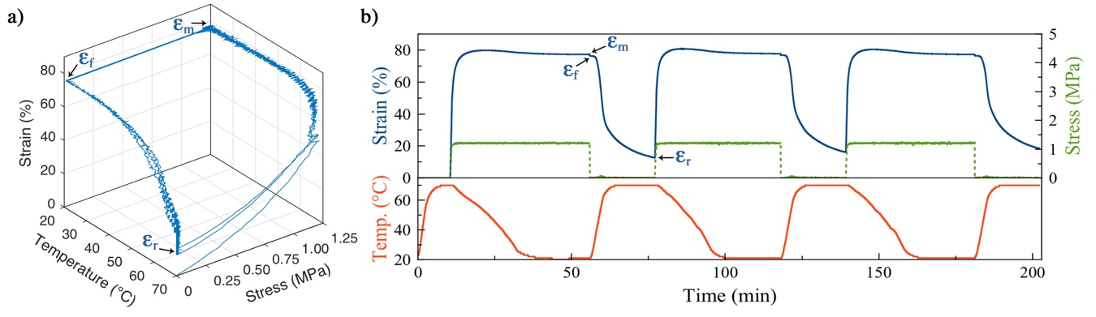
Figure 1: Graphical representation of the cyclic shape-memory experiments for PU-1. (a) 3D plot (b) Stress-strain-temperature as a function of time.

The samples were stretched at elevated temperature, followed by cooling below the melting temperature of PCL ($T_{m,PCL}$= ± 50 °C) to store a temporary shape. When removing the stress, i.e. unloading, the fixity ratio $R_{f}$ is determined, which defines how good the material can store this temporary shape. This value was determined according to Equation (1), where $ε_{m}$ is the targeted maximum strain and $ε_{f}$ is the strain after unloading. Next, the sample was heated above $T_{m,PCL}$ and allowed to restore its original shape, i.e. shape-recovery. At this point, a recovery ratio $R_{r}$ can be determined, which defines how well the material can restore the original shape. This value was determined according to Equation (2), where $ε_{0}$ is the original strain and $ε_{r}$ is the strain after shape-recovery. These steps were repeated for at least 3 cycles.
$R_{f}=\frac{ε_{f}}{ε_{m}} × 100\%$ (1)
$R_{r}=\frac{ε_{f}-ε_{r}}{ε_{f}-ε_{0}} × 100\%$ (2)
Table 1 shows the fixity and recovery ratios obtained during this cyclic test for PU-1 to PU-11. Reasonable to excellent shape-memory properties were obtained for almost all samples. When comparing the different cycles, it is evident that the fixity ratio is very reproducible in each cycle, whereas the recovery ratio in the first cycle is typically lower than the other cycles. This ‘learning step’ can be attributed to the testing method, where a longitudinal force is applied and polymer chains creep slightly to reduce the stress. This leads to a permanent deformation that cannot be restored upon heating the sample and thus results in a lower recovery ratio. This effect is enhanced in the used cyclic tensile test as a result of the large deformations (cm range) that are applied and will not be problematic for typical final applications, where smaller deformations (µm-mm range) are targeted.
To understand which sample shows the best combination of fixity and recovery ratios, first the events during a damage and healing event are explained. When cutting the PU with a knife, covalent bonds will be broken and part of the material will be pushed away perpendicular from the cutting direction. Since this process occurs below $T_{m,PCL}$, it leads to plastic deformation of the material and a new temporary (damaged) shape is fixed. However, part of the dissipated energy is stored as elastic energy, which can be released upon heating the material above $T_{m,PCL}$. When the crystalline fraction melts, the built-up tension is released and the original shape will be recovered. Therefore, the most important parameter in the context of healing is the recovery ratio.
It could be assumed through the data presented in Table 1, that PU-4, with a recovery ratio $R_{r}$ of 93.3%, would be the most optimal material. However, it is important to note that the fixity ratio $R_{f}$ of PU-4 is very low compared to the other samples, which indicates poor shape-memory properties. This is due to the use of short PCL chains (2000 g/mol), which are less suited to form strong crystalline domains compared to higher molar mass PCL chains. Indeed, the good $R_{r}$ suggests that the suffered damage will be closed immediately and without heating as a result of elastic behavior. However, as we aimed for the production of high-modulus healable materials, not PU-4 with poor mechanical strength but PU-1 was evaluated as the best material with a recovery ratio $R_{r}$ of 82.1%, and a fixity ratio $R_{f}$ of 98.3%. While PU-3, PU-5 and PU-9 also showed good shape-memory properties, their synthesis was troublesome due to difficult homogenization and fast gelation, presumably caused by the high $M_{w}$ of the used PCL diol (6000 g/mol).
Healing efficiency experiment. The ability to reversibly exchange chemical bonds and restore mechanical properties, was studied by performing healing efficiency experiments. Samples were cut in half and placed in silicon molds together with uncut reference samples. Next, they were submitted to a healing step at elevated temperatures (120 °C) while applying a modest pressure of 0.5 bar to ensure reproducibility through good contact between the cut surfaces. After the healing procedure, the healed and reference samples were tested mechanically. The healing efficiency $η_{σ}$ was determined as the ratio of the maximum stress $σ$ of the healed sample to the reference sample, according to Equation (3). The results are listed in Table 1.
$η_{σ}=\frac{σ_{healed}}{σ_{ref}}$ (3)
It is clear that the healing efficiency varies significantly for different compositions. The best results were obtained for PU-3, PU-4, PU-5, PU-7 and PU-9 with efficiencies over 100%, indicating toughening of the matrix. However, bearing in mind the aforementioned troublesome synthesis and unsatisfactory shape-memory properties, these materials were not of interest. Therefore, PU-1 was evaluated as the best all-round material with excellent shape-memory properties and a high healing efficiency $η_{σ}$ of 73.7%. In what follows, the aim was to further optimize PU-1 in terms of shape-memory and healing efficiency.
Optimization of healable PU networks. The design of experiments was chosen according to a common 3-level Definitive Screening Design (DSD).³⁴ Initially, we envisioned data analysis with statistical software to calculate a theoretical model and predict the composition of the ultimate PU network. However, on a critical note, data analysis would be inappropriate since the used model assumed independent factors. This means that, due to excessive parameter correlation, a reliable theoretical model could not be created. Nevertheless, optimization of the PU materials is still feasible by fine-tuning of the critical parameters.
As can be seen from Table 1, PU-1 was composed of a PCL diol with a $M_{w}$ of 4000 g/mol (PCL4000), which appeared the ideal molar mass to achieve the desired shape-memory properties. As the curing temperature did not significantly affect the shape-memory or healing efficiency, this parameter was fixed at 70 °C. The amount of thermoreversible crosslinker was kept constant at 15 mol%, as changing this parameter would result in an unpredictable variation of the material properties. For example, the number of crosslinks has an effect on the stiffness of the material, which in turn influences the shape-memory property. In addition, the number of crosslinks is inherently linked to the number of reversible covalent bonds that are available for exchange. Thus, besides the shape-memory property, also the healing efficiency would be affected by changing the number of crosslinks. On the other hand, the hard segment (HS) and free indole content were chosen as variables in this part of the study.
For PU-1, these parameters were 65 wt% HS and 20 mol% free indole respectively. Lowering the hard segment content was believed to enhance the shape-memory property, since the accompanied increase of soft segment content leads to the formation of larger crystalline domains and a higher degree of crystallization. Furthermore, the healing efficiency should be improved by increasing the amount of free indole groups present in the material, which might allow for faster exchange and thus better healing. To investigate this, a new series of 6 PU compositions was prepared with varying hard segment (50-65 wt%) and free indole (20-35-50 mol%) content. The new PU compositions and the experimental results are listed in the bottom part of Table 1. It is important to note that PU-1 in the original PU series is the same material as PU-65-20 in the optimization series. Therefore, the properties of PU-65-20 were selected as benchmark for future comparison.
With respect to the optimization of the shape-memory property, lowering the hard segment content provided a slight improvement when comparing the samples with equal free indole content. Indeed, PU-50-20 showed slightly higher fixity and recovery ratios compared to the benchmark material PU-65-20. Unexpectedly, the healing efficiency was also positively affected by the lower hard segment content (Figure 2). Indeed, the PU networks with 50 wt% HS showed better restoration of the initial properties after healing (dashed lines), compared to the networks with 65 wt% HS. Furthermore, an interesting behavior emerged from the variation of the free indole content. While the assumption that an increasing amount of free indole content (from 20 to 50 mol%) would improve the healing efficiency, was not confirmed, the resulting materials reached higher strain values and showed lower Young’s moduli during the tensile experiments. This reduced stiffness is ascribed to the fact that the free indole groups act as internal plasticizers.

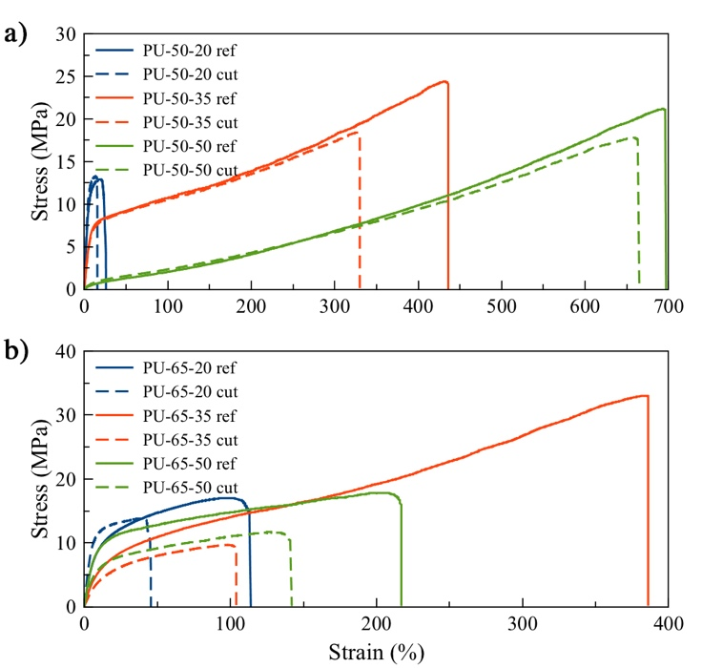
Figure 2: Stress-strain measurements of the reference (solid lines) and healed (dashed lines) samples acquired during healing efficiency experiments. (a) PU networks with a HS content of 50 wt%, (b) PU networks with a HS content of 65 wt%.
In conclusion, lowering the HS content to 50 wt% had a beneficial effect on the shape-memory and healing efficiency. Variation of the indole content resulted in minimal changes of these properties, yet the mechanical properties were affected considerably. The most optimal composition in terms of shape-memory and healing efficiency was PU-50-20 but in fact any material composition between PU-50-20 and PU-50-50 is considered being useful as PU materials that can heal fast from large scale damage.
A qualitative assessment of the healing performance was performed by imaging the damage site before and after healing (30 min at 120 °C). To this purpose, two types of damage - respectively a 1 mm deep cut (50 µm width) and a puncture of 1 mm diameter - were applied to the material and examined using optical microscopy and scanning electron microscopy (SEM) (Figure 3 and Figures S1-S2).
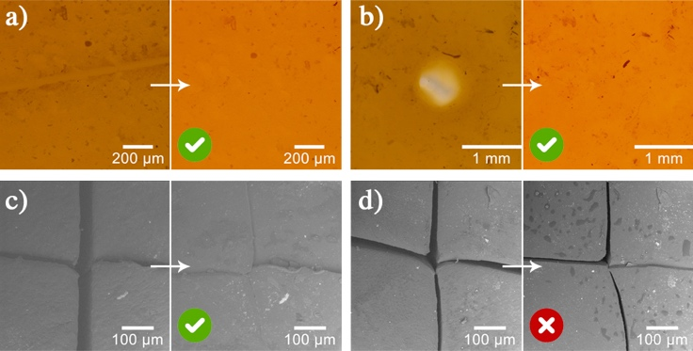
Figure 3: Optical microscopy image before and after healing sample PU-50-20 from a cut (a) or a puncture (b). Scanning electron microscopy image before and after healing of a cross cut in sample PU-50-35 (c) and PU-65-35 (d).

While the optical microscopy images seem to demonstrate that each material was able to restore completely from the applied large damage, SEM revealed the importance of the shape-memory property on the healing ability, since ligation of the damage edges is only possible when the damage is closed sufficiently. For example, Figure 3c shows that sample PU-50-35 was able to close and heal the applied damage, leaving only a scar on the surface, whereas sample PU-65-35 did not show complete healing (Figure 3d). When stretching this imperfectly healed sample, the damage site was opened up, whereas the damage sites on the other samples remained sealed. These observations were in line with the results obtained during the healing efficiency experiments, which showed poor healing efficiencies for PU-65-35. It should be noted, however, that the damage on sample PU-65-35 was not closed, even though this sample showed reasonable shape-memory properties. We therefore assume that the two simultaneous processes of shape-recovery and bond exchange are cooperating to yield the best result. This implies that upon damage reduction (i.e. shape-recovery), new bonds are formed at the interphase (i.e. reversible exchange), which in turn aid in further reducing the damage. As the materials were able to repair relatively large damage (up to 1 mm), this is going beyond the current state-of-the-art for intrinsic healing.⁵
Healing efficiency experiments on reference materials. Reference experiments were performed to prove that the observed intrinsic healing was induced by action of reversible TAD-indole chemistry. To this purpose, an irreversible analogue of PU-50-35 was prepared by replacing the indole with 2,4-hexadien-1-ol (HDEO), which is known to form an irreversible Diels-Alder adduct with TAD (Figure S3).²⁷ This reference PU network, referred to as PU-50-35 irrev, had exactly the same composition as PU-50-35, but contained irreversible TAD-HDEO crosslinks.
The stress-strain curves (solid lines) in Figure 4 show that the properties of the irreversible PU were similar to those of the reversible PU. After performing the healing test on both samples, the reversible PU network showed the ability to restore its mechanical properties (dashed lines), whereas the irreversible PU network showed hardly any healing.
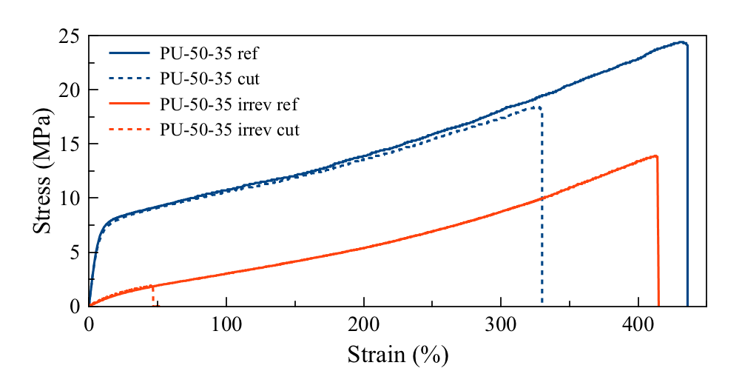
Figure 4: Comparison of stress-strain measurements acquired during healing efficiency experiments of PU-50-35 and its irreversible analogue (PU-50-35 irrev).

Since the irreversible PU network did not have the ability to exchange bonds, the slight restoration of its properties was attributed to intermolecular forces, originating from PCL crystallization at the interface of the cut samples, that prevented immediate breaking of the sample during testing. In conclusion, this reference experiment proves that the exchange of reversible TAD-indole adducts is essential to generate new covalent bonds that span the damage interface, which leads to ligation and healing of the previously separated parts.
Thermal and mechanical characterization of PU networks. In Table 2, the results of thermal and mechanical characterization are shown.

Table 2: Thermal and mechanical characterization of PU networks.
Sample | $$T_{deg, 5\%}$$  (°C) | $$T_{g}$$  (°C) | $$T_{m}$$  (°C) | $χ_{c}$ª  (%) | $$σ_{max}$$  (MPa) | $$ε_{max}$$  (%) | $$E$$  (MPa)
PU-50-20 | 313 | -53 | 43-62 | 22.6 | 8.9 ± 0.6 | 40 ± 17 | 199 ± 8
PU-50-35 | 321 | -53 | 41-64 | 34.9 | 18.6 ± 2.6 | 429 ± 34 | 48 ± 3
PU-50-50 | 321 | -47 | 37-63 | 29.6 | 19.8 ± 1.8 | 685 ± 32 | 12 ± 2
PU-65-20 | 312 | -50 | 39-64 | 29.4 | 23.7 ± 2.7 | 204 ± 29 | 349 ± 68
PU-65-35 | 314 | -53 | 36-62 | 26.6 | 20.1 ± 3.7 | 375 ± 37 | 37 ± 6
PU-65-50 | 315 | -49 | 39-63 | 28.0 | 7.6 ± 1.3 | 314 ± 44 | 31 ± 11
ª:Degree of PCL crystallinity, based on enthalpy of fusion (${∆H}_{f}$) from DSC experiments
and theoretical value of ${∆H}_{f}^{0}$ = 139,3 J/g for 100% crystalline PCL.³⁵

TGA analysis showed a degradation temperature at 5% mass loss ($T_{deg, 5\%}$) of about 315 °C and a maximal degradation rate at 360 °C for all samples (Figure S4). The two-step degradation profile of the PU network was attributed to an initial decomposition of urethane groups, followed by total degradation of the polyol. DSC thermograms (Figure S5) all showed a glass transition, melting and crystallization peak that can be assigned to the presence of the PCL soft segments. It should be noted that the presence of a melting transition does not indicate that the PU material started to flow. On the contrary, the material remains crosslinked (cf. rheological measurements below), but the chain mobility and exchange rate are enhanced. In contrast to the retro Diels-Alder (rDA) reaction observed for furan-maleimide chemistry for example,¹⁴ the theoretical endothermic peak as a result of the retro Alder-Ene reaction of the TAD-indole adduct, could not be observed in any DSC thermogram. This is a direct consequence of the fast kinetics that are typical for TAD chemistry. Indeed, when the reversible reaction occurs, released TAD moieties quickly react with suitable binding partners nearby, which means the DSC instrument is unable to register a netto change in heat capacity.
Beneficial to obtain good shape-memory properties is the formation of PCL crystalline domains, which can be verified by determination of the degree of crystallinity $χ_{c}$ (Table 2). The PU materials showed a degree of PCL crystallinity ranging from 22.6 until 34.9%, which is rather low considering the high weight percentage of PCL (cf. Table 1). Nevertheless, the aforementioned shape-memory experiments showed that it was sufficient to exhibit a good shape-memory effect.
Tensile measurements revealed that the mechanical properties of the PU materials ranged from hard and brittle to soft and tough (Table 2 and Figure S6). The main contributor to this versatility in mechanical behavior was the free indole content, which had an effect on the stiffness of the material as evidenced by the decreasing Young’s modulus $E$. When considering the PU samples with a 50 wt% HS content, a clear trend of increasing stress $σ$ and strain $ε$ values upon increasing free indole content could be observed.
Rheological characterization of exchange processes. Rheological measurements were performed to gain insight into the behavior of the healable PU samples at elevated temperature. Figure 5a shows the results of a frequency sweep at 120 °C using a strain of 10%.

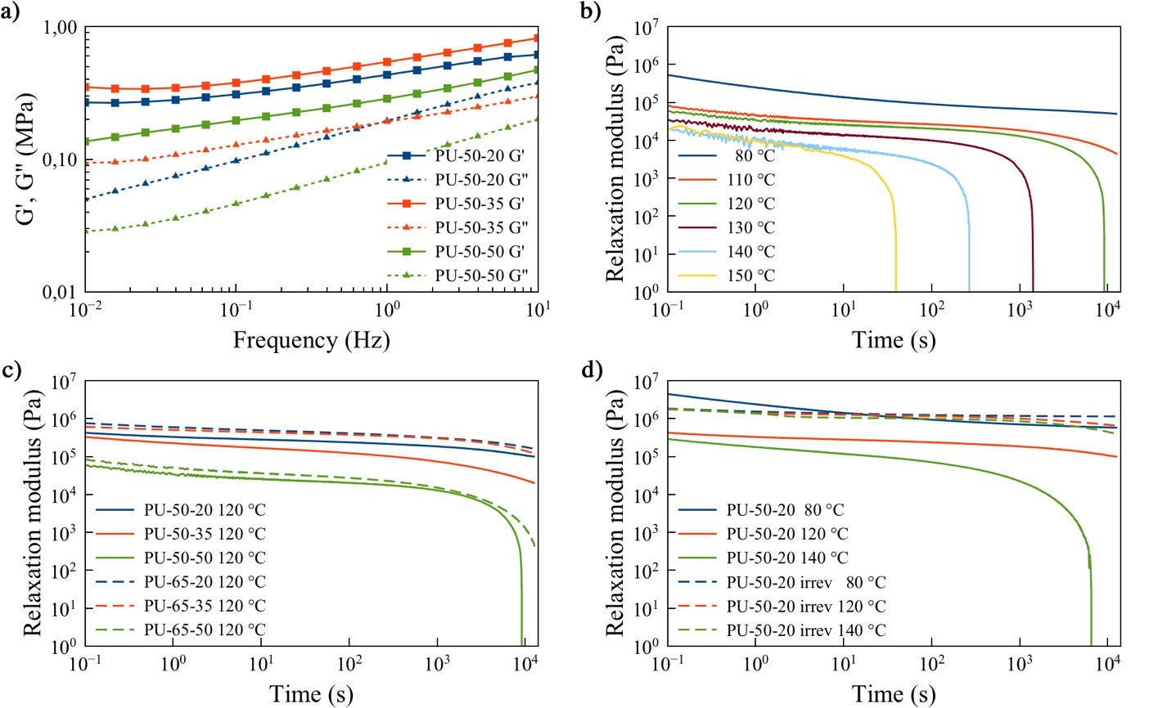
Figure 5: Results from dynamic rheology experiments. (a) Frequency sweep of PU-50-20, PU-50-35 and PU-50-50 at 120 °C. (b) Stress-relaxation of PU-50-50. (c) Influence of indole content on stress-relaxation at 120 °C. (d) Reference experiment with irreversible sample.
Within the examined frequency range, the storage modulus $G'$ exceeded the loss modulus $G"$, indicating that the material did not flow or adopt a liquid state during the healing experiments, even though the reversibility temperature of this specific TAD-indole system ($T_{rev}$ = 95 °C)²⁹ was exceeded. A hypothesis for this phenomenon is the fact that reversible exchange of the adduct shows ultrafast kinetics and is only favored when a suitable TAD binding partner is in close proximity, resulting in exchange with associative characteristics. This means that the reversible crosslinks are able to preserve the structural integrity of the material unless a continuous deformation is applied to deliver new suitable binding partners close to the adduct and allow for exchange. In other words, the crosslink density will remain constant and thus the material could in theory show vitrimer-like properties, such as a temperature dependence of the relaxation time described by the Arrhenius equation.^{36,37}
To verify this statement, stress-relaxation experiments were performed. The relaxation modulus was determined as a function of time and at different temperatures to demonstrate a faster exchange rate with increasing temperature. Figure 5b shows the stress-relaxation of PU-50-50 as an example. When a deformation of 10% strain was applied at 80 °C (below $T_{rev}$), the material did not relax, but the modulus evolved towards a plateau. When increasing the temperature (above $T_{rev}$), reversible bond exchange allowed relaxation of the applied stress. It should be noted however that an initial fast relaxation at short time scale was observed, which was found in all stress-relaxation experiments and attributed to rearrangement of hydrogen bonds in the PU networks and creep of the long polymer chains. This observation had consequences for the investigation of the vitrimer-like behavior of the TAD-indole exchange, since the presence of multiple relaxation processes did not allow to fit the results with a typical Maxwell model. Thus, determination of a relaxation time $τ_{rel}$ at 37% ($=1/e$) of the normalized relaxation modulus was not feasible. However, the relaxation time $τ_{rel}$ could be obtained by integration of the rheological data according to equation (4)³⁸:
$τ_{rel}=\frac{\int_{0}^{∞}{tG\left(t\right)dt}}{\int_{0}^{∞}{G\left(t\right)dt}}$ (4)
Extracting $τ_{rel}$ for each temperature allowed to create an Arrhenius plot (Figure S7), which showed a linear dependence within the temperature window of 120-150 °C with an activation energy $E_{a}$ = 108 kJ/mol, which fits very well to data from kinetic reversibility tests ($E_{a}$ = 108.9 ± 4.0 kJ/mol)²⁹. Relaxation times at temperatures below 120 °C were not considered, since full relaxation was not achieved within the examined time scale. Furthermore, data above 150 °C were not measured to avoid potential degradation (dimerization) of TAD moieties.²⁸ Kuang et al. recently showed a similar vitrimer-like behavior for the dissociative furan-maleimide system in the specific temperature range where a DA/rDA reaction equilibrium is established (70-100 °C).³⁹ Within this temperature range, the incomplete dissociation of the adducts ensured conservation of the crosslink density and thus a vitrimer-like behavior could be observed. However, complete adduct decomposition is typically already reached above 110 °C.⁴⁰ In contrast, even at the temperature limit of 150 °C, the TAD-indole system showed a thermodynamic preference towards the adduct, thereby ensuring structural integrity. To show the fundamental difference between reversible TAD-indole chemistry and furan-maleimide chemistry, a temperature sweep was performed. In this experiment, the moduli were followed in a temperature range of 30 until 140 °C. Whereas materials containing furan-maleimide crosslinks would typically exhibit a liquid state above 110 °C ($G"$ > $G^{'}$)¹⁶ as a result of adduct decomposition, materials crosslinked with TAD-indole chemistry do not show loss of structure ($G'$ > $G"$) upon heating within the examined time scale (Figure S8).
Figure 5c shows how the free indole content affects the kinetics of bond exchange. When increasing the free indole content from 20 mol% to 50 mol%, faster relaxation was observed. All samples were prepared with 15 mol% of crosslinker, which means that they contain the same amount of TAD functional groups in the network. Therefore, the faster exchange should be ascribed to the increasing free indole content of the materials.
Since polyurethanes are known to show a certain degree of stress-relaxation in the presence of a catalyst at elevated temperature by the action of transcarbamoylation^{41,42}, a reference experiment was essential to prove that the observed stress-relaxation was indeed caused by action of reversible TAD chemistry. Therefore, the stress-relaxation experiment was repeated with the irreversible PU material analogue. Figure 5d shows clearly that the irreversible network is not able to relax the applied stress. However, one can observe a slight stress-relaxation in the irreversible network at large time scales and high temperature, which might be attributed to transcarbamoylation. Nevertheless, this measurement demonstrates that the observed exchange at 140 °C is primarily caused by the action of reversible TAD chemistry. By repeating the frequency sweep measurement with the irreversible PU analogue (Figure S9), the absence of reversible exchange could also be proven since $G'$ did not exceed $G"$.
Recycling experiment. To investigate the effect of several healing cycles on the materials, a recycling experiment was performed, i.e. the material was grinded and remolded in a cyclic way to mimic a very drastic damage/healing cycle. During the first three cycles, healing conditions of 30 min at 120 °C were used, whereas a longer healing time of 2 hours was used in the fourth cycle to verify if a longer healing time is desired. After each cycle, tensile measurements were performed to evaluate the change in mechanical properties and the results are depicted in Figure S10. With the exception of samples PU-65-20 and PU-65-35 (Figure S10d and S10e), a good restoration of mechanical properties was found for all samples after multiple recycling steps. However, a change in toughness was observed, which was mostly reflected by an increase of the Young’s modulus. This increase might be a consequence of the density rise that develops during the compression molding step, which makes comparison with the original materials inappropriate. Nevertheless, these measurements show that multiple healing cycles could be applied and remolding was possible without severe change of properties. Although the materials showed a slight discoloration, infrared spectroscopy did not show chemical degradation upon recycling (Figure S11). A longer healing time of 2 hours logically resulted in improved results in some cases. However, for most samples, a good restoration of properties could be obtained already after 30 minutes of healing.
Conclusion
Polyurethanes containing a thermoreversible TAD-indole crosslinker were successfully synthesized and optimized in terms of healing efficiency. The composition of the PU and its ability to recover the original shape, proved to be essential for good healing. The networks were able to heal from a deep cut (1 mm deep, 50 µm wide) or puncture damage (1 mm diameter) by thermal treatment at 120 °C for 30 minutes with healing efficiencies up to 100%. With these results, the described polyurethanes expand the current state-of-the-art for intrinsic healing of high-modulus materials. Rheological measurements revealed interesting vitrimer-like behavior of reversible TAD chemistry, leading to fast bond exchange without flow of material. An activation energy of 108 kJ/mol was found for the reversible exchange reaction of TAD-indole, which coincided with previous reported data from kinetic reversibility tests. Reference polyurethane networks allowed to conclude that the outstanding properties were indeed caused by the use of the TAD-indole crosslinker. Finally, the materials were able to withstand multiple recycling steps.

Author information
Corresponding Author
*E-mail: filip.duprez@ugent.be.
Notes
The authors declare no competing financial interest.
Acknowledgements
N. Van Herck thanks the Research Foundation – Flanders (Fonds Wetenschappelijk Onderzoek – Vlaanderen) for a Ph.D. scholarship. F.D.P acknowledges UGent funding (BOF-GOA). B. De Meyer, T. Courtin and J. Alves Anjos are thanked for their technical support. S. Vandewalle is acknowledged for MALDI-TOF experiments.
Associated Content
Supporting Information available. This material is available free of charge on the ACS Publications website: http://pubs.acs.org.
Table S1, Figure S1-S11, NMR spectra (Figure S12-S20) and SEC traces (Figure S21) of synthesized compounds.

References
(1) Wiederhorn, S. M.; Townsend, P. R. Crack Healing in Glass. J. Am. Ceram. Soc. 1970, 53 (9), 486–489.
(2) White, S. R.; Sottos, N. R.; Geubelle, P. H.; Moore, J. S.; Kessler, M. R.; Sriram, S. R.; Brown, E. N.; Viswanathan, S. Autonomic healing of polymer composites. Nature 2001, 409 (6822), 794–797.
(3) Kessler, M. R.; Sottos, N. R.; White, S. R. Self-healing structural composite materials. Compos. Part A Appl. Sci. Manuf. 2003, 34 (8), 743–753.
(4) van der Zwaag, S. Self Healing Materials: an Alternative Approach to 20 Centuries of Materials Science; Springer, 2007.
(5) Blaiszik, B. J.; Kramer, S. L. B.; Olugebefola, S. C.; Moore, J. S.; Sottos, N. R.; White, S. R. Self-Healing Polymers and Composites. Annu. Rev. Mater. Res. 2010, 40, 179–211.
(6) Billiet, S.; Hillewaere, X. K.; Teixeira, R. F.; Du Prez, F. E. Chemistry of Crosslinking Processes for Self‐Healing Polymers. Macromol. Rapid Commun. 2013, 34 (4), 290–309.
(7) Hillewaere, X. K. D.; Du Prez, F. E. Fifteen chemistries for autonomous external self-healing polymers and composites. Prog. Polym. Sci. 2015, 49–50, 121–153.
(8) Urdl, K.; Kandelbauer, A.; Kern, W.; Müller, U.; Thebault, M.; Zikulnig-Rusch, E. Self-healing of densely crosslinked thermoset polymers - a critical review. Prog. Org. Coatings 2017, 104, 232–249.
(9) Taylor, D. L.; in het Panhuis, M. Self-Healing Hydrogels. Adv. Mater. 2016, 28 (41), 9060–9093.
(10) Mozhdehi, D.; Ayala, S.; Cromwell, O. R.; Guan, Z. Self-Healing Multiphase Polymers via Dynamic Metal − Ligand Interactions. J. Am. Chem. Soc. 2014, No. 136, 16128–16131.
(11) White, S. R.; Moore, J. S.; Sottos, N. R.; Krull, B. P.; Santa Cruz, W. A. Gergely, R. C. R. Restoration of Large Damage Volumes in Polymers. Science 2014, 344 (6184), 620–623.
(12) Rodriguez, E. D.; Luo, X.; Mather, P. T. Linear/network poly(ε-caprolactone) blends exhibiting shape memory assisted self-healing (SMASH). ACS Appl. Mater. Interfaces 2011, 3 (2), 152–161.
(13) Farhan, M.; Rudolph, T.; Nöchel, U.; Kratz, K.; Lendlein, A. Extractable Free Polymer Chains Enhance Actuation Performance of Crystallizable Poly(ε-caprolactone) Networks and Enable Self-Healing. Polymers 2018, 10 (3), 255.
(14) Rivero, G.; Nguyen, L. T. T.; Hillewaere, X. K. D.; Du Prez, F. E. One-Pot Thermo-Remendable Shape Memory Polyurethanes. Macromolecules 2014, 47 (6), 2010–2018.
(15) Gandini, A.; Belgacem, M. N. Furans in polymer chemistry. Prog. Polym. Sci. 1997, 22 (6), 1203–1379.
(16) Bose, R. K.; Kötteritzsch, J.; Garcia, S. J.; Hager, M. D.; Schubert, U. S.; Van Der Zwaag, S. A Rheological and Spectroscopic Study on the Kinetics of Self-Healing in a Single-Component Diels-Alder Copolymer and Its Underlying Chemical Reaction. J. Polym. Sci. Part A Polym. Chem. 2014, 52 (12), 1669–1675.
(17) Nguyen, L.-T. T.; Truong, T.; Nguyen, H. T.; Le, L.; Nguyen, V. Q.; Le, T. V.; Luu, A. T. Healable shape-memory (thio)urethane thermosets. Polym. Chem. 2015, 6, 3143–3154.
(18) Lu, X.; Fei, G.; Xia, H.; Zhao, Y. Ultrasound healable shape memory dynamic polymers. J. Mater. Chem. A 2014, 2 (38), 16051–16060.
(19) Zhang, J.; Niu, Y.; Huang, C.; Xiao, L.; Chen, Z.; Yang, K.; Wang, Y. Self-healable and recyclable triple-shape PPDO–PTMEG co-network constructed through thermoreversible Diels–Alder reaction. Polym. Chem. 2012, 3 (6), 1390.
(20) Heo, Y.; Sodano, H. A. Self-Healing Polyurethanes with Shape Recovery. Adv. Funct. Mater. 2014, 24 (33), 5261–5268.
(21) Zhang, G.; Zhao, Q.; Yang, L.; Zou, W.; Xi, X.; Xie, T. Exploring Dynamic Equilibrium of Diels−Alder Reaction for Solid State Plasticity in Remoldable Shape Memory Polymer Network. ACS Macro Lett. 2016, 5 (7), 805-808.
(22) Michal, B. T.; Jaye, C. A.; Spencer, E. J.; Rowan, S. J. Inherently Photohealable and Thermal Shape-Memory Polydisulfide Networks. ACS Macro Lett. 2013, 2 (8), 694–699.
(23) Raidt, T.; Hoeher, R.; Meuris, M.; Katzenberg, F.; Tiller, J. C. Ionically Cross-Linked Shape Memory Polypropylene. Macromolecules 2016, 49 (18), 6918–6927.
(24) Wang, D.; Guo, J.; Zhang, H.; Cheng, B.; Shen, H.; Zhao, N.; Xu, J. Intelligent Rubber with Tailored Properties for Self-Healing and Shape Memory. J. Mater. Chem. A 2015, 3 (24), 12864–12872.
(25) Meng, H.; Xiao, P.; Gu, J.; Wen, X.; Xu, J.; Zhao, C.; Zhang, J.; Chen, T. Self-healable macro-/microscopic shape memory hydrogels based on supramolecular interactions. Chem. Commun. 2014, 50 (82), 12277–12280.
(26) Wang, Z.; Fan, W.; Tong, R.; Lu, X.; Xia, H. Thermal-healable and shape memory metallosupramolecular poly(n-butyl acrylate-co-methyl methacrylate) materials. RSC Adv. 2014, 4 (49), 25486–25493.
(27) Billiet, S.; De Bruycker, K.; Driessen, F.; Goossens, H.; Van Speybroeck, V.; Winne, J. M.; Du Prez, F. E. Triazolinediones enable ultrafast and reversible click chemistry for the design of dynamic polymer systems. Nat. Chem. 2014, 6, 815–821.
(28) De Bruycker, K.; Billiet, S.; Houck, H. A.; Chattopadhyay, S.; Winne, J. M.; Du Prez, F. E. Triazolinediones as Highly Enabling Synthetic Tools. Chem. Rev. 2016, 116 (6), 3919–3974.
(29) Houck, H. A.; De Bruycker, K.; Billiet, S.; Dhanis, B.; Goossens, H.; Catak, S.; Van Speybroeck, V.; Winne, J. M.; Du Prez, F. E. Design of a thermally controlled sequence of triazolinedione-based click and transclick reactions. Chem. Sci. 2017, 8 (4), 3098–3108.
(30) Defize, T.; Riva, R.; Thomassin, J.-M.; Alexandre, M.; Van Herck, N.; Du Prez, F. E.; Jérôme, C. Reversible TAD Chemistry as a Convenient Tool for the Design of (Re)processable PCL-Based Shape-Memory Materials. Macromol. Rapid Commun. 2016, 38, 1600517.
(31) Roling, O.; De Bruycker, K.; Vonhören, B.; Stricker, L.; Körsgen, M.; Arlinghaus, H. F.; Ravoo, B. J.; Du Prez, F. E. Rewritable Polymer Brush Micropatterns Grafted by Triazolinedione Click Chemistry. Angew. Chem. Int. Ed. 2015, 54, 13126-13129.
(32) Yim, S. H.; Huh, J.; Ahn, C. H.; Park, T. G. Development of a Novel Synthetic Method for Aliphatic Ester Dendrimers. Macromolecules 2007, 40 (2), 205–210.
(33) Houck, H. A.; De Bruycker, K.; Barner-Kowollik, C.; Winne, J. M.; Du Prez, F. E. Tunable Blocking Agents for Temperature-Controlled Triazolinedione-Based Cross-Linking Reactions. Macromolecules 2018, DOI: 10.1021/acs.macromol.7b02526.
(34) Jones, B.; Nachtsheim, C. J. A Class of Three-Level Designs for Definitive Screening in the Presence of Second-Order Effects. J. Qual. Technol. 2011, 43 (1), 1–15.
(35) Crescenzi, V.; Manzini, G.; Calzolari, G.; Borri, C. Thermodynamics of fusion of poly-β-propiolactone and poly-ε-caprolactone. comparative analysis of the melting of aliphatic polylactone and polyester chains. Eur. Polym. J. 1972, 8, 449–463.
(36) Denissen, W.; Winne, J. M.; Du Prez, F. E. Vitrimers: permanent organic networks with glass-like fluidity. Chem. Sci. 2016, 7 (1), 30–38.
(37) Obadia, M. M.; Jourdain, A.; Cassagnau, P.; Montarnal, D.; Drockenmuller, E. Tuning the Viscosity Profile of Ionic Vitrimers Incorporating 1,2,3-Triazolium Cross-Links. Adv. Funct. Mater. 2017, 27, 1703258.
(38) Röttger, M.; Domenech, T.; van der Weegen, R.; Breuillac, A.; Nicolaÿ, R.; Leibler, L. High-performance vitrimers from commodity thermoplastics through dioxaborolane metathesis. Science 2017, 356 (6333), 62–65.
(39) Kuang, X.; Liu, G.; Dong, X.; Wang, D. Correlation between stress relaxation dynamics and thermochemistry for covalent adaptive networks polymers. Mater. Chem. Front. 2017, 1, 111–118.
(40) Gandini, A. The furan/maleimide Diels–Alder reaction: A versatile click–unclick tool in macromolecular synthesis. Prog. Polym. Sci. 2013, 38 (1), 1–29.
(41) Zheng, N.; Fang, Z.; Zou, W.; Zhao, Q.; Xie, T. Thermoset Shape-Memory Polyurethane with Intrinsic Plasticity Enabled by Transcarbamoylation. Angew. Chem. Int. Ed. 2016, 55 11421–11425.
(42) Fortman, D. J.; Brutman, J. P.; Cramer, C. J.; Hillmyer, M. A.; Dichtel, W. R. Mechanically Activated, Catalyst-Free Polyhydroxyurethane Vitrimers. J. Am. Chem. Soc. 2015, 137 (44), 14019–14022.

