Structurally diverse polymers from norbornene and thiolactone containing building blocks

Daniel Frank,1 Pieter Espeel,1 Nezha Badi,1,2 Filip Du Prez1*

–––––––––

1 Polymer Chemistry Research, Centre of Macromolecular Chemistry (CMaC), Department of Organic and Macromolecular Chemistry, Group, Ghent University, Krijgslaan 281 S4-bis, B-9000 Ghent, Belgium.

2 Université de Strasbourg, CNRS, Institut Charles Sadron, F-67000 Strasbourg, France.

E-mail: filip.duprez@ugent.be

–––––––––

**Abstract**

A wide set of norbornene-derived polymers with a diversity in backbone and side chain structures has been prepared based on norbornene building blocks that also include a thiolactone group. For this purpose, two thiolactone monomers with differently substituted norbornene moieties were synthesized and their reactivity compared using three different polymerization strategies. First, their potential for amine-thiol-ene polymerization was evaluated using different amines, solvents and initiator concentrations in order to screen their influence on the molecular weight and glass transition temperature. Free radical (co-)polymerization and ring-opening metathesis polymerization were also applied and the obtained polymers were submitted to post-polymerization modification. The results showed that only the monomer 5-norbornenemethyl thiolactone carbamate results in polymer formation under the tested conditions. The obtained compounds were characterized by SEC, TGA, DSC and NMR.

**Keywords**: norbornene, thiolactone, amine-thiol-ene, ROMP, photopolymerization

1. **Introduction**

Norbornene and its derivatives are generally known as starting compounds for industrial olefin polymerization processes. This class of monomers can be polymerized using different approaches, i.e. ring-opening metathesis polymerization (ROMP), free radical polymerization (FRP) and transition metal catalyzed vinylogous 1,2-polymerization (**Scheme 1**). Norbornene is mostly used in ring-opening metathesis polymerization (ROMP), resulting in high transparency polymers with high glass transition temperature (*T*g) and good electric and resilience properties [1-3]. Applications can be found in electronics,as oil absorberand other engineering sectors [4]. On the other hand, transition metal-catalyzed 1,2-polymerization (vinyl insertion) leads to rigid polymers with exceptional thermal and physical properties [5]. Norbornene has many other properties and can also be used in polymer modification [6]. However, only lately, involvement in the formation of more complex polymer structures [7-9], *e.g.* bio-mimicking structures [10], has been investigated.



Scheme 1. Three polymerization methods for polymerization of norbornene and derivatives, including ring-opening metathesis polymerization (top), free radical polymerization (middle) and transition metal catalyzed vinylogous 1,2-polymerization (bottom).

Substituted norbornenes are also widely applied in thiol-ene chemistry as a result of their high reaction rate in comparison to other types of double bonds [11]. However, the direct use of thiol groups has some drawbacks as they are generally prone to oxidation, lead to disulfide formation, have a low shelf-life, often have a displeasing odor and they can react as transfer agent in radical polymerization. Therefore, we proposed a possible solution to circumvent the issues related to thiols by making use of thiolactone chemistry. This chemical approach has become more and more important in contemporary polymer research [12], combining the convenience and safety of protected thiols [13] with the advantages and multiplicity of ‘thiol-X’ chemistries [14]as well as straightforward one-pot double modification reactions (**Scheme 2**) [15, 16].



Scheme 2. Amine-thiol-ene polymerization: Initial thiolactone aminolysis triggers thiol release, which subsequently is used in situ for thiol-ene polymerization.

Last but not least, because of their up-scalable synthesis procedure [17], safe handling and sustainable origin, thiolactone derivatives found vast applications in sequence-controlled polymerization [18, 19], end-group (double) modification [20] and the build-up of sophisticated polymer topologies [21-25]. For instance, lately, functional materials, such as coatings [26], polyampholytes [27], theranostics [28] and hydrogels [29], were prepared using the thiolactone chemistry platform.

In the present study, combination of norbornene polymerization and the versatility of thiolactone chemistry has been envisioned with the aim to provide norbornene-derived polymers with a diversity in backbone and side chain structures, which could result in novel application opportunities for norbornene-derived polymer materials.



Scheme 3. Synthesis of two norbornene-thiolactone compounds, 5-norbornenemethyl (2-oxotetrahydrothiophen-3-yl) carbamate (M1) and 4-thiotricyclo[5.2.1.0]undec-8-en-3-one (M2), based on adapted literature procedures [17, 30, 31].

In order to associate both norbornene resilience and thiolactone modifiability, two norbornene thiolactone derivatives were synthesized based on adapted literature protocols (**Scheme 3**) and tested with regard to their ability to be polymerized using different techniques such as ROMP or thiol-ene polymerization (**Figure 1**).

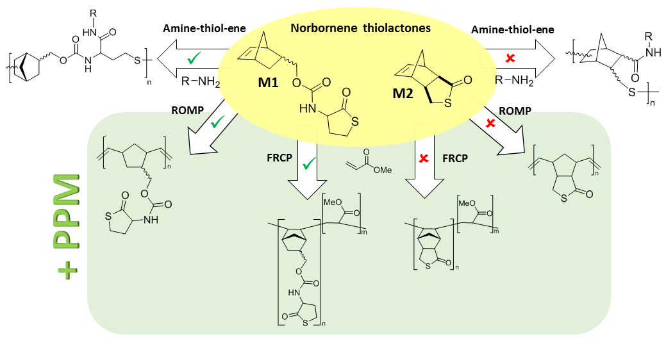

**Figure 1.** Strategies proposed in this study starting from norbornene-thiolactone derivatives (yellow background). Top (white background): Opening of the thiolactone rings via addition of primary amine and subsequent thiol-ene polymerization. Bottom (green background): ROMPandfree radical copolymerization (FRCP), if possible followed by post-polymerization modification (PPM).

1. **Results and Discussion**

For amine-thiol-ene (ATE) and free radical polymerization (FRP) experiments, **M1** derived from pure *exo*-5-norbornene-2-methanol was used (**Scheme 3**) while for ROMP and comparative experiments in amine-thiol-ene polymerization, **M1** based on an *endo/exo* mixture of 5-norbornene-2-methanol was used to reduce costs of the starting materials and to check macroscopic differences of the resulting polymers.

* 1. Amine-thiol-ene polymerization

Thiolactone-based polymers built up using amine-thiol-ene polymerization have extensively been described [18, 24, 26, 27, 32]. The choice of the amine group dominantly influences the physical properties of the polymers, such as the Tg [26, 32], while it also affects molecular weight [32, 33]. Following a generic procedure (*vide infra*), only 5-norbornenemethyl (2-oxotetrahydrothiophen-3-yl) carbamate (**M1**), could successfully be polymerized to result in polymer **P1** (**Scheme 4**). LC-MS revealed that the aminolysis of **M2** does not take place at the chosen conditions (see **Figure S1**).



Scheme 4. Aminolysis and subsequent thiol-ene polymerization of thiolactone-norbornene derivatives M1 and M2 with (i) aminolysis using a primary amine (R-NH2) and (ii) photopolymerization in the presence of 2,2-dimethoxy-2-phenylacetophenone (DMPA).

Calculations reveal a higher electron density in the double bond of **M2** than in norbornene and **M1** (**Figure S1**). This observation is in compliance with the fact that electron-deficient olefins are more reactive in thiol-ene additions and free radical polymerizations [11]**,** while for ROMP, only ring strain is of significance and, thus, no major influence in reaction speed should be observed.

The comparative amine-thiol-ene studies were performed in 1M monomer solution in THF, using 1.1 eq. of the amine. Since most amine-thiol-ene reactions use high amounts of radical initiator for monomers that are less reactive than norbornene [26, 32, 33], 3 mol% of 2,2-dimethoxy-2-phenylacetophenone (DMPA) as photoinitiator was considered as a sufficient quantity. Tg’s were measured by DSC-analysis after one completed heating/cooling cycle.

Table 1. Overview of amine-thiol-ene experiments in THF and chlorobenzene (PhCl). Conditions: Monomer M1, 1M, 1.1 eq. amine (R-NH2) and 3 mol% of DMPA. The results for polymerizations in PhCl were generated after a solvent study (*vide infra*).

|  |  |  |  |  |  |  |
| --- | --- | --- | --- | --- | --- | --- |
| Entry | | Isomer | Amine  (R group) | Mn / Đ (THF)a | Mn / Đ (PhCl)a | *T*g (°C)b |
| 1 | | *exo* | n-Propyl | 4650 / 1.97 | n.pc | 95.0 |
| 2 | | *exo* | n-Butyl | 8000 / 2.05 | 16400 / 2.01 | 87.7 |
| 3 | | *exo* | Hexyl | 3500 / 2.80 | 8300 / 2.34 | 74.0 |
| 4 | | *exo* | Octyl | 7000 / 1.90 | 9800 / 1.60 | 65.6 |
| 5 | | *exo* | C2H4OH | 32600 / 1.91 | 10600 / 2.69 | 66.6 |
| 6 | | *exo* | C3H6OH | 16300 / 2.66 | n.pc | 92.7 |
| 7 | | *endo/exo* | Octyl | 3750 / 1.83 | 5500 / 1.87 | 59.0 |
| 8 | *endo/exo* | | C2H4OH | n.pc | 15400 / 1.25 | 67.8 |

a Measured by SEC in N,N-dimethylacetamide (DMA) using poly(methyl methacrylate) (PMMA) standards.

b *T*g values are given for the experiments performed in THF.

c Experiment not performed.

In case of the pure *exo*-substituted norbornene derivative **M1**, the molecular weights ranged from 4650 to 32600 g·mol-1 (in THF) using n-propylamine and ethanolamine respectively. During all polymerizations, amine compounds bearing hydroxyl groups (ethanolamine and 3-propanolamine) formed a precipitate within a few minutes of irradiation, while all other polymers stayed in solution. This can be explained by a strong hydrogen bond interaction of those specific polymers. Because of the precipitation, polymerization experiments with ethanolamine and propanolamine were not further investigated. Independent of the solvent, volatile amine derivatives, such as n-propylamine gave irreproducible results with average molecular weights ranging between 1000 and 8600 g/mol. After a solvent study (v*ide infra*), syntheses optimized for molecular weight were performed in chlorobenzene (PhCl) and the results are displayed in **Table 1**.

The results showed that for the *endo/exo* mixture of **M1**, the molecular weights, in general, were slightly lower than those obtained for the pure *exo*-**M1**. A possible explanation might be the substituent position on the norbornene moiety of the molecule, which potentially increases steric hindrance of the double bond. A decreased reactivity of norbornene derivatives with polar endo-substituents has been reported in literature [34], however, this behavior is related to a different polymerization mechanism and is not applicable in this case.

The Tg-values (see **Table 1** and **Figure S2**) of **P1** fluctuate between 59 °C (n-octylamine) and 95 °C (ethanolamine), which is a significant increase in comparison to other thiolactone-based polymers [26, 32]. On the other hand, the unusual integration of the norbornene moiety into the backbone, which happens on the 2,5- or 2,6- position (**Scheme 4**), and a rather large linear segment between the norbornyl units prevent *T*g-values higher than 200 °C, as reported in literature for some norbornene-derived polymers [1, 5].

Next, a solvent study was conducted, using 0.5 and 1M solutions in various solvents and 1.1 eq. n-octylamine. To increase the theoretical molecular weight and, thus, enhance the influence of the solvent, 1 mol% DMPA photoinitiator was chosen (**Table 2**).

**Table 2.** Polymerization of **M1**in different solvents with different polarity [35].

|  |  |  |  |  |  |
| --- | --- | --- | --- | --- | --- |
| Isomer | Solvent | Electric dipole (10-30 Cm) | Concentration (mol·L-1) | Mna | Đa |
| *exo* | THF | 5.84 | 1 | 7000 | 1.90 |
| *exo* |  |  | 0.5 | 3250 | 1.58 |
| *exo* | DMF | 12.67 | 1 | 1950 | 1.24 |
| *exo* |  |  | 0.5 | 1750 | 1.25 |
| *exo* | 1,4-Dioxane | 1.33 | 1 | 2500 | 1.35 |
| *exo* |  |  | 0.5 | 3900 | 3.54 |
| *exo* | Acetonitrile | 10.67 | 1 | 1350 | 1.23 |
| *exo* |  |  | 0.5 | 8700 | 1.60 |
| *endo/exo* | *o*-Dichlorobenzene | 7.14 | 1 | 4600 | 1.88 |
| *exo* | PhCl | 4.33 | 1 | 9800 | 1.60 |
| *endo/exo* |  |  | 1 | 5500 | 1.87 |
| *endo/exo* |  |  | 1.5 | 5300 | 1.82 |
| *endo/exo* |  |  | 2 | 6800 | 2.02 |

a Measured by SEC in DMA using PMMA standards.

The analyses showed that solvents with a medium polarity result in higher molecular weights under given conditions. Since both monomer and polymer are soluble in all investigated solvents except acetonitrile, the influence can be described to the solvation of the reactive species during the reaction, in which less polar solvent molecules favor a homolytic cleavage of the S-H bond. As mentioned before, slightly higher molecular weights can be observed when using the pure *exo*-derivative of **M1**.

* 1. Free radical copolymerization

The copolymerization of norbornene (and derivatives) with acrylates has been reported multiple times in literature [4, 36]. Thus, free radical copolymerization (FRCP) of **M1** and **M2** with methyl acrylate (MA) was conducted with four different ratios of norbornene derivative and comonomer (0, 50, 75, 100% of methyl acrylate) (**Table 3**)**.** While the copolymerizations of **M1** resulted in polymers, homopolymerizations of both norbornene thiolactone monomers as well as the copolymerization of **M2** were not successful (**Scheme 5**)**.**



**Scheme 5.** Radical copolymerization of norbornene-thiolactone derivatives with methyl acrylate.

As reported in the literature, radical polymerization of norbornene is possible, but requires long reaction times, high (bulk) monomer concentrations, and is low yielding [36]. Additionally, the radical mechanism involves an intramolecular rearrangement, which results in a different polymer structure (**Scheme 6**) [37].



**Scheme 6.** Radical rearrangement of norbornene during homopolymerization [37].

In copolymerizations, the rearrangement usually is suppressed by the higher reaction rate of the comonomer and regular 1,2-insertion of the norbornene moiety occurs. In the present case, a lower reactivity – in comparison to the comonomer methyl acrylate – can be observed with the formation of lower molecular weight polymers, while the incorporation of norbornene moieties into the polymer immediately results in a notable increase of *T*g (**Table 3 and Figure S3**). The slightly higher molecular weight of the methyl acrylate/norbornene copolymer most likely derives from the more rigid polymer backbone. A possible explanation for the difference in results for the copolymerizations using 50% *exo*- and *endo/exo*-M1 is a different monomer ratio in the polymers, which would suggest a decreased reactivity of the *endo* isomer. The only plausible reason for this is a steric effect, since no difference in structure or electron density of the norbornene moiety alone could be observed.

**Table 3.** Results of free radical polymerizations of **M1** and methyl acrylate, using 1 mol% of 2,2-azobis(2-methylpropionitrile) (AIBN), in butyl acetate at 80 °C for 3h.

|  |  |  |  |  |
| --- | --- | --- | --- | --- |
| Amount MA | Comonomer | Mna | Đa | *T*g (°C) |
| 50% | M1 (*exo*) | 5000 | 1.34 | 75.3 |
| 50% | M1 (*endo*/*exo*) | 5800 | 1.75 | 53.9 |
| 50% | Norbornene | 12600 | 1.90 | 26.7 |
| 75% | M1 | 7050 | 1.73 | 36.8 |
| 0% | Norbornene | - | - | - |
| 100% | - | 10400 | 1.90 | ≥ 15 |

a Measured by SEC using DMA as eluent and PMMA standards.

* 1. Ring-opening metathesis polymerization

The incorporation of functional handles into ROMP derived norbornene polymers provides the opportunity to perform a convenient post-polymerization modification and, thus, opens a door for new, robust hybrid materials [38].

Five ROMP-reactions, *i.e*. three homopolymerizations of the available monomers (*i.e.* norbornene (**nb**), **M1** and **M2**) and two **nb**/**M1** and **nb**/**M2** thiolactone copolymerizations, were performed in DCM, using 0.1 mol% of a third generation Grubbs catalyst (**Scheme 7**)**.**



**Scheme 7.** ROMP of different norbornene-thiolactone derivatives, using dichloro[1,3-bis(2,4,6-trimethylphenyl)-2-imidazolidinylidene](benzylidene)bis(3-bromopyridine)ruthenium(II) as Grubbs catalyst.

Polymerizations involving **M1** were successful with masses up to 600 kDa, while homo- and copolymerization of **M2** only resulted in low molecular weight polymers, which could not be precipitated. A possible suggestion for this, is a coordination of the thiolactone to the metal center of the catalyst, influencing its reactivity, as well as a reduced reactivity *per se*, as seen in experiments with similar compounds [39]. Similar behavior for polar coordinating groups could be observed in other studies [40]. The incorporation of **M1** into the ROMP polymers could be proven with post-polymerization modification (PPM) using n-octylamine and benzyl acrylate as model reaction, resulting in an increase of molecular weight (see **Table 4**, entry 3a and 5a). While n-octylamine triggers the release of a thiol group *via* ring-opening of the thiolactone group, benzyl acrylate is involved in a subsequent thiol-click reaction [12].

**Table 4.** Results of ROMP polymerizations, performed in DCM at room temperature, using 0.1 mol% of generation III Grubbs catalyst. Post-polymerization modification was performed using n-octylamine and benzyl acrylate.

|  |  |  |  |  |
| --- | --- | --- | --- | --- |
| Entry | (Co)monomer | Mna | Đa | *T*g (°C) |
| 1 | nb | 221000 | 1.39 | 139.1 |
| 2 | M2 | - | - | - |
| 3 | M1 | 455400 | 1.22 | 100.7 |
| 3a | M1 and PPMb | 544000 | 1.25 | n.pc |
| 4 | M2 / nb (1:1) | - | - | - |
| 5 | M1 / nb (1:1) | 505000 | 1.31 | 108.2 |
| 5a | M1 / nb and PPMb | 611700 | 1.46 | n.pc |

a Measured by SEC in THF using polystyrene standards

b Results obtained after post-polymerization modification

c Measurement not performed

**M1**-based polymers revealed a two-step degradation in thermo-gravimetric analysis, while pure poly(norbornene) and **M2**-based (co)polymers showed only one distinct degradation. Indeed, the urethane sidechain of **M1** first degrades at temperatures higher than 300 °C, while the rigid poly(divinylidenecyclopentane) backbone only fragments at higher temperatures (T > 400 °C) (**Figure 2**). The weight progression of poly(norbornene) and poly(**M1**) appears abnormal, starting with an initial reproducible and non-understood weight increase.

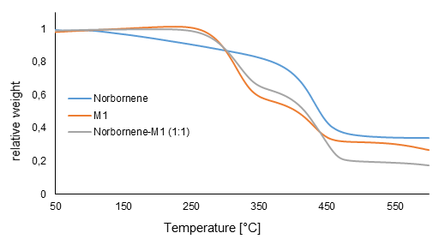

**Figure 2.** TGA curves of polymers obtained from ROMP.

DSC analysis revealed a *T*g of 139 °C for norbornene homopolymer, while (co)polymers based on **M1** showed lower *T*g values. The difference of measured Tg and cited value (35 °C with 90% trans double bonds) [41] for the poly(norbornene) can be ascribed to different masses, as well as to the polymer structure: while the reported homopolymer has a molecular weight of 221000 g/mol and has been synthesized using a rather expensive Grubbs III catalyst, commercial polymers are produced in different conditions and with a higher molecular weight. Catalysts directly influence the cis/trans ratio of double bonds in the backbone, which, besides the molecular weight and the dispersity of the polymer, has a direct impact on the glass transition temperature. Nonetheless, poly(**M1**) showed a Tg-value slightly above 100 °C, which increased when **M1** was copolymerized with norbornene (**Figure S4**).

1. **Conclusion**

Two monomers containing both a norbornene and a thiolactone functionality were successful synthesized and their reactivity was compared using different polymerization techniques. The potential of the two monomers for amine-thiol-ene polymerization was evaluated using different amines, solvents and initiator concentrations in order to screen their influence on the molecular weight and Tg. Free radical (co-)polymerization and ring-opening metathesis polymerization were then tested and the obtained polymers were submitted to post-polymerization modification. The results showed that only **M1** leads to polymer formation under the tested conditions. In conclusion, the combination of norbornene and thiolactone chemistry allows for the formation of a wide, novel set of norbornene-derived polymers, which can be functionalized according to the needs of envisaged applications.

1. **Experimental Section**
   1. General information
      1. Chemicals

5-Norbornene-2-methanol(98%, *endo/exo* mixture), dibutyltin dilaurate (DBTL) and triphosgene were purchased from TCI. Amines (98% purity or higher), HPLC grade reaction solvents and all other chemicals were purchased from Sigma-Aldrich and used as received, unless mentioned otherwise. Solvents and pyridine (HPLC grade) for compound synthesis were dried over calcium hydride prior to use.

* + 1. Characterization techniques

**Thermal analyses** were performed using a Mettler Toledo TGA SDTA851 system. Measurements were performed under nitrogen atmosphere in a temperature range from 25 to 800 °C with a heating rate of 10 °C/min. DSC measurements were performed using a Mettler Toledo DSC1 Star system. Measurements were performed under nitrogen atmosphere in a temperature range from -80 to +140 °C with a heating rate of 10 °C/min. For Tg determination, only the second heating cycle was used.

**Nuclear magnetic resonance spectroscopy (NMR).** NMR spectra were recorded in CDCl3 on a Bruker Avance 300 (300 MHz). Chemical shifts are presented in parts per million (δ), relative to CDCl3 as the internal standard.

**Size exclusion chromatography (SEC).** Molecular weights and molecular weight distributions of polymers derived from radical polymerizations (FRP, Amine-Thiol-Ene) were determined using SEC performed on a Waters Instrument with an RI detector (2414 Waters), equipped with three Polymer Standards Services GPC serial columns (1 X GRAM Analytical 30 Å, 10 µm and 2 X GRAM Analytical 1000 Å, 10 µm) at 40 °C. PMMA standards were used and measurements were conducted using DMA containing 5 g·L-1 lithium bromideat a flow rate of 1mL·min-1. Molecular weights were derived in third order. ROMP polymers were analyzed using a Varian PL-GPC 50 plus instrument, using a refractive index detector, equipped with two Plgel 5 mm MIXED-D columns at 25 °C. Polystyrene standards were used for calibration. THF was used as eluent at a flow rate of 1mL·min-1. Samples were injected using a PL-AS RT autosampler.

**FT-ATR-IR spectra** were recorded on a Perkin-Elmer Spectrum1000 FTIP infrared spectrometer with pike-HATR module.

* 1. Synthesis of thiolactone derivatives
     1. Synthesis of thiolactone isocyanate

Thiolactone isocyanate was synthesized following a known procedure [18]: Briefly, triphosgene (25 g, 84 mmol) was dissolved in ice-cooled dry dichloromethane (250 mL) and stirred for 15 minutes. Subsequently, 200 mL DCM and DL-homocysteine thiolactone hydrochloride (37 g, 241 mmol) were gently added. Next, dry pyridine (64.11 ml, 794 mmol) was added dropwise to the reaction mixture. After one hour the reaction mixture was allowed to reach room temperature and was stopped after five hours. The reaction mixture was directly filtered in a separation funnel to remove the salts formed during the reaction. The organic phase was washed with 2N HCl solution (250 mL), ice water (250 mL) and brine (250 mL). Subsequently, this phase was collected in a beaker with magnesium sulfate to remove residual water. After filtration and evaporation of the solvent, a brown residue was obtained. The crude product was purified by vacuum distillation, yielding a xanthic oil (87%).

* + 1. Synthesis of 5-norbornene-2-methyl (homocysteine thiolactone) carbamate monomer (**M1**)

***Exo*-M1.** The synthesis was adapted from literature [15]: *Exo*-5-norbornene-2-methanol was dried for 4 h under high vacuum prior to use. 4.04 g exo-norbornene methanol (34.6 mmol, 1.0 eq.) was dissolved in 10 mL dry ethyl acetate in a Schlenk flask equipped with a septum and a stir bar. Thiolactone isocyanate (5.00 g, 35.5 mmol, 1.02 eq.) and 50 µL dibutyltin dilaurate (DBTL) were added via cannula and the reaction mixture was stirred at room temperature. After 1 hour, the temperature was raised to 60 °C. The progress of the reaction was monitored using TLC. After reaction completion, the reaction mixture was cooled down to room temperature and the crude product was purified using column chromatography (hexane / ethyl acetate 1:1). Yield: 88% of a colorless oil, which crystallized overnight. The product was kept in the freezer under argon atmosphere. 1H NMR (300 MHz, CDCl3) (**Figure S5**): δ (ppm) = 6.10 (m, 2 H, *H*C=C*H*), 5.25 (bs, 1 H, NH), 4.40 – 4.28 (m, 1H, NHC*H*), 4.18 (ddd, 1 H, CO2C*H*2, 10.5, 6.6, 3.9 Hz), 4.00 (ddd, 1 H, CO2C*H*2, 14.4, 9.3, 5.1 Hz), 3.42 – 3.22 (m, 2 H, SC*H2*), 2.97 – 2.86 (m, 1 H, OCH2C*H*), 2.85 (s, 1 H, C*t*H), 2.72 (s, 1 H, C*t*H), 2.02 (ddd, 1 H, SCH2CH2, 24.6, 12.3, 6.9 Hz), 1.79 – 1.66 (m, 1 H, SCH2CH2), 1.41 – 1.23 (m, 3 H, nb), 1.17 (dt, 1 H, nb, 11.7, 3.9 Hz). IR (cm-1) = 3298, 1703, 1686, 1542, 1302, 1246, 1050, 912, 778, 724, 712 (see **Figure S6**); HRMS: calc.: 267.0929; found: 268.0997 (Δ = 1.8 ppm)

**(*Endo/exo*)-M1.** The same procedure was applied for the synthesis of (*endo/exo*) mixture of **M1**, yielding in a colorless liquid that solidified overnight (Yield: 90.4%).

* + 1. Synthesis of monomer 2 (**M2**)

3-Thiolen-2-one was synthesized according to [42] from 65.2 g 2-bromothiophene (0.4 mol, 38.4 mL, 1.25 eq.) and 10 g magnesium in 200 mL dry ether under inert gas atmosphere in a 1 L round bottom flask. The resulted Grignard solution was treated with *tert*-butyl perbenzoate (62 g, 56 mL, 0.32 mol, 1.0 eq.), worked up with concentrated hydrochloric acid, dried and distilled. The 2-thiophene *tert*-butyl ether was treated with 0.1 g *p*-toluenesulfonic acid and heated to give a yellow oil (16.5 g, 0.165 mol, 67%), which was subsequently used to synthesize M2, using 110 mL toluene, 10.2 mL (11.7 g, 0.082 mol) boron trifluoride ether adduct and 27.3 g (34.7 mL, 0.413 mol, 2.5 eq.) freshly distilled cyclopentadiene. Yield: 63% of a sticky white solid.

* 1. General polymerization procedures
     1. ROMP of norbornene

Norbornene (0.45 mmol, 1.0 eq.) was introduced in a vial equipped with a stirring bar, sealed with a septum and flushed with argon. 1 mL of degassed DCM was introduced to the vial with a degassed syringe. A degassed solution of generation III Grubbs catalyst (1.1·10-3 mmol, 2.5·10-3 eq.) in 0.5 mL of DCM was added rapidly *via* the septum and the solution was stirred vigorously. After 30 min., an excess of ethyl vinyl ether (2 mmol, 4.4 eq.) was introduced to quench the reaction. Afterwards, the polymer is precipitated in methanol, filtered and dried under vacuum at 40 °C.

* + 1. Amine-thiol-ene polymerization

For amine-thiol-ene polymerizations, the monomer(s) (1 mmol) and photoinitiator (1 or 3 mol% respectively) were weighed in test tubes, equipped with a stir bar, sealed and flushed with argon for 10 min. The solvent, which was degassed separately, was added with a syringe and the monomer was allowed to dissolve. The amine was pointedly added to the reaction mixture. After 30 min. of stirring, the reaction mixture was placed in a UV photoreactor (9 X Philips Actinic BL PL-S 9W/10/2p UV-A light bulbs) and irradiated for 30min. The reaction was stopped after 30 minutes by removing the energy source and aeration of the reaction mixture. The polymers were precipitated in 35 mL cold methanol and dried under vacuum at 40 °C for several days.

* + 1. Free radical (co)polymerization

1 mmol norbornene thiolactone monomer (and appropriate amounts of comonomer) were placed in a Schlenk vial. Butyl acetate and AIBN (1 mol% in total) were added to result in a 1N reaction solution. After three freeze-pump-thaw cycles, the Schlenk vial was placed in an oil bath at 80 °C. After stirring for 3h, the reaction was stopped by exposure to air and cooled down to room temperature. The polymers were precipitated in cold methanol (20-fold excess).

* 1. General procedure for the post-polymerization modification

A few milligrams of polymer were dissolved in 1 mL THF. Two drops of n-octylamine and two drops of benzyl acrylate were added and the reaction was stirred overnight at room temperature. In case of ROMP derived polymers, the reaction solutions were immediately used and subjected to SEC analysis. For polymers synthesized by free radical polymerization, the solvent was evaporated and the residue was dissolved in DMA for SEC analysis.

**Acknowledgements:**

The research leading to these results has received funding from the People Program (Marie Curie Actions) of the European Union’s Seventh Framework Program (FP7/2007-2013) under REA grant agreement n˚ 607882. The authors thank Laetitia Vlaminck for her scientific advice and molecular modeling.

**References**

[1] Dorkenoo KD, Pfromm PH, Rezac ME. Gas transport properties of a series of high Tg polynorbornenes with aliphatic pendant groups. J Polym Sci, Part B: Polym Phys. 1998;36:797-803.

[2] Zhuang R, Liu H, Guo J, Dong B, Zhao W, Hu Y, et al. Highly active nickel(II) and palladium(II) complexes bearing N,N,P tridentate ligand for vinyl addition polymerization of norbornene. European Polymer Journal. 2017;93:358-67.

[3] Li Y, Gao M, Gao H, Wu Q. Synthesis and structural characterization of ethylene–norbornene copolymer with high norbornene content catalyzed by β-diketiminato nickel/methylaluminoxane. European Polymer Journal. 2011;47:1964-9.

[4] Houlihan FM, Wallow TI, Nalamasu O, Reichmanis E. Synthesis of Cycloolefin−Maleic Anhydride Alternating Copolymers for 193 nm Imaging. Macromolecules. 1997;30:6517-24.

[5] Tetsuka H, Isobe K, Hagiwara M. Synthesis and Properties of Addition-Type Poly(norbornene)s with Siloxane Substituents. Polym J. 2009;41:643-9.

[6] Stamenović MM, Espeel P, Camp WV, Du Prez FE. Norbornenyl-Based RAFT Agents for the Preparation of Functional Polymers via Thiol–Ene Chemistry. Macromolecules. 2011;44:5619-30.

[7] Radzinski SC, Foster JC, Chapleski RC, Troya D, Matson JB. Bottlebrush Polymer Synthesis by Ring-Opening Metathesis Polymerization: The Significance of the Anchor Group. J Am Chem Soc. 2016;138:6998-7004.

[8] Liaw D-J, Huang C-C, Hong S-M. Novel doubly polymerizable functional norbornene: Its synthesis, reactivity, and macromolecular architectures from a dual cure via ring-opening metathesis polymerization and radical photopolymerization. Journal of Polymer Science Part A: Polymer Chemistry. 2006;44:6287-98.

[9] Rahman MA, Lokupitiya HN, Ganewatta MS, Yuan L, Stefik M, Tang CB. Designing Block Copolymer Architectures toward Tough Bioplastics from Natural Rosin. Macromolecules. 2017;50:2069-77.

[10] Conrad RM, Grubbs RH. Tunable, Temperature-Responsive Polynorbornenes with Side Chains Based on an Elastin Peptide Sequence. Angewandte Chemie International Edition. 2009;48:8328-30.

[11] Nguyen L-TT, Gokmen MT, Du Prez FE. Kinetic comparison of 13 homogeneous thiol–X reactions. Polym Chem. 2013;4:5527-36.

[12] Espeel P, Du Prez FE. One-pot multi-step reactions based on thiolactone chemistry: A powerful synthetic tool in polymer science. Eur Polym J. 2015;62:247-72.

[13] Goethals F, Frank D, Du Prez F. Protected thiol strategies in macromolecular design. Progress in Polymer Science. 2017;64:76-113.

[14] Le Neindre M, Nicolaÿ R. One-pot deprotection and functionalization of polythiol copolymers via six different thiol–X reactions. Polymer International. 2014;63:887-93.

[15] Espeel P, Goethals F, Du Prez FE. One-pot multistep reactions based on thiolactones: extending the realm of thiol-ene chemistry in polymer synthesis. J Am Chem Soc. 2011;133:1678-81.

[16] Reinicke S, Espeel P, Stamenović MM, Du Prez FE. One-Pot Double Modification of p(NIPAAm): A Tool for Designing Tailor-Made Multiresponsive Polymers. ACS Macro Letters. 2013;2:539-43.

[17] Frank D, Espeel P, Claessens S, Mes E, Du Prez FE. Synthesis of thiolactone building blocks as potential precursors for sustainable functional materials. Tetrahedron. 2016;72:6616-25.

[18] Martens S, Van den Begin J, Madder A, Du Prez FE, Espeel P. Automated Synthesis of Monodisperse Oligomers, Featuring Sequence Control and Tailored Functionalization. J Am Chem Soc. 2016;138:14182-5.

[19] Espeel P, Carrette LLG, Bury K, Capenberghs S, Martins JC, Du Prez FE, et al. Multifunctionalized Sequence-Defined Oligomers from a Single Building Block. Angew Chem Int Ed. 2013;52:13261-4.

[20] Driessen F, Martens S, De Meyer B, Du Prez FE, Espeel P. From One-Pot Double Modification to Polymer-polymer Conjugation: Tailoring the End Groups for Functional Polymer Design. Macromolecular rapid communications. 2016;37:947-51.

[21] Driessen F, Herckens R, Espeel P, Du Prez FE. Thiolactone chemistry and copper-mediated CRP for the development of well-defined amphiphilic dispersing agents. Polym Chem. 2016;7:1632-41.

[22] Zhang Z, Tan Z-B, Hong C-Y, Wu D-C, You Y-Z. One-pot sequential multicomponent reaction and a multicomponent polymerization method for the synthesis of topologically different polymers. Polymer Chemistry. 2016;7:1468-74.

[23] Stamenović MM, Espeel P, Baba E, Yamamoto T, Tezuka Y, Du Prez FE. Straightforward synthesis of functionalized cyclic polymers in high yield via RAFT and thiolactone–disulfide chemistry. Polym Chem. 2013;4:184-93.

[24] Belbekhouche S, Reinicke S, Espeel P, Du Prez FE, Eloy P, Dupont-Gillain C, et al. Polythiolactone-Based Redox-Responsive Layers for the Reversible Release of Functional Molecules. ACS Appl Mater Interfaces. 2014;6:22457-66.

[25] Kaya NU, Du Prez FE, Badi N. Multifunctional Dendrimer Formation Using Thiolactone Chemistry. Macromol Chem Phys. 2017;218:1600575.

[26] Resetco C, Frank D, Dikić T, Claessens S, Verbrugge T, Du Prez FE. Thiolactone-based polymers for formaldehyde scavenging coatings. Eur Polym J. 2016;82:166-74.

[27] Resetco C, Frank D, Kaya NU, Badi N, Du Prez F. Precisely Alternating Functionalized Polyampholytes Prepared in a Single Pot from Sustainable Thiolactone Building Blocks. ACS Macro Letters. 2017;6:277-80.

[28] Zhao Y, Yang B, Zhang Y, Wang S, Fu C, Wei Y, et al. Fluorescent PEGylation agent by a thiolactone-based one-pot reaction: a new strategy for theranostic combinations. Polymer Chemistry. 2014;5:6656-61.

[29] Mommer S, Truong K-N, Keul H, Moller M. An epoxy thiolactone on stage: four component reactions, synthesis of poly(thioether urethane)s and the respective hydrogels. Polym Chem. 2016;7:2291-8.

[30] Hawkins RT. Thienyl methacrylates. J Heterocycl Chem. 1974;11:291-4.

[31] Dowd P, Weber W. 3-Thiolen-2-one. A useful dienophile. J Org Chem. 1982;47:4777-9.

[32] Goethals F, Martens S, Espeel P, van den Berg O, Du Prez FE. Diversely Substituted Polyamide Structures through Thiol–Ene Polymerization of Renewable Thiolactone Building Blocks. Macromolecules. 2014;47:61-9.

[33] Espeel P, Goethals F, Driessen F, Nguyen L-TT, Du Prez FE. One-pot, additive-free preparation of functionalized polyurethanes via amine-thiol-ene conjugation. Polym Chem. 2013;4:2449-56.

[34] Commarieu B, Claverie JP. Bypassing the lack of reactivity of endo-substituted norbornenes with the catalytic rectification-insertion mechanism. Chem Sci. 2015;6:2172-81.

[35] Smallwood IM. Handbook of organic solvent properties. London - Sydney - Auckland: Arnold; 1996.

[36] Elyashiv-Barad S, Greinert N, Sen A. Copolymerization of Methyl Acrylate with Norbornene Derivatives by Atom Transfer Radical Polymerization. Macromolecules. 2002;35:7521-6.

[37] Gaylord NG. Temperature and Dilution Effects in Polymerization Induced by Peroxides Undergoing Rapid Decomposition (t1/2 <60 Minutes). Initiation of Polymerization: AMERICAN CHEMICAL SOCIETY; 1983. p. 449-57.

[38] Öztürk BÖ, Yakut E, Ak E, Şehitoğlu SK. Imidazole-substituted ROMP polymers: Post-modification of poly(norbornenediester) derivatives with aminolysis reactions. Reactive and Functional Polymers. 2017;111:22-9.

[39] Morbelli L, Eder E, Preishuber-Pflügl P, Stelzer F. Copolymerizations between cyclic olefins and norbornene lactone. Journal of Molecular Catalysis A: Chemical. 2000;160:45-51.

[40] Contreras AP, Cerda AM, Tlenkopatchev MA. Synthesis of high-Tg polymers by ring-opening metathesis polymerization of N-cycloalkylnorbornene dicarboximide. Macromolecular Chemistry and Physics. 2002;203:1811-8.

[41] Madan R, Srivastava A, Anand RC, Varma IK. Polymers derived from bicylo[2.2.1]heptene and its derivatives. Progress in Polymer Science. 1998;23:621-63.

[42] Frisell C, Lawesson SO. 2-Hydroxythiophene. Organic Syntheses: John Wiley & Sons, Inc.; 2003.

**Table of contents**

**Structurally diverse polymers from norbornene and thiolactone containing building blocks**

Norbornene-containing polymers have been prepared using thiolactone chemistry with two thiolactone monomers with differently substituted norbornene moieties. The reactivity of the novel building blocks have been compared using three different polymerization strategies.

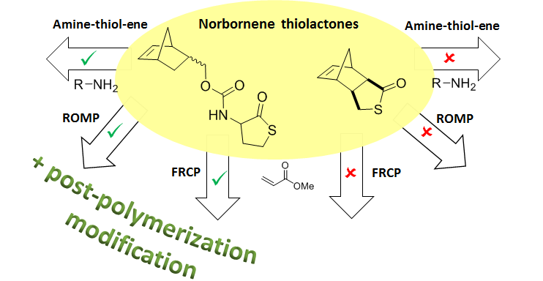

**Supporting information**

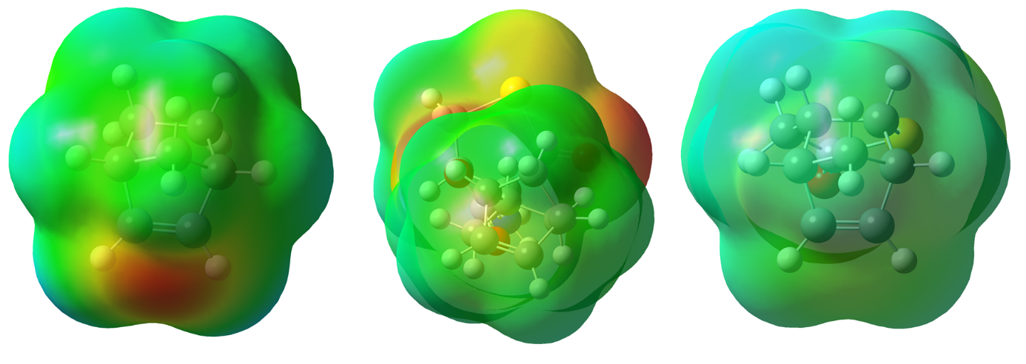

**Figure S1.** From left to right: electron densities of norbornene, **M1** and **M2**, calculated with Gaussian (v6.1). The double bonds are brought to the foreground.



**Figure S2.** DSC curves, showing glass transition temperatures of different P1 derivatives obtained by ATE using various amines (entry 1 to 7 on **Table 1**).



**Figure S3.** DSC curves of polymers derived from free radical (co)polymerization, using different amounts of methyl acrylate (MA) as comonomer (see **Table 3**).



**Figure S4.** DSC curves of poly(norbornene) and (co)polymers based on **M1** synthesized via ROMP.

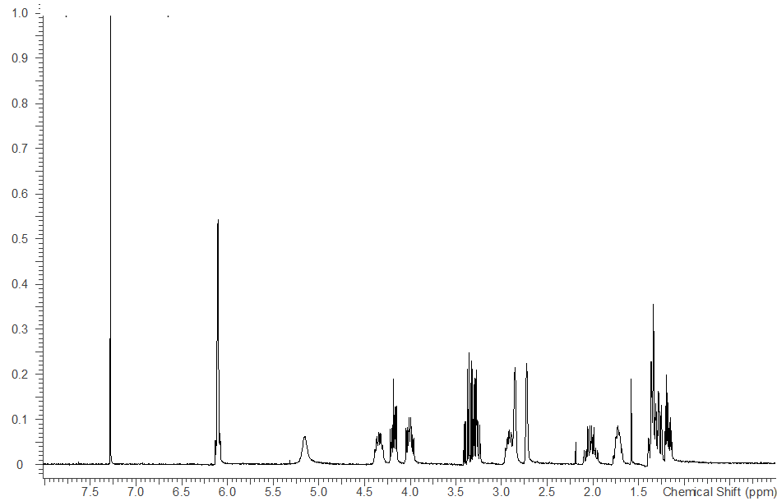

**Figure S5.** 1H-NMR in CDCl3 of5-norbornenemethyl (2-oxotetrahydrothiophen-3-yl) carbamate **(M1).**

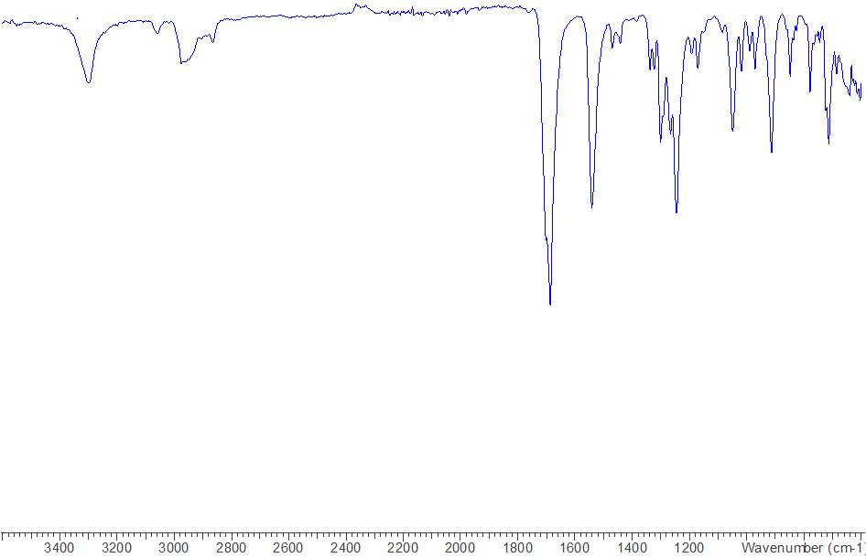

**Figure S6.** IR spectrumof5-norbornenemethyl (2-oxotetrahydrothiophen-3-yl) carbamate **(M1).**



**Figure S7.** LC-MS elugramof5-norbornenemethyl (2-oxotetrahydrothiophen-3-yl) carbamate **(M1).** The mass detectedfor the peak at 6.02 min. is 268.1 (M+1).