Thermoresponsive hyperbranched glycopolymers: synthesis, characterization and lectin interaction studies
  - Stef Vandewalle,ª Sofie Wallyn,ª Subrata Chattopadhyay,ª C. Remzi Becer,^{b,*} Filip Du Prez ^{a,*}
a Polymer Chemistry Research Group, Department of Organic and Macromolecular Chemistry, Ghent University, Krijgslaan 281, S4, 9000 Ghent, Belgium.
b School of Engineering and Materials Science, Queen Mary University of London, Mile End Road, E1 4NS, London, United Kingdom
Correspondence: filip.duprez@ugent.be and r.becer@qmul.ac.uk

Keywords: Hyperbranched glycopolymers, thermoresponsive glycopolymers, lectin-polymer interactions, Cu(0) mediated controlled radical polymerization.

Abstract: Preparation of stimuliresponsive hyperbranched glycopolymers that are able to simultaneously enhance and control the lectin-polymer interaction has been challenging. Hyperbranched glycopolymers have been prepared in which thermo-responsive Poly(N-isopropylacrylamide) [poly(NIPAM)], connected by redox-responsive disulfide bonds, forms the skeleton and for which mannose units are present at each branching point. Degradation of the hyperbranched structure via chemical reduction of the disulfide bond was demonstrated. Moreover, the thermoresponsive behaviour of the glycopolymer was studied. Finally, the lectin-polymer interaction was investigated to understand the influence of both the polymer concentration and different chain conformations below and above cloud point, respectively.
1. Introduction
Synthetic glycopolymers have attracted great interest as an alternative or mimics of naturally occurring biopolymers due to their multivalency and recognition properties^{1,2}. The latter depends largely on the accessibility of sugar units in the polymer backbone. The properties and application can be tuned by preparing suitable sugar containing polymers. Two major approaches to synthesize glycopolymers can be distinguished: (i) The first approach starts from the polymerization of suitable glycomonomers. For example, Stenzel et al. reported the synthesis of glycomonomers, followed by the preparation of polymers via RAFT polymerization³. Haddleton et al. reported the synthesis of sugar methacrylate monomers by CuAAC click reactions. A series of glycopolymers were prepared via atom transfer radical polymerization (ATRP) using these monomers⁴. (ii) The second approach relies on a post-polymerization modification. In this approach, suitable functional polymers were prepared using different polymerization techniques. In the subsequent steps clickable, sugar units were reacted with the polymer backbone, via various click reactions. In one of the first examples, Haddleton et al. reported the preparation of polymers containing reactive propargyl units by ATRP. The propargyl groups act as a clickable scaffold to introduce a variety of sugar units resulting in the generation of a library of polymers⁴. Another interesting example was demonstrated by Zi-Chen et al. on the preparation of biodegradable block copolymers of poly(caprolactone) and poly (bromo caprolactone) by ring opening polymerization. In the subsequent step, bromine groups were replaced by azide groups, which acted as a scaffold to introduce sugar units, and thus to obtain the final biodegradable glycopolymers⁵. In a recent article published by our group we reported the synthesis of glycopolymer nanoparticles. Sugar units were introduced by a post polymer modification approach using thiolactone rings as a scaffold to generate thiol groups that acted as a suitable nucleophile to introduce the sugar units⁶.
Besides knowledge about the synthesis, understanding the lectin-polymer interactions is crucial from the application point of view. Glycopolymers exhibit specific interactions with lectins and proteins, which were observed to be stronger than that from single carbohydrate molecules due to the ‘glycocluster effect’⁷. In different biological applications these polymers play important role as either inhibitors or effectors depending on their mechanism of interactions; i.e., steric stabilization, chelating effect, and statistical rebinding etc^{8a, 8b}. The binding rate of the polymers depends on several parameters: the density of sugar units, the type of the sugar units and the shape of the glycopolymers^{9a, 9b}. Extensive reports have already been published on this topic in the last decade, highlighting the synthesis of different glycopolymers with variety of shapes, composition etc. and the influence of the different parameters on the binding capacities with lectins and proteins^{10, 11}. At this stage, it is indispensible to continue the preparation of novel series of responsive glycopolymers with the aim to (i) maximise their interaction with lectins by controlling the shape of the polymer and (ii) understand the possibility of controlling the polymer-lectin interactions by making use of external stimuli. This kind of studies will definitely help to improve the performance of polymer based delivery systems^{12a, 12b}.
In the current work, we report on the synthetic strategy to prepare thermoresponsive hyperbranched glycopolymers, in which the mannose units are present in each branching point and the skeleton is based on poly(NIPAM) (Figure 1).

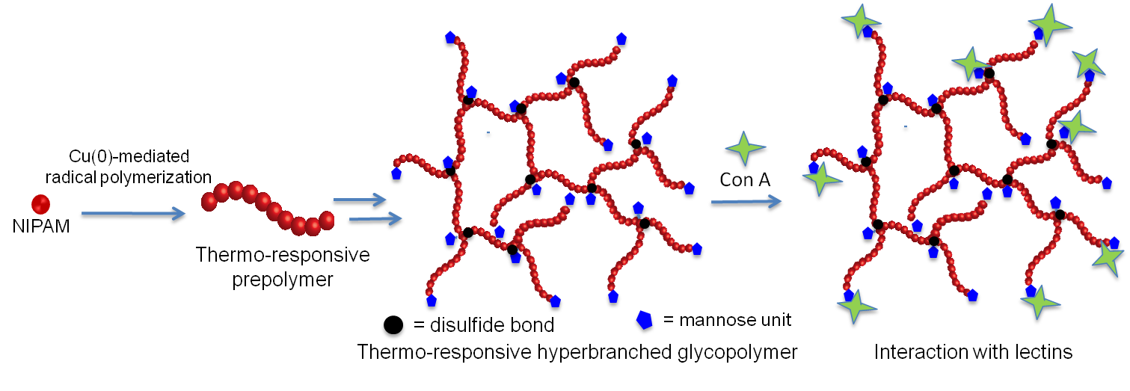
Figure 1: Synthetic strategy to prepare hyperbranched glycopolymers, containing mannose units at each branching point.

The thermoresponsive behaviour is related to the poly(NIPAM) skeleton¹³ while mannose was chosen as sugar unit because of its specific binding ability with lectin ConA ¹⁴. One can expect that such hyperbranched polymers will have enhanced interactions with lectins, despite the presence of a low number of sugar units in the polymer backbone, because the mannose moieties, situated at each branching point, should be more available for cluster formation, compared to linear analogues. Furthermore, as a result of the thermoresponsive behaviour of these kind of polymers, different conformations of the polymers below and above the cloud point temperature should influence the lectin-polymer interaction¹⁵.

2. Experimental section
Materials
Ethanol (95%; Chem-Labs), diethyl ether (≥ 99.8%; Aldrich), n-toluene (99.9%; Aldrich), n-hexane (98%; Aldrich); methanol (≥ 99%; Chem-labs), N,N-dimethylformamide (DMF) (≥ 99%; Acros), tetrahydrofuran (THF) (≥ 99.9%; Aldrich), dimethylsulfoxide (DMSO) (≥ 99.9%; Aldrich), ethyl acetate (≥ 99.8%; Aldrich), dichloromethane (DCM) (≥ 99.8%; Aldrich), N,N-dimethylacetamide (DMA) (99%; Aldrich), acetic acid (≥ 99.8%; Acros), citric acid (≥ 99.5%; Aldrich), sodium trifluoroacetic acid (NaTFA) (98%; Aldrich), K₂CO₃ (≥ 99%; Roth), MgSO₄ (pure; Boom), triethyl amine (Et₃N) (99%; Acros), phenothiazine (99%; Acros), aluminiumoxide (Al₂O₃) (Aldrich), trans-2-(3-(4-tert-butylphenyl)-2-methyl-2-propenylidene) malononitrile (DCTB) (≥ 98%; TCI), copper(II) dibromide (99%, Aldrich), D-(+)-mannosamine hydrochloride (≥ 99%; Aldrich), DL-homocysteine thiolactone hydrochloride (99%; Acros), 2-bromoacetylbromide (≥98%; Aldrich), 1-thioglycerol (≥ 97%; Aldrich), 2-bromopropionyl bromide (97%; Aldrich), sodium sulphide nonahydrate (≥ 98%; Aldrich), methanesulfonyl chloride (≥ 99.7%; Aldrich), calcium chloride (≥ 93%; Aldrich), tributylphosphine (95%; Acros), and Concanavalin A from Canavalia ensiformis (type IV; Aldrich) were used as received. N-Isopropyl acrylamide (NIPAM) (≥ 98%; TCI) was recrystallized twice from a 50/50 toluene/n-hexane mixture. Copper(I) bromide (98%; Aldrich) was treated with acetic acid for 24 hours, filtered off, washed with ethanol and diethyl ether and dried overnight at 70°C under vacuum.
Characterization
Size Exclusion Chromatography (SEC) analyses were performed on three serial Polymer Standards GPC columns (1 × GRAM Analytical 30 Å, 10 μm and 2 × GRAM Analytical 1000 Å, 10 μm) with N,N-dimethylacetamide (DMA) with 0.42 mg.L⁻¹ LiBr at 35°C with a Hitachi Column Oven L-7300, a Waters 2414 Refractive Index Detector, a Waters 600 controller and a Waters 610 Fluid Unit. PMMA standards were used for calibration and the flow rate for analysis was standard 1 mL/min. The SEC spectra were analyzed with the Empower software from Waters.
¹H- and ¹³C-NMR (Attached Proton Test, APT) spectra were recorded in CDCl₃ (Eurisotop) or DMSO-d₆ (Eurisotop) on a Bruker Avance 300 (300MHz) or a Bruker Avance 500 (500MHz) FT-NMR spectrometer.
An Agilent technologies 1100 series LC/MSD system equipped with a diode array detector and single quad MS detector (VL) with an electrospray source (ESI-MS) was used for classic reversed phase liquid chromatography-mass spectroscopy (LC-MS) and MS analysis. Analytic reversed phase HPLC was performed with a Phenomenex C18 (2) column (5 μm, 250 × 4.6 mm) using a solvent gradient (0 100% acetonitrile in H₂O in 15 min) and the eluting compounds were detected via UV-detection (λ = 254 nm).
MALDI-TOF-MS measurements were performed on an Applied Biosystems Voyager device with 2 m linear and 3 m reflector ‘flight’ tubes, and a 355 nm Blue Lion Biotech Marathon solid state laser (3.5 ns pulse). All spectra were obtained with a potential difference of 20 kV with trans-2-[3-(4-tert-butylphenyl)-2-methyl-2-propenylidene]malononitrile (DCTB) as matrix (30 mg.mL⁻¹ in DCM), Na⁺⁻TFA (19 mg.mL⁻¹ in acetone) as cationic salt while the polymer samples were dissolved in THF (4 mg.mL⁻¹).
Turbidimetry measurements were performed for determination of the cloud point temperature for the designed polymer structures. The measurements were performed on a Cary 300 Bio UV Visible spectrophotometer at a wavelength of 600 nm. First, the samples (1mg/mL in water) were cooled to ensure the solubility of the polymer in the water phase. Subsequently the samples were placed in the machine and cooled to 5°C. Two controlled heating/cooling cycles with a heating/cooling rate of 1°C/min were performed on the polymer samples, whereby the transmission through the samples was monitored. The cloud point temperature was determined by the temperature where the transmission starts to decrease during the heating.
Interaction measurements of the glycopolymers with Con A via turbimetry measurements were performed following a procedure described by Kiessling et al.¹⁶ Con A (2mg/mL) was completely dissolved in a HBS buffer (0.1M Tris-HCl pH 7.5, 90 μM NaCl, 1 mM CaCl₂, 1 mM MnCl₂). Subsequently, the concentration was diluted to a concentration of 1 mM. After addition of a certain concentration of glycopolymer in HBS buffer into a polycarbonate cuvette, the cuvette was placed in the UV-Vis spectrometer. Following addition of the diluted Con A solution into the cuvette via a pipette, the absorbance of the mixture was quickly recorded at 420 nm for 10 min every 0.12 s. The relative rate of interaction was determined by a linear fit of the steepest portion of the initial aggregation. Each experiment was repeated three times. This procedure was done at room temperature to investigate the binding rate and at higher temperatures to investigate the effect of the thermoresponsive nature of the glycopolymer.

Synthesis
Synthesis of 2-bromo-N-thiolactone acetamide. DL-homocysteine thiolactone hydrochloride (9.2 g; 60 mmol) and potassium carbonate (25 g; 180 mmol) were dissolved in 200 mL water followed by the addition of 200 mL CH₂Cl₂. This two-phase system was cooled down to 0°C and a solution of 2-bromoacetyl bromide (10.5 mL; 120 mmol) in CH₂Cl₂ (40 mL) was added dropwise over a period of 30 minutes. Hereafter, the solution was stirred for another hour at room temperature. The two phases were separated and the organic phase was washed twice with a 5% aqueous solution of citric acid (40 mL) and twice with water (40 mL) before drying over MgSO₄. The solvent was removed under reduced pressure to obtain a white solid with a yield of 86%.
Synthesis of 2-((2,3-dihydroxypropyl)thio)-N-thiolactone acetamide: To a solution of 2-bromo-N-thiolactone acetamide (5 g; 21 mmol) and 1-thioglycerol (4.54 g; 42 mmol) in dichloromethane (40 mL), a solution of Et₃N (12.8 g; 126 mmol) in DCM (10 mL) was added dropwise at room temperature. The conversion of the reaction was followed via TLC (eluents: DCM/ EtOAc: 7/1) (R_{f} : 0.6 to R_{f} : 0.15).
Synthesis of the branched AB₂ thiolactone initiator 1: After complete conversion, determined via TLC, the reaction solution of 2-((2,3-dihydroxypropyl)thio)-N-thiolactone acetamide was cooled down to 0°C and a solution of 2-bromopropionyl bromide (27.2; 126 mmol) in CH₂Cl₂ (40 mL) was added dropwise over a period of 45 minutes. The reaction mixture was subsequently stirred for two hours at room temperature whereby the conversion was followed by TLC (eluents: DCM/EtOAc: 7/1). Next, the mixture was diluted with diethyl ether (100 mL) and washed with water (2 × 50 mL) followed by a saturated solution of NaHCO₃. The organic phase was dried over MgSO₄ and concentrated under reduced pressure. The residue was purified via flash chromatography (eluetns: hexane/EtOAc: 4/1), yielding a brownish oil with an overall yield of 65%. ¹H NMR (300 MHz, CDCl₃); δ(ppm): 1.77 (d, 6H, 2× CH₃); 1.99 (m, 1H, CH₂); 2.77 (m, 1H, CH₂); 2.85 (m, 2H, CH₂S); 3.26 (m, 4H, CH₂S and CH₂O); 4.11-4.73 (m, 2H, 2× CHBr), 4.11-4.73 (m, 2H, SCH₂CO); 4.11-4.73 (m, 1H, N(H)CHCO); 5.21 (m, 1H, CHO); 6.94 (m, 1H, NH). ¹³C NMR (300MHz, CDCl₃); δ(ppm): 21.78 (2× CH₃); 27.55 (CH₂S); 31.51 (CH₂CH₂); 32.79 (CH₂S); 36.28 (CH₂O); 39.89 (2× CHBr); 59.76 (N(H)CHCO); 64.50 (SCH₂CO); 71.75 (CHO); 169.13 (C(O)O); 170 (C(O)S); 205 (C(O)NH). M.W.= 535.27 g/mol; ESI-MS (m/z): 536.5 g/mol [M+H⁺].
Synthesis of sodium methanethiosulfonate
Sodium methanethiosulfonate was synthesized according to a procedure described in literature¹⁷. Sodium sulphide nonahydrate (72.1 g; 0.3 mol) was dissolved in water (80 mL) with gentle heating to about 60°C. The solution was cooled to 0−5°C in an ice bath with stirring. Methanesulfonyl chloride (23.3 mL, 34.5 g, 0.3 mol) was added dropwise over an hour. The mixture first turned yellow, then orange-brown, and finally colorless. The mixture was heated under reflux for 18 h and then cooled. At this stage, the reaction mixture was brown. The solution was evaporated on a high-vacuum rotary evaporator resulting in a white solid. The solid was dried for 24 h in a vacuum desiccator over calcium chloride, ground with a pestle and mortar, and replaced in the vacuum desiccator for an additional 24 h. The white solid was extracted with dry ethanol (ca. 15 x 100 mL), and the slurry was filtered after each extraction. The filtrate was evaporated down to thick slurry of precipitated sodium methanethiosulfonate, which was collected by filtration. The obtained filtrate was evaporated further and refiltered. Sodium methanethiosulfonate (32.5 g, 87%) was obtained as white crystals. ¹H NMR (300 MHz, D₂O); δ(ppm): 3.24 (s, SCH₃); ¹³C NMR (300 MHz, D₂O); δ(ppm): 54.9 (CH₃).
Synthesis of the ligand tris[2-(dimethylamino)ethyl]amine (Me₆TREN)
Tris[2-(dimethylamino)ethyl]amine (Me₆TREN) was synthesized via a procedure described in literature¹⁸.
Homopolymerization of NIPAM using the AB₂ initiator
a. Using Cu(0) pellets as initiator: In the first sealed flask, containing 5 Cu(0) pellets, the monomer NIPAM (2 g, 17.68 mmol) was dissolved together with the AB₂ initiator (94.64 mg, 0.1768 mmol) in water (3.5 mL), with a minimum amount of DMF (3-5 drops) to enhance the solubility of the initiator. In a second flask, CuBr₂ (1.974 mg, 0.00884 mmol) and Me₆TREN (5.6 μL, 0.0212 mmol) were dissolved in water (3.5 mL). The conditions of the reaction were chosen as followed: [M]₀/[I]₀/[L]₀/[CuBr₂]₀ = 100 or 50/1/0.12/0.05 whereby the monomer concentration is 2.5 mol/L. Both solutions were bubbled with N₂ gas for 45 minutes to remove all oxygen from the reaction mixtures. Subsequently, the solution of the second flask was added to the first flask with a degassed syringe, to start the actual polymerization. The polymerizations were performed at room temperature for 3 or 4 hours, depending on the desired molecular weight. After polymerization, toluene was added to the reaction mixture and the mixture was concentrated under reduced pressure to remove the water. The solution was filtered over Al₂O₃ to remove all the copper from the reaction mixture and the filter was washed several times with THF. The colourless solution was concentrated under reduced pressure to a smaller volume (±10 mL) and subsequently precipitated twice in cold diethyl ether, filtered and washed with diethyl ether to obtain a white solid which was dried overnight in a vacuum oven at 40°C. (Remark: the amounts are given for a polymerization, which was performed with [M]₀/[I]₀/[L]₀/[CuBr₂]₀ = 100/1/0.12/0.05).
b. Disproportionation of Cu(I)Br to Cu(0): In the first sealed flask, the ligand Me₆TREN (37.79 μL, 0.1414 mmol) was dissolved in water (3.5 mL) and Cu(I)Br (20.29 mg, 0.1414 mmol) was added subsequently. The solution turned blue after addition of the copper(I) and after 45 minutes of stirring, purple/red powder was observed in the suspension. The stirring was further allowed at ambient temperature for another 30 minutes under nitrogen protection for disproportionation of Cu(I) to Cu(0). The monomer NIPAM (2 g, 17.68 mmol), the AB₂ initiator (189.27 mg, 0.354 mmol) and water (3.5 mL) with a minimum amount of DMF (3−5 drops) were charged in a second flask fitted with a rubber septum and the mixture was degassed for 30 minutes by bubbling N₂ gas through the solution. The conditions were chosen as such: [M]₀/[I]₀/[L]₀/[CuBr]₀= 50/1/0.4/0.4 with a monomer concentration of 2.5 mol/L. The degassed monomer/initiator was then transferred with a degassed syringe to the first flask, starting the polymerization. The mixed solution was allowed to stir at room temperature for 3 to 5 hours depending on the desired molecular weight. Catalyst residues were removed by filtering through a column of aluminium oxide and the work-up of the polymer was performed in accordance to the procedure above. (Remark: the amounts are given for a polymerization, which was performed with [M]₀/[I]₀/[L]₀/[CuBr₂]₀ = 50/1/0.4/0.4).
Post-modification of the PNIPAM with sodium methanethiosulfonate
Poly(N-isopropyl acrylamide) (1 g; 0.22 mmol) was dissolved in DMF (50 mL) and sodium methanethiosulfonate (58.54 mg; 0.66 mmol) was added. The reaction mixture was subsequently stirred at 40°C for 16 hours. The excess of sodium methanethiosulfonate was subsequently removed by precipitation in THF. After filtration, the solution was concentrated under reduced pressure and the polymer was isolated by two-fold precipitation in cold diethyl ether.
Formation of hyperbranched glycopolymers by opening the thiolactone ring
The thiolactone ring of the PNIPAM prepolymers was opened by adding the deprotected D-(+)-mannosamine (179 mg; 1 mmol) to a solution of the polymer (500 mg; 0.1 mmol) in DMSO as solvent to promote the formation of disulfide bonds. Hereby it was chosen to work with highly concentrated solutions (6 M) to favour the formation of hyperbranched structures and to reduce ring formation. The solution was stirred for 6 hours while samples were taken for SEC and NMR analysis. After 6 hours, the solution became so viscous that stirring was not possible anymore and the polymer was investigated by SEC.
Degradation of the hyperbranched glycopolymers via chemical reduction of the disulfide bond
The hyperbranched glycopolymer (40 mg, 0.0016 mmol) was dissolved in THF. To this solution n-tributylphosphine (6.47 mg , 0.032 mmol) was added. The reaction mixture was allowed to stir for 2 hours and the reduced polymer was isolated by two-fold precipitation in cold diethyl ether and investigated by SEC. The obtained ‘prepolymers’ could again be converted into hyperbranched glycopolymers by dissolving the polymer in DMSO, a known solvent that promotes disulfide bond formation. Hereby hyperbranched polymers were again formed, although a fraction of the prepolymers stayed unreacted in the mixture.

3. Results and Discussion
3.1. Synthesis of hyperbranched glycopolymers
Hyperbranched glycopolymers with mannose units at the branching points were synthesized via a three step procedure (Scheme 1). In the first step, a functional branched AB₂ type of initiator 1 was synthesized, where A and B represents the thiolactone and bromo-propionyl functionality respectively. Linear poly(NIPAM) 2 was synthesized using the AB₂ type initiator via Cu(0) mediated controlled radical polymerization. For this, two different approaches were used for reasons of comparison, namely the direct use of Cu(0) pallets as active species¹⁹ and the disproportionation of Cu(I) to Cu(0) (Table 1)²⁰. No significant changes in the outcome of both approaches have been observed. In the first approach, Cu(0) was used in the form of pellets, while in the second approach Cu(I) was stirred under inert atmosphere during an hour in the presence of Me₆Tren ligand allowing the reduction of Cu(I) to Cu(0). This reduction was observed by the formation of copper metal particles that were precipitated in the solution. For more information, the reader is referred to the experimental section.

Scheme 1: Synthesis of the hyperbranched glycopolymer, containing one mannose unit in each branching point.

In both approaches, the polymerization reactions were performed at room temperature and water was used as solvent. A small amount of DMF was added to enhance the solubility of the initiator. After polymerization, the poly(NIPAM) was purified by two-fold precipitation in cold diethyl ether, yielding a white powder. The excellent end-group fidelity was proven via MALDI TOF - MS analysis (Figure 2). Both approaches resulted in similar homopolymers, with an average relative molecular weight (M_{n}) between 4500 and 7500 g/mol, and low dispersity (below 1.15).

Table 1 : Reaction conditions and results of the Cu(0)-mediated polymerization of NIPAM by (A) the direct use of Cu(0) pellets and (B) the disproportionation of Cu(I) to Cu(0).
A) Entry | [M]₀/[I]₀/[L]₀/[CuBr₂]₀ |  |  | Time  [h] |  | M_{n,}(SEC) ª  [g/mol] |  | M_{n,}(NMR)^{b}  [g/mol] |  | Đ |  | Conv.^{b}  [%]
1 | 100/1/0.12/0.05 |  |  | 6 |  | 6300 |  | 4300 |  | 1.09 |  | 89
2 | 100/1/0.12/0.05 |  |  | 4 |  | 5000 |  | 3200 |  | 1.10 |  | 95
3 | 50/1/0.12/0.05 |  |  | 4 |  | 4500 |  | 2900 |  | 1.09 |  | 95
B) Entry |  | [M]₀/[I]₀/[L]₀/[CuBr]₀ | Time  [h] |  | M_{n},(SEC)ª  [g/mol] |  | M_{n,}(NMR)^{b}  [g/mol] |  | Đ |  | Conv. ^{b}  [%]
4 |  | 50/0.8/0.4/0.4 | 4 |  | 7800 |  | 4600 |  | 1.13 |  | 85
5 |  | 50/1/0.4/0.4 | 6 |  | 4500 |  | 3200 |  | 1.08 |  | 90
6 |  | 50/1/0.5/0.5 | 4 |  | 5000 |  | 4100 |  | 1.10 |  | 95
7 |  | 100/1/0.5/0.5 | 4 |  | 8900 |  | 6100 |  | 1.09 |  | 95
Polymerizations performed in H₂O (+ minimum amount of DMF) at room temperature. ªSEC, calibrated with PMMA standards; ^{b}Determined via ¹H NMR.

In the second step, the bromine end-groups of the poly(NIPAM) were replaced by methanethiosulfonate groups via S_{N}2 reaction. This nucleophilic substitution reaction was performed in DMF as solvent at 40°C for 16 hours in the presence of sodium methanethiosulfonate with a [bromide]/[sodium methanethiosulfonate] ratio equal to 1/3. After the reaction, the excess of methanethiosulfonate was removed by several consecutive precipitations in THF. Finally, the polymers were purified by precipitation in cold diethyl ether twice, yielding a white powder.
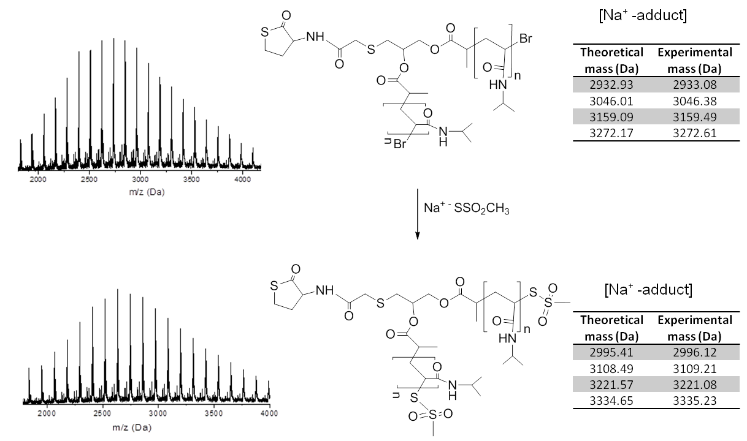
Figure 2: MALDI TOF- MS study for the end group modification.

MALDI-TOF MS analysis confirmed the successful replacement of the bromine end group with methanethiosulfonate (Figure 2). The presence of the methanethiosulfonate groups was also confirmed by ¹H NMR (not shown), via the appearance of a new signal at δ = 3.2 ppm, which could be attributed to the protons of the methyl groups of methanethiosulfonate. Moreover, the SEC analysis showed no characteristic change in the dispersity before and after end group modification.
In the third step, aiming for the preparation of the hyperbranched polymers 4, two known reactions were combined: (i) ring opening of thiolactone with an amine to generate thiol groups^{21a, 21b, 21c} and (ii) the reaction of methanethiosulfonate with thiol groups, forming a disulfide bond²². The thiolactone moiety on the poly(NIPAM) chain end (Entry 5) was opened by reacting the polymer with D-(+)-mannosamine hydrochloride, leading to introduction of mannose units in the polymer chain and the simultaneous generation of thiol functionalities. At the same time, the thiol groups can react with the methanethiosulfonate groups in situ to form the disulfide bonds, resulting in the formation of the hyperbranched polymer. The formation of hyperbranched polymers was confirmed by SEC analysis (Figure 3), showing a large increase in molecular weight and dispersity (Đ = 7.3).
B C A

Figure 3: SEC traces of (A) Poly(NIPAM) 2, (B) hyperbranched polymer 4 and (C) poly(NIPAM) 5 (after degradation).

3.2. Degradation of the hyperbranched polymer
Disulfide moieties can be reduced to the thiol groups by making use of a reducing agent ²³. To demonstrate this in our present work, the obtained hyperbranched polymer was treated by n-tributylphosphine, resulting in the formation of linear poly(NIPAM). SEC analysis showed that a linear polymer, with a molecular weight of 4900 g/mol and dispersity of 1.25 was obtained (Figure 3C), which is similar to the earlier prepared poly(NIPAM) 2. This degradation behaviour could be applied in the area of drug or gene delivery applications.

3.3. Thermoresponsive behaviour studies
Poly(NIPAM) is a well-known thermoresponsive polymer - generally having a cloud point (T_{cp}) in the range of 28ºC - 32ºC ²⁴. To understand the thermoresponsive behaviour of the newly prepared hyperbranched polymer, the cloud point was determined via turbidimetry. This cloud point is directly related to the interaction of the polymer with water and thus its conformation in solution. Below the cloud point, the polymer is present in coil form while above the cloud point, the coil conformations collapse to form globular structures²⁵. In the present work, the cloud point for the prepared linear poly(NIPAM) prepolymer was determined being 32ºC (Figure 4). The introduction of hydrophilic mannose units in the polymer chain has an impact on the cloud point and, thus, for the hyperbranched polymers T_{cp} increases from 32°C to 39°C. This increase can be attributed to the fact that introduction of hydrophilic mannose units in the polymer chain leads to an favourable enthalpic interaction of the polymer with water, resulting in an increase of the cloud point temperature^{26, 27}.
A
B
Figure 4: Turbidimetry measurements of the PNIPAM prepolymer (A) and the hyperbranched glycopolymer (B) indicating the cloud point temperature increase from 32°C to 39°C as a result of the introduction of the hydrophilic sugar units.

3.4. Con A-polymer interaction
As mentioned in the introduction, the interaction of the glycopolymers with lectin is well known and a lot of work was already performed to understand the influence of different parameters such as the type of sugar unit and polymer architecture. However, the interaction of thermoresponsive hyperbranched glycopolymers with lectin has not been described yet to our knowledge. The two aims of this part of the study is to understand (i) their interaction with lectin as a function of polymer concentration and (ii) the influence of different conformations of the polymers in solution present below and above cloud point (T_{cp}).
Figure 5 : Schematic drawing showing the interaction of lectin (Con A) with the mannose units present in the hyperbranched polymer.
For the current study, Con A was chosen as a model lectin due to its signaling properties and excellent complex forming abilities with sugar units²⁸. Solutions of hyperbranched glycopolymers were added to a known concentration of Con A (2 mg/mL) and the rate of interaction was determined by UV-Vis measurements. The lectin-glycopolymer interaction leads to precipitation of the polymer-lectin clusters, which can be monitored by analyzing the transmission of light (wavelength 420 nm) through the solution using a UV-VIS spectrometer. Three different concentrations of the polymer solution were first studied to understand the interaction of the polymer with Con A. As expected, the lectin-polymer interaction is higher with increasing polymer concentration, mainly due to the higher presence of mannose units that are responsible for lectin binding (Figure 6, left).

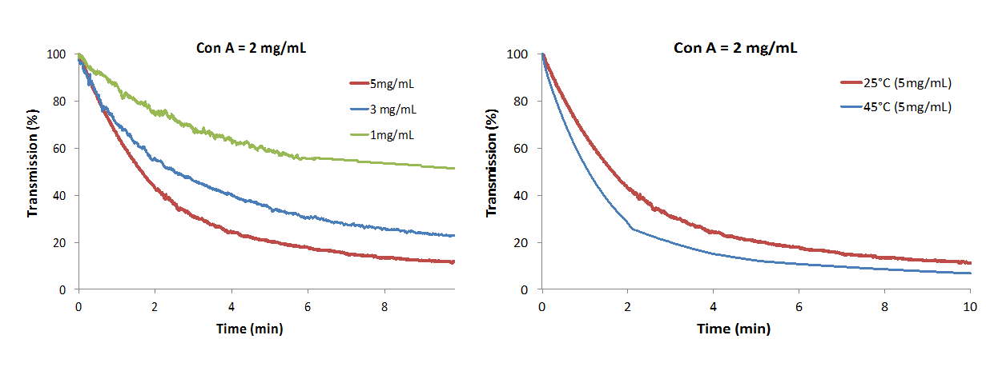
Figure 6: UV-Vis turbidimetry measurements for determining the rate of interaction of the hyperbranched glycopolymers with Con A lectin: (left) Determination of the interaction rate for different concentrations of the hyperbranched glycopolymer with a fixed concentration of Con A. (right) Determination of the interaction rate of the hyperbranched glycopolymer with Con A above and below the cloud point temperature.
The hyperbranched glycopolymers exhibit a thermo-responsive behaviour (T_{cp} = 39°C), which indicates the presence of coiled forms below T_{cp} and a collapsed globule structure above T_{cp}.

This conformational change is expected to have an impact on the interaction properties with lectins because the availability of the mannose units should be different in the coil and globule structure. This hypothesis was examined by studying the lectin-polymer interaction above or below the cloud point temperature. It was observed that the interaction occurs faster above the cloud point temperature (Figure 6, right). This phenomenon could be explained by the presence of the globular structure above T_{cp}, which leads to a higher concentration of hydrophilic mannose moieties at the outer part of the globules. In this way, it is assumed that the availability of mannose units is higher, thus resulting in faster ConA-glycopolymer interaction.

4. Conclusion
In the current work, we described the synthesis of a thermoresponsive hyperbranched glycopolymer containing sugar moieties in each branching point and redox-degradable links. Degradation of the hyperbranched PolyNIPAM-containing structure was demonstrated by chemically reducing the disulfide bond at the branching point. The hyperbranched polymer shows thermoresponsive behaviour with a cloud point of 39ºC. In the lectin-polymer interaction study, it was found that the interaction increases with the concentration of the polymer. Also, it was demonstrated that the polymer-lectin interaction is higher above the cloud point, as a result of the easier access of the mannose units in the globular conformation.

Acknowledgements
S.W. thanks the Agency for Innovation by Science and Technology in Flanders for a PhD scholarship. F.D.P. acknowledges the FWO (Vlaanderen), the Research Board of Ghent University and the Belgian Science Policy Office Interuniversity Attraction Poles (IAP) programme in the frame of IAP 7/05 for financial support.
References
(1) Valtola L., Rahikkala A., Raula J., Kauppinen E. I., Tenhu H., Hietala S., Eur. Polym. J. 2014, 59, 282.
(2) Kiessling L. L., Grim J. C., Chem. Soc. Rev. 2013, 42, 4476.
(3) Hetzer M, Chen G, Barner-Kowollik C, Stenzel MH., Macromol. Biosci. 2010;10, 119

(4) Nurmi L, Lindqvist J, Randev R, Syrett J, Haddleton DM., Chem. Commun. 2009, 2727.
(5) Ning X, Rui W, Fu-Sheng D, Zi-Chen L., J Polym Sci A: Polym Chem 2009, 47, 3583.
(6) Chen Y., Espeel P., Reinicke S., Du Prez F. E., Stenzel M. H., Macromol. Rapid Commun. 2014, 35, 1128
(7) Lundquist, J. J.; Toone, E. J. Chem. Rev. 2002, 102, 555.
(8) a. Gestwicki J. E., Cairo C. W., Strong L. E., Oetjen K. A., Kiessling L. L., J. Am. Chem.
Soc. 2002, 124, 14922. b. Ladmiral V., Mantovani G., Clarkson G. J., Cauet S., Irwin J., Haddleton D. M., J. Am. Chem. Soc. 2006, 128, 4823.

(9) a. Becer C. R., Macromol. Rapid. commun. 2012, 33, 742. b. Lin K. Kasko A. M., Biomacromol. 2013, 14, 350

(10) Slavin S., Burns J., Haddleton D. M., Becer C. R., Eur. Polym. J. 2011, 47, 435.

(11) Becer, C. R.; Gibson, M. I.; Geng, J.; Ilyas, R.; Wallis, R.; Mitchell, D. A.; Haddleton, D. M. J. Am. Chem. Soc., 132, 15130.

(12) a. Tran N. T. D., Truong N. P., Gu W., Jia Z., Cooper M.A., Monteiro M. J., Biomacromol. 2013, 14, 495. b. Tran N. T. D., Jia Z., Truong N. P., Cooper M.A., Monteiro M. J., Biomacromol. 2013, 14, 3463

(13) Heskins M., Juillet J. E., J. Macromol. Sci. Part A- Chemistry 1968, 2, 1441.

(14) Gou, Y.; Geng, J.; Richards, S.-J.; Burns, J.; Becer, C. R.; Haddleton, D. M. J. Polym. Sci. Pol. Chem., 51, 2588.

(15) Min E. H., Ting S. R. S., Billon L., Stenzel M. H., J. Polym. Sci. Pol. Chem. 2010, 48, 3440.

(16) C. W. Cairo, J. E. Gestwicki, M. Kanai, L. L. Kiessling, J. Am. Chem. Soc. 2002, 124, 1615.

(17) E. J. Grayson, S. J. Ward, A. L. Hall, P. M. Rendle, D. P. Gamblin, A. S. Batsanov, B. G. Davis, J Org. Chem. 2005, 70, 9740.

(18) Ciampoli.M, N. Nardi, Inorg. Chem. 1966, 5, 41.

(19) Percec, V.; Guliashvili, T.; Ladislaw, J. S.; Wistrand, A.; Stjerndahl, A.; Sienkowska, M. J.; Monteiro, M. J.; Sahoo, S. J. Am. Chem. Soc. 2006, 128, 14156

(20) Zhang, Q.; Wilson, P.; Li, Z.; McHale, R.; Godfrey, J.; Anastasaki, A.; Waldron, C.; Haddleton, D. M., J. Am. Chem. Soc. 2013, 135, 7355.

(21) a. Espeel P., Goethals F., Du Prez F. E., J. Am. Chem. Soc. 2011, 133, 1678. b. Espeel P., Du Prez F. E., Eur. Polym. J. 2015, 62, 247.

(22) Boyer C., Soeriyadi A. H., Roth P. J., Whittaker M. R., Davis T. P., Chem. Commun. 2011, 47, 1318

(23) Humphrey R. E., Potter J. L., Anal. Chem. 1965, 37, 164.

(24) Lutz J. F., Akdemir Ö., Hoth A., J. Am. Chem. Soc. 2006, 128, 13046.

(25) Wu C., Wang X., Phys. Rev. Lett. 1998, 80, 4092.

(26) Herman F., Bae Y. H., Feijen J., Kim S. W., Macromol. 1993, 26, 2496.

(27) Z. Oezyuerek, H. Komber, S. Gramm, D. Schmaljohann, A. H. E. Mueller, B. Voit, Macromolecular Chemistry and Physics 2007, 208, 1035.

(28) Chen G. J. , Amajjahe S., Stenzel M. H., Chem. Commun. 2009 ,1198.

