**Laser-induced vapor nanobubbles for efficient delivery of macromolecules in live cells**

Ranhua Xionga,b, Koen Raemdoncka, Karen Peynshaerta, Ine Lentackera, Ine De Cocka, Jo Demeestera, Stefaan C. De Smedta, Andre G. Skirtachb,c,d, Kevin Braeckmansa,b *

aLaboratory of General Biochemistry and Physical Pharmacy, Ghent University, Harelbekestraat 72, 9000 Ghent, Belgium;  bCentre for Nano- and Biophotonics, Harelbekestraat 72, 9000 Ghent, Belgium; cDepartment of Molecular Biotechnology, Ghent University, 9000 Ghent, Belgium; dMax-Planck Institute of Colloids and Interfaces, 14424 Potsdam, Germany

**ABSTRACT**

Macromolecular agents such as nucleic acids and proteins need to be delivered into living cells for therapeutic purposes. Among physical methods to deliver macromolecules across the cell membrane, laser-induced photoporation using plasmonic nanoparticles is a method that is receiving increasing attention in recent years. By irradiating gold nanoparticles bound to the cell membrane with laser light, nanosized membrane pores can be created. Pores are formed by localized heating or by vapour nanobubbles (VNBs) depending on the incident laser energy. Macromolecules in the surrounding cell medium can then diffuse through the transiently formed pores into the cytoplasm. While both heating and VNBs have been reported before for permeabilization of the cell membrane, it remains unclear which of both methods is more efficient in terms of cell loading with minimal cytotoxicity. In this study we report that under condition of a single 7 ns laser pulse VNBs are substantially more efficient for the cytosolic delivery of macromolecules. We conclude that VNB formation is an interesting photoporation mechanism for fast and efficient macromolecular delivery in live cells.

**Keywords:** gold nanoparticles, vapour nanobubbles, photoporation, intracellular delivery , macromolecules

1. **INTRODUCTION**

Delivering macromolecules into living cells is essential for many therapeutic applications[1]. Next to the use of non-viral nanocarriers, physical approaches have been developed to permeate the cell membrane, such as electroporation and sonopoartion. More recently, photoporation has as an alternative method in recent years, especially in combination with plasmonic nanoparticles[2-4]. Irradiation of plasmonic nanoparticles with suitable laser light can lead to distinct phenomena such as heating of the surrounding tissue, acoustic shockwaves, and formation of water vapour nanobubbles (VNBs)[3]. Recently, it was shown that laser-induced heating of gold nanoparticles (AuNPs) can be used to permeate the plasma membrane and deliver cell impermeable compounds into the cytosol[5-7]. However, diffusion of heat throughout the cell can result in hyperthermia-induced cell stress, substantially decreasing cell viability[2, 8]. Instead, when using short laser pulses (< 10 ns) of sufficiently high intensity, the temperature of a AuNP can rapidly increase to several hundred degrees. When located in hydrated tissue this leads to evaporation of the water surrounding the AuNP, resulting in an expansive VNB that emerges around its surface. When the thermal energy of the AuNP is consumed, the VNB violently collapses and causes local damage by high-pressure shockwaves. A particularly interesting feature of VNBs is that essentially all thermal energy of the AuNP is converted into mechanical energy (expansion of the VNB) without heating of the environment. This property limits potential collateral thermal damage to the surrounding healthy tissue. It has been shown that VNBs can induce pores in the cell membrane[9, 10]. However, it is currently unclear whether heating or VNBs are preferred in terms of intracellular delivery efficiency and cytotoxicity.

*Kevin.Braeckmans@UGent.be; phone +32 (0)9 264 80 98; fax +32 (0)9 264 81 89;

In this study we have performed a systematic comparison loading cells with model macromolecules by permeabilizing the cell membrane by heat or VNBs. Under condition of a single 7 ns laser pulse we have found that VNBs allow more efficient cellular uptake of compounds as compared to direct heating. At higher pulse energies bigger VNBs were formed, resulting in bigger membrane pores and the delivery of larger molecules. Based on these results it seems that VNB photoporation offers the possibility to deliver macromolecules in live cells quickly and efficiently.

### MATERIALS AND METHODS

**2.1 Materials**

Cationic AuNPs with 70 nm were purchased from NanoPartzTM (#C2159, Nanopartz Inc., Loveland, USA). By dynamic light scattering (NanoSizer, Malvern, UK) it was found that AuNPs had a zeta potential of 30 mV. FITC-dextrans (10 kD and 500 kD) were purchased from Sigma-Aldrich (Belgium). Calcein red-orange AM (#C34851,CellTraceTM Calcein Red-Orange) and Alexa Fluor 647 labeled dextran of 10 kD (#D-22914, Dextran, Alexa Fluor® 647) were obtained from InvitrogenTM (Belgium).

**2.2 Cell experiments**

Before laser treatment, HeLa cells (1×104 cells/well) were grown in cell medium of DMEM/F-12 with 2 mM glutamine, 10% heat-inactivated fetal bovine serum (FBS, Hyclone) and 100 U/mL penicillin/streptomycine, for 24 hours. Next, the cells were incubated with AuNPs for 30 min and subsequently washed to remove unbound AuNPs. Fluorescently labeled dextran was added to the cells immediately prior to the laser treatment. After laser treatment, cells were washed and supplied with fresh cell medium containing CellTrace® calcein red-orange AM to stain for live cells. Images were finally acquired by confocal microscopy (C1-si, Nikon, Japan) to quantify the loading efficiency and cell viability.

**2.3** **Generation and detection of AuNP heating and VNB formation**

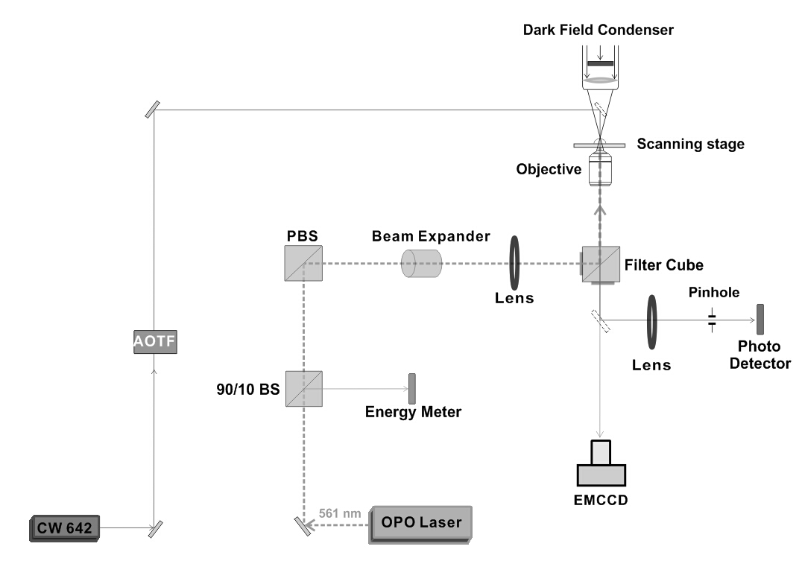

Figure 1. Optical setup for generation and detection of PT and VNBs.

A homemade setup was used to generate and detect AuNPs heating or VNB formation (Fig.1). A pulsed laser with pulse duration of ~7 nm was tuned at wavelength of 561 nm (OpoletteTM HE 355 LD, OPOTEK Inc., Faraday Ave, CA, USA) for illumination of the AuNPs. The setup has two modes for discriminating AuNP heating or VNB formation, respectively. The time-response mode makes use of a photo detector (APD110A, Thorlabs) that monitors a change in transmitted light of a CW red laser (Spectra-PhysicsExcelsion-640, Santa Calara, CA, US) due to changes in refractive index upon heating or due to VNB formation (Fig. 2a-b)[11]. Additionally, the dark-field imaging mode can be used to detect VNBs as they efficiently scatter light (Fig. 2c-d).

For treating all cells within a well of a 96 well titre plate, an electronic microscope stage was used to scan the laser beam (20 Hz pulse frequency) line by line across the entire sample. The scanning speed was 2 mm/s and the distance between subsequent lines was 0.1 mm (diameter of laser beam) so that each location in the sample receives a single laser pulse. Total treatment time of a single well was ~3.6 min. An energy meter (J-25MB-HE&LE, Energy Max-USB/RS sensors, Coherent) was used to measure the laser energy.



Figure 2. In transmitted light mode, heating of AuNPs (a) can be clearly discriminated from VNB formation (a, b). Heating of AuNPs causes heat diffusion, resulting in a long-lasting thermal lensing effect. VNBs on the other hand have a short lifetime (10-100 ns), resulting in a distinct brief pulse of scattered light. VNBs can also be detected by dark field microscopy (c-d). HeLa cells are shown in dark field mode during laser illumination, showing VNBs (bright spots) (c) and after laser illumination (d). The green circle in (c) marks the laser illumation area of approx. 100 µm diameter.

1. **RESULTS AND DISCUSSION**

**3.1 Determining the number of membrane attached AuNPs per cell**

Positively charged AuNPs (70 nm) were incubated with HeLa cells at 3 different AuNP concentrations (4.1×107, 8.2×107 and 16.5×107 particles/ml) during half an hour at 37°C. After washing of unbound AuNPs, the number of cell-attached AuNPs was quantified from confocal reflection images. More AuNPs were found to be adsorbed to the cell membrane proportional to the incubation concentration, resulting in respectively 4, 8 and 15 AuNPs per cell on average.

**3.2 Determining the laser fluence threshold for VNB formation**

Next, we evaluated the laser fluence threshold for the generation of VNBs with a single 7 ns laser pulse. Below the VNB threshold, the absorbed laser energy will lead to heating of the AuNPs and the cell membrane. At a laser fluence above the VNBs threshold, the heat of the AuNPs is converted to VNB formation, essentially without heat transfer to the environment. From these experiments we found that VNBs could be clearly generated at a laser fluence of 1.02 J/cm2 , while 0.38 J/cm2 only resulted in heating of the surrounding medium in agreement with previously published data[7].

**3.3 Intracellular delivery of macromolecules and cell viability *via* local heating or VNB generation.**

Cell loading with FITC-dextran and cell viability were systematically evaluated for different laser fluences at a AuNP concentration corresponding to 8 AuNPs per cell. All cells in a well of a 96-well titer plate were treated with a single laser pulse of the indicated energy. After laser treatment the cells were washed to remove the remaining extracellular FITC-dextran and fresh cell medium was added for live cell imaging. Calcein red- orange AM was added to the cells to quantify cell viability. Exemplary fluorescence microscopy images are shown in Fig. 3, from which it can be seen that VNB mediated cell poration (2.04 J/cm2) leads to more efficient cell loading as compared to heating of the cell membrane (0.38 J/cm2). From quantitative image analysis (cfr. Fig. 4) we found that approximately 40% of the treated cells were positive for FITC-dextran at a laser fluence of 0.38 J/cm2 (heating). Increasing the laser fluence level above the VNB threshold resulted in more positive cells and higher loading degree per cell. The process was most efficient at 2.04 J/cm2 with ~90% positive cells and ~6 times more fluorescence per cell as compared to heating at 0.38 J/cm2. There was no noticeable decrease in cell viability up to 2.04 J/cm2. Further increasing the laser fluence to 4.08 J/cm2 resulted in higher cytotoxicity, likely because VNBs are becoming rather large and more damaging to the cells.



Figure 3. Hela cells with on average 8 membrane attached AuNPs were treated with different laser fluence settings. The top row (a-c) shows cell viability (calcein red-orange), while the bottom row (d-f) shows the intracellular FITC-dextran fluorescence. (a, d) Negative control, (b, e) laser flence of 0.38 J/cm2 (heating), and (c, f) 2.04 J/cm2 (VNB formation).



Figure 4. Cell viability and delivery efficiency of FITC-dextran 10 kDa (FD10) as quantified by image processing of confocal images. HeLa cells were incubated with 70 nm cationic AuNPs at a concentration corresponding to approx. 8 AuNPs per cell. The laser fluence was adjusted to compare heating of the plasma membrane (0.38 J/cm2) with pore formation by VNBs (1.02, 2.04 and 4.08 J/cm2). (a). Black bars are the fraction of FD10 positive cells, gray bars are the fraction of live cells and olive bars are the average fluorescence intensity. (b). The average FD10 fluorescence per cell is a measure for the loading efficiency.

**3.4 Influence of number of cell-adherent AuNPs on loading efficiency and cell viability**

When increasing the AuNP concentration to 16.5×107 particles/ml (corresponding to 16 AuNPs per cell) a similar trend was found, here the percentage of positive and viable cells already decreased to ~65% at a laser fluence of 2.04 J/cm2 (Fig.5). This shows that photoporation by VNBs also requires careful optimization of the concentration of AuNPs used.



Figure 5. Cells were incubated with 16.5X107 particles/ml and illuminated with different laser fluences from 0.38 J/cm2 below the VNB threshold to 1.02, 2.04 and 4.08 J/cm2 above the VNB threshold.

* 1. **Delivering larger macromolecules by heat and VNB**



Figure 6. Efficiency of delivering FD500 and cell viability as a function of laser fluence as quantified by imaging processing of confocal images. Black bars are the fraction of FD500 positive cells, red bars are the fractions of live cells and green bars are the mean fluorescence intensity (MFI). MFI per cell is a measure of the loading efficiency of extracellular agents of FD500. The data shown are the results from three independent experiments.

Next we went one step further and evaluated the delivery of a larger model macromolecule, FITC-dextran of 500 kDa. As the results show in Fig. 6, VNB mediated membrane poration (2.08 J/cm2) clearly results in more efficient delivery of such large macromolecules as compared to heating (<1.04 J/cm2). Likely this is due to larger membrane pores being formed by VNBs as compared to heating, allowing easier passage of larger molecules.

### CONCLUSIONS

It was demonstrated that delivering macromolecules across the plasma membrane in cells is more efficient when pores are created by VNBs rather than by direct heating when using single 7 ns laser pulses. Considering the fact that this procedure can be applied to large cell numbers in a relatively short time span, VNB photoporation is a promising alternative physical technique to efficiently deliver compounds into cells in high throughput with little or no toxicity.

### REFERENCES

[1] S. Mann, “Life as a nanoscale phenomenon,” Angewandte Chemie-International Edition*,* 47(29), 5306-5320 (2008).

[2] X. H. Sun, G. D. Zhang, R. S. Keynton *et al.*, “Enhanced drug delivery via hyperthermal membrane disruption using targeted gold nanoparticles with PEGylated Protein-G as a cofactor,” Nanomedicine-Nanotechnology Biology and Medicine*,* 9(8), 1214-1222 (2013).

[3] Z. P. Qin, and J. C. Bischof, “Thermophysical and biological responses of gold nanoparticle laser heating,” Chemical Society Reviews*,* 41(3), 1191-1217 (2012).

[4] P. Zijlstra, and M. Orrit, “Single metal nanoparticles: optical detection, spectroscopy and applications,” Reports on Progress in Physics*,* 74(10), (2011).

[5] E. Y. Lukianova-Hleb, M. B. G. Mutonga, and D. O. Lapotko, “Cell-Specific Multifunctional Processing of Heterogeneous Cell Systems in a Single Laser Pulse Treatment,” Acs Nano*,* 6(12), 10973-10981 (2012).

[6] D. Lapotko, “Plasmonic nanoparticle-generated photothermal bubbles and their biomedical applications,” Nanomedicine*,* 4(7), 813-845 (2009).

[7] D. Lapotko, “Optical excitation and detection of vapor bubbles around plasmonic nanoparticles,” Optics Express*,* 17(4), 2538-2556 (2009).

[8] D. Heinemann, M. Schomaker, S. Kalies *et al.*, “Gold Nanoparticle Mediated Laser Transfection for Efficient siRNA Mediated Gene Knock Down,” Plos One*,* 8(3), (2013).

[9] E. Y. Lukianova-Hleb, D. S. Wagner, M. K. Brenner *et al.*, “Cell-specific transmembrane injection of molecular cargo with gold nanoparticle-generated transient plasmonic nanobubbles,” Biomaterials*,* 33(21), 5441-5450 (2012).

[10] E. Y. Lukianova-Hleb, X. Y. Ren, J. A. Zasadzinski *et al.*, “Plasmonic Nanobubbles Enhance Efficacy and Selectivity of Chemotherapy Against Drug-Resistant Cancer Cells,” Advanced Materials*,* 24(28), 3831-3837 (2012).

[11] V. P. Zharov, and D. O. Lapotko, “Photothermal imaging of nanoparticles and cells,” Ieee Journal of Selected Topics in Quantum Electronics*,* 11(4), 733-751 (2005).