Title page
An unusual type of kidney stone
De Koninck Anne-Sophie¹, Groen Luitzen-Albert², Maes Heleen², Verstraete Alain Gaston^{1,3}, Stove Veronique^{1,3}, Delanghe Joris Richard^{1,3}
¹Department of Laboratory Medicine, Ghent University hospital, Belgium
²Dept of Urology, Ghent University Hospital, Belgium
³Department of Clinical chemistry, microbiology and immunology, Ghent University, Belgium

Correspondence and offprint requests to:
¹Department of Laboratory Medicine, Ghent University hospital
De Pintelaan 185, B 9000 Ghent, Belgium
Joris.delanghe@ugent.be

Acknowledgements: None
Source of support in the form of grants, equipment or drugs: None
Declaration of Interest: None
Summary
A very rare case of acetylsulfapyridine nephrolithiasis is presented in a 54-year old female patient who had been prescribed sulfasalazine (6 x 500 mg/day) because of psoriasis arthritis for the last 9 years. The patient’s renal function was only slightly impaired. Reflectance infrared spectroscopy and gas chromatography-mass spectrometry allowed the identification of the chemical nature of the stone. As acetylsulfapyridine is a metabolite of sulfasalazine, administration of the latter drug was the cause of the nephrolithiasis.
Key words: sulfasalazine - sulfapyridine – acetylsulfapyridine - kidney stone - N-acetyltransferase 2 polymorphism
Case presentation
A 54-year old Caucasian woman (166 cm, 97 kg, BMI 35.2) presented with nausea, dysuria, suprapubic pain and renal colic symptoms on the right side, which could be attributed to ureterolithiasis. Medical history revealed three antecedents of kidney stones, one of which was identified as a calcium oxalate monohydrate stone eight years before. The patient was diagnosed with type 2 diabetes 8 years before, complicated by an early stage diabetic nephropathy for which metformin (3 x 850 mg/day) and perindopril (5 mg/day) had been prescribed. The patient also suffered from multifocal atrial tachycardia that had been treated with verapamil (6 x 80 mg daily). Furthermore, the patient had been diagnosed with psoriasis arthritis, for which she received treatment with sulfasalazine (6 x 500 mg/day) for 9 years. Ultrasound imaging showed hydronephrosis grade 2 in the right kidney. Mild uretero-hydronephrosis due to prevesical ureterolithiasis was shown on non-contrast spiral CT scan. The CT scan demonstrated additional microlithiasis in the middle part of the left kidney. The ureter stone, orange – red in color and 7 mm maximal length, was removed by uncomplicated uretroscopy with laser disintegration and dormia extraction of the fragments.
Laboratory analysis showed a slightly reduced kidney function (serum creatinine 0.81 mg/dL, eGFR 81 mL/min). The chemical nature of the kidney stone was identified with reflectance infrared spectroscopy.
Kidney stone analysis
Infrared spectroscopy
The stone was grinded. The obtained powder was analyzed using infrared (IR) spectroscopy in reflectance mode on a Spectrum 2 photometer (Perkin Elmer, Waltham, MA, USA). The obtained IR spectrum was compared with reference spectra between 4000 and 400 cm⁻¹ from the laboratory's library.
GC-MS based analysis of the kidney stone
A fraction of the stone was dissolved in 100 µL 1 mol/L sodium hydroxide; 50 µL of the solution was extracted at pH 9.2 using a Toxi-vial® (Interchim, Montluçon, France). The resulting organic extract was evaporated to dryness at 56 °C and resuspended in 50 µL of ethyl acetate.
The Shimadzu QP2010 Plus gas chromatograph mass spectrometer (Shimadzu Benelux, 's-Hertogenbosch, The Netherlands) was operated in full scan mode (m/z 40 to 550) at 70 kV. The ion source was kept at 200 °C, the interface at 200 °C. We used a HP-5ms GC column (Agilent technologies, Santa Clara, CA, USA) 12 cm x 0.2 mm, film thickness 0.33 µm. Helium was used as the carrier gas at a constant flow rate (50 cm/sec). The oven temperature started at 100 °C for 1 min, was ramped at 30°C/min to 310 °C and kept at 310 °C for 5 min. One microliter extract was injected into the GC system at a split injection ratio of 20, the injection temperature was 270 °C.
Analysis of sulfasalazine metabolites in serum
Serum of this patient was stored at -20°C until assay. We measured free and total concentrations of the sulfapyridine (SP) and acetylsulfapyridine (AcSP) metabolites of sulfasalazine in the serum.
After protein precipitation with acetonitrile containing the internal standard sulfamethazine, the concentrations of SP and AcSP were measured using an in-house developed UPLC-DAD method (UPLC H-class, Waters, Zellik, Belgium). The separation was carried out using a reverse-phase column (BEH C18, particle size 1.7 µm, 2.1 x 100 mm internal diameter). The mobile phase was formic acid 0.1% in water and formic acid 0.1% in acetonitrile (with a gradient from 90:10 vol/vol to 75:25). Flow rate was 0.5 mL/min, and the column temperature was maintained at 35°C. An injection volume of 5 µL was used and the metabolites were quantitated at 260 nm. The calibration curves were linear over a concentration range of 0.8 to 100 mg/L for SP en AcSP (R > 0.9999). The concentrations of the serum SP and AcSP of the patient were calculated from the peak area ratios.
For measurement of the free concentrations, an ultrafiltrate of the patient’s serum sample was obtained by incubating 500 µL serum in a Centrifree® Ultrafiltration device (Merck Millipore, Ireland) for 30' at 37°C, followed by centrifugation for 30' at 37°C and 1885g.
Results
The spectrum revealed a series of absorption peaks in the range between 1600 cm⁻¹ and 400 cm⁻¹ (Figure 1). As the obtained IR spectrum did not match any entry in the laboratory's library (which contains the most commonly encountered types of kidney stones), further investigations were carried out in order to identify the chemical nature of the stone. As a drug-induced kidney stone was suspected, gas chromatography mass spectrometry (GC-MS) was carried out.
Gas chromatography of the dissolved stone material showed two peaks: the first peak showed a mass spectrum with principal mass peaks at m/z 184,185, 92, 65, 108 and was identified as sulfapyridine (SP). The mass spectrum of the second and largest peak contained m/z 226, 243, 65, 184, 227, 92 and was identified as acetylsulfapyridine (AcSP), the major metabolite of sulfapyridine (Figures 2A and 2B).
The observed serum metabolite concentrations of our patient were 14.3 mg/L SP (of which 47% was free, and 53% protein bound) and 55.6 mg/L AcSP (77% bound).
Discussion
Sulfasalazine was developed in the 1950s to treat rheumatoid arthritis. Sulfasalazine (SASP) is formed by combining sulfapyridine and aminosalicylate (5-ASA, mesalazine) with an azo bond. It is on the World Health Organization's List of Essential Medicines. Sulfasalazine is used in the treatment of inflammatory bowel disease and is also used in rheumatoid arthritis and other types of inflammatory conditions [1].
When orally administered, only a small part of sulfasalazine is absorbed from the small intestine, whereas the major part (up to 90%) of the dose reaches the colon unchanged [2-4]. In the colon, SASP is split by bacterial action into the two active components 5-ASA and SP [2-5]. The 5-ASA remains largely within the large bowel, but the SP is totally absorbed and metabolized to inactive metabolites, which retain the toxicity of the parent compound. SP is metabolized by acetylation, hydroxylation and glucuronidation. Acetylsulfapyridine is the major metabolite [3-5]. The acetylation of SP is conducted predominantly by hepatic N-acetyltransferase 2, also known as NAT 2, which is encoded by the NAT 2 gene [4]. Hereditarily determined polymorphisms in this gene are responsible for the N-acetylation polymorphism with fast and slow acetylator phenotypes [1,3,4]. Approximately 60% of the Caucasian population can be classified as belonging to the slow acetylator phenotype [1]. Several reports have described the relationship between the NAT 2 acetylator phenotypes and the pharmacokinetics, efficacy, and toxicity of SASP [3,4]. According to Das et al. [5], a single estimation of serum for SP and AcSP in patients taking SASP could be sufficient to determine the acetylator phenotype.
The calculated clearance of sulfasalazine following intravenous administration is 1 L/hr. Renal clearance was estimated to account for 37% of total clearance [1]. Gender appears not to affect either the rate or the pattern of metabolites of SASP, SP or 5-ASA [1].
The solubility of AcSP in water is 56 mg/L at 20 °C, whereas SP is hardly water-soluble [2,6,7].
Urinary concretions have been reported in patients receiving SP more than 70 years ago [8]. Urinary concretions and renal calculi were reported in rats during toxicology and carcinogenesis studies of SASP [9]. Despite the widespread use of SASP for many decades, case reports dealing with AcSP kidney stones are extremely rare. In 1994 the formation of bilateral renal calculi secondary to sulfasalazine therapy for juvenile rheumatoid arthritis has been reported. Analysis of the fragments revealed AcSP [10]. In 1999 and 2003, other cases were described in Japan and the US [11,12].
As classical chemical analysis of kidney stones may not detect (acetyl-)sulfapyridine kidney stones, the true prevalence of this type of renal calculi may be underestimated. In our laboratory records, the present finding has never been observed in a database of over 10,000 kidney stones analyzed with the same technique.
The observed serum metabolite concentrations of our patient slightly exceeded the mean serum concentrations described for patients under steady state receiving 3 to 6 g sulfasalazine daily [1,2,5]. Relative protein binding was consistent with the range reported by Moffat et al. [6] (SP 40-60%), but lower than the protein binding reported by the FDA Professional Drug Information database (SP 70% and AcSP 90% bound) [1]. The calculated log 10 AcSP/SP in our patient was 0.59, which corresponds to a rapid acetylator phenotype [3]. These findings can help to explain why the kidney stone was predominantly made of AcSP and to a lesser extent of SP. Taking into account the low solubilities of SP en AcSP in water, a delicate balance between solubility and precipitation of these components is formed in urine. Therefore, it is not inconceivable that our patient had formed an acetylsulfapyridine kidney stone under sulfasalazine therapy.
The use of sulfasalazine was subsequently discontinued in our patient. Adequate fluid intake and an urinary pH between between 6.5 and 7.5 must be maintained in order to prevent crystalluria and stone formation while taking sulfasalazine [1,11-13].
References
- FDA Professional Drug Information database. Sulfasalazine [document on the internet]. Revised 04/2014 [cited 2015 April 30]. Available from: http://www.drugs.com/pro/sulfasalazine.html .
- Sulfasalazine. In: Moffat AC, Osselton MD, Widdop B, Watts J. (eds). Clarke's Analysis of Drugs and Poisons, 4th ed. Volume 2. London: Pharmaceutical Press, 2011:2087-2088.
- Kuhn UD, Anschütz M, Schmücker K, Schug BS, Hippius M, Blume HH. Phenotyping with sulfasalazine - time dependence and relation to NAT2 pharmacogenetics. Int J Clin Pharmacol Ther. 2010;48:1-10.
- Kumagai S, Komada F, Kita T, et al. N-acetyltransferase 2 genotype-related efficacy of sulfasalazine in patients with rheumatoid arthritis. Pharm Res. 2004;21:324-9.
- Das KM, Eastwood MA, McManus JPA, Sircus W. The metabolism of salicylazosulphapyridine in ulcerative colitis: I The relationship between metabolites and the response to treatment in inpatients. Gut 1973;14:631-636.
- Sulfapyridine. In: Moffat AC, Osselton MD, Widdop B, Watts J. (eds). Clarke's Analysis of Drugs and Poisons, 4th ed. Volume 2. London: Pharmaceutical Press, 2011:2086-2087.
- Santa Cruz Biotechnology, Inc. N-Acetyl Sulfapyridine (CAS 19077-98-6) [document on the internet], [cited 2015 april 30]. Available from: http://www.scbt.com/datasheet-207961-n-acetyl-sulfapyridine.html .
- Toomey JA. Urinary concretions and sulfapyridine. JAMA. 1939;113:250-251.
- National Toxicology Program. NTP Toxicology and Carcinogenesis Studies of Salicylazosulfapyridine (CAS No. 599-79-1) in F344/N Rats and B6C3F1 Mice (Gavage Studies). Natl Toxicol Program Tech Rep Ser. 1997;457:1-327.
- Erturk E, Casemento JB, Guertin KR, Kende AS. Bilateral acetylsulfapyridine nephrolithiasis associated with chronic sulfasalazine therapy. J Urol. 1994;151:1605-6
- Yanagisawa R, Kamijo T, Nagase Y. A case of drug induced urolithiasis composed of acetyl sulphapyridine associated with ulcerative colitis [in Japanese]. Nihon Hinyokika Gakkai Zasshi 1999;90:462-5.
- Russinko PJ, Agarwal S, Choi MJ, Kelty PJ. Obstructive nephropathy secondary to sulfasalazine calculi. Urology 2003;62:748.
- Türk C, Knoll T, Petrik A, et al., Guidelines on urolithiasis. European Association of Urology (EAU), Arnhem, The Netherlands. 2015. Electronic copies available from the EAU Website http://uroweb.org/guideline/urolithiasis/ .
Fig.1 Infra red spectrum of the kidney stone. Multiple absorption maxima were observed ranging from 1600 to 400 cm⁻¹.

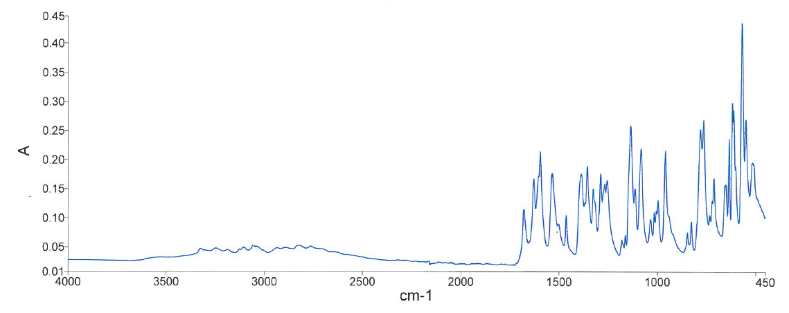

Fig.2 GC-MS chromatogram of the dissolved kidney stone showing the mass spectra of sulfapyridine and acetylsulfapyridine: the first peak showed a mass spectrum with principal mass peaks at m/z 184,185, 92, 65, 108 (Fig. 2A) and was identified as sulfapyridine. The mass spectrum of the second peak contained m/z 226, 243, 65, 184, 227, 92 and was identified as acetylsulfapyridine, the major metabolite of sulfapyridine (Fig. 2B).
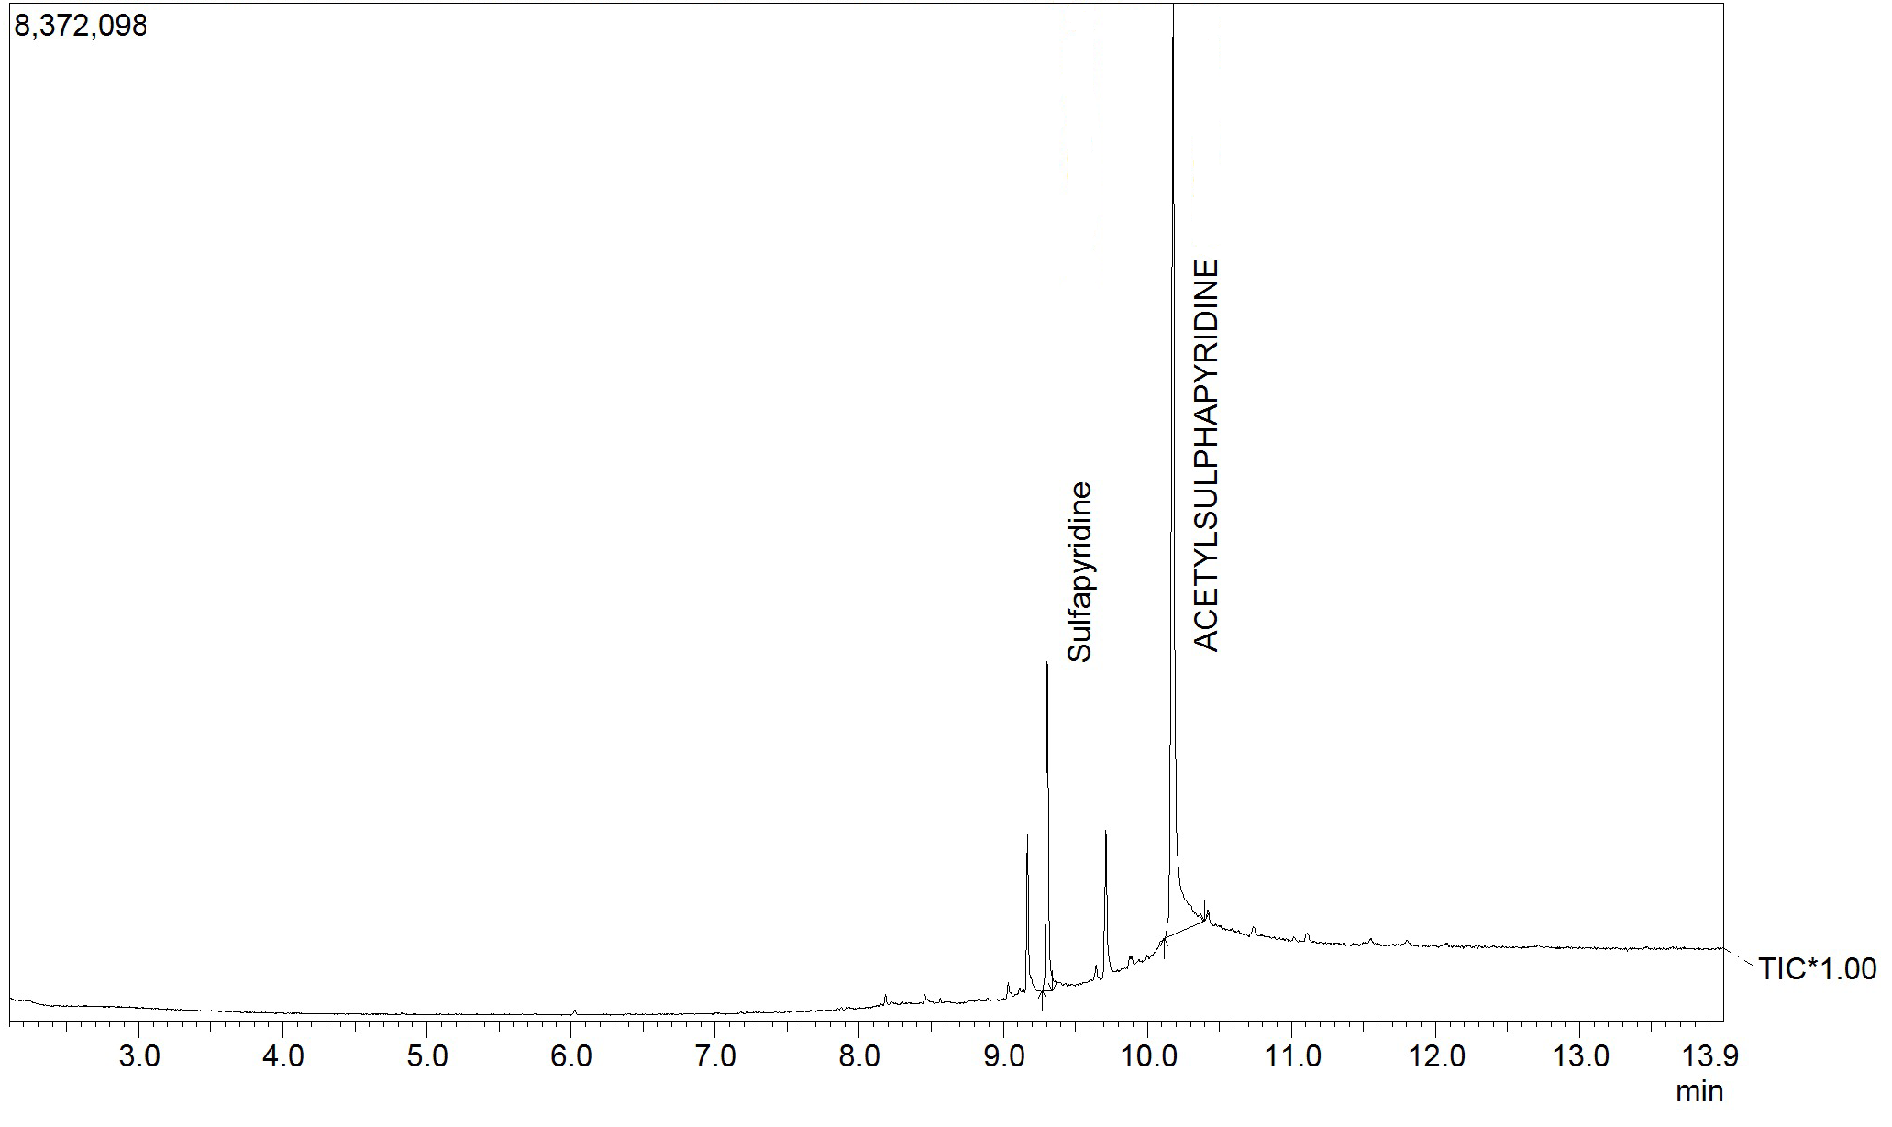
Chromatogram
Retention time 9.305: Sulfapyridine
Retention time 10.08: Acetylsulfapyridine

