**Crystal coating via spray drying to improve powder tabletability**

V.Vanhoorne, E. Peeters, B. Van Snick, J.P. Remon, C. Vervaet

Laboratory of Pharmaceutical Technology, Ghent University

Corresponding Author:

Chris Vervaet

Ghent University

Laboratory of Pharmaceutical Technology

Harelbekestraat 72

9000 Ghent

Belgium

Tel: +32 9 264 80 69

Fax: +32 9 222 82 36

E-mail: [Chris.Vervaet@UGent.be](mailto:Chris.Vervaet@UGent.be)

***Abstract***

A continuous crystal coating method was developed to improve both flowability and tabletability of powders. The method includes the introduction of solid, dry particles into an atomized spray during spray drying in order to coat and agglomerate individual particles. Paracetamol was used as a model drug as it exhibits poor flowability and high capping tendency upon compaction. The particle size enlargement and flowability was evaluated by the mean median particle size and flow index of the resulting powders. The crystal coating coprocessing method was successful for the production of powders containing 75% paracetamol with excellent tableting properties. However, the extent of agglomeration achieved during coprocessing was limited. Tablets compressed on a rotary tablet press in manual mode showed excellent compression properties without capping tendency. A formulation with 75% paracetamol, 5% PVP and 20% amorphous lactose yielded a tensile strength of 1.9 MPa at a compression pressure of 288 MPa. The friability of tablets compressed at 188 MPa was only 0.6%. The excellent tabletability of this formulation was attributed to the coating of paracetamol crystals with amorphous lactose and PVP through coprocessing and the presence of brittle and plastic components in the formulation. The coprocessing method was also successfully applied for the production of directly compressible lactose showing improved tensile strength and friability in comparison to a spray dried direct compression lactose grade.

***KEYWORDS***: Spray drying, Coprocessing, Particle coating, Direct compression, Amorphous lactose, Paracetamol, Tabletability, Continuous production.

**List of abbreviations**

PVP Polyvinylpyrrolidone

SEM Scanning electron microscopy

LOD Loss on drying

ffc Flowability index

XRD X-ray diffractin

MDSC Modulated differential scanning calorimetry

d50 Mean median particle size

1. **Introduction**

Tablets are the most popular dosage form for patients as well as manufacturers because of the convenience of administration, accurate dosing, ease of manufacturing, product stability in comparison to liquids and tamper-proofness in comparison to capsules [1]. Direct compression is the preferred manufacturing method for tablets because of its simplicity, continuous nature and related financial benefits. However, it is estimated that less than 20% of pharmaceutical powders can be directly compressed into tablets as powders must have appropriate flowability, compressibility and homogeneity to be suited for direct compression [1, 2].

To improve these properties coprocessing of materials is widely applied for the preparation of powder mixtures enabling direct compression of a drug substance. During coprocessing two or more components are combined by a specific process, yielding a material with superior properties compared to physical mixtures of their components, without modification of the chemical structure of the ingredients [1, 3].

In this work we aimed to improve both flowability and tabletability of powders by the development of a continuous crystal coating method. The manufacturing method is based on the introduction of dry powder particles into an atomized spray during spray drying. The resulting powders were microscopically evaluated and characterized through particle size analysis, flowability testing and tableting experiments. It was first investigated if the method allowed to produce paracetamol tablets without capping tendency via coating of paracetamol particles with spray dried lactose and polyvinylpyrrolidone (PVP). The flowability and tabletability of the resulting powders was assessed and compared to the characteristics of the corresponding physical mixtures. In a second part, it was investigated if the method is also applicable for the production of direct compression lactose.

1. **Materials and methods**
   1. **Materials**

Paracetamol (semi fine) was received from Mallinckrodt Chemical (Hazelwood, USA). Milled α-lactose monohydrate (Pharmatose® 200M) was purchased from Caldic (Hemiksem, Belgium). A direct compression grade of spray dried lactose (DCL 11) was purchased from DFE Pharma (Goch, Germany). Silicon dioxide and magnesium stearate (Fagron, Waregem, Belgium) were used as glidant and lubricant, respectively. PVP and Crospovidone® were used as binder and desintegrant, respectively and were received from BASF (Burgbernheim, Germany). Miglyol (Cremer Oleo, Witten, Germany) with 0.2% polysorbate 80 (Fagron, Waregem, Belgium) was used as dispersant for laser diffraction measurements.

* 1. **Methods**
     1. **Preparation of the coprocessed powders**

In a first set of experiments, aqueous solutions of lactose and PVP (16% and 8% w/w lactose with lactose/PVP ratio: 4/1) and of pure PVP (3% w/w) were prepared. These solutions were fed to the fountain two-fluid nozzle (nozzle orifice 2.6 mm) of a production-scale spray dryer (type 6.3-SD, GEA Niro, Copenhagen, Denmark) by a peristaltic pump (type 520U, Watson Marlow, Cornwall, UK) and marprene tubing (inside diameter 4.8 mm). The spray dryer operated in counter-current mode. The dimensions of the spray dryer were 2.0 m cylindrical height with a diameter of 3.5 m and 60° conical base. The main powder fraction was collected in a reservoir under the drying chamber and fines were collected in a reservoir attached to a cyclone. The solutions were spray dried according to the following parameters: feed rate: 100 g/min, inlet drying air temperature: 240°C, outlet drying air temperature: 112°C, drying gas rate: 210 kg/h, atomizing air pressure: 0.5 bar. Paracetamol was preblended with 0.05% silicon dioxide and introduced during the spray drying process into the cone of the drying chamber via an in-house designed setup shown in Figure 1. This setup consists of a vibratory feeder (DR 100, Retsch, Haan, Germany) presenting the powder to a Venturi-based system that introduces the powder through two small tubes (internal diameter 7 mm) into the dryer. The tubes were positioned close to the nozzle and were oriented to directly inject the solid particles in the spray pattern of the atomized drops. The composition of the spray dried solutions, the feed rate of solid particle introduction and the final composition of the coprocessed powders (fraction spray dried lactose, fraction dry inserted paracetamol, content PVP) is given in Table 1.

In a second set of experiments, aqueous solutions of lactose (2.5%, 5%, 10% and 16% w/w) and PVP (0.85%, 1%, 1.25%, 0.8% w/w, respectively) and of pure PVP (0.8% w/w) were spray dried, while lactose crystals were introduced via the same procedure as described above. For spray drying of the pure PVP solution the inlet temperature was increased to 240°C in order to ensure that the moisture content of the coprocessed powder does not exceed the moisture content of the starting material by more than 2.5%. The composition of the solutions, feed rate of solid particle introduction and the final composition of these coprocessed powders are listed in Table 2.

* + 1. **Tableting**

The coprocessed powders, physical mixtures and reference lactose (spray dried α-lactose monohydrate for direct compression) were blended (Turbula mixer type T2F, W.A. Bachofen Maschinenfabrik, Basel, Switzerland) with 5% Crospovidon® and 0.5% magnesium stearate.

Tablets (500 ± 5 mg) of the coprocessed powders with paracetamol and of the corresponding physical mixtures were compressed on a rotary tablet press (MODULTM P, GEA Pharma Systems, Courtoy, Halle, Belgium) equipped with a single round concave Euro B punch of 12 mm diameter at a tableting speed of 5 rpm. The tablets were compressed at 7 different main compression pressures: 31, 61, 104, 146, 188, 237 and 288 MPa after precompression at 18 MPa. The friability was tested on tablets compressed at 188 MPa.

The coprocessed powders consisting of lactose and PVP and the lactose reference were compressed (1g ± 10 mg) on an excentric tablet press (Type EKO, Korsch, Berlin, Germany) equipped with 16.0 mm edged punches at a compression force of 132 MPa.

* + 1. **Material characterization** 
       1. **Morphology**

The powders were examined by scanning electron microscopy (SEM) (JEOL JSM-5600-LV, JEOL Ltd., Zaventem, Belgium) after sputtering with a platinum coating using the JEOL JFC 1300 Autofine Coater (JEOL Ltd., Zaventem, Belgium) to improve the electron conductivity of the samples.

* + - 1. **Loss on drying (LOD)**

The residual moisture content of the coprocessed powders was determined via LOD using a moisture analyzer (Mettler LP16, Mettler-Toledo, Zaventem, Belgium) including an infrared dryer and a balance. A sample of 5 g was dried at 105°C until the weight was constant for 30 s.

* + - 1. **Particle size analysis**

The particle size distribution of the paracetamol starting material and coprocessed powders was measured in triplicate by laser diffraction (Mastersizer S long bench, Malvern Instruments, Worcestershire, UK). The wet dispersion technique was applied using the 300RF lens (Malvern Instruments, Worcestershire, UK). The powders were dispersed in a solution of 0.2% Tween 80 in Miglyol 812 and subsequently vortexed and sonicated in order to eliminate agglomerates. The results are expressed as volume diameters.

* + - 1. **Ring shear testing**

The flowability expressed as the flowability index (ffc) of the powders was measured in triplicate by ring shear testing (Type RST-XS, Dietmar Schulze Schüttgutmesstechnik, Wolfenbuttel, Germany). The powders were tested using three consolidation stresses, 400, 600 and 800 Pa, and a preshear of 1000 Pa.

* + - 1. **Solid state characterization**

Crystallinity was analyzed using X-ray diffraction (XRD) and modulated differential scanning calorimetry (MDSC) on the pure compounds, physical mixtures and coprocessed samples. XRD was performed on a CuKα diffractor (ARLTM X’TRA, Thermo Fischer Scientific, Waltham, United States) with a voltage of 40mV in the angular range of 8°<2θ<60° using a step scan mode with step size of 0.02° and counting time of 1s/step.

MDSC was performed using a Q2000 differential scanning calorimeter (TA Instruments, Zellik, Belgium) equipped with a refrigerated cooling system. Samples (5-10 mg) were accurately weighed and run in Tzero pans (TA Instruments, Zellik, Belgium). They were cooled to -20°C and subsequently heated up to 220°C with a heating rate of 2°C/min. The modulation time and amplitude were set at 60 s and 0.318°C, respectively. Dry nitrogen was used as a purge gas through the cell at a flow rate of 50 ml/min. The results were analyzed using TA Instruments Universal Analysis software.

* + 1. **Tablet characterization**

The hardness, thickness and diameter of the tablets (n=10) were determined using a hardness tester (Type HT 10, Sotax, Basel, Switzerland) and the tensile strength (T) of the tablets was calculated according to the formula of Fell and Newton [4]:

T = 2*F*/π*dt*

Where F, d and t denote the diametral crushing force, tablet diameter and tablet thickness, respectively.

The tablet friability was determined using a friabilator (PTFE, Pharma Test, Hainburg, Germany) as described in the European Pharmacopea at a speed of 25 rpm for 4 min. The percentage weight loss was expressed as the tablet friability.

1. **Results and discussion**

Lack of flowability and tabletability often constitutes a problem for the production of tablets. Turchiuli et al. reported particle size enlargement due to forced secondary agglomeration when part of the spray dried powder was reintroduced into a spray of droplets [5]. The agglomeration is attributed to the sticky nature of spray dried maltodextrin acting as an amorphous binder between reintroduced particles and spray dried drops. Similarly, Williams et al. studied the effect of fines recycling on agglomeration of milk powder during spray drying aiming to produce a free-flowing, non-dusty and easily dispersable powder [6]. It is known that fast evaporation during spray drying can yield amorphous particles and a high content of low molecular sugars reduces the glass transition temperature of the spray dried material below its product temperature. At this stage a liquid-like state of amorphous material exists, which is responsible for cohesion between particles [7]. As uncontrolled recycling of particles is not applicable in pharmaceutical industry, we investigated if particle size enlargement and as a consequence also improvement of flowability through formation of agglomerates of discrete particles was achievable via injection of solid particles in the atomization zone of a spray dryer.

In a first set of experiments it was investigated if the proposed coprocessing method could overcome the poor tableting properties of paracetamol by coating paracetamol crystals with spray dried lactose and PVP. PVP was included in the formulation as it is reported to increase the physical stability of amorphous lactose [8]. Paracetamol was used as a poorly compactable model drug as it has a low flowability and high capping tendency during tableting. Moreover, high doses (300 to 1000 mg) are needed for its analgesic and antipyretic actions, indicating that a minimal amount of excipients should be added to the formulation to minimize the weight of the final dosage form. Approaches to overcome the high capping tendency of monoclinic paracetamol include the preparation of a different crystal structure [9, 10], special crystal habits [11-16], production of partially amorphous particles [17, 18], formation of cocrystals [19], granulation with different binder types [20, 21] and coprocessing via spray drying and extrusion [22, 23]. As most of these approaches address only the tableting issues associated with paracetamol, it is our aim to improve both tabletability and flowability of paracetamol through application of the proposed coprocessing method. Aqueous solutions of lactose and PVP and pure PVP were spray dried while introducing paracetamol crystals in the atomized spray.

The mean median particle size (d50) of the samples was measured (Table 3) in order to evaluate the extent of agglomeration taking place during coprocessing. The d50 of samples Lac/PVP/par(1) and (2) were 226.0 and 165.0 µm, respectively, exceeding highly the d50 of paracetamol starting material. The composition of these powders is identical but they were processed under different conditions. A higher d50 value was obtained by spray drying an almost saturated lactose solution (16% w/w) and introducing paracetamol crystals at a higher feed rate. Under these conditions the collision probability between particles and droplets is higher which induces more agglomeration. Therefore, it appears that forced secondary agglomeration is achievable via the proposed coprocessing method as the density of particles inside the drying chamber is sufficient to allow interaction between the solid particles and the liquid droplets. Despite the differences in d50, all powders were classified as cohesive powders based on their ffc value. This is attributed to the short residence time of particles in the dryer. In contrast to the food industry where the agglomeration efficiency is increased by recycling fines to the process, this way of extending product residence time is not desirable in pharmaceutical processing. It is however expected that the extent of agglomeration will increase when the process is scaled-up to a production spray dryer. Especially when using tall spray drying towers, the residence time of the product will be prolonged [24]. Although in preliminary tests the position of the tubes to inject solid particles in the atomization zone was evaluated, the setup is probably also susceptible for improvement. Addition of more tubes for particle injection around the spraying nozzle could favor the mixing between particles and atomized drops and therefore also the agglomeration efficiency.

The crystallinity of the powders was investigated by XRD and MDSC. It was clear from XRD that lactose in all samples was amorphous after coprocessing as no characteristic reflections from the lactose crystals were detected in the spectral region specific for lactose between 19.2 and 20.1° (Figure 2). The assessment of the crystallinity of lactose by MDSC was complicated by the predominant presence of paracetamol in the samples. However, a weak Tg was detected for the Lac/PVP/par(1) sample at 53.0°C, confirming the presence of amorphous lactose. The morphology of the coprocessed particles was examined via SEM. While the paracetamol starting material consisted of needle-like particles, the sharp edges were rounded during coprocessing with spray dried lactose and PVP, due to the presence of an amorphous coating of lactose and PVP on the paracetamol crystals (Figure 3). The compression profiles of the coprocessed powders and their corresponding physical mixtures were compared in order to evaluate their tableting behavior (Figure 4). The Lac/PVP/par(1) and (2) powders exhibited similar tabletability with an almost linear relationship between the applied compaction pressure and tensile strength. The composition of these powders was identical but they were produced under different conditions resulting in a slightly different particle size distribution. Thus, the process conditions do not to influence the tabletability of the formulation.

Paracetamol coprocessed with lactose and PVP clearly exhibited superior tabletability in comparison to the corresponding physical mixtures that in addition to low tensile strengths suffered from capping and lamination during tableting (Figure 4). The excellent tabletability of the coprocessed powders can be attributed to the coating of monoclinic paracetamol crystals, exhibiting fragmentation and elastic recovery upon compaction, with a layer of amorphous lactose and PVP, displaying plastic behavior. In contrast to the coprocessed powders, the lactose present in the physical mixtures is crystalline α-lactose monohydrate which is brittle. It is well recognized that if a brittle and plastic material are combined in an optimal ratio, tabletability can be improved as during compaction of the fragmenting material a large number of interparticulate contacts are created while stronger bonds are formed during compaction of a ductile material [3, 25, 26]. The amorphous coating of lactose and PVP on the paracetamol crystals induces more binder-binder interactions during compression which also contributes to the excellent tabletability. The binding action of this coating is sufficient to allow some elastic recovery of paracetamol without breakage of the interparticulate bonds in the compacts.

In order to assess the impact of solely PVP in the coprocessed powders, a solution of PVP was sprayed over paracetamol crystals (formulation PVP/par). The tensile strength of the resulting powder was inferior to the tensile strength of the coprocessed powders containing lactose, PVP and paracetamol (Figure 4). This indicates that the presence of amorphous lactose in the coprocessed powders is essential for the production of coprocessed powders with improved tableting properties.

The excellent tabletability of the coprocessed Lac/PVP/par powders is also reflected in the friability of the resulting tablets, respectively 0.6 and 0.6%, whereas the friability of their physical mixtures was 21.8%. The PVP/par formulation also suffered from a too high friability (4.7%).

As the proposed coprocessing method was successfully applied to improve the tabletability of paracetamol, it was investigated in a second set of experiments if the method is also applicable for the production of direct compression lactose. Therefore lactose crystals were coated with spray dried lactose and PVP via the proposed coprocessing method, the percentage of spray dried lactose in the coprocessed powders varied between 0 and 40% w/w (formulation 1 to 4 in Table 2). The d50, flowability, morphology and tabletability of these powders was assessed.

The d50 of the coprocessed powders ranged between 80 and 134.5 µm, and all powders were classified as cohesive based on their ffc values. From microscopic evaluation, the edges of the particles appeared to be rounder and smoother when more spray dried lactose was present in the coprocessed powders. These coprocessed powders consisted of a mixture of amorphous and crystalline lactose (as indicated by XRD), whereas a spray dried solution of lactose and PVP was completely amorphous. It could therefore be assumed that by coprocessing a lactose solution in combination with solid lactose crystals an amorphous lactose coating was formed on the lactose crystals, smoothening the edges of the solid particles.

As it is known that lactose powders consisting of an amorphous fraction (which displays plastic deformation) and a crystalline fraction (which exhibits brittle fragmentation upon compaction) have excellent tableting properties [1, 27, 28], we compared the tensile strength of tablets manufactured using the coprocessed powders to tablets formulated with a commercially available direct compression spray dried lactose grade (Table 3). The coprocessed powders showed improved tensile strength when compared to a direct compression spray dried lactose grade. This was linked to the presence of PVP in the formulations as it was seen that the coprocessed powder consisting of solely crystalline lactose and PVP (formulation 1) also showed excellent tableting properties. It was reported by Schmidt et al. that PVP is present in Ludipress®, a commerciallyavailable direct compression lactose grade produced by spray agglomeration and consisting of both amorphous and crystalline lactose, in order to increase the compactibility of lactose [29]. The friability of the tablets consisting of coprocessed powders was acceptable as it ranged between 0.0 and 1.2%. In contrast, tablets made from the commercially available direct compression spray dried lactose grade suffered from a too high friability (Table 4).

Thus, although the extent of agglomeration achieved by application of the coprocessing method was limited, it allowed producing powders with excellent tableting properties which were attributed to coating of lactose or paracetamol crystals with a layer of amorphous lactose and PVP.

1. **Conclusions**

Paracetamol crystals, used as a poorly compactable model drug, were successfully coated with amorphous lactose and PVP in a continuous way via the simultaneous introduction of paracetamol crystals during spray drying of a lactose/ PVP solution. These particles eliminated the high capping tendency of paracetamol tablets during compaction. The excellent tableting properties are credited to the combination of a ductile (amorphous lactose, PVP) and brittle component (paracetamol) and to the coating of amorphous lactose and PVP on the paracetamol crystals ensuring extensive binder-binder contact. The proposed method was also suitable for the production of direct compression lactose and can therefore be considered as a promising platform technology for the single-step production of coprocessed drug substances or excipients with improved tableting properties.

**References**

[1] M.C. Gohel, P.D. Jogani, A review of co-processed directly compressible excipients, J. Pharm. Pharm. Sci. 8 (2005) 76-93.

[2] N.A. Armstrong, Tablet manufacture by direct compression, in: J. Swarbrick (Ed.) Encyclopedia of pharmaceutical technology Informa Healthcare Inc., New York, USA, 2007, pp. 3673-3683.

[3] S. Patel, A.M. Kaushal, A.K. Bansal, Compression physics in the formulation development of tablets, Crit. Rev. Ther. Drug Carrier Syst. 23 (2006) 1-65.

[4] Fell and Newton] J.T. Fell, J.M. Newton, The tensile strength of lactose tablets, J. Pharm. Pharmacol. 20 (1968) 658-675.

[5] C. Turchiuli, A. Gianfrancesco, S. Palzer, E. Dumoulin, Evolution of particle properties during spray drying in relation with stickiness and agglomeration control, Powder Technol. 208 (2011) 433-440.

[6] A.M. Williams, J.R. Jones, A.H.J. Paterson, D.L. Pearce, Effect of fines on agglomeration in spray dryers: An experimental study, Int. J. Food Eng. 5 (2009) Article 7.

[7] V. Truong, B.R. Bhandari, T. Howes, Optimization of co-current spray drying process of sugar-rich foods. Part I—Moisture and glass transition temperature profile during drying, J. Food Eng. 71 (2005) 55–65.

[8] J. Berggren, G. Alderborn, Effect of polymer content and molecular weight on the morphology and heat- and moisture induced transformations of spray dried composite particles of amorphous lactose and poly(vinylpyrrolidone), Pharm. Res. 20 (2003) 1039-1046.

[9] P. Di Martino, A.-M. Guyot-Hermann, P. Conflant, M. Drache, J.-C. Guyot, A new pure paracetamol for direct compression: the orthorhombic form, Int. J. Pharm. 128 (1996) 1-8.

[10] G. Nichols, C.S. Frampton, Physicochemical characterization of the orthorhombic polymorph of paracetamol crystallized from solution, J. Pharm. Sci. 87 (1998) 684-693.

[11] N. Rasenack, B. Müller, Crystal habit and tableting behavior, Int. J. Pharm. 244 (2002) 45-57.

[12] K. Kachrimanis, S. Malamataris, Crystallization of Paracetamol from Ethanol-water solutions in the presence of Polymers, J. Pharm. Pharmacol. 51 (1999) 1219-1227.

[13] J.-M. Fachaux, A.-M. Guyot-Hermann, J.-C. Guyot, P. Conflant, M. Drache, S. Veesler, R. Boistelle, Pure paracetamol for direct compression Part 1: Development of sintered-like crystals of Paracetamol, Powder Tech. 82 (1995) 123-128.

[14] H.A. Garekani, J.L. Ford, M.H. Rubinstein, A.R. Rajabi-Siahboomi, Highly compressible paracetamol – 2. Compression properties, Int. J. Pharm. 208 (2000) 101-110.

[15] W. Kaialy, H. Larhrib, B. Chikwanha, S. Shojaee, A. Nokhodchi, An approach to engineer paracetamol crystals by antisolvent crystallization technique in presence of various additives for direct compression, Int. J. Pharm. 464 (2014) 53-64.

[16] A. Ogienko, E. Boldyreva, A. Manakov, V. Boldyrev, A. Yunoshev, A. Ogienko, S. Myz, A. Ancharov, A. Achkasov, T. Drebushchak, A new method of producing monoclinic paracetamol suitable for direct compression, Pharm. Res. 28 (2011) 3116-3127.

[17] H. Takahashi, R. Chen, H. Okamoto, K. Danjo, Acetaminophen particle design using chitosan and a spray drying technique, Chem. Pharm. Bull. 53 (2005) 37-41.

[18] F. Sadeghi, M. Torab, M. Khattab, A. Homayouni, A. Garekani, Improvement of physicomechanical properties of partially amorphous acetaminophen developed from hydroalcoholic solution using spray drying technique, Iran. J. Basic Med. Sci. 16 (2013) 1100-1108.

[19] S. Karki, T. Friscic, L. Fabian, P. Laity, G. Day, W. Jones, Improving mechanical properties of crystalline solids by cocrystal formation: new compressible forms of paracetamol, Adv. Mater. 21 (2009) 3905–3909.

[20] Z. Saska, J. Dredán, E. Balogh, O. Luhn, G. Shafir, I. Antal, Effect of isomalt as novel binding agent on compressibility of poorly compactable paracetamol evaluated by factorial design, Powder Tech. 201 (2010) 123-129.

[21] M. Turkoglu, I. Aydin, M. Murray, A. Sakr, Modeling of a roller-compaction process using neural networks of genetic algorithms, Eur. J. Pharm. Biopharm. 48 (1999) 239-245.

[22] Y. Gonnissen, E. Verhoeven, E. Peeters, J.-P. Remon, C. Vervaet, Coprocessing via spray drying as a formulation platform to improve the compactibility of various drugs, Eur. J. Pharm. Biopharm. 69 (2008) 320-334.

[23] F. Ndindayino, C.Vervaet, G. Van den Mooter, J.-P. Remon, Direct compression and moulding properties of co-extruded isomalt/drug mixtures, Int. J. Pharm. 235 (2002) 159-168.

[24] K. Masters, Spray drying in practice, SprayDryConsult International ApS, Charlottenlund, Denmark, 2002, pp. 313-314.

[25] X. Lin, C.W. Chyi, K. Ruan, Y. Feng, P.W.S. Heng, Development of potential novel cushioning agents for the compaction of coated multi-particulates by co-processing micronized lactose with polymers, Int. J. Pharm. Biopharm. 79 (2011) 406–415.

[26] M. Jivraj, L. Martini; C. Thomson, An overview of the different excipients useful for the direct compression of tablets, Pharm. Sci. Technol. Today 3 (2000) 58-63.

[27] J. Ruangchayajatuporn, T. Amornsakchai, N. Sinchaipanid, A. Mitrevej, Compaction behavior and optimization of spray-dried lactose with various amorphous content, J. Drug Delivery Sci. Technol. 21 (2011) 175-181.

[28] G. Bolhuis, Z. Chowhan, Materials for direct compaction, in: G. Alderborn, C. Nyström (Eds.) Pharmaceutical Powder Compaction Technology, Marcel Dekker, Inc., New York, USA, 1996, pp. 419-500.

[29] P. Schmidt, C. Rubensdörfer, Evaluation of Ludipress as a multipurpose excipient for direct compression, Drug Dev. Ind. Pharm. 20 (1994) 2899-2925.

**Figures**

Figure 1 Schematic of the setup that allows to directly inject solid particles into the atomization zone of a two-fluid nozzle positioned in the drying chamber of a spray dryer. 1. Wall of the drying chamber, 2. Two-fluid nozzle, 3. Tubes for dry powder injection into the spray zone.

Figure 2 XRD patterns of coprocessed Lac/PVP/par(1), Lac/PVP/par(2) mixtures and their corresponding physical mixtures and starting materials

Figure 3 SEM photographs of the coprocessed Lac/PVP/par(1) mixture and paracetamol starting material consisting of needle-like particles

Figure 4 Tabletability of the coprocessed powders with lactose and/or PVP: Lac/PVP/par (1) (full black line ▪) and Lac/PVP/par (2) (full black line▲) and their physical mixture (dotted black line), PVP/par (full blue line) and its physical mixture (dotted blue line)

Figure 1: Schematic of the setup that allows to directly inject solid particles into the atomization zone of a two-fluid nozzle positioned in the drying chamber of a spray dryer. 1. Wall of the drying chamber, 2. Two-fluid nozzle, 3. Tubes for dry powder injection into the spray zone.

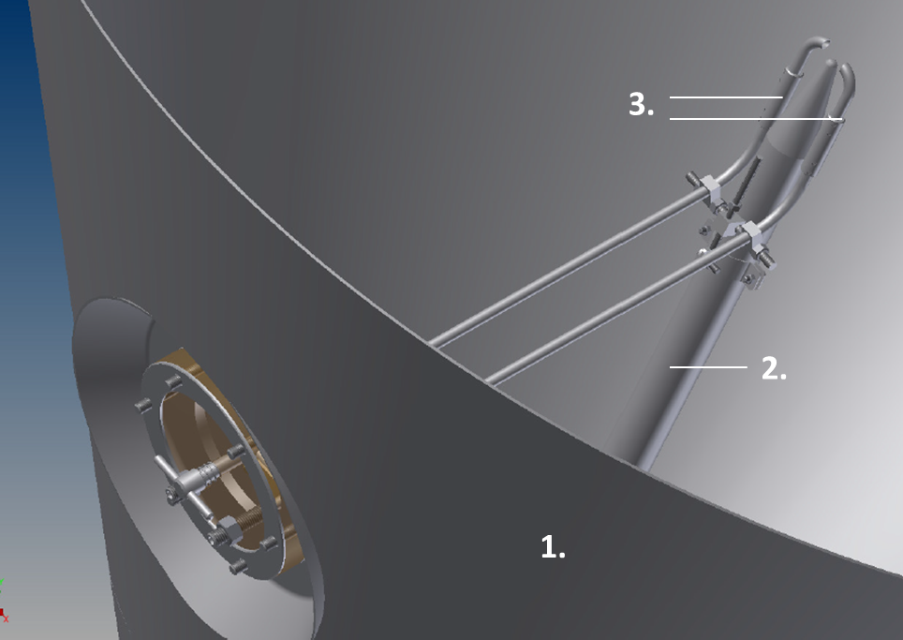

Figure 2: XRD patterns of coprocessed Lac/PVP/par(1), Lac/PVP/par(2) mixtures and their corresponding physical mixtures and starting materials

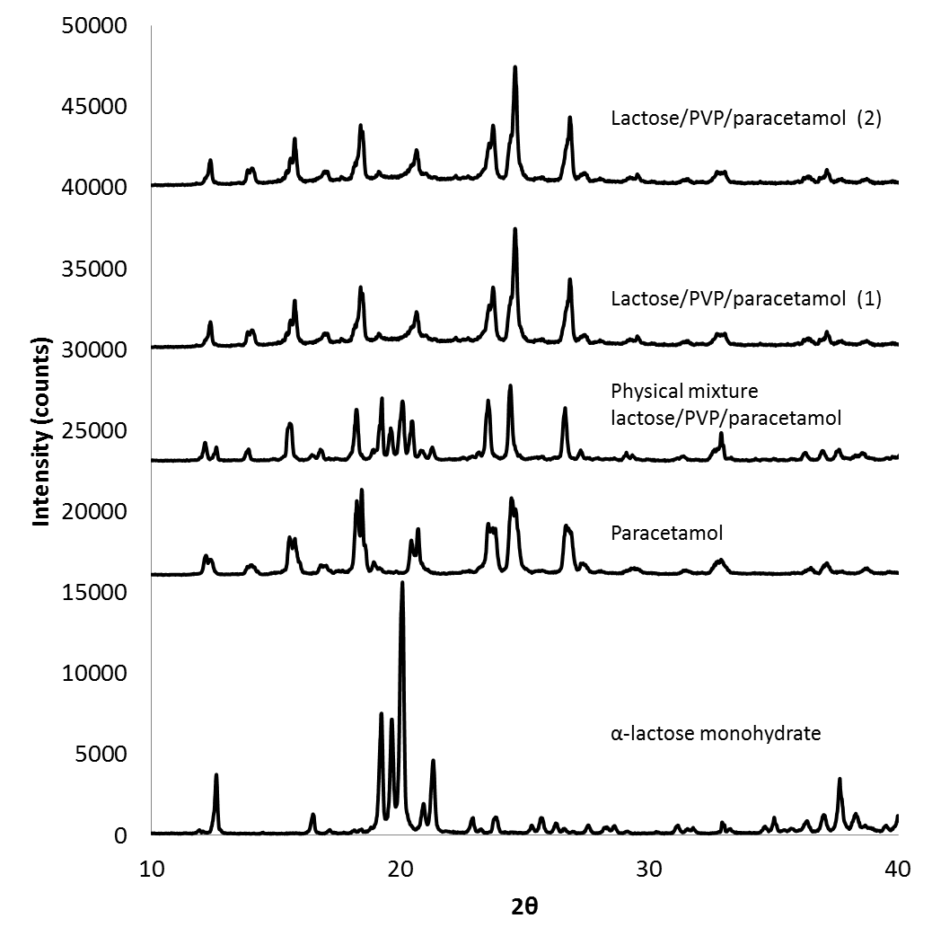

Figure 3: SEM photographs of the coprocessed Lac/PVP/par(1) mixture and paracetamol starting material consisting of needle-like particles

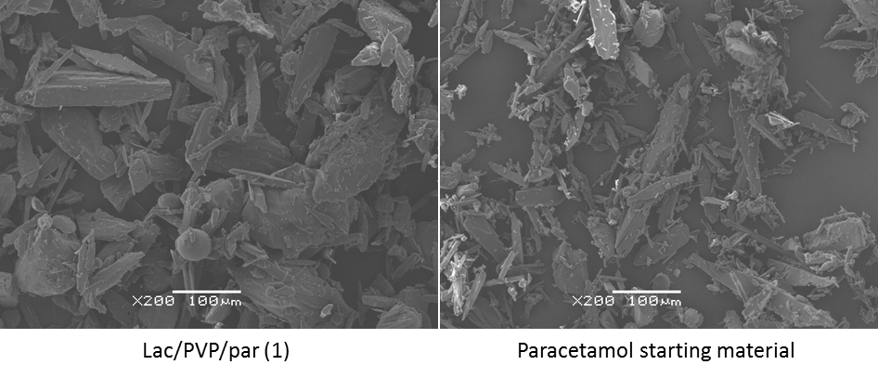

Figure 4: Tabletability of the coprocessed powders with lactose and/or PVP: Lac/PVP/par (1) (full black line ▪) and Lac/PVP/par (2) (full black line▲) and their physical mixture (dotted black line), PVP/par (full blue line) and its physical mixture (dotted blue line)

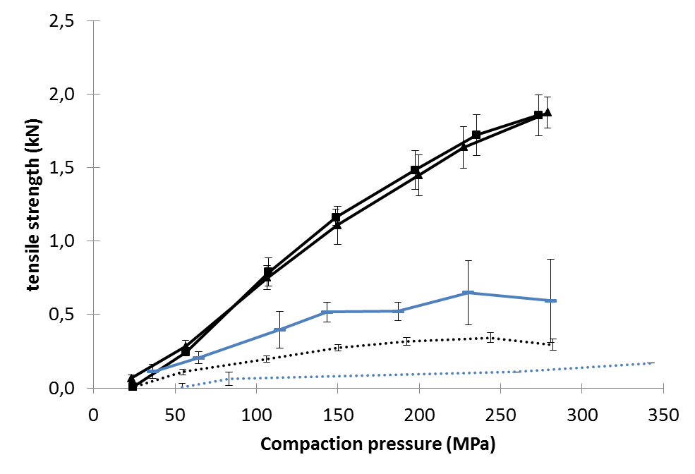

**Tables**

Table 1 Composition of the spray dried solution, feed rate of the solid particles introduced into the spray drying chamber and final composition of the coprocessed paracetamol powders

Table 2 Composition of the spray dried solution, feed rate of the solid particles introduced in the spray drying chamber (g/min) and final composition of the coprocessed lactose powders

Table 3 Mean median particle size (µm) and flowability index (n:3, mean ± SD) of coprocessed paracetamol powders and paracetamol starting material, and friability (%) of tablets compressed at 188 MPa from the coprocessed paracetamol powders and corresponding physical mixtures

Table 4 Powder (mean median particle size, flowability index, n:3, mean ± SD) and tablet (tensile strength, n:10, mean ± SD, friability) properties of the coprocessed lactose samples and reference (direct compression spray dried lactose grade, DCL 11)

Table 1: Composition of the spray dried solution, feed rate of the solid particles introduced into the spray drying chamber and final composition of the coprocessed paracetamol powders

|  |  |  |  |  |  |  |
| --- | --- | --- | --- | --- | --- | --- |
| **Formulation** | **Composition of the spray dried solution** | | **Feed rate solid particles (g/min)** | **Final composition of the coprocessed powders (%)** | | |
| **Lactose**  **(%w/w)** | **PVP (%w/w)** | **Lactose** | **PVP** | **Para-cetamol** |
| Lac/PVP/par(1) | 16 | 4 | 60 | 20 | 5 | 75 |
| Lac/PVP/par(2) | 8 | 2 | 30 | 20 | 5 | 75 |
| PVP/par | - | 3 | 49 | - | 5 | 95 |

Table 2: Composition of the spray dried solution, feed rate of the solid particles introduced in the spray drying chamber (g/min) and final composition of the coprocessed lactose powders

|  |  |  |  |  |  |  |
| --- | --- | --- | --- | --- | --- | --- |
| **Formulation** | **Composition of spray dried solution** | | **Feed rate solid particle introduction (g/min)** | **Final composition of the coprocessed powders (%)** | | |
| **PVP (%w/w)** | **Lactose (%w/w)** | **Spray dried lactose** | **Dry introduced lactose** | **PVP** |
| 1 | 0.8 | 0 | 14 | 0 | 95 | 5 |
| 2 | 0.85 | 2.5 | 14 | 14 | 81 | 5 |
| 3 | 1 | 5 | 14 | 25 | 70 | 5 |
| 4 | 1.25 | 10 | 14 | 40 | 55 | 5 |
| 5 | 0.8 | 16 | - | 95 | - | 5 |

Table 3: Mean median particle size (µm) and flowability index (n:3, mean ± SD) of coprocessed paracetamol powders and paracetamol starting material, and friability (%) of tablets compressed at 188 MPa from the coprocessed paracetamol powders and corresponding physical mixtures

|  |  |  |  |  |
| --- | --- | --- | --- | --- |
|  | **d50 (µm) ± SD** | **ffc ± SD** | **Friability (%)** | |
| **Coprocessed powder** | **Physical mixture** |
| Lac/PVP/par(1) | 226.0 ± 4.2 | 2.9 ± 0.1 | 0.6 | 21.8 |
| Lac/PVP/par(2) | 165.0 ± 4.0 | 2.9 ± 0.2 | 0.6 | 21.8 |
| PVP/par | 167.4 ± 2.6 | 2.6 ± 0.2 | 4.7 | - * |
| Paracetamol starting material | 66.5 ± 0.8 | 1.3 ± 0.1 | - | - |

* Tablets could not be compressed at 188 MPa due to extensive capping

Table 4: Powder (mean median particle size, flowability index, n:3, mean ± SD) and tablet (tensile strength, n:10, mean ± SD, friability) properties of the coprocessed lactose samples and reference (direct compression spray dried lactose grade, DCL 11)

|  |  |  |  |  |
| --- | --- | --- | --- | --- |
| **Formulation** | **D50 (µm)** | **Ffc** | **Tensile strength (MPa)** | **Friability (%)** |
| 1 | 134.5 ± 3.5 | 3.9 ± 0.1 | 8.2 ± 2.0 | 0.1 |
| 2 | 93.3 ± 4.8 | 3.2 ± 0.3 | 8.5 ± 1.3 | 0.0 |
| 3 | 80.9 ± 3.4 | 3.2 ± 0.1 | 8.3 ± 1.71 | 1.0 |
| 4 | 85.3 ± 4.7 | 3.1 ± 0,1 | 8.3 ± 2.0 | 1.2 |
| 5 | 117.3 ± 4.1 | 2.8 ± 0.4 | 6.9 ± 1.0 | 0.2 |
| reference | 93.0 ± 3.6 | 3.9 ± 0.5 | 4.9 ± 0.9 | 3.9 |