Cost-effective integrated optimization of the Eindhoven wastewater system: stepwise implementation of selected measures
Lorenzo Benedetti¹, Jeroen Langeveld^{2,3}, Youri Amerlinck⁴, Jarno de Jonge⁵, Jeroen de Klein⁶, Tony Flameling⁵, Ingmar Nopens⁴, Oscar van Zanten⁵ and Stefan Weijers⁵
¹WATERWAYS srl, Via del Ferrone 88, 50023 Impruneta, Italy
²Royal HaskoningDHV, P.O. Box 151, 6500 AD, Nijmegen, The Netherlands
³Delft University of Technology, PO Box 5048, Delft, The Netherlands
⁴BIOMATH, Department of Mathematical Modelling, Statistics and Bioinformatics, Ghent University, Coupure Links 653, 9000 Gent, Belgium
⁵Waterschap De Dommel, PO Box 10.001, 5280 DA Boxtel, The Netherlands
⁶Aquatic Ecology and Water Quality Management Group, Wageningen University, PO Box 47 6700 AA Wageningen, The Netherlands
Abstract: This project aims at finding cost-efficient measures to meet the Water Framework Directive goals for the Dommel River (The Netherlands). Both acute and long-term impacts of the urban wastewater system (wastewater treatment plant and sewers) on the chemical and ecological quality of the river are studied. An integrated model, which proved to be a powerful tool to analyse the interactions within the integrated urban wastewater system, was used to evaluate the measures using the existing and new infrastructure and real-time control (RTC) strategies. In this paper, the incremental implementation of selected infrastructural measures was investigated. Emphasis was put on the first steps, i.e. a modified use of primary settlers, RTC in the southern part of the sewer catchment and in-stream aeration, which resulted in considerable improvement in receiving water quality (in terms of simulated ammonium and dissolved oxygen dynamics) at a much lower cost than initially estimated.
Keywords: cost-effective systems upgrade; impact based real-time control; integrated urban wastewater system modelling and optimization

Introduction
The Dommel is a relatively small and sensitive river flowing through the city of Eindhoven (The Netherlands), receiving discharges from the 750,000 PE wastewater treatment plant (WWTP) of Eindhoven and over 200 combined sewer overflows (CSOs). The WWTP has circular activated sludge tanks in a modified University of Cape Town configuration. The tanks have an anaerobic inner ring, an anoxic middle ring and a partly aerated outer ring.
In summer time, the WWTP effluent can make up to 50% of the base flow of the Dommel River, which does not yet meet the requirements of the European Union Water Framework Directive (WFD). Waterschap De Dommel, the utility responsible for this compliance, is conducting a research project in order to find the most cost-effective set of measures for meeting the WFD requirements by means of an integrated strategy for the urban wastewater system (Benedetti et al. (2012) and Langeveld et al. (2012)). The focus is on protection of the aquatic environment from oxygen minima and ammonia peaks caused by the combined discharges of the biologically treated WWTP effluent, a rainwater buffer and settling tank (RBT) at the WWTP and the CSOs within the Eindhoven area.
The specific objective of this contribution is the illustration of the model results of the stepwise future implementation of the selected cost-effective solutions in the actual system, and some results of pilot tests of some of those solutions.

Material and Methods
The project consists of several steps. Previous work focussed on the realisation of the integrated system model, the model analysis and the design of RTC. Here, we focus on the latest results, in particular regarding the evaluation of the stepwise implementation of the selected measures (Table 1).
All scenarios were first tested by simulating the integrated model with three rain events with return periods of 5, 0.25 and 0.08 years as input. An ecological evaluation framework (Table 2) based on the local relationship between dissolved oxygen (DO) and NH₄ and the presence of macro-invertebrates was used (de Klein et al., 2012). The quality criteria are defined in terms of thresholds for low DO (for both basic and critical species) and high NH₄ in several combinations of frequency and duration of exceedance, to be used in the evaluation of scenarios simulated for long periods (e.g. 10 years). This framework was applied to evaluate the water quality at six critical sections (where water quality data is collected by the Waterboard) along the Dommel River, together with the calculation of capital and operational costs of measures.

Table 1 List of selected measures evaluated in scenarios.
 | Measure | Field of application/objective
A | Increase interceptor/pumping capacities | Reduce DO minima in the river
B | RTC in the sewer system | Reduction of DO minima and NH₄ peaks in the river improving the use of the available system capacity
C | Increase the hydraulic capacity of the biological treatment at the WWTP | Increase of sewer RTC benefits: lower risk of CSOs while storing water in the sewer
D | NH₄-based feed-forward control at the WWTP for additional aeration package in outer ring | Increase responsiveness of aeration to the influent NH₄ peak loads
E | Decrease of the NH₄ set-point for aeration in the outer ring at the WWTP | Increase intensity of aeration
F | Use of PSTs as dry buffers at WWTP inlet with RTC | Reduction of influent peak load in wet weather flow (WWF) to reduce NH₄ peaks in WWTP effluent
G | Chemically Enhanced Primary Treatment (CEPT) | Reduction of COD load in WWF
J | Effluent aeration | Reduce DO minima in river due to the WWTP effluent
K | Additional aeration capacity in the activated sludge system (middle ring aeration) | Increase nitrification capacity to further reduce NH₄ peak effluent loads during WWF
H | River aeration | Reduce DO minima in river due to WWTP effluent and CSOs

Some tested measures aim at a specific water quality issue, i.e. DO depletion or ammonia toxicity, while others affect both issues, see Table 1. Some of those measures required specific model development. The comparison starts with the current situation (current) and with the new baseline (new) which consists of the implementation of measures A to E. Incremental steps were then tested applying the additional measures listed in Table 1 (F to H). The first steps after the new baseline are:
- step1, the addition of measure F to new: a modified use of the primary settling tanks (PSTs), partly used as dry buffers for NH₄ peak shaving;
- step2, the addition of measure G to step1: dosage of coagulants in the PSTs in wet-weather for COD reduction, i.e. increase of oxygen available for nitrification;
- step3a, the addition of measure J to step2: aeration of WWTP effluent with set-point of 7 mgO₂/l;
- step3b, the addition of measure K to step2: additional aeration during NH4 peak loads in the WWTP middle ring, currently anoxic, therefore becoming a swing zone;
- step3c, the addition of measure J and K to step2: the combination of the previous two;
- step4, the addition of measure H to step3c: in-stream river aeration upstream of the WWTP with set-point at 3 mgO₂/l;
- step5, the addition to step4 of river aeration also downstream of the WWTP with setpoint at 3.5 mgO₂/l.
Measures G (CEPT) and H (in-stream river aeration) were tested at the Eindhoven WWTP and the Dommel River respectively. CEPT was applied to one of the PSTs to measure mostly the PO₄ and COD removals. River aeration was installed shortly upstream of the WWTP with the goal to investigate whether fine bubble aeration in the Dommel is an applicable technique and to estimate the dimensions of a full-scale river aeration. In addition, ecological consequences and practical issues such as the required maintenance of the river aeration were looked at.

Results and discussion
Figures 1 and 2 show, for a 5-year return period event, the incremental effect of measures on NH₄ and DO concentrations in the river downstream the WWTP and the city CSOs. For NH₄, a significant improvement with the implementation of the measures constituting the new baseline (new1) can be observed, and additional substantial benefits of the use of PSTs as dry buffers (step1) is found, as they are meant to flatten the peak load of NH₄, decreasing the load of NH₄ beyond the nitrification capacity of the plant. Other measures appear to have a marginal effect (this was verified also by implementing them independently, not incrementally). Concerning DO, all measures have a limited effect, except in-stream aeration just upstream the considered section (step5). In the case of a less severe events (0.25 years return period), all incremental measures show more effect for both NH₄ and DO (Figures 3 and 4). In this event it is more visible the secondary peak which is due to the outflow of the rainwater tank. The analysis of the results of the 10-year evaluation (Table 2) indicates that the addition of dry buffers, CEPT and middle ring aeration (step3b) provides the maximum benefits when trying to reduce NH₄ peaks. As for Figures 1 and 2, in Table 2 it results that for DO only minor improvements can be accomplished by all measures except for in-stream aeration.

Figure 1 NH₄ concentration in mg/l at the river section 2 km downstream the WWTP effluent and most CSOs; the x-axis shows the hours from the beginning of the rain event (with return period of 5 years).

Figure 2 DO concentration in mg/l at the river section 2 km downstream the WWTP effluent and most CSOs; the x-axis shows the hours from the beginning of the rain event (with return period of 5 years).

Figure 3 NH₄ concentration in mg/l at the river section 2 km downstream the WWTP effluent and most CSOs; the x-axis shows the hours from the beginning of the rain event (with return period of 0.25 years).

Figure 4 DO concentration in mg/l at the river section 2 km downstream the WWTP effluent and most CSOs; the x-axis shows the hours from the beginning of the rain event (with return period of 0.25 years).

Table 2 Results of selected incremental scenarios with the ecological evaluation framework; scores from 1 (very good quality) to 5 (very bad quality) at the river section 2 km downstream the WWTP effluent and most CSOs; for each scenario, the class (coloured left side) results from comparing the simulated yearly exceedance frequency (white right side) to the tolerated simulated yearly exceedance frequency (white left side of the table).
Concerning cost evaluations, the reference scenario, consisting of conventional methods of solving water quality issues and building sewer storage facilities at CSOs, would require a yearly cost (including depreciation on investments) of about € 10.6M (designed to solve only DO problems in the river). The scenario fulfilling all the criteria would require about € 3.7 M implying a yearly saving of € 6.9 M (65%).
As for the pilot tests, Table 3 shows the results of the measured removals with and without Alum dosing in one of the primary settlers, with all dry weather flow sent to only one of the three settlers. CEPT clearly affects PO₄ and BOD/COD removals. The dosage of Alum was controlled with a set point for PO₄ effluent of the PST at 3 mg/l. The other two settlers will be kept available as dry buffers for wet weather flows.

Table 3 Removals in the PST with and without Alum dosing
 | TP | TP filtered | PO₄ | COD | BOD | SS | NH₄ | TKN
Without Alum | 12% | 3% | 0% | 26% | 24% | 51% | 0% | 3%
With Alum | 36% | 53% | 51% | 42% | 37% | 57% | 2% | 10%

Regarding in-stream river aeration, the goal was to investigate whether fine bubble aeration of the Dommel River (Figure 5) is an applicable technique and to help dimensioning of a full-scale river aeration. In addition, the ecological consequences and practical issues such as the required maintenance of such type of river aeration were identified.

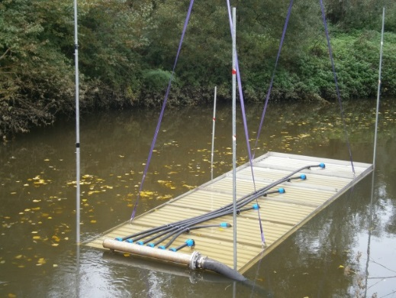 | 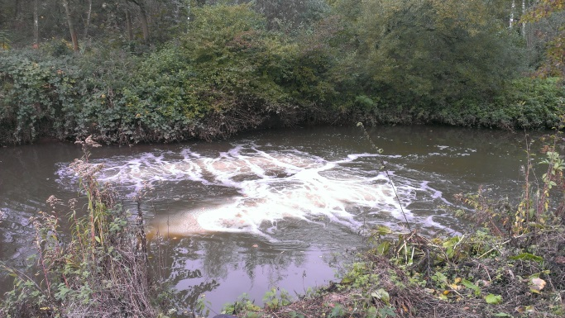

Figure 5 Pilot installation of fine bubble plates for aeration of a stretch of the Dommel River; plates before submersion (left) and in function (right).

The test was performed with 12 plate aerators on two frames of 6 plates each. For each plate, the maximum airflow is 40 Nm³/hr and the size is 1 m x 2 m. The water depth of the Dommel River at the point of immersion is 2.5 m, with an average water velocity of about 0.12 m/s and an average base flow of 9,580 m³/hr. The alpha factor (the ratio of the oxygen transfer rate in dirty water to the oxygen transfer rate in clean water) of the river water was tested once during dry weather conditions and found to be 0.99, which is comparable to drinking water (alpha equal to 1).
The oxygenation capacity of the pilot installation was sufficient to raise the DO concentration in the river by 0.4 mgDO/l at high oxygen concentrations (between 10 and 11.5 mgDO/l). Based on these measurements there is confidence that an approximately 10 times larger installation will raise the DO concentration in the river from 1 to 5 mgDO/l, assuming that alpha will not drop below 0,8 as a result of the CSOs discharge.
Pollution on and around the aeration plates did not cause problems with the oxygen transfer and caused no maintenance issues within the trial period of four months. Floating material is pushed aside by the strong airflow. In the full-scale installation, measures will have to be taken for canoes and small boats to pass safely the section with the aeration equipment.
For the ecology, no adverse effects were noticed. The plates turned out to be a shelter for the (exotic) fish Gobio gobio L.

Conclusions
In this article, the stepwise incremental implementation of a selection of measures previously thoroughly simulated is tested with the aid of the integrated model of the wastewater system of Eindhoven, resembling the planned implementation on the actual system. In parallel, the highest priority measures (CEPT and in-stream aeration) were investigated at pilot scale to measure their actual impact. The combination of modelling and piloting will allow to better design the next steps in the programme.

References
Benedetti, L., Langeveld, J.G., de Jonge, J., de Klein, J.J.M., Flameling, T., Nopens, I., van Nieuwenhuijzen, A., van Zanten, O. and Weijers, S. (2013) Cost-effective solutions for water quality improvement in the Dommel River supported by sewer-WWTP-river integrated modelling. Water Science and Technology 68(5), 965-973.
de Klein, J., Peeters, E., Zanten, O. van, Barten, I. (2012) An Ecological Assessment Framework (EAF) for evaluating the effect of Waste Water Treatment Plant and Combined Sewer Overflows loads on the river Dommel, Wageningen Universiteit, Waterschap De Dommel. 19 p.
Langeveld, J.G., Benedetti, L., de Klein, J.J.M., Nopens, I., Amerlinck, Y, van Nieuwenhuijzen, A., Flameling, T., van Zanten, O. and Weijers, S. (2013) Impact-based integrated real-time control for improvement of the Dommel River water quality. Urban Water Journal 10(5) http://dx.doi.org/10.1080/1573062X.2013.820332

