Sensitive detection of 3’-hydroxy-stanozolol glucuronide by liquid chromatography-tandem mass spectrometry

E. Tudela*, K. Deventer, P. Van Eenoo

Short title: Detection of stanozolol in urine.

* Author to whom all correspondence should be addressed
Address for correspondence
Eva Tudela
DoCoLab, Ghent University (UGent), Department of Clinical Chemistry, Microbiology and Immunology
Technologiepark 30, B-9052 Zwijnaarde, Belgium
Tel: +32 (0)9/3313295
Fax: +32 (0)9/3313299
e-mail: Eva.TudelaPalomar@UGent.be
http://www.docolab.UGent.be

Abstract
Stanozolol is one of the most frequently detected anabolic steroids in doping control samples. This compound is metabolized to a large extent and its metabolites can be detected in urine much longer than the parent compound. The main stanozolol metabolites are excreted in urine as glucuronide conjugates. 3’-hydroxy-stanozolol glucuronide (3STANG) is one of the main stanozolol metabolites in human urine. Therefore enzymatic hydrolysis is usually applied prior to extraction.
In this paper a method for the sensitive detection of 3’-hydroxy-stanozolol glucuronide, by liquid chromatography tandem mass spectrometry, is described.
The method takes advantage of an easy and fast sample preparation based on a single solid-phase extraction avoiding enzymatic hydrolysis or derivatization. It allows to detect stanozolol abuse in human urine at 25 pg mL⁻¹. The method was validated according to Eurachem guidelines. The matrix effect, expressed as ion enhancement was +14 %. The extraction recovery of the method was 93 %. The limit of detection (LOD), whereby all WADA-criteria in chromatography and mass spectrometry are fulfilled, was determined at 50 pg mL⁻¹. Application of the method to an excretion study revealed that the 3’-hydroxy-stanozolol glucuronide could be confirmed for 10 days after oral administration of 2 mg of stanozolol, prolonging detection times compared to other metabolites and methodologies by almost 50%.

Keywords: stanozolol, 3’OH-stanozolol, doping, urine, LC-MS, glucuronide
1. Introduction
Due to the ability to improve the physical performance in human sports anabolic androgenic steroids (AAS) are one of the groups of prohibited substances according to the World Anti-Doping Agency (WADA) . Additionally, they can cause serious health problems as side effects . The presence of synthetic AAS in urine is considered as an evidence of steroids misuse and can result in an adverse analytical finding (AAF) . AAS can be extensively modified by phase-I and phase-II metabolism before excretion in urine . Among the latter metabolic pathways, glucuronidation is commonly observed for AAS .
Stanozolol (17β-hydroxy-17α-methyl-5α-androst-2-eno[3,2-c]-pyrazole) (STAN) was first synthesized in 1959 and is still one of the mostly detected anabolic steroids in doping control samples . The particular structure of the stanozolol, a pyrazole ring fused to the androstane framework, differs from most of AAS.
Stanozolol is intensively metabolized and its urinary metabolites can be detected much longer than the parent compound . The main phase-I metabolic products, important for human doping control purposes, are 3’-hydroxy-stanozolol (3STAN), 4β-hydroxy-stanozolol (4STAN), 16β-hydroxy-stanozolol (16STAN) and 4,16-dihydroxy-stanozolol (4,16STAN) .
Stanozolol metabolites are excreted in urine as glucuronide conjugates, for this reason enzymatic hydrolysis is applied prior to extraction . Before the introduction of liquid chromatography-mass spectrometry (LC-MS) the detection was performed by gas chromatography-mass spectrometry (GC-MS) . However LC-MS is nowadays the first choice for the detection of stanozolol metabolites in urine of both human and animal origin because derivatization is not necessary and the pyrazole ring is easily ionized during electrospray process.
In human doping analysis monitoring the 4,16STAN in negative electrospray ionization has proven to be very attractive for the long term detection of stanozolol abuse . Unfortunately, no commercial standard is available for this compound and confirmation of a suspicious sample can be done by comparing retention time and mass spectrum in a suspicious sample with a contemporaneously analysed reference sample (excretion urine) . Most procedures identify 3STAN, 4STAN and 16STAN using enzymatic hydrolysis and dedicated extraction methods using single/multiple liquid-liquid extractions (LLE) or single/multiple solid phase extractions (SPE) or combinations of both, to obtain sub ng mL⁻¹ detection limits (LOD) in urine .
Recently, the metabolite 3’-hydroxy-stanozolol glucuronide (3STANG) has become commercially available as a reference substance (figure 1.a). Therefore the aim of this work was to investigate if the intact 3STANG can be used to confirm screening positive results in sub ng mL⁻¹ concentrations using a single extraction step.
It should be noted that throughout this paper concentration of 3STANG are expressed as aglycone equivalents to allow direct comparison with other papers.

2. Experimental
2.1. Chemical and Reagents
3’-hydroxy-stanozolol glucuronide (figure 1.a) and the internal standard (I.S.) d3-epitestosterone glucuronide (ETGd3, figure 1.c) were purchased from the National Measurement Institute (Pymble, Australia). The I.S. prostanozol (17β-hydroxy-5α-androst-2-eno[3,2-c]-pyrazole, PROSTAN, figure 1.b) was obtained from TRC (Toronto, Canada).
LC-MS grade methanol and LC-MS grade water were purchased from Biosolve (Valkenswaard, Netherlands) respectively. Ammonium acetate (NH₄OAc) was obtained from Sigma (St. Louis, MO, USA) and hydrochloric acid (HCl), ammonium hydroxide (NH₄OH) and acetic acid (HOAc) were purchased from Merck (Darmstadt, Germany). Oasis® MCX LP extraction cartridges (3 cm³, 60 mg) were purchased from Waters (Milford, MA, USA).
Stock solutions were prepared by dissolving the reference material in methanol and stored at -15ºC. Working solutions were prepared by diluting adequate amounts of stock solutions in methanol and stored at -15ºC.

2.2. Instrumentation
The liquid chromatographic system consist of a Finnigan Surveyor HPLC system which is interfaced to a TSQ Quantum Discovery MAX triple quadrupole mass spectrometer (Thermo, San Jose, USA) using the electrospray surface.
Separation was performed on a Sunfire C₁₈ 3.5µm (2.1 mm x 50 mm) (Waters, Milford, Massachusetts, USA) at a flow rate of 250 µl/min. The temperature of the autosampler and column oven were 15ºC and 35ºC respectively.
The aqueous and methanolic mobile phases consisted both of 1mM NH₄OAc and 0.1% HOAc. The percentage of organic solvent on the gradient program used changed as follows: 0 min, 40%; 0.5 min, 40%; 2 min, 55%; 8.9 min 70%; 9.0 min, 100%; 10 min, 100%; 10.10 min, 40%; 14 min, 40%.
Nitrogen was used as sheath gas and auxiliary gas at flows of 50 and 20 arbitrary units, respectively. Sample ionization was carried out in both positive and negative modes using spray voltages of 4500 V. The capillary temperature was set at 350ºC. The collision gas was argon (Air Liquid, Desteldonk, Belgium) with a collision gas pressure of 1.5 mTorr.

2.3. Sample preparation
A volume of 3 mL of urine sample was spiked with 60 ng of I.S. PROSTAN followed by 1 mL of HCl 1N. The acidified sample was loaded on an Oasis MCX cartridge after a conditioning step consisting of 1 mL of methanol and 1 mL of HCl 0.1 N. The cartridge was subsequently washed with 2 mL of HCl 0.1 N, 2 ml of 2% of acetic acid in methanol and 5% of ammonia in water. Elution was performed with 1.2 mL of 5% ammonia in methanol. Then, 20 ng of ETGd3 were added and the sample was concentrated to dryness on a rotary evaporator under reduced pressure. The residue was reconstituted in 100 µL of a solution containing 1mM ammonium acetate with 5% acetic acid in water-methanol (1:1). After centrifugation of the sample (5 min at 14000 g) the supernatant was transferred to a vial and 40 µL were injected into the system.

2.4. Assay Validation
The qualitative determination of 3STANG in human urine was validated regarding specificity, recovery and limit of detection (LOD) in compliance with the WADA International Standards for Laboratories (ISL) and according to Eurachem guidelines .

Specificity
Specificity was tested during the validation procedure to probe interfering peaks in the selected ion chromatograms at the expected retention times for the target analytes.

Limit of Detection (LOD)
The LOD was defined as the lowest level of the analyte that can be detected in ten urine samples fulfilling the identification criteria established by WADA for chromatography and mass spectrometry .
Ten different blank human urine samples (8 male and two female; pH-range from 5.6 to 8.5; specific gravity between 1.008 and 1.021 g·L⁻¹) were spiked at 25, 50, 75 and 100 pg mL⁻¹ respectively with 3STANG. Blank urines and distilled water sample spiked only with the I.S were also included. The samples were analyzed according to the described method providing the data necessary to determine the LOD.

Extraction Recovery
The recovery of the analytes in the confirmatory analysis was determined at 100 pg mL⁻¹. The 10 blank urines used for determination of the LOD were spiked with 3STANG before sample preparation, and another batch of the same blank urines were extracted according to the described protocol followed by addition of the target compounds into the eluate from the MCX cartridge (after sample preparation). Recovery was calculated by comparison of the mean peak area of the analytes for samples spiked before and after the sample preparation. The I.S. PROSTAN was added in all samples before any sample preparation, following the described protocol to ensure that all the extraction are properly performed and consequently the obtained results are reliable.

Matrix Effects
Matrix effects were studied following the method described by Matuszewski et al .
Assays were performed at 100 pg mL⁻¹. Matrix effects were measured comparing the peak area of the analytes spiked in 10 extracted urines and in a neat standard solution following the formula: M.E. (%) = (Area_{analyte,urine} - Area_{analyte,H20})/Area_{analyte,H20} x100.

2.5. Excretion urine samples and application to doping control samples
An excretion study was performed in a healthy volunteer (male, 37 years) who took a single dose (2mg stanozolol) of Winstrol® (Desma, Madrid, Spain). Urine samples were collected before the intake and at 2 h, 4 h, 6 h, 9 h, 12 h, 24 h, 36 h, 48 h, 72 h, 96 h, 120 h, 144 h, 168 h, 192 h, 216 h and 240 h after the administration. The study protocol was approved by the ethical committee (UZGent, Project B67020084191). Samples were stored frozen at -20°C awaiting analysis.
Additionally, four positive doping test samples, reported for the presence of stanozolol-metabolites, were reanalyzed using the described protocol.

3. Results
3.1. Mass spectrometry
Investigating full scan mass spectra in both positive and negative ionization showed several potential precursors for the SRM method. Negative ionization mode yielded one abundant deprotonated molecule [M-H]⁻ (m/z 519) due to the acidity of the glucuronide moiety. In positive mode an abundant protonated molecular ion was observed [M+H]⁺ (m/z 521) due to the proton affinity of the pyrazol ring . Additionally, an [M+Na]⁺ adduct and [2M+H]⁺ were observed in positive mode and [2M-H]⁻ in negative ionization mode. However, due to their low intensities (<10%), these ions were not further investigated and only the protonated and deprotonated ions were selected for full scan MS/MS experiments. Fragmentation of the 3STANG yielded the loss of the glucuronide moiety at low collision energies. This fragmentation takes places in both positive and negative mode yielding the corresponding aglycone at m/z 345 and m/z 343 respectively (figure 2 a,c). This fragmentation has also been described previously for other steroids glucuronides .
The automatic optimization (data not shown) of the collision energy for the loss of the glucuronide group in positive mode resulted in a value of 26 eV. However, during prevalidation experiments it was observed that, despite a 20% lower intensity, a collision energy of 40 eV increased the S/N by 50%. For this reason, the latter value was used during the validation. Further increment of the CE, in positive mode, yielded a fragmentation pattern similar to the aglycone with one abundant product ion at m/z 97 (figure 2d). The origin of this fragment ion has been described elsewhere . Further increment of the CE in negative mode yielded ions at m/z 85, 113 and 175 which originate from fragmentation of the glucuronide moiety (figure 2b) . These ions were of low abundance and were not used in further experiments.
In a second step, the mass spectrometric behavior of 3STANG and 3STAN were compared. Therefore equimolar solutions of both were analyzed in full scan MS. Comparison of the spectra showed similar ionization efficiency in positive and negative mode. Therefore, it can be concluded that the presence of the glucuronide group does not improve the ionization properties. However, comparison of optimized SRM settings showed that the transition corresponding to the loss of the glucuronide (521/345) is ten times more abundant than the most abundant fragment of 3STAN, i.e. 345/97. The product ion 97 obtained from 3STANG and 3STAN had comparable intensity. The product ion 343 in negative mode also had approximately the same intensity as the 97 being 10 times lower than the 345. Finally, the ions 345, 97 (positive mode) and 343 (negative mode) were included in the SRM method used for method’s validation. Mass spectrometric settings are displayed in table 1.

3.2. Chromatography
Initially, an Omnispher C₁₈ (100mm x 2mm) column was selected due to previous good results for the analysis of stanozolol metabolites . However, during method development, an interference at the retention time of product ion 343 was observed in some urines. Unfortunately, the origin of the interference could not be explained. Changing the chromatographic elution program did not allow to baseline separate the interference from the 3STANG. When the column was replaced by another, shorter, column (Sunfire C₁₈, 50mm x 2.1mm) the interference could not be detected anymore.
Another problem observed during method development was that 3STANG shifted approximately 0.2 min to the front of the chromatogram in some urine samples compared to a reference sample.
This difference exceeded the tolerated shift of 0.1 minutes compared to a reference sample analyzed contemporaneously, making the confirmation criteria not fulfilled . This shift to the front was also observed for the I.S. ETGd3 but not for PROSTAN. This suggests that the shift is related with the acidic glucuronide moiety and supported the choice for ETGd3 as I.S. for chromatography. Despite the fact that ETGd3 showed a similar shift, also the RRT-criterium (maximum allowed difference of 1%) was not fulfilled . This effect was attributed to interaction with the extracted urinary matrix. In order to improve the reproducibility of the retention time, the amount of HOAc in the solution used to redissolve extraction residue was increased from 0,1% to 5%. In this way both reference sample and urinary extracts had the same pH. This change yielded shifts less than 0.1 min compared to an authentic reference sample. Also RRT criteria were fulfilled.

3.3. Sample preparation
3STANG contains a zwitterionic structure which hampers efficient recovery by liquid-liquid extraction (LLE). Therefore solid-phase extraction (SPE) was mandatory. Due to the acidic behaviour of the glucuronide moiety and the basic character of the pyrazol group both cationic and anionic SPE can be applied. Since cation exchange columns have previously been used successfully for the extraction of stanozolol metabolites this type of sorbent was preferred.
Initially an extraction approach previously described was applied . However the 3STANG could not be recovered from the cartridges. Investigating the washing steps showed that the second washing step, used to remove polar basic interferences (5% NH₄OH in MeOH/H₂O 20/80) eluted the 3STANG. Therefore, only a basic wash using 5% NH₄OH in H₂0 was used.
Due to the absence of an isotopic labeled derivative of 3STANG, two substances were selected for quality control purposes: prostanozol was used to control the SPE while ETGd3 was used to control the chromatography (figure 1).

3.4. Assay Validation
In all ten urine samples 3STANG was detected at 25 pg mL⁻¹ with a S/N>3 using the 3 diagnostic ions. However, at this level the ratio’s of the ions did not fulfill WADA identification criteria . Although, in general the criterion of S/N>3 could be used as a definition of an LOD, it was chosen to use more stringent criteria to define the LOD in this paper, taking into account the stringent requirements of doping control.
Therefore the LOD was defined as the lowest level where 3STANG fulfilled all applicable WADA criteria. This was determined at 50 pg mL⁻¹ using the diagnostic ions 97 and 345. At 100 pg mL⁻¹ the ion at m/z 343 would also fulfill all applicable criteria.
Using the optimized extraction protocol the extraction recovery was determined to be 93 ± 4 %. The calculated matrix effects resulted to be an ion enhancement and was +14 ± 7 %.
Specificity of the method was satisfactory since no interfering substances at the appropriate retention times were found when the 10 blank urines were analysed. The described method also seems to be very selective as no interferences were detected when other doping products and medicines, including a wide range of narcotics, corticosteroids, stimulants, anabolic steroids and NSAIDs, were analyzed.

4. Discussion
The approach presented here introduces significant improvements compared to previous research, allowing the confirmation of stanozolol misuse at very low concentration in human urine using one extraction step without the need for an enzymatic hydrolysis.
Comparing the observed LOD, the method exhibited 10 times more sensitive than previous described methods where LODs of 500 pg/mL for 3STAN were achieved after enzymatic hydrolysis and detection by LC-MS or GC-MS . The method also exhibits better sensitivity than that described for 4STAN and 16STAN (LOD of 200 pg/mL) . Similar LODs of 50 pg mL⁻¹ for 4STAN and 16STAN, and 25 pg mL⁻¹ for STAN could only be reached using high-field asymmetric waveform ion mobility mass-spectrometry (FAIMS) .
The significant improvement compared with the other detection-methods, is probably due to a combination of factors. The presence of an additional product ion (521/345) with an intensity 10 times higher than the 345/97 contributes to the sensitivity of the assay. The main difficulty in the confirmation of 3STAN is that the most intense transition (345/97) is approximately 5 times more abundant than the second most intense one (345/121). Although a single precursor-product ion can be sufficient for the identification, if the uniqueness of that transition is proved, normally two precursor–product diagnostic ions are used to confirm an AAF . Additionally, the absence of an enzymatic hydrolysis, the high extraction recovery and the low matrix effect contributes to the sensitivity as well. Finally, the absence of a time-consuming hydrolysis step (generally 1.5-2.5 h) also improves turn-around time.
Applying the method to an administration study showed, in the sample prior administration of 2 mg of stanozolol, no peak at the retention time of 3STANG. In the samples post-administration, 3STANG could successfully be detected until 240 hours (10 days) after intake (figure 3). This means a prolongation of detection times of almost 50% compared to another approach detecting the aglycone 3STAN .
The validated method was also applied to an AAF for which 4,16STAN was observed as most abundant metabolite during routine analysis. 3STANG was identified and the retention time and ratio between the ion transitions also fulfilled the WADA criteria compared with a spiked urine at 50 pg mL⁻¹ (Figure 4).

5. Conclusion
A sensitive method for the detection of 3’OH-stanozolol glucuronide has been validated. Taking into account WADA identification criteria an LOD of 50 pg mL⁻¹ was obtained. This low LOD can be attributed to the presence of an additional abundant and specific transition. The omission of the enzymatic hydrolysis step, low matrix effect and high extraction recovery also contribute to the sensitivity of the assay. The method was also successfully applied to positive samples and to excretion urine samples showing an increase in detection times of 50% compared to detection of the aglycone.

Acknowledgement
The authors wish to thank WADA for financial support (grant 11A17PV).

References

Figures:

Figure 1: Chemical structures of the investigated compound and the internal standards used: (a) 3STANG; (b) PROSTAN; (c) ETGd3.

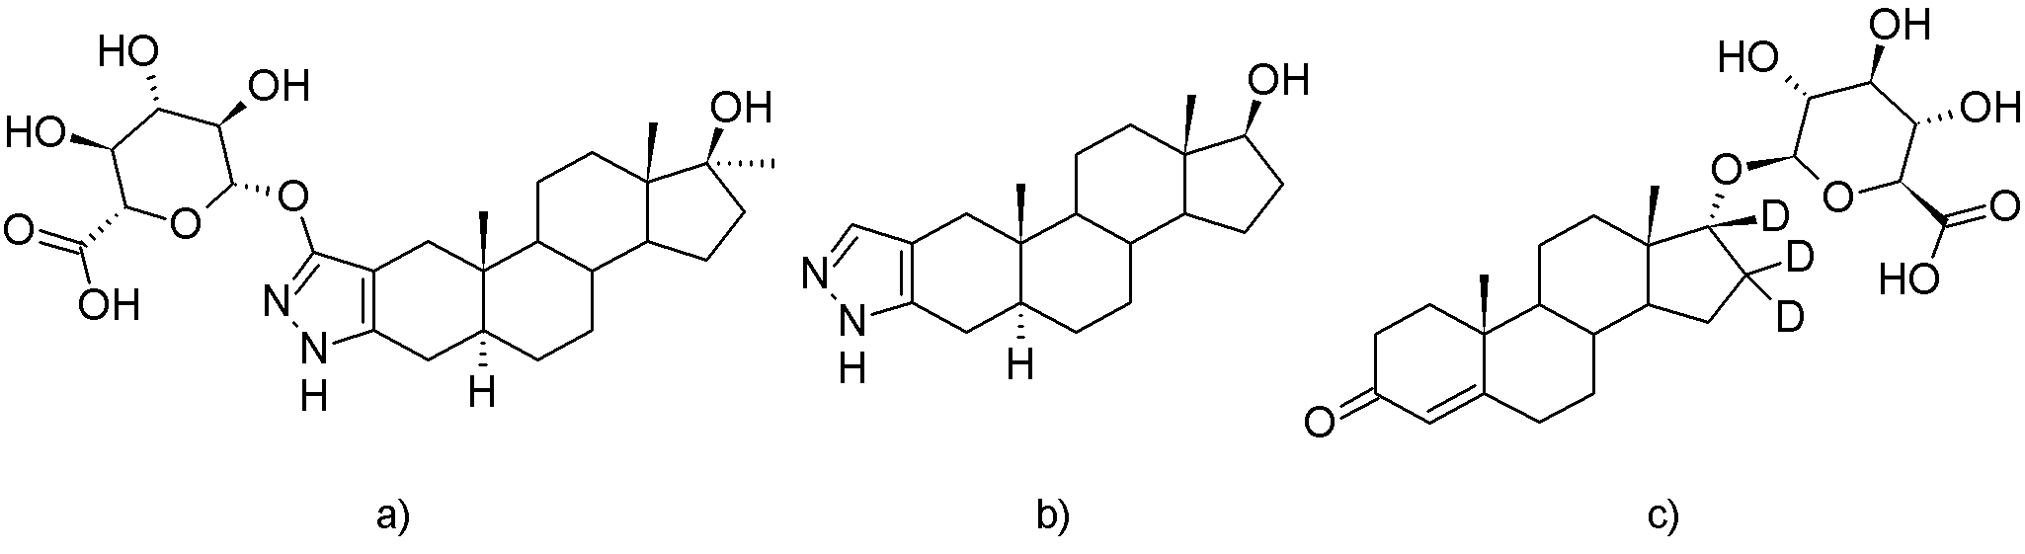
Figure 2: Product ion spectra for 3STANG: in negative ionization mode at 20 eV (a) and 30 eV (b) and in positive ionization mode at 20 eV (c) and 80 eV (d).
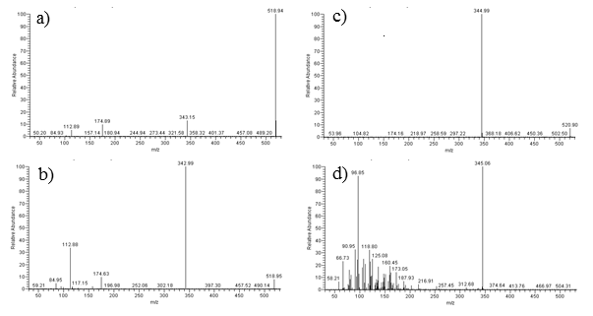
Figure 3: Administration sample after 240 h: (a) sample prior administration; (b) sample post-administration, 240 h; (c) standard solution of 3STANG at 3 ng mL⁻¹
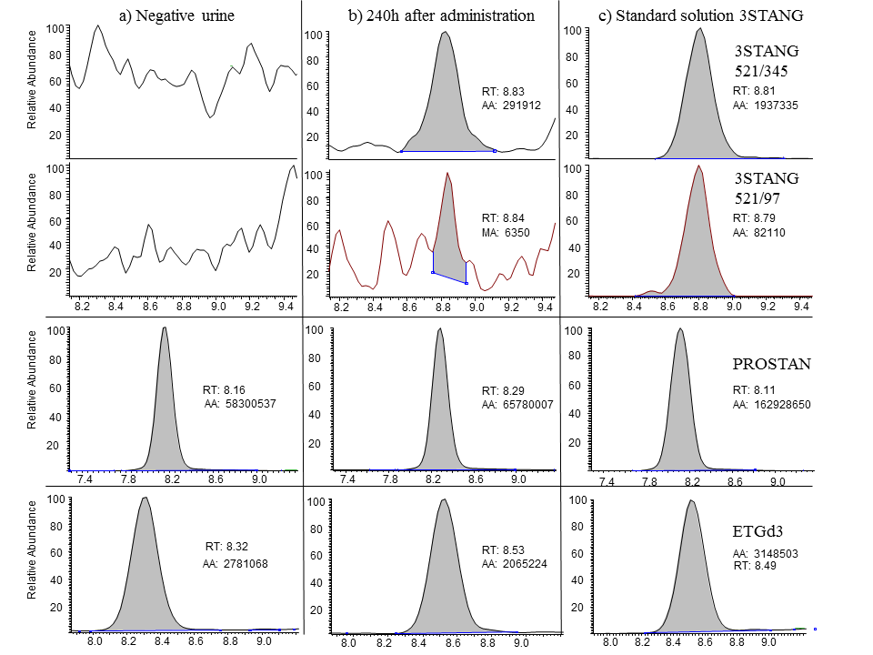
Figure 4: Adverse Analytical Finding: (a) negative urine; (b) AAF; (c) spiked urine at 50 pg mL⁻¹
