Modeling Ferrite Core Losses in Power Electronics

A. Van den Bossche*, V. C. Valchev **

Abstract – The paper summarizes the research of the authors dedicated to ferrite core losses under conditions specific for Power Electronics. Models named NSE and DNSE and models of the losses with DC bias are fully presented and validated. The models are checked with measurements on two different ferrite grades, with square voltage waves with a large variation in duty ratio. The model NSE is extended and improved to DNSE (Double Natural Steinmetz Extension). The dependency of the core looses in half bridge and full bridge configurations of the waveforms are well modeled using a hysteresis part and a part dependent on dB/dt. A model for ferrite loss under DC bias was proposed It is found the relative sensitivity to DC bias is mainly present in the low frequency component of the losses and that the higher frequency losses show an almost quadratic loss dependency on the peak induction.

Keywords: Ferrite core losses, Modeling and measuring core losses

I. Introduction
Losses in magnetic components for power electronics are very significant for their design. The losses can be separated in core and winding losses. High-frequency core losses have been considered in lots of publications under three traditional categories: hysteresis, eddy-current and residual losses. A dynamic model, based on Preisach modeling, and considering all the categories of losses in given in [1]. The macroscopic mechanisms responsible for losses in magnetic materials are discussed in classical books [2], [3], [4] and also summarized and updated in [5]. The articles [6], [7] present a technique that predicts a more accurate magnetic core loss for pulsed operation than does the traditional method of assuming core loss for sinusoidal excitation. A practical approach for computing high-frequency ferrite core losses for arbitrary voltage waveforms is presented in [8]. The approach requires a few material parameters.
Practical oriented approaches for optimizing losses in the design of magnetic components are presented in [9], [10]. The disadvantages of most of proposed methods are the required additional measurements for given material and extensive parameter calculations.
Traditionally, the peak induction is used to determine the losses of ferrite materials and it is derived for sine waves. The most popular formula is known as the Steinmetz equation [11],

$P_{\text{av},v}= k f^{α} {\hat{B}}^{β}$ (1)

where $\hat{B}$ is the peak induction, P_{av,v} is the average power loss per unit volume and f is the frequency of the sinusoidal excitation. This corresponds to straight lines in a double logarithmic diagram when the power loss is shown depending on frequency or peak induction. For common used power ferrites, α=1.2−2 and β=2.3−3. This type of behavior loss is not corresponding to pure hysteresis loss (α=1) or Foucault losses (α=2). It is also non-linear as β≠2. Low values of α correspond to low frequencies. High temperatures tend to result in a higher β. The losses of ferrites can be ranged in excess losses, where a general model is not obvious.
The usual waveforms in power electronics are square waves or a superposition of square waves rather than sine waves. For square waves of 50% duty ratio the equation (1) looses in accuracy, but remains still a good approximation. When the same peak-peak induction is maintained, but with a duty ratio of 5% (or 95%), we did observe in earlier calorimetric experiments more than doubled losses compared to sine wave. This was the starting point to make a set-up for an oscilloscope based accurate power measurements in square wave like voltages and to model the ferrite core losses under these conditions. In power electronics also some magnetic components operate under DC bias, which has a significant influence on the ferrite losses. This phenomenon is not investigated and described enough in the literature.
The paper summarizes the research of the authors dedicated to ferrite core losses under conditions specific for Power Electronics. Models named NSE and DNSE and models of the losses with DC bias are fully presented and validated.

II. Ferrite core loss measurement set-up
A high frequency test platform was used for tests [12]. It uses MOSFET transistors for fast switching, but the topology avoids high switching losses minimizing losses due to the recovery charge of the freewheel diodes of the MOSFET transistors. The converter is protected using de-saturation feature of IGBT transistors. A Yokogawa DL1540 digital oscilloscope is applied for power measurement. The average power is computed by the multiplying capability of channel 1 and channel 2. Exactly two periods are displayed, triggering at the zero crossing of the current. An averaging factor of 32 is used in the acquisition. The duty ratio is changed to obtain a variable waveform, while maintaining a constant peak-to-peak flux. A wide band current probe has been used (150Hz-50MHz), together a voltage probe with almost the same characteristic as the current probe, to obtain a phase shift close in the order of 1ns at 50MHz.
Different ferrite materials are measured: 3F3 material, core ETD 44 core: N67 material, core EE42. A peak induction of 0.1T is maintained.
To have an independent check of the power loss measurement, a calorimeter (20W size) test is done for D=50%. The comparison shows a 2% overestimation of the proposed measuring method to the calorimetric measurements, and for D=95%, with a 5% underestimation. These differences are low considering the operating frequency and the special waveforms.

III. Modified Steinmetz Equation
The ‘Modified Steinmetz Equation’ (MSE) presented in [13] and later in [14] is a known prediction of losses with non-sinusoidal waveforms.
The losses in MSE are then given as

$P_{\text{MSE}}=k f_{\text{eq}}^{α} {\hat{B}}^{β} f$ (2)

where $f_{\text{eq}}$ is an ‘equivalent frequency’;
$f$ is the operating frequency;
$α$ and $β$ are the exponents, derived under sine excitation.

The modified Steinmetz equation uses the root mean square (rms) value of dB/dt, and defines an equivalent frequency for which this rms value would correspond to a sinusoidal B. This derivative dB/dt is usually proportional with a voltage of a winding, which can easily be measured or calculated.
First, the rms value of dB/dt is calculated:

${\left({\left\langle \frac{\text{dB}}{\text{dt}}\right\rangle }_{\text{rms}}\right)}^{2}= \frac{1}{T}\int_{0}^{T}{{\left|\frac{\text{dB}}{\text{dt}}\right|}^{2}} \text{dt}$ (3)

Then, an equivalent frequency is defined as

$f_{\text{eq}}=\frac{2}{{\left(2 π \frac{B_{\text{pp}}}{2}\right)}^{2}} \int_{0}^{T}{{\left(\frac{\text{dB}}{\text{dt}}\right)}^{2}\text{dt}}$ (4)

where $B_{\text{pp}}$ is peak-to-peak induction value;
$T=1/f$ is the period of the operating frequency.

Note that $f_{\text{eq}}=f$ for sine wives. The equivalent frequency is used to apply the original Steinmetz equation to compute the losses.
The origin of the losses in ferrite is nor pure eddy current, nor pure hysteresis but can be attributed to excess losses. The modified Steinmetz equation is clearly a good model when the losses depend on the square of dB/dt, i.e. when $α=2$. But the question remains for other values of $α$.

IV. Proposed Natural Steinmetz Extension
In ferrite materials, there is some dependency of the batch and also manufacturer data change in time. We measured the samples with sine waves to avoid this problem.
To define a working area, a reference frequency is defined with a reference power and induction:

$k_{\text{ref}}= \frac{P_{\text{ref}}}{B_{\text{ref}}^{β} f_{\text{ref}}^{α}}$ (5)

$P= k_{\text{ref}} B^{β} f^{α}=P_{\text{ref}} {\left(\frac{B}{B_{\text{ref}}}\right)}^{β} {\left(\frac{f}{f_{\text{ref}}}\right)}^{α}$ (6)

The parameter β is fitted at the reference frequency (100kHz), for the reference induction (0.1T), and other levels (0.05 and 0.15T). The parameter α is determined using the losses at the reference induction at higher frequency. A second frequency of 250kHz was taken as is lies between the second and third harmonic.
Here we give the values α and β for two ferrite grades: 3F3 and N67, obtained after measuring the corresponding cores. The found value of β at 100°C is higher than the value at 25°C. The value of α is higher at 100kHz than at 25kHz. The values are shown in Table I.

TABLE I
Measured material constants at the reference points
Material  Grade | K_{ref} | α | β | Operational  conditions
3F3 | 0.0482 | 1.842 | 3.06 | 100°C, 100kHz
N67 | 0.1127 | 1.76 | 2.94 | 100°C, 100kHz
3F3 | 17.26 | 1.31 | 2.9 | 100°C, 25kHz
The parameters α and β are quite close to the actual data sheets (internet sites).
In a quasi-static approach, no power loss is generated during moments where B is constant. The losses can be represented as a surface in the B/H loop. A natural way to include the frequency dependence is to include a dependence on dB/dt with power α, dictated by the frequency dependence. A similar type of equation has been mentioned as a possibility in [13] and other only more involved solutions have been elaborated, which do not increase the accuracy.
We propose the following loss model called ‘Natural Steinmetz Extension’:

$P_{\text{NSE}}= {\left(\frac{ΔB}{2}\right)}^{β−α} \frac{k_{N}}{T}\int_{0}^{T}{{\left|\frac{\text{dB}}{\text{dt}}\right|}^{α}} \text{dt}$ (7)

This equation is consistent with the Steinmetz equation (1) for sine waves, if k_{N} is defined as:

$k_{N}= \frac{k}{{\left(2π\right)}^{α−1} \int_{0}^{2π}{{\left|\text{cos}θ\right|}^{α}}dϑ}$ (8)
where k comes form the equation (1). The value k_{N}/k is a constant, once α is known. Fig. 1 shows this relation.

Fig. 1 Ratio of the constants kN /k as a function of α.

For a square wave voltage with duty ratio D, the equation (7) can be simplified to:
$P_{\text{NSE}}=k_{N} f^{α} {\left(Δ B\right)}^{β} \left({\left(\frac{2}{D}\right)}^{α}+{\left(\frac{2}{1−D}\right)}^{α}\left(1−D\right)\right)$ (9)
and then to:

$P_{\text{NSE}}=k_{N} {\left(2f\right)}^{α} {\left(Δ B\right)}^{β} \left(D^{1−α}+{\left(1−D\right)}^{1−α}\right)$ (10)

where f is the operating frequency;
${ΔB}/2$ is the peak induction;
D is the duty ratio of the square wave voltage.
Note: The second and third harmonics are dominant at moderate values of duty ratio D. For extreme values of D (95%), a higher value of α could give better matching to the actual losses.
The specific loss predictions (P_{V}, losses per unit volume) calculated by NSE, the equation (8), are shown in Fig. 2 and Fig.3 for the ferrite grades 3F3 and N67 at 100kHz and 25kHz, 0.1 T. The same graphs show the experimental measurements for square voltage waveforms with D=50%–95%.
The computed results of the ‘Modified Steinmetz Equation’ (MSE), equation (5), and the classical Steinmetz Equation (1) with corresponding α and β for sine wave, are also shown in the same graphs. The experiments were made with an ETD 44 core, 3F3 material grade and an EE42 core, N67 material grade.

Fig.2 Specific ferrite core losses with square voltage waveforms for ferrite grade 3F3 at 100kHz, 100°C, 0.1 T as a function of duty ratio D; the experiments are the circles; the Natural Steinmetz Extension is the solid curve (NSE), for α=1.842; β =3.06; the Modified Steinmetz Equation (5) is the dashed curve (MSE); classical Steinmetz Equation (1) is dash-dot curve (SE).

Fig.3 Specific ferrite core losses with square voltage waveforms for ferrite grade N67 at 100kHz, 100°C, 0.1 T as a function of duty ratio D; the experiments are the circles; the Natural Steinmetz Extension is the solid curve (NSE), for α=1.76; β =2.94; the Modified Steinmetz Equation (5) is the dashed curve (MSE); classical Steinmetz Equation (1) is dash-dot curve (SE).
The given comparisons show that the matching with the experimental results for NSE is within 5% for duty ratio D up to 90%. The small difference for D=95% can be explained by the high frequency content at that point and the fact that material characteristics show a higher α at higher frequencies.
Note that NSE and MSE show the same numerical results for α=1 (pure hysteresis losses) and for α=2 (pure Foucault losses).
Since in non-linear magnetic materials, harmonic superposition is not allowed, the solution was to fit α on a reference frequency (the fundamental) and on a frequency in the region of the most dominant harmonics. The disadvantage is that although the overall accuracy can be satisfactory, the modeling is somewhat dependent on the dominant harmonics.

V. Improved Double Natural Steinmetz Extension
It is clear that a higher number of parameters usually fits better, but it is valuable if the parameters can be determined and if it improves the modeling. We sum two Steinmetz equations one term with α=1, which means pure hysteresis and one term with α>1. For convenience we define a reference frequency, a reference induction and a reference power, we give them the index r:
$P_{\text{sin}}= P_{ r} γ\frac{f}{f_{r}} {\left(\frac{B}{B_{r}}\right)}^{β_{1}} +P_{ r}(1−γ) {\left(\frac{f}{f_{r}}\right)}^{α} {\left(\frac{B}{B_{r}}\right)}^{β_{2}}$ (11)
f_{r} : reference frequency (here 100kHz)
γ : fraction of hysteresis losses at the reference case
We expect that $0<γ<1$, $α>1$, $β_{1}>2$and $β_{2}>2$
The above equation is called the Double Natural Steinmetz Extension (DNSE). The word double refers that the Steinmetz extension is applied two times, once with α=1 in the first term, where only the peak value influences the losses and once for α>1 in the second term.
The reference power can be one of the measurement points, we did take it at 100kHz, 0.1T. The parameter α and γ can be determined by fitting the experimental data or manufacturer data. We fit it with experimental data.
For γ = 1 we are in the pure hysteresis situation; whereas γ = 0 corresponds to a traditional Steinmetz with constant α. For α =2 we would have a loss type known as Foucault losses. In this article the parameter α is only used as a curve fitting, even an α > 2 is possible.
The used material was 3F3, the shape ETD44, the induction 0.1 T peak (0.2 T peak to peak). We performed the measurements in sine wave, the results are shown in Table II.

TABLE II
performed measurements in sine wave
f , [kHz] | 20 | 50 | 100 | 250 | 500 | 700
P [W] | 0.136 | 0.410 | 1.18 | 6.25 | 25..6 | 50

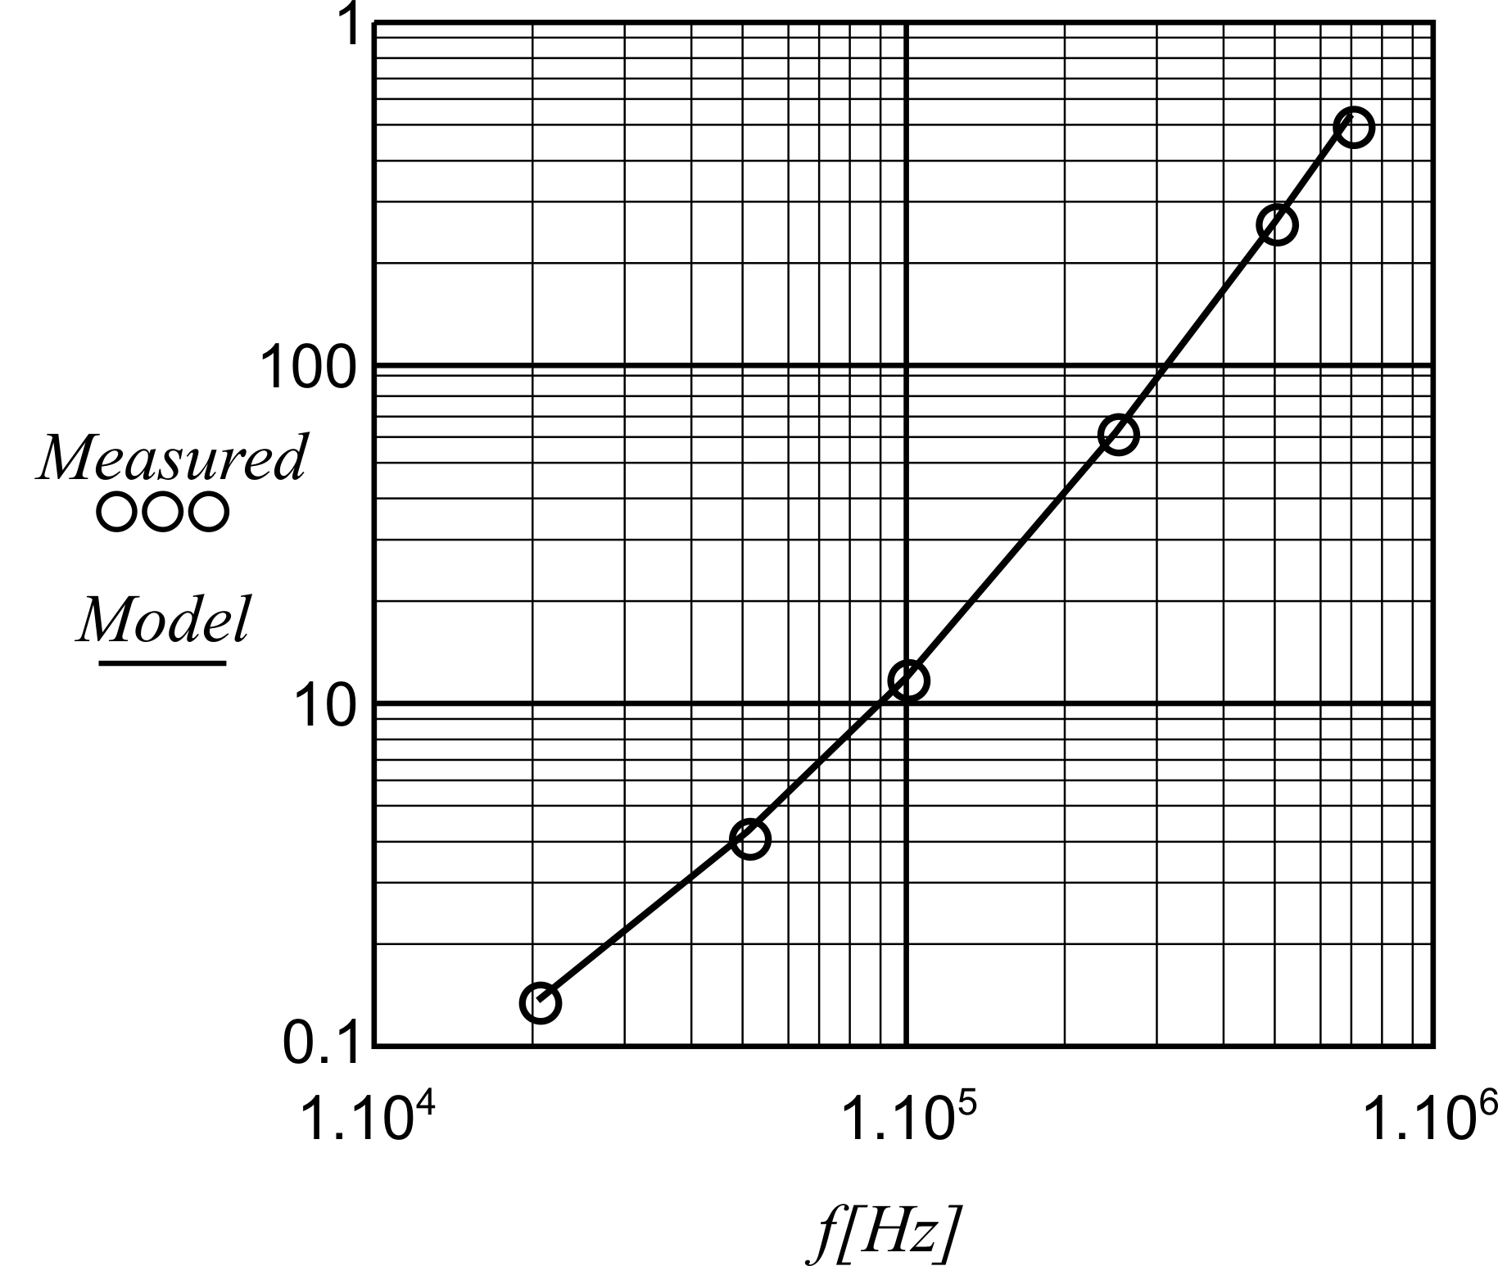
Fig.4. Specific ferrite core losses (per volume) with sine wave voltage for ferrite grade 3F3, 0.1T and 100°C,
Measurements – the circles
the curve: Double Steinmetz Natural Extension
with α=2.26 and γ= 0.50, Pr = 1.18W.

All the measurements are carried out at 100°C as that corresponds to a minimum loss for the material. In this way stable and repeatable measurements can be done.
A good match is obtained for α=2.26 and γ= 0.5 as shown in Fig. 4.
To improve the equation, we attribute the power α part to a dependency on dB/dt. This part is similar to the proposed Natural Steinmetz Extension NSE. The purpose is to match also non-sinusoidal cases. Thus, the following expression is obtained:

$P_{\text{DNSE}}=γ P_{ r} \frac{f}{f_{r}} {\left(\frac{B}{B_{r}}\right)}^{β_{ 1}}+(1−γ) P_{ r} {\left(\frac{B}{B_{r}}\right)}^{β_{ 2}−α} \frac{κ(α)}{T} \int_{0}^{T}{{\left|\frac{\text{dB}}{\text{dt}}\right|}^{α}\text{dt}}$(12)

The parameter γ is the part of the losses at the reference frequency, which follows the hysteresis losses.
The function κ(α) in (5) is defined in such way that it satisfies the sine wave solution:

$κ(α)= \frac{1}{{\left(2π\right)}^{α−1} \int_{0}^{2π}{{\left|\text{cos}θ\right|}^{α}}dϑ}$ (13)

Note that κ(α) is only depending on α, this is shown in Fig2. Corresponding to hysteresis losses, for α=1, the function κ(α) = 1/4. Corresponding to Foucault losses, for α=2, the function κ(α) = 1/(2 π² ) = 0.0507.

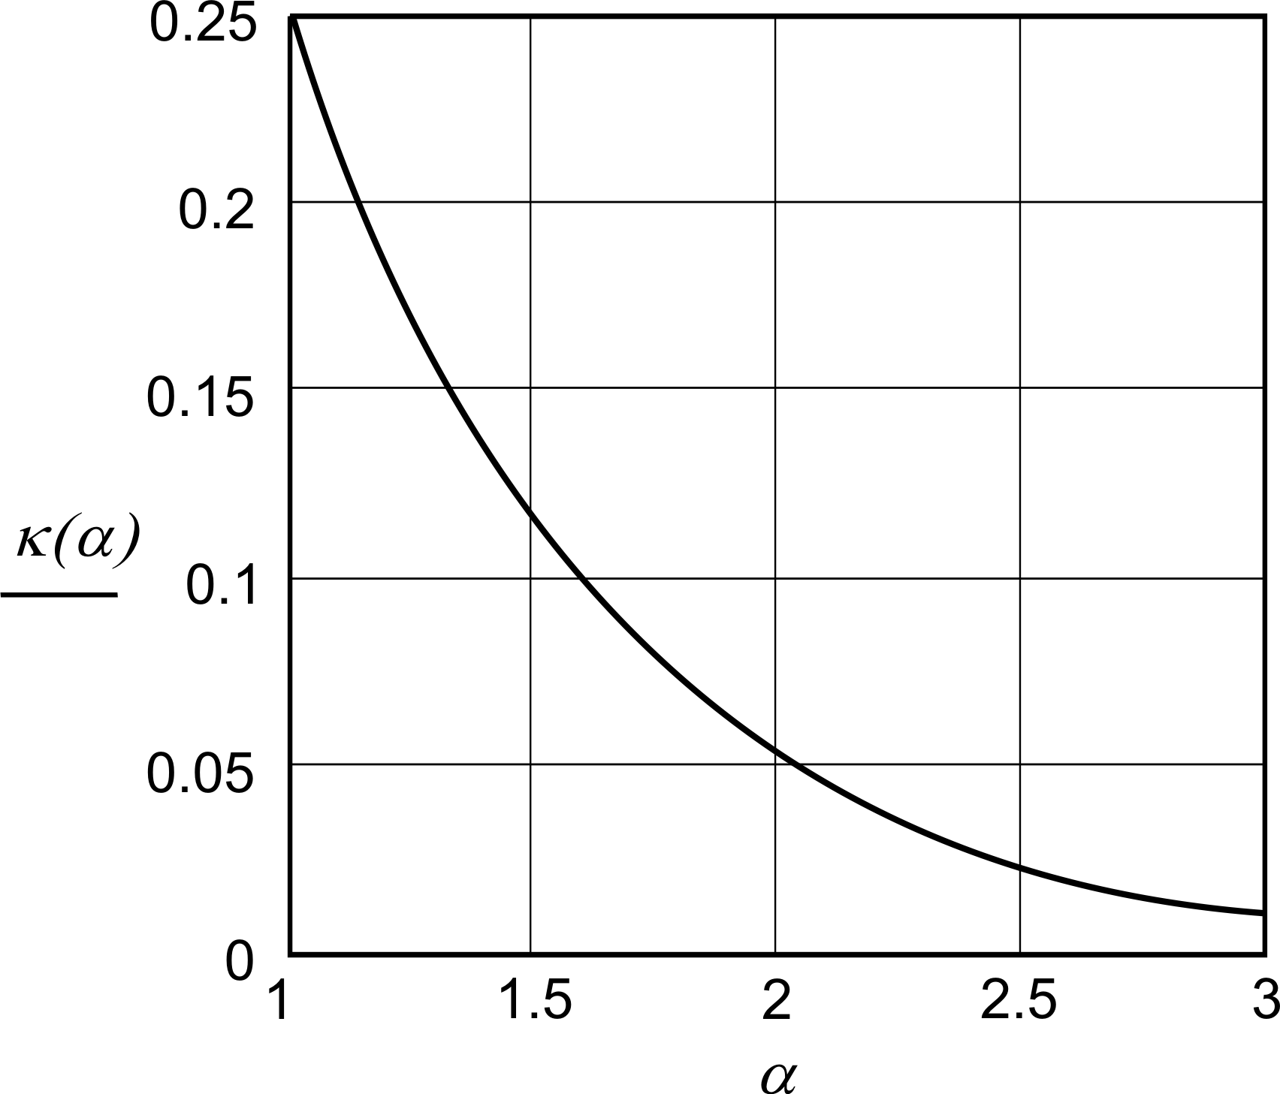
Fig.5 Factor κ(α) as function of α

Note also that in this article we keep the peak inductance constant, so that the values of β₁ and β₂ are not important.

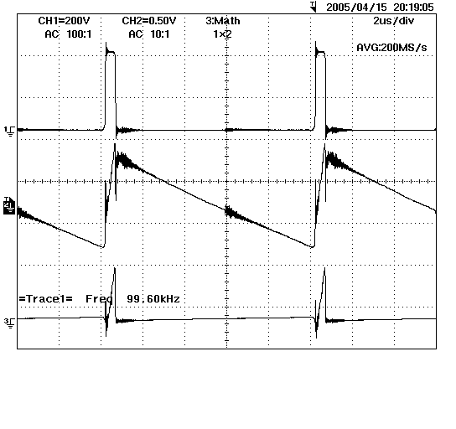 Fig.6. Measured voltage, current and power for a half bridge at D=0.05, 200V/div 500mA/div, 100W/div

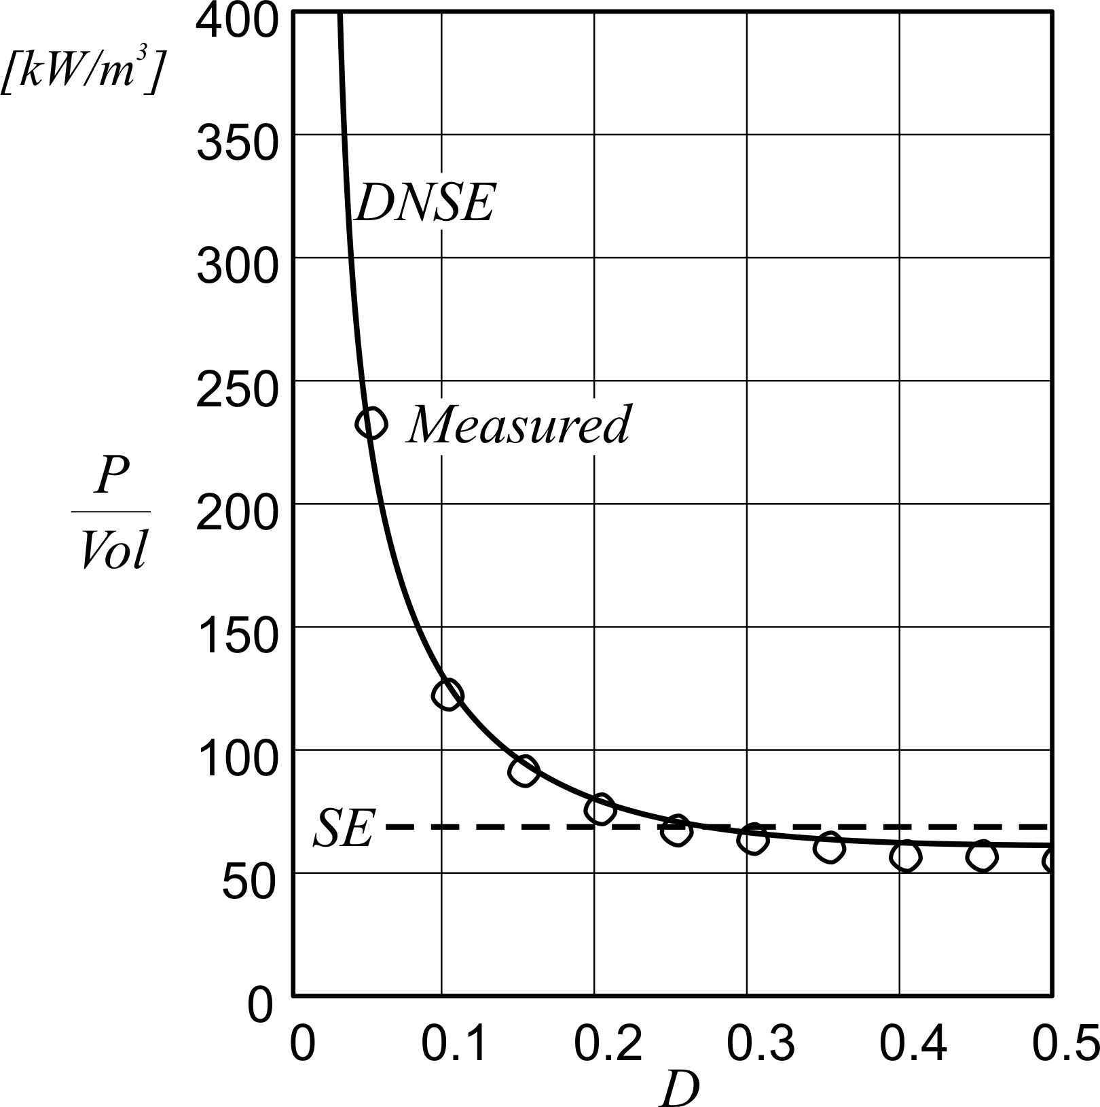
Fig.8 Ferrite losses/volume for a half bridge measurement as a function of D (duty ratio), 0.1T, 100kHz
DNSE, measured results and classical Steinmetz Equation, SE

We can separate the losses in:
$P_{\text{DNSE}}=P_{\text{hyst}}+P_{\text{NSE}}$ (14)
with:
$\begin{aligned}P_{\text{hyst}}=γ P_{ r} \frac{f}{f_{r}} {\left(\frac{B}{B_{r}}\right)}^{β_{1}} \\ P_{\text{NSE}}=(1−γ) P_{r} {\left(\frac{B}{B_{r}}\right)}^{β_{2}−α} \frac{κ(α)}{T} \int_{0}^{T}{{\left|\frac{\text{dB}}{\text{dt}}\right|}^{α}\text{dt}}\end{aligned}$ (15)
For a half bridge square wave voltage with duty ratio D, the integral can be rewritten as:
$\frac{1}{T} \int_{0}^{T}{{\left|\frac{\text{dB}}{\text{dt}}\right|}^{α}\text{dt}}= f^{α} B^{α} \left({\left(\frac{2}{D}\right)}^{α}D+{\left(\frac{2}{1−D}\right)}^{α}\left(1−D\right)\right)$ (16)
and then to
$\frac{1}{T} \int_{0}^{T}{{\left|\frac{\text{dB}}{\text{dt}}\right|}^{α}\text{dt}}=f^{α}B^{α}2^{α}\left(D^{1−α}+{\left(1−D\right)}^{1−α}\right)$ (17)

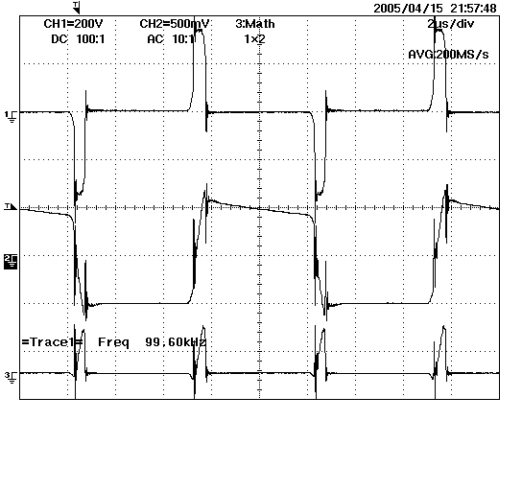 Fig.7. Measured voltage, current and power for a full bridge at D=0.05, 200V/div 500mA/div, 100W/div

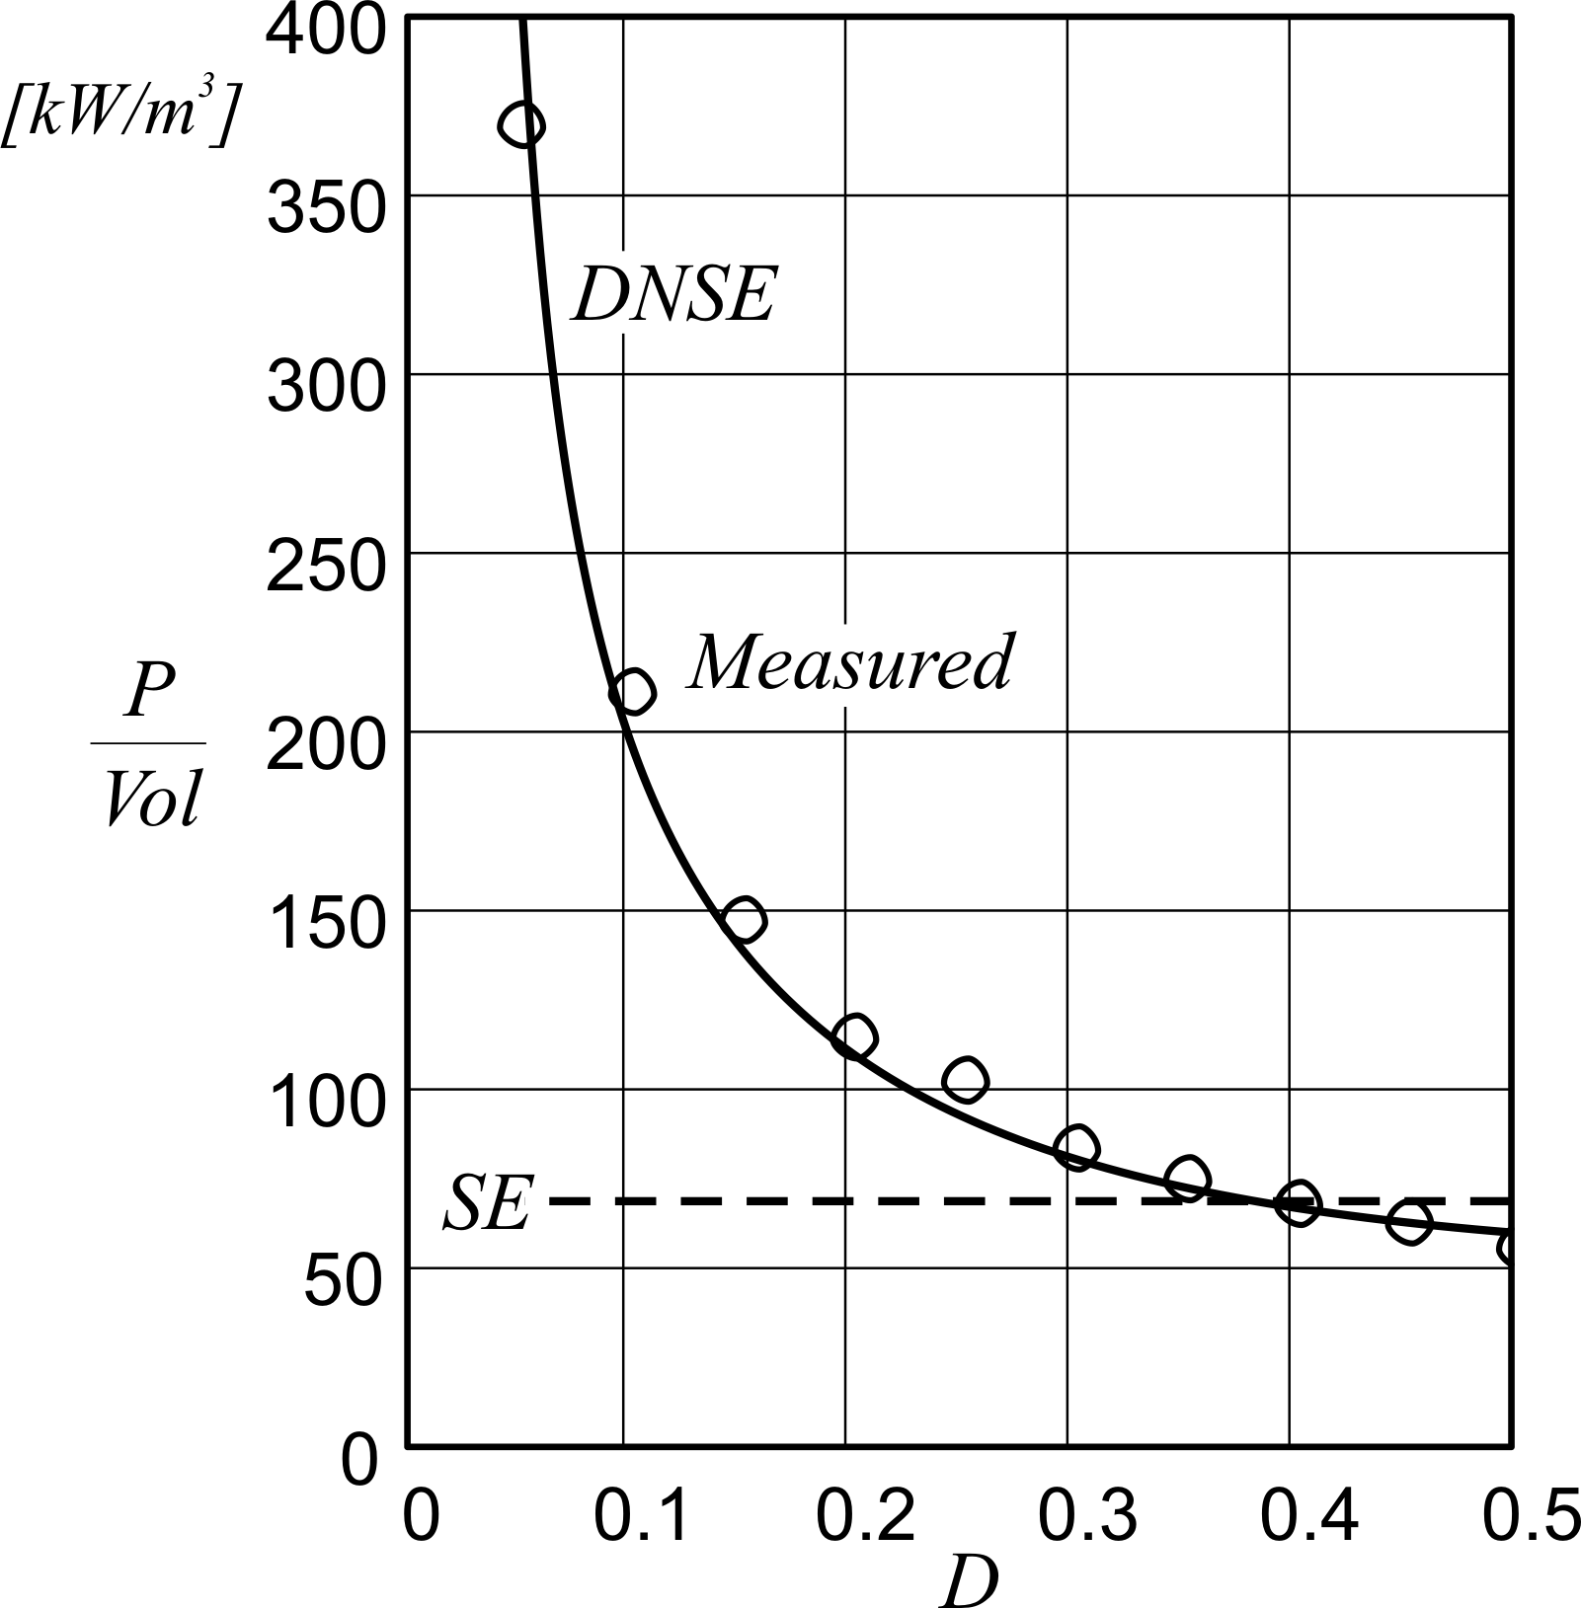
Fig.9 Ferrite losses/volume for a full bridge measurement as a function of D, 0.1T, 100kHz
DNSE, measured results and classical Steinmetz Equation, SE

Substituting the obtained expressions in (5) yields

$\begin{aligned}P_{\text{DNSE}}=γ P_{r}\frac{f}{f_{r}}{\left(\frac{B}{B_{r}}\right)}^{β1} \\ +(1−γ)P_{r}{\left(\frac{f}{\text{fr}}\right)}^{α}{\left(\frac{B}{B_{r}}\right)}^{β2}κ(α) 2^{α}\left(D^{1−α}+{\left(1−D\right)}^{1−α}\right)\end{aligned}$ (18)

We consider a full bridge waveform with a phase shift D; D=0 corresponds with no phase shift; D=1 with a phase shift of a full period. For this condition, the DNSE becomes

$\begin{aligned}P_{\text{DNSE}}=γ P_{r}\frac{f}{f_{r}}{\left(\frac{B}{B_{r}}\right)}^{β}+ \\ +(1−γ)P_{r}{\left(\frac{f}{f_{r}}\right)}^{α}{\left(\frac{B}{B_{r}}\right)}^{β}κ(α) \left({\left(\frac{2}{D}\right)}^{α} 2 D\right)\end{aligned}$ (19)
The current, voltage and power waveforms for 100kHz and with a duty ratio of 5% are shown in Fig. 3 and Fig. 4. At this extreme duty ratio, a notch in the current is clearly visible during the high voltage pulse.
Fig. 5 and Fig. 6 show the measures losses together with the model curves. The obtained good matching validates the presented model.

VI. Modeling Core Losses under DC-Bias
A half bridge converter [12] was used to do perform the tests. A large DC coupling polyester film capacitor is used (8.8μF) in series with the device under test. The DC-bias is obtained by changing the value of the resistor across the capacitor.
Square waves are used for the tests as they are the closest to the power electronics applications. The measurements are limited to 50% duty ratio as this is often the point where the maximal peak-peak induction occurs. It is known that for extreme duty ratios, the losses increase a lot if a constant peak-peak induction is maintained, but fortunately the peak-peak induction decreases a lot at losses decrease a lot at extreme duty ratios is practical cases (at constant frequency operation).
The starting point of modeling losses is the presented above DNSE, equation (4). However, when the peak-peak induction varies in a large range, we observe that the power β is not a constant! It equals 2 for small signal (the ferrite becomes linear) and rises up to 3 or more for large peak-peak inductance. At low amplitude, not only the material becomes linear but also parameters such as P/B² should have a zero derivative for B approaching 0. The following equations are introduced to be compatible with these requirements, where the core losses are presented by two terms:

$P_{\text{hyst}}=\left[1+{\left(\frac{B_{\text{ac},p}}{B_{r}}\right)}^{b1}{\left(\text{tanh}\left(\frac{B_{\text{ac},p}}{B_{1}}\right)\right)}^{2}C_{1}\right] \left(\frac{f}{f_{r}}\right){\left(\frac{B_{\text{ac},p}}{B_{r}}\right)}^{2}P_{a}$(20)
$$P_{\text{other}}=\left[1+{\left(\frac{B_{\text{ac},p}}{B_{r}}\right)}^{b3}{\left(\text{tanh}\left(\frac{B_{\text{ac},p}}{B_{3}}\right)\right)}^{2}C_{3}\right] {\left(\frac{f}{f_{r}}\right)}^{α}{\left(\frac{B_{\text{ac},p}}{B_{r}}\right)}^{2}P_{b}$$
(21)

where P_{a} and P_{b} are the hysteresis fraction without DC bias and the additional hysteresis fraction due to DC bias at the reference frequency and induction.
The use of the square of a tangent hyperbolic function creates a knee in the curve and creates a zero derivative in parameters as P/B². These type of equations fit well with the core losses at usual frequency ranges and induction levels in power electronics. The use of square waves compared to sine wave is only visible in small changes in the parameters.
When introducing a DC bias current, usually higher losses occur. This dependency is mainly observable at low frequency and high AC induction. It seemed that the DC bias field B-field of a magnetic circuit is relevant, as the H-field is mainly dependent on air gap or parasitic air gaps.
To translate a measurable DC bias current into the B-field, a marginal curve was first measured (Fig.4), Table III. This curve gives the relationship between the peak-peak H-field to the peak-peak B-field at AC (20kHz) excitation. All the measurements in this paper are done at 100°C. The core was demagnetized with AC square wave voltage at 20kHz from saturation to zero, prior to each new test.

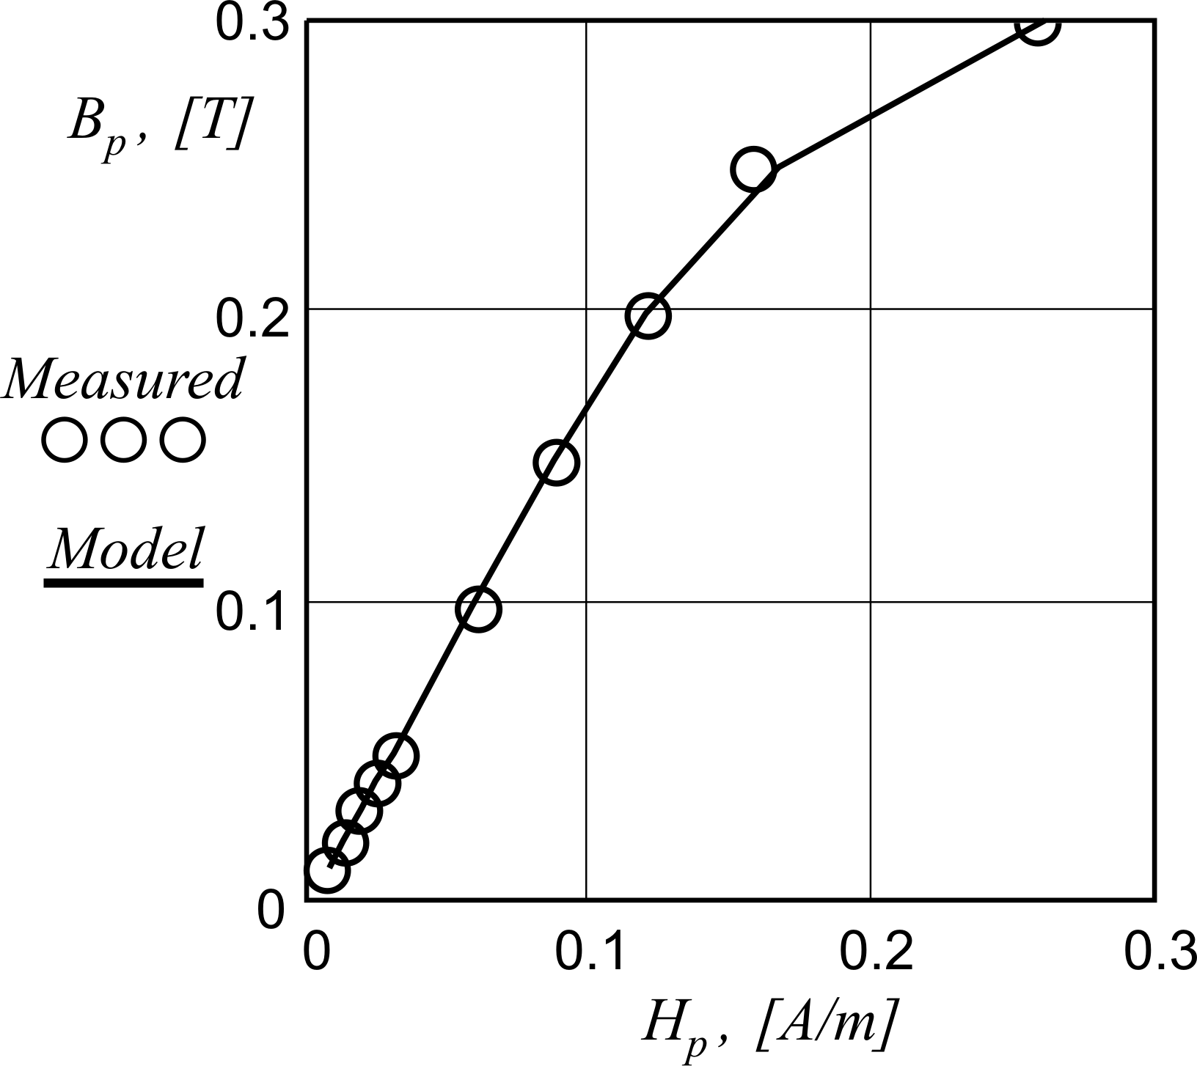
Fig. 10 Marginal curve (H-B) for the device under test

TABLE III
Marginal Curve Measurement [I-B ]
B_{ac, p} [T] | 0.01 | 0.03 | 0.05 | 0.10 | 0.15 | 0.20 | 0.25 | 0.30
I_{p,} [A] | 0.13 | 0.36 | 0.61 | 1.22 | 1.8 | 2.44 | 3.22 | 5.3

The following equations were used to present the B-H relation:

$B_{p}\left(H_{p}\right)=B_{\text{sat}}\left[\text{tanh}\left({\left(\frac{H_{p}}{H_{\text{knee}}}\right)}^{g}\right)\right]$ (22)
and
$H_{p}\left(B_{p}\right)=H_{\text{knee}}{\left[\text{atanh}\left(\frac{B_{p}}{B_{\text{sat}}}\right)\right]}^{1/g}$ (23)

with B_{sat} = 0.32T, H_{knee} =159A/m, and g=1.1

To represent the total core losses under the DC bias, an additional term is proposed. This part is in fact a part of the hysteresis losses, which is split off. For B_{dc} we take the value obtained by substituting the DC current in the marginal curve:

$P_{\text{dcbias}}=\left[{\left(\frac{B_{\text{dc}}}{B_{r}}\right)}^{b2}{\left(\text{tanh}\left(\frac{B_{\text{acp}}}{B_{1}}\right)\right)}^{2}C_{2}\right]\left(\frac{f}{f_{r}}\right){\left(\frac{B_{\text{acp}}}{B_{r}}\right)}^{2}P_{a}$ (24)

Then total core losses are:

$P_{\text{total}}=P_{\text{hyst}}+P_{\text{other}}+P_{\text{dc},\text{bias}}$ (25)

Note that, in the total losses only the other losses have a frequency dependence different from power 1. So only that part of the losses is waveform dependent according to equations (14-19). This allows using (25) also in various waveforms, where only $P_{\text{other}}$is changing if a constant peak-peak and DC bias is maintained.

TABLE IV
Parameters
Hysteresis | Bias | Other | Reference
b₁=1.2 | b₂=2.0 | b₃=1.2 | f_{ref}= 10⁵ Hz
B₁=0.04T | B₂=0.03T | B₃=0.12T | B_{ref}=0.1T
C₁=2.0 | C₂=3.5 | C₃=10 | α=3.8
P_{a}=0.24 | P_{a}=0.24 | P_{b}=0.03

Experiments were carried out at 20kHz, 100kHz and 500kHz. The measuring results and the model curves are shown in Fig. 5 and Fig. 6 for operating frequency of 20kHz and 100kHz.
For the model, the parameters of Table IV are used. Real efforts were made to reduce the number of parameters. However, the quite high number of parameters is needed due to the curvature of the dependence of three parameters: AC peak, DC bias, and frequency. Also the real curves are non-linear, which asks also for parameters.

Fig. 5 and Fig. 6 show a good matching, which validates the proposed model of ferrite core losses under DC bias.
It is observed that the DC bias sensitivity is important at 20kHz, that it is significant at 100kHz and almost negligible at 500kHz. This results in the fact that it was not necessary to make P_{other} dependent on DC bias. The term P_{other} can be seen as losses, which depend on dB/dt rather than on peak induction [15].

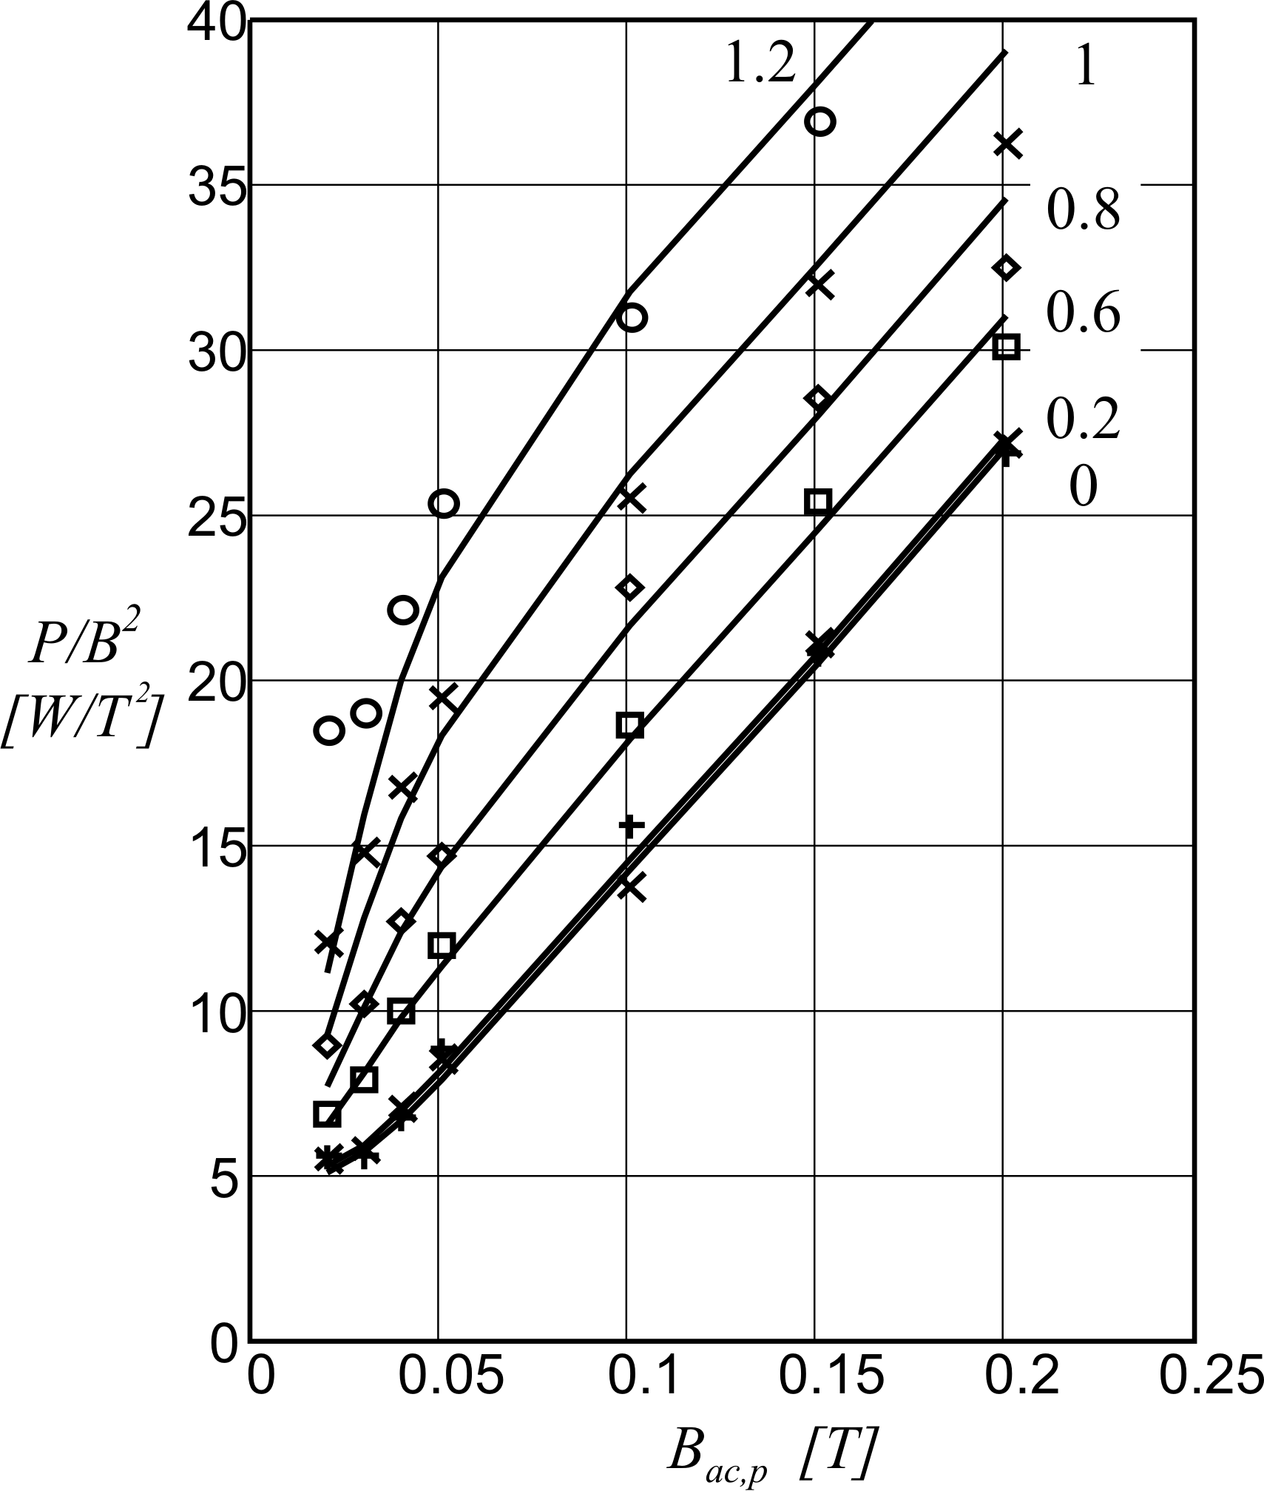
Fig. 11 P/B² [W/T²] at 20kHz for ETD 44.
From lower to upper curves and measuring points:
DC bias 0A; 0.2A; 0.6A; 0.8A; 1A; 1.2A

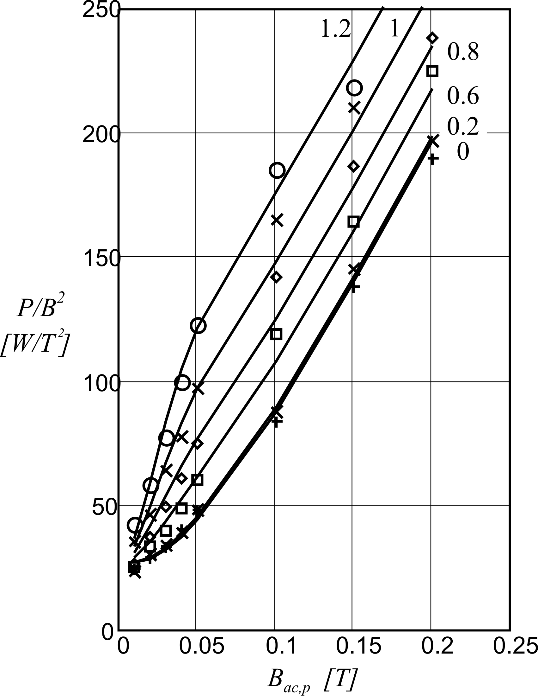
Fig. 12 P/B² [W/T2] at 100kHz for ETD 44.
From lower to upper curves and measuring points:
DC bias 0A; 0.2A; 0.6A; 0.8A; 1A; 1.2A
Other intermediate DC bias levels were measured, which do fit as well. These measurements are not shown as the drawings would get too crowded. The measuring points at high induction and high frequency are less reliable as the measurement has to be done fast because the core exhibits a serious self-heating.

VII. Conclusion
A ferrite loss model named Natural Steinmetz Extension (NSE) is proposed. The model is checked with measurements on two different ferrite grades, with square waves with a large variation in duty ratio. The formulation of the proposed NSE is quite straightforward, and it matches well the experiments of two quite different materials.
For a given peak induction, the sinusoidal losses of ferrites can be modeled with a double extended Steinmetz equation (DNSE), for common frequencies in power electronics. The dependency of the waveform in half bridge and full bridge configurations can be well modeled using a hysteresis part and a part dependent on dB/dt. The losses at extreme duty ratio of the full bridge can be almost twice the losses of a half bridge, for the same peak-peak induction.
A model for ferrite loss under DC bias was proposed taking in account a wide range of frequency, induction levels and DC bias, which can occur in power electronics. It is found the relative sensitivity to DC bias is mainly present in the low frequency component of the losses and that the higher frequency losses show an almost quadratic loss dependency on the peak induction.
The experiments show that the DC bias sensitivity is important at 20kHz, that it is significant at 100kHz and almost negligible at frequencies around 500kHz. The presented model, validated by the carried out experiments, is useful for prediction ferrite core losses in power electronics inductors and transformers.
Acknowledgment
Vencislav Valchev participated in this research in the framework of the NATO Research Project EAP.RIG.981.482.
References

[1] K.N. Carpenter, Simple models for dynamic hysteresis curves which add frequency dependent losses to static models, IEEE Transactions on Magnetics, Vol. 34, №3, pp. 406-413, 1997.

[2] G. Bertotti, Hysteresis in magnetism (Academic Press, San Diego, USA, 1998, 225-429).

[3] R. Boll, Soft Magnetic Materials, The Vacuumschmelze Handbook (Heyden&Son Ltd., London, UK,1979, 13-108).

[4] D. Jiles, Introduction to Magnetism and Magnetic Materials (Chapman & Hall, London, UK, 1991, 89-174).

[5] J. B. Goodenough, Summary of losses in magnetic materials, IEEE Transactions on Magnetics, Vol. 38, №5, pp. 3398-3408, September 2002.

[6] C. Jamerson, Core loss calculations, Power Electronic Technology, Vol. 28, №2, pp.14-24, February 2002.

[7] R. Severns, Additional losses in high frequency magnetics due to non ideal field distributions, APEC’92, 7th Annual IEEE Appl. Power Electronics Conf., 1992, pp. 333-338.

[8] W. Roshen, Ferrite core los for power magnetic component design, IEEE Transactions on Magnetics, Vol. 27, pp. 4407-4415, №6, November 1991.

[9] J. D. Lavers and V. Bolborici, Loss Comparison in the Design of High Frequency Inductors and Transformers, IEEE Transactions on Magnetics, Vol. 35, pp. 3541-3542, №5, September 1999.

[10] C. Jamerson, ‘Core loss calculations’, Power Electronic Technology, Vol.28, No2, Feb. 2002, pp.14-24.

[11] E. C. Snelling, Soft Ferrites, Properties and Applications (2nd edition, London, U.K., Butterworths, 1988).
[12] A. Van den Bossche, T. Filchev, V. Valchev, Test Platform for Resonant Converters, EPE Toulouse, 3-4 Sept. 2003, cd-rom.

[13] A. Brockmeyer, Dimensionierungswerkzeug für magnetische Bauelementein Stromrichteranwendungen, Ph.D. dissertation, Aachen, University of Technology, Germany,1997.

[14] Jieli Li, T. Abdallah and C. Sullivan, Improved calculation of core loss with nonsinusoidal waveforms IEEE, IAS 36-th Annual Meeting, Chicago, USA, Sept. 30 – Oct. 4, 2001, pp. 2203-2210.
[15] A. Van den Bossche, V. C. Valchev, Inductors and transformers for power electronics ( 2005, CRC - press, Boca Raton, Florida, US).

Authors’ information

* Ghent University
Department of Electrical Energy, Systems and Automation, EELAB
Sint-Pietersnieuwstraat, 41
Gent, BELGIUM
E-mail: alex.vandenbossche@UGent.be
Tel. +32/92643419, Fax +32/92643582

** Technical University of Varna
Department of Electronics
Studenska Str.1
Varna 9010, BULGARIA
E-mail: vencivalchev@hotmail.com
Fax: 00359-52-302-771


Alex P. M. Van den Bossche received the M.S. and the Ph.D. degrees from the University of Ghent, Belgium in 1980 and 1990 respectively. He has worked there at the Electrical Energy Laboratory. His research is in the field of electrical drives, power electronics on various converter types and passive components. Since 1993, he is a full professor at the same university in the same field. He became Member (M) of IEEE , a Senior Member (SM) in 2003. He is co-author of a book “Inductors and transformers for power electronics”.


V. C. Valchev was born in Vidin, Bulgaria in 1962. Dr. Valchev has become a member of IEEE since 2004. He received the M.Sc. and Ph.D. degrees in Electrical Engineering from the Technical University of Varna, Bulgaria in 1987 and 2000, respectively. Since 1988 he has been with the Department of Electronics, Technical University of Varna.
His research interests include power electronics, soft switching converters, resonant converters, magnetic components for power electronics, renewable energy conversion. He has published more than 40 papers and a scientific book: A. Van den Bossche, V. C. Valchev, Inductors and transformers for power electronics. 2005, CRC - press, Boca Raton, Florida, US)
Dr. Valchev is a member of Science and Research Union in Bulgaria.

