Composites of polyvinyl alcohol (PVA) hydrogel and calcium and magnesium phosphate formed by enzymatic functionalization
Timothy E.L. Douglas ¹*, Agnieszka Piegat ², David Schaubroeck ³, Miroslawa El Fray ², Peter Dubruel ¹
¹ Polymer Chemistry and Biomaterials (PBM) Group, Ghent University, Belgium
² Division of Biomaterials and Microbiological Technologies, West Pomeranian University of Technology, Szczecin, Poland
³ Center for Microsystems Technology (CMST), ELIS, imec, Ghent, Belgium
* e-mail: Timothy.Douglas@UGent.be
Abstract
In this study, polyvinyl alcohol (PVA) hydrogels designed for osteochondral regeneration were mineralized with calcium phosphate (CaP) and magnesium phosphate (MgP) by incorporation of the enzyme alkaline phosphatase (ALP) and incubation in solutions of 0.1 M calcium or magnesium glycerophosphate (CaGP, MgGP). Hydrogels incubated in water served as controls. Dry mass percentage, i.e. the percentage consisting of polymer and mineral and not water, was markedly higher for samples incubated in CaGP and MgGP and decreased in the order: CaGP > MgGP > water. CaP and MgP formation was confirmed by FTIR. SEM revealed spherical deposits characteristic for apatite in samples incubated in CaGP and plate-like crystals of the magnesium phosphate bobierrite in samples incubated in MgGP, while samples incubated in water were devoid of deposits. Rheometric testing showed that storage modulus of hydrogels incubated in CaGP and MgGP was markedly higher and decreased in the order: CaGP > MgGP > water. The results prove the principle of enzymatic mineralization of PVA with CaP and MgP to improve their suitability for bone regeneration applications.

Keywords: hydrogel, composite, mineralization, enzyme (4-6 keywords)

Introduction
Mineralization of hydrogels with calcium phosphate (CaP) for bone regeneration applications can be realized by addition of the enzyme alkaline phosphatase (ALP) and incubation in a calcium glycerophosphate (CaGP) solution [1]. Mineralization with magnesium phosphate (MgP) is also promising, as MgP has comparable cytocompatibility to CaP and supports osteoblast adhesion and differentiation [2]. In this study, PVA hydrogels designed for osteochondral tissue regeneration [3] were mineralized enzymatically with CaP and MgP by incubation in CaGP and MgGP solutions.

Materials and Methods
Cylindrical PVA hydrogels (10% w/v) of height 5 mm and diameter 8 mm containing ALP at a concentration of 2.5 mg/ml were prepared as described previously [3]. Gel mineralization was induced by incubation in mineralization medium for 14 d in 0.1 M CaGP or MgGP. Samples incubated in Milli-Q water served as a control. Mineralization medium was changed every day. After conclusion of mineralization, gels were rinsed three times in Milli-Q water and subsequently incubated in Milli-Q for 1 d with the aim of removing residual CaGP and MgGP. The dry mass percentage, i.e. the gel weight percentage not consisting of water, was calculated as: (weight after mineralization and subsequent freeze-drying/weight after mineralization but before freeze-drying)*100. This served as a measure of the extent of mineral formation. Mineral formed was characterized by FTIR and SEM. Mechanical properties were investigated by performing rheometry and measuring storage modulus at a strain of 0.1 % and angular frequency of 10 rad/s.

Results and Discussions
Dry mass percentages increased as a result of incubation in in CaGP and MgGP (Figure 1). The values for samples incubated in water, CaGP and MgGP were 12.3 ± 0.6, 28.8 ± 0.6 and 23.0 ± 1.2, respectively. The higher amount of mineral formed in the CaGP group may be due to the lower solubility of CaP relative to MgP.
The formation of CaP and MgP in hydrogels was demonstrated directly by FTIR (Figure 2). Bands typical for PVA became less prominent in samples incubated in CaGP and MgGP. Bands typical for apatite were observed at 1030 and 540 cm⁻¹ [4] while characteristic bands for bobierrite (Mg₃(PO₄)₂·8H₂O) were seen at 3460, 3150, 1040, 990, 940, 830 and 680, as well as 540 cm⁻¹ [5].
SEM examination (Figure 3) revealed no mineral deposits on hydrogels incubated in water, however spherical deposits of diameter 1-2 μm were seen on samples incubated in CaGP, which resemble CaP deposits in enzymatically mineralized hydrogels in previous studies [1]. Plate-like crystals approximately 5 μm in length and 1-2 μm in width which resemble bobierrite (Mg₃(PO₄)₂·8H₂O) [2] were seen on samples incubated in MgGP.
Rheometric testing (Figure 4) showed that storage modulus increased by factors of over 100 and 40 as a result of incubation in CaGP and MgGP, respectively. This is consistent with the differences in dry mass percentage (Figure 1), which serves as a measure of mineral formation.

Conclusions
CaP and MgP mineral formation in PVA hydrogels containing ALP was induced by incubation in solutions of CaGP and MgGP. More CaP was formed than MgP. CaP and MgP formed appeared to be predominantly apatite and bobierrite, respectively. Gels containing CaP were stronger than those containing MgP.

Acknowledgments
The authors acknowledge the Research Foundation Flanders (FWO) and Ghent University for support.

References
[1] DOUGLAS, T. E. L., et al. (2012) Macromol Biosci.
[2] TAMIMI, F., et al. (2012) Acta Biomater, 7, 2678-85.
[3] EL FRAY M., et al. (2005) European Polymer Journal, 43, 2035-2040
[4] KOUTSOPOULUS, S. (2002) J Biomed Mater Res 62:600–612
[5] FROST, R.L. et al. (2002) Mineralogical Magazine, 66, 1063–1073
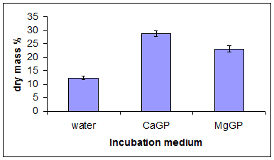
Figure 1. Dry mass percentage of PVA hydrogels incubated for 14 d in water or 0.1 M CaGP or MgGP (n=3).
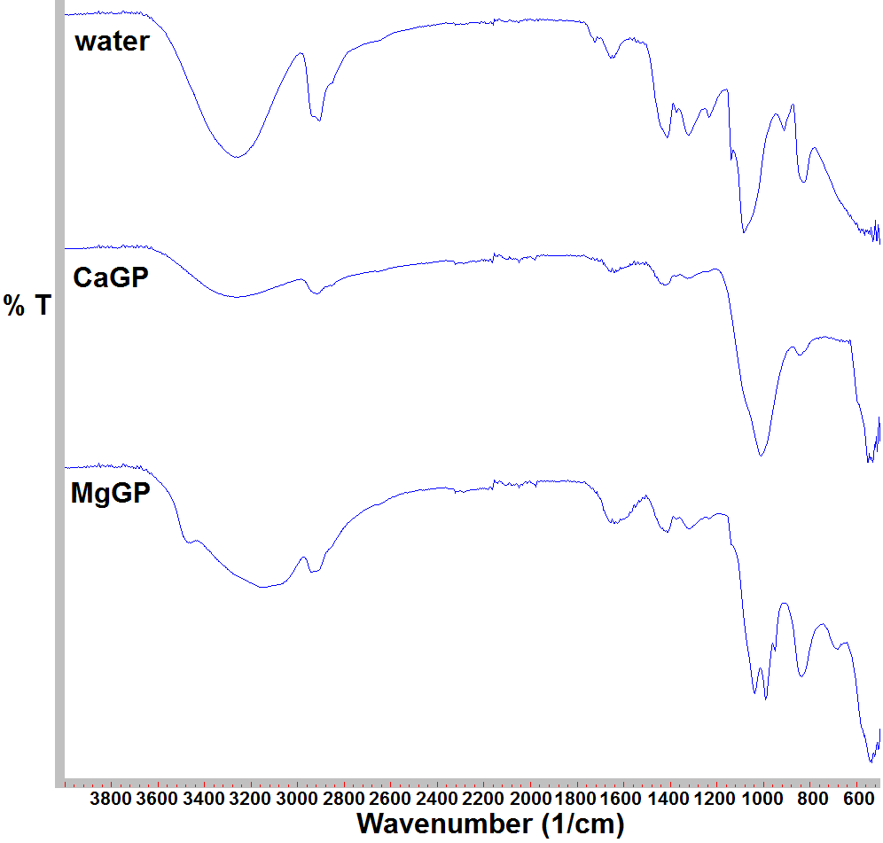
Figure 2. FTIR spectra of PVA hydrogels incubated for 14 d in water or 0.1 M CaGP or MgGP after lyophilization
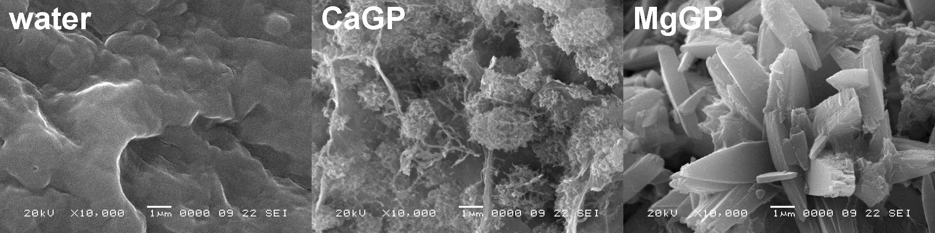
Figure 3. SEM images of PVA hydrogels incubated for 14 d in water or 0.1 M CaGP or MgGP after lyophilization
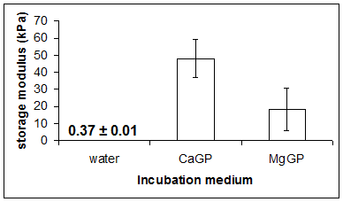
Figure 4. Storage moduli of PVA hydrogels incubated for 14 d in water or 0.1 M CaGP or MgGP (n=3)

