Rural Economy and Society in Northwestern Europe, 500-2000
A new and original synthesis of rural history in four volumes

General editorial board:
Erik Thoen (Director) and Eric Vanhaute (Ghent University)
Leen Van Molle and Yves Segers (University of Leuven)
Bas van Bavel (Utrecht University)

The volumes in this new series are written by an international research team (CORN/Comparative Rural History of the North Sea Area) coordinated by scholars of Ghent University and the University of Leuven (Belgium) in collaboration with Utrecht University (The Netherlands).

In these volumes (c.400 pages each), an international team of more than 60 well-known researchers aims to explain how rural societies around the North Sea coped with the enormous social changes between the sixth and the twenty-first centuries. These publications investigate the relationship between economic growth and ecological constraints, between markets and income structures as well as between lords, governments and peasants. Over the past millennium and more, the regions surrounding the North Sea have developed from the periphery of the Mediterranean world to the core of the modern world economy. A crucial element in this world-historical process is the restructuring of physical, demographic, economic and social relationships within these rural societies. The four volumes of the series focus on the rural producers as central actors. They explore four core processes that configured rural production and survival.
Each book opens with a general chapter on the period 500-1000 and is further subdivided into two periods, 1000-1750 and 1750-2000, and five regional subchapters (Northern France, the British Isles, the Low Countries, Northern Germany and Scandinavia). The books conclude with a comparative synthesis.

This series of four volumes is the first collectively written synthesis of the comparative rural history of Northwestern Europe.

CORN (Comparative Rural History of the North Sea Area) is a research network founded in 1995 and coordinated by scholars from Ghent University and the University of Leuven (Belgium) in collaboration with Utrecht University (The Netherlands). It consists of different research units that primarily aim to study long-term developments of rural societies from the Middle Ages to the twentieth century. It focuses on the North Sea area from a comparative and an interdisciplinary point of view.

Address of correspondence:
CORN
Sint-Pietersnieuwstraat 35
B-9000 Gent

email: erik.thoen@UGent.be

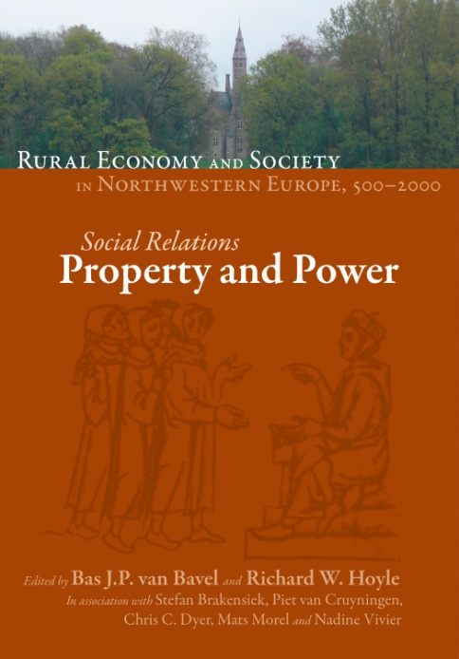

Social Relations: Property and Power

Edited by Bas J.P. van Bavel and Richard W. Hoyle
in association with Stefan Brakensiek, Piet van Cruyningen,
Chris C. Dyer, Mats Morell and Nadine Vivier

approx. 450 p., 178 x 254 mm, 2010, HB, ISBN 978-2-503-53050-5, approx. € 69
Publication scheduled for September 2010

PUBLISHED The organisation of society formed a crucial element in the remarkable development of the countryside in the North Sea area in the last 1500 years. Vital questions are: who owned the land? Who gained the profits from its exploitation? How was the use of rural resources controlled and changed? These questions have no simple answers, because the land has been subjected to competing claims, varying from region to region. In early times peasants mostly possessed and worked their holdings, but lords took much of the produce, and had the ultimate control over the land. In more recent times the occupiers and cultivators gained stronger rights over their farms. Neither lords nor peasants were free agents because communities governed the use of common lands. In the highly urbanised North Sea region towns and townspeople had considerable and increasing influence over the countryside. Change came from within society, for example from the tension and negotiation between lords and peasants, and the growing importance of the state and its policies. This volume also looks at the interaction between society and external changes, such as the rise and fall of the market, trends in population, and European integration.

COVER
The Agro-Food Market: Production, Distribution and Consumption
Edited by Leen Van Molle and Yves Segers
in association with John Chartres, Marc de Ferrière le Vayer,
Pim Kooij, Michael Kopsidis, Bjørn Poulsen and Jean-Pierre Williot

approx. 450 p., 178 x 254 mm, 2011, HB, ISBN 978-2-503-53048-2, approx. € 69 - Publication scheduled for 2011

Agriculture and nourishment are, from early times and up to now, crucial elements in the development of market systems. Shortage and surplus gave shape to different forms of exchange and sale, to the dynamics of supply and demand, and to expanding interconnections between regions and social groups. Farmers learned to adapt their production to market conditions and to the shifting needs and tastes of a growing and demanding public. But the path from a self-supporting way of life to the present forms of market integration in the complex, global world was far from uniform and linear. Food production, market structures and market mechanisms changed over time and differed between regions and countries of the North Sea area. This volume aims at exploring and unravelling the complexity of the agro-food market, from the field to the table.

COVER

Struggling with the Environment: Land Use and Productivity
Edited by Erik Thoen and Tim Soens
in association with Annie Antoine, Michael Kopsidis, Janken Myrdal,
Mark Overton and Theo Spek

approx. 450 p., 178 x 254 mm, 2012, HB, ISBN 978-2-503-53047-5, approx. € 69 - Publication scheduled for 2012
Agriculture is always a struggle with the environment since agricultural production is in fact applied ecology. However, in the past the struggle with the environment was to a large extent determined by the social organisation which was regionally very diverse. The aim of this volume is to find out how, when and within which structural boundaries, land was made useful for agriculture. In the first part of each chapter, this is studied in general, focusing on the evolution of land use: how and why was land reclaimed and by whom? How intensively was this land used? Which actors played a part in this process? What were the environmental and social limits? In the second part the production techniques and production systems are scrutinized: crop choices, crop rotations, the importance of fallow and cattle, crop yields etc. All this is looked at in light of different farming strategies and social conditions. The comparative approach of this volume also enables a new and innovating perspective on the occurrence and impact of ‘agricultural’ and ‘green’ revolutions in the past.

COVER
Making a Living: Family, Income and Labour
Edited by Eric Vanhaute, Isabelle Devos and Thijs Lambrecht
in association with Gérard Béaur, Georg Fertig, Carl-Johan Gadd, Erwin Karel, Michael Limberger,
Richard Paping and Phillipp Schofield

approx. 450 p., 178 x 254 mm, 2011, HB, ISBN 978-2-503-53049-9, approx. € 69 - Publication scheduled for 2011

The central issue in this volume is the relation and the interaction between production, reproduction and labour in rural societies. The main questions concern the way in which resources became available to the rural family and to its members, and the strategies which were employed to generate these resources. The goal is to interpret household formation and the economic behaviour of its members within the context of the structural features of the regional social agro-system. Two sets of research questions structure the chapters in this book. The first set evaluates the impact of these processes on the family as a unit (of reproduction and production) and the relationships between its members (internal family relations). These issues are essentially dealt with from a socio-demographic perspective. The second set of questions aims to understand how families adapted their behaviour to changing social and economic circumstances. These topics are studied from a predominantly socio-economic perspective.

ORDER FORM

- Please enter my standing order to the series Rural Economy and Society in Northwestern Europe 500-2000. I will receive the first volume at a special price of € 55 and free of shipping costs.

- I wish to order a copy of:

(All prices exclude taxes – where applicable – and shipping costs)

Name:
Address:
Postcode: Town:
Country: Email:
- lPlease send me an invoice – VAT N°:
- I wish to pay by credit card: O VISA O Mastercard O American Express
Card n°: Exp. date:
Date: Signature:

FHG
Begijnhof 67 • 2300 Turnhout (Belgium)
T +32 14 448030 • F +32 14 428919 • info@brepols.net • www.brepols.net

