Physical function measurements predict mortality in ambulatory older men
Stefanie L. De Buyserª, PharmD, Mirko Petrovicª, MD, PhD, Youri E. Taes^{b}, MD, PhD, Kaatje R.C. Toye^{b}, BSc, Jean-Marc Kaufman^{b}, MD, PhD, Stefan Goemaere^{b}, MD
ª Department of Geriatrics, ^{b} Department of Endocrinology and Unit for Osteoporosis and Metabolic Bone Diseases, Ghent University Hospital, Ghent, Belgium.
Corresponding Author:
Stefanie De Buyser
Department of Geriatrics
Ghent University Hospital
De Pintelaan 185
B-9000 Ghent, Belgium
Tel: +32-9-332.21.30
Fax: +32-9-332.38.17
E-mail: Stefanie.Debuyser@UGent.be
Alternate Corresponding Author: Mirko Petrovic
E-mail: Mirko.Petrovic@UGent.be
Requests for reprints should be sent to the corresponding author

Word-character count: 3550

ABSTRACT
Background To assess and compare the predictive value of physical function measurements for all-cause mortality in older men, and to evaluate the Timed Up and Go test as a predictor in subjects with underlying comorbidity.
Design Observational study of a population-based sample of 352 ambulatory older men aged 71 to 86 at study baseline. The Rapid disability rating scale-2, 36-Item short form health survey, Hand grip strength, Five times sit-to-stand test, Standing balance, and Timed Up and Go test were determined at baseline. Associations with all-cause mortality were assessed using Cox proportional hazard analyses. Age, BMI, smoking status, education, physical activity, and cognitive status were included as confounders. Follow-up exceeded 15 years. Comorbidity status was categorized into cardiovascular disease, chronic obstructive pulmonary disease, and diabetes mellitus.
Results All examined physical function measurements were associated with all-cause mortality. The Timed Up and Go test was the best predictor (adjusted HR per SD increase = 1.58, 95% CI = 1.40-1.79, P < 0.001) for global mortality and continued to be predictive in subjects with cardiovascular disease (adjusted HR per SD increase = 1.80, 95% CI = 1.40-2.33, P < 0.001).
Conclusions The assessment of physical functioning is important in the evaluation of older persons. We encourage the use of the Timed Up and Go test as a reliable, quick and feasible screening tool in clinical settings.
Key words Timed up and Go, mortality, older men, physical function measurements; physical performance measurements, functional status measurements.

Introduction
In the care of older patients, it is important to assess physical functioning [1, 2]. Physical function measurements (PFMs) may identify problems not observable in a routine physical examination [3], and moreover PFMs are able to predict health-related outcomes, such as hospitalization and mortality [4, 5]. Generally, physical functioning is assessed through functional status measurements [1]. Well-introduced instruments are the activities of daily living (ADL) scale [6] and the instrumental ADL (IADL) scale [7]. Other instruments include the Rapid disability rating scale-2 (RDRS-2) [8] and the Physical function index (PFI) of the 36-Item short form health survey (SF-36) [9, 10]. Besides, there has been a growing interest in objective measurements of physical functioning, such as muscle strength measurements and physical performance measurements. Compared to questionnaires, these objective measurements have clear face validity for the task being performed, better reproducibility and greater sensitivity to change in functioning [1]. Furthermore, they are considered to be better predictors for health risks [4]. Commonly used in clinical and research settings are Grip strength, Standing balance, and the Five times sit-to-stand (5TSTS) test, the latter two as part of the Short Physical Performance Battery (SPPB) test [11]. Few have compared the relative strength of PFMs in predicting global mortality. Yet, knowing which PFM has the strongest predictive value for health-related risks, such as mortality risk, would support its use in clinical practice.
The Timed Up and Go (TUG) test includes both standing and walking, two physical activities of daily life, therefore its concept [12] seems very appealing to implement. The TUG test is quick and easy to conduct; it requires little equipment and no special training. Previous publications regarding the association of TUG with mortality are limited. Moreover these studies all had short (≤ 5 years) or intermediate (9 years) follow-up. Research concerning the predictive value of TUG for all-cause mortality during a prolonged follow-up (>15 years), has not been done. Also it is not known whether underlying comorbidity, such as cardiovascular disease, chronic obstructive pulmonary disease (COPD) or diabetes mellitus type 2, affects TUG’s predictive ability.
Taking into consideration the above mentioned aspects, we aimed to evaluate the association of six PFMs with all-cause mortality. The primary goal was to compare the predictive value for global mortality of RDRS-2 ADL, SF-36 PFI, Hand grip strength, Standing balance, 5TSTS, and TUG. A secondary goal was to assess the potential role of chronic diseases in the association of TUG with mortality.

Materials and Methods

Study Population
This longitudinal study was initiated in 1996 to investigate the process of aging, mainly focusing on hormonal changes and bone metabolism. The participants were men, recruited from the population register of a semirural community of 20 000 inhabitants (Merelbeke) near Ghent University Hospital (Belgium). Age between 70 and 85 years and willingness to participate were the only selection criteria at recruitment. From the 748 men in the age group investigated, 407 (54%) gave written informed consent, as approved by the ethics committee of the Ghent University Hospital; 352 men (47%) took part in all key examinations. This participation rate is in accordance with other population-based studies [13]. Reasons for nonparticipation comprised of lack of interest in 255 subjects (34.1%), 36 felt unable to participate because of interfering diseases (4.8%), 20 died before start of the study (2.6%), 12 considered themselves too old to participate (1.6%), 8 moved to another area (1.1%), and there were various other reasons in 64 subjects (8.5%). For the present study there were no exclusion criteria. We report on data obtained by interviews and physical examinations at the start of the study. Reporting of the study conforms to the STROBE statement [14, 15]. Follow-up is still on-going with the latest update finalized in December, 2011. Of the 352 subjects included at baseline, 77 men were still alive and 2 men were lost to follow-up in 2011. Baseline data on unrelated issues have previously been reported [16, 17].

Functional status measurements
The RDRS-2 was used to rate the amount of assistance required in 18 activities [8]. It contains eight questions on ADL, rated on four point response scales. The summary score on these questions was used for analyses. The SF-36 was also completed [9] and includes a physical function index (PFI), composed of 10 items covering a range of difficulties [10].

Muscle Strength Measurements

Hand grip strength
Measurement of Hand Grip strength was performed using a Smedley-type hand dynamometer (Smith & Nephew Rolyan, Inc., Germantown, WI)[18, 19]. Subjects held the dynamometer in the dominant hand with the arm hanging by the side. The score was the best result of two consecutive measurements, expressed to the nearest kilogram. Test-retest reliability for all participants was excellent (intra-class correlation coefficient (ICC) = 0.92).

Physical Performance Measurements

Standing balance
Standing balance was adapted from the method applied in the SPPB test [11]. Subjects were asked to stand in three positions for up to 10 seconds each: parallel stand with the feet together side-by-side, semi tandem stand with the heel of one foot touching the big toe of the other foot, and tandem stand with the heel of one foot aligned to the toes of the other foot. Each position was scored from 0 to 2, based on degree of steadiness and amount of time the stand was held.

Five times sit-to-stand
Subjects were instructed to complete five full stands from seated position as quickly as possible [20, 21]. The seat height for the chair was 45 cm. The minimum time to the nearest tenth of a second of two assessments was used as final score. Test-retest reliability for all participants was excellent (ICC = 0.92). Eight subjects were unable to perform the 5TSTS test, mainly due to osteoarthritis symptoms or because they considered the test too difficult.

Timed Up and Go
The TUG test was performed according to the method described by Podsiadlo & Richardson [12]. Subjects were instructed to stand up from an armchair (seat height of 45 cm), walk at a comfortable and secure pace to a line on the floor 3 meters away, turn, return to the chair and sit down again. Test-retest reliability was tested in a subset of patients. ICC was 0.90, suggesting very good reliability. Four participants did not perform the TUG test due to foot pain or other non-specified reasons.

Total Mortality
Data on all-cause mortality were obtained by contacting proxies and the treating general practitioners by telephone. The most recent update was completed on December 31st, 2011.

Covariates
All participants completed questionnaires to gain information on chronic diseases, medication use, educational degree, and current life style, including smoking habits and physical activity. Subjects’ weight and height were measured in light indoor clothing without shoes. Body mass index (BMI) was calculated as weight in kilograms divided by the square of height in meters. Underlying comorbidity was abstracted from the self-reported diseases and use of medication. For evaluation of the cognitive status, subjects had to remember five items and were questioned three times.

Statistical analysis
Descriptive data are presented as mean ± standard deviation (SD), median (first to third quartile) or percentage. Univariate associations between PFMs were studied by calculating the Spearman correlation coefficients. Test-retest reliability of Grip Strength, 5TSTS and TUG was examined using ICCs. Associations between PFMs and all-cause mortality were assessed by Cox proportional hazards models. The proportional hazards assumption was first verified by including time dependent covariates into the Cox model. For subjects who were lost to follow-up in 2011, survival time until the last date of contact was entered. Cox regression analyses were also performed using the z-scores of the PFMs, to calculate the risk for mortality associated with 1 SD increase in physical functioning. Three sequential Cox models were built: in which there were no adjustments made, in which age was adjusted for, and in which age, BMI, smoking status, education, physical activity, and cognitive status were covariates, respectively. To further assess the association, survival curves adjusted for age were plotted according to tertiles of physical functioning. Three unequal groups had to be made for survival curves of RDRS-2 ADL (score = 8 for 270 men; 9-10 in 47 men; >10 in 32 men). Independent samples T-test or one-way analysis of covariance (ANCOVA) was performed where appropriate, to compare physical functioning and survival time between healthy subjects and subjects with comorbidity. Bar charts were used to present median survival time of subjects dichotomized by performance on TUG; associated significances were calculated with the Mann-Whitney U test. All analyses were performed using SPSS software, version 20.0 (SPSS Inc., Chicago, IL). Statistical significance was indicated by a P value < 0.05; all P values were two-tailed.

Results
Average follow-up duration was 184 ± 2 months. Seventy-eight percent (273) of the 352 men died during follow-up, with a median survival time of 110 months. Characteristics of the study population at baseline are described in Table 1. At inclusion, the age of the subjects ranged between 71 and 86 years. Fourteen men out of 352 (4%) were underweight (BMI: < 20kg/m²); 61 (17%) reported the use of at least five medications; 72 (21%) were currently smoking, which is in accordance with the proportion of smoking, older men in Belgium at that time [22]. Mean number of pack years was 34.4 (SD: ± 31.1 pack years). Three hundred twenty two men (92%) finished primary school, 154 (44%) also completed lower secondary education and 71 men (20%) completed upper secondary education. With scores on the RDRS-2 that can range from 18 to 72, a mean score of 22 indicated that there was little disability in the study population. Merely 71 men (20%) reported to only occasionally perform some type of physical exercise, while 165 (47%) reported to exercise at least 1 hour / week. All PFMs correlated significantly with each other (P < 0.001). The TUG time score had the best correlation with the 5TSTS time score (Spearman’s correlation coefficient r = 0.60) and was inversely associated with Grip strength (r = -0.29) and Standing balance (r = - 0.31). Correlation of TUG with RDRS-2 ADL (r = 0.42) and SF-36 PFI (r = -0.50) was also low.
The predictive value of the PFMs for all-cause mortality was examined by Cox regression analyses. Since all time dependent covariates were statistically non-significant in the Cox model, the proportional hazards assumption was met. Preceding univariate Cox regression analyses examined the effect of age, BMI, smoking status, education, physical activity, and cognitive status. Age was significantly associated with mortality (hazard ratio (HR) = 1.12, 95% confidence interval (CI) = 1.09-1.15, P < 0.001). The same was true for education, physical activity, and cognitive status (HR = 0.96, 95% CI = 0.93-1.00, P = 0.043; HR = 0.86, 95% CI = 0.77-0.96, P = 0.008; HR = 0.84, 95% CI = 0.78-0.89, P < 0.001; respectively). BMI and smoking status were not significantly associated (HR = 0.97, 95% CI = 0.93-1.00, P = 0.054 and HR = 0.98, 95% CI = 0.73-1.31, P = 0.878, respectively). Subsequently, models were built unadjusted, adjusted for age and additionally adjusted for BMI, smoking status, education, physical activity, and cognitive status.
As summary score on the eight ADL questions of the RDRS-2 indicated higher assistance levels, mortality risk increased (age-adjusted HR = 1.18, 95% CI = 1.12 – 1.24, P < 0.001). Correspondingly, when less limitations were reported on the SF-36 PFI, mortality risk decreased (age-adjusted HR = 0.99, 95% CI = 0.98-0.99, P < 0.001). Mortality risk also decreased as absolute levels of Grip strength and Standing balance increased (age-adjusted HR per 1 kg = 0.97, 95% CI = 0.96-0.99, P = 0.001; HR = 0.87, 95% CI = 0.78-0.98, P = 0.020, respectively). As more time was needed to complete the 5TSTS and TUG test, mortality risk increased (age-adjusted HR per 1 second increase for 5TSTS = 1.08, 95% CI = 1.06-1.11, P < 0.001; HR for TUG = 1.10, 95% CI = 1.07-1.12, P < 0.001). Mortality risk doubled for every 8 seconds increase in time needed to perform the TUG test (age-adjusted HR per 8 seconds increase for TUG = 2.08, 95% CI = 1.70-2.54, P < 0.001). Table 2 shows the HRs associated with 1 SD increase in physical functioning. This allows direct comparison of the predictive ability between PFMs. In each model, TUG performance exhibited the strongest hazard ratio. Every time, the results were attenuated when adjusting for covariates, as can be seen in Table 2. The age-adjusted survival curves in Figure 1 likewise show that the worst physical functioning participants had lower survival probability. The higher mortality rates existed not only after 15 years but during the full follow-up period. The HR comparing the lowest with the highest tertile for performance on TUG was 2.09 (95% CI = 1.53-2.85, P <0.001) with adjustment for age.
As can be seen in Table 3, subjects with cardiovascular disease or COPD performed poorer on the PFMs in comparison with healthy subjects. ANCOVA further revealed shorter survival time for subjects with cardiovascular disease (P = 0.001), COPD (P = 0.006), and diabetes (P = 0.006). This can also be observed in Figure 2. In subjects with COPD or diabetes, performance on TUG had little influence on survival time (P = 0.281 and P = 0.309, respectively). In patients with cardiovascular disease however, TUG remained to have a significant association with mortality (HR in the fully adjusted model per SD = 1.80, 95% CI = 1.40-2.33, P < 0.001).

Discussion
In this study we assessed the predictive value of RDRS-2 ADL, SF-36 PFI, Hand grip strength, Standing balance, 5TSTS, and TUG, for all-cause mortality in older men. All PFMs showed an association with global mortality during the full follow-up period. Interestingly, the proportional hazards models including TUG had the best fit and TUG exhibited the strongest HR of all PFMs. These findings suggest that TUG is the best predictor for global mortality. TUG remained to be a significant predictor after presence of cardiovascular disease was taken into account.
Our results confirm the previously reported association between PFMs and mortality among older persons. A former study likewise described an association between the SF-36 PFI and mortality [23]. When comparing subjects with a SF-36 PFI score ≤ 39 with those with a score ≥ 81, an age-adjusted HR of 0.4 (95% CI = 0.4-0.5) was found. Cesari et al. [24] analysed the association of ADL and IADL score with mortality, the unadjusted HRs per SD increase were 0.54 (95% CI = 0.45-0.65) and 0.48 (95% CI = 0.38-0.61), respectively [24]. Their results indicate a stronger association of functional status measurements with mortality than our findings. Most studies regarding Grip strength found an independent association with mortality risk [25-28]. In the study of Cesari et al. [24], 1 SD decrease in Grip strength was associated with a higher risk for mortality (unadjusted HR = 0.55, 95% CI = 0.43-0.71), than in our study (unadjusted HR per SD = 0.72, 95% CI = 0.63-0.81). Perhaps this could be explained by the difference in follow-up duration since there is evidence for a weaker association between Grip strength and mortality in studies with longer follow-up [5]. Moreover, the shorter follow-up in the study of Cesari et al. [24] might explain their stronger HR corresponding with 1 SD increase in Standing balance-score (unadjusted HR = 0.55, 95% CI = 0.44-0.68)[24], compared to ours (HR = 0.77, 95% CI = 0.70-0.86). In the comparative study between the SPPB tasks and Grip strength of Cesari et al., Chair rising had the strongest association with mortality [24]. Similarly, 5TSTS was a better predictor than Grip strength and Standing balance in our study as well. Conversely, one study found Chair rising and Standing balance to be equally prognostic [29].
Although the TUG test has been examined mostly for evaluating balance, as a predictor of falls [30, 31], there is some evidence for an association with mortality. Tice et al. found a strong association in postmenopausal women [23] and Hoshide et al. reported a correlation between TUG and cardiovascular mortality in the very old subjects at least 80 years of age [32]. Lastly, according to Davis et al., TUG was independently of sex and age associated with an increased risk of death [33]. Our results can confirm the association of TUG with global mortality in older men after 15 years follow-up.
The TUG test and 5TSTS test, both being objective, timed physical performance measurements, confirm to be more predictive for mortality than the RDRS-2 ADL and SF-36 PFI, both subjective reports of functional status. Other studies have stated that performance measurements were more able to predict outcomes, such as mortality than self-reports of functional status [4], we only found this to be true for timed physical performance measurements. Among all 6 PFMs, TUG appeared to have strongest predictive value for all-cause mortality. However, in case a subject is unable to stand or walk, alternative PFMs can be used and are valid; functional status measurements and Grip strength can be used to provide a good estimate of survival.
In our study, most of the subjects with comorbidity had significantly poorer physical function than healthy subjects. This is in concordance with the known association of chronic diseases such as stroke, coronary heart disease, COPD, and diabetes, with steep strength decrease [34]. The TUG test continued to be a significant predictor for mortality in subjects with cardiovascular disease. The lack of predictive value of TUG in subjects with COPD or diabetes in our study is most probably due to the small sample size. Previous studies did show functional capacity is a strong predictor of all-cause mortality in patients with cardiovascular disease [35], COPD [36], and type 2 diabetes mellitus [37].
Some limitations of our study should be noted. Our study population is composed solely of men, of which only 47% took part in all key examinations. Although this participation rate seems in line with other population-based studies [13], nonparticipants revealed to have higher mortality than participants in the population-based HUNT-study [38]. Therefore, the 47% participation rate may result in selection bias. As mentioned above, the limited size of groups with comorbidity may have also influenced some or our results. An important physical performance measurement that was not addressed in our study is gait speed. This timed measurement has frequently been associated with mortality in older patients. According to a pooled analyses by Studenski et al. the age-adjusted mortality risk per 0.1 m/s higher gait speed ranges from 0.83 to 0.94 [39]. When comparing gait speed and TUG, no differences were found in their predictive ability for decline in global health, new ADL difficulty, and falls [31]. In the comparative study of Cesari et al. [24], 4-meter walking speed, categorized into four groups by increasing speed, had an unadjusted HR for mortality of 0.49 (95% CI = 0.38-0.63) per SD increase. Adjusted, its predictive ability (HR - 95% CI) was of the same magnitude as that of Grip Strength and the SPPB Balance test.
Strength of this study is the long follow-up. With an average of 184 months, our study has much longer follow-up than other related studies. This could have an important influence on our findings. As already mentioned, a weaker association between muscle strength and mortality has been found in studies with longer follow-up [5]. As a result of this long follow-up period, there is also little censoring, which reduces bias.
Although our study population consisted of independently functioning ambulatory older men, we believe that the TUG test can be useful in signalling of functional decline. Moreover, after a low performance on the TUG test, comprehensive geriatric assessment should take place in order to detect specific underlying problems. To perform the TUG test, only an arm chair, a measuring tape in order to indicate the 3 m distance and a watch with a second-hand are required. Since the instructions are straight-forward, professional expertise or training is not required [12]. The time score is objective and easy to record [12]. In addition, the TUG test has shown good reliability between observers and over time [12, 30].
Potential use of the TUG test in clinical practice could be enhanced with the implementation of a clear cut-off point. Further research regarding PFMs in general should also focus on prediction of mortality following invasive procedures (e.g. chemotherapy), as this would enable targeted interventions.
In this study we have presented the evaluation of 6 PFMs with regard to their predictive value for all-cause mortality. Our findings indicate that the TUG test, a timed measurement of observed performance, is the best predictor for global mortality. We consequently encourage the use of TUG as a reliable, quick and feasible screening tool in clinical settings.

Acknowledgements
Conflict of interest: The authors declare no conflicts of interest.
Author contributions: SDB analysed and interpreted the data, and wrote the manuscript. MP and YT contributed to conception of the manuscript, provided statistical support, and provided critical revisions of the manuscript. KT contributed substantially to acquisition of data and reviewed the manuscript. JMK and SG designed the study, supported data collection, and provided critical revisions of the manuscript.
Sponsor’s role: This work was supported by grants G0662.07 and G0867.11 from 'Fonds voor Wetenschappelijk Onderzoek - Vlaanderen (FWO; Research Foundation - Flanders)' and by an unrestricted grant of Novartis Belgium. YT is a Postdoctoral Fellow with the FWO.

References
1 Guralnik JM, Branch LG, Cummings SR and Curb JD. Physical performance measures in aging research. J Gerontol 1989;44:M141-6.
2 Applegate WB, Blass JP and Williams TF. Instruments for the functional assessment of older patients. N Engl J Med 1990;322:1207-14.
3 Tinetti ME and Ginter SF. Identifying mobility dysfunctions in elderly patients. Standard neuromuscular examination or direct assessment? JAMA 1988;259:1190-3.
4 Studenski S, Perera S, Wallace D, Chandler JM, Duncan PW, Rooney E et al. Physical performance measures in the clinical setting. J Am Geriatr Soc 2003;51:314-22.
5 Cooper R, Kuh D and Hardy R. Objectively measured physical capability levels and mortality: systematic review and meta-analysis. BMJ 2010;341:c4467. doi:10.1136/bmj.c4467.
6 Katz S, Ford AB, Moskowitz RW, Jackson BA and Jaffe MW. Studies of illnes in the aged. The index of ADL: a standardized measure of biological and psychosocial function. JAMA 1963;185:914-9.
7 Lawton MP and Brody EM. Assessment of older people: self-maintaining and instrumental activities of daily living. Gerontologist 1969;9:179-86.
8 Linn MW and Linn BS. The rapid disability rating scale-2. J Am Geriatr Soc 1982;30:378-82.
9 Hays RD, Sherbourne CD and Mazel RM. The RAND 36-Item Health Survey 1.0. Health Econ 1993;2:217-27.
10 Bohannon RW and DePasquale L. Physical Functioning Scale of the Short-Form (SF) 36: internal consistency and validity with older adults. J Geriatr Phys Ther 2010;33:16-8.
11 Guralnik JM, Simonsick EM, Ferrucci L, Glynn RJ, Berkman LF, Blazer DG et al. A short physical performance battery assessing lower extremity function: association with self-reported disability and prediction of mortality and nursing home admission. J Gerontol 1994;49:M85-94.
12 Podsiadlo D and Richardson S. The timed "Up & Go": a test of basic functional mobility for frail elderly persons. J Am Geriatr Soc 1991;39:142-8.
13 Koopmans B, Nielen MM, Schellevis FG and Korevaar JC. Non-participation in population-based disease prevention programs in general practice. BMC Public Health 2012;12:856.
14 von Elm E, Altman DG, Egger M, Pocock SJ, Gotzsche PC and Vandenbroucke JP. The Strengthening the Reporting of Observational Studies in Epidemiology (STROBE) statement: guidelines for reporting observational studies. Lancet 2007;370:1453-7.
15 Simera I, Moher D, Hoey J, Schulz KF and Altman DG. A catalogue of reporting guidelines for health research. Eur J Clin Invest 2010;40:35-53.
16 Van Pottelbergh I, Goemaere S, Nuytinck L, De Paepe A and Kaufman JM. Association of the type I collagen alpha1 Sp1 polymorphism, bone density and upper limb muscle strength in community-dwelling elderly men. Osteoporos Int 2001;12:895-901.
17 Goemaere S, Van Pottelbergh I, Zmierczak H, Toye K, Daems M, Demuynck R et al. Inverse association between bone turnover rate and bone mineral density in community-dwelling men >70 years of age: no major role of sex steroid status. Bone 2001;29:286-91.
18 Bechtol CO. Grip test; the use of a dynamometer with adjustable handle spacings. J Bone Joint Surg Am 1954;36-A:820-4.
19 Innes E. Handgrip strength testing: A review of the literature. Australian Occupational Therapy Journal 1999;46:120-40.
20 Csuka M and McCarty DJ. Simple method for measurement of lower extremity muscle strength. Am J Med 1985;78:77-81.
21 Bohannon RW. Sit-to-stand test for measuring performance of lower extremity muscles. Percept Mot Skills 1995;80:163-6.
22 Demarest S, Leurquin P, Tafforeau J, Tellier V, Van der Heyden J and Van Oyen H. De gezondheid van de bevolking in België. Gezondheidsenquête door middel van Interview, België, 1997. www.wiv-isp.be. Accessed September 7, 2012
23 Tice JA, Kanaya A, Hue T, Rubin S, Buist DS, Lacroix A et al. Risk factors for mortality in middle-aged women. Arch Intern Med 2006;166:2469-77.
24 Cesari M, Onder G, Zamboni V, Manini T, Shorr RI, Russo A et al. Physical function and self-rated health status as predictors of mortality: results from longitudinal analysis in the ilSIRENTE study. BMC Geriatr 2008;8:34. doi:10.1186/1471-2318-8-34.
25 Rantanen T. Muscle strength, disability and mortality. Scand J Med Sci Sports 2003;13:3-8.
26 Rolland Y, Lauwers-Cances V, Cesari M, Vellas B, Pahor M and Grandjean H. Physical performance measures as predictors of mortality in a cohort of community-dwelling older French women. Eur J Epidemiol 2006;21:113-22.
27 Takata Y, Ansai T, Soh I, Awano S, Yoshitake Y, Kimura Y et al. Physical fitness and 6.5-year mortality in an 85-year-old community-dwelling population. Arch Gerontol Geriatr 2012;54:28-33.
28 Gale CR, Martyn CN, Cooper C and Sayer AA. Grip strength, body composition, and mortality. Int J Epidemiol 2007;36:228-35.
29 Cesari M, Kritchevsky SB, Newman AB, Simonsick EM, Harris TB, Penninx BW et al. Added value of physical performance measures in predicting adverse health-related events: results from the Health, Aging And Body Composition Study. J Am Geriatr Soc 2009;57:251-9.
30 Shumway-Cook A, Brauer S and Woollacott M. Predicting the probability for falls in community-dwelling older adults using the Timed Up & Go Test. Phys Ther 2000;80:896-903.
31 Viccaro LJ, Perera S and Studenski SA. Is timed up and go better than gait speed in predicting health, function, and falls in older adults? J Am Geriatr Soc 2011;59:887-92.
32 Hoshide S, Ishikawa J, Eguchi K, Oowada T, Shimada K and Kario K. Cognitive dysfunction and physical disability are associated with mortality in extremely elderly patients. Hypertens Res 2008;31:1331-8.
33 Davis DH, Rockwood MR, Mitnitski AB and Rockwood K. Impairments in mobility and balance in relation to frailty. Arch Gerontol Geriatr 2011;53:79-83.
34 Rantanen T, Masaki K, Foley D, Izmirlian G, White L and Guralnik JM. Grip strength changes over 27 yr in Japanese-American men. J Appl Physiol 1998;85:2047-53.
35 Mandic S, Myers J, Oliveira RB, Abella J and Froelicher VF. Characterizing differences in mortality at the low end of the fitness spectrum in individuals with cardiovascular disease. Eur J Cardiovasc Prev Rehabil 2010;17:289-95.
36 Pinto-Plata VM, Cote C, Cabral H, Taylor J and Celli BR. The 6-min walk distance: change over time and value as a predictor of survival in severe COPD. Eur Respir J 2004;23:28-33.
37 Kokkinos P, Myers J, Nylen E, Panagiotakos DB, Manolis A, Pittaras A et al. Exercise capacity and all-cause mortality in African American and Caucasian men with type 2 diabetes. Diabetes Care 2009;32:623-8.
38 Langhammer A, Krokstad S, Romundstad P, Heggland J and Holmen J. The HUNT study: participation is associated with survival and depends on socioeconomic status, diseases and symptoms. BMC Med Res Methodol 2012;12:143.
39 Studenski S, Perera S, Patel K, Rosano C, Faulkner K, Inzitari M et al. Gait speed and survival in older adults. JAMA 2011;305:50-8.

Legends
Figure 1 Adjustedª survival curves according to tertiles^{b} of physical functioning. P-values indicate significant differences in survival probability between best and worst functioning subjects. Survival curves diverge further with follow-up.
ªAdjusted for age
^{b} For the Rapid disability rating scale-2 questions on activities of daily living, three unequal groups had to be made.
ADL = activities of daily living.

Figure 2 Median survival time for subjects, dichotomized by performance on the Timed Up and Go test. Error bars represent the 95% confidence interval. In subjects with cardiovascular disease, performance on the Timed Up and Go test has an important influence on survival; this influence is no longer observed in subjects with chronic obstructive pulmonary disease or diabetes mellitus type 2.
COPD = chronic obstructive pulmonary disease

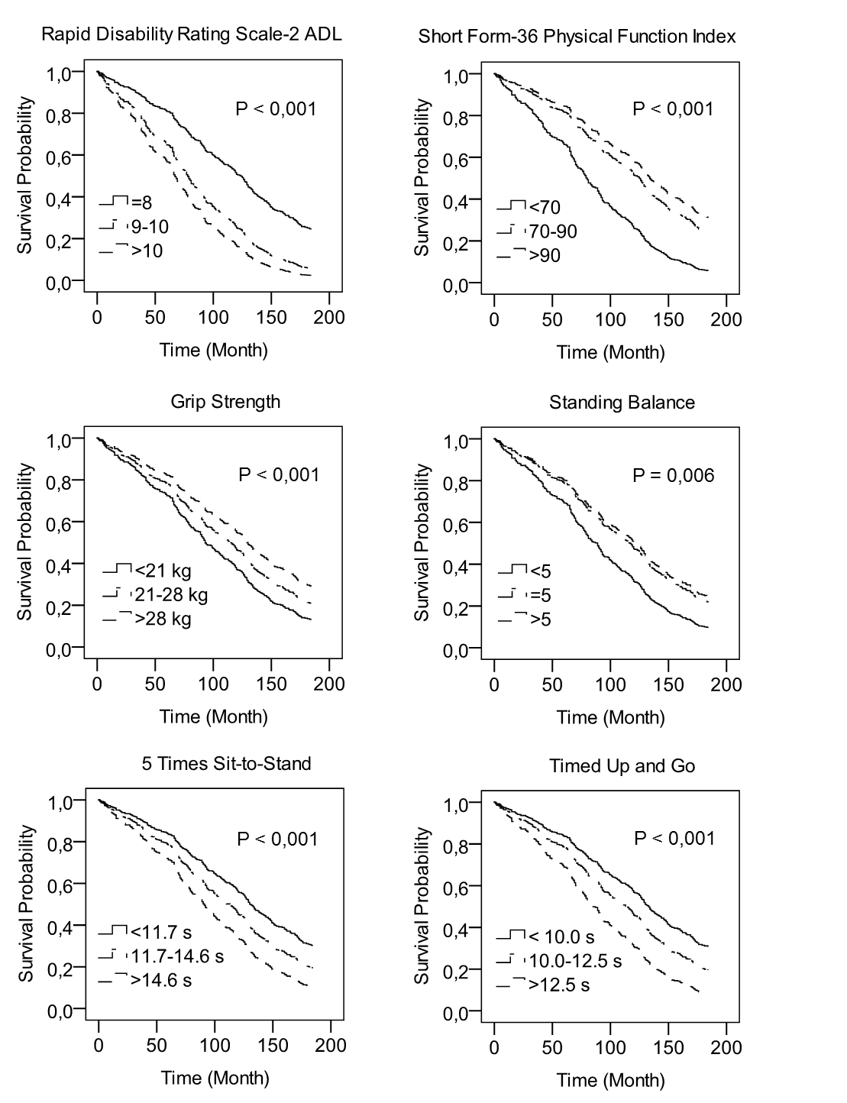

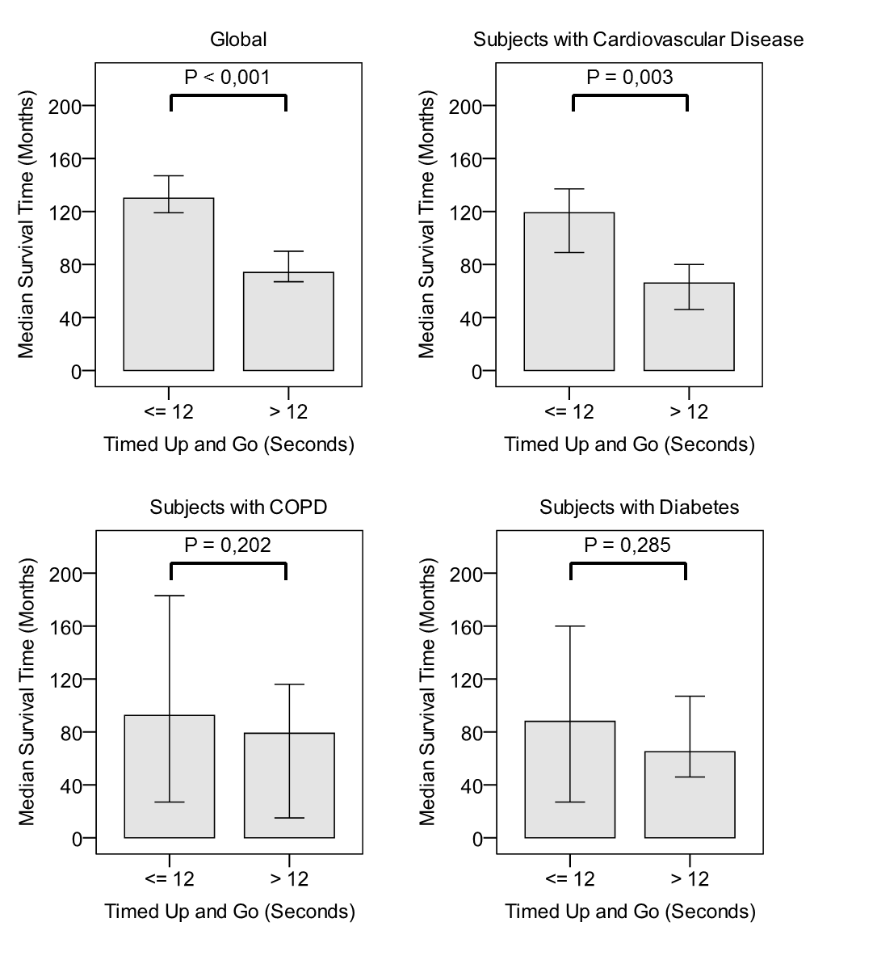

Tables
Table 1 Characteristics of the study population at baseline
Variable | Value
Age, years | 76.0 ± 4.2
Weight, kg | 74.1 ± 11.9
Body mass index, kg/m² | 26.3 ± 3.7
Smoking status, % (N)
Never | 3 (12)
Former | 76 (268)
Current | 21 (72)
Cognitive status | 13.3 ± 1.7
RDRS-2 ADL | 8,7 ± 1.9
SF-36 PFI | 73 ± 24
Grip strength, kg | 24.3 ± 7.9
Standing balance | 5.0 ± 1.0
Five times sit-to-stand, seconds | 13.8 ± 4.7
Timed Up and Go, seconds | 12.2 ± 4.7
Number of medications, median (IQR) | 2 (1-4)
Self-reported chronic diseases, % (N)
Cardiovascular disease | 32 (111)
Chronic obstructive pulmonary disease | 8 (28)
Diabetes mellitus | 7 (25)
Data are reported as mean ± SD unless otherwise indicated
IQR = interquartile range; RDRS-2 = rapid disability rating scale-2; ADL = activities of daily living; SF-36 = 36-item short form health survey; PFI = physical function index

Table 2 Hazard ratios for total mortality of physical performance measurements (per standard deviation increase)
 | Model 1ª |  |  | Model 2^{b} |  |  | Model 3^{c}
Characteristic | HR (95% CI) | P | Chi² | HR (95% CI) | P | Chi² | HR (95% CI) | P | Chi²
RDRS-2 ADL | 1.44 (1.30-1.58) | < 0.001 | 62 | 1.37 (1.24-1.52) | < 0.001 | 105 | 1.19 (1.03-1.37) | 0.016 | 77
SF-36 PFI | 0.66 (0.59-0.74) | < 0.001 | 56 | 0.71 (0.63-0.79) | < 0.001 | 97 | 0.83 (0.71-0.97) | 0.020 | 73
Grip strength | 0.72 (0.63-0.81) | < 0.001 | 27 | 0.80 (0.70-0.91) | 0.001 | 70 | 0.85 (0.74-0.99) | 0.031 | 74
Standing balance | 0.77 (0.70-0.86) | < 0.001 | 23 | 0.87 (0.78-0.98) | 0.020 | 67 | 0.90 (0.78-1.05) | 0.186 | 71
Five times sit-to-stand | 1.59 (1.41-1.80) | < 0.001 | 54 | 1.46 (1.28-1.65) | < 0.001 | 99 | 1.30 (1.10-1.52) | 0.002 | 79
Timed Up and Go | 1.70 (1.53-1.90) | < 0.001 | 94 | 1.54 (1.37-1.74) | < 0.001 | 123 | 1.40 (1.19-1.66) | < 0.001 | 98
ª Unadjusted
^{b} Adjusted for age
^{c} Additionally adjusted for body mass index and smoking status
HR = hazard ratio; CI = confidence interval; RDRS-2 = rapid disability rating scale-2; ADL = activities of daily living; SF-36 = 36-item short form health survey; PFI = physical function index

Table 3 Physical performance of healthy subjects and subjects with comorbidities
 | Healthy Subjects  (N= 200) | Subjects with CV Disease  (N = 111) |  | Subjects with COPD  (N=28) |  | Subjects with Diabetes  (N =25)
Characteristic | Mean ± SD | Mean ± SD | P | Mean ± SD | P | Mean ± SD | P
RDRS-2 ADL | 8.5 ± 1.7 | 8.9 ± 2.1 | 0.082ª | 9.3 ± 2.8 | 0.152ª | 9.8 ± 3.4 | 0.067ª
SF-36 PFI | 78.8 ± 20.7 | 65.1 ± 26.1 | < 0.001ª | 54.8 ± 29.9 | < 0.001ª | 55.4 ± 29.3 | 0.001ª
Grip strength (kg) | 25.4 ± 7.8 | 22.7 ± 7.2 | 0.033^{b} | 22.1 ± 9.6 | 0.041^{b} | 22.7 ± 8.6 | 0.464^{b}
Standing balance | 5.1 ± 0.9 | 4.8 ± 1.2 | 0.008ª | 4.6 ± 1.0 | 0.003^{b} | 4.2 ± 1.3 | 0.003ª
Five times sit-to-stand (seconds) | 13.1 ± 3.8 | 15.2 ± 5.8 | 0.002ª | 15.7 ± 4.9 | 0.002^{b} | 14.3 ± 4.8 | 0.186ª
Timed Up and Go (seconds) | 11.2 ± 2.9 | 14.0 ± 6.7 | < 0.001ª | 13.6 ± 5.3 | 0.032ª | 14.8 ± 8.0 | 0.038ª
ª Independent samples T-test testing the null hypothesis that there is no difference in mean physical performance between healthy subjects and subjects with comorbidity
^{b} ANCOVA testing the null hypothesis that there is no difference in mean physical performance between healthy subjects and subjects with comorbidity, taking the variability of age into account
CV = cardiovascular; COPD = chronic obstructive pulmonary disease; SD = standard deviation; RDRS-2 = rapid disability rating scale-2; ADL = activities of daily living; SF-36 = 36-item short form health survey; PFI = physical function index

