Please cite as follows: De Keyser, A., Verleye, K., Lemon, K. N., Orsingher, C., Zion, A., & Johnson, A. (2024). Customer experience: The touchpoints-contexts-qualities nomenclature. In P. Kristensson, L. Wittell, & M. Zaki (Eds.), Handbook on Service Experience. E. Elgar Publishers.

Customer Experience: The Touchpoint-Contexts-Qualities Nomenclature

Arne De Keyser, EDHEC Business School, France
Katrien Verleye, Ghent University, Belgium
Katherine N. Lemon, Boston College, USA
Chiara Orsingher, University of Bologna, Italy
Aric Zion, Zion & Zion, USA
Amanda Johnson, Zion & Zion, USA

ABSTRACT

This chapter explores the facilitation of customer experience analysis, management, and innovation through the adoption of the Touchpoints-Contexts-Qualities (TCQ) nomenclature. Fundamentally, customer experiences are shaped by "touchpoints" (T) situated within a broader "context" (C) and characterized by a collection of "qualities" (Q) that cumulatively influence customers’ value assessment. The TCQ framework offers a nomenclature for rendering customer experience actionable by deconstructing it into a set of manageable components. In addition to elaborating on the TCQ components, the authors examine how firms can employ this framework to (1) audit their customer journeys, (2) innovate customer journeys, and (3) position their firm strategically with customer experience practices along customer journeys.

Keywords: Customer Experience, TCQ, Customer Experience Management, Touchpoint, Context, Quality

1. Introduction

In today’s business landscape, customers interact with firms in complex, nonlinear ways through diverse touchpoints like online and mobile channels. These customers also expect personalized and contextualized experiences. This puts great pressure on firms. It is thus not surprising that customer experience is a key battleground on which firms fight to attract, retain, and develop customers. Failure to deliver risks losing customers to competitors who can provide a more compelling customer experience.
Despite the tremendous growth of opportunities for gathering and analyzing data, many firms are at a loss on how to win the customer experience game. A key starting point toward successful customer experience management is a clear understanding of what customer experience entails and a common language to discuss customer experience initiatives. This chapter zooms-in on De Keyser et al.'s (2020) recently introduced language system – the Touchpoints-Contexts-Qualities (TCQ hereafter) nomenclature – and discusses three ways in which it can be used. To this end, we also rely on the expertise of a U.S. marketing agency that employs the TCQ framework with their clients.
Essentially, TCQ offers a descriptive language to aid firms and managers in organizing thoughts, discussions, and projects linked to customer experience in a clear and consistent way. Moreover, TCQ is not limited to any specific domain, industry, or context and may be applied to business-to-consumer, consumer-to-consumer, business-to-business, and business-to-government settings. Ultimately, it offers a simple, manageable, and flexible way to take a step forward in the customer experience space.

2. Customer Experience: A TCQ Perspective

Customer experiences encompass the non-deliberate, spontaneous responses and reactions to offering-related stimuli embedded within a specific context (Becker and Jaakkola, 2020, p. 642). The broad and comprehensive nature of this definition, however, is not instrumental in guiding the development and implementation of a practical customer experience program (Keiningham et al. 2020; Maklan et al. 2017). TCQ was introduced to address this shortcoming and to help break down the constituent elements of customer experience. By dissecting customer experience into its smaller components, TCQ endeavors to create a formalized nomenclature for customer experience, which is necessary to facilitate more structured discussions and effective customer experience management.
Based on an inductive analysis of the customer experience literature, De Keyser et al. (2020) derive twelve components that aggregate into three overarching building blocks: (1) Touchpoints (i.e., points of interaction between the customer and firm), (2) Contexts (i.e., situationally available resources internal and/or external to the customer), and (3) Qualities (i.e., attributes that reflect the nature of customer responses to interactions with the firm) – see Figure 1 for a complete overview. Customer experiences are the result of a combination of these three building blocks in that they are formed through “touchpoints” (T) which are embedded in a broader “context” (C) and marked by a set of “qualities” (Q) that, together, result in a value judgment by the customer (i.e., am I – as a customer – better off?). In what follows, we detail the three building blocks and their respective components.

2.1 Touchpoints
A touchpoint is any individual point of contact between a firm and a customer (Lemon and Verhoef 2016; Homburg et al. 2017) – such as a firm’s website, social media page, a peer talking about the firm to a customer, a customer imagining their next contact with the firm, etc. Without any actual or imagined interaction, no customer experience can take place (Hoffman and Novak 2018). Touchpoints vary in terms of nature, control, and stage of the customer journey.
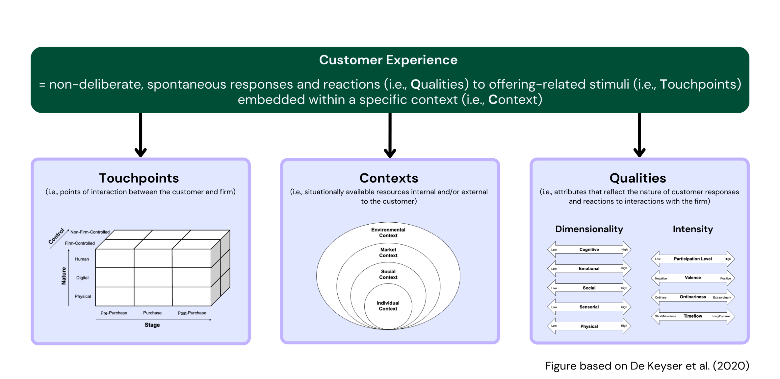
Figure 1: Touchpoints-Contexts-Qualities Nomenclature

Touchpoint nature refers to how the firm is represented in the interaction with the customer. Touchpoints can be human (e.g., frontline employees), digital (e.g., service robots) or physical (e.g., store layout) in nature, or any combination of these.
Touchpoint control refers to who manages the points of contact between the customer and the firm: the firm or an (a set of) external actor(s). Firm-controlled touchpoints are those designed and managed fully – such as store environments, advertisements, and packaging – or partially – think Amazon premium product pages or paid influencer campaigns – by the firm (Verhoef et al. 2009). These touchpoints are highly adaptable, allowing the firm to implement them as desired, making them key elements of a firm’s strategy. Oftentimes, however, customers interact with a firm through so-called non-firm-controlled touchpoints (Kranzbühler et al. 2019). These include customer-controlled (e.g., a passenger bringing their own headphones on an airplane), social (e.g., online reviews and blogs), and other external (e.g., comparative advertisements, independent sellers) touchpoints. Firms have much less influence over these touchpoints.
Touchpoint stage refers to the specific position of a touchpoint along the customer journey, entailing a pre-purchase, purchase, and post-purchase stage (Lemon and Verhoef, 2016). The pre-purchase stage includes all interactions before the actual purchase decision. Here, customers are typically building awareness, conducting research, and evaluating options, all of which are crucial persuasive parts of the consumer journey. The purchase stage includes interactions during the purchase decision and act, such as consumer choice, ordering, paying, pickup, and delivery. The post-purchase stage, finally, entails interactions related to actual usage and consumption, such as product-returns, and repair requests, but also the active participation in a brand community. When thinking about these stages, it is important to keep in mind customers are usually driven by a set of (sub)goals they want to achieve – one may, for instance, think of customers wanting information in the pre-purchase stage, easy payment in the purchase stage, or clear ‘how-to-use’ instructions post-purchase. As a firm, it is crucial to understand what is driving your customers at the different stages and why they are interacting with you.
  - Contexts

Customers experience touchpoints differently based upon the broader context they find themselves in, as recognized by service-dominant logic and consumer culture theory scholars (Akaka, Vargo, and Schau, 2015). This means that customer experience is, by definition, subjective and context-driven (Sandström et al. 2008). We define context as the conditional state that influences the resources a person can access directly or indirectly at any given time (Bettencourt, Lusch, and Vargo 2014; Chandler and Vargo 2011). In other words, it may be seen as the collection of situational opportunities and/or constraints that impact an individual. There are four levels of context: individual, social, market, and environmental context.
Individual context reflects the personal state of a customer at a given moment in time. Individuals are inherently driven by their own logic (i.e., the way a customer thinks), and this impacts how they react to specific touchpoints. A variety of individual factors may be at play here. Customers’ emotional state, including feelings of joy, happiness, anger, and sadness, may drive how an individual experiences an interaction with a firm. People in a good mood, for instance, are likely to try new goods/services, while those in a bad temper are more likely to stick to familiar brands and notice negative cues more easily (Puccinelli et al. 2009). Customers’ cognitive state is also a highly relevant factor and determined by, among others, previous brand experiences, memories, or imagined future interactions (Holbrook and Hirschmann 1982; Jaakkola, Helkkula, and Aarikka-Stenroos 2015; Lemon and Verhoef 2016). A previously bad experience, for instance, may lead a customer to be reluctant to re-engage with a firm offering. Customers’ normative state is another critical individual contextual factor that entails internalized institutions, rules, thinking styles, processing strategies, and judgements (Akaka, Vargo, and Shau 2015). For example, imagine two customers who call a bank’s customer service for the first time. One customer is from a collectivistic culture that values harmony, respect, and loyalty. The other customer is from an individualistic culture that values autonomy, efficiency, and innovation. They may experience the same touchpoint (e.g., talking to a representative) very differently based on their internalized institutions. Finally, individual physical and economic factors may also impact how a touchpoint is experienced. For example, a customer who feels sick or tired may not have the energy or motivation to pursue their goals, while a customer on a tight budget may have to abandon a preferred option based on its price (De Keyser et al. 2015).
Social context entails customers’ social connections – family, friends, other customers. Customers are not isolated individuals but are connected to their surroundings. These include a diverse range of people and groups, each with their own goals, preferences, and needs (Verhoef et al. 2009). Customers take on different social roles – parent, spouse, friend, colleague – with different expectations that influence customer experience. A customer going to the mall with their best friend or with their three kids is likely to result in a different experience, despite touchpoints being equal in nature.
Market context relates to conditions created by market-related actors with whom customers engage, including competitors, substitutes, complements, and potential new entrants in the market. Customers, for instance, often rely on a network of firms and partners to meet their needs (Tax, McCutcheon, and Wilkinson 2013). An evening out can encompass the combined services of a taxi company, a restaurant, a cinema, a bar, and a babysitting service. The performance of each firm in this network impacts the overall ‘going out experience’ as well the individual experience with each party in the network. If the taxi company underserves by coming late, this may negatively impact any following interaction. Simultaneously, competitors, substitutes, and new entrants may also influence the customer's experience with a focal firm. Think what Uber and Airbnb did to revolutionize the mobility experience and hospitality experience, respectively, and how customers were suddenly more negative about previously ‘neutral’ touchpoints offered by a traditional hotel chain like Hilton or the New York yellow cabs, resulting in higher expectations for these existing offerings.
Environmental context is composed of a broad set of natural, economic, public, and political factors impacting customer experience. These factors are largely non-controllable for an individual organization but may be highly impactful, nonetheless. Think, for instance, how the Covid19 pandemic radically impacted customers’ behavior and interactions with firms. Natural factors such as weather and outside temperature can affect a customer's experience. Research, for instance, finds sunny and rainy weather have a positive impact on daily sales (relative to cloudy weather), while air quality has a negative effect on daily sales (Tian et al. 2021). Economic factors such as changes in income, gasoline prices, real estate value, and the overall state of the economy impact customers’ brand preferences, store choices, willingness to purchase goods and services, and frequency of service purchases (Kumar et al. 2014). Public factors, such as road infrastructure, the power grid, and government support programs, may also play a crucial role in shaping customers’ experiences (McColl-Kennedy et al. 2012). Someone’s experience with an electric car, for instance, may be driven by the availability and reliability of public charging stations (Kumar and Alok, 2020). Finally, political factors may influence one’s consumption experience or even impede access to specific products. Consider how the Russia-Ukraine war impacted global food security (Behnassi and Haiba, 2022), pushing customers to search for alternatives.
2.3 Qualities

Qualities reflect the very nature of the customer experience – think about a customer feeling joy, learning something new, being active, or feeling totally wow-ed. They can essentially be classified into two broad categories: (1) customer experience dimensionality and (2) customer experience intensity.
Customer experience dimensionality comprises five sub-components: cognitive, emotional, social, sensorial, and physical experiences. Each of these may be considered on a continuum, ranging from low presence (i.e., absent) to high presence (i.e., very present). Cognitive experiences stimulate customers to think, reflect, and use their brain power. We may think about experiences resulting from touchpoints where customers need to provide and/or receive a lot of information (e.g., registering a new customer profile or visiting a historical museum) or where they need to reflect on their needs and preferences (e.g., filling in a personalization survey on a fashion platform). Emotional experiences are those that trigger one of many possible emotions like joy, anger, fear, disgust, and surprise and are often seen as a vital dimension of any customer experience (Manthiou, Hickman, and Klaus, 2020). Consider how Disney succeeds in bringing joy and surprise to many of its theme park visitors, while a dentist visit entails a level of fear for certain patients. Social experiences result from touchpoints that lead customers to connect with others, whether these others are real humans or virtual entities like social robots and chatbots. The popularity of escape rooms, for instance, is largely driven by teams of friends being able to play together to solve mysteries and riddles. Sensorial experiences activate or trigger one or more of customers’ five senses (i.e., vision, hearing, smell, taste, and touch). Bakeries and other food stores, for instance, heavily use (artificial or natural) smells to entice customers into buying and uplifting their overall experience. Finally, physical experiences have a bodily impact on customers in that they, for instance, get them to move and be physically active (i.e., How physical is the experience?). Consider how sporting goods stores, such as Nike, have in-store tracks allowing customers to try out new shoes and athletic gear, while Decathlon offers the opportunity to test fitness equipment on its premises.
Customer experience intensity, in turn, comprises four sub-components: participation level, valence, ordinariness, and timeflow. Participation level reflects whether the customer experience is passive or active (Dong and Sivakumar, 2017). The experience for customers designing their own teddy bear via Build-a-Bear Workshop, for instance, is very active, while selecting a pre-built bear requires significantly less input from the customer. Valence reflects whether the nature of the experience is positive, negative, neutral, or mixed (i.e., ambivalent) (Manthiou et al., 2020). While most firms strive for their touchpoints to come with positive valence, some may be inherently (e.g., medical visits) or intentionally (e.g., rollercoaster ride) negatively valenced. It is important to note that even negatively valenced touchpoints may be seen as valuable. While fear may be experienced during a rollercoaster ride, a customer may evaluate it positively afterward. Ordinariness reflects how ‘common’ or ‘extraordinary’ a customer experience is (Bhattacharjee and Mogilner, 2014). A typical grocery shopping visit would be considered ordinary and normal, whereas luxury boutiques like those of LVMH or Chanel are all about wow-ing the customer and continuously offering novel and surprising touchpoint interactions. Finally, timeflow relates to customers’ perceptions of how long or short an experience is, as well as the dynamics (i.e., tempo, speed, rhythm – Woermann and Rokka 2015) experienced by the customer. Think how grocery stores experiment to reduce subjective waiting time perceptions at the check-out and make use of tech-driven innovations like selfscans. Traditional bookstores, in contrast, may offer a cozy reading area with comfortable chairs to encourage customers to spend more time browsing and enjoying books as a core part of their value proposition.
3. Putting TCQ To Use

U.S.-based marketing agency Zion & Zion (https://www.zionandzion.com/) have been employing the TCQ framework with their clients to gain new insights and to drive innovation and customer experience improvement. Their insights suggest that adopting a TCQ perspective within the customer experience (management) realm offers various benefits. At its core, TCQ brings consistency and a structure to customer experience through proposing a shared nomenclature that emphasizes the core building blocks of what a customer experience is. This structure is pivotal, especially when customer experience feels overwhelmingly broad, helping organizations manage and direct change more effectively. At a tactical level, TCQ may help enhance customer journey audits and boost innovation ideation. More precisely, the ability to dissect customer experience through TCQ aids in deepening insights that arrive from design thinking and journey mapping tools and help create new insights that enable innovation. At a strategic level, TCQ may aid in deciding what customer experience an organization wants to be known for (i.e., customer experience positioning), and how to ensure all touchpoints support this objective.

3.1 TCQ as an auditing language

For any firm, it is recommended to periodically audit the experiences they enable through their interactions with customers. TCQ may be used to improve this audit process by providing a common language to discuss the customer experiences’ elementary building blocks. Depending on the firm's goals, such an audit may happen at a segment (most typical) or individual customer level.
To conduct a TCQ-informed audit, managers should begin by streamlining the touchpoint overview. This involves inventorying all touchpoint types (human, digital, physical) across the different stages of the customer journey and determining who is in control. Typical tools for this overview are customer journey mapping (Rosenbaum, Otalora, Raminez, 2017; Tueanrat, Papagiannidis, and Alamanos, 2021) – whether or not complemented with service blueprinting (Bitner, Ostrom, and Morgan, 2008; Patrício, Fisk, Falcão e Cunha, and Constantine, 2011).
The next step involves recognizing what contextual elements are at play. Here, an assessment is needed to determine the key contextual influences across the various touchpoints, the extent to which current touchpoints are context-adaptive, and the means through which the firm already does or may capture contextual information. Typical tools to enhance a firm’s contextual understanding include customer surveys, in-depth interviewing, web analytics services (i.e., tracking of location, time, device type, browsing history, etc.), and design thinking methodologies like the Five Whys, empathy mapping, and contextual inquiry.
Finally, the various touchpoints along the customer journey need to be assessed in terms of their experience qualities. Firms may use tools like customer surveys and real-time experience tracking to link data about customer experience qualities to data associated with customers’ evaluative judgments, such as customer satisfaction and NPS scores. This will enable managers to assess the relative importance of customer experience qualities and the potential for improvement across touchpoints.
The audit will likely reveal strengths, weaknesses, opportunities, and threats in the firm's current customer experience. The value of the TCQ approach is that it provides a sufficient level of detail and specificity to allow managers to quickly identify the specific touchpoints that require improvement and what needs to be addressed. When a customer pain point is identified at a specific touchpoint, operational changes may be implemented to ratify the problem. See Exhibit 1 for an example application of a TCQ-driven audit – based on an anonymized client of Zion & Zion.
Exhibit 1: Example TCQ Audit
Imagine a Do-It-Yourself (DIY) chain serving customers with products to paint their house walls. Given the infrequent nature of this activity, the segment of inexperienced customers (i.e., beginners) is important. As such, a TCQ audit for this segment is performed. Following the above steps, the following TCQ-enhanced customer journey mapping appears:
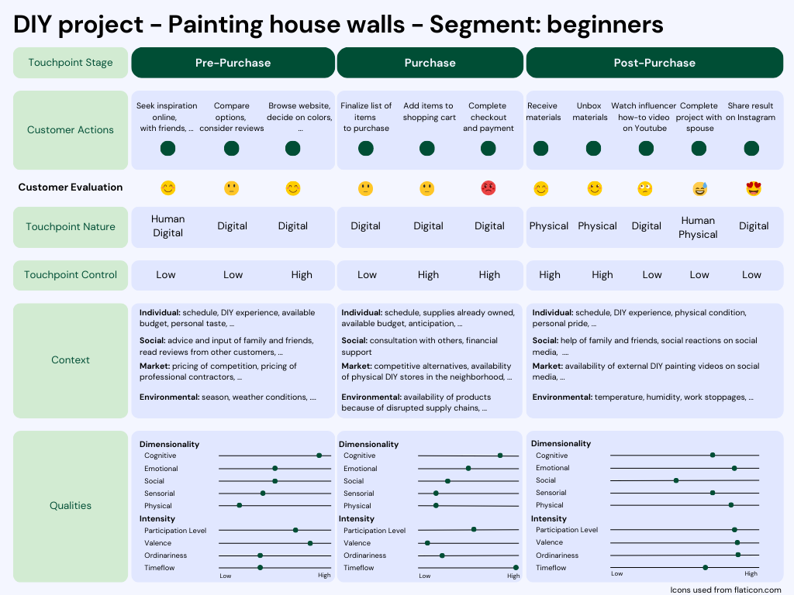
Note how the organization of the audit quickly and easily allows management to identify what is working or not working for all aspects of the customer experience. Specifically, we see that the ‘check-out and payment’ touchpoint comes out as negatively evaluated ().
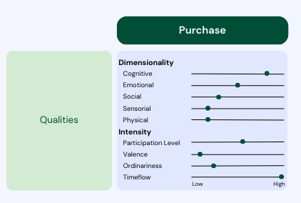
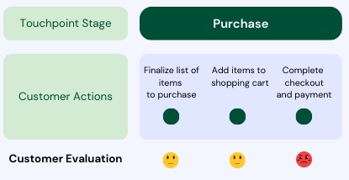

Looking closer at the realized qualities in the purchase phase, both valence (negative) and timeflow (procedure that is perceived to take a long time) are different from what the DIY retailer is aiming for (i.e., neutral/positive and short/efficient). As a result, managerial action is needed to work on these two experience qualities of the ‘check-out and payment’ touchpoint.

  - TCQ as an Innovation Language

TCQ further has the potential to enhance customer experience design through innovating or even developing new touchpoints and journeys. By considering various combinations of TCQ components, firms may generate new ideas to innovate their offering and interactions with customers. This would include answering questions like: How do different types of touchpoints (e.g., human vs. digital) affect different qualities of CX (e.g., emotional vs. cognitive) across different contexts (e.g., crowded vs. non-crowded stores)? How does context (e.g., home-access to AR/VR devices) impact the qualities (e.g., ordinariness) that result from novel touchpoints (e.g., interactive website design)?
To think about TCQ-driven innovation, it is useful to first identify what experience qualities are needed. What are customers looking for at various touchpoints along the customer journey? Tools such as customer surveys, ethnography, netnography, and depth interviews may help gain insights into the desired qualities, identifying the extent to which each quality—level of participation, multidimensionality, timeflow, valence, and ordinariness—is potentially important (or unimportant) at each journey stage and valued by the customer.
Second, firms need to assess what contextual data can be collected and used to create touchpoints that allow specific qualities to occur. Given the abundance of contextual data collection opportunities, the challenge lies in selecting what data is most relevant. Interesting opportunities reside in social media, web-tracking, and customer transaction history but may equally stem from human frontline employees who developed an in-depth understanding of individual customers they often interact with.
In a third step, managers need to assess what type of touchpoint constellation is best to promote the sought-after qualities. They can evaluate whether existing touchpoints can be adapted or whether new touchpoints need to be introduced, as well as consider the level of control that is desired.
Going through these steps results in a list of potential opportunities to innovate and differentiate the customer experience. Firms must then select the actions that are most likely to be successful given their capabilities and customer base. Different types of service design tools – related to experimentation, prototyping, and choice modeling – may help in this effort (Zomerdijk and Voss, 2010; Sierra-Pérez, Teixeira, Romero-Piqueras, and Patrício, 2021). See Exhibit 2 for an application of TCQ-driven innovation.
Exhibit 2: Example TCQ Innovation
Imagine a hotel chain with prime locations at U.S. airports. With tens of thousands of flights cancelled annually, stranded airline passengers form a major source of income. The goal of this hotel chain is to have stranded passengers select their properties as a preferred option to spend the night.
(1) What qualities are these stranded passengers looking for?
Above all, stranded passengers are looking for a place to spend the night. In this effort, they will likely desire three qualities in their search experience: they want factual information – How far away is the hotel? What is the room price? (cognitive component) – think about using a tagline like: “Rooms only 0.5 miles away!”); they want to be emotionally reassured and get rid of their stress by knowing there are room available (emotional component – think about using a tagline like “We’ve got you covered!”), and they want all of this to be fast and hassle-free (timeflow component – think about using a tagline like “We have spots to book now!”).
(2) How to find these passengers (i.e., context)?
To know what passengers the hotel should speak to, it could track real-time flight information cancellation data (i.e., market context). Such publicly available data is easy to monitor and possible to connect with internal data systems through an Application Programming Interface (API).
(3) Where to get in touch with these passengers?
Most passengers looking for a hotel room will use a search engine like Google (digital touchpoint, partner-owned) to look up information (pre-purchase stage). The first results that appear are the search engine ads. To appear on top of the search advertising results, the hotel chain could make use of the cancellation tracker API to increase its search advertising bidding (within a specific geographical area) at times flights are canceled. This would ultimately help reach the stranded passengers through the right medium with the right message.

A real-life application of the above scenario was implemented by US hotel chain Red Roof Inn: https://www.mmaglobal.com/case-study-hub/upload/pdfs/mma-2014-827.pdf
The campaign resulted in a major success, with Red Roof Inn reaching 75 percent of key last-minute queries in Google and a significant increase in bookings.

3.3 TCQ as a Strategic Positioning Language

A final way to use TCQ resides at the corporate strategy level, answering the question: “What type of experience player do I want to be?”. Indeed, any firm should reflect on what sort of experience they want to be known for. The TCQ nomenclature may assist in bringing clarity to this decision.
First, firms may strategically position themselves with the qualities of the experience, as this TCQ component is reflective of customer experience’s nature. Exhibit 3 provides some example firms and the experience quality they are known for.
Exhibit 3: Examples of Strategic Positioning with Qualities
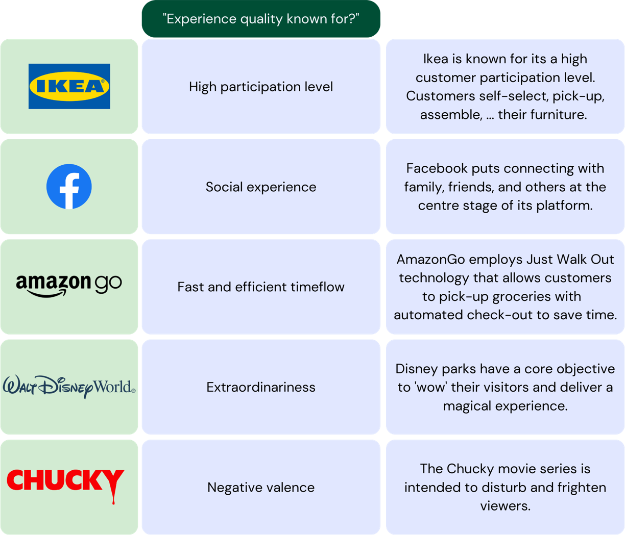

Another way in which firms can strategically position themselves is through their touchpoints. Indeed, firms can bring the consistency or connectivity of their touchpoints to the forefront. Exhibit 4 provides illustrations of firms that are known for their touchpoint constellation.

Exhibit 4: Examples of Strategic Positioning with Touchpoints
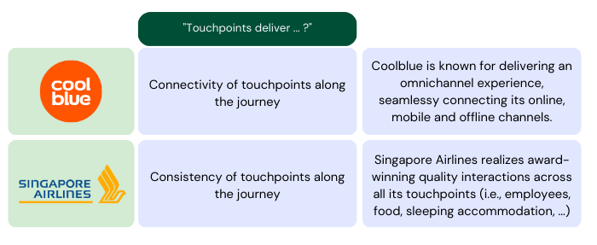

Finally, offering contextualized experiences is another way in which firms can differentiate themselves from their competitors. Exhibit 5 provides illustrations of firms that are known for their contextualization efforts.
Exhibit 5: Examples of Strategic Positioning with Context
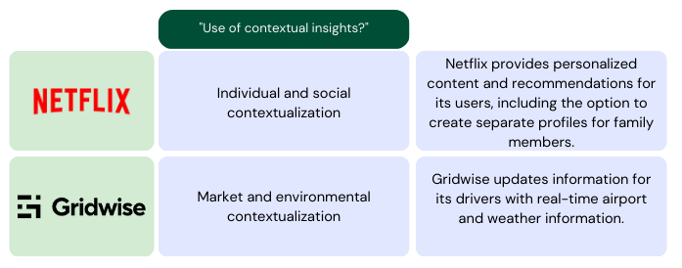

6. Conclusion

In conclusion, adopting the Touchpoints-Contexts-Qualities (TCQ) nomenclature provides a powerful tool for companies to analyze, innovate, and position their customer experience strategies. By breaking down customer experiences into manageable components of touchpoints, contexts, and qualities, TCQ offers a practical and actionable approach for companies to understand and improve their customer experiences. Through the examination of the TCQ components, this chapter provides a clear understanding of how companies can leverage the framework to create more meaningful and impactful customer experiences that drive customer loyalty and business success.

7. References

Akaka, M.A., Vargo, S.L. and Schau, H.J. (2015), "The context of experience", Journal of Service Management, 26(2), 206-223.

Becker, L., & Jaakkola, E. (2020). Customer experience: fundamental premises and implications for research. Journal of the Academy of Marketing Science, 48, 630-648.

Behnassi, M., & El Haiba, M. (2022). Implications of the Russia–Ukraine war for global food security. Nature Human Behaviour, 6(6), 754-755.

Bettencourt, L. A., Lusch, R. F., & Vargo, S. L. (2014). A service lens on value creation: marketing's role in achieving strategic advantage. California Management Review, 57(1), 44-66.

Bhattacharjee, A., & Mogilner, C. (2014). Happiness from ordinary and extraordinary experiences. Journal of Consumer Research, 41(1), 1-17.

Bitner, M. J., Ostrom, A. L., & Morgan, F. N. (2008). Service blueprinting: a practical technique for service innovation. California Management Review, 50(3), 66-94.

Chandler, J. D., & Vargo, S. L. (2011). Contextualization and value-in-context: How context frames exchange. Marketing Theory, 11(1), 35-49.

De Keyser, A., Lemon, K. N., Klaus, P., & Keiningham, T. L. (2015). A framework for understanding and managing the customer experience. Marketing Science Institute working paper series, 85(1), 15-121.

De Keyser, A., Verleye, K., Lemon, K. N., Keiningham, T. L., & Klaus, P. (2020). Moving the customer experience field forward: introducing the touchpoints, context, qualities (TCQ) nomenclature. Journal of Service Research, 23(4), 433-455.

Dong, B., & Sivakumar, K. (2017). Customer participation in services: domain, scope, and boundaries. Journal of the Academy of Marketing Science, 45, 944-965.

Hoffman, D. L., & Novak, T. P. (2018). Consumer and object experience in the internet of things: An assemblage theory approach. Journal of Consumer Research, 44(6), 1178-1204.
Holbrook, M. B., & Hirschman, E. C. (1982). The experiential aspects of consumption: Consumer fantasies, feelings, and fun. Journal of Consumer Research, 9(2), 132-140.
Homburg, C., Jozić, D., & Kuehnl, C. (2017). Customer experience management: toward implementing an evolving marketing concept. Journal of the Academy of Marketing Science, 45, 377-401.

Jaakkola, E., Helkkula, A., & Aarikka-Stenroos, L. (2015). Service experience co-creation: conceptualization, implications, and future research directions. Journal of Service Management, 26(2), 182-205.

Keiningham, T., Aksoy, L., Bruce, H. L., Cadet, F., Clennell, N., Hodgkinson, I. R., & Kearney, T. (2020). Customer experience driven business model innovation. Journal of Business Research, 116, 431-440.

Kumar, R. R., & Alok, K. (2020). Adoption of electric vehicle: A literature review and prospects for sustainability. Journal of Cleaner Production, 253, 119911.

Kranzbühler, A.-M., Kleijnen, M. H. P., & Verlegh, P. W. J. (2019). Outsourcing the pain, keeping the pleasure: Effects of outsourced touchpoints in the customer journey. Journal of the Academy of Marketing Science, 47, 308-327.

Lemon, K. N., & Verhoef, P. C. (2016). Understanding customer experience throughout the customer journey. Journal of Marketing, 80(6), 69-96.

Maklan, S., Antonetti, P., & Whitty, S. (2017). A better way to manage customer experience: Lessons from the Royal Bank of Scotland. California Management Review, 59(2), 92-115.

Manthiou, A., Hickman, E., & Klaus, P. (2020). Beyond good and bad: Challenging the suggested role of emotions in customer experience (CX) research. Journal of Retailing and Consumer Services, 57, 102218.

Patrício, L., Fisk, R. P., Falcão e Cunha, J., & Constantine, L. (2011). Multilevel service design: from customer value constellation to service experience blueprinting. Journal of Service Research, 14(2), 180-200.
Puccinelli, N. M., Goodstein, R. C., Grewal, D., Price, R., Raghubir, P., & Stewart, D. (2009). Customer experience management in retailing: understanding the buying process. Journal of Retailing, 85(1), 15-30.
Rosenbaum, M. S., Otalora, M. L., & Ramírez, G. C. (2017). How to create a realistic customer journey map. Business Horizons, 60(1), 143-150.

Sandström, S., Edvardsson, B., Kristensson, P., & Magnusson, P. (2008). Value in use through service experience. Managing Service Quality: An International Journal, 18(2), 112-126.

Sierra-Pérez, J., Teixeira, J. G., Romero-Piqueras, C., & Patrício, L. (2021). Designing sustainable services with the ECO-Service design method: Bridging user experience with environmental performance. Journal of Cleaner Production, 305, 127228.

Tax, S. S., McCutcheon, D., & Wilkinson, I. F. (2013). The service delivery network (SDN) a customer-centric perspective of the customer journey. Journal of Service Research, 16(4), 454-470.

Tian, X., Cao, S., & Song, Y. (2021). The impact of weather on consumer behavior and retail performance: Evidence from a convenience store chain in China. Journal of Retailing and Consumer Services, 62, 102583.

Tueanrat, Y., Papagiannidis, S., & Alamanos, E. (2021). Going on a journey: A review of the customer journey literature. Journal of Business Research, 125, 336-353.

Teixeira, J., Patrício, L., Nunes, N. J., Nóbrega, L., Fisk, R. P., & Constantine, L. (2012). Customer experience modeling: from customer experience to service design. Journal of Service management, 23(3), 362-376.

Verhoef, P. C., Lemon, K. N., Parasuraman, A., Roggeveen, A., Tsiros, M., & Schlesinger, L. A. (2009). Customer experience creation: Determinants, dynamics and management strategies. Journal of Retailing, 85(1), 31-41.

Woermann, N., & Rokka, J. (2015). Timeflow: How consumption practices shape consumers’ temporal experiences. Journal of Consumer Research, 41(6), 1486-1508.

Zomerdijk, L. G., & Voss, C. A. (2010). Service design for experience-centric services. Journal of Service Research, 13(1), 67-82.

