History page: leaders in MSK radiology
Stanislas de Sèze, 1903-2000
Filip M. Vanhoenacker^{1,2,3}, MD, PhD, Antoine Feydy, MD, PhD^{4,5}

1. Antwerp University Hospital, Dept of Radiology and Antwerp University Faculty of Medicine and Health Sciences, B-2650 Edegem, Belgium
2. General Hospital Sint-Maarten Mechelen, Liersesteenweg 435, 2800 Mechelen, Belgium
3. Faculty of Medicine and Health Sciences, University of Ghent, Belgium
4. Radiologie B, Hôpital Cochin APHP, Paris, France
5. Université Paris Cité

Address for correspondence:
Filip M. Vanhoenacker
Antwerp University Hospital, Dept of Radiology and Antwerp University Faculty of Medicine and Health Sciences, Drie Eikenstraat, 655, B-2650 Edegem, Belgium

E-mail: filip.vanhoenacker@telenet.be

E-mail addresses of other co-authors:
antoine.feydy@aphp.fr

Abstract
This history page is dedicated to the memory and achievements of the French rheumatologist Stanislas de Sèze whose name is connected to the so-called “de Sèze view”, which is used to evaluate the sacro-iliac joints, the lumbar and lower thoracic spine, pelvis and hip joints on a single anteroposterior radiograph.

Keywords

de Sèze view
Radiography
History

Main text
Stanislas de Sèze (Fig. 1) was born in Paris, France in October 1903¹.
One of his ancestors was Romain de Sèze, who was a lawyer defending King Louis XVI before the tribunal during the French revolution². His father and grandfather were medical doctor and professor of medicine respectively. Therefore it was not surprising that he followed in their footsteps by entering medical school in Paris.
After his internalship, he began to practice as a hospital doctor at the age of 32.
At that time, his initial clinical interest went to neurology by carefully examining patients with sciatica who consulted him and whom he was trying to relieve by anesthetic injections. When Henri Dausset, the founding editor of the Revue du Rhumatisme, asked him to write an article for his journal on anesthetic infiltrations in neuralgia, his career took a turn to rheumatology. The impact of his publication was so overwhelming that Henri Dausset proposed in his will to Stanislas de Sèze to succeed him as editor-in-chief of the Revue du Rhumatisme³.
Based on his clinical observations, he was the first in 1939 to correlate clinical symptoms of sciatica with the presence of a disc herniation⁴.
From 1945 on, his career was further directed to clinical rheumatology at the Lariboisière hospital in Paris. The department he founded (also known later as the Viggo-Petersen center related to a generous private donation from Mr. and Mrs. Viggo-Petersen in 1952) had its own radiology unit, an immunology laboratory, a research unit focused on phosphocalcium metabolism and teaching facilities for students.
Also in 1945, he obtained his aggregate thesis and he became appointed Professor of the History of Medicine and Surgery in 1960 at the Faculty of Medicine in Paris and Professor of Rheumatology Clinic in 1965.
Although being a rheumatologist, he led X-ray interpretation sessions in his department every week, which was highly appreciated by his students and colleagues.
He retired from clinical work in 1975 but he continued by contributing to clinical research and teaching.
He was a very prolific writer, with more than 600 articles indexed in PubMed, mainly written in French.
His main work is Le Traité de rhumatologie, written in collaboration with Antoine Ryckewaert, first published by Flammarion in 1953 with several re-editions later, become the reference work in French not only for rheumatologists but also for radiologists and other musculoskeletal disciplines (Fig. 2).
In addition to his work on sciatica, he focused particularly on the other causes of spinal pain and stiffness including degenerative disease of the spine, cancer, tuberculosis, infections, parasitosis and ankylosing spondylitis and spondylolisthesis, with a special interest on precise semiological analysis of high-quality radiographs².
The so-called “de Sèze view” on radiography -named after him- is used to evaluate the sacro-iliac joints, the lumbar and lower thoracic spine, pelvis and hip joints on one single anteroposterior radiograph. Later, Gérard Morvan et al. promoted to use a coronal STIR sequence with large Field of View (FOV), as the equivalent Magnetic Resonance (MR) sequence of de Sèze projection as part of the lumbar spine MRI protocol : “de Sèze Magnétique” . This additional sequence can demonstrate lesions of the pelvis and retroperitoneum that would otherwise go undetected on routine sagittal and axial MR images of the lumbar spine³.

He served as President of the Society of Rheumatology, of the European Anti-Rheumatic League (EULAR), the Société Médicale des Hôpitaux de Paris and the Académie de Médecine.
For his outstanding contributions to medicine, he was awarded the prestigious Commander of the French Légion d’honneur (Fig. 1).
Health problems and a forgetfulness of proper names came with age. A few weeks after hospitalization in “his” Lariboisière hospital for an acute neurological accident, he passed away on April 27, 2000.

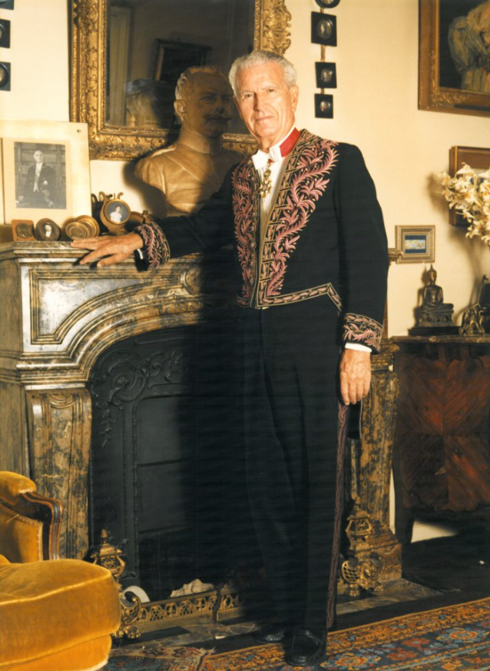

Figure 1. Professor Stanislas de Sèze as commander of the « Légion d’honneur » (used with permission from¹, open licence)

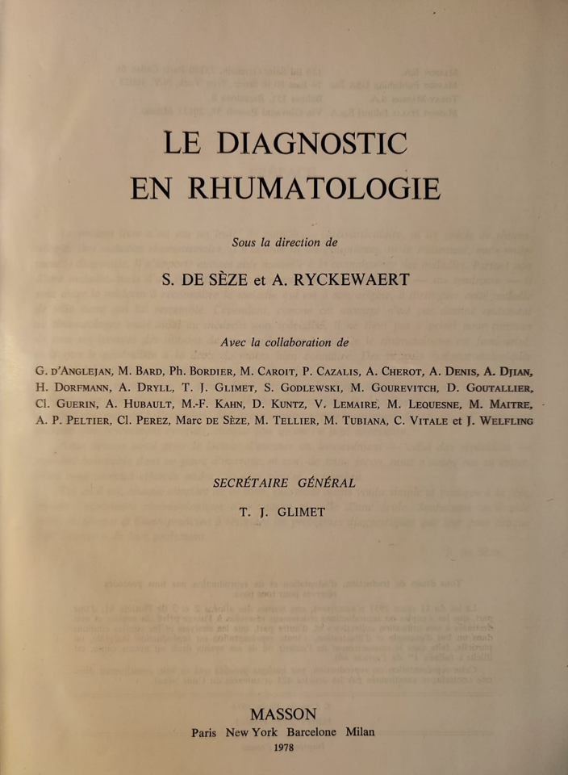

Figure 2. Front page of the reference work edited by de Sèze and Ryckewaert.

References

1. Stanislas de Sèze. Accessed October 10, 2023. https://fr.wikipedia.org/wiki/Stanislas_de_Sèze
2. Auquier L. Éloge de M. Stanislas de Sèze (1903-2000). Académie nationale de médecine. Accessed October 10, 2023. https://www.academie-medecine.fr/eloge-de-m-stanislas-de-seze-1903-2000/
3. Morvan G, Vuillemin-Bodaghi V, Wybier M, Mathieu P, Busson J, Haddad A. The “de Sèze” magnetic imaging. J Radiol. 2007;88(7-8 Pt 1):943-946. doi:10.1016/S0221-0363(07)89900-8
4. de Sèze S. La sciatique dite banale, essentielle, ou rhumatismale et le disque lombo-sacréle. Rev Du Rhum. 1939;(6):936-1036.

