**Title:** What is the meaning of Value in a Circular Economy? A Conceptual Framework

**Authors:** Kobe Vulsteke1, Sophie Huysveld1, Gwenny Thomassen1,2,3, Antoine Beylot4, Helmut Rechberger5, Jo Dewulf1

1*Sustainable Systems Engineering (STEN), Department of Green Chemistry and Technology, Faculty of Bioscience Engineering, Ghent University, Coupure Links 653, 9000 Ghent, Belgium*

2 *Department of Engineering Management, University of Antwerp, Prinsstraat 13, 2000 Antwerp, Belgium*

*3Flanders Make @UAntwerp, Belgium*

*4BRGM, F-45060 Orléans, France*

*5Vienna University of Technology, Institute for Water Quality and Resource Management, Karlsplatz 13/226, 1040, Vienna, Austria*

**Abstract**

Today, the concept of a circular economy (CE) has become omnipresent. Central to this concept is the term value, however, it is not properly defined, which leads to different interpretations, and hinders implementation of the CE concept. Hence, this article operationalizes the theoretical concept of value into a more practical understanding. First, the meaning of value within the CE context is examined, followed by the development of a framework wherein value is decomposed into two essential types; functional and created value. Next, the framework is applied to an illustrative case study involving four different end-of-life strategies: landfilling, closed loop recycling, remanufacturing and reusing. The framework enables a holistic comparison of the different strategies, represented in a visually compelling way, and clarifies the connection between theoretical CE concepts and practical measures. Consequently, it enhances the understanding of existing CE indicators and serves as a stepstone for the development of new indicators.

1. **Introduction**

The circular economy (CE) concept has gained tremendous prominence in recent times, drawing attention from governments, academics, businesses, and the public as an essential stride toward attaining sustainable development (Ghisellini et al., 2016; Velenturf and Purnell, 2021). The current linear resource consumption model is unsustainable and is related to numerous global challenges, such as climate change and resource depletion. Consequently, the adoption of the CE is widely considered as a potential solution to address these issues (Kara et al., 2022). Worldwide, numerous policy initiatives are being implemented aimed towards this transition (Fitch-Roy et al., 2021). Notably, the European Union (EU) has taken decisive steps with the introduction of the Circular Economy Action Plan in 2015 (European Commission, 2015).

However, despite the worldwide adoption of CE policies, practical implementation appears to be slow. According to the Circularity Gap report, the circularity of the global economy is declining year after year (Circle Economy, 2023), while in the EU, a recent report concluded that there is only limited evidence that the CE action plan has been effective in influencing CE activities in its member states (European Court of Auditors, 2023). The reason for this hindered implementation can be traced back to several barriers, often categorized as technological, market, regulatory and cultural barriers (Govindan and Hasanagic, 2018; Kirchherr et al., 2018).

One persistent regulatory barrier is the lack of consistent definitions and standards in CE policy frameworks (Stumpf et al., 2021). This is an issue not limited to regulatory frameworks, but is compounded by the ongoing scholarly debate regarding the definition and interpretation of the CE concept (Kirchherr et al., 2017; Korhonen et al., 2018; Nobre and Tavares, 2021). Different stakeholders perceive the CE concept in varying ways, leading to different interpretations (Corona et al., 2019; Kalmykova et al., 2018). While there is a growing consensus among scholars on the core principles, aims and enablers of the CE (Kirchherr et al., 2023a, 2023b), unresolved ambiguities, such as the use of certain loosely defined terms, impedes the consolidation and effective implementation of the CE concept (Reike et al., 2018). Recognizing this issue, the International Organization for Standardization (ISO) is working at establishing a set of international standards for the CE, including standards for terminology and principles (ISO, 2022).

One recurring keyword central to the discourse surrounding the CE is *value*. This term gained prominence with the influential definition of the Ellen MacArthur Foundation (EMF), which states that a CE “aims to keep products, components, and materials at their highest utility and value at all times” (Ellen MacArthur Foundation, 2015), and this was adopted by many others. In fact, when analyzing CE definitions collected by Kirchherr et al. (2017) and Kirchherr et al. (2023b), respectively 21%[1] and 29%1 of definitions include the term *value*. The word is also central in the EU CE Action Plan, where the CE is defined as an economy where “the value of products, materials and resources is maintained in the economy for as long as possible” (European Commission, 2015). However, due to the absence of a precise definition for this term, understanding what it truly entails is challenging.

The term *value* also appears to have multiple meanings, depending on the perspective of the author, exemplified by definitions stating that a CE “attempts to minimize value destruction in the overall system and to maximize value creation in each link in the system” (Bastein et al., 2013) or “the CE articulates (more clearly) the capacity to extend the productive life of resources as a means to create value and reduce value destruction” (Blomsma and Brennan, 2017). In addition, the intertwining with other commonly used, yet vaguely defined terms, including *utility* and *quality*, further adds to the confusion and misinterpretation of the CE concept.

One critical juncture where these ambiguities pose a real risk to obstruct implementation, is the development of indicators. The CE concept encompasses a broad range of strategies and approaches, and properly assessing the most circular one is difficult when “keeping materials, components and products at their highest value at all times” or “maximizing value creation” is not fully understood. Consequently, there is a high urgency to properly define the term *value* and establish a comprehensive value framework originating from fundamental CE principles that enhances the understanding and development of indicators essential for the dissemination of the concept (Iacovidou et al., 2017a; Kristensen and Mosgaard, 2020; Lata et al., 2023).

Hence, the objective of this research is to study the meaning of value and associated concepts in the context of the CE, and construct a value framework that bridges the gap between the concept of value in CE definitions and indicators. To achieve this, first, current uses of value and related concepts within the CE are discussed in section 2 through a literature review. Findings from this literature review provide the basis for the development of a novel conceptual value framework presented in section 3, distinguishing between different value types. In section 4, an illustrative case study is performed to demonstrate how the framework can enhance the understanding of the CE concept and CE strategies. This is followed by a discussion of the main findings in section 5, and finally, conclusions in section 6.

1. **Current use of *value* and related concepts within the CE**

To gain insight into the current understanding of the value concept in the CE, a comprehensive literature review was conducted. This process began by consulting overviews of CE definitions by Kirchherr et al. (2017, 2023) from which different uses of the word were identified, as illustrated by the examples in the introduction section. Subsequently, a snowballing approach was adopted to identify additional relevant sources, complemented by searches for value frameworks in article databases (Web Of Science, Google Scholar).

Based on this review, few explicit definitions of value could be identified. Many authors make use of the word, but never define it. Consequently, given that value is rarely a standalone term, words frequently paired with it were examined to help understand its meaning. From here, two prevalent uses could be revealed. First, several definitions refer to value of materials, components and products, which should be “maintained” (e.g., European Commission (2015)), “preserved” (e.g., den Hollander et al. (2017)) or “kept high” (e.g., Ellen MacArthur Foundation (2015)) in our economy, whereas others refer to value as something that should be “created” (e.g., Bastein et al. (2013)) or “provided” (e.g., Baxter et al. (2017)). Therefore, in the following two sections, both uses will be addressed separately, followed by a section on existing value frameworks.

* 1. **Value preservation**

The preservation of material, component and product value is a recurring theme in the CE. It implies that a certain value is associated with the existence of materials, components and products, and in a CE, this value should be maintained.

The idea of value associated with materials, components and products, as well as its evolution throughout the life cycle has been described in more detail by Kumar et al. (2007) and Achterberg et al. (2016). They divide the product life cycle into three stages: the pre-use, use, and post-use stage. During the pre-use or manufacturing stage, materials, components and products are manufactured, and value is added. At the start of the use stage, the maximum value is reached, and during the use and the post-use stage, value diminishes again. Consequently, graphically representing the product life cycle resembles a "value hill" (Achterberg et al., 2016). In a linear economy, the process of increasing and decreasing value takes place over a short time period.

Contrastingly, in the CE, the goal is to preserve the value that is build-up in the pre-use stage, i.e., stay high on the value hill for as long as possible (Kurilova-Palisaitiene et al., 2023). Different actions can be employed to fulfill this goal, typically grouped under the two fundamental strategies of slowing and closing of resource loops (Bocken et al., 2016). The former corresponds to optimizing the use stage, e.g., through product-life extension, while the latter involves the recovery of residual value at the post-use stage. This is typically done via different value retention strategies, for example, reuse, repair or recycle. These strategies are also often referred to as CE strategies, R frameworks or R hierarchies (e.g., 10R framework of Reike et al. (2018)).

While there appears to be a consensus that value accumulates during the pre-use stage of the life cycle and that it should be conserved in the use and post-use stages, the precise nature of this value often remains elusive. Answering how and why materials, components and products have value is not straightforward, and is rooted in the research area of value theory in fields such as philosophy and economics (Hirose and Olson, 2015). Nevertheless, drawing on the classic utility theory that underpins modern economics and aligns closely with the prevailing CE narrative, value can be understood primarily as determined by the utility experienced by users (Lowe and Genovese, 2022). In other words, materials, components and products hold value as they are capable of delivering functions that bring benefits to humans. Given that many CE definitions combine value with the term *utility* (e.g., the definition by Ellen MacArthur Foundation (2015)), it is presumed that this value type is implicitly alluded to in these contexts.

This anthropocentric perspective of value, grounded in the utility for humans, is often adopted in the realm of natural resources and Life Cycle Assessment (LCA), where it is termed ‘instrumental value’ (e.g., Berger et al. (2020) and Greffe et al. (2023)), ‘functional value’ (e.g., Stewart and Weidema (2005) and Ardente et al. (2023)) or ‘use value’ (e.g., Charpentier Poncelet et al. (2022)). In this context, it is used to assess the impact of the dissipation of resources due to human actions. When resources are dissipated, their capacity to be useful to humans is compromised, and thus, their value decreases (Greffe et al., 2023). This aligns well with the principle of value preservation in the CE.

This viewpoint can be extended beyond natural resources and also be applied to materials, components, and products, since these also have the potential to be useful to humans. Iacovidou et al. (2017a, 2017b) and Velenturf and Jopson (2019) introduce the term ‘technical value’, which encompasses technical properties which are desired by humans, and ultimately lead to consumer satisfaction. They state that, in a CE, this technical value should be preserved (Iacovidou et al., 2017a). Kumar et al. (2007) and Baxter et al. (2017) include the notion of ‘perceived value’, and highlight the importance of maintaining consumer satisfaction derived from materials, components, and products.

In addition to the value concept, another concept closely linked to or sometimes even mixed with the term value is *quality*, and is therefore also discussed shortly. Similar to the value concept, it is often used, but rarely properly defined, and therefore has also been identified as a potential factor hindering policy implementation (Hahladakis and Iacovidou, 2018; Steinmann et al., 2019; Tonini et al., 2022). It is primarily used in the context of materials and recycling, and is then defined as the potential of materials to fulfil certain functions, based on technical properties (Demets et al., 2021; Roosen et al., 2023). However, some authors, such as Sirkin and ten Houten (1994) and Sakao et al. (2019) use quality also for products, and link it to the satisfaction the product brings to the consumer. In both cases however, the anthropocentric perspective reoccurs.

* 1. **Value creation**

The second use of value in the CE context pertains to value that should be “created” or “provided”. Typically, this use is closely tied to sustainable development. For example, van Buren et al. (2016) include all three pillars of sustainability, and state that “a circular economy aims for the creation of economic value, the creation of social value as well as value creation in terms of the environment”. With sustainable development increasingly regarded as the principal aim of a CE, there is a growing trend of incorporating the term value in CE context with this connotation (Kirchherr et al., 2023b).

Although in literature, the concept of value creation appears to be less ambiguous compared to the concept of value preservation, the actual effects of the implementation of CE strategies on sustainable development are complex. A set of 17 concrete Sustainable Development Goals (SDGs) has been developed by the United Nations (United Nations, 2015), which can help determine how circular practices boost or hinder the achievement of a sustainable society (Schroeder et al., 2019).

At the level of a product’s life cycle, the Life Cycle Sustainability Assessment (LCSA) methodology is generally applied. Nonetheless, an important restriction of LCSA is that the focus is mainly on quantifying social, environmental and economic burdens. Although some positive impacts are typically considered within the functional unit, there is a growing push towards more holistic assessments that capture all positive and negative impacts associated with a product's full life cycle. An example is the framework developed by Alvarenga et al. (2020), where all positive impacts for the intended product user and other affected subjects are captured in the handprint, whereas all negative impacts are recorded in the footprint.

* 1. **Toward a value framework**

While existing CE literature covers research on one of both value uses, to the author’s knowledge, only one holistic value framework has been developed addressing the multiple facets of value and their relationship. Iacovidou et al. (2017a) developed the Complex Value Optimisation for Resource Recovery framework, consisting of four value domains: technical, environmental, economic and social value. They state that technical value should be preserved to create social and economic wellbeing and development. In follow-up research, different indicators are linked to the different value domains (Iacovidou et al., 2017b). Furthermore, an illustrative case study is performed by Millward-Hopkins et al. (2018), who also indicate that changes of the technical value of resources drive changes in social, environmental and economic value. However, the framework currently lacks a clear connection with CE principles, hindering the assessment of the mechanisms underlying various CE strategies.

1. **Development of the value framework**

Despite efforts to explore the value concept in the CE context, ambiguity persists due to the absence of a comprehensive value framework. Consequently, drawing on collected evidence from literature, a novel value framework is developed. Central to the value framework is the distinction between two value types.

The first value type is referred to as *functional value*. It is defined as value attributed to resources, materials, components and products, due to their ability to provide functions to products or humans, resulting in benefits for human well-being. Consequently, the anthropocentric perspective is adopted. In the CE, functional value of resources, materials, components and products is to be retained maximally.

The second value type is termed *created value*, and is defined as the net sum of all positive and negative economic, social and environmental impacts, generated over a certain time of the life cycle of a product. From here on, the collection of all positive economic, social and environmental impacts will be termed the *handprint*, while all negative economic, social and environmental impacts constitute the *footprint*. Created value also encompasses all positive and negative impacts associated with the product’s usage directed to the consumer. It forms the bridge between the CE and sustainable development. In a sustainable CE, one of the objectives is to maximize the created value.

Figure 1 schematically illustrates both value types and how they are linked to a product’s life cycle. In addition, Figure 1 introduces the compositional structure of a product as used in this framework: a consumer product is the final good a consumer can buy, and typically consists of components. These components, in turn, are composed of specific materials, which can originate from either the natural environment or the technosphere. The former are called primary resources, while the latter are secondary resources (Sonderegger et al., 2020).

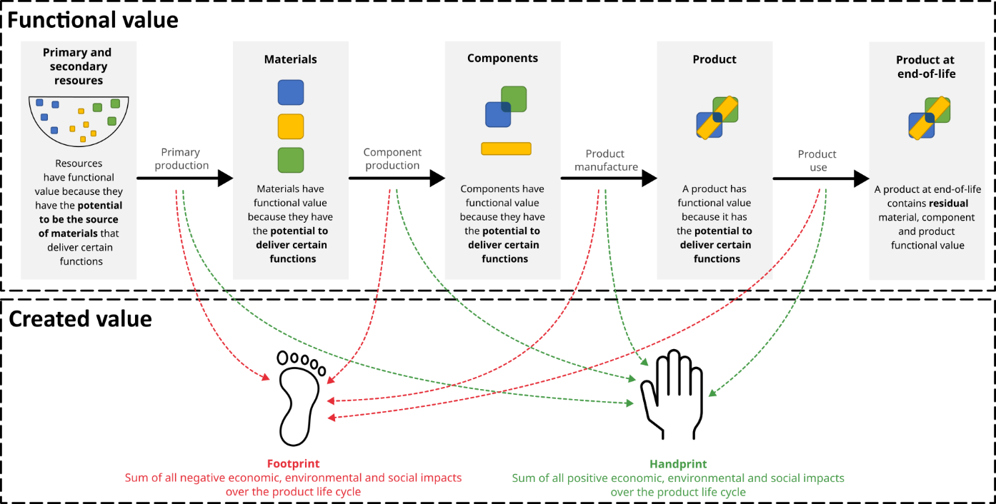

Figure 1 Schematic overview of the two value types relevant to the circular economy. The illustration is limited to the product life cycle until the end-of-life, providing a visual representation of the meaning and relation of both value types.

While the value framework consists of two distinct value types, important is that both value types are tightly connected, as also visible in Figure 1. Generally, the functional value of resources, materials, components, and products changes as they are subjected to various actions throughout the product's life cycle. These actions generate both positive and negative impacts, leading to the creation of handprints and footprints.

The subsequent sections will delve deeper into both value types, their constituents, and how they evolve during the product's life cycle. In section 4, different end-of-life (EOL) strategies and their relation to both value types will be discussed.

* 1. **Functional value**

In line with CE definitions that often specifically include that the aim is “to keep products, components, and materials at their highest utility and value at all times” (e.g., Ellen MacArthur Foundation (2015)), in the framework, a specific distinction is made between three different subtypes of functional value: material, component and product functional value. The total functional value can be assessed at any point in the product’s life cycle, and is the sum of these three subtypes. No separate resource functional value is included, as resources are a potential source for materials, and typically do not provide functions to humans directly. Therefore, resource functional value is expressed as material functional value.

The names assigned to the various functional value types are not inherently tied to a specific compositional product level, but are associated with their presence within that level. For example, the total functional value of a component is not solely comprised of component functional value. It also encompasses material functional value since there are materials present within the component that can provide specific functions.

It is important to note that the definition of functional value in this framework deviates slightly from the definition of functional value and its synonyms (such as instrumental and use value) as often used in literature on LCSA. Many authors (e.g., Ardente et al. (2023), Charpentier Poncelet et al. (2022) and Greffe et al. (2023)) refer to these terms as the satisfaction, benefits, or utility for humans, making it a subjective type of value. In this framework however, functional value is defined as an objective measure of the functions that materials, components, and products can potentially provide to humans. These functions ultimately lead to consumer satisfaction, however, in this framework, this satisfaction is included in the created value. Since the framework primarily focuses on the potential to deliver functions rather than utility, the term “functional value” was selected to clearly indicate that connection.

* + 1. Material functional value

Material functional value is the first constituent of the total functional value. It exists throughout the life cycle of a product due to the presence of materials that have the potential to serve specific functions within components or products. For example, copper is used in computer printed circuit boards due to its conductivity, while indium is used in mobile phone touch screens.

The functional value of materials depends on several factors, and aligns with the attractiveness to use the materials for specific applications in components or products. The specific material functional value, representing functional material value per unit mass, depends on several technical characteristics linked to physical and chemical characteristics, and in this sense shows a lot of similarities to what is often defined as (material) quality in literature (Tonini et al., 2022). For instance, the use of certain plastics in products requires materials to have specific properties like strength, stiffness, and toughness. When impurities are present, these properties can change and limit the use of the materials for specific applications, and thus the material functional value decreases (Demets et al., 2021). However, the presence of elements in small concentrations does not automatically lead to lower functional values. In some cases, the presence of certain elements at low concentration (e.g., additives, alloying elements) can improve the material functional value.

Material functional value is complex, primarily due to the extensive variety of materials and their capacity to offer a wide range of functions, each demanding specific technical characteristics. The technical characteristics of materials may change up to a point where the material is no longer suitable for a certain application, but it can still be used for other applications. For instance, mixed plastic waste fractions are used for low-end applications. The process of subsequent use of materials for different applications is often termed “cascading” (Campbell-Johnston et al., 2020; Sirkin and ten Houten, 1994). As long as materials can fulfil a certain function, their material value does not depreciate to zero. Only dissipative processes, such as the incineration of plastics, can almost completely compromise material functional value.

* + 1. Component functional value

When materials with specific functions are combined into specific configurations, functionalities arise that can be allocated to that structure. For example, the combination of lithium cobalt oxide, graphite, electrolytes and various other materials, each serving a distinct function, results in the creation of a lithium-ion battery (Mossali et al., 2020). This component has the capacity to store and supply power to a laptop, which is encapsulated in the component functional value.

Component functions can vary wildly, from delivering power to providing structural support. Essential is that these functions are delivered within a product, and not directly toward the consumer. The lithium-ion battery, for instance, does not provide any direct function to the consumer, but the laptop in which the battery is installed, does. This is an important distinction to make between component functional value and product functional value, discussed hereafter.

* + 1. Product functional value

Similar to component functional value, product functional value represents the value created when components are integrated into a final consumer product. This product is capable of providing a function directly to a consumer, who benefits from using the product. For example, consider an electric vehicle, which enables a user to commute to their workplace or other destinations. The capacity of the vehicle to travel a certain distance on a single fully charged battery is incorporated into its product functional value.

Product functions can be very diverse, and classifications can be made based on the needs of the consumer they aim to fulfill. Various classifications exist, including the United Nations' Classification of Individual Consumption by Purpose (COICOP) (United Nations, 2018), and Genkova’s (2021) classification that associates different product categories with Maslow’s (1943) hierarchy of basic human needs.

Functional value, as addressed in this article, is regarded as an objective measure. This is especially important for the product functional value, as subjectivity of value is mainly introduced here. The utility a consumer receives is not solely dependent on product functional aspects, but also emotional, social, epistemic and conditional aspects (Sheth et al., 1991). Although the expression of product functions as objective properties is sometimes challenging, it makes product functional value independent of consumer perspectives. Examples are the nutritional value of a food product and the lumen-maintenance life of a LED bulb. In the case of more complex products, multiple functions are often present.

* + 1. The evolution of functional value through the product life cycle

With the introduction of the different subtypes of functional value, it is possible to assess how functional value changes throughout the product's life cycle. For this, a simple conceptual example of one product life cycle of a durable product will be used: from resources to materials, over components and finally to a product which, after one life cycle, reaches EOL. The evolution of the different types of functional value is depicted in Figure 2.

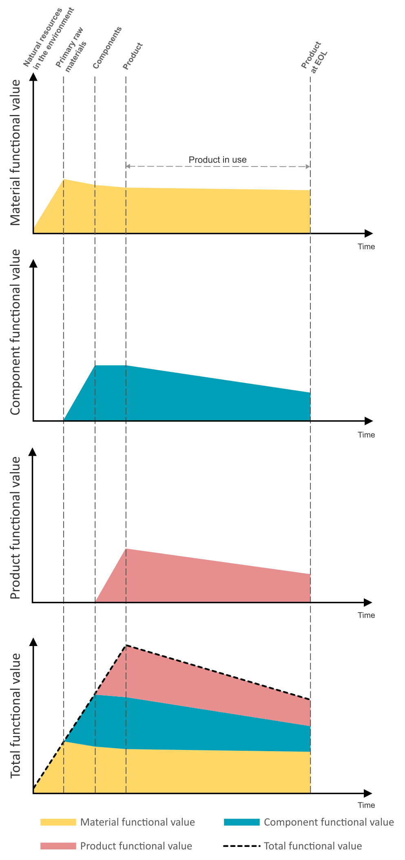

Figure 2 Conceptual illustration of the estimated evolution of functional value of a durable product with a gradual decrease of product, component and material functional value throughout the use phase until the end-of-life (EOL). Lines connecting two consecutive life cycle stages are drawn straight between their respective points, and are thus a simplification.

At the start of the product life cycle, assuming all materials originate from the natural environment, there is only a small amount of material functional value associated with the natural resources. Since a component or product has not yet been manufactured, component and product functional value are zero. Typically, natural resources that are mined have already gone through a certain natural degree of concentration. For example, bauxite, the principal aluminum-containing ore for aluminum production already contains 16 to 27% aluminum (Georgitzikis et al., 2021). Consequently, there is a small amount of material functional value present at the beginning of the product's life cycle as the resources have the potential to become functional materials.

Through primary production processes, including mining and refining, material functional value increases as materials are extracted and purified. Typically, a peak of material functional value can be observed as the (pure) primary raw materials possess a high potential to deliver functions within a component or product.

In component manufacturing, different primary raw materials are deliberately combined into a specific configuration, which typically leads to a decline in material functional value. More complex components that incorporate various materials generally lead to a greater decline in material functional value. Nevertheless, as a component is manufactured with a certain function, the component functional value arises.

Similarly, during product assembly, the combination of components can results in further decreases in material functional value. Component functional value can also change, which mainly depends on the product’s design. Sometimes, components are assembled in a manner that renders disassembly nearly impossible, which causes component functional value to be completely lost. In fact, this is also true for material functional value. Sometimes, materials are integrated into components or products in a way that makes recovery almost impossible, a phenomenon named “lost by design” (Ciacci et al., 2015).

Upon the creation of a functional product, product functional value is generated. The point at which a functional product is manufactured corresponds to the point of the highest total functional value.

During the product’s use phase, the type of product plays a pivotal role in determining the trajectory of its functional value (Böckin et al., 2020). Consumable products, such as food and personal care items, are characterized by rapid declines in functional value. As these products are consumed, their materials transform and may be released into the environment, leading to the loss of nearly all functional value. In some cases, materials within a product are even designed to dissipate, e.g., copper in brake pads (Ciacci et al., 2015).

In contrast, durable products, such as electronic devices, clothing, or furniture, tend to retain their functional value for an extended period, as illustrated in Figure 2. However, as the performance of components and products often decreases (e.g., laptop battery), a decrease in component and product functional value can be observed. Material functional value can also decline, e.g., degradation of plastics because of exposure to sunlight.

At a certain point within the use phase, a durable product may reach the end of its first life cycle, here defined as the EOL point. This is the point at which the product's initial user ceases to use it, and can occur for various reasons. For instance, a product might reach the end of its physical life when it completely breaks down, leaving the product unable to fulfil its function to its user, corresponding to a complete loss of product functional value. Often, component and material functional value remain (partially) intact. In other cases however, the EOL point is prematurely reached, meaning the product's functional value has not yet reached zero. This can be traced back to several reasons, such as user dissatisfaction with the declining performance of the product or legal constraints that prohibit its continued use (Ashby, 2013). In all cases, the amount and type of remaining functional value predominantly determine which EOL strategy can be employed, which will be discussed in section 4.

* 1. **Created value**

The same actions throughout the product life cycle affecting functional value, lead to the creation of positive impacts, i.e., the handprint, and negative impacts, i.e., the footprint. Collectively, these impacts contribute to what is termed "value creation".

Handprints and footprints can be classified based the cause of their generation, and to what or who they are directed, as indicated in the framework of Alvarenga et al. (2020). They can be generated from the product’s functionality (e.g., the satisfaction a consumer gets from eating a food product) or any intervention flow of the product life cycle (e.g., emissions during the production process), and they can be directed to the intended user of the product or to the society at large.

Due to the diverse types of handprints and footprints, visualizing value creation over the product's lifecycle in a similar way to functional value is difficult, and representing different handprint and footprint types on one figure can even lead to wrong interpretations. However, for completeness and illustration purposes, an attempt is made at presenting an estimation of the accumulation of handprint and footprint over the product life cycle in Figure 3.

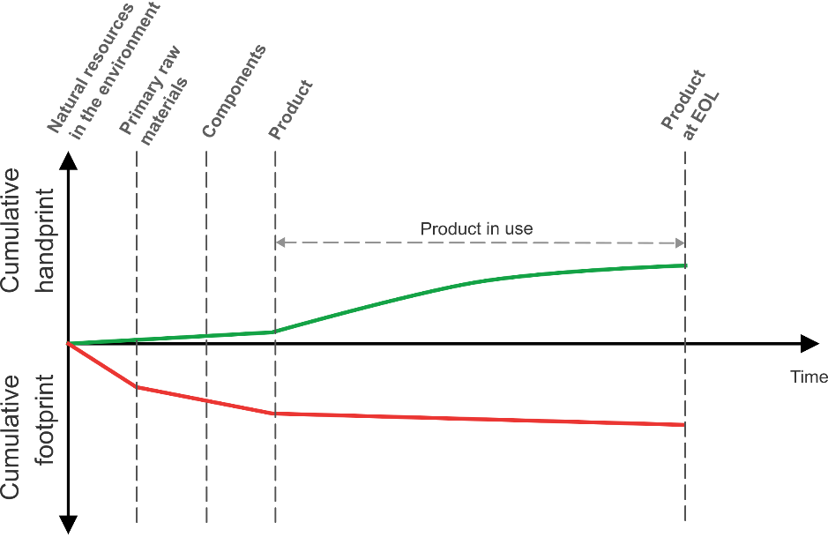

Figure 3 Estimated evolution of the handprint and footprint creation of a durable product until the end-of-life (EOL).

During the first part of the product life cycle, there is not yet a functional product, and handprints and footprints are generated from intervention flows. Typically, the footprint dominates, as processes in the production process contribute more to negative social (e.g., bad working conditions) and environmental impacts (e.g., contribution to climate change). Positive impacts such as job creation lead to handprint creation.

During the use phase, as the product is used by the intended user, the user experiences benefits and satisfaction. These benefits and satisfactions can be associated directly to the product’s function(s), however, also emotional, social, epistemic and conditional aspects contribute to the experienced benefits (Sheth et al., 1991). These benefits are subjective, thus two consumers using the same product may experience different handprints. Besides the consumer, the experienced benefits depend also on the product type. Consumable products, such as food or medication, generate a one-time handprint. Durable products continually provide benefits to the consumer each time they are used, as seen with electronic devices. As the functional value of products can decrease, the handprint creation can also decrease over time, as illustrated in Figure 3. Footprints can also be generated during the use phase, and can be directed to the intended user of the product (e.g., excessive consumption of alcoholic beverages) or have broader societal implications (e.g., the release of particulate matter resulting from tire abrasion).

1. **Illustrative example of the framework to compare different end-of-life strategies**

After examining different value subtypes, the link with the CE can be made through a comparative, illustrative analysis of different EOL strategies for a durable product. As a quantitative case study is not yet feasible, a qualitative example was worked out and considered appropriate for the objective to compare the mechanisms of different EOL strategies. In the case study, four different EOL strategies are compared: landfilling, closed loop recycling, remanufacturing and reusing. Landfilling serves as the reference point, representing a linear economy. Next, three different CE strategies are included, each characterized by a different preservation strategy, as identified by Moraga et al. (2019). The closed loop recycling scenario aims to preserve materials, remanufacturing aims to preserve components, while reuse aims to preserve the entire product. This approach allows for testing the framework's capability to study multiple EOL strategies within the CE context.

As indicated, a potential risk of visualizing qualitative case studies is that they can lead to misinterpretations. This concern is particularly relevant for created value (Figure 3), as integrating different handprint and footprint types into a single figure allows one to compare them, which is not possible, and also deviates from the framework's core purpose. Therefore, in this section, the mechanisms of value creation during the product life cycle are purely indicated qualitatively with text, and not with figures.

Another aspect that needs to be addressed, is the selection of system boundaries. In our economy, many material cycles are interconnected. For instance, crude oil serves as a natural resource for the production of various materials, including fuels, chemicals, and plastics. Thus, when analyzing functional value, theoretically, all these distinct primary raw materials and their subsequent uses should be considered. To decrease (figure) complexity, we focus solely on the materials composing the product within the first life cycle. Consequently, an allocation of the functional value of the natural resource is made based on the materials included in the studied product. Similarly, when, after a first life cycle, additional primary raw materials are added to replace lost materials, the material functional value originating from these materials is not included in the figure, and resulting component and product functional value is allocated based on the materials originally present in the studied system boundaries.

The results of the case study, comparing four different EOL strategies, are presented in Figure 4. As in each scenario, the first use phase considers the same product, the functional value is identical up until the end of the first life cycle. The focus in this section is on how the remaining functional value is maintained or recovered.

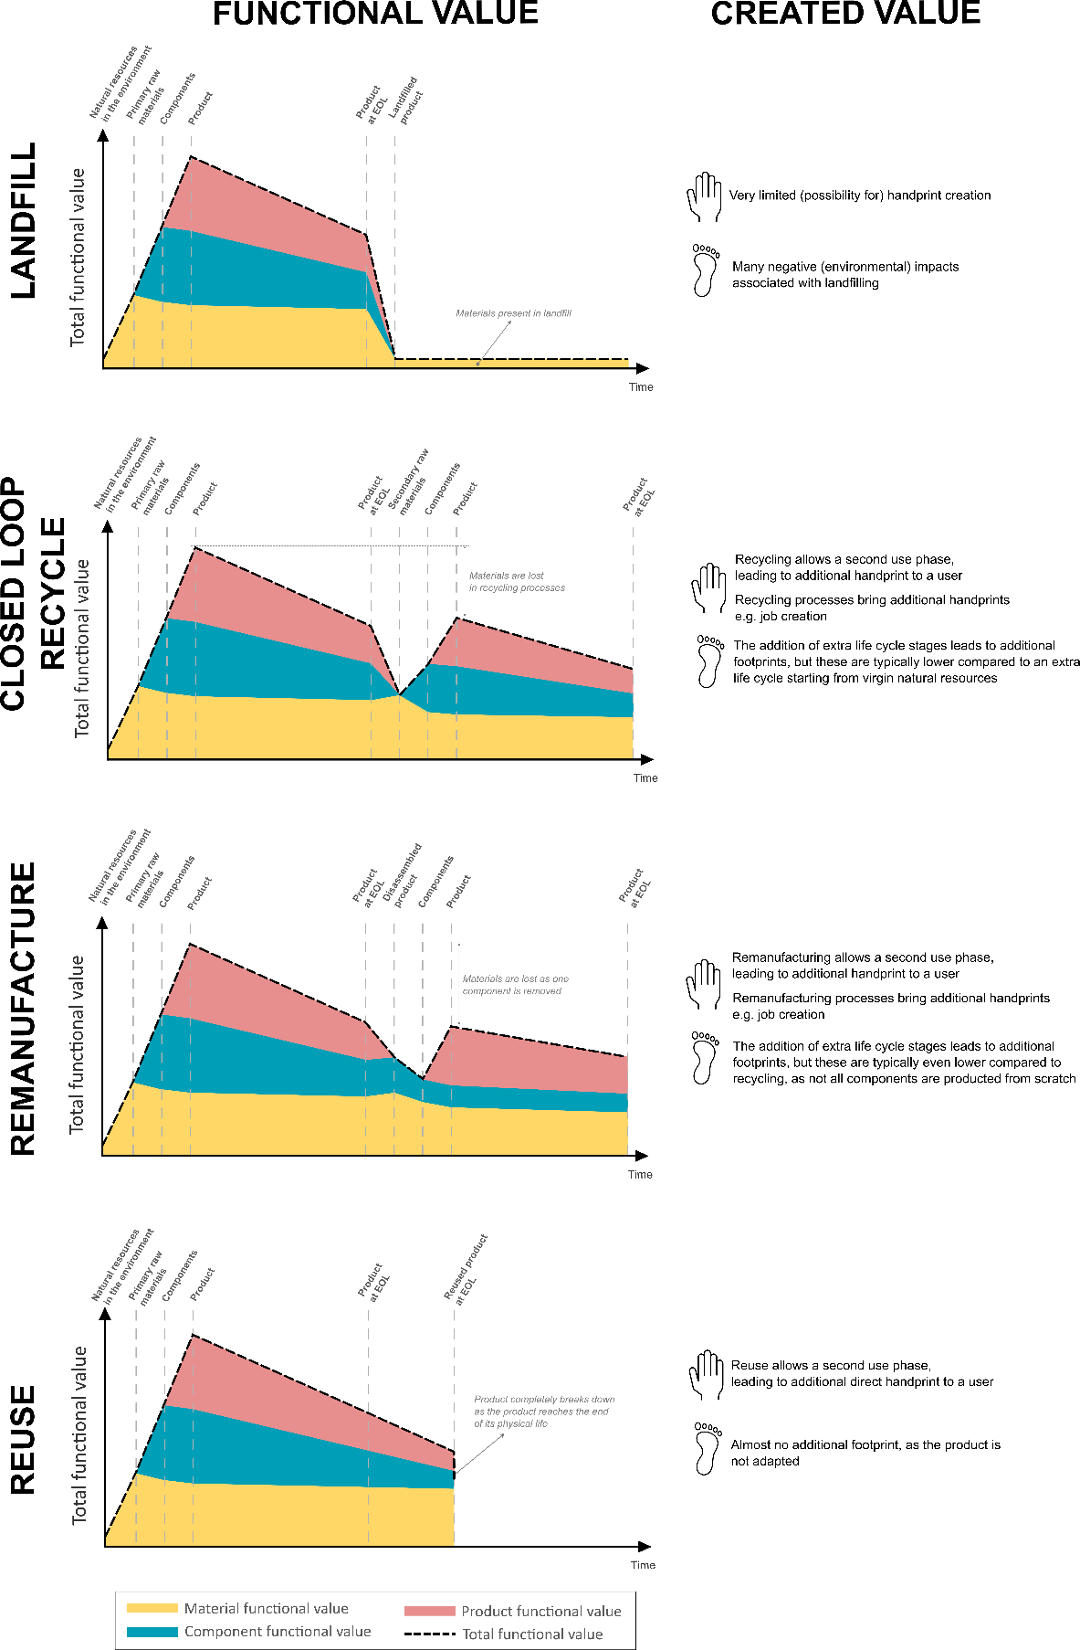

Figure 4 Estimated evolution of functional and created value for four different end-of-life strategies for a durable product.

The first EOL strategy is landfill, and is included as a reference linear economy scenario. Here, discarded products end up in landfills, and typically, their product and component functional value is entirely forfeited, leaving behind the materials. Depending on the material type, some of their functional value can be retained. For example, metals can remain in landfills in elevated concentration for longer times and could possibly be mined in the future. In terms of value creation, landfilling offers minimal to no room for handprint creation after the EOL point. Instead, discarded products predominantly generate negative impacts, especially from an environmental standpoint, contributing to an enlarged footprint.

Closed loop recycling is the second EOL strategy studied, and focuses on recovering material functional value for the production of products of the same type. It distinguishes itself from open loop recycling, where the recycled materials are used for different product types (Ragaert et al., 2023). In the closed loop recycling process, product and component functional value are inevitably lost. Often, there is an increase of material functional value. This rise is primarily observed when secondary raw materials are separated from one another, enhancing their purity. Once secondary raw materials are obtained, a process similar to the first production stages takes place, and component and product functional value are reconstructed. As the efficiency of recycling processes is never 100%, new primary raw materials are added to substitute the materials lost during the recycling process. As these newly introduced materials fall outside the established system boundary, and part of the new component and product functional value is allocated to these new materials, the overall component and product functional value is lower compared to the first life cycle.

Through recycling, materials from the first life cycle are used to create value a second time, contributing substantially to the handprint. Processes used in recycling processes contribute to both handprint and footprint creation, however, footprint creation usually prevails. Nevertheless, negative impacts associated with the production of secondary materials are typically lower compared to primary production from natural resources. A prime illustration is the recycling of aluminum, which consumes 95% less energy than the production of virgin aluminum (Das and Yin, 2007). Furthermore, at the end of the second life cycle, a substantial amount of functional value remains, leaving opportunities for further value creation.

The third strategy, remanufacturing, revolves around the recovery of component and product functional value, as well as the encapsulated material functional value. It entails the disassembly of the product and the introduction of new components wherever necessary, with the goal of manufacturing a product that is essentially "like-new". For example, a new battery can be placed in an electronic device, as the original battery has lost part of its performance. The disassembly process leads to a temporary increase in material functional value, as with component isolation, less materials are combined. With the inclusion of the new component, product functional value can be reestablished. However, similar to recycling, part of this value is allocated to the new component. Therefore, the overall component and product functional value is lower compared to the first life cycle. Value creation for remanufacturing is similar to recycling, with the advantage of reducing footprint generation by bypassing processes required for the manufacturing of new components.

Finally, in the reuse scenario, when the product reaches its first EOL point, the product is passed on to another consumer unmodified. Therefore, the reuse process itself does not lead to changes in functional value. During the second life cycle, the functional value continues to decrease as a consequence of product usage. As represented in Figure 4, at a certain point, the product can completely break down and reach the end of its physical life, leaving only material and possibly some component functional value. Reuse stands out as one of the most straightforward methods to create additional value. It offers the advantage of providing a consumer with supplementary handprint, while generating minimal footprint.

1. **Discussion**
   1. **Comprehending value in the circular economy**

Based on the application of the value framework to the illustrative case study, two key observations emerge regarding the interplay between the two value types. First, typically, footprint creation is dominant when actions are undertaken to increase functional value. This appears on two occasions: production processes at the beginning of the life cycle, as well as value recovery processes at the EOL point. Second, handprint creation occurs most frequently when functional value is high, i.e., during the use phase of a product. Consequently, in order to contribute to sustainable development, as a general principle, efforts should be undertaken to minimize the need to build-up functional value while maximizing the in-use time at which functional value is high.

One important remark is needed related to the maximization of the time at which functional value is high. As functional value is defined objectively and does not incorporate consumer satisfaction, situations can arise where functional value is high, but no handprint is created, for instance when a product is hoarded (Dewulf et al., 2021). As in a CE, this is not a desirable situation, it is important to consistently assess both types of value. The overarching goal in the CE is not solely to preserve functional value, but more holistically, to maximize the actual in-use time during which functional value is high, as this maximizes handprint creation.

* 1. **Circular economy strategies to preserve functional value**

Distinguishing between functional and created value provides a clearer understanding of the underlying mechanisms of implementing CE strategies, as demonstrated in the illustrative case study. By recognizing and analyzing these mechanisms, it is possible to systematically categorize various CE strategies based on their specific approaches to functional value preservation and value creation.

The effect of preserving value is apparent from comparing the landfill scenario, typical for a linear economy, and the recycle, remanufacture and reuse scenario, typical for a CE. In the former, almost all functional value is lost after a single life cycle, leaving only a small fraction preserved at the end of the considered timeframe. In the latter, aside from a marginal decline in total functional value for recycling and remanufacturing, a substantial degree of functional value is retained. This preservation enables a second use phase and, at the end of the considered period, there exist further opportunities for additional life cycles and value creation.

CE strategies can be categorized based on the specific type of functional value they aim to retain, as previously identified by other authors (e.g., Moraga et al. (2019)). The first group primarily focuses on preserving material functional value and encompasses recycling processes. In some cases, only part of the material's functional value is retained, with the recycled materials being used for alternative applications. This concept is often referred to as open loop recycling in the literature (Ragaert et al., 2023). Another group, which includes reusing and repurposing components, is geared towards preserving component functional value. This group also maintains the material functional value contained within the components. Lastly, strategies that maintain product functional value, such as reuse and remanufacture, come into play. With reuse, the product remains unchanged, so that the total functional value left at the end of the first life cycle matches that at the beginning of the second life cycle. This is feasible as long as the product has not yet reached the end of its physical life. In contrast, remanufacture may involve restoration processes, where product functionality is restored or even improved, resulting in an increase in total functional value. However, this can result in an increased created footprint as well.

Generally, CE strategies that preserve the hierarchical highest subtype of functional value are preferred, as this corresponds to the preservation of the maximal amount of functional value, and typically also the lowest footprints. Exactly this is why CE strategies are often depicted as hierarchies. However, this is only a guidance, and a proper assessment of all possible strategies should be performed based on both value types.

Another critical group of strategies for the CE comprises design strategies. Design plays a pivotal role in functional value retainment, as it is possible to lose functional value during the production process. For instance, materials or components can be integrated in a way that makes their separation impossible, causing a sudden, substantial decrease in material and component functional value during the production stage. This already compromises the functional value of materials and components early on in the product life cycle.

Similar to CE strategies aimed at EOL value recovery, various design strategies exist that focus on the maintenance or recovery of specific functional value types (den Hollander et al., 2017). Product functional value can be retained by strategies such as design for durability or design for maintenance, while component functional value is targeted by design for disassembly. Finally, the retainment of material functional value can be improved through strategies such as design for recycling.

* 1. **Toward indicators for the value framework**

The holisticness of the developed value framework, linked to fundamental CE principles, is where this value framework goes further compared to existing frameworks. First, many existing frameworks do not analyze the meaning of what (functional) value means (Achterberg et al., 2016; Halada, 2020; Kurilova-Palisaitiene et al., 2023). Others provide more detail on what (functional) value is, how it changes throughout the product life cycle and how it can be maintained, but for a great part exclude the process of value creation (Kumar et al., 2007; Sirkin and ten Houten, 1994). Finally, Iacovidou et al. (2017a) provide the most holistic framework, including both aspects of functional and created value, but details on how these value types change over the product life cycle are limited.

Due to the detailed way CE mechanisms can be explained with the framework, it greatly enhances the understanding of CE concepts and strategies, and could for instance be employed by product developers in their efforts towards designing more circular products. It encourages a holistic assessment of CE strategies, where product developers can evaluate qualitatively how different value types can be preserved through different CE strategies. As the focus of the CE is proven to be often on recycling and recycling indicators (Moraga et al., 2019), holistic assessments including multiple CE strategies can improve the inclusion of different CE strategies in such assessments.

While the framework could qualitatively support product developers, its main limitation is that it does not yet include quantitative indicators. Therefore, connecting the conceptual value framework with quantifiable indicators is the next required step, as the ability to measure circularity is essential for the transition to the CE (Kristensen and Mosgaard, 2020). Here, the framework’s definition of functional value stands out as a key contribution. In the context of the CE, value is mainly regarded as a subjective measure, primarily based on consumer satisfaction. This perspective poses challenges in the development of quantifiable indicators. The developed value framework makes a clear distinction between objective attributes associated with materials, components, and products (constituting functional value) and the subjective consumer satisfaction resulting from these attributes (incorporated within created value). As a result, the framework not only aids in categorizing existing CE indicators but also serves as a foundation for the formulation of novel indicators.

Providing an exhaustive list to link the value framework with existing indicators is beyond the scope of this article, and in fact, multiple authors have provided reviews of CE indicators which include a distinction between indicators focusing on the cyclical flow of resources (i.e., value preservation) and indicators analyzing the effects on the economy, environment and society (i.e., value creation) (e.g., Moraga et al. (2019) and Saidani et al. (2019)). These authors thus implicitly recognize the two value types.

Examples of quantifying aspects of material functional value include statistical entropy methods (Parchomenko et al., 2020; Skelton et al., 2022; Zeng and Li, 2016) or approaches focusing on technical aspects of materials, e.g., for plastics (Demets et al., 2021; Huysman et al., 2017). Hatzfeld et al. (2022) and Mellquist et al. (2022) aim at quantifying preservation of product function, i.e., product functional value.

In order to holistically assess value creation, the Life Cycle Sustainability Assessment (LCSA) methodology would be the evident choice. However, several methodological advances are needed so that the methodology contains all mechanisms leading to value creation across environmental, social and economic dimensions, for example also including social equity and environmental justice (Fauzi et al., 2019). Furthermore, the focus should not only be on negative impacts but also positive impacts. Indeed, quantifying positive impacts of value creation over the life cycle, which are here termed handprints, is challenging (Di Cesare et al., 2018). This also includes the handprint directed toward the user of the product, which is often highly subjective, and therefore difficult to capture (Alvarenga et al., 2020). Hence, further research is needed to develop robust methodologies that effectively capture these aspects. In addition, a further link between value creation and the SDGs could be developed as a way to improve the understanding how value creation helps reaching these goals.

Finally, integration and linkage of methods to assess both functional value and value creation is the next step. This integration has gained more attention in recent research (e.g., Brändström and Saidani (2022), Moraga et al. (2022) and Salvi et al. (2023)). The framework of Iacovidou et al. (2017a) illustrates how different value types could be assessed together. However, before reaching this point, multiple challenges related to each value type should be overcome, and the creation of standards regarding terminology is needed to align future research on this topic.

1. **Conclusion**

In this research article, the meaning of the value concept within the CE was addressed. First, different uses of the term in literature were identified, from which a novel holistic framework was developed distinguishing between two value types: functional and created value. Functional value was defined as value attributed to resources, materials, components and products, due to their ability to provide functions to products or humans, resulting in benefits for human well-being. On the other hand, created value encompasses the net sum of all positive (handprint) and negative (footprint) economic, social and environmental impacts, generated over a certain time of the life cycle of a product. Both value types, what they entail, as well as their relation was studied in detail. Furthermore, their practical use was analyzed based on a simplified case study of four different EOL strategies.

Based on the framework, it was possible to study CE mechanisms in detail, and present these mechanisms in a visually compelling way. A general principle could be formulated stating that the goal of the CE should be to minimize the need to build-up functional value while maximizing the in-use time at which functional value is high. Furthermore, different CE practices could be compared and categorized based on the type of functional value they aim to preserve. The novel framework greatly improves the theoretical understanding of the CE and the often vaguely defined concept of value.

Finally, the framework was highlighted as having the potential to bridge the CE concept with practical implementation and CE indicators. Although the framework itself does not contain quantitative indicators, it helps industries understand how material, component and product functional value can be maintained through multiple CE strategies. The framework also offers a means to categorize existing CE indicators and serves as a stepping stone for the development of new, comprehensive indicators that enable to assess how materials, components and products can be preserved at their highest value at all times. In this sense, this article can substantially aid in the transition towards a more circular, sustainable economy.

1. **Acknowledgements**

Financial support from the Special Research Fund (Bijzonder Onderzoeksfonds – BOF) from Ghent University under grant agreement number BOF.DOC.2021.0081.02. is gratefully acknowledged by K. Vulsteke. A. Beylot received financial support from the French State managed by the National Research Agency under France 2030 bearing the reference "ANR-22-PERE-0003". J. Dewulf acknowledges support of FWO (FWO.SAB.2023.0003.01).

1. **Declaration of Generative AI and AI-assisted technologies in the writing process**

During the preparation of this work the author(s) used ChatGPT-3.5 in order to improve the readability of the text. After using this tool/service, the author(s) reviewed and edited the content as needed and take(s) full responsibility for the content of the publication.

1. **References**

Achterberg, E., Hinfelaar, J., Bocken, N., 2016. Master Circular Business with the Value Hill.

Alvarenga, R.A.F., Huysveld, S., Taelman, S.E., Sfez, S., Préat, N., Cooreman-Algoed, M., Sanjuan-Delmás, D., Dewulf, J., 2020. A framework for using the handprint concept in attributional life cycle (sustainability) assessment. J Clean Prod 265, 1–9. https://doi.org/10.1016/j.jclepro.2020.121743

Ardente, F., Beylot, A., Zampori, L., 2023. A price-based life cycle impact assessment method to quantify the reduced accessibility to mineral resources value. International Journal of Life Cycle Assessment 28, 95–109. https://doi.org/10.1007/s11367-022-02102-4

Ashby, M.F., 2013. Chapter 4 - End of first life: A problem or a resource?, in: Ashby, M.F. (Ed.), Materials and the Environment (Second Edition). Butterworth-Heinemann, Boston, pp. 79–97. https://doi.org/https://doi.org/10.1016/B978-0-12-385971-6.00004-X

Bastein, T., Roelofs, E., Rietveld, E., Hoogendoorn, A., 2013. Opportunities for a Circular Economy in the Netherlands. Delft.

Baxter, W., Aurisicchio, M., Childs, P., 2017. Contaminated Interaction: Another Barrier to Circular Material Flows. J Ind Ecol 21, 507–516. https://doi.org/10.1111/jiec.12612

Berger, M., Sonderegger, T., Alvarenga, R., Bach, V., Cimprich, A., Dewulf, J., Frischknecht, R., Guinée, J., Helbig, C., Huppertz, T., Jolliet, O., Motoshita, M., Northey, S., Peña, C.A., Rugani, B., Sahnoune, A., Schrijvers, D., Schulze, R., Sonnemann, G., Valero, A., Weidema, B.P., Young, S.B., 2020. Mineral resources in life cycle impact assessment: part II – recommendations on application-dependent use of existing methods and on future method development needs. International Journal of Life Cycle Assessment 25, 798–813. https://doi.org/10.1007/s11367-020-01737-5

Blomsma, F., Brennan, G., 2017. The Emergence of Circular Economy: A New Framing Around Prolonging Resource Productivity. J Ind Ecol 21, 603–614. https://doi.org/10.1111/jiec.12603

Bocken, N.M.P., de Pauw, I., Bakker, C., van der Grinten, B., 2016. Product design and business model strategies for a circular economy. Journal of Industrial and Production Engineering 33, 308–320. https://doi.org/10.1080/21681015.2016.1172124

Böckin, D., Willskytt, S., André, H., Tillman, A.M., Ljunggren Söderman, M., 2020. How product characteristics can guide measures for resource efficiency — A synthesis of assessment studies. Resour Conserv Recycl 154, 104582. https://doi.org/10.1016/j.resconrec.2019.104582

Brändström, J., Saidani, M., 2022. Comparison between circularity metrics and LCA: A case study on circular economy strategies. J Clean Prod 371. https://doi.org/10.1016/j.jclepro.2022.133537

Campbell-Johnston, K., Vermeulen, W.J.V., Reike, D., Brullot, S., 2020. The Circular Economy and Cascading: Towards a Framework. Resources, Conservation and Recycling: X 7. https://doi.org/10.1016/j.rcrx.2020.100038

Charpentier Poncelet, A., Beylot, A., Loubet, P., Laratte, B., Muller, S., Villeneuve, J., Sonnemann, G., 2022. Linkage of impact pathways to cultural perspectives to account for multiple aspects of mineral resource use in life cycle assessment. Resour Conserv Recycl 176. https://doi.org/10.1016/j.resconrec.2021.105912

Ciacci, L., Reck, B.K., Nassar, N.T., Graedel, T.E., 2015. Lost by Design. Environ Sci Technol 49, 9443–9451. https://doi.org/10.1021/es505515z

Corona, B., Shen, L., Reike, D., Rosales Carreón, J., Worrell, E., 2019. Towards sustainable development through the circular economy—A review and critical assessment on current circularity metrics. Resour Conserv Recycl. https://doi.org/10.1016/j.resconrec.2019.104498

Circle Economy, 2023. The circularity gap report 2023. Amsterdam.

Das, S.K., Yin, W., 2007. The worldwide aluminum economy: The current state of the industry. JOM. https://doi.org/10.1007/s11837-007-0142-0

Demets, R., Van Kets, K., Huysveld, S., Dewulf, J., De Meester, S., Ragaert, K., 2021. Addressing the complex challenge of understanding and quantifying substitutability for recycled plastics. Resour Conserv Recycl 174. https://doi.org/10.1016/j.resconrec.2021.105826

den Hollander, M.C., Bakker, C.A., Hultink, E.J., 2017. Product Design in a Circular Economy: Development of a Typology of Key Concepts and Terms. J Ind Ecol 21, 517–525. https://doi.org/10.1111/jiec.12610

Dewulf, J., Hellweg, S., Pfister, S., León, M.F.G., Sonderegger, T., de Matos, C.T., Blengini, G.A., Mathieux, F., 2021. Towards sustainable resource management: identification and quantification of human actions that compromise the accessibility of metal resources. Resour Conserv Recycl 167. https://doi.org/10.1016/j.resconrec.2021.105403

Di Cesare, S., Silveri, F., Sala, S., Petti, L., 2018. Positive impacts in social life cycle assessment: state of the art and the way forward. International Journal of Life Cycle Assessment. https://doi.org/10.1007/s11367-016-1169-7

Ellen MacArthur Foundation, 2015. Towards a Circular Economy: Business Rationale for an Accelerated Transition.

European Commission, 2015. Closing the loop - An EU action plan for the Circular Economy 10–27.

European Court of Auditors, 2023. Special report circular economy: Slow transition by member states despite EU action. Luxembourg.

Fauzi, R.T., Lavoie, P., Sorelli, L., Heidari, M.D., Amor, B., 2019. Exploring the current challenges and opportunities of Life Cycle Sustainability Assessment. Sustainability (Switzerland). https://doi.org/10.3390/su11030636

Fitch-Roy, O., Benson, D., Monciardini, D., 2021. All around the world: Assessing optimality in comparative circular economy policy packages. J Clean Prod 286. https://doi.org/10.1016/j.jclepro.2020.125493

Genkova, D., 2021. Modeling of the human needs: An economic interpretation of Maslow’s theory of motivation. WSEAS Transactions on Business and Economics 18, 253–264. https://doi.org/10.37394/23207.2021.18.26

Georgitzikis, K., Mancini, L., Elia, E., Vidal-Legaz, B., 2021. Sustainability aspects of Bauxite and Aluminium Climate change, Environmental, Socio-Economic and Circular Economy considerations. https://doi.org/10.2760/702356

Ghisellini, P., Cialani, C., Ulgiati, S., 2016. A review on circular economy: The expected transition to a balanced interplay of environmental and economic systems. J Clean Prod 114, 11–32. https://doi.org/10.1016/j.jclepro.2015.09.007

Govindan, K., Hasanagic, M., 2018. A systematic review on drivers, barriers, and practices towards circular economy: a supply chain perspective. Int J Prod Res 56, 278–311. https://doi.org/10.1080/00207543.2017.1402141

Greffe, T., Margni, M., Bulle, C., 2023. An instrumental value-based framework for assessing the damages of abiotic resources use in life cycle assessment. International Journal of Life Cycle Assessment 28, 53–69. https://doi.org/10.1007/s11367-022-02107-z

Hahladakis, J.N., Iacovidou, E., 2018. Closing the loop on plastic packaging materials: What is quality and how does it affect their circularity? Science of the Total Environment 630, 1394–1400. https://doi.org/10.1016/j.scitotenv.2018.02.330

Halada, K., 2020. Activities of circular economy in japan – towards global multi-value circulation –. International Journal of Automation Technology 14, 867–872. https://doi.org/10.20965/ijat.2020.p0867

Hatzfeld, T., Backes, J.G., Guenther, E., Traverso, M., 2022. Modeling circularity as Functionality Over Use-Time to reflect on circularity indicator challenges and identify new indicators for the circular economy. J Clean Prod 379. https://doi.org/10.1016/j.jclepro.2022.134797

Hirose, I., Olson, J., 2015. Introduction to Value Theory. Oxford University Press. https://doi.org/10.1093/OXFORDHB/9780199959303.013.0001

Huysman, S., Schaepmeester, J. De, Ragaert, K., Dewulf, J., Meester, S. De, De Schaepmeester, J., Ragaert, K., Dewulf, J., De Meester, S., 2017. Resources , Conservation and Recycling Performance indicators for a circular economy : A case study on post-industrial plastic waste. Resour Conserv Recycl 120, 46–54. https://doi.org/10.1016/j.resconrec.2017.01.013

Iacovidou, E., Millward-Hopkins, J., Busch, J., Purnell, P., Velis, C.A., Hahladakis, J.N., Zwirner, O., Brown, A., 2017a. A pathway to circular economy: Developing a conceptual framework for complex value assessment of resources recovered from waste. J Clean Prod 168, 1279–1288. https://doi.org/10.1016/j.jclepro.2017.09.002

Iacovidou, E., Velis, C.A., Purnell, P., Zwirner, O., Brown, A., Hahladakis, J., Millward-Hopkins, J., Williams, P.T., 2017b. Metrics for optimising the multi-dimensional value of resources recovered from waste in a circular economy: A critical review. J Clean Prod. https://doi.org/10.1016/j.jclepro.2017.07.100

ISO, 2022. Towards a circular economy [WWW Document]. URL https://www.iso.org/contents/news/2022/08/towards-a-circular-economy.html (accessed 10.5.23).

Kalmykova, Y., Sadagopan, M., Rosado, L., 2018. Circular economy - From review of theories and practices to development of implementation tools. Resour Conserv Recycl 135, 190–201. https://doi.org/10.1016/j.resconrec.2017.10.034

Kara, S., Hauschild, M., Sutherland, J., McAloone, T., 2022. Closed-loop systems to circular economy: A pathway to environmental sustainability? CIRP Annals 71, 505–528. https://doi.org/10.1016/j.cirp.2022.05.008Kirchherr, J., Piscicelli, L., Bour, R., Kostense-Smit, E., Muller, J., Huibrechtse-Truijens, A., Hekkert, M., 2018. Barriers to the Circular Economy: Evidence From the European Union (EU). Ecological Economics 150, 264–272. https://doi.org/10.1016/j.ecolecon.2018.04.028

Kirchherr, J., Reike, D., Hekkert, M., 2017. Conceptualizing the circular economy: An analysis of 114 definitions. Resour Conserv Recycl 127, 221–232. https://doi.org/10.1016/j.resconrec.2017.09.005

Kirchherr, J., Urbinati, A., Hartley, K., 2023a. Circular economy: A new research field? J Ind Ecol. https://doi.org/10.1111/jiec.13426

Kirchherr, J., Yang, N.H.N., Schulze-Spüntrup, F., Heerink, M.J., Hartley, K., 2023b. Conceptualizing the Circular Economy (Revisited): An Analysis of 221 Definitions. Resour Conserv Recycl. https://doi.org/10.1016/j.resconrec.2023.107001

Korhonen, J., Nuur, C., Feldmann, A., Birkie, S.E., 2018. Circular economy as an essentially contested concept. J Clean Prod 175, 544–552. https://doi.org/10.1016/j.jclepro.2017.12.111

Kristensen, H.S., Mosgaard, M.A., 2020. A review of micro level indicators for a circular economy – moving away from the three dimensions of sustainability? J Clean Prod. https://doi.org/10.1016/j.jclepro.2019.118531 Kumar, V., Shirodkar, P.S., Camelio, J.A., Sutherland, J.W., 2007. Value flow characterization during product lifecycle to assist in recovery decisions. Int J Prod Res 45, 4555–4572. https://doi.org/10.1080/00207540701474633

Kurilova-Palisaitiene, J., Sundin, E., Sakao, T., 2023. Orienting around circular strategies (Rs): How to reach the longest and highest ride on the Retained Value Hill? J Clean Prod 424. https://doi.org/10.1016/j.jclepro.2023.138724

Lata, I.B., Wiering, M., Witjes, S., 2023. Problematising Value Retention for a Circular Economy: Dilemmas and New Value Balancing Principles. Circular Economy 1. https://doi.org/10.55845/tkig3907

Lowe, B.H., Genovese, A., 2022. What theories of value (could) underpin our circular futures? Ecological Economics 195. https://doi.org/10.1016/j.ecolecon.2022.107382

Maslow, A.H., 1943. A theory of human motivation. Psychol Rev 50, 370–396.

Mellquist, A.C., Boyer, R., Williander, M., 2022. Market Endurance: A cost-accounting based metric for measuring value retention for the Circular Economy. Resour Conserv Recycl 179. https://doi.org/10.1016/j.resconrec.2021.106117

Millward-Hopkins, J., Busch, J., Purnell, P., Zwirner, O., Velis, C.A., Brown, A., Hahladakis, J., Iacovidou, E., 2018. Fully integrated modelling for sustainability assessment of resource recovery from waste. Science of the Total Environment 612, 613–624. https://doi.org/10.1016/j.scitotenv.2017.08.211

Moraga, G., Huysveld, S., De Meester, S., Dewulf, J., 2022. Resource efficiency indicators to assess circular economy strategies: A case study on four materials in laptops. Resour Conserv Recycl 178. https://doi.org/10.1016/j.resconrec.2021.106099

Moraga, G., Huysveld, S., Mathieux, F., Blengini, G.A., Alaerts, L., Van Acker, K., de Meester, S., Dewulf, J., 2019. Circular economy indicators: What do they measure? Resour Conserv Recycl 146, 452–461. https://doi.org/10.1016/j.resconrec.2019.03.045

Mossali, E., Picone, N., Gentilini, L., Rodrìguez, O., Pérez, J.M., Colledani, M., 2020. Lithium-ion batteries towards circular economy: A literature review of opportunities and issues of recycling treatments. J Environ Manage 264, 110500. https://doi.org/https://doi.org/10.1016/j.jenvman.2020.110500

Nobre, G.C., Tavares, E., 2021. The quest for a circular economy final definition: A scientific perspective. J Clean Prod 314. https://doi.org/10.1016/j.jclepro.2021.127973

Parchomenko, A., Nelen, D., Gillabel, J., Vrancken, K.C., Rechberger, H., 2020. Evaluation of the resource effectiveness of circular economy strategies through multilevel Statistical Entropy Analysis. Resour Conserv Recycl 161, 104925. https://doi.org/10.1016/j.resconrec.2020.104925

Ragaert, K., Ragot, C., Van Geem, K.M., Kersten, S., Shiran, Y., De Meester, S., 2023. Clarifying European terminology in plastics recycling. Curr Opin Green Sustain Chem 100871. https://doi.org/10.1016/j.cogsc.2023.100871

Reike, D., Vermeulen, W.J.V., Witjes, S., 2018. The circular economy: New or Refurbished as CE 3.0? — Exploring Controversies in the Conceptualization of the Circular Economy through a Focus on History and Resource Value Retention Options. Resour Conserv Recycl 135, 246–264. https://doi.org/10.1016/j.resconrec.2017.08.027

Roosen, M., Tonini, D., Albizzati, P.F., Caro, D., Cristóbal, J., Lase, I.S., Ragaert, K., Dumoulin, A., De Meester, S., 2023. Operational Framework to Quantify “Quality of Recycling” across Different Material Types. Environ Sci Technol 57, 13669–13680. https://doi.org/10.1021/acs.est.3c03023

Saidani, M., Yannou, B., Leroy, Y., Cluzel, F., Kendall, A., 2019. A taxonomy of circular economy indicators. J Clean Prod 207, 542–559. https://doi.org/10.1016/j.jclepro.2018.10.014

Sakao, T., Wasserbaur, R., Mathieux, F., 2019. A methodological approach for manufacturers to enhance value-in-use of service-based offerings considering three dimensions of sustainability. CIRP Annals 68, 33–36. https://doi.org/10.1016/j.cirp.2019.04.084

Salvi, A., Arosio, V., Monzio Compagnoni, L., Cubiña, I., Scaccabarozzi, G., Dotelli, G., 2023. Considering the environmental impact of circular strategies: A dynamic combination of material efficiency and LCA. J Clean Prod 387. https://doi.org/10.1016/j.jclepro.2023.135850

Schroeder, P., Anggraeni, K., Weber, U., 2019. The Relevance of Circular Economy Practices to the Sustainable Development Goals. J Ind Ecol 23, 77–95. https://doi.org/10.1111/jiec.12732

Sheth, J.N., Newman, B.I., Gross, B.L., 1991. Why We Buy What We Buy: A Theory of Consumption Values.

Sirkin, T., ten Houten, M., 1994. The cascade chain. A theory and tool for achieving resource sustainability with applications for product design. Resour Conserv Recycl 10, 213–276. https://doi.org/10.1016/0921-3449(94)90016-7

Skelton, M., Huysveld, S., De Meester, S., Van Geem, K.M., Dewulf, J., 2022. Statistical entropy of resources using a categorization tree for material enumeration: Framework development and application to a plastic packaging case study. Resour Conserv Recycl 181, 106259. https://doi.org/10.1016/j.resconrec.2022.106259

Sonderegger, T., Berger, M., Alvarenga, R., Bach, V., Cimprich, A., Dewulf, J., Frischknecht, R., Guinée, J., Helbig, C., Huppertz, T., Jolliet, O., Motoshita, M., Northey, S., Rugani, B., Schrijvers, D., Schulze, R., Sonnemann, G., Valero, A., Weidema, B.P., Young, S.B., 2020. Mineral resources in life cycle impact assessment—part I: a critical review of existing methods. International Journal of Life Cycle Assessment 25, 784–797. https://doi.org/10.1007/s11367-020-01736-6

Steinmann, Z.J.N., Huijbregts, M.A.J., Reijnders, L., 2019. How to define the quality of materials in a circular economy? Resour Conserv Recycl 141, 362–363. https://doi.org/10.1016/j.resconrec.2018.10.040

Stewart, M., Weidema, B., 2005. A consistent framework for assessing the impacts from resource use: A focus on resource functionality. International Journal of Life Cycle Assessment 10, 240–247. https://doi.org/10.1065/lca2004.10.184

Stumpf, L., Schöggl, J.P., Baumgartner, R.J., 2021. Climbing up the circularity ladder? – A mixed-methods analysis of circular economy in business practice. J Clean Prod 316. https://doi.org/10.1016/j.jclepro.2021.128158

Tonini, D., Albizzati, P.F., Caro, D., De Meester, S., Garbarino, E., Blengini, G.A., 2022. Quality of recycling: Urgent and undefined. Waste Management 146, 11–19. https://doi.org/10.1016/j.wasman.2022.04.037

United Nations, 2018. Classification of Individual Consumption According to Purpose (COICOP). New York.

United Nations, 2015. Sustainable Development Goals.

van Buren, N., Demmers, M., van der Heijden, R., Witlox, F., 2016. Towards a circular economy: The role of Dutch logistics industries and governments. Sustainability (Switzerland) 8. https://doi.org/10.3390/su8070647

Velenturf, A.P.M., Jopson, J.S., 2019. Making the business case for resource recovery. Science of the Total Environment 648, 1031–1041. https://doi.org/10.1016/j.scitotenv.2018.08.224

Velenturf, A.P.M., Purnell, P., 2021. Principles for a sustainable circular economy. Sustain Prod Consum. https://doi.org/10.1016/j.spc.2021.02.018

Zeng, X., Li, J., 2016. Measuring the recyclability of e-waste: An innovative method and its implications. J Clean Prod 131, 156–162. https://doi.org/10.1016/j.jclepro.2016.05.055

1. For these calculations, only uses of value specific to the CE context were included. Mentions such as ‘value chain’ were excluded.