Tree diversity reduces variability in sapling survival under drought

# Authors

Haben Blondeel1, Joannès Guillemot2,3,4, Nicolas Martin-StPaul5, Arsène Druel5, Simon Bilodeau-Gauthier6, Jürgen Bauhus7, Charlotte Grossiord8,9, Andrew Hector10, Hervé Jactel11, Joel Jensen12, Christian Messier13, Bart Muys14, Hernán Serrano-León7, Harald Auge15,16, Nadia Barsoum17, Emiru Birhane18,19, Helge Bruelheide16,20,, Jeannine Cavender-Bares21, Chengjin Chu22, Jonathan R. Cumming23, Abebe Damtew14,18, Nico Eisenhauer16, Olga Ferlian16, Sebastian Fiedler24, Gislene Ganade25, Douglas L. Godbold26, Dominique Gravel27, Jefferson S. Hall28, Dirk Hölscher29, Kristin B. Hulvey30, Julia Koricheva31, Holger Kreft32, Cathleen Lapadat33, Jingjing Liang34, Xiaojuan Liu35, Céline Meredieu36, Simone Mereu37, Rebecca Montgomery38, Lourdes Morillas39, Charles Nock40, Alain Paquette41, John D. Parker42, William C. Parker43, Gustavo B. Paterno32, Michael P. Perring44, Quentin Ponette45, Catherine Potvin46, Peter Reich38,47, James Rentch48, Boris Rewald26, Hans Sandén26, Katherine Sinacore49, Rachel J. Standish50, Artur Stefanski51, Patrick C. Tobin52, Michiel van Breugel53, Marina Vergara Fagundes25, Martin Weih54, Laura J. Williams51,55, Mo Zhou56, Michael Scherer-Lorenzen57, Kris Verheyen1, Lander Baeten1

# Addresses

1Ghent University, Department Environment, Forest & Nature Lab , Campus Gontrode, Geraardsbergsesteenweg 267, B-9090 Melle-Gontrode, Belgium; 2CIRAD, UMR Eco&Sols, Montpellier, France; 3Eco&Sols, Univ Montpellier, CIRAD, INRAE, Institut Agro, IRD, Montpellier, France; 4University of São Paulo/ESALQ, Forest Science Department, Piracicaba, Brazil; 5Ecologie des Forêts Méditerranéennes (URFM), INRAe, Avignon 84914, France; 6Direction de la recherche forestière, Ministère des Ressources naturelles et des Forêts, 2700 rue Einstein, G1P 3W8, Québec, QC, Canada; 7Chair of Silviculture, Faculty of Environment and Natural Resources, University of Freiburg, Tennenbacherstrasse 4, 79106, Freiburg, Germany; 8Plant Ecology Research Laboratory - PERL, Ecole polytechnique fédérale de Lausanne (EPFL); 9Institut fédéral de recherches WSL, Site Lausanne, Station 2, CH - 1015 Lausanne (Switzerland); 10Dept. of Biology, University of Oxford, OX1 3RB, UK; 11INRAE, University of Bordeaux, umr BIOGECO, 33612, Cestas, France; 12Department of Crop Production Ecology, Swedish University of Agricultural Sciences, Ulls väg 16, 756 51, Uppsala, Sweden; 13Département des sciences biologiques, 141 Avenue du Président-Kennedy, 52X 1Y4, Montréal, Canada; 14KU Leuven, Department Forest, Nature and Landscape, Celestijnenlaan 200e - box2411, 3001 Leuven, Belgium; 15Helmholtz Centre for Environmental Research - UFZ, Department of Community Ecology, Theodor-Lieser-Straße 4, 06120 Halle, Germany; 16German Centre for Integrative Biodiversity Research (iDiv) Halle-Jena-Leipzig, Puschstraße 4, 04103 Leipzig, Germany; 17Centre for Ecosystems, Society and Biosecurity, Forest Research Alice Holt Lodge Farnham, Surrey GU10 4LH, UK; 18Department of Land Resource Management and Environmental Protection, Mekelle University, P.O.Box 231, Mekelle, Ethiopia; 19Faculty of Environmental Sciences and Natural Resource Management, Norwegian University of Life Sciences (NMBU), Ås, Norway; 20Institute of Biology/Geobotany and Botanical Garden, Martin Luther University Halle-Wittenberg, Am Kirchtor 1, 06108 Halle, Germany; 21Department of Ecology, Evolution and Behavior, University of Minnesota, USA; 22State Key Laboratory of Biocontrol, School of Ecology, Sun Yat-sen University, 510275 Guangzhou, China; 23Department of Natural Sciences, University of Maryland Eastern Shore, Princess Anne, MD 21853, USA; 24Department of Ecosystem Modeling, University of Göttingen, Büsgenweg 4, 37077 Göttingen, Germany; 25DECOL, Centro de Biociências, Universidade Federal do Rio Grande do Norte (UFRN), Lagoa Nova, Natal, RN, CEP: 59072970, Brazil; 26Institute of Forest Ecology, Department of Forest and Soil Sciences, University of Natural Resources and Life Sciences (BOKU), Peter-Jordan-Straße 82, 1190 Vienna, Austria; 27Département de biologie, Faculté des sciences, Université de Sherbrooke, 2500 Boulevard Université, Sherbrooke, Qc., J1K 2R1, Canada; 28Forest GEO, Smithsonian Tropical Research Institute, Av. Roosevelt 401, Balboa, Ancón, Panama City 0843-03092, Panama; 29Tropical Silviculture and Forest Ecology, University of Göttingen, Büsgenweg 1, 37077 Göttingen, Germany; 30Working Lands Conservation, 1460 E 1220 N, Logan, Utah, 84341, USA; 31Department of Biological Sciences, Royal Holloway University of London, Egham, Surrey TW20 0EX, UK; 32Biodiversity, Macroecology & Biogeography, Georg-August-University of Göttingen, Büsgenweg 1, 37077 Göttingen, Germany; 33Department of Ecology, Evolution and Behavior, University of Minnesota, 1987 Upper Buford Cir, St. Paul, MN, 55108, USA; 34Department of Forestry and Natural Resources, Purdue University, West Lafayette, IN 47906. USA; 35Institute of Botany, CAS, 20 Nanxincun, Xiangshan, Beijing, 100093, China; 36INRAE, Biogeco, 33610 Cestas, France; 37National Research Council-Insititute of Bioeconomy (CNR-IBE), Traversa la Crucca 3, 07100, Sassari, Italy; 38Department of Forest Resources, University of Minnesota, 1530 Cleveland Ave., St. Paul, MN 55108, USA; 39Department of Plant Biology and Ecology, University of Seville, 6 Reina Mercedes Avenue, Seville, 41012, Spain; 40Department of Renewable Resources, Faculty of Agricultural, Life and Environmental Sciences, Earth Sciences Building, Room 430-A, University of Alberta, Edmonton, Alberta, Canada; 41Centre for Forest Research and Département des sciences biologiques, Université du Québec à Montréal, CP 8888, Succursale Centre-ville, H3C 3P8, Montréal, Qc, Canada; 42Smithsonian Environmental Research Center, 647 Contees Wharf Road, Edgewater,MD 21037, USA; 43Ontario Forest Research Institute, 1235 Queen St. E, Sault Ste. Marie, ON, P6A 2E5, Canada; 44UK Centre for Ecology & Hydrology, Environment Centre Wales, Deiniol Road, Bangor, Gwynedd, LL57 2UW, UK; 45Environmental Sciences, Earth and Life Institute, Université catholique de Louvain, Croix du Sud 2 box L7.05.24, 1348 Louvain-la-Neuve, Belgium; 46Stewart Biology Building, 1205 Docteur Penfield, Montreal, Quebec, H3A 1B1, Canada; 47Institute for Global Change Biology, University of Michigan, 440 Church St., Ann Arbor, MI 48109, USA, 48105 Richmond Ave, Morgantown, WV 26501, Australia; 49ForestGEO, Agua Salud Project, Smithsonian Tropical Research Institute, Balboa, Ancón, Panamá, Panama; 50Murdoch University, 90 South Street Murdoch , Western Australia 6150, Australia; 51Department of Forest Resources, University of Minnesota,1530 Cleveland Ave N, St Paul, MN 55108, USA; 52University of Washington, School of Environmental and Forest Sciences, 123 Anderson Hall, 3715 W. Stevens Way NE, Seattle, WA 98195-2100, USA; 53Department of Geography and Yale-NUS College, National University of Singapore, 12 College Avenue West, 138610, Singapore, Singapore; 54Swedish University of Agricultural Sciences, Department of Crop Production Ecology, Box 7043, SE-75007 Uppsala, Sweden; 55Hawkesbury Institute for the Environment, Western Sydney University, Locked Bag 1797, Penrith NSW 2751, Australia, 56Department of Forestry and Natural Resources, Purdue University , 715 W. State Street, West Lafayette, IN 47907, USA; 57University of Freiburg, Faculty of Biology, Geobotany, Schänzlestr. 1, 79104 Freiburg, Germany

Corresponding author:

Haben Blondeel

Ghent University

Department of Environment

Forest & Nature Lab

9090 Melle-Gontrode, Belgium

[haben.blondeel@ugent.be](mailto:haben.blondeel@ugent.be)

+32(0)9 264 90 37

Statement of authorship:

HB conceived ideas for the manuscript, performed data analysis and lead the manuscript writing. JG, NMS and AD helped with data analysis and writing. SBG, AH, CM and BM conceived an initial version of the manuscript while JB, CG and HJ helped with conceiving the second version of this study. JJ and HSL helped with data synthesis and the collection of datasets. HA, NB, EB, HBr, JCB, CC, JRC, ADa, NE, OF, SF, GG, DLG, DG, JSH, DH, KBH, JK, HK, CL, JL, XL, CéM, SM, RM, LM, CN, AP, JDP, WCP, GBP, MPP, QP, CP, PR, JR, BR, HS, KS, RJS, AS, PCT, MvB, MVF, MW, LJW and MZ contributed with data from a unique experiment. MSL and KV coordinate TreeDivNet and contributed with data from a unique experiment. LB conceived ideas for the manuscript, aided in data analysis, and is lead principal investigator for this study. All authors commented on multiple versions of the manuscript.

Running title: Tree diversity reduces survival variability

Keywords: TreeDivNet, climate change adaptation, standardized precipitation evapotranspiration index (SPEI), relative extractable water (REW), tree mortality, functional traits, IDENT

Data accessibility statement: Data will be made accessible after publication on figshare via the link https://doi.org/10.6084/m9.figshare.25359751

# Abstract

1. Enhancing tree diversity may be important to fostering resilience to drought-related climate extremes. So far, little attention has been given to whether tree diversity can increase the survival of trees and reduce its variability in young forest plantations.
2. We conducted an analysis of seedling and sapling survival from 34 globally distributed tree diversity experiments (363 167 trees, 168 species, 3744 plots, 7 biomes) to answer two questions: 1) Do drought and tree diversity alter the mean and variability in plot-level tree survival, with higher and less variable survival as diversity increases? and 2) Do species that survive poorly in monocultures survive better in mixtures and do specific functional traits explain monoculture survival?
3. Tree species richness reduced variability in plot-level survival, while functional diversity (Rao’s Q entropy) increased survival and also reduced its variability. Importantly, the reduction in survival variability became stronger as drought severity increased. We found that species with low survival in monocultures survived comparatively better in mixtures when under drought. Species survival in monoculture was positively associated with drought resistance (indicated by hydraulic traits such as turgor loss point), plant height and conservative resource-acquisition traits (e.g. low leaf nitrogen concentration and small leaf size).
4. Synthesis. The findings highlight: 1) The effectiveness of tree diversity for decreasing the variability in seedling and sapling survival under drought, and 2) The importance of drought resistance and associated traits to explain altered tree species survival in response to tree diversity and drought. From an ecological perspective, we recommend mixing be considered to stabilize tree survival, particularly when functionally diverse forests with drought-resistant species also promote high survival of drought sensitive species.

# Introduction

Many public actors such as policy makers view tree planting as a pathway to offsetting anthropogenic CO2 emissions (Goffner, Sinare, & Gordon, 2019; Seddon et al., 2021; Verdone & Seidl, 2017). Large-scale monoculture plantations with fast-growing species are often favoured to quickly increase both forested cover and carbon sequestration (Lewis, Wheeler, Mitchard, & Koch, 2019; Seddon, Turner, Berry, Chausson, & Girardin, 2019). Yet, such monocultures may trade off short-term productivity against other ecosystem functions (Baeten et al., 2019; Bukoski et al., 2022; van der Plas et al., 2016), potentially at the cost of long-term productivity and resistance to disturbance factors (Bauhus et al., 2017; Felton et al., 2016). Climate change is expected to intensify regional droughts (Chiang, Mazdiyasni, & AghaKouchak, 2021; Spinoni et al., 2019; Xu, Chen, & Zhang, 2019), which should increase tree mortality risk globally (Anderegg, Trugman, Badgley, Konings, & Shaw, 2020; Forzieri et al., 2021; Hammond et al., 2022; Senf, Buras, Zang, Rammig, & Seidl, 2020). Building on two decades of experimental work, the scientific community and the Tree Diversity Network (TreeDivNet) in particular, have therefore emphasized the need for diversifying planted forests to foster resilience to drought and other disturbances (Grossman et al., 2018; Jactel et al., 2017; Messier et al., 2021; Paquette et al., 2018).

Higher tree diversity could increase early survival of planted trees and reduce its variability by increasing drought resistance (Aquilué et al., 2020; Ingrisch & Bahn, 2018; Messier et al., 2021; Newton & Cantarello, 2015).In this early stage, planting species mixtures rather than monocultures could reduce survival uncertainty (i.e. variability) as a form of biodiversity insurance to reduce risk of plantation failure in an uncertain future (Loreau et al., 2021; Van de Peer, Verheyen, Baeten, Ponette, & Muys, 2016; Yachi & Loreau, 1999). This approach is based on common economic principles, where diversity in investments is promoted as a risk management strategy to not “put all one’s eggs in one basket” (Figge, 2004; Schindler, Armstrong, & Reed, 2015; Schindler et al., 2010). In the context of biodiversity – ecosystem function experiments, a better understanding of survival variability under drought can contribute to an improved notion of ecological stability. If variability in survival remains lower at high tree diversity under drought, then this shows that the drought impact is dampened and the ecosystem shows more resistance to the disturbance than low-diversity communities such as monocultures (Bauhus et al., 2017). Over time, this ability of the ecosystem to resist disturbance impacts from drought may contribute to stability in other ecosystem functions such as biomass production (Van Meerbeek, Jucker, & Svenning, 2021). Despite this importance of understanding variability in community properties, ecologists have generally shown more interest in how mean values of community properties change in response to abiotic and biotic drivers compared to the properties’ variability (Holyoak & Wetzel, 2020).

Two main mechanisms could cause a reduced variability in survival of young trees under drought. First, diversification can lower variability in stand survival by way of a sampling effect (Baeten et al., 2013; Gamfeldt & Källström, 2007), as it is more likely that mixtures will contain a drought resistant species compared to a given monoculture. Over time, such species with high survival could also become more dominant in the community which would constitute a selection effect (Loreau & Hector, 2001). Second, complementary use of resources in functionally diverse communities can reduce survival variability as the intensity of intraspecific competition for water in monocultures may be stronger than overall competition between functionally different species in mixtures (Fichtner et al., 2017; Hajek et al., 2022). Alternatively, shade-tolerant species that are vulnerable to drought may benefit from shade of diverse neighbors (Kothari, Montgomery, & Cavender-Bares, 2021). Species could thus grow and survive comparatively better in mixture than in monoculture under drought due to complementarity resource use and/or facilitation effects (Grossiord, 2020). Tree diversity could hence reduce the variability in survival in mixtures compared to monocultures of different species (Van de Peer et al., 2016).

Uncertainties behind the mechanisms driving biodiversity insurance currently limit its application for enhancing resilience in managed forests and ecological restoration projects (Loreau et al., 2021; Zabin et al., 2022). The magnitude by which tree diversity can reduce survival variability may vary with the functional traits of the species used for the mixtures and environmental conditions (Lhomme & Winkel, 2002; Loreau et al., 2021). Hydraulic traits on their own can be predictive of tree mortality during or after drought (Brodribb, Powers, Cochard, & Choat, 2020; Choat et al., 2018; McDowell et al., 2022; Zhu et al., 2018), but they may vary depending on leaf and whole plant economic traits (Greenwood et al., 2017; Guillemot et al., 2022; H. Liu et al., 2019; Sanchez-Martinez, Martínez-Vilalta, Dexter, Segovia, & Mencuccini, 2020). Under non-drought conditions, water availability may have a low impact on tree performance and survival, resulting in overall high survival with low variability in both monocultures and mixtures. However, under severe drought, monocultures of drought sensitive species may experience higher mortality compared to monocultures of drought resistant species, thus increasing variability in survival among stands. In mixtures, higher diversity could provide higher drought resistance, which should reduce survival variability at the stand level (Loreau et al., 2021) while also safeguarding forest multi-functionality (van der Plas et al., 2016) and resilience to other disturbances (Messier et al., 2021). Understanding which functional traits drive the drought survival of trees is essential to decide which species mixtures could promote survival and hence foster drought resilience.

To test how tree diversity and functional traits affect plot-level mean and variability in survival under varying environmental conditions, we used data collected within the Tree Diversity Network (TreeDivNet; Fig. 1). We first tested the hypothesis that *tree diversity reduces mortality under drought*, with less variability in survival as tree diversity increases. In addition to using species richness as a predictor for survival, we also looked at the role of functional diversity. Expectations suggest that communities characterized by higher functional dissimilarity in key traits, which define distinct ecological strategies, will demonstrate enhanced survival and diminished variability. This stands in contrast to communities possessing an equivalent species count (i.e., independent of a sampling effect) but exhibiting a lower degree of functional dissimilarity. Next, we tested the hypothesis that *species that survive poorly in monocultures survive better in mixtures*. Species with poor survival in monocultures have identifiable functional traits related to strategies in drought tolerance, resource acquisition, reproduction, and whole plant economics that explain their vulnerability to drought.

# Materials and Methods

### TreeDivNet

TreeDivNet is a global network of tree diversity experiments that collectively covers 857 ha and over a million trees ([www.treedivnet.ugent.be](http://www.treedivnet.ugent.be/))(Paquette et al., 2018; Verheyen et al., 2016). We gathered data on sapling survival from TreeDivNet for over 350 000 trees from 34 sites located in boreal, temperate, Mediterranean and tropical biomes. In these experiments, trees were planted in various plot-based designs, but always included monocultures and mixtures of two or more species. Species pools for each experiment varied and generally consisted of native species adapted to local growing conditions (Supplementary Metadata M1). For this analysis, we compiled survival data from all diversity levels within experiments at an early stage of development and excluded plots with treatments other than diversity (e.g., water addition, fertilization, …) to avoid confounding between experiments.

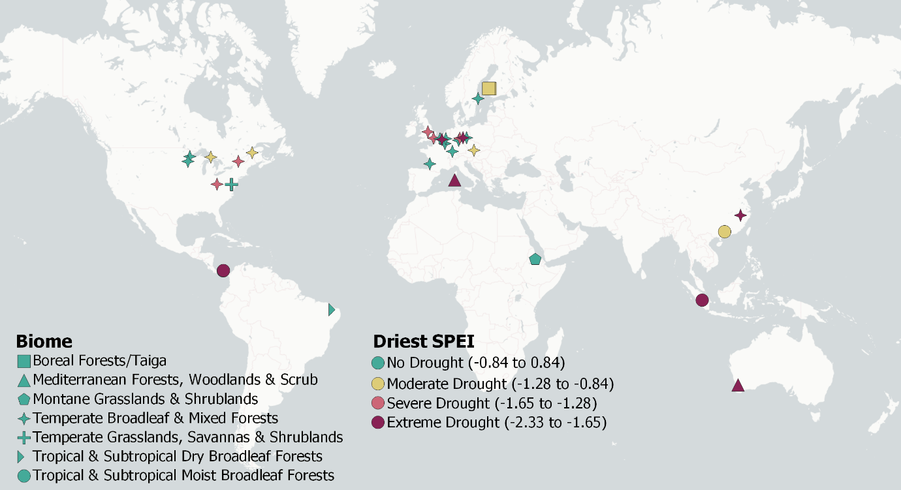

Fig. 1| Experiment location and comparative drought severity of 34 sites in TreeDivNet. The drought severity of the driest growing season between planting and survival sampling is shown here using the standardized precipitation-evapotranspiration index.

### Tree survival data

We attempted to include survival data from each site around year three after planting, to provide a balance between data availability and comparability among sites. As not all sites provided data for year three, we used survival data of saplings and seedlings for between two (i.e. after two entire growing seasons) and five years after planting (Supplementary Metadata M2). This allowed us to capture the effects of site-specific drought events within multiple growing seasons. The first growing season was not included in the analysis to minimize any nursery and management effects on initial establishment. The upper end of the sampling period was set at five years after planting to avoid the potential effects of crown closure and light limitation on tree performance and survival. While crown interactions may generally be limited (given the age of the saplings), whether significant root interactions are present will depend on the planting density in the site, growth rates of the included species and the climate system (Sinacore et al., 2017; Van de Peer et al., 2018). Each experimental site provided survival data for a single year (median: year three), yielding data from 363 167 saplings representing 167 tree species collected from 3744 plots, 34 sites, and seven biomes (Fig. 1, Supplementary Metadata M1).

### Climate and drought indices

A meteorological drought is commonly defined as any prolonged period with a meteorological water deficit, relative to the long-term local climatic conditions (Slette et al., 2019). Drought periods can be identified in this way via the standardized precipitation evapotranspiration index (SPEI). SPEI is calculated from the local monthly climatic water balance (precipitation minus potential evapotranspiration) over a selected time window of interest, with its deviation from the long-term mean expressed as a standardized Gaussian variable with a mean of zero and a standard deviation of one (Beguería, Vicente-Serrano, Reig, & Latorre, 2014; Vicente-Serrano, Beguería, & López-Moreno, 2010). As such, drought severity quantified via SPEI disregards soil moisture or inherent climatic aridity. Instead, SPEI can identify dry periods with abnormal climatic precipitation deficit for a given location and climate system (Slette et al., 2019) that can be discretely categorized into four drought classes related to drought severity (Agnew, 2000)(Fig. 1).

We calculated SPEI over a 30-year climate period (1991-2021) for each study site to ascertain whether any dry growing seasons occurred within the year of planting and the year of the survival survey. We downloaded the ERA5-Land monthly averaged data (1990-2021) for total precipitation and potential evaporation at 0.1° x 0.1° or 9 km horizontal resolution for each grid cell that contained a focal site, as well as air temperature measured at 2m height. To estimate the site-specific length of the growing season, we obtained data on total leaf area index (LAI) from ERA5Land (Fig. S1). We calculated the start and end of the growing season as the first and last month, respectively, with total LAI greater than the annual mean (Supplementary Metadata M1 and Supplementary Information 1.1). For tropical systems with year-round biomass production, this growing season period can be interpreted as the period of peak biomass production. SPEI of each site was calculated with the *spi* function in R (Beguería & Vicente-Serrano, 2017) over the site-specific growing season, i.e. accounting only for drought in the growing season. To estimate drought intensity at each site, we used the minimum SPEI observed between the year of planting and the survival survey. We used the Ecoregions2017 dataset of Dinerstein et al. (2017) to classify each site into one of 846 global ecoregions and one of 14 terrestrial biomes (see Supplementary Metadata M1) based on its point coordinate.

To characterize the drought intensity in terms of drought stress experienced by the trees, we also calculated the relative extractable water (REW) in the soil of each site for the period January 1990 to December 2022 (see Supplementary Information section 1.1.2). To calculate REW, we used the process-based model SurEau (Ruffault, Pimont, Cochard, Dupuy, & Martin-Stpaul, 2022). SurEau is dedicated to the computation of extreme drought stress impacts on vegetation using plant hydraulic theory, but includes all the functions to compute forest stand water balance (Granier, Bréda, Biron, & Villette, 1999; Ruffault, Martin-StPaul, Rambal, & Mouillot, 2013). The model is driven by hourly climatic data aggregated per day, soil parameters (e.g., soil water retention curves, soil depth), plant parameters describing stomatal regulation and resistance to drought induced cavitation as well as LAI. The model estimates the stand water balance and the water potential of the trees at an hourly time step. The REW is computed from soil water content as follows:

$$REW=\frac{θ-θ_{℘}}{θ_{fc}-θ_{℘}}$$

where $θ$ is the actual soil water content, $θ_{fc}$ is the soil water content at field capacity, and $θ_{℘}$ is the soil water content at the wilting point (i.e*.* at -1.5MPa). The REW equals 1 when soil water is at field capacity, 0 when soil water content reaches the wilting point, and can have negative values in SurEau at soil water content below the permanent wilting point. The latter can occur due to delayed stomatal closure or residual transpiration. The model was applied at each site using vegetation parameters specific to one species representative of the biome and the local species pool of each experiment (see Supplementary Metadata M3). The trait data were gathered from global databases (see Functional traits section). The soil parameters were extracted from the SoilGrids database (Poggio et al., 2021). The input LAI data for the SurEau model were obtained from the high resolution (333m) Copernicus database (Baret et al., 2013; Lacaze et al., 2015). The climate data for each study was obtained from ERA5-Land hourly data (Muñoz-Sabater et al., 2021). The minimum monthly REW during the growing season was calculated as a measure of drought intensity. The drought stress threshold is considered as being at a REW value below 0.4 (Granier et al. 1999).

### Functional traits

We collected species-level hydraulic, leaf and whole plant economic traits from various sources to test the relationship of traits with species survival. Not only did we include hydraulic traits that may indicate a plant's drought strategy, we also considered traits related to reproductive strategy, resource acquisition strategy and whole plant economics to provide a holistic understanding of which traits can influence species' responses to drought in this multi-site study (see Supplementary Metadata M4 for overview of the traits and the strategies they represent). The hydraulic traits were water potential at which 50% of xylem cavitates (P50, unit: MPa), minimum water potential (Ψmin, unit: MPa) and turgor loss point (TLP, unit: MPa), all collected from multiple sources (Bartlett, Scoffoni, & Sack, 2012; Choat et al., 2018; Guillemot et al., 2022; Kunert & Tomaskova, 2020; Larter et al., 2017; Lens et al., 2016; H. Liu et al., 2019; Lobo et al., 2018; Maitner, 2022; Martin-StPaul, Delzon, & Cochard, 2017; Sjöman, Hirons, & Bassuk, 2015; Skelton et al., 2021; Song, Poorter, Horsting, Delzon, & Sterck, 2022; Ziegler et al., 2019). Leaf traits and whole plant economic traits were collected from the TRY database (Kattge et al., 2011) and the BIOMASS database (Réjou‐Méchain, Tanguy, Piponiot, Chave, & Hérault, 2017). The included leaf traits were leaf mass per area (LMA, unit: mg mm-2), leaf nitrogen (N) concentration (unit: mg g-1), leaf phosphorus (P) concentration (unit: mg g-1) and leaf size (unit: cm²). The whole plant economic traits were wood density (unit: g cm-3) and maximum height (unit: m). We also included seed mass (unit: g) as a trait related to reproduction and contributing to a plant’s ecological strategy (Díaz et al., 2016; Westoby, 1998) . Trait data availability was variable among species, with only 24 of the 168 species having values for the complete set of traits, but widely collected traits (e.g. seed mass, LMA, height, …) were much more available than measurement-intensive traits such as the hydraulic ones (See Supplementary Metadata M4 for the data availability between traits and species). We chose not to impute trait values and instead constrained the analysis to those species with available trait values from databases. Furthermore, trait values found in databases mostly originated from adult trees and not saplings. Hence, we did not interpret any trait values as stand-alone findings or used them to estimate ecosystem functions or processes from our experimental plots. We rather applied the trait-based approach to get an integrated indication of the ecological strategy of the species included.

We calculated plot-level functional diversity using Rao’s quadratic entropy (Rao’s Q). Rao’s Q is the abundance-weighted variance of trait dissimilarities between all species pairs and hence a measure of functional divergence (Schleuter, Daufresne, Massol, & Argillier, 2010). It was calculated using the *fundiversity* package in R (Villéger, Mason, & Mouillot, 2008), on a trait dissimilarity matrix using the Gower distance, and as such was able to handle the missing trait values in our dataset. Given the constraining trait data availability between plots, we did not compute any community weighted means (CWM) and performed an analysis of species-level survival instead.

### Analysis of plot-level survival

We tested whether the change in between-plot variability (i.e. variance) in survival along the species diversity gradient was dependent on drought intensity. Survival data were scored as a binary tree-level condition (0 = dead, 1 = alive). We aggregated data to the plot level, calculating the percent survival in each plot by dividing the number of living trees by the total number of planted trees regardless of species. Plot-level survival was used as the response variable in a hierarchical beta regression modelled within a Bayesian framework.

The beta distribution is a flexible exponential distribution well suited to modelling ecological phenomena measured using proportional data ranging between 0 and 1 (Damgaard & Irvine, 2019; Douma & Weedon, 2019). The beta distribution is defined by an expected value $μ$ (logit link function) and a precision parameter $φ$ (log link function) that can be moderated separately (Damgaard & Irvine, 2019). The expected value $μ$ can be intuitively interpreted as plot-level mean survival, so the model quantifies how mean survival changes with tree species diversity and drought. The precision parameter $φ$ is the inverse of a dispersion parameter, as for fixed $μ$, the larger the $φ$ value the smaller the variance in the response variable. The $φ$ parameter thus allows the modelling of heteroscedasticity, in this case between-plot variability in percent survival. A higher value of $φ$ will thus result in a lower variability in the distribution.

Each model included an interaction term between species diversity and drought, which quantified how changes in variance in survival along the diversity gradient is moderated by drought. Four versions of the model were fitted (see Supplementary Information section 1.2.1), one for each combination of the diversity metrics (species richness and functional diversity) and the drought index (SPEI and REW). Inter-tree planting distance (median: 1.36 m) was included as a covariate in the model to control for density effects. The hierarchical structure of the data was accounted for by including group-level (random) effects for biome and site within biome. Plot size was not included in the models as it did not explain any residual variation (see Supplementary information section 1.2.1). This multilevel model was fitted using the R package *brms* function (Bürkner, 2017) in R version 4.2.1 (R Core Team, 2021). Predictions from this model were performed on a new dataset containing a gradient of 1 to 6 species (a common gradient in TreeDivNet experiments, Supplementary Metadata M1) and the boundary values of the four SPEI classes (see color codes on Fig. 1) or four REW values (0.6 = no drought stress, 0.4 = drought stress threshold, 0.2 = drought stress, 0 = permanent wilting point) as input data. For the predictions of functional diversity effects, we used the observed gradient in Rao’s Q (between 0 and 0.2). Variability in survival is presented on a 90% prediction interval to avoid sampling instability in the presented tails of the posterior distribution (Kruschke, 2014; McElreath, 2020). For further details on model specification, see Supplementary Information section 1.2.

### Analysis of species-level survival

To test for differences in species-level drought survival between monocultures and mixtures, the average survival of a species at a given richness level was subtracted from the average survival in monocultures of that species (∆survival). We expected that increases in survival in mixtures would be more pronounced under drought and in those species that survived more poorly in monoculture. The ∆survival value was fitted as the response variable to the survival of that species in monoculture (see also King, Pullen, Cook-Patton, & Parker, 2023), in interaction with SPEI and REW using a Gaussian distribution and the *brms* package (Bürkner, 2017). See Supplementary Information, section 1.2.2 for further details.

To quantify the relationship between functional traits and species survival, we examined the effect of the ten different functional traits on species survival in monoculture. Rather than imputing missing trait data, we fitted separate models for each functional trait to account for differences in data coverage between traits. Each trait was modelled separately to estimate its effect on species survival in monoculture. The hierarchical structure of the data was accounted for by including group-level (random) effects for biome and site within biome. This multilevel model was fitted using the R package *brms* (Bürkner, 2017) in R version 4.2.1 (R Core Team, 2021). The effects are presented on a 90% credible interval (CI). For further details, see Supplementary Information, section 1.2.2.

We constructed a correlation plot to display the pairwise correlations between traits and support the interpretation of the results. In addition, we used principal component analysis (PCA) to graphically depict the multi-dimensional correlation structure of all functional traits using the function *bpca* of the R package (Faria, Demétrie, & Allaman, 2022). The PCA only included the 24 species with complete records for all ten traits.

# Results

### Analysis of plot-level survival

Mean plot-level survival was not sensitive to tree species richness and drought conditions as indicated by SPEI and REW. In contrast, variability in survival was sensitive to richness and drought (Fig. 2). Predictions from the posterior distributions using a 1-6 species richness gradient as input values showed that mean survival ranged from 88% under non-drought conditions (SPEI = 0) to 85% under extreme drought (SPEI =-1.65) (Fig. 2A), with a near equal pattern emerging with REW as the predictor variable (Fig. 2B). This means that plot-level survival was not increased by tree species richness under any drought intensity. Variability in survival decreased with increasing species richness and increased with drought intensity, but with an interactive effect on the slope of the precision parameter $φ$. The effect on the precision parameter $φ$ showed that richness reduced variability more with increasing drought intensity (Supplementary Information Fig. S11). Under non-drought conditions (SPEI = 0 and similarly for REW = 0.6), the model estimated that the 90th percentile of survival ranged from 65 % to 100% for monocultures but from 70% to 100% for six-species mixtures. Under extreme drought conditions (SPEI = -1.65 , REW = 0), each additional species increased survival rate precision by 2 percentage points. This means that the 5% poorest surviving monocultures (falling outside the low-end of the 90th percentile range) had a predicted maximum survival of ca. 50% that increased to ca. 60% for six-species mixtures. The density covariate was negative in value, indicating higher survival in plots with lower inter-tree planting distance. For site-specific model outcomes, see Supplementary Information 2.1.2.

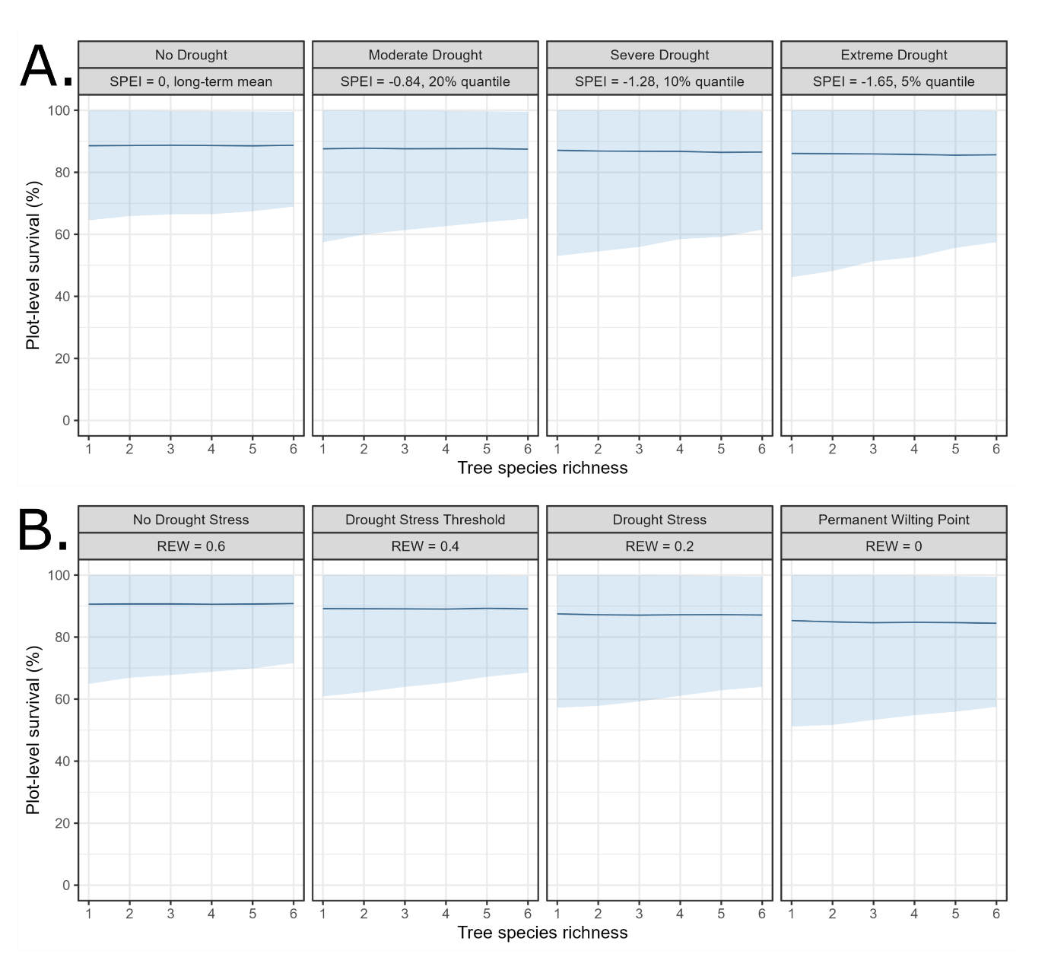

Fig. 2 | Changes in plot-level percent survival with increasing species richness at four levels of growing season drought indicated by SPEI (panel A) and REW (panel B). Predicted mean survival (blue line) and its variability (90% percentile, light blue shaded area) are presented for an input dataset with a species richness ranging from 1 to 6 species.

Mean survival marginally increased in response to functional diversity (Rao’s Q entropy) and the drought indicators SPEI (Fig. 3A) and REW (Fig. 3B). This effect was evident on a 90% CI (Fig. S12), with an added 2-5 percentage points over the observed functional diversity gradient depending on the drought indicator (Fig. 3). Variability in survival consistently decreased in response to functional diversity, albeit more strongly when using SPEI as the drought indicator compared to REW. SPEI and functional diversity had an interactive effect on the precision parameter $φ$ and hence the variance (Fig. S13), indicating that variability in survival decreases faster in response to functional diversity with increasingly negative SPEI (Fig. 3A). The slope of this interactive effect was different when using REW as the indicator, showing a smaller decrease in variability with increasing functional diversity as REW approached zero (Fig. 3B).

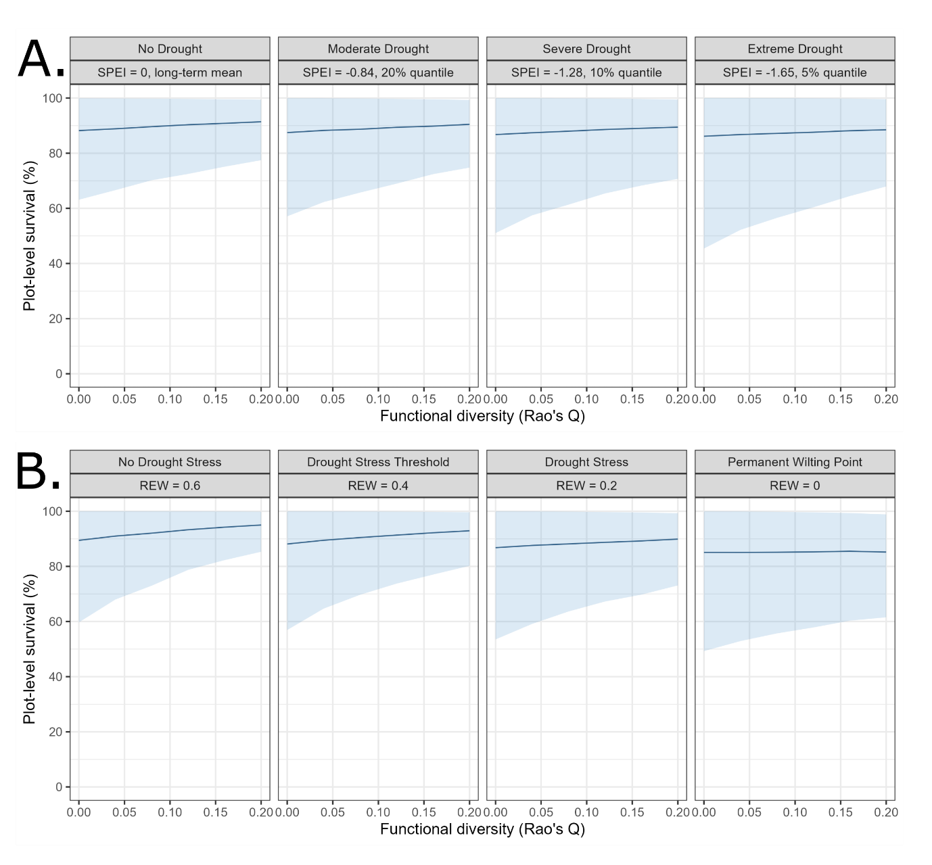

Fig. 3 | Changes in plot-level percent survival with increasing functional diversity at four levels of growing season drought indicated by SPEI (panel A) and REW (panelB**).** Predicted mean survival (blue line) and variability in survival (90% percentile, light blue shaded area) are presented.

### Analysis of species-level survival

Species with low survival in monoculture survived comparatively better in mixture, but this effect varied between drought indicators. This effect was only marginal for SPEI, showing a consistent negative slope for the relationship of monoculture survival with ∆survival (Fig. 4A). At high monoculture survival, the regression line shows a slight negative response, but with considerable variability in observed differences. However, a clear interaction with REW was exhibited, showing that once the drought stress threshold (REW = 0.4) was surpassed, the slope of the linear relationship was more negative, leading to a larger difference (∆survival) for species with low survival in monoculture (Fig. 4B, Supplementary Information section 2.2.1).

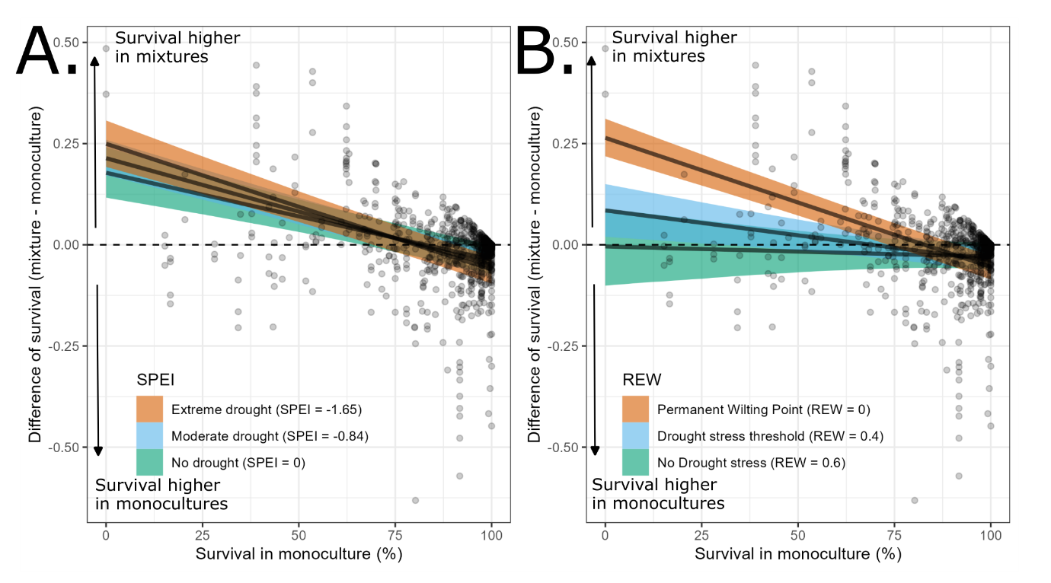

Fig. 4| Difference in species survival percentage (∆survival) in response to survival of that species in monoculture, varying by SPEI (panel A) and REW (panel B).

Maximum height, water potential at turgor loss point (Ψtlp), leaf N concentration, leaf size and leaf P concentration showed significant (90%) effects on species survival in monoculture (Fig. 5). With increasing maximum height and leaf P, survival in monoculture increased. Ψtlp showed a negative effect, meaning that species with less negative Ψtlp (i.e. lower leaf drought resistance and/or water-saving strategy) showed a lower survival in monoculture. The other hydraulic traits (ΨP50 and Ψmin) showed similar effect sizes, but with larger variability so that the effects cannot be reported as significant on a 90% CI. Species with high leaf N concentration and large leaf size had lower survival in monoculture. The pairwise correlation matrix using Spearman’s rank correlations showed that the hydraulic traits (Ψtlp, ΨP50, and Ψmin) are highly correlated between themselves (p < 0.001), and with wood density (p < 0.001). The leaf traits (leaf N, leaf P, LMA, leaf size), seed mass and maximum height showed varying pairwise correlations (Supplementary Information section 2.2.2). The first axis of the PCA alone explained 30.29% of the multi-dimensional functional space variation; it was dominated by characteristics of hydraulic resistance to drought (lower ΨP50, Ψtlp, and Ψmin). This first axis was to a lesser extent associated to small leaves and low leaf N and P concentration, a large seed mass and a high wood density, and only in a limited manner to height (Supplementary Information 2.2.3).

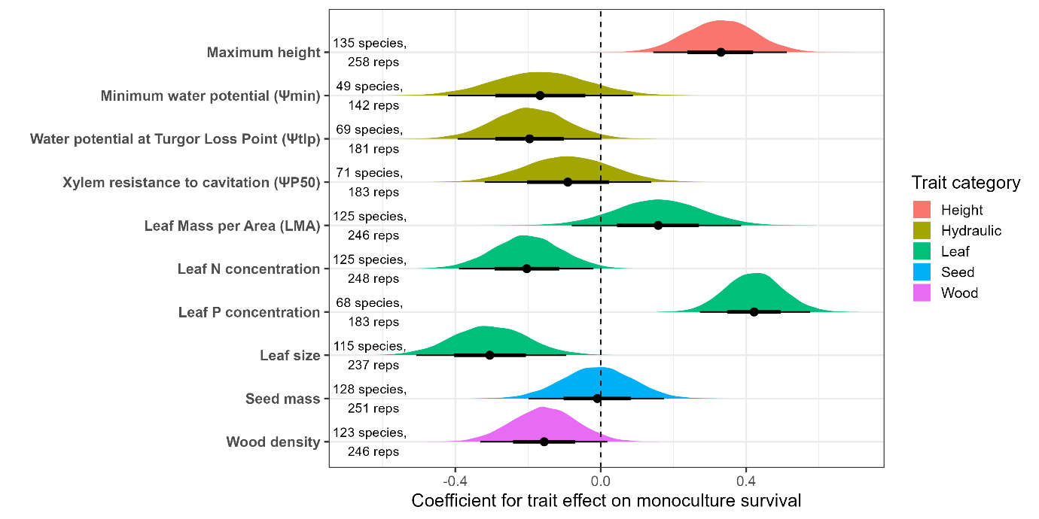

Fig. 5| Effects of functional traits on mean species survival in monoculture. The posterior distribution of the coefficients for the expected value parameter ($μ$, logit-link function) are displayed for each trait. The effects are displayed per unit increase of the trait value (i.e. one standard deviation). Number of species with trait values and the number of monocultures are listed for each trait. Credible intervals (CI) presented here are on 50% (bold line) and 90% CI (thin line). Estimates with CI’s not crossing the zero line are significantly different at 90% CI.

# Discussion

Our analysis of sapling survival showed that higher tree species richness and functional diversity reduced variability in survival. This effect became stronger as drought severity increased. Using a species-based approach, we found that species with low survival in monocultures survived comparatively better in mixtures when under drought (as indicated by REW and independent of SPEI). A higher species survival in monoculture was associated with drought resistance (characterized by hydraulic traits), greater maximum height and conservative resource acquisition traits (e.g. low leaf size and low leaf N concentration). These results highlight: 1) the importance of tree diversity as a form of insurance to increase sapling survival during drought, and 2) the importance of drought resistance and associated traits to explain altered tree species survival in response to tree diversity and drought, showing that drought sensitive species survive comparatively better in mixtures compared to monocultures.

### Tree diversity reduces variability in survival

Tree species richness did not affect mean survival of trees but decreased its variability, which is in line with a sampling effect.. Mean survival across tree diversity levels was stable around 85%, which is higher than the 50% survival commonly reported for managed plantations (Banin et al., 2023). In mature forests of Northern America, a clear link between higher tree diversity (Searle, Chen, & Paquette, 2022) and density (Bradford et al., 2022) on the one hand and lower mean survival on the other was recently reported, but with unclear effects on variability. In contrast, the experimental sites within TreeDivNet are generally young, small in scale (a few ha) and are designed to maximize scientific output (Grossman et al., 2018). Because of this, experimental site managers may invest more in management (e.g. replanting or weed and pest control in the first year) and careful species selection which could boost mean survival rates compared to commercial plantation forests. In addition, densities in the experiments range from high to hasten interactions between trees (Tobner, Paquette, Reich, Gravel, & Messier, 2014) to intermediately dense to reflect local silvicultural practice (Verheyen et al., 2013), which may explain the negative density effect that we found in our statistical analysis. Nonetheless, such experiments are needed to accurately quantify effects of tree diversity and drought on variability in survival with pools of functionally dissimilar species (Baeten et al., 2013; Nock et al., 2017).

While tree species richness effects on mean survival were not observed, we found evidence that functional diversity increased plot-level survival, suggesting that complementary resource uptake and/or facilitation occurred under drought at an early age (Fichtner et al., 2017; Sinacore et al., 2017). Indeed, Urgoiti et al. (2023) too have shown that the mixing of species with contrasting resource-use strategies can decrease rates of mortality (i.e. self-thinning) in a tree diversity experiment. We found that variability in survival was consistently reduced at higher tree species richness and with functional diversity too, which is consistent with a sampling effect (Baeten et al., 2013; Gamfeldt & Källström, 2007; Loreau & Hector, 2001). Simply put, it is more likely to have species that survive well under drought in a mixture than in a monoculture (that is, when species are not chosen specifically for their drought resistance). However, mean survival in mixtures cannot exceed survival of monocultures of the most drought resistant species when drought is the major driver of mortality. Tree diversity simply reduced survival variability in more functionally diverse communities, and perhaps due to other site-specific biotic and abiotic disturbances in addition to drought (Messier et al., 2021).

Tree diversity effects on early survival may have important implications for post-drought development and long-term forest functioning (Bauhus et al., 2017; Hisano, Chen, Searle, & Reich, 2019; Serra‐Maluquer et al., 2020). Reducing the risk of tree mortality is crucial during the sapling stage to ensure growth recovery and the development of plantation forests that perform multiple ecosystem functions well (Gessler, Bottero, Marshall, & Arend, 2020). Of course, survival in the sapling stage does not necessarily imply long-term survival, nor sustained growth. After the sapling stage, young trees remain vulnerable to drought (Bretfeld, Ewers, & Hall, 2018), but diversity can reduce drought impact by e.g. promoting growth recovery via complementarity in resource use (Fichtner et al., 2020; Schnabel et al., 2021; Sinacore, Asbjornsen, Hernandez-Santana, & Hall, 2019).

### Functional traits influence species’ drought response in mixtures and monocultures

Under drought stress, species that survived poorly in monoculture survived comparatively better in mixture. This finding suggests that tree-to-tree interactions can already occur in young mixtures and can influence survival when an acute water limitation occurs. This likely resulted from stronger intraspecific competition in monocultures compared to mixtures (Fichtner et al., 2017; Hajek et al., 2022; King et al., 2023). Alternatively, or in addition, shade-tolerant species that are vulnerable to drought stress may have benefitted from shade of diverse neighbors (Kothari et al., 2021). Here, we found that species survival in monoculture was strongly associated with leaf drought resistance (lower Ψtlp) and maximum height. The survival of drought sensitive species was thus improved when they were planted in mixtures. These finding strongly suggest that mixing of drought sensitive and resistant species can increase total plot or plantation level survival (Ammer, 2019; Forrester, 2015; Su, Liu, Wang, Zhang, & Cui, 2022).

The finding of increased survival under drought resistance was associated with functional traits representative of a conservative resource-use strategy. We found that low leaf size and low leaf N concentration were associated with higher species survival in monoculture (Díaz et al., 2016; Reich, 2014; Wright et al., 2004). Surprisingly, leaf P concentration showed an opposite trend indicating higher survival in species with higher leaf P concentration. This result may be due to the fact that species with leaf P trait data were mostly from temperate biomes (Supplementary Metadata M4). Another surprising finding at first glance is the positive effect of maximum height and negative effects of wood density on monoculture survival. High wood density and low maximum plant height are known to promote survival in arid biomes and hence a viable ecological strategy there is to be small in stature with high wood density ¶(Guillemot et al., 2022; H. Liu et al., 2019). However, tree survival together with plant height is usually lower in stressful arid biomes as opposed to survival of the comparatively larger tree with lower wood density in temperate biomes (H. Liu et al., 2019). This comparison of within-environmental context findings from literature vs the across-context synthesis in our work may be the cause of our counter-intuitive observed positive effect of maximum plant height and negative effect of wood density on survival. We also found strong positive pairwise correlations between the ΨP50, Ψtlp, and Ψmin and wood density. Furthermore, the PCA on the subset of complete trait data showed that functional traits indicative of a conservative resource use strategy (Díaz et al., 2016; Reich, 2014; Wright et al., 2004) correlated with a negative P50 and TLP along the first axis of variation (30% of variance explained). These results indicate that drought resistance strategies are coordinated with other ecological strategies that may promote survival (Kröber, Zhang, Ehmig, & Bruelheide, 2014; H. Liu et al., 2019). Predicting species mortality solely from hydraulic traits can be uncertain given their correlation with other functional traits, but hydraulic characteristics can still be used to rank or define species drought resistance and their capacity to survive climate extremes (Trugman, Anderegg, Anderegg, Das, & Stephenson, 2021).

### Application of tree diversity to reduce variability in survival

Theoretically, reducing survival uncertainty by increasing tree diversity does not require that trees are planted in mixtures, as planting monocultures of several species could also improve survival at the landscape scale (Loreau et al., 2021). However, from a functional perspective, we found that mixtures of drought resistant and sensitive species respond differently to the drought disturbance compared with monocultures. First, we found that the survival of drought sensitive species is enhanced when growing in mixtures. Hence, planting monocultures of different (drought sensitive) species in a landscape puts the plantations more at risk of dramatic planting failure, in case of increasingly likely intensive droughts. Such a planting failure would result in a significant loss of tree cover, with potential disproportional effects on associated biodiversity, microclimate, soil development and erosion, and evapotranspiration (Allen, 2007; Batllori et al., 2020; De Frenne et al., 2019; Senf et al., 2018). Hence, a landscape consisting of large-scaled monocultures from a varied species palette would not be equally functioning under a future climate as a landscape with mixtures from that same varied species palette (Messier et al., 2021) or an already present diverse ecosystem (Fleischman et al., 2020). The risk-spreading role of tree diversity in the sapling stage may be pivotal as a climate change adaptation measure in forest landscapes, in order to safeguard functions such as productivity or carbon storage in the long-term (Doak et al., 1998; Lehman & Tilman, 2000; Tilman, 1999).

Even so, trade-offs in the resource-use strategy of tree species should be considered when selecting tree species for planting, so as to balance the outcomes on ecosystem functions and services (Baeten et al., 2019). Drought resistance is correlated to some degree with a conservative resource-use strategy, and such a strategy invokes a trade-off of lower growth rates and short-term carbon uptake against longevity (Díaz et al., 2016; Guillemot et al., 2022). On the other end, resource acquisitive species are characterized by fast growth and short life-span of plant tissues, but may boost carbon uptake and ecosystem productivity in the short term (Díaz et al., 2016; Reich, 2014) instead of the long term (Büntgen et al., 2019). Especially in arid environments, the combination of shade-casting fast-growing pioneering species with slow-growing late-successional species is known to benefit survival and spontaneous recovery of other vegetation as well (Aerts et al., 2007; Elliott, Tucker, Shannon, & Tiansawat, 2023; Grossiord, 2020; Poorter et al., 2019). Our findings support that drought sensitive species are better suited to combat drought effects when in mixture compared to monoculture, and can hence still contribute to multi-functionality of forests (Baeten et al., 2019; Gillerot, Forrester, Bottero, Rigling, & Lévesque, 2020; Grossiord et al., 2014; X. Liu et al., 2022; van der Plas et al., 2016; Zhu et al., 2018).

In conclusion, our findings are relevant to the adaptation of forest management strategies in an era of rapid global environmental change and increasing anthropogenic disturbances. First, more functionally diverse, young plantations exhibited lower variability in survival, which can reduce the uncertainty in achieving successful forest development. Second, tree species mixtures of drought resistant and sensitive species could improve survival and enhance resilience. The application of these findings can contribute to forest management by stabilizing survival of young plantations where climate change and other disturbances are anticipated to increase mortality. Even if managers increase tree diversity to focus on other ecosystem functions (e.g. productivity, nutrient retention), this approach will not decrease the benefits arising from reduced variability in early survival. From an ecological perspective, we recommend consideration of planting intimate tree mixtures to stabilize tree survival and create functionally diverse, drought adapted, managed forests.

# Acknowledgements

We thank all the site managers, field technicians, and researchers who have made the collaborative work within the TreeDivNet possible. The research in this study was funded through the research project CAMBIO, funded by the BNP Paribas foundation through its Climate & Biodiversity initiative. This research was funded through the 2019-2020 BiodivERsA joint call for research proposals, under the BiodivClim ERA-Net COFUND program (MixForChange project), and with the funding organizations ANR (ANR-20-EBI5-0003), BELSPO, DFG (project number 451394862), FAPESP, FWF (l 5086-B) and FORMAS. This research was supported by iDiv, through the workshop “Using Tree Diversity as an Insurance for the Stable Functioning of Forest Ecosystems – sTree Div”, which took place in Leipzig in 2014, and where the data gathering process for a TreeDivNet-wide survival study was first discussed and initiated. NE (Nico Eisenhauer) and OF (Olga Ferlian) acknowledge support of iDiv funded by the German Research Foundation (DFG– FZT 118, 202548816) and funding by the DFG (Ei 862/29-1 and Ei 862/31-1). Agua Salud is part of ForestGEO and is a collaboration with the Panama Canal Authority (ACP), the Ministry of the Environment (MiAmbiente) of Panama, and other partners. Plantation establishment of Agua Salud was supported by the HSBC the ACP. Funding for this work came from Stanley Motta, Frank and Kristin Levinson, and the Hoch Family. EFForTS-BEE was financed by the Deutsche Forschungsgemeinschaft (DFG) German Research Foundation—project number 192626868– SFB 990 in the framework of the collaborative German — Indonesian research project CRC990 EFForTS (http://www.unigoettingen.de/crc990). We thank Anne Gérard, Delphine Clara Zemp, Wollni Meike, Leti Sundawati, Bambang Irawan and Eduard Siahaan for their support in EFForTS-BEE. We thank Jamie Pullen for site management and data collection in BiodiversiTREE. We would like to thank the Walloon forest service (Service Public de Wallonie—Département de la Nature et des Forêts) for its financial support to the installation and maintenance of the FORBIO-Gedinne site through the 5-year research programme “Accord-cadre de recherches et de vulgarisation forestières”. SIDE was supported by the Division of Forestry and Natural Resources, West Virginia University. We thank Allison Scott, Sarah Hobbie and the NSF (LTER DEB 1831944) for their support in IDENT FAB. We thank Josephine Haase, Daniel Prati and Felix Gottschall, the Department of Community Ecology of the UFZ and the Team of the Bad Lauchstädt field station of the UFZ for contributing to the establishment, maintenance and measurements in the Kreinitz experiment. We thank Richard Hobbs, Tim Morald and Rebecca Campbell for their support in Ridgefield. We thank Wei Lin, Zhiyi C hen, Zhiqiang Shen, Buhang Li, Bingwei Zhand and Yuanzhi Li for their support in CADE. We thank Abadi Tesfay, Sisay Yemae, Asmelash Aynalem, Tesfahunegn Abraha and the College of Dryland Agriculture and Natural Resources (Mekelle University) for their support in IDENT Ethiopia. We thank Cornelia Garbe and Jon Urgoiti for collecting data in IDENT Montreal. We thank Daniel Lesieur for preparing and sharing various IDENT data as well as data from the Sardinilla site. The Sardinilla site was supported by the Smithsonian Tropical research Institute as well as NSERC grant to C. Potvin. We thank Jose Monteza for his invaluable help in the field in Sardinilla. The IDENT Freiburg experiment has been supported by the University of Freiburg (Innovationsfonds Forschung, grant to MSL and JB). We thank the Sardinian Forest Authority “Forestas” for hosting IDENT-Macomer experiment and contributing to its establishment and management. The BIOTREE experiments have been established by the Max-Planck-Institute for Biogeochemistry Jena (Germany), with support by the Federal Forestry Office Thüringer Wald (Bundesforstamt Thüringer Wald, Bad Salzungen, Germany) and the Thuringian Forestry Research and Competence Center (Thüringer Forstliches Forschungs- und Kompetenzzentrum, Gotha, Germany). We thank Bernard Issenhuth and INRAE - Forest experimental Facility UEFP ([https://doi.org/10.15454/1.5483264699193726E12](https://eur03.safelinks.protection.outlook.com/?url=https%3A%2F%2Fdoi.org%2F10.15454%2F1.5483264699193726E12&data=05%7C01%7CHaben.Blondeel%40ugent.be%7Cad71ae6ae1784b8842eb08dad6e5f5ad%7Cd7811cdeecef496c8f91a1786241b99c%7C1%7C0%7C638058580754435394%7CUnknown%7CTWFpbGZsb3d8eyJWIjoiMC4wLjAwMDAiLCJQIjoiV2luMzIiLCJBTiI6Ik1haWwiLCJXVCI6Mn0%3D%7C3000%7C%7C%7C&sdata=JNktX8ijhMblg3KML2MwqHHIabSyaYwERK1PXfxu%2Bjc%3D&reserved=0)) for the coordination, establishment, maintenance and measurements in ORPHEE. The B-tree experiments were supported by the FWF grant I 4372-B. IDENT-Cloquet was supported by the U.S. National Science Foundation, Biological Integration Institutes grant NSF-DBI-2021898.

# References

Aerts, R., Negussie, A., Maes, W., November, E., Hermy, M., & Muys, B. (2007). Restoration of dry afromontane forest using pioneer shrubs as nurse-plants for Olea europaea ssp. cuspidata. *Restoration Ecology*, *15*(1), 129–138. doi: 10.1111/j.1526-100X.2006.00197.x

Agnew, C. T. (2000). Using the SPI to Identify Drought. *Drought Network News (1994 - 2001)*, (May 2000), 5–12.

Allen, C. D. (2007). Interactions across spatial scales among forest dieback, fire, and erosion in northern New Mexico landscapes. *Ecosystems*, *10*(5), 797–808. doi: 10.1007/s10021-007-9057-4

Ammer, C. (2019). Diversity and forest productivity in a changing climate. *New Phytologist*, *221*(1), 50–66. doi: 10.1111/nph.15263

Anderegg, W. R. L., Trugman, A. T., Badgley, G., Konings, A. G., & Shaw, J. (2020). Divergent forest sensitivity to repeated extreme droughts. *Nature Climate Change*, *10*(12), 1091–1095. doi: 10.1038/s41558-020-00919-1

Aquilué, N., Filotas, É., Craven, D., Fortin, M. J., Brotons, L., & Messier, C. (2020). Evaluating forest resilience to global threats using functional response traits and network properties. *Ecological Applications*, *30*(5), 1–14. doi: 10.1002/eap.2095

Baeten, L., Bruelheide, H., van der Plas, F., Kambach, S., Ratcliffe, S., Jucker, T., … Scherer-Lorenzen, M. (2019). Identifying the tree species compositions that maximize ecosystem functioning in European forests. *Journal of Applied Ecology*, *56*(3), 733–744. doi: 10.1111/1365-2664.13308

Baeten, L., Verheyen, K., Wirth, C., Bruelheide, H., Bussotti, F., Finér, L., … Scherer-Lorenzen, M. (2013). A novel comparative research platform designed to determine the functional significance of tree species diversity in European forests. *Perspectives in Plant Ecology, Evolution and Systematics*, *15*(5), 281–291. doi: 10.1016/j.ppees.2013.07.002

Banin, L. F., Raine, E. H., Rowland, L. M., Chazdon, R. L., Smith, S. W., Rahman, N. E. B., … Burslem, D. F. R. P. (2023). The road to recovery: a synthesis of outcomes from ecosystem restoration in tropical and sub-tropical Asian forests. *Philosophical Transactions of the Royal Society B: Biological Sciences*, *378*(1867). doi: 10.1098/rstb.2021.0090

Baret, F., Weiss, M., Lacaze, R., Camacho, F., Makhmara, H., Pacholcyzk, P., & Smets, B. (2013). GEOV1: LAI and FAPAR essential climate variables and FCOVER global time series capitalizing over existing products. Part1: Principles of development and production. *Remote Sensing of Environment*, *137*, 299–309. doi: 10.1016/j.rse.2012.12.027

Bartlett, M. K., Scoffoni, C., & Sack, L. (2012). The determinants of leaf turgor loss point and prediction of drought tolerance of species and biomes: A global meta-analysis. *Ecology Letters*, *15*(5), 393–405. doi: 10.1111/j.1461-0248.2012.01751.x

Batllori, E., Lloret, F., Aakala, T., Anderegg, W. R. L., Aynekulu, E., Bendixsen, D. P., … Zeeman, B. (2020). Forest and woodland replacement patterns following drought-related mortality. *Proceedings of the National Academy of Sciences of the United States of America*, 1–10. doi: 10.1073/pnas.2002314117

Bauhus, J., Forrester, D. I., Gardiner, B., Jactel, H., Vallejo, R., & Pretzsch, H. (2017). Ecological Stability of Mixed-Species Forests. In H. Pretzsch, D. I. Forrester, & J. Bauhus (Eds.), *Mixed-Species Forests: Ecology and Management* (pp. 337–382). Berlin, Heidelberg: Springer Berlin Heidelberg. doi: 10.1007/978-3-662-54553-9_7

Beguería, S., Latorre, B., Reig, F., & Vicente-Serrano, S. M. (2022). SPEI Global Drought Monitor. Retrieved from https://spei.csic.es/map/

Beguería, S., & Vicente-Serrano, S. M. (2017). *SPEI: Calculation of the Standardised Precipitation-Evapotranspiration Index*. Retrieved from https://cran.r-project.org/package=SPEI

Beguería, S., Vicente-Serrano, S. M., Reig, F., & Latorre, B. (2014). Standardized precipitation evapotranspiration index (SPEI) revisited: Parameter fitting, evapotranspiration models, tools, datasets and drought monitoring. *International Journal of Climatology*, *34*(10), 3001–3023. doi: 10.1002/joc.3887

Bradford, J. B., Shriver, R. K., Robles, M. D., McCauley, L. A., Woolley, T. J., Andrews, C. A., … Bell, D. M. (2022). Tree mortality response to drought‐density interactions suggests opportunities to enhance drought resistance. *Journal of Applied Ecology*, *59*(2), 549–559. doi: 10.1111/1365-2664.14073

Bretfeld, M., Ewers, B. E., & Hall, J. S. (2018). Plant water use responses along secondary forest succession during the 2015–2016 El Niño drought in Panama. *New Phytologist*, *219*(3), 885–899. doi: 10.1111/nph.15071

Brodribb, T. J., Powers, J., Cochard, H., & Choat, B. (2020, April 17). Hanging by a thread? Forests and drought. *Science*, Vol. 368, pp. 261–266. American Association for the Advancement of Science. doi: 10.1126/science.aat7631

Bukoski, J. J., Cook-Patton, S. C., Melikov, C., Ban, H., Chen, J. L., Goldman, E. D., … Potts, M. D. (2022). Rates and drivers of aboveground carbon accumulation in global monoculture plantation forests. *Nature Communications*, *13*(1), 1–13. doi: 10.1038/s41467-022-31380-7

Büntgen, U., Krusic, P. J., Piermattei, A., Coomes, D. A., Esper, J., Myglan, V. S., … Körner, C. (2019). Limited capacity of tree growth to mitigate the global greenhouse effect under predicted warming. *Nature Communications*, *10*(1), 1–6. doi: 10.1038/s41467-019-10174-4

Bürkner, P. C. (2017). brms: An R package for Bayesian multilevel models using Stan. *Journal of Statistical Software*, *80*(1). doi: 10.18637/jss.v080.i01

Chiang, F., Mazdiyasni, O., & AghaKouchak, A. (2021). Evidence of anthropogenic impacts on global drought frequency, duration, and intensity. *Nature Communications*, *12*(1), 1–10. doi: 10.1038/s41467-021-22314-w

Choat, B., Brodribb, T. J., Brodersen, C. R., Duursma, R. A., López, R., & Medlyn, B. E. (2018). Triggers of tree mortality under drought. *Nature*, *558*(7711), 531–539. doi: 10.1038/s41586-018-0240-x

Damgaard, C. F., & Irvine, K. M. (2019). Using the beta distribution to analyse plant cover data. *Journal of Ecology*, *107*(6), 2747–2759. doi: 10.1111/1365-2745.13200

De Frenne, P., Zellweger, F., Rodríguez-Sánchez, F., Scheffers, B. R., Hylander, K., Luoto, M., … Lenoir, J. (2019). Global buffering of temperatures under forest canopies. *Nature Ecology & Evolution*, *3*(5), 744–749. doi: 10.1038/s41559-019-0842-1

Díaz, S., Kattge, J., Cornelissen, J. H. C., Wright, I. J., Lavorel, S., Dray, S., … Gorné, L. D. (2016). The global spectrum of plant form and function. *Nature*, *529*(7585), 167–171. doi: 10.1038/nature16489

Dinerstein, E., Olson, D., Joshi, A., Vynne, C., Burgess, N. D., Wikramanayake, E., … Saleem, M. (2017). An Ecoregion-Based Approach to Protecting Half the Terrestrial Realm. *BioScience*, *67*(6), 534–545. doi: 10.1093/biosci/bix014

Doak, D. F., Bigger, D., Harding, E. K., Marvier, M. A., O’Malley, R. E., & Thomson, D. (1998). The statistical inevitability of stability-diversity relationships in community ecology. *American Naturalist*, *151*(3), 264–276. doi: 10.1086/286117

Douma, J. C., & Weedon, J. T. (2019). Analysing continuous proportions in ecology and evolution: A practical introduction to beta and Dirichlet regression. *Methods in Ecology and Evolution*, *2019*(October 2018), 1412–1430. doi: 10.1111/2041-210x.13234

Elliott, S., Tucker, N. I. J., Shannon, D. P., & Tiansawat, P. (2023). The framework species method: harnessing natural regeneration to restore tropical forest ecosystems. *Philosophical Transactions of the Royal Society B: Biological Sciences*, *378*(1867). doi: 10.1098/rstb.2021.0073

Faria, J. C. F., Demétrie, C. G. B., & Allaman, I. B. (2022). *Biplot of multivariate data based on Principal Components Analysis*. Ilheus, Bahia, Brasil and Piracicaba, Sao Paulo, Brasil. Retrieved from https://cran.r-project.org/web/packages/bpca/

Felton, A., Nilsson, U., Sonesson, J., Felton, A. M., Roberge, J. M., Ranius, T., … Wallertz, K. (2016). Replacing monocultures with mixed-species stands: Ecosystem service implications of two production forest alternatives in Sweden. *Ambio*, *45*, 124–139. doi: 10.1007/s13280-015-0749-2

Fichtner, A., Härdtle, W., Li, Y., Bruelheide, H., Kunz, M., & von Oheimb, G. (2017). From competition to facilitation: how tree species respond to neighbourhood diversity. *Ecology Letters*, *20*(7), 892–900. doi: 10.1111/ele.12786

Fichtner, A., Schnabel, F., Bruelheide, H., Kunz, M., Mausolf, K., Schuldt, A., … von Oheimb, G. (2020). Neighbourhood diversity mitigates drought impacts on tree growth. *Journal of Ecology*, *108*(3), 865–875. doi: 10.1111/1365-2745.13353

Figge, F. (2004). Bio-folio: applying portfolio theory to biodiversity. *Biodiversity and Conservation*, *13*, 827–849.

Fleischman, F., Basant, S., Chhatre, A., Coleman, E. A., Fischer, H. W., Gupta, D., … Veldman, J. W. (2020). Pitfalls of Tree Planting Show Why We Need People-Centered Natural Climate Solutions. *BioScience*, *70*(11), 947–950. doi: 10.1093/biosci/biaa094

Forrester, D. I. (2015). Transpiration and water-use efficiency in mixed-species forests versus monocultures: Effects of tree size, stand density and season. *Tree Physiology*, *35*(3), 289–304. doi: 10.1093/treephys/tpv011

Forzieri, G., Girardello, M., Ceccherini, G., Spinoni, J., Feyen, L., Hartmann, H., … Cescatti, A. (2021). Emergent vulnerability to climate-driven disturbances in European forests. *Nature Communications*, *12*(1), 1–12. doi: 10.1038/s41467-021-21399-7

Gamfeldt, L., & Källström, B. (2007). Increasing intraspecific diversity increases predictability in population survival in the face of perturbations. *Oikos*, *116*(4), 700–705. doi: 10.1111/j.2007.0030-1299.15382.x

Gessler, A., Bottero, A., Marshall, J., & Arend, M. (2020). The way back: recovery of trees from drought and its implication for acclimation. *New Phytologist*, *228*(6), 1704–1709. doi: 10.1111/nph.16703

Gillerot, L., Forrester, D. I., Bottero, A., Rigling, A., & Lévesque, M. (2020). Tree Neighbourhood Diversity Has Negligible Effects on Drought Resilience of European Beech, Silver Fir and Norway Spruce. *Ecosystems*, 20–36. doi: 10.1007/s10021-020-00501-y

Goffner, D., Sinare, H., & Gordon, L. J. (2019). The Great Green Wall for the Sahara and the Sahel Initiative as an opportunity to enhance resilience in Sahelian landscapes and livelihoods. *Regional Environmental Change*, *19*(5), 1417–1428. doi: 10.1007/s10113-019-01481-z

Granier, A., Bréda, N., Biron, P., & Villette, S. (1999). A lumped water balance model to evaluate duration and intensity of drought constraints in forest stands. *Ecological Modelling*, *116*(2–3), 269–283. doi: 10.1016/S0304-3800(98)00205-1

Greenwood, S., Ruiz-Benito, P., Martínez-Vilalta, J., Lloret, F., Kitzberger, T., Allen, C. D., … Jump, A. S. (2017). Tree mortality across biomes is promoted by drought intensity, lower wood density and higher specific leaf area. *Ecology Letters*, *20*(4), 539–553. doi: 10.1111/ele.12748

Grossiord, C. (2020). Having the right neighbors: how tree species diversity modulates drought impacts on forests. *New Phytologist*, *228*(1), 42–49. doi: 10.1111/nph.15667

Grossiord, C., Granier, A., Ratcliffe, S., Bouriaud, O., Bruelheide, H., Chećko, E., … Schlesinger, W. H. (2014). Tree diversity does not always improve resistance of forest ecosystems to drought. *Proceedings of the National Academy of Sciences of the United States of America*, *111*(41), 14812–14815. doi: 10.1073/pnas.1411970111

Grossman, J. J., Vanhellemont, M., Barsoum, N., Bauhus, J., Bruelheide, H., Castagneyrol, B., … Verheyen, K. (2018). Synthesis and future research directions linking tree diversity to growth, survival, and damage in a global network of tree diversity experiments. *Environmental and Experimental Botany*, *152*(December 2017), 68–89. doi: 10.1016/j.envexpbot.2017.12.015

Guillemot, J., Martin‐StPaul, N. K., Bulascoschi, L., Poorter, L., Morin, X., Pinho, B. X., … Brancalion, P. H. S. (2022). Small and slow is safe: on the drought tolerance of tropical tree species. *Global Change Biology*, *13*(3), 287–288. doi: 10.1111/gcb.16082

Hajek, P., Link, R. M., Nock, C. A., Bauhus, J., Gebauer, T., Gessler, A., … Schuldt, B. (2022). Mutually inclusive mechanisms of drought‐induced tree mortality. *Global Change Biology*, *28*(10), 3365–3378. doi: 10.1111/gcb.16146

Hammond, W. M., Williams, A. P., Abatzoglou, J. T., Adams, H. D., Klein, T., López, R., … Allen, C. D. (2022). Global field observations of tree die-off reveal hotter-drought fingerprint for Earth’s forests. *Nature Communications*, *13*(1). doi: 10.1038/s41467-022-29289-2

Hisano, M., Chen, H. Y. H., Searle, E. B., & Reich, P. B. (2019). Species‐rich boreal forests grew more and suffered less mortality than species‐poor forests under the environmental change of the past half‐century. *Ecology Letters*, *22*(6), 999–1008. doi: 10.1111/ele.13259

Holyoak, M., & Wetzel, W. C. (2020). Variance-Explicit Ecology: A Call for Holistic Study of the Consequences of Variability at Multiple Scales. In *Unsolved Problems in Ecology* (pp. 25–42). doi: 10.1515/9780691195322-005

Ingrisch, J., & Bahn, M. (2018). Towards a Comparable Quantification of Resilience. *Trends in Ecology and Evolution*, *33*(4), 251–259. doi: 10.1016/j.tree.2018.01.013

Jactel, H., Bauhus, J., Boberg, J., Bonal, D., Castagneyrol, B., Gardiner, B., … Brockerhoff, E. G. (2017). Tree Diversity Drives Forest Stand Resistance to Natural Disturbances. *Current Forestry Reports*, *3*(3), 223–243. doi: 10.1007/s40725-017-0064-1

Kattge, J., Diaz, S., Lavorel, S., Prentice, I. C., Leadley, P., Bönisch, G., … Wright, I. J. (2011). TRY–a global database of plant traits. *Global Change Biology*, *17*(9), 2905–2935.

King, R. A., Pullen, J., Cook‐Patton, S. C., & Parker, J. D. (2023). Diversity stabilizes but does not increase sapling survival in a tree diversity experiment. *Restoration Ecology*, *31*(5), 1–11. doi: 10.1111/rec.13927

Kothari, S., Montgomery, R. A., & Cavender-Bares, J. (2021). Physiological responses to light explain competition and facilitation in a tree diversity experiment. *Journal of Ecology*, *109*(5), 2000–2018. doi: 10.1111/1365-2745.13637

Kröber, W., Zhang, S., Ehmig, M., & Bruelheide, H. (2014). Linking xylem hydraulic conductivity and vulnerability to the leaf economics spectrum - A cross-species study of 39 evergreen and deciduous broadleaved subtropical tree species. *PLoS ONE*, *9*(11), 1–24. doi: 10.1371/journal.pone.0109211

Kruschke, J. (2014). *Doing Bayesian data analysis: A tutorial with R, JAGS, and Stan*.

Kunert, N., & Tomaskova, I. (2020). Leaf turgor loss point at full hydration for 41 native and introduced tree and shrub species from Central Europe. *Journal of Plant Ecology*, *13*(6), 754–756. doi: 10.1093/jpe/rtaa059

Lacaze, R., Smets, B., Baret, F., Weiss, M., Ramon, D., Montersleet, B., … Camacho, F. (2015). Operational 333m biophysical products of the copernicus global land service for agriculture monitoring. *International Archives of the Photogrammetry, Remote Sensing and Spatial Information Sciences - ISPRS Archives*, *40*(7W3), 53–56. doi: 10.5194/isprsarchives-XL-7-W3-53-2015

Larter, M., Pfautsch, S., Domec, J. C., Trueba, S., Nagalingum, N., & Delzon, S. (2017). Aridity drove the evolution of extreme embolism resistance and the radiation of conifer genus Callitris. *New Phytologist*, *215*(1), 97–112. doi: 10.1111/nph.14545

Lehman, C. L., & Tilman, D. (2000). Biodiversity, Stability, and Productivity in Competitive Communities. *The American Naturalist*, *156*(5), 534–552. doi: 10.1086/303402

Lens, F., Picon-Cochard, C., Delmas, C. E. L., Signarbieux, C., Buttler, A., Cochard, H., … Delzon, S. (2016). Herbaceous angiosperms are not more vulnerable to drought-induced embolism than angiosperm trees. *Plant Physiology*, *172*(2), 661–667. doi: 10.1104/pp.16.00829

Lewis, S. L., Wheeler, C. E., Mitchard, E. T. A., & Koch, A. (2019). Regenerate natural forests to store carbon. *Nature*, *568*, 25–28.

Lhomme, J. P., & Winkel, T. (2002). Diversity-Stability Relationships in Community Ecology: Re-Examination of the Portfolio Effect. *Theoretical Population Biology*, *62*(3), 271–279. doi: 10.1006/tpbi.2002.1612

Liu, H., Gleason, S. M., Hao, G., Hua, L., He, P., Goldstein, G., & Ye, Q. (2019). Hydraulic traits are coordinated with maximum plant height at the global scale. *Science Advances*, *5*(2), eaav1332. doi: 10.1126/sciadv.aav1332

Liu, X., Huang, Y., Chen, L., Li, S., Bongers, F. J., Castro-Izaguirre, N., … Ma, K. (2022). Species richness, functional traits and climate interactively affect tree survival in a large forest biodiversity experiment. *Journal of Ecology*, *110*(10), 2522–2531. doi: 10.1111/1365-2745.13970

Lobo, A., Torres-Ruiz, J. M., Burlett, R., Lemaire, C., Parise, C., Francioni, C., … Delzon, S. (2018). Assessing inter- and intraspecific variability of xylem vulnerability to embolism in oaks. *Forest Ecology and Management*, *424*, 53–61. doi: 10.1016/j.foreco.2018.04.031

Loreau, M., Barbier, M., Filotas, E., Gravel, D., Isbell, F., Miller, S. J., … Dee, L. E. (2021). Biodiversity as insurance: from concept to measurement and application. *Biological Reviews*, *96*(5), 2333–2354. doi: 10.1111/brv.12756

Loreau, M., & Hector, A. (2001). Partitioning selection and complementarity in biodiversity experiments. *Nature*, *412*(6842), 72–76. Retrieved from http://www.biology.mcgill.ca/faculty/loreau/

Maitner, B. (2022). *BIEN: Tools for Accessing the Botanical Information and Ecology Network Database*. Retrieved from https://cran.r-project.org/package=BIEN

Martin-StPaul, N., Delzon, S., & Cochard, H. (2017). Plant resistance to drought depends on timely stomatal closure. *Ecology Letters*, *20*(11), 1437–1447. doi: 10.1111/ele.12851

McDowell, N. G., Sapes, G., Pivovaroff, A., Adams, H. D., Allen, C. D., Anderegg, W. R. L., … Xu, C. (2022). Mechanisms of woody-plant mortality under rising drought, CO2 and vapour pressure deficit. *Nature Reviews Earth & Environment*, *3*(5), 294–308. doi: 10.1038/s43017-022-00272-1

McElreath, R. (2020). *Statistical rethinking: A Bayesian course with examples in R and Stan*. Chapman and Hall/CRC.

Messier, C., Bauhus, J., Sousa-Silva, R., Auge, H., Baeten, L., Barsoum, N., … Zemp, D. C. (2021). For the sake of resilience and multifunctionality, let’s diversify planted forests! *Conservation Letters*, (January), 1–8. doi: 10.1111/conl.12829

Muñoz-Sabater, J., Dutra, E., Agustí-Panareda, A., Albergel, C., Arduini, G., Balsamo, G., … Thépaut, J. N. (2021). ERA5-Land: A state-of-the-art global reanalysis dataset for land applications. *Earth System Science Data*, *13*(9), 4349–4383. doi: 10.5194/essd-13-4349-2021

Newton, A. C., & Cantarello, E. (2015). Restoration of forest resilience: An achievable goal? *New Forests*, *46*(5–6), 645–668. doi: 10.1007/s11056-015-9489-1

Nock, C. A., Baeten, L., Hector, A., Verheyen, K., Weisser, W. W., & Scherer-Lorenzen, M. (2017). Quantifying relationships between biodiversity and ecosystem function with experiments. In *Terrestrial Ecosystem Research Infrastructures* (pp. 119–136). CRC Press.

Paquette, A., Hector, A., Vanhellemont, M., Koricheva, J., Scherer-Lorenzen, M., Verheyen, K., … Zemp, D. C. (2018). A million and more trees for science. *Nature Ecology and Evolution*, *2*(5), 763–766. doi: 10.1038/s41559-018-0544-0

Poggio, L., De Sousa, L. M., Batjes, N. H., Heuvelink, G. B. M., Kempen, B., Ribeiro, E., & Rossiter, D. (2021). SoilGrids 2.0: Producing soil information for the globe with quantified spatial uncertainty. *Soil*, *7*(1), 217–240. doi: 10.5194/soil-7-217-2021

Poorter, L., Rozendaal, D. M. A., Bongers, F., de Almeida-Cortez, J. S., Almeyda Zambrano, A. M., Álvarez, F. S., … Westoby, M. (2019). Wet and dry tropical forests show opposite successional pathways in wood density but converge over time. *Nature Ecology & Evolution*, *3*(6), 928–934. doi: 10.1038/s41559-019-0882-6

R Core Team. (2021). R: A language and environment for statistical computing. *URL: Https://Www.r-Project.Org/*.

Reich, P. B. (2014). The world-wide ‘fast-slow’ plant economics spectrum: a traits manifesto. *Journal of Ecology*, *102*(2), 275–301. doi: 10.1111/1365-2745.12211

Réjou‐Méchain, M., Tanguy, A., Piponiot, C., Chave, J., & Hérault, B. (2017). BIOMASS: an R package for estimating above‐ground biomass and its uncertainty in tropical forests. *Methods in Ecology and Evolution*, *8*(9), 1163–1167. doi: 10.1111/2041-210X.12753

Ruffault, J., Martin-StPaul, N. K., Rambal, S., & Mouillot, F. (2013). Differential regional responses in drought length, intensity and timing to recent climate changes in a Mediterranean forested ecosystem. *Climatic Change*, *117*(1–2), 103–117. doi: 10.1007/s10584-012-0559-5

Ruffault, J., Pimont, F., Cochard, H., Dupuy, J. L., & Martin-Stpaul, N. (2022). SurEau-Ecos v2.0: a trait-based plant hydraulics model for simulations of plant water status and drought-induced mortality at the ecosystem level. *Geoscientific Model Development*, *15*(14), 5593–5626. doi: 10.5194/gmd-15-5593-2022

Sanchez-Martinez, P., Martínez-Vilalta, J., Dexter, K. G., Segovia, R. A., & Mencuccini, M. (2020). Adaptation and coordinated evolution of plant hydraulic traits. *Ecology Letters*, *23*(11), 1599–1610. doi: 10.1111/ele.13584

Schindler, D. E., Armstrong, J. B., & Reed, T. E. (2015). The portfolio concept in ecology and evolution. *Frontiers in Ecology and the Environment*, *13*(5), 257–263. doi: 10.1890/140275

Schindler, D. E., Hilborn, R., Chasco, B., Boatright, C. P., Quinn, T. P., Rogers, L. A., & Webster, M. S. (2010). Population diversity and the portfolio effect in an exploited species. *Nature*, *465*(7298), 609–612. doi: 10.1038/nature09060

Schleuter, D., Daufresne, M., Massol, F., & Argillier, C. (2010). A user’s guide to functional diversity indices. *Ecological Monographs*, *80*(3), 469–484. doi: 10.1890/08-2225.1

Schnabel, F., Liu, X., Kunz, M., Barry, K. E., Bongers, F. J., Bruelheide, H., … Wirth, C. (2021). Species richness stabilizes productivity via asynchrony and drought-tolerance diversity in a large-scale tree biodiversity experiment. *Science Advances*, *7*(51), 11–13. doi: 10.1126/sciadv.abk1643

Searle, E. B., Chen, H. Y. H., & Paquette, A. (2022). Higher tree diversity is linked to higher tree mortality. *Proceedings of the National Academy of Sciences of the United States of America*, *119*(19), 1–7. doi: 10.1073/pnas.2013171119

Seddon, N., Smith, A., Smith, P., Key, I., Chausson, A., Girardin, C., … Turner, B. (2021). Getting the message right on nature‐based solutions to climate change. *Global Change Biology*, *27*(8), 1518–1546. doi: 10.1111/gcb.15513

Seddon, N., Turner, B., Berry, P., Chausson, A., & Girardin, C. A. J. (2019). Grounding nature-based climate solutions in sound biodiversity science. *Nature Climate Change*, *9*(2), 84–87. doi: 10.1038/s41558-019-0405-0

Senf, C., Buras, A., Zang, C. S., Rammig, A., & Seidl, R. (2020). Excess forest mortality is consistently linked to drought across Europe. *Nature Communications*, *11*(1), 1–8. doi: 10.1038/s41467-020-19924-1

Senf, C., Pflugmacher, D., Zhiqiang, Y., Sebald, J., Knorn, J., Neumann, M., … Seidl, R. (2018). Canopy mortality has doubled in Europe’s temperate forests over the last three decades. *Nature Communications*, *9*(1), 1–8. doi: 10.1038/s41467-018-07539-6

Serra‐Maluquer, X., Granda, E., Camarero, J. J., Vilà‐Cabrera, A., Jump, A. S., Sánchez‐Salguero, R., … Gazol, A. (2020). Impacts of recurrent dry and wet years alter long‐term tree growth trajectories. *Journal of Ecology*, (December 2020), 1–14. doi: 10.1111/1365-2745.13579

Sinacore, K., Asbjornsen, H., Hernandez-Santana, V., & Hall, J. S. (2019). Drought differentially affects growth, transpiration, and water use efficiency of mixed and monospecific planted forests. *Forests*, *10*(2), 1–19. doi: 10.3390/f10020153

Sinacore, K., Hall, J. S., Potvin, C., Royo, A. A., Ducey, M. J., & Ashton, M. S. (2017). Unearthing the hidden world of roots: Root biomass and architecture differ among species within the same guild. *PLoS ONE*, *12*(10), 1–22. doi: 10.1371/journal.pone.0185934

Sjöman, H., Hirons, A. D., & Bassuk, N. L. (2015). Urban forest resilience through tree selection-Variation in drought tolerance in Acer. *Urban Forestry and Urban Greening*, *14*(4), 858–865. doi: 10.1016/j.ufug.2015.08.004

Skelton, R. P., Anderegg, L. D. L., Diaz, J., Kling, M. M., Papper, P., Lamarque, L. J., … Ackerly, D. D. (2021). Evolutionary relationships between drought-related traits and climate shape large hydraulic safety margins in western North American oaks. *Proceedings of the National Academy of Sciences of the United States of America*, *118*(10). doi: 10.1073/pnas.2008987118

Slette, I. J., Post, A. K., Awad, M., Even, T., Punzalan, A., Williams, S., … Knapp, A. K. (2019). How ecologists define drought, and why we should do better. *Global Change Biology*, *25*(10), 3193–3200. doi: 10.1111/gcb.14747

Song, Y., Poorter, L., Horsting, A., Delzon, S., & Sterck, F. (2022). Pit and tracheid anatomy explain hydraulic safety but not hydraulic efficiency of 28 conifer species. *Journal of Experimental Botany*, *73*(3), 1033–1048. doi: 10.1093/jxb/erab449

Spinoni, J., Barbosa, P., De Jager, A., McCormick, N., Naumann, G., Vogt, J. V., … Mazzeschi, M. (2019). A new global database of meteorological drought events from 1951 to 2016. *Journal of Hydrology: Regional Studies*, *22*(February), 100593. doi: 10.1016/j.ejrh.2019.100593

Su, R., Liu, H., Wang, C., Zhang, H., & Cui, J. (2022). *Leaf turgor loss point is one of the best predictors of drought-induced tree mortality in tropical forest*. (August), 1–7. doi: 10.3389/fevo.2022.974004

Tilman, D. (1999). The ecological consequences of changes in biodiversity: A search for general principles. *Ecology*, *80*(5), 1455–1474. doi: 10.1890/0012-9658(1999)080[1455:tecoci]2.0.co;2

Tobner, C. M., Paquette, A., Reich, P. B., Gravel, D., & Messier, C. (2014). Advancing biodiversity-ecosystem functioning science using high-density tree-based experiments over functional diversity gradients. *Oecologia*, *174*(3), 609–621. doi: 10.1007/s00442-013-2815-4

Trugman, A. T., Anderegg, L. D. L., Anderegg, W. R. L., Das, A. J., & Stephenson, N. L. (2021). Why is Tree Drought Mortality so Hard to Predict? *Trends in Ecology and Evolution*, *36*(6), 520–532. doi: 10.1016/j.tree.2021.02.001

Urgoiti, J., Messier, C., Keeton, W. S., Belluau, M., & Paquette, A. (2023). Functional diversity and identity influence the self-thinning process in young forest communities. *Journal of Ecology*, *111*(9), 2010–2022. doi: 10.1111/1365-2745.14158

Van de Peer, T., Mereu, S., Verheyen, K., María Costa Saura, J., Morillas, L., Roales, J., … Muys, B. (2018). Tree seedling vitality improves with functional diversity in a Mediterranean common garden experiment. *Forest Ecology and Management*, *409*(November 2017), 614–633. doi: 10.1016/j.foreco.2017.12.001

Van de Peer, T., Verheyen, K., Baeten, L., Ponette, Q., & Muys, B. (2016). Biodiversity as insurance for sapling survival in experimental tree plantations. *Journal of Applied Ecology*, *53*(6), 1777–1786. doi: 10.1111/1365-2664.12721

van der Plas, F., Manning, P., Allan, E., Scherer-Lorenzen, M., Verheyen, K., Wirth, C., … Fischer, M. (2016). Jack-of-all-trades effects drive biodiversity–ecosystem multifunctionality relationships in European forests. *Nature Communications*, *7*(1), 11109. doi: 10.1038/ncomms11109

Van Meerbeek, K., Jucker, T., & Svenning, J. C. (2021). Unifying the concepts of stability and resilience in ecology. *Journal of Ecology*, *109*(9), 3114–3132. doi: 10.1111/1365-2745.13651

Verdone, M., & Seidl, A. (2017). Time, space, place, and the Bonn Challenge global forest restoration target. *Restoration Ecology*, *25*(6), 903–911. doi: 10.1111/rec.12512

Verheyen, K., Ceunen, K., Ampoorter, E., Baeten, L., Bosman, B., Branquart, E., … Ponette, Q. (2013). Assessment of the functional role of tree diversity: The multi-site FORBIO experiment. *Plant Ecology and Evolution*, *146*(1), 26–35. doi: 10.5091/plecevo.2013.803

Verheyen, K., Vanhellemont, M., Auge, H., Baeten, L., Baraloto, C., Barsoum, N., … Scherer-Lorenzen, M. (2016). Contributions of a global network of tree diversity experiments to sustainable forest plantations. *Ambio*, *45*(1), 29–41. doi: 10.1007/s13280-015-0685-1

Vicente-Serrano, S. M., Beguería, S., & López-Moreno, J. I. (2010). A multiscalar drought index sensitive to global warming: The standardized precipitation evapotranspiration index. *Journal of Climate*, *23*(7), 1696–1718. doi: 10.1175/2009JCLI2909.1

Villéger, S., Mason, N. W. H., & Mouillot, D. (2008). New multidimensional functional diversity indices for a multifaceted framework in functional ecology. *Ecology*, *89*(8), 2290–2301. doi: 10.1890/07-1206.1

Westoby, M. (1998). A leaf-height-seed (LHS) plant ecology strategy scheme. *Plant and Soil*, *199*(2), 213–227.

Wright, I. J., Westoby, M., Reich, P. B., Oleksyn, J., Ackerly, D. D., Baruch, Z., … Villar, R. (2004). The worldwide leaf economics spectrum. *Nature*, *428*, 821–827. doi: 10.1038/nature02403

Xu, L., Chen, N., & Zhang, X. (2019). Global drought trends under 1.5 and 2 °C warming. *International Journal of Climatology*, *39*(4), 2375–2385. doi: 10.1002/joc.5958

Yachi, S., & Loreau, M. (1999). Biodiversity and ecosystem productivity in a fluctuating environment: The insurance hypothesis. *Proceedings of the National Academy of Sciences of the United States of America*, *96*(4), 1463–1468. doi: 10.1073/pnas.96.4.1463

Zabin, C. J., Jurgens, L. J., Bible, J. M., Patten, M. V., Chang, A. L., Grosholz, E. D., & Boyer, K. E. (2022). Increasing the resilience of ecological restoration to extreme climatic events. *Frontiers in Ecology and the Environment*, 310–318. doi: 10.1002/fee.2471

Zhu, S. D., He, P. C., Li, R. H., Fu, S. L., Lin, Y. B., Zhou, L. X., … Ye, Q. (2018). Drought tolerance traits predict survival ratio of native tree species planted in a subtropical degraded hilly area in South China. *Forest Ecology and Management*, *418*(October 2017), 41–46. doi: 10.1016/j.foreco.2017.09.016

Ziegler, C., Coste, S., Stahl, C., Delzon, S., Levionnois, S., Cazal, J., … Bonal, D. (2019). Large hydraulic safety margins protect Neotropical canopy rainforest tree species against hydraulic failure during drought. *Annals of Forest Science*, *76*(4). doi: 10.1007/s13595-019-0905-0