**Please cite this book chapter as follows:** De Bruyne, M. J., Khitous, F., & Verleye, K. (2024). Engaging consumers and providers to make a beeline for circular economy: platforms as enablers? (pp. 361-377). In Glinska-Newes, A., & Ulkuniemi, P. (eds), *The Human Dimension of the Circular Economy,* Edward Elgar Publishing. <https://doi.org/10.4337/9781035314225.00028>

**Engaging Consumers and Providers to Make a Beeline for the Circular Economy: Platforms as Enablers?**

**Abstract**

Pressing grand challenges such as climate change and social inequality urge a transition from linear business models to circular business models. Researchers, practitioners and policymakers, however, point out that engaging actors with circular business models is a key challenge (Bocken et al., 2019a; Elzinga et al., 2020; European Commission, 2019). Therefore, efforts to uncover determinants of engagement with circular business models are strongly encouraged (Fehrer and Wieland, 2021; Geissdoerfer and al., 2020; Khitous et al., 2020). To fill this gap, this chapter introduces the concepts “circular business models” and “actor engagement” before delving into the role of engagement platforms to stimulate actor engagement with circular business models. This chapter helps circular business models to elicit demand-side as well as supply-side engagement so that these business models can realize their circular potential even more.

**Keywords**

Circular business models; Actor engagement; Engagement platforms; Value propositions

**The rise of a circular economy**

The current linear economy with “take-make-dispose” business models has become unsustainable at global scale. Indeed, these business models are at the heart of several negative phenomena, ranging from environmental pollution and global climate change to social inequality and exclusion (Esposito et al., 2017). To transition to a more sustainable circular economy in which economic growth is decoupled from resource usage, new business models must be developed, and existing business models must be altered (Kirchherr et al., 2017; Ünal et al., 2019; Vijverman et al., 2019). By focusing on slowing down, narrowing or closing resource loops, these so-called circular business models not only allow for the generation of economic value but also environmental and/or social value and hence contribute to the transition to a circular economy (Geissdoerfer et al., 2020; Lüdeke‐Freund et al., 2019; Nußholz, 2017).

To date, the uptake of circular business models remains slow (Bocken et al., 2019a). An important catalyst in this adoption process is actor engagement,that is the psychological state of an actor in relation to a circular business model (e.g., Brodie et al., 2011; Hollebeek et al., 2014; van Doorn et al., 2010). This psychological state entails non-behavioural manifestations (e.g., thinking and feeling positive about a circular business model) as well as behavioural manifestations (e.g., using and recommending a circular business model). Indeed, several researchers, practitioners and policymakers point out that actively engaging different actors – such as consumers and providers – with circular business models is crucial to transition to a circular economy (European Commission, 2019; He et al., 2021; Vijverman et al., 2019). In recent years, academic research has devoted increasing attention to the topic of actor engagement with circular business models, such as those oriented towards recycled, refurbished and remanufactured products (e.g., van Weelden et al., 2016) and rental, resale and sharing services (e.g., Khitous et al., 2022). Yet, the ways to engage actors with different types of circular business models in a circular economy are not well-understood.

Therefore, this chapter aims to offer a framework that provides insight into engaging actors in the roles of consumers and providers with circular business models, along with illustrative examples. In doing so, specific attention is directed to (1) the different types of business models in a circular economy, (2) the benefits of engaging with those business models, (3) the role of engagement platforms, and (4) the ways to boost the engagement potential of these platforms.

**Types of business models in a circular economy**

Circular business models are business models (i.e., sets of decision variables that describe how businesses use and coordinate their resources to create and deliver value to consumers and other stakeholders – Fehrer and Wieland, 2021) that embrace the principles of the circular economy: (1) preserving natural systems, (2) retaining products and materials, and (3) eliminating waste and pollution (Ellen MacArthur Foundation, 2013; Vijverman et al., 2019). In this chapter, we contend – in line with the work of Verleye et al. (2023) – that circular business models may vary in terms of their level of servitization and their level of collectivity (see Figure 1).

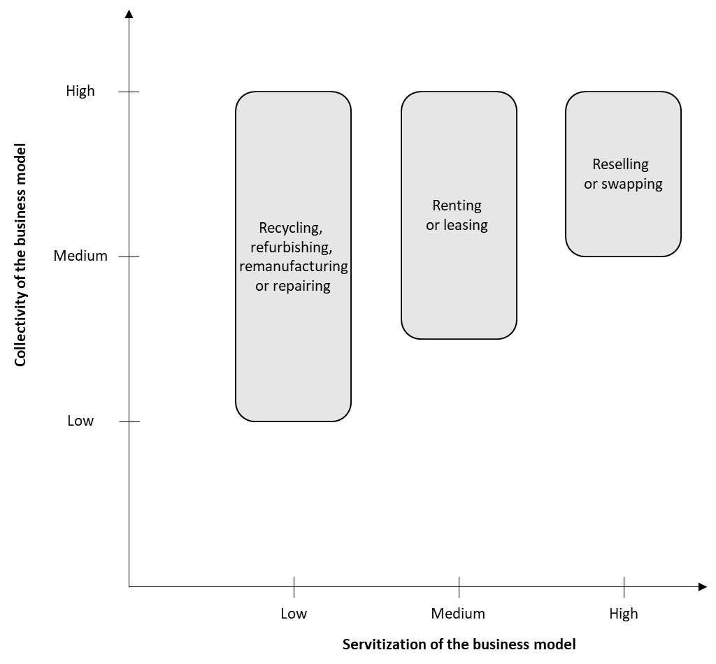

*Figure 1* – *Different types of circular business models (own source)*

The level of ***servitization*** refers to the extent to which the circular business model embraces a service (rather than a product) as a unit of exchange (Verleye et al., 2023). Circular business models are low in servitization when their focus is still on the product as a unit of exchange. Think, for instance, about recycled, refurbished or remanufactured products or products whose lifecycle is extended by investing in their durability and longevity. The level of servitization increases when circular business models focus on increasing the utilization rate of products by providing consumers with repair services for products. Alternatively, consumers can interact with product-service systems like rental, leasing, and access-based services (De Bruyne and Verleye, 2022; Khitous et al., 2022). In those situations, there is a medium level of servitization, as consumers can no longer have full ownership over products yet they only have temporary access to products. The highest levels of servitization, in turn, emerge when there is no longer a transfer of product ownership from the provider to the consumer through the circular business model. This occurs when circular business models focus on offering platforms through which consumers and providers can connect with one another (Brodie et al., 2019; Fehrer and Wieland, 2021). Think about organizers of swapping events or apps through which peers can sell products among one another.

The level of ***collectivity*** refers to the extent to which the circular business model requires collective action and collaboration (Verleye et al., 2023). Circular business models with a low, medium, and high level of servitization always require the involvement of consumers and providers yet collective action and collaboration with more actors might also be necessary. As a matter of fact, we contend that higher levels of servitization go along with an increased need for collective action and collaboration. Indeed, one of the key characteristics of services is that they are consumed when being delivered (Vargo and Lusch, 2016, 2017). Meanwhile, a number of scholars also call for upscaling different types of circular business models (e.g., Fehrer and Wieland, 2021). This can only be achieved when a multitude of actors engage in collective action and collaboration, going from individual consumers and providers to social movements and industries to governmental systems (Verleye et al., 2023). For example, the Flemish Green Deal Renting and Sharing – which aims to accelerate the transition to a circular economy by encouraging renting and sharing – relies upon intense collaboration between consumers, non-profit organizations, for-profit organizations and the government.

**Types of benefits for circular economy engagement**

Circular business models may vary – as also shown in Figure 1 – in terms of servitization (i.e., the unit of exchange) and collectivity (i.e., the need for collective action and collaboration). Yet, the success of any type of circular business model depends on the engagement of individual actors to realize the transition to a circular economy (Elzinga et al., 2020; Köhler et al., 2019; Urbinati et al., 2017). Here, actor engagement represents the psychological state of an actor in relation to a circular business model, which entails non-behavioural and behavioural manifestations (e.g., Brodie et al., 2011; Hollebeek et al., 2014; 2023; van Doorn et al., 2010). In the context of the circular transition, individual actors, whether they fulfil the role of consumers or providers, should engage with not only the circular business models but also with the circular economy principles. Indeed, engagement with circular business models does not automatically promote a more sustainable circular economy (Bocken and Short, 2020; Phipps et al., 2013; Prothero et al., 2011). For example, business models oriented towards refurbished products may result in less material and energy usage but cheaper phone prices may result in additional sales and thus more material and energy usage in case engagement with the circular economy principles is lacking. Or, car sharing may result in social cohesion but may also increase car usage and emissions as a result of lack of engagement with the circular economy principles (Acquier et al., 2017; Laukkanen and Tura, 2020). Hence, both engagement with the circular business models and engagement with the circular economy principles are necessary for a circular economy without rebound effects (Bocken et al., 2019b; Laukkanen and Tura, 2020).

Against the aforementioned background, we define circular economy engagement as an actor’s psychological state in relation to the circular business models and principles, which can have non-behavioural and behavioural manifestations (Brodie et al., 2019; Verleye et al., 2023). For example, consumers may think and feel positive about circular business models, and principles (cf. non-behavioural manifestations) and also use circular business models, recommend circular business models and live by the circular economy principles (cf. behavioural manifestations). Providers, in turn, may think and feel positive about circular business models and (cf. non-behavioural manifestations) and enthusiastically serve consumers in compliance with the circular economy principles (cf. behavioural manifestations). To elicit circular economy engagement, several researchers stress – in line with social exchange theory (Blau 1964) – the importance of expected and/or perceived benefits (Verleye, 2015). Indeed, social exchange theory posits that actors’ non-behavioural and behavioural engagement with circular business models and principles is motivated by the extent to which these actors get benefits in return (Blau 1964; Harrigan et al., 2018). Building upon extant research (Anderson et al., 2013; Blocker and Barrios, 2015; Khitous et al., 2022; Leroi-Werelds, 2019; Verleye, 2015), we contend that benefits which stimulate circular economy engagement can be divided into four categories: (1) short-term individual benefits, (2) long-term individual benefits, (3) short-term collective benefits, and (4) long-term collective benefits (see Figure 2).

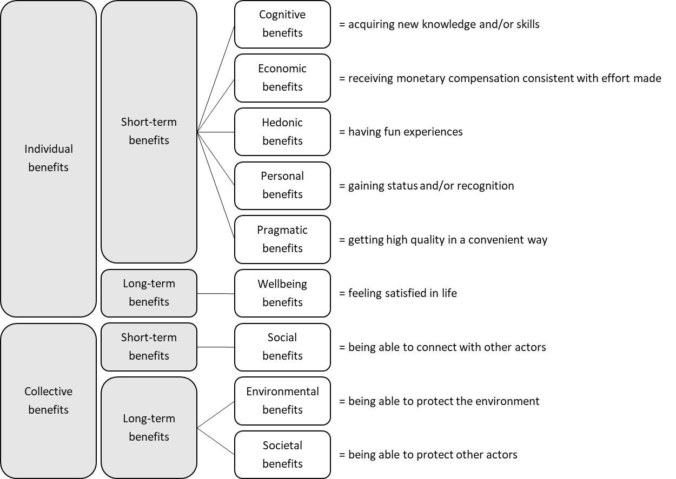

*Figure 2* – *Different types of benefits that stimulate circular economy engagement (own source)*

Short-term individual benefits are expected and/or perceived benefits that (almost) immediately accrue to the actor who shows engagement. This category of benefits entails cognitive benefits (i.e., acquiring new knowledge and/or skills), economic benefits (i.e., receiving monetary compensation consistent with effort made), hedonic benefits (i.e., having fun experiences), personal benefits (i.e., gaining status and/or recognition) and pragmatic benefits (i.e., getting high quality in a convenient way). Short-term collective benefits are (almost) immediately shared among multiple actors and include the social benefits that are expected and/or perceived (i.e., being able to connect with other actors). Long-term individual benefits accrue to individual actors over time and refer to the wellbeing benefits that are expected and/or perceived (i.e., feeling satisfied in life). Finally, long-term collective benefits entail expected and/or perceived benefits that are shared among multiple actors over time, namely environmental benefits (i.e., being able to protect the environment) and societal benefits (i.e., being able to protect other actors).

**The role of engagement platforms for circular economy engagement**

Circular economy engagement emerges in return for benefits, yet, circular business models should allow individual actors in the roles of consumers and providers to connect with one another. This is where engagement platforms come into play (Storbacka et al. 2016; Vijverman et al., 2019; Brodie et al., 2019). Engagement platforms are defined as “physical or virtual touch points designed to provide structural support for the exchange and integration of resources, and thereby co-creation of value, between actors in a service system” (Breidbach et al., 2014, p. 596). This definition stresses several characteristics of engagement platforms. First, engagement platforms cover physical as well as digital realms. Yet, digital engagement platforms are gaining popularity because of the rise of digital technologies. Second, engagement platforms enable the exchange and integration of resources, which involves both tangible resources (e.g., cars and clothes) and intangible resources (e.g., information and ratings). Third, engagement platforms act as intermediaries in the process of connecting multiple actors with one another (e.g., consumers and providers). In other words, they orchestrate the collaboration between interdependent actors in service ecosystems (Blasco-Arcas et al., 2016; Breidbach et al., 2014; Breidbach and Brodie, 2017). As multiple actors interact through physical or digital engagement platforms to exchange resources, these platforms foster circular economy engagement and value co-creation in service ecosystems. In other words, engagement platforms have the potential to create significant economic, environmental and social value for multiple actors in the transition to a more sustainable circular economy. Table 1 includes examples of engagement platforms for each circular business model type.

*Table 1* – *Examples of engagement platforms for each circular business model type*

|  |  |
| --- | --- |
| **Circular business model type** | **Examples of engagement platforms** |
| Recycling | * Green Toys Inc. manufactures toys from milk jugs and sells these toys in stores across the United States but also by means of an online store. (<https://www.greentoys.com/>) * The Recycled Shop sells a range of recycled products by means of an online shop. (<https://www.therecycledshop.com/>) |
| Repairing | * iRepairShop offers repair services for electronic devices in physical stores across Belgium but also by means of an online website. (<https://www.irepairshop.be/>) * RepairMyStuff.ie connects consumers with professional providers of repair services by means of an online website. (<https://www.repairmystuff.ie/>) |
| Renting | * A.S.Adventure offers equipment rental services in several of their brick-and-mortar shops in Belgium. (<https://www.asadventure.com/>) * Hertz facilitates car rental services at locations all around the world yet also by means of a digital platform. (<https://www.hertz.com/>) |
| Reselling | * Skibörse sells new and second-hand winter sports equipment in several cities in Austria, Germany and Switzerland. (<https://www.skiboerse.info/>) * Unclaimed Baggage offers in-store as well as online resale services of lost airline baggage. (<https://www.unclaimedbaggage.com/>) |
| Swapping | * Don't Shop, Swap facilitates the swapping of fashion items by means of an online website. (<https://www.dontshopswap.co.uk/>) * The Swapshop offers in-store as well as online swapping of fashion items. (<https://www.the-swapshop.com/>) |

*Note.* All websites were accessed on February 9, 2023.

As illustrated by the examples in Table 1, an engagement platform can connect actors to facilitate the exchange and integration of resources. Though the engagement platform aspires to bring actors together, tensions may arise in case there exists a mismatch between the expected and/or perceived benefits of circular economy engagement among actors. For example, an engagement platform with the ambition to generate long-term collectivity benefits (e.g., Too Good To Go) may benefit from connecting actors who expect environmental (e.g., reducing food waste) and societal benefits (e.g., supporting local businesses). In case (some) actors engage to get short-term individual benefits (e.g., hand-picked fresh meals), the engagement platform may not realize its ambition. Therefore, it is crucial that engagement platforms accurately set the expectations of the actors they aim to bring together.

To set the right expectations in relation to circular economy engagement, however, a number of studies contend that engagement platforms need to have a strong value proposition, that is a clear message as to what benefits actors can expect when engaging with the platform (Payne et al. 2017; Piepponen et al., 2022; Ranta et al., 2020, Rintamäki and Saarijärvi, 2021; Leroi-Werelds et al., 2021). A value proposition namely allows engagement platforms to communicate the benefits they offer to a variety of actors in their ecosystem, as illustrated by the examples in Table 2 (Verleye and Reber, 2022; Wruk et al., 2019).

*Table 2* – *Examples of value propositions of engagement platforms*

|  |  |
| --- | --- |
| **Engagement platform** | **Value proposition** |
| Refurbed is an online marketplace for refurbished electronic devices. (<https://www.refurbed.ie/>) | “We offer renewed electronic devices that look and work like new. You save up to 40% and buy 100% more sustainable products. All refurbed™ devices are refurbished, reconditioned and thoroughly tested by experts.” (<https://www.refurbed.ie/advantages/>) |
| First Serve UK offers domestic appliance repairs by means of an online website. (<https://firstserveuk.co.uk/>) | “[…] it has been our belief that our customers deserve to get top quality service and repairs at affordable prices. We aim to serve every customer with a world-class service experience and we guarantee all work undertaken.” (<https://firstserveuk.co.uk/>) |
| Swap Society facilitates the swapping of fashion items by means of an online website. (<https://www.swapsociety.co/>) | “Swap Society is an online clothing swap that makes it easy and affordable to mix up your wardrobe sustainably.” (https://www.swapsociety.co/pages/about) |
| Skibörse sells new and second-hand winter sports equipment in several cities in Austria, Germany and Switzerland. (<https://www.skiboerse.info/>) | “New & 2nd-hand ski, snowboard & ski touring equipment as well as new winter clothing: top brands at strongly reduced prices.” (<https://www.skiboerse.info/>) |
| Haverdash offers fashion rental services by means of a digital platform. (<https://www.haverdash.com/>) | “Haverdash is the new, fun and easy way to get dressed. No more pressure to wear something multiple times and multiple ways. No more compromises between the practical and the fabulous. Experience all the new trends you’ve wanted to try, or the go-to-styles you love. Wear them once, or as many times as you like. Return them for something new, or keep them forever.” (<https://www.haverdash.com/pages/about-us>) |

*Note.* All websites were accessed on February 9, 2023.

With the help of a clear value proposition, the engagement platform can set the expectations of actors who (intend to) engage with one another through this platform (Lepak et al. 2007; Wruk et al., 2019). Yet, engagement platforms need – in accordance with the Gaps Model of Parasuraman et al. (1985) – to make sure that the expected benefits of circular economy engagement are also perceived when engaging with the platform (Parasuraman et al., 1985; Zeithaml et al., 1990). Put differently, when interacting with the engagement platform, it is important for actors to get the expected benefits. If not, a gap emerges between the expected and perceived benefits, which may have negative repercussions for the extent to which the platform achieves to engage its consumers and providers in the long-run and hence can realize its economic, environmental, and/or social ambition. Table 3 includes examples of consumer and provider reviews that indicate a match (respectively, mismatch) between the expected benefits resulting from the value proposition and the perceived benefits resulting from the experience.

*Table 3* – *Expected and/or perceived benefits in return for circular economy engagement*

|  |  |  |
| --- | --- | --- |
| **Value proposition** | **Value proposition perceived**  **by actor** | **Value proposition**  **not perceived**  **by actor** |
| Refurbed is an online marketplace for refurbished electronic devices. Refurbed stresses several advantages, among others, Like new, only better [cf., pragmatic benefits]; Up to 40% cheaper [cf., economic benefits]; and 100% more sustainable [cf., environmental benefits]. (<https://www.refurbed.ie/>) | Consumer review on Trustpilot (January 27, 2023): “Ordered two iPhones for myself and my wife, price was very competitive [cf., economic benefits], arrived quite quickly, was very impressed with the quality and condition of the iPhone that I bought [cf., pragmatic benefits].  Finally I subscribe to the idea of sustainability that’s why I buy from Refurbed [cf., environmental benefits]. [...]” (<https://www.trustpilot.com/>) | Consumer review on Trustpilot (December 16, 2022): “[...] The glue job is pretty poor and one can clearly see that it’s not original [cf., pragmatic benefits]. For 560€ I just don’t feel like I got what it should be [cf., economic benefits] and then a 1 year warranty feels risky. Not for me. Honestly I think spending a bit more is ultimately more sustainable than this [cf., environmental benefits].” (<https://www.trustpilot.com/>) |
| Tred is an online marketplace that facilitates the buying and selling of used cars. On its website, Tred stresses several elements of value for individual car sellers, among others, more money [cf., economic benefits] and a simple process [cf., pragmatic benefits]. (<https://www.tred.com/>) | Provider review on ConsumerAffairs (July 21, 2020): “I have now sold two vehicles through TRED.com and been able to get top dollar for them [cf., economic benefits]. The website is extremely easy to use, features you in several different advertisements and even provides the carfax report [cf., pragmatic benefits]. Once your vehicle sells they handle all of the lien and DMV paperwork for you! The service fee is extremely reasonable. I will definitely use them again. Thank you TRED!” (<https://www.consumeraffairs.com/>) | Provider review on ConsumerAffairs (June 5, 2020): “Attempted to use their services to sell my vehicle. Paid the initial $19.00. Their listings generated very little interest [cf., pragmatic benefits]. Their portal never gave me a trade in amount for the vehicle as they had advertised [cf., economic benefits]. […]” (<https://www.consumeraffairs.com/>) |
| Haverdash offers fashion rental services. Haverdash introduces itself as “Haverdash is the new, fun [cf., hedonic benefits] and easy [cf., pragmatic benefits] way to get dressed. […] Experience all the new trends you’ve wanted to try, or the go-to-styles you love [cf., cognitive benefits]. Wear them once, or as many times as you like. Return them for something new, or keep them forever.” (<https://www.haverdash.com/>) | Consumer review on Trustpilot (September 12, 2019): “[...] What a great experience to receive fun [cf., hedonic benefits], fashion-forward clothing options [cf., cognitive benefits] in a hassle-free renting experience [cf., pragmatic benefits]. Lots of seasonally appropriate options updated regularly- wow! I get lots of compliments [cf., personal benefits] and lots more ladies asking ‘is that a rental!?’ YES, it is! And I’m proud of it!!” (<https://www.trustpilot.com/>) | Consumer review on Trustpilot rev(January 21, 2020): “So many things...The clothes are not very good quality [cf., pragmatic benefits]. The selection is awful, AWFUL. Very similar items could be purchased for cheaper than it cost to rent them from stores like Forever 21 or Target [cf., economic benefits]. […] I was excited about this, what a bummer [cf., hedonic benefits]! [...]” (<https://www.trustpilot.com/>) |

*Note.* All websites were accessed on February 9, 2023.

**Towards more engaging platforms in the transition to a circular economy**

To ensure that the expected and perceived benefits of circular economy engagement do not differ too much from one another when interacting with an engagement platform, we call – inspired by the Gaps Model of Parasuraman et al. (1985) – for (1) generating a better understanding of the expectations that actors have when engaging with the platform (cf., GAP 1), (2) translating and meeting these expectations through the way in which the engagement platform facilitates the exchange and integration of resources among actors (cf., GAP 2), and (3) reflecting upon what benefits to emphasize when launching a value proposition for the engagement platform (cf., GAP 3). Figure 3 summarizes these conditions for circular economy engagement with the help of platforms.

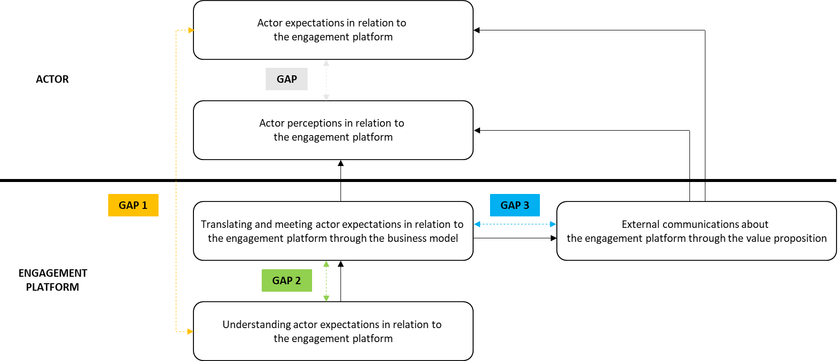

*Figure 3* – C*onditions for circular economy engagement with the help of engagement platforms*

*(adapted from Parasuraman et al., 1985)*

When it relates to gaining insight into the expectations that actors have when engaging with the platform (cf., GAP 1), it is important to note that the context in which actors are embedded may exert an influence on their expectations and perceptions. The socio-cultural group to which you belong, for instance, may shape your expectations (De Bruyne et al., 2022). Other researchers have shown that other contextual factors – such as sector or industry characteristics and governmental regulations – may shape actor expectations (De Keyser et al., 2020). Alternatively, the actor expectations and perceptions in developed countries may differ from those in developing countries, which could have significant effects on the success of circular business models (Rodríguez-Espíndola et al., 2022; Do et al., 2022). Therefore, future research is necessary to better understand how the context in which actors are embedded shapes their expectations in relation to circular business models and the engagement platforms upon which they rely. In addition, managers need to understand the context of the actors in their ecosystem.

To ensure that the expectations of actors are met when engaging in a circular platform (cf., GAP 2), it is important that the underlying business model corresponds with their circular economy engagement. Since business models may vary in terms of servitization and collectivity (cf., Figure 1), future research may investigate how different types of circular business models affect the engagement of consumers and providers through the engagement platform. Moreover, engagement platforms may embrace different business models at the same time as well as over time (De Bruyne and Verleye, 2022; Guyader and Piscicelli, 2019). In this regard, further research should also investigate how circular business model diversification and dynamism affect circular economy engagement. For managers, understanding consumers’ and providers’ expectations is a first step towards designing circular business models and delivering on these expectations.

When it relates to external communications about the engagement platform through value propositions (cf., GAP 3), a key challenge revolves around what benefits to emphasize and how to communicate about these benefits (Verleye and Reber, 2022; Reczek et al., 2018). Some scholars call for accompanying circular business models by value propositions that highlight the environmental benefits (Bocken and Short, 2016; Freudenreich and Schaltegger, 2020) while others point out that communicating about environmental benefits may not stimulate circular economy engagement through its negatively impact on other expectations like the expected pragmatic benefits (Luchs et al., 2010; Falchi et al., 2021). Additionally, expected benefits are heterogenous and dynamic (Böcker and Meelen, 2017; Palmatier & Crecelius, 2019; Khitous et al., 2022), which calls for tailoring the communication to different actors in the ecosystem. Hence, more research is needed to better understand how circular economy engagement is shaped by external communications through value propositions. Similarly, managers should have a detailed understanding of the benefits that consumers seek, and endeavour to reflect those benefits in the value proposition of their circular business models.

**References**

Acquier, A., Daudigeos, T., & Pinkse, J. (2017). Promises and paradoxes of the sharing economy: An organizing framework. *Technological Forecasting and Social Change*, *125*, 1-10.

Anderson, L., Ostrom, A. L., Corus, C., Fisk, R. P., Gallan, A. S., Giraldo, M., ... & Williams, J. D. (2013). Transformative service research: An agenda for the future. *Journal of Business Research*, *66*(8), 1203-1210.

Blasco-Arcas, L., Hernandez-Ortega, B. I., & Jimenez-Martinez, J. (2016). Engagement platforms: The role of emotions in fostering customer engagement and brand image in interactive media. *Journal of Service Theory and Practice*, *26*(5), 559-589.

Blau, P. M. (1964). *Exchange and power in social life*. Wiley.

Blocker, C. P., & Barrios, A. (2015). The transformative value of a service experience. *Journal of Service Research*, *18*(3), 265-283.

Bocken, N., Strupeit, L., Whalen, K., & Nußholz, J. (2019a). A review and evaluation of circular business model innovation tools. *Sustainability*, *11*(8), 2210.

Bocken, N., Boons, F., & Baldassarre, B. (2019b). Sustainable business model experimentation by understanding ecologies of business models. *Journal of Cleaner Production*, *208*, 1498-1512.

Bocken, N. M., & Short, S. W. (2016). Towards a sufficiency-driven business model: Experiences and opportunities. *Environmental Innovation and Societal Transitions*, *18*, 41-61.

Bocken, N. M., & Short, S. W. (2020). Transforming business models: towards a sufficiency-based circular economy. In *Handbook of the Circular Economy* (pp. 250-265). Edward Elgar Publishing.

Böcker, L., & Meelen, T. (2017). Sharing for people, planet or profit? Analysing motivations for intended sharing economy participation. *Environmental Innovation and Societal Transitions*, *23*, 28-39.

Breidbach, C. F., Brodie, R., & Hollebeek, L. (2014). Beyond virtuality: from engagement platforms to engagement ecosystems. *Managing Service Quality, 24*(6), 592-611.

Breidbach, C. F., & Brodie, R. J. (2017). Engagement platforms in the sharing economy: conceptual foundations and research directions. *Journal of Service Theory and Practice, 27*(4), 761-777.

Brodie, R. J., Fehrer, J. A., Jaakkola, E., & Conduit, J. (2019). Actor Engagement in Networks: Defining the Conceptual Domain. *Journal of Service Research*, *22*(2), 173–188. https://doi.org/10.1177/1094670519827385

Brodie, R. J., Hollebeek, L. D., Jurić, B., & Ilić, A. (2011). Customer engagement: Conceptual domain, fundamental propositions, and implications for research. *Journal of Service Research*, *14*(3), 252–271. https://doi.org/10.1177/1094670511411703

De Bruyne, M.-J., & Verleye, K. (2022). Realizing the economic and circular potential of sharing business models by engaging consumers. *Journal of Service Management*, (ahead-of-print).

De Bruyne, M.-J., Verleye, K., Slabbinck, H., & Crucke, S. (2022). Full throttle! Engaging ethnic minority and majority consumers in car sharing. *Academy of Management Proceedings*, *2022*(1).

De Keyser, A., Verleye, K., Lemon, K. N., Keiningham, T. L., & Klaus, P. (2020). Moving the customer experience field forward: introducing the touchpoints, context, qualities (TCQ) nomenclature. *Journal of Service Research*, *23*(4), 433-455.

Do, Q., Mishra, N., Colicchia, C., Creazza, A., & Ramudhin, A. (2022). An extended institutional theory perspective on the adoption of circular economy practices: Insights from the seafood industry. *International Journal of Production Economics*, *247*, 108400. https://doi.org/10.1016/j.ijpe.2021.108400

Ellen MacArthur Foundation. (2013). *Towards the Circular Economy*.

Elzinga, R., Reike, D., Negro, S. O., & Boon, W. P. (2020). Consumer acceptance of circular business models. *Journal of Cleaner Production*, *254*, 119988.

Esposito, M., Tse, T., & Soufani, K. (2017). Is the circular economy a new fast-expanding market? *Thunderbird International Business Review*, *59*(1), 9–14. https://doi.org/10.1002/tie.21764

European Commission. (2019). *REPORT FROM THE COMMISSION TO THE EUROPEAN PARLIAMENT, THE COUNCIL, THE EUROPEAN ECONOMIC AND SOCIAL COMMITTEE AND THE COMMITTEE OF THE REGIONS on the implementation of the Circular Economy Action Plan* (COM/2019/190 final). https://eur-lex.europa.eu/legal-content/EN/TXT/?qid=1551871195772&uri=CELEX:52019DC0190

Falchi, A., Grolleau, G., & Mzoughi, N. (2022). Why companies might under‐communicate their efforts for sustainable development and what can be done?. *Business Strategy and the Environment*, *31*(5), 1938-1946.

Fehrer, J. A., & Wieland, H. (2021). A systemic logic for circular business models. *Journal of Business Research*, *125*, 609–620. https://doi.org/10.1016/j.jbusres.2020.02.010

Freudenreich, B., & Schaltegger, S. (2020). Developing sufficiency-oriented offerings for clothing users: Business approaches to support consumption reduction. *Journal of Cleaner Production*, *247*, 119589.

Geissdoerfer, M., Pieroni, M. P. P., Pigosso, D. C. A., & Soufani, K. (2020). Circular business models: A review. *Journal of Cleaner Production*, *277*, 123741. https://doi.org/10.1016/j.jclepro.2020.123741

Guyader, H., & Piscicelli, L. (2019). Business model diversification in the sharing economy: The case of GoMore. *Journal of Cleaner Production*, *215*, 1059-1069.

Harrigan, P., Evers, U., Miles, M. P., & Daly, T. (2018). Customer engagement and the relationship between involvement, engagement, self-brand connection and brand usage intent. *Journal of Business Research*, *88*, 388-396.

He, L., Sopjani, L., & Laurenti, R. (2021). User participation dilemmas in the circular economy: An empirical study of Scandinavia’s largest peer-to-peer product sharing platform. *Sustainable Production and Consumption*, 27, 975–985. https://doi.org/10.1016/j.spc.2021.02.027

Hollebeek, L. D., Glynn, M. S., & Brodie, R. J. (2014). Consumer brand engagement in social media: Conceptualization, scale development and validation. *Journal of Interactive Marketing*, *28*(2), 149–165. https://doi.org/10.1016/j.intmar.2013.12.002

Hollebeek, L. D., Sarstedt, M., Menidjel, C., Sprott, D. E., & Urbonavicius, S. (2023). Hallmarks and potential pitfalls of customer‐and consumer engagement scales: A systematic review. *Psychology & Marketing*.

Khitous, F., Strozzi, F., Urbinati, A., & Alberti, F. (2020). A systematic literature network analysis of existing themes and emerging research trends in circular economy. *Sustainability*, *12*(4), 1633. https://doi.org/10.3390/su12041633

Khitous, F., Urbinati, A., & Verleye, K. (2022). Product-Service Systems: A customer engagement perspective in the fashion industry. *Journal of Cleaner Production*, *336*, 130394. https://doi.org/10.1016/j.jclepro.2022.130394

Kirchherr, J., Reike, D., & Hekkert, M. (2017). Conceptualizing the circular economy: An analysis of 114 definitions. *Resources, Conservation and Recycling*, *127*, 221–232. https://doi.org/10.1016/j.resconrec.2017.09.005

Köhler, J., Geels, F. W., Kern, F., Markard, J., Onsongo, E., Wieczorek, A., Alkemade, F., Avelino, F., Bergek, A., & Boons, F. (2019). An agenda for sustainability transitions research: State of the art and future directions. *Environmental Innovation and Societal Transitions*, *31*, 1–32.

Laukkanen, M., & Tura, N. (2020). The potential of sharing economy business models for sustainable value creation. *Journal of Cleaner Production*, *253*, 120004.

Lepak, D. P., Smith, K. G., & Taylor, M. S. (2007). Value creation and value capture: A multilevel perspective. *Academy of Management Review*, *32*(1), 180-194.

Leroi-Werelds, S. (2019). An update on customer value: state of the art, revised typology, and research agenda. *Journal of Service Management*, *30*(5), 650-680.

Leroi-Werelds, S., Verleye, K., Line, N., & Bove, L. (2021). Value proposition dynamics in response to external event triggers. *Journal of Business Research*, *136*, 274-283.

Luchs, M. G., Naylor, R. W., Irwin, J. R., & Raghunathan, R. (2010). The sustainability liability: Potential negative effects of ethicality on product preference. *Journal of Marketing*, *74*(5), 18-31.

Lüdeke‐Freund, F., Gold, S., & Bocken, N. M. P. (2019). A review and typology of circular economy business model patterns. *Journal of Industrial Ecology*, *23*(1), 36–61. https://doi.org/10.1111/jiec.12763

Nußholz, J. L. (2017). Circular business models: Defining a concept and framing an emerging research field. *Sustainability*, *9*(10), 1810.

Palmatier, R. W., & Crecelius, A. T. (2019). The “first principles” of marketing strategy. *Ams Review*, *9*, 5-26.

Parasuraman, A., Zeithaml, V. A., & Berry, L. L. (1985). A conceptual model of service quality and its implications for future research. *Journal of Marketing*, *49*(4), 41-50.

Parida, V., Burström, T., Visnjic, I., & Wincent, J. (2019). Orchestrating industrial ecosystem in circular economy: A two-stage transformation model for large manufacturing companies. *Journal of Business Research*, *101*, 715–725. https://doi.org/10.1016/j.jbusres.2019.01.006

Payne, A., Frow, P., & Eggert, A. (2017). The customer value proposition: evolution, development, and application in marketing. *Journal of the Academy of Marketing Science*, *45*, 467-489.

Phipps, M., Ozanne, L. K., Luchs, M. G., Subrahmanyan, S., Kapitan, S., Catlin, J. R., ... & Weaver, T. (2013). Understanding the inherent complexity of sustainable consumption: A social cognitive framework. *Journal of Business Research*, *66*(8), 1227-1234.

Piepponen, A., Ritala, P., Keränen, J., & Maijanen, P. (2022). Digital transformation of the value proposition: A single case study in the media industry. *Journal of Business Research*, *150*, 311-325.

Prothero, A., Dobscha, S., Freund, J., Kilbourne, W. E., Luchs, M. G., Ozanne, L. K., & Thøgersen, J. (2011). Sustainable consumption: Opportunities for consumer research and public policy. *Journal of Public Policy & Marketing*, *30*(1), 31-38.

Ranta, V., Keränen, J., & Aarikka-Stenroos, L. (2020). How B2B suppliers articulate customer value propositions in the circular economy: Four innovation-driven value creation logics. *Industrial Marketing Management*, *87*, 291-305.

Reczek, R. W., Trudel, R., & White, K. (2018). Focusing on the forest or the trees: How abstract versus concrete construal level predicts responses to eco-friendly products. *Journal of Environmental Psychology*, *57*, 87-98.

Rintamäki, T., & Saarijärvi, H. (2021). An integrative framework for managing customer value propositions. *Journal of Business Research*, *134*, 754-764.

Rodríguez-Espíndola, O., Cuevas-Romo, A., Chowdhury, S., Díaz-Acevedo, N., Albores, P., Despoudi, S., Malesios, C., & Dey, P. (2022). The role of circular economy principles and sustainable-oriented innovation to enhance social, economic and environmental performance: Evidence from Mexican SMEs. *International Journal of Production Economics*, *248*, 108495. https://doi.org/10.1016/j.ijpe.2022.108495

Storbacka, K., Brodie, R. J., Böhmann, T., Maglio, P. P., & Nenonen, S. (2016). Actor engagement as a microfoundation for value co-creation. *Journal of Business Research*, *69*(8), 3008–3017. https://doi.org/10.1016/j.jbusres.2016.02.034

Ünal, E., Urbinati, A., Chiaroni, D., & Manzini, R. (2019). Value creation in circular business models: The case of a US small medium enterprise in the building sector. *Resources, Conservation and Recycling*, *146*, 291–307. https://doi.org/10.1016/j.resconrec.2018.12.034

Urbinati, A., Chiaroni, D., & Chiesa, V. (2017). Towards a new taxonomy of circular economy business models. *Journal of Cleaner Production*, *168*, 487–498. https://doi.org/10.1016/j.jclepro.2017.09.047

Van Doorn, J., Lemon, K. N., Mittal, V., Nass, S., Pick, D., Pirner, P., & Verhoef, P. C. (2010). Customer engagement behavior: Theoretical foundations and research directions. *Journal of Service Research*, *13*(3), 253-266.

Van Weelden, E., Mugge, R., & Bakker, C. (2016). Paving the way towards circular consumption: exploring consumer acceptance of refurbished mobile phones in the Dutch market. *Journal of Cleaner Production*, *113*, 743-754.

Vargo, S. L., & Lusch, R. F. (2016). Institutions and axioms: An extension and update of service-dominant logic. *Journal of the Academy of Marketing Science*, *44*(1), 5–23.

Vargo, S. L., & Lusch, R. F. (2017). Service-dominant logic 2025. *International Journal of Research in Marketing*, *34*(1), 46–67.

Verleye, K. (2015). The co-creation experience from the customer perspective: its measurement and determinants. *Journal of Service Management*.

Verleye, K., & Reber, B. (2022). Communication in service ecosystems through value propositions: dilemmas and future research avenues. *Journal of Service Management*, (ahead-of-print).

Verleye, K., De Keyser, A., Raassens, N., Alblas, A., Lit, F., Huijben, B. (2023). Pushing forward the transition to a circular economy by adopting an actor engagement lens. *Journal of Service Research*.

Vijverman, N., Henkens, B., & Verleye, K. (2019). Engagement and technology as key enablers for a circular economy. In *Handbook of Research on Customer Engagement* (pp. 97–113). Edward Elgar. <http://hdl.handle.net/1854/LU-8606643>

Wruk, D., Oberg, A., Klutt, J., & Maurer, I. (2019). The presentation of self as good and right: How value propositions and business model features are linked in the sharing economy. *Journal of Business Ethics*, *159*, 997-1021.

Zeithaml, V.A., Parasuraman, A. and Berry, L.L. (1990), *Delivering Quality Service. Balancing Customer Perceptions and Expectations*, The Free Press, New York, NY.