**Effects of ocean warming on the fatty acid and epigenetic profile of *Acartia tonsa*: a multigenerational approach**

Lotte Janssensαβ, Jana Asselmanβ, Marleen De Trochα

αMarine Biology Research Group, Ghent University, Campus Sterre S8, Krijgslaan 281, B-9000 Ghent, Belgium

βBlue Growth Research Lab, Ghent University, Bluebridge, Wetenschapspark 1, 8400, Ostend, Belgium

Corresponding author: Lotte Janssens, lottejan.janssens@ugent.be

1. **Abstract**

The effects of climate change are becoming more prevalent, and it is important to know how copepods, the most abundant class in zooplankton, will react to changing temperatures as they are the main food source for secondary consumers. They act as key transferers of nutrients from primary producers to organisms higher up the food chain. Little is known about the effects of temperature changes on copepods on the long term, i.e., over several generations. Especially the epigenetic domain seems to be understudied and the question remains whether the nutritional value of copepods will permanently change with rising water temperatures. In this research, the effects of temperature on the fatty acid and epigenetic profiles of the abundant planktonic copepod *Acartia tonsa* were investigated, since we expect to see a link between these two. Indeed, changing methylation patterns helped copepods to deal with higher temperatures, which is in line with the relative abundance of the most important fatty acids, e.g., DHA. However, this pattern was only observed when temperature increased slowly. A sudden increase in temperature showed the opposite effect; *Acartia tonsa* did not show deviant methylation patterns and the relative abundance of DHA and other important fatty acids dropped significantly after several generations. These results suggest that local fluctuations in temperature have a greater effect on *Acartia tonsa* than an elevation of the global mean.

Key words: climate change, heat stress, DNA methylation, docosahexaenoic acid, Copepoda, crustaceans,

1. **Introduction**

Copepods (Arthropoda, Crustacea, Copepoda) make up a major part of zooplankton and play a vital role as primary consumers, serving as intermediaries between primary producers and secondary consumers. Van Ginderdeuren (2013) stated that 66% of the zooplankton in the North sea consists of copepods, which makes them the most important food source for secondary consumers in that area. This trend extends to the rest of the world as copepods are widely distributed. Turner (2004) described the importance and wide distribution of small copepods (i.e. *Acartia sp.*) and their relevance in marine food webs. It is mainly copepods that are responsible for the transfer of nutrients and compounds from primary producers to higher trophic levels. Among these compounds are fatty acids, the building blocks of lipids in living organisms. Some poly unsaturated fatty acids (PUFAs) are essential for animals to survive, and therefore omega 3 fatty acids (i.e., fatty acids with three double bonds) are so important. Copepods transfer a lot of omega 3 fatty acids to higher trophic levels and ultimately, to human food sources. These PUFAs include DHA, the major omega-3 long chain PUFA in the human brain (Drouin et al., 2019), and EPA, another omega-3 fatty acid that decreases risks of several diseases and malfunctions in the brain (von Schacky, 2021). The importance of these two fatty acids has been extensively investigated. Overall, PUFA’s are important for vertebrates because of their role in the regulation of membrane fluidity, cell function, and contribution to brain functionality and brain health (Bell et al., 1986; GISSI-HF investigators, 2008; Hernando et al., 2022; Marchioli, 1999; Prado-Cabrero & Nolan, 2021; Simopoulos, 2002).

PUFA’s are made by marine primary producers, such as algae, and consumed by primary consumers, such as copepods, which in turn pass their nutrients to organisms higher up the food chain. This transfer is well documented but the response of this flow of energy under changing environmental conditions is under actual debate. Holm et al (2022) already proved the inversed relationship between unsaturated lipids and temperature in primary producers, which means the amount of available PUFA’s in marine ecosystems will decrease. Recent studies suggest that some orders of copepods possess enzymes to bioconvert saturated or monounsaturated short-chain fatty acids to long-chain unsaturated FA. More specifically, harpacticoids contain methyl-end desaturases, but calanoids do not (Monroig et al., 2022). Therefore, calanoids are not able to produce PUFA’s by themselves and are dependent on dietary uptake. This pattern has evolved with the large availability of PUFA’s in pelagic producers (Monroig & Kabeya, 2018), where in normal circumstances, the presence of desaturases is not needed to gain sufficient PUFA’s. Marine fish do not contain these specific enzymes (Monroig et al., 2022), and therefore are dependent on zooplankton for their essential fatty acids. Consequently, any change in their FA source (i.e., pelagic copepods) could have detrimental effects for the community composition if species are not able to rapidly adapt to the new situation. Recent insights show that freshwater fish can evolve alternative pathways to foresee themselves in DHA (Matsushita et al., 2020), as the amount of DHA in freshwater ecosystems is more limited. However, these pathways are not yet developed in marine species.

DNA methylation seems to be particularly important in response to heat stress (Horowitz, 2016). In addition, it is known that heat stress alters gene expression, with changing protein profiles as a result (Horowitz, 2014). In the light of climate change, unfolding these mechanisms is of uttermost importance and urgency, which is why we focus on DNA methylation and its link with the fatty acid metabolism. This link can be traced back to the molecular level, where the one carbon pathway provides methyl donors for methylation on one hand, and substrates and co-factors for basic metabolisms on the other hand (Clare et al., 2019). He et al. (2018) for example, concluded that DNA methylation regulates gene expression of desaturases in humans. Multiple studies also stress the importance of transgenerational experiments to unravel these links (Clare et al., 2019; Eirin-Lopez & Putnam, 2021; Jeremias et al., 2018; Pedersen et al., 2014). Therefore, we are particularly interested in the effects of different temperature exposures on fatty acid profiles and global methylation patterns over the course of several generations. This kind of information might be able to tell us if ocean warming and marine heatwaves will influence the quality of zooplankton as a food source for higher trophic levels. As mentioned above, Holm et al. (2022) state that the amount of double bonds in marine plankton decreases with increasing temperature, which implies a decrease in food quality for zooplankton. If we can, in addition to this information, support this finding at a higher trophic level, this can be a deal breaker for revealing cascade effects in the marine food web. Multiple studies have already investigated the change in important fatty acids, like DHA and EPA, due to heat stress. However, none have exposed test organisms to heat stress over several generations to curve their variation in response to different temperature treatments. Furthermore, exposure to heat stress over generations makes it possible to map methylation responses over time. The variation in global DNA methylation levels in response to diverse types of heat stress can reflect the resilience of organisms to climate change and ever more occurring heatwaves.

There is clearly a gap in our knowledge about transgenerational epigenetic responses and to what extend they are being inherited (Eirin-Lopez & Putnam, 2021). For sure, epigenetic mechanisms are important in the process of adapting to stressors, and to increase resilience (Bernstein et al., 2007; Jaenisch & Bird, 2003; Jeremias et al., 2018).

The pelagic copepod species *Acartia tonsa* was used as a test organism as it is ecologically relevant, widely distributed, and consumed by commercially important fish species (Marcus & Wilcox, 2007; Sunar & Kır, 2021; Turner, 2004). Additionally, *A. tonsa* is easily culturable. Consequently, it is considered a model species for pelagic copepods.

1. **Methods**
   1. *Origin of test organisms*

Eggs of *A. tonsa* Dana were obtained from the Danish stock culture DFH.AT1 (Støttrup et al., 1986), that is maintained in the Centre for Ocean Life at the Technical University of Denmark. *A. tonsa* is a well investigated species with straightforward culture protocols (Marcus & Wilcox, 2007; Rotolo et al., 2021; C. Zhou et al., 2018). The eggs grew to adults at Ghent University and an *A. tonsa* culture was maintained in a climate-controlled room of 20 °C (+-1°C) for 6 months before the start of the experiment to allow adaptation to lab conditions. A 12h/12h light-darkness cycle was applied, and all tanks were covered with lids to avoid evaporation. Gentle aeration was provided through a cotton wool filter. The cultures were fed *ad libitum* two to three times a week with concentrations of 3400 cells per ml for *Tisochrysis lutea* and 2300 cells per ml for *Rhodomonas salina* in the pots. Before feeding, the volume of added algae solution was adjusted according to the concentration of the stock cultures. These algae species were chosen as they resemble the species used by Breteler et al. (Breteler et al., 1982; Breteler, 1980). Quantities were chosen at the lower limits of concentrations defined by Klein Breteler (1980). The concentrations of living algae cultures were measured with a Coulter Counter (Z1S, Beckman-Coulter, Miami, USA) prior to feeding. The algae were grown in L1 medium (Guillard & Morton in Hallegraeff et al., 1995) with monthly refreshment procedures.

* 1. *Experimental design*

During the experiment, adults of *A. tonsa* were exposed to two different treatments, fixed raised temperature, and increasing temperature, plus a control run in five replicates (Figure 1). The control was set to 20°C (±1°C), which is also the stock culture temperature (see also Carotenuto et al., 2020; Pavlaki et al., 2017; Vu et al., 2017; C. Zhou et al., 2018; Z. Zhou et al., 2020). The fixed raised temperature was set at 25°C (±1°C) as sea surface temperature is estimated to rise between 2 and 4.5°C over the next century (Aral & Guan, 2016). For the increasing temperature treatment, temperature increased slowly from 20°C to 25°C (±1°C), over a timespan of three months by increasing the temperature in the incubator manually with 0.4°C every week, so that each generation could experience an equal amount of stress. The replicates (5 per treatment) were treated in the same way as the stock cultures, with feeding three times a week with the same concentration of algae and gentle aeration. Each replicate contained 90 adults at the start, e.g., copepods in their last life stage (C6). The temperature switch to the fixed raised temperature treatment (25°C) happened at slow pace to soften the transition. The copepods were left in treatment conditions to lay eggs for a week before they were collected and stored frozen. These adults are referred to as the F0 generation. After that, a fixed number (n=110±10) of naupliar larvae was collected from each of the replicates and put in fresh filtered seawater. Transfer of generations was done by picking nauplii as hatching success is already assured in this stage, and so density effects could be avoided. These larvae represented the F1 generation and were given time to develop until the adult stage. This procedure was repeated until generation F4 was reached. Once the copepods of the F4 generation were adult, they were stored frozen, and the experiment ended. Exposure times of each generation per treatment are indicated in supplementary table 1.

Figure 1. Visual representation of the experimental design. Arrow adults: after every generation, adults were removed and used for DNA extractions and FA analysis. Arrow larvae: larvae were used to start the new generation.

* 1. *DNA extraction*

DNA was extracted applying a cetyltrimethylammonium bromide (CTAB)-based method (Winnepenninckx et al., 1993). Adult copepods collected for molecular analyses were immediately put in 150 µL warm CTAB-buffer and stored frozen at -20°C. To obtain enough biomass for DNA extraction, 32 copepods (16 males, 16 females) per replicate were pooled together. We made sure that equal amounts of males and females were present in each sample as methylation patterns can be gender specific in invertebrates (Kvist et al., 2020; Sun et al., 2022). Subsequently, another 150 µL of warm CTAB buffer was added to the copepods and they were grinded with pestles to break their carapaces. Grounding was realised with a pestle that fitted the Eppendorf tube. The same movement of plunge, mash, twist and grind was repeated during one minute per sample. They were then incubated in a water bath at 65°C for one hour with periodical vortexing. After this, 300µL of phenol: chloroform: IAA solution (25:24:1) was added and the mixture was vortexed firmly. From this moment onwards, tubes were kept on ice between the steps of the protocol. Samples were then centrifuged in a cooled microfuge at 15000 rcf for 15-20 minutes. The supernatant was transferred to a new plastic Eppendorf and RNase A was added to a final concentration of 10 µg/mL. Samples were left 20 minutes at room temperature to allow incubation. Thereafter, 500 µL of chloroform: isoamyl alcohol (24:1) was added and the samples were vortexed vigorously. Again, the tubes were centrifuged in a cooled microfuge at 15000 rcf for 15 minutes where after the supernatant was transferred to a new Eppendorf tube. Subsequently, 27 µL of Na Acetate and 500 µL of 2-propanol were added, tubes were inverted to mix, and the samples were then placed at -20 °C for 10 minutes, after which they were again centrifuged in a cooled microfuge for 15 minutes but at 10 000 rcf this time. Eventually, the 2-propanol was removed carefully to avoid damage of the pellet. This pellet was washed twice with 70% ethanol before the samples were left to air-dry. When the ethanol was evaporated completely, the pellet with extracted DNA was resuspended in TE buffer and quality and quantity of the extracted DNA was checked with the Nanodrop (NanoDrop 2000, Thermo Fisher Scientific). After this, the samples were stored at -80°C until further analysis.

* 1. *Methylation analyses*

Methylation analyses were performed with the MethylFlash™ Global DNA Methylation (5-mC) ELISA Easy Kit (Colorimetric) from EpigenTek following the manufacturer’s user guide.

* 1. *Fatty acid analyses*

Freeze-dried copepod samples for fatty acid analysis were handled as in De Troch et al. (2012). First, an internal standard (19:0, 2.5 µg) was added. Fatty acids were then separated from other compounds by 2.5% (v: v) sulfuric acid in methanol according to a direct transesterification procedure. Next, derivatization of the samples took place by adding hexane to the vials to convert fatty acids into fatty acid methyl esters (FAMEs). Per sample, 2 µL FAMEs in hexane were injected in the inlet of a gas chromatograph (HP 7890B, Agilent Technologies, Diegem, Belgium). Technical specifications and temperature program were identical to those described in Boyen et al. (2020).

Fatty acid chromatogram results were analysed with the Masshunter workstation software (Agilent Technologies). In this step, the different peaks of the chromatograms were identified based on their retention times, external standards (Supelco 37 Component FAME Mix, Sigma-Aldrich, Overijse, Belgium), and mass spectra generated with the Mass Selective Detector. The peak areas of the FAMEs were converted according to the weight of the fatty acids by a response factor for each fatty acid (Ackman and Sipos, 1964; Wolff et al., 1995). Hence, the relative amount of each fatty acid was calculated according to:

|  |
| --- |
| $${FA}_{i}= \frac{A_{i}*W_{IS}*R_{i}*C_{i}}{A_{IS}}$$ |
| Formula 1. Calculation of the amount of an individual fatty acid (FAi). With Ai being the peak area of fatty acid methyl ester, WIS the mass of the internal standard, Ri the response factor relative to the internal standard, Ci the factor to convert the fatty acid methyl ester to fatty acid, and AIS the peak area of the internal standard. |

* 1. *Statistical analyses*

RStudio 2023.03.0+386 "Cherry Blossom" Release for Windows was used to perform all tests and statistical analyses, unless specified otherwise. Used packages are ‘readxl’ (Wickham and Bryan, 2023), ‘car’ (Fox and Weisberg, 2019), ‘carData’ (Fox et al., 2022), ‘lattice’ (Sarkar, 2008), ‘permute’ (Simpson, 2022), ‘vegan’ (Oksanen et al., 2022), ‘ggplot2’ (Wickham, 2016), ‘drc’ (Ritz et al., 2015), ‘parameters’ (Lüdecke, 2020), and ‘magrittr’ (Bache and Wickham, 2022).

Data from the methylation analysis was first evaluated with a PERMANOVA to see which variables could potentially influence differences in our data. Additionally, most suitable models were fitted over the data per treatment group using the ‘drc’ package (Ritz et al., 2015). Parameters b and e, referring to the steepness of the curve and the inflection point respectively, were extracted from the different models and compared with each other. Parameter d, the upper limit, could not be evaluated as this parameter is not included in the LL.2 model, and so this parameter was not available for one of our treatment groups. Statistical comparison of these parameters was then done by a Kruskal-Wallis test (non-parametric). Differences between means were checked with one-sided Wilcoxon tests.

Fatty acid data were subjected to a multivariate analysis to compare entire FA profiles (relative concentrations). A non-metric multidimensional scaling (nMDS or metaMDS) with Bray-Curtis distance matrix was performed to visualize scatter in data clouds. A permutational multivariate analysis of variance (PERMANOVA) was used to see if one of the variables had a significant influence on the dispersion of the data. An extra permutational multivariate analysis of dispersion (PERMDISP) was performed to confirm that p-values obtained by the PERMANOVA were truly the result of the variables, rather than an effect of random dispersion. Analysis of similarities (ANOSIM) was used to see if groups were significantly different from each other. Additionally, a similarity percentages breakdown test (SIMPER) was conducted to indicate which fatty acids define the differences between our treatment groups. Means and medians were calculated and plotted with R, to visualize relative abundances of the most influential fatty acids. The deltas between generation F3 and F4 were calculated per treatment, as the data exploration showed potentially interesting results. Differences were assessed with Wilcoxon tests.

1. **Results**
   1. *Methylation analyses*

The mean methylation levels of our test organisms per treatment, per generation were 0.17 ± 0.01% at minimum, and 0.87 ± 0.05% at maximum (Supplementary table 2). The minimum mean was registered in the F3 generation for the increasing temperature treatment. The maximum mean was registered in the F0 generation for the control treatment. Methylation data from the F1 generation could not be sampled due to technical issues.

Differences were found for the variable ‘generation’, but not for the variable ‘treatment’, using PERMANOVA. Furthermore, the generation:treatment interaction tested not significant. A log-logistic two parameter model was best fitting for the control group (20°C), and three parameter Weibull models were best fitting for the increasing (20°C 🡪 25°C) and the steady raised (25°C) temperature treatments. The Wilcoxon tests returned one significant outcome for the increasing temperature treatment. Global DNA methylation of the F2 generation was higher than the methylation levels of the F3 generation, but there is a borderline statistical significance (p-value: 0.041). Other combinations were not significant (Figure 2).

Figure 2. Left: the different models, fitted over our data per treatment. Blue line: two parameter log logistic model over data from the control treatment (20°C). Yellow line: three parameter Weibull model over data from the increasing temperature treatment (20°C 🡪 25°C). Red line: three parameter Weibull model over data from the steady raised treatment (25°C).

Right: Parameter estimates of steepness for the three treatment groups with error bars representing the standard error.

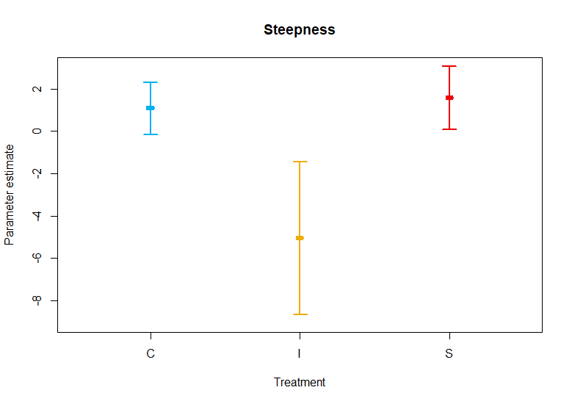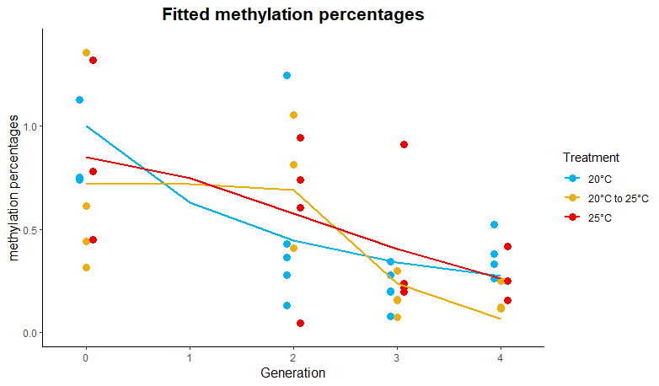

The Kruskal-Wallis test returned a non-significant p-value of 0.368 for both parameters (steepness and inflection point). However, our sample size was small, and the fact that the test returned identical p-values for both parameters, makes them unreliable. If we look at the values and standard errors of the steepness parameter (Figure 3), we can see that error margins of the increasing treatment group do not overlap with the error margins of the other treatment groups. Therefore, we conclude that the curve of the increasing treatment group is different from the curves of the other treatment groups in terms of steepness.

* 1. *Fatty acid analyses*

A stress plot of the metaMDS on relative FA composition (supplementary figure 1) resulted in an excellent fit of the data (R² value: 0.992, stress value: 0.089). On the metaMDS itself (Figure 3), we can see the three treatment groups overlapping, yet they have different shapes and distributions.

The PERMANOVA resulted in significant p-values for both variables, ‘Treatment’ and ‘Generation,’ and their interaction effect. However, when homogeneity of multivariate spread was evaluated, the variable Treatment tested non-significant (p-value of 0.155). Therefore, only the effect of treatment can be confirmed, as the low p-values of ‘Generation’ and the interaction effect might be caused by random dispersion.

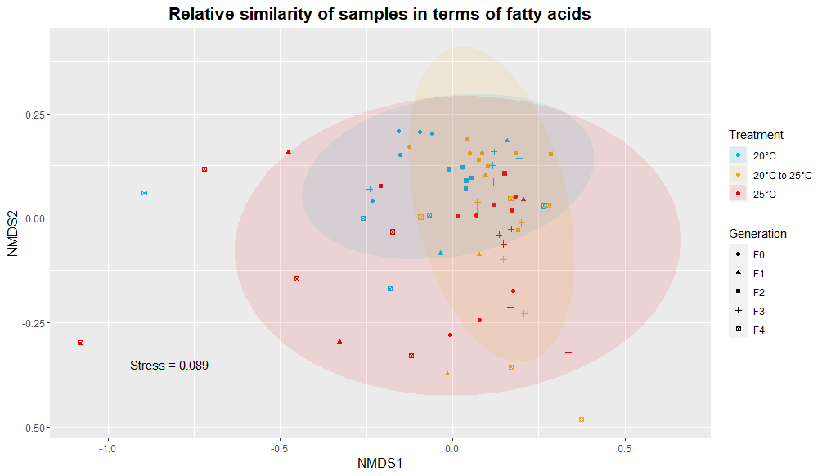

Figure 3. Visual representation of the fatty acid data according to a non-metric multidimensional scaling with Bray-Curtis distance matrix. Grouping was based on the treatment groups; blue: control (20°C), yellow: increasing temperature (20°C 🡪 25°C), red: steady raised temperature (25°C).

The ANOSIM yielded low R statistics for the variables ‘Treatment’ and ‘Generation’ (0.086 and 0.139, respectively). The R statistic for the interaction effect was higher (0.282) but still low. However, all p-values returned by the ANOSIM were significant (0.002 for ‘Treatment’ and 0.001 for ‘Generation’ and the interaction effect).

Figure 4. Percentages of the three most influential fatty acids, relative to the total amount of fatty acids in the sample. Lines connect the **means** per treatment, per generation. Error bars represent the standard deviation of the data. Blue line: control treatment (20°C), yellow line: increasing temperature (20°C 🡪 25°C), red line: steady raised temperature (25°C).

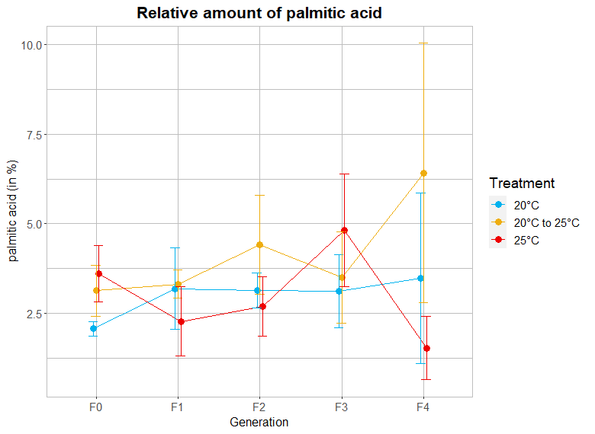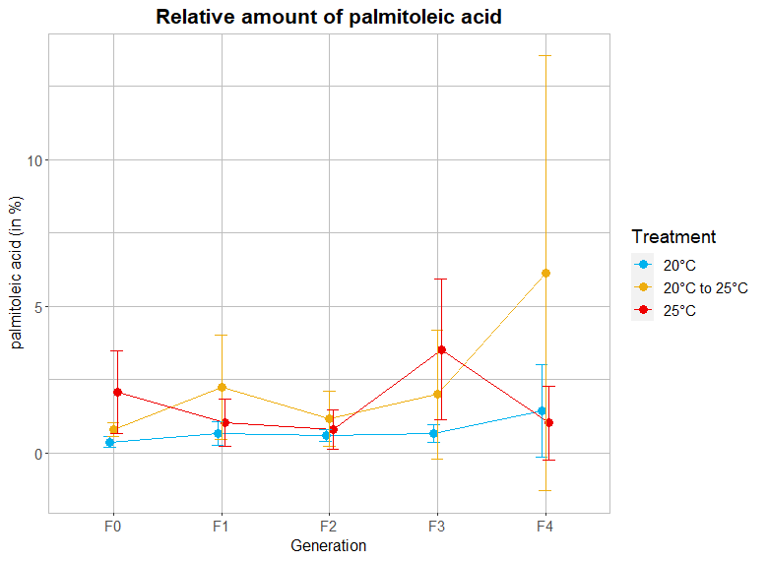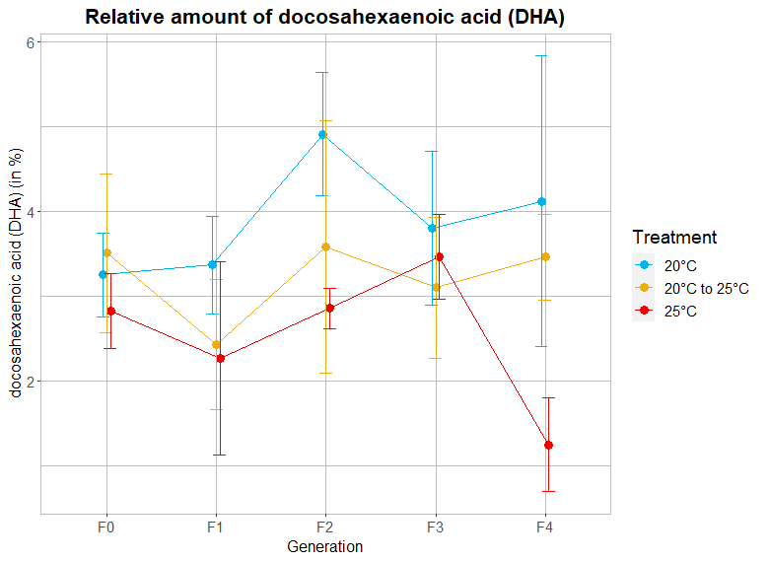

The SIMPER test indicated that palmitic acid (16:0), palmitoleic acid (16:1 n-7), and DHA (22:6 n-3) explained in total 40.2 % of the variance between the treatments.

The most remarkable outcome of the Wilcoxon tests was that the contribution of the three tested FA in the steady raised treatment group were significantly lower at generation F4, compared to generation F3. It is striking that, when copepods of the steady raised treatment reach the F4 generation, relative abundance of the FAs with most influence drops to almost zero (Figure 4). There were no significant differences between the F3 and the F4 generation in the control and increasing temperature treatment (Wilcoxon tests).

1. **Discussion**

The mean methylation levels of our test organisms (min: 0.17 ± 0.01%, max: 0.87 ± 0.05%) lie within the range of total methylation levels found in invertebrates (Cribiu et al., 2018) and correspond with methylation levels reported for *Daphnia magna* (Asselman et al., 2015; Vandegehuchte et al., 2009). The methylation levels of all groups decreased over the generations. This was expected as DNA methylation incites genetic changes; methylated cytosine will mutate faster to thymine in comparison to their non-methylated twins (Gonzalgo & Jones, 1997; Hanson & Liebl, 2022; Nabel et al., 2012; D. Zhou et al., 2015). Therefore, it could be stated that acclimatization through DNA methylation accelerates evolution.

It is important to note the difference between adaptation and acclimation. The definitions of Collier et al. (2019) are being used throughout this paper: acclimation is the phenotypic change in response to a single variable, acclimatization is the phenotypic change in response to several variables (Collier et al., 2019), and adaptation is the genotypic change of an organisms in response to one or several variables (Collier et al., 2019). Phenotypic changes are usually reversible and genotypic responses are not. When phenotypic changes due to acclimation or acclimatization are inherited, this is called transgenerational plasticity. Transgenerational plasticity can occur through a variety of mechanisms, and one of them is epigenetics.

When a mutation occurs, the methyl group will detach from the DNA strand, resulting in a steady decrease of global methylation levels over time, as seen in the control group. By model selection, different models were found best fitting for data from the different treatment groups. Treatments did not test significant in our models, probably due to high variance. However, the steepness parameter of the curves suggested that methylation patterns behave differently within treatments.

Particularly, the methylation curve of the increasing temperature treatment differs from the other treatment groups in terms of steepness with no overlapping confidence intervals. Contrary to the control and steady treatment curve, methylation levels undergoing slowly increasing temperature remained stable until generation two, after which methylation levels dropped drastically. This might indicate a turning point, where the temperature increase crosses a certain threshold, showing a reaction in methylation status.

The fatty acid data, on the other hand, showed no significant differences between the control and increasing temperature treatment. In addition, it has been proven that methylation levels influence gene expression (Bonasio et al., 2012; Jeremias et al., 2018; Kvist et al., 2020; Weinberg & Morris, 2016). Therefore, our results imply that the changes in global methylation levels for the increasing temperature treatment have their effect, resulting in relative fatty acid amounts like those in the control samples. Nevertheless, the exact mechanisms taking place are yet to be discovered.

In various transgenerational experiments where copepods are being exposed to a fixed raised temperature, researchers observed decreased hatching, reduced number of offspring, decreased body size, decreased urosome length, increased vulnerability to pollution, and decreased faecal pellet production (Byrne et al., 2020; Dinh et al., 2020, 2021; Truong et al., 2020). Those responses are all related to the base metabolism of the organisms and might be influenced by transgenerational plasticity. However, researchers found that previous environmental conditions do not alter copepods responses to new stressors (Byrne et al., 2020; Kelly et al., 2012; Langer et al., 2019). Prior studies on invertebrates exposed to temperature stressors also showed that global methylation patterns can change rapidly (Gavery & Roberts, 2010; Marsh & Pasqualone, 2014). Therefore, we expected to see a significant difference in global methylation patterns between the fixed raised temperature treatment and the control treatment. In our study, we did not see a difference. This might be because of the initial ’heat shock’ experienced by copepods at the beginning in comparison to the increasing temperature treatment. This explains why the methylation profile of the 25°C treatment initially differs from the control treatment but follows the same curve as the control treatment after one generation. However, it has been proven that this small change, followed by a trend that does not differ from the control, does not necessarily mean that the organism has acclimated (Byrne et al., 2020). Indeed, the drop in relative amounts of important fatty acids in the 25°C treatment, shows that the copepods in this treatment lack the capability and/or time to cope with a sudden rise in temperature of 5°C. The relative amount of DHA specifically, drops after three generations, with no overlapping confidence intervals between the third and fourth generation in the fixed raised temperature treatment.

Our data indicate that a slow build-up of temperature has a greater effect on global DNA methylation levels over a long period than a sudden increase of temperature. A striking discovery since climate change will not increase the ocean temperature on a short term but it will take time to develop and spread its effects. On the other hand, short-term fluctuations can influence methylation patterns in short periods of time (Asselman et al., 2015; Marsh & Pasqualone, 2014), and so become more important (Baldanzi et al., 2015; Jeremias et al., 2018). Additionally, Mathes et al. (2021) stress the importance of interactions between short- and long-term environmental changes. In this regard, the growing occurrence of heatwaves plays a vital role as well. Siegle et al. (2018) demonstrate that exposure to higher temperatures decreases the resilience of the copepod *Tigriopus californicus* to heatwaves. Semmouri et al. (2023) observed population collapses in calanoid copepods during heat waves in the Belgian part of the North Sea. As climate change evolves and heatwaves become more prevalent, effects of local fluctuations and how this affects organisms’ responses and resilience will become vital information.

It is remarkable that the relative abundance of DHA, palmitic acid and palmitoleic acid, drops drastically during the last generation in samples that underwent the high temperature treatment. Differences between the means of the F3 and F4 generation, for these three fatty acids, at 25°C were the only ones showing a clear pattern of significance. The sudden decrease after F3 at high temperature extends to the eight FA that most influence the variance between treatment groups (supplementary figure 2). This phenomenon is not present in the other temperature treatments, and no other clear patterns could be distinguished. It is also noteworthy that the standard errors, for the fatty acid measurements of the F4 generation at 25°C, are low and thus supporting a clear tendency. This pattern emphasizes the influence of temperature on the fatty acid metabolism in copepods with possible consequences for the impact of climate on the fatty acid composition of zooplankton. We know that calanoids lack desaturases (Monroig & Kabeya, 2018) and are dependent on food uptake to obtain enough essential FA. In that regard, we should analyse lower trophic levels when we try to explain changes in fatty acid profiles in calanoids. Holm et al. (2022) investigated temperature effects on primary producers and found that the number of double bounds in FA will decrease with increasing temperature.

Despite all efforts to control algae concentration, not all pots were evenly murky, and we visually observed that the colour was not even. This might be due to algal degradation, as they got transferred from their optimal growth conditions to test medium. Consequently, this might have caused variations in food quality, which in turn can cause variations in our results. For this reason, the use of peristaltic pumps is recommended in future long-term and/ or transgenerational experiments. To avoid the FA composition of the used algae to change because of treatment conditions, freeze-dried algae could also be a solution on the condition that an additional check for its effect on the life history parameters of the tested species is included. Nevertheless, the grouping in our fatty acid data cloud can be explained by the treatment factor, and the treatment groups significantly differ from each other. The fact that this result is visible through data with this variability, points to a strong connection.

During the experiment, we also observed faster growth and earlier maturity in the 25°C treatment. Although we have no strict data to prove this, previous research shows that generation times of copepods generally reduce with increasing temperature (Landry, 1975; Palmer & Coull, 1980; Relva et al., 2023). This points to higher turnover rates, as observed in tropical ecosystems. In summary, we can say that when water temperatures keep rising, ecosystems might shift to mechanisms observed in tropical waters.

DNA methylation might play a crucial role in this shift. It can be proposed that, when temperatures rise, calanoids will start to generate desaturases as well, because of evolution; that is because algae will produce less PUFA’s and so the availability will not remain infinite, therefore, calanoids will have to find alternative pathways to obtain enough PUFA’s. That is, when copepods will adapt and evolve fast enough to keep up with their rapidly changing environment.

*Acartia tonsa* is specifically known to be tolerant for a wide range of temperatures and salinity and is easily spread by ballast water and other anthropogenic transport. However, we demonstrate that the nutritional value of *Acartia tonsa* knows a decrease at elevated temperature treatments. This combination can lead to a shift in the marine food web structures, with bottom-up cascade effects that will change the ecosystem composition and make communities collapse.

1. **Conclusion**

Overall, we conclude that there is a great difference between the effects of short-term and long-term temperature changes. This is because the individual FA curves, for the slowly increasing temperature, do not show a significant difference from the control. This indicates that the changes we see in the methylation curve have their effect; the animal is acclimating to the changes. The methylation curve from the steady treatment is not significantly different from the control one, and in the FA profiles we see drastic decreases in the relative amount of essential fatty acids. We conclude that the copepods did not have time to acclimate to the higher temperature in this treatment and this reflects in their FA profiles. These findings prove two things. First, *Acartia tonsa* can acclimate when the water temperature increases slowly. This means that, over time, this organism will be able to adapt as climate change evolves. Secondly, *Acartia tonsa* is not able to acclimate when temperature increases fast and remains high. This indicates that prolonged heatwaves lasting until the next generation have a more drastic effect. In general, the amount, duration and frequency of heatwaves will increase because of climate change. The mean temperature will know a slight increase over a longer period, but short-term changes will have a greater effect on species with such short life cycles. We should be careful to investigate the effects of climate change over long-time frames, as short-time frames are more important and have more drastic effects on organisms with short generation times.

1. **Acknowledgements**

The authors would like to express their thanks to Jolien Depecker, Nancy De Saeyer, and Emmy Pequeur for the technical support and help during the experiment, and Bruno Vlaeminck for the fatty acid analyses. We would like to thank Ilias Semmouri, Jens Boyen, Julieta Vigliano, Robyn Sahota and Bram Martin for helping to improve to the experimental design and jumping in. Lastly, we would like to thank an anonymous reviewer from the Marine Pollution Bulletin for revising our manuscript and providing us with valuable feedback.

1. **Funding**

This work was supported by the Special Research Fund at Ghent University (Bijzonder Onderzoeksfonds) [BOF/24J/2021/164]; the Research Foundation Flanders [FWO project G003622N]; and EMBRC Belgium - FWO international research infrastructure [I001621N].

1. **Declaration of competing interest**

The authors declare that there is no conflict of interest, either in terms of professional or personal relationships.

1. **Author contributions**

**Lotte Janssens**: conceptualization, methodology, software, validation, formal analysis, investigation, data curation, writing-original draft, visualization. **Jana Asselman**: conceptualization, validation, resources, writing-review & editing, supervision, project administration, funding acquisition. **Marleen De Troch**: conceptualization, validation, resources, writing-review & editing, supervision, project administration, funding acquisition

1. **Corresponding author**

Lotte Janssens; Ghent University, Campus Sterre S8, Krijgslaan 281, B-9000 Ghent, Belgium. Email: [lottejan.janssens@ugent.be](mailto:lottejan.janssens@ugent.be)

1. **References**

Ackman, R.G., Sipos, J.C. (1964). Application of specific response factors in the gas chromatographic analysis of methyl esters of fatty acids with flame ionization detectors. [*Journal of the American Oil Chemists Society*](https://link.springer.com/journal/11746), *41*, 377–378. https://doi.org/10.1007/BF02654818.

Aral, M. M., & Guan, J. (2016). Global sea surface temperature and sea level rise estimation with optimal historical time lag data. *Water (Switzerland)*, *8*(11). https://doi.org/10.3390/w8110519

Asselman, J., De Coninck, D. I. M., Vandegehuchte, M. B., Jansen, M., Decaestecker, E., De Meester, L., Vanden Bussche, J., Vanhaecke, L., Janssen, C. R., & De Schamphelaere, K. A. C. (2015). Global cytosine methylation in Daphnia magna depends on genotype, environment, and their interaction. *Environmental Toxicology and Chemistry*, *34*(5), 1056–1061. https://doi.org/10.1002/etc.2887

Bache, S., Wickham, H. (2022). Magrittr: A Forward-Pipe Operator for R. R package version 2.0.3,<https://CRAN.R-project.org/package=magrittr.

Baldanzi, S., Weidberg, N. F., Fusi, M., Cannicci, S., McQuaid, C. D., & Porri, F. (2015). Contrasting environments shape thermal physiology across the spatial range of the sandhopper Talorchestia capensis. *Oecologia*, *179*(4), 1067–1078. https://doi.org/10.1007/s00442-015-3404-5

Bell, M. V., Henderson, R. J., & Sargent, J. R. (1986). The role of polyunsaturated fatty acids in fish. *Elsevier*, *83B*(4), 711–719.

Bernstein, B. E., Meissner, A., & Lander, E. S. (2007). The Mammalian Epigenome. *Cell*, *128*(4), 669–681. https://doi.org/10.1016/j.cell.2007.01.033

Bonasio, R., Li, Q., Lian, J., Mutti, N. S., Jin, L., Zhao, H., Zhang, P., Wen, P., Xiang, H., Ding, Y., Jin, Z., Shen, S. S., Wang, Z., Wang, W., Wang, J., Berger, S. L., Liebig, J., Zhang, G., & Reinberg, D. (2012). Genome-wide and caste-specific DNA methylomes of the ants camponotus floridanus and harpegnathos saltator. *Current Biology*, *22*(19), 1755–1764. https://doi.org/10.1016/j.cub.2012.07.042

Boyen, J., Fink, P., Mensens, C., Hablützel, P. I., & De Troch, M. (2020). Fatty acid bioconversion in harpacticoid copepods in a changing environment: A transcriptomic approach. *Philosophical Transactions of the Royal Society B: Biological Sciences*, *375*(1804). https://doi.org/10.1098/rstb.2019.0645

Byrne, M., Foo, S. A., Ross, P. M., & Putnam, H. M. (2020). Limitations of cross- and multigenerational plasticity for marine invertebrates faced with global climate change. *Global Change Biology*, *26*(1), 80–102. https://doi.org/10.1111/gcb.14882

Carotenuto, Y., Vitiello, V., Gallo, A., Libralato, G., Trifuoggi, M., Toscanesi, M., Lofrano, G., Esposito, F., & Buttino, I. (2020). Assessment of the relative sensitivity of the copepods Acartia tonsa and Acartia clausi exposed to sediment-derived elutriates from the Bagnoli-Coroglio industrial area: Sensitivity of Acartia tonsa and Acartia clausi to sediment elutriates. *Marine Environmental Research*, *155*(January), 104878. https://doi.org/10.1016/j.marenvres.2020.104878

Clare, C. E., Brassington, A. H., Kwong, W. Y., & Sinclair, K. D. (2019). One-Carbon Metabolism: Linking Nutritional Biochemistry to Epigenetic Programming of Long-Term Development. *Annual Review of Animal Biosciences*, *7*, 263–287. https://doi.org/10.1146/annurev-animal-020518-115206

Collier, R. J., Baumgard, L. H., Zimbelman, R. B., & Xiao, Y. (2019). *Heat stress : physiology of acclimation and adaptation*. *9*(1). https://doi.org/10.1093/af/vfy031

Cribiu, P., Chaumot, A., Geffard, O., Ravanat, J. L., Bastide, T., Delorme, N., Quéau, H., Caillat, S., Devaux, A., & Bony, S. (2018). Natural variability and modulation by environmental stressors of global genomic cytosine methylation levels in a freshwater crustacean, Gammarus fossarum. *Aquatic Toxicology*, *205*(July), 11–18. https://doi.org/10.1016/j.aquatox.2018.09.015

De Troch, M., Boeckx, P., Cnudde, C., Van Gansbeke, D., Vanreusel, A., Vincx, M., & Caramujo, M. J. (2012). Bioconversion of fatty acids at the basis of marine food webs: Insights from a compound-specific stable isotope analysis. *Marine Ecology Progress Series*, *465*, 53–67. https://doi.org/10.3354/meps09920

Dinh, K. V., Doan, K. L. U., Doan, N. X., Pham, H. Q., Le, T. H. O., Le, M. H., Vu, M. T. T., Dahms, H. U., & Truong, K. N. (2021). Parental exposures increase the vulnerability of copepod offspring to copper and a simulated marine heatwave. *Environmental Pollution*, *287*(May), 117603. https://doi.org/10.1016/j.envpol.2021.117603

Dinh, K. V., Nguyen, Q. T. T., Vo, T. M. C., Bui, T. B., Dao, T. S., Tran, D. M., Doan, N. X., Truong, T. S. H., Wisz, M. S., Nielsen, T. G., Vu, M. T. T., & Le, M. H. (2020). Interactive effects of extreme temperature and a widespread coastal metal contaminant reduce the fitness of a common tropical copepod across generations. *Marine Pollution Bulletin*, *159*(May), 111509. https://doi.org/10.1016/j.marpolbul.2020.111509

Drouin, G., Rioux, V., & Legrand, P. (2019). The n-3 docosapentaenoic acid (DPA): A new player in the n-3 long chain polyunsaturated fatty acid family. *Biochimie*, *159*, 36–48. https://doi.org/10.1016/j.biochi.2019.01.022

Eirin-Lopez, J. M., & Putnam, H. (2021). Editorial: Marine Environmental Epigenetics. *Frontiers in Marine Science*, *8*. https://doi.org/10.3389/fmars.2021.685075

Fox, J., Weisberg, S. (2019). An R Companion to Applied Regression, Third edition. *Sage, Thousand Oaks CA*. https://socialsciences.mcmaster.ca/jfox/Books/Companion/.

Fox, J., Weisberg, S., Price, B. (2022). CarData: Companion to Applied Regression Data Sets. R package version 3.0-5, https://CRAN.R-project.org/package=carData.

Gavery, M. R., & Roberts, S. B. (2010). DNA methylation patterns provide insight into epigenetic regulation in the Pacific oyster (Crassostrea gigas). *BMC Genomics*, *11*(1). https://doi.org/10.1186/1471-2164-11-483

GISSI-HF investigators. (2008). Effect of n-3 polyunsaturated fatty acids in patients with chronic heart failure (the GISSI-HF trial): a randomised, double-blind, placebo-controlled trial. *The Lancet*, *372*(9645), 1223–1230. https://doi.org/10.1016/S0140-6736(08)61239-8

Gonzalgo, M. L., & Jones, P. A. (1997). Mutagenic and epigenetic effects of DNA methylation. *Mutation Research - Reviews in Mutation Research*, *386*(2), 107–118. https://doi.org/10.1016/S1383-5742(96)00047-6

Guillard, R. R. L. and Morton, S. L. (2004). Culture methods. In G., Hallegraeff, D. M., Anderson & A., Cembella (Ed.). *Manual on harmful marine microalgae* (2nd ed., pp. 77-98). France, UNESCO.

Hallegraeff, G., Anderson, D. M., Hole, W., & Cembella, A. (1995). *0Dqxdo Rq + Dupixo 0Dulqh* (Issue 33).

Hanson, H. E., & Liebl, A. L. (2022). The Mutagenic Consequences of DNA Methylation within and across Generations. *Epigenomes*, *6*(4), 1–15. https://doi.org/10.3390/epigenomes6040033

He, Z., Zhang, R., Jiang, F., Zhang, H., Zhao, A., Xu, B., Jin, L., Wang, T., Jia, W., Jia, W., & Hu, C. (2018). FADS1-FADS2 genetic polymorphisms are associated with fatty acid metabolism through changes in DNA methylation and gene expression. *Clinical Epigenetics*, *10*(1), 1–13. https://doi.org/10.1186/s13148-018-0545-5

Hernando, M. P., Schloss, I. R., De La Rosa, F., & De Troch, M. (2022). Fatty acids in microalgae and cyanobacteria in a changing world: Contrasting temperate and cold environments. *Biocell*, *46*(3), 607–621. https://doi.org/10.32604/biocell.2022.017309

Holm, H. C., Fredricks, H. F., Bent, S. M., Lowenstein, D. P., Ossolinski, J. E., Becker, K. W., Johnson, W. M., Schrage, K., & Van Mooy, B. A. S. (2022). Global ocean lipidomes show a universal relationship between temperature and lipid unsaturation. *Science (New York, N.Y.)*, *376*(6600), 1487–1491. https://doi.org/10.1126/science.abn7455

Horowitz, M. (2014). Heat acclimation, epigenetics, and cytoprotection memory. *Comprehensive Physiology*, *4*(1), 199–230. https://doi.org/10.1002/cphy.c130025

Horowitz, M. (2016). Epigenetics and cytoprotection with heat acclimation. *Journal of Applied Physiology*, *120*(6), 702–710. https://doi.org/10.1152/japplphysiol.00552.2015

Jaenisch, R., & Bird, A. (2003). Epigenetic regulation of gene expression: How the genome integrates intrinsic and environmental signals. *Nature Genetics*, *33*(3S), 245–254. https://doi.org/10.1038/ng1089

Jeremias, G., Barbosa, J., Marques, S. M., Asselman, J., Gonçalves, F. J. M., & Pereira, J. L. (2018). Synthesizing the role of epigenetics in the response and adaptation of species to climate change in freshwater ecosystems. *Molecular Ecology*, *27*(13), 2790–2806. https://doi.org/10.1111/mec.14727

Kelly, M. W., Sanford, E., & Grosberg, R. K. (2012). Limited potential for adaptation to climate change in a broadly distributed marine crustacean. *Proceedings of the Royal Society B: Biological Sciences*, *279*(1727), 349–356. https://doi.org/10.1098/rspb.2011.0542

Klein Breteler, W. C. M. (1980). Continuous Breeding of Marine Pelagic Copepods in the Presence of Heterotrophic Dinoflagellates. *Marine Ecology Progress Series*, *2*, 229–233. https://doi.org/10.3354/meps002229

Klein Breteler, W. C. M., Fransz, H. G., & Gonzalez, S. R. (1982). Growth and development of four calanoid copepod species under experimental and natural conditions. *Netherlands Journal of Sea Research*, *16*(C), 195–207. https://doi.org/10.1016/0077-7579(82)90030-8

Kvist, J., Athanàsio, C. G., Pfrender, M. E., Brown, J. B., Colbourne, J. K., & Mirbahai, L. (2020). A comprehensive epigenomic analysis of phenotypically distinguishable, genetically identical female and male Daphnia pulex. *BMC Genomics*, *21*(1), 1–17. https://doi.org/10.1186/s12864-019-6415-5

Landry, M. R. (1975). The relationship between temperature and the development of life stages of the marine copepod Acartia clausi Giesbr. *Limnology and Oceanography*, *20*(5), 854–857. https://doi.org/10.4319/lo.1975.20.5.0854

Langer, J. A. F., Meunier, C. L., Ecker, U., Horn, H. G., Schwenk, K., & Boersma, M. (2019). Acclimation and adaptation of the coastal calanoid copepod Acartia tonsa to ocean acidification: A long-term laboratory investigation. *Marine Ecology Progress Series*, *619*, 35–51. https://doi.org/10.3354/meps12950

Lüdecke, D., Ben-Shachar, M., Patil, I., Makowski, D. (2020). Extracting, Computing and Exploring the Parameters of Statistical Models using R. *Journal of Open Source Software, 5*(53), 2445. https://doi.org/10.21105/joss.02445.

Marchioli, R. (1999). Dietary supplementation with N-3 polyunsaturated fatty acids and vitamin E after myocardial infarction: Results of the GISSI-Prevenzione trial. *Lancet*, *354*(9177), 447–455. https://doi.org/10.1016/S0140-6736(99)07072-5

Marcus, N. H., & Wilcox, J. A. (2007). Guide To the Meso-Scale Production of the Copepod Acartia Tonsa. *Production*, 1–29.

Marsh, A. G., & Pasqualone, A. A. (2014). DNA methylation and temperature stress in an Antarctic polychaete, Spiophanes tcherniai. *Frontiers in Physiology*, *5 MAY*(May), 1–9. https://doi.org/10.3389/fphys.2014.00173

Mathes, G. H., van Dijk, J., Kiessling, W., & Steinbauer, M. J. (2021). Extinction risk controlled by interaction of long-term and short-term climate change. *Nature Ecology and Evolution*, *5*(3), 304–310. https://doi.org/10.1038/s41559-020-01377-w

Matsushita, Y., Miyoshi, K., Kabeya, N., Sanada, S., Yazawa, R., Haga, Y., Satoh, S., Yamamoto, Y., Strüssmann, C. A., Luckenbach, J. A., & Yoshizaki, G. (2020). Flatfishes colonised freshwater environments by acquisition of various DHA biosynthetic pathways. *Communications Biology*, *3*(1), 4–5. https://doi.org/10.1038/s42003-020-01242-3

Monroig, Ó., & Kabeya, N. (2018). Desaturases and elongases involved in polyunsaturated fatty acid biosynthesis in aquatic invertebrates: a comprehensive review. *Fisheries Science*, *84*(6), 911–928. https://doi.org/10.1007/s12562-018-1254-x

Monroig, Shu-Chien, A. C., Kabeya, N., Tocher, D. R., & Castro, L. F. C. (2022). Desaturases and elongases involved in long-chain polyunsaturated fatty acid biosynthesis in aquatic animals: From genes to functions. *Progress in Lipid Research*, *86*(January), 101157. https://doi.org/10.1016/j.plipres.2022.101157

Nabel, C. S., Manning, S. A., & Kohli, R. M. (2012). The curious chemical biology of cytosine: Deamination, methylation, and oxidation as modulators of genomic potential. *ACS Chemical Biology*, *7*(1), 20–30. https://doi.org/10.1021/cb2002895

Oksanen, J., Simpson, G., Blanchet, F., Kindt, R., Legendre, P., Minchin, P., O'Hara, R., Solymos, P., Stevens, M., Szoecs, E., Wagner, H., Barbour, M., Bedward, M., Bolker, B., Borcard, D., Carvalho, G., Chirico, M., De Caceres, M., Durand, S., Evangelista, H., FitzJohn, R., Friendly, M., Furneaux, B., Hannigan, G., Hill, M., Lahti, L., McGlinn, D., Ouellette, M., Ribeiro Cunha, E., Smith, T., Stier, A., Ter Braak, C., Weedon, J. (2022). Vegan: Community Ecology Package. R package version 2.6-4, https://CRAN.R-project.org/package=vegan.

Palmer, M. A., & Coull, B. C. (1980). The prediction of development rate and the effect of temperature for the meiobenthic copepod, Microarthridion littorale (Poppe). *Journal of Experimental Marine Biology and Ecology*, *48*(1), 73–84. https://doi.org/10.1016/0022-0981(80)90008-8

Pavlaki, M. D., Morgado, R. G., van Gestel, C. A. M., Calado, R., Soares, A. M. V. M., & Loureiro, S. (2017). Influence of environmental conditions on the toxicokinetics of cadmium in the marine copepod Acartia tonsa. *Ecotoxicology and Environmental Safety*, *145*(February), 142–149. https://doi.org/10.1016/j.ecoenv.2017.07.008

Pedersen, S. A., Håkedal, O. J., Salaberria, I., Tagliati, A., Gustavson, L. M., Jenssen, B. M., Olsen, A. J., & Altin, D. (2014). Multigenerational exposure to ocean acidification during food limitation reveals consequences for copepod scope for growth and vital rates. *Environmental Science and Technology*, *48*(20), 12275–12284. https://doi.org/10.1021/es501581j

Prado-Cabrero, A., & Nolan, J. M. (2021). Omega-3 nutraceuticals, climate change and threats to the environment: The cases of Antarctic krill and Calanus finmarchicus. *Ambio*, *50*(6), 1184–1199. https://doi.org/10.1007/s13280-020-01472-z

Relva, J. V., Van Colen, C., Barhdadi, W., Daly, A., & De Troch, M. (2023). Temperature increase alters fatty acid composition and has negative effects on reproductive output of the benthic copepod Microarthridion littorale (Copepoda: Harpacticoida). *Research Square*. Preprint. https://doi.org/https://doi.org/10.21203/rs.3.rs-2858869/v1

Ritz, C., Baty, F., Streibig, J. C., Gerhard, D. (2015). Dose-Response Analysis Using R. *PLOS ONE, 10*(12), e0146021

Rotolo, F., Vitiello, V., Pellegrini, D., Carotenuto, Y., & Buttino, I. (2021). Historical control data in ecotoxicology: Eight years of tests with the copepod Acartia tonsa. *Environmental Pollution*, *284*(May), 117468. https://doi.org/10.1016/j.envpol.2021.117468

Sarkar, D. (2008). Lattice: Multivariate Data Visualization with R. *Springer*, New York. ISBN 978-0-387-75968-5, http://lmdvr.r-forge.r-project.org.

Semmouri, I., De Schamphelaere, K. A. C., Mortelmans, J., Mees, J., Asselman, J., & Janssen, C. R. (2023). Decadal decline of dominant copepod species in the North Sea is associated with ocean warming: Importance of marine heatwaves. *Marine Pollution Bulletin*, *193*(May), 115159. https://doi.org/10.1016/j.marpolbul.2023.115159

Siegle, M. R., Taylor, E. B., & O’Connor, M. I. (2018). Prior heat accumulation reduces survival during subsequent experimental heat waves. *Journal of Experimental Marine Biology and Ecology*, *501*(December 2017), 109–117. https://doi.org/10.1016/j.jembe.2018.01.012

Simopoulos, A. P. (2002). Omega-3 fatty acids in inflammation and autoimmune diseases. *Journal of the American College of Nutrition*, *21*(6), 495–505. https://doi.org/10.1080/07315724.2002.10719248

Simpson, G. (2022). Permute: Functions for Generating Restricted Permutations of Data. R package version 0.9-7, https://CRAN.R-project.org/package=permute.

Støttrup, J. G., Richardson, K., Kirkegaard, E., & Pihl, J. (1986). The cultivation of tea. *Elsevier*, *80*(2065), 87–96. https://doi.org/10.1038/080385b0

Sun, D., Li, Q., & Yu, H. (2022). DNA methylation differences between male and female gonads of the oyster reveal the role of epigenetics in sex determination. *Gene*, *820*(August 2021). https://doi.org/10.1016/j.gene.2022.146260

Sunar, M. C., & Kır, M. (2021). Thermal tolerance of Acartia tonsa: In relation to acclimation temperature and life stage. *Journal of Thermal Biology*, *102*(October), 103116. https://doi.org/10.1016/j.jtherbio.2021.103116

Truong, K. N., Vu, N. A., Doan, N. X., Le, M. H., Vu, M. T. T., & Dinh, K. V. (2020). Predator cues increase negative effects of a simulated marine heatwave on tropical zooplankton. *Journal of Experimental Marine Biology and Ecology*, *530*–*531*(March), 151415. https://doi.org/10.1016/j.jembe.2020.151415

Turner, J. T. (2004). The importance of small planktonic copepods and their roles in pelagic marine food webs. *Zoological Studies*, *43*(2), 255–266.

Van Ginderdeuren, K. (2013). *Zooplankton and its role in North Sea food webs: community structure and selective feeding by Pelagic fish in Belgian marine waters.* 1–226.

Vandegehuchte, M. B., Lemière, F., & Janssen, C. R. (2009). Quantitative DNA-methylation in Daphnia magna and effects of multigeneration Zn exposure. *Comparative Biochemistry and Physiology - C Toxicology and Pharmacology*, *150*(3), 343–348. https://doi.org/10.1016/j.cbpc.2009.05.014

von Schacky, C. (2021). Importance of epa and dha blood levels in brain structure and function. *Nutrients*, *13*(4). https://doi.org/10.3390/nu13041074

Vu, M. T. T., Hansen, B. W., & Kiørboe, T. (2017). The constraints of high density production of the calanoid copepod Acartia tonsa Dana. *Journal of Plankton Research*, *39*(6), 1028–1039. https://doi.org/10.1093/plankt/fbx056

Weinberg, M. S., & Morris, K. V. (2016). Transcriptional gene silencing in humans. *Nucleic Acids Research*, *44*(14), 6505–6517. https://doi.org/10.1093/nar/gkw139

Wickham, H. (2016). ggplot2: Elegant Graphics for Data Analysis. *Springer-Verlag New York*.

Wickham, H., Bryan, J. (2023). Readxl: Read Excel Files. R package version 1.4.2, https://CRAN.R-project.org/package=readxl.

Winnepenninckx, B., Backeljau, T., & De Wachter, R. (1993). Extraction of high molecular weight DNA from molluscs. *Trends in Genetics*, *9*(12), 407. https://doi.org/10.1016/0168-9525(93)90102-N

Wolff, R. L., Bayard, C. C., Fabien, R. J. (1995). Evaluation of sequential methods for the determination of butterfat fatty acid composition with emphasis on trans-18:1 acids. Application to the study of seasonal variations in French butters. *J Am Oil Chem Soc, 72*,(1471–83).

Zhou, C., Carotenuto, Y., Vitiello, V., Wu, C., Zhang, J., & Buttino, I. (2018). De novo transcriptome assembly and differential gene expression analysis of the calanoid copepod Acartia tonsa exposed to nickel nanoparticles. *Chemosphere*, *209*, 163–172. https://doi.org/10.1016/j.chemosphere.2018.06.096

Zhou, D., Li, Z., Yu, D., Wan, L., Zhu, Y., Lai, M., & Zhang, D. (2015). Polymorphisms involving gain or loss of CpG sites are significantly enriched in trait-associated SNPs. *Oncotarget*, *6*(37), 39995–40004. https://doi.org/10.18632/oncotarget.5650

Zhou, Z., Wang, B., Zeng, S., Gong, Z., Jing, F., & Zhang, J. (2020). Glutathione S-transferase (GST) genes from marine copepods Acartia tonsa: cDNA cloning and mRNA expression in response to 1,2-dimethylnaphthalene. *Aquatic Toxicology*, *224*(March), 105480. https://doi.org/10.1016/j.aquatox.2020.105480

1. **Supplementary**

Supplementary figure 1. Stress plot of the metaNMDS performed on our fatty acid data, including R2 values.

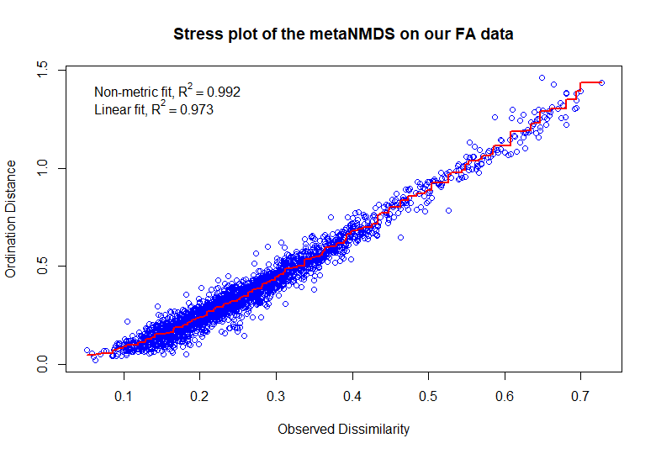

Supplementary figure 2. Relative amounts of the eight FA that most influence the differences between treatment groups in terms of fatty acid profile. Presented in percentage of the total amount of FA found in a sample. The dots represent the **means** per treatment group, the error bars represent the standard error of the means.

|  |  |
| --- | --- |
|  |  |
|  |  |
|  |  |
|  |  |

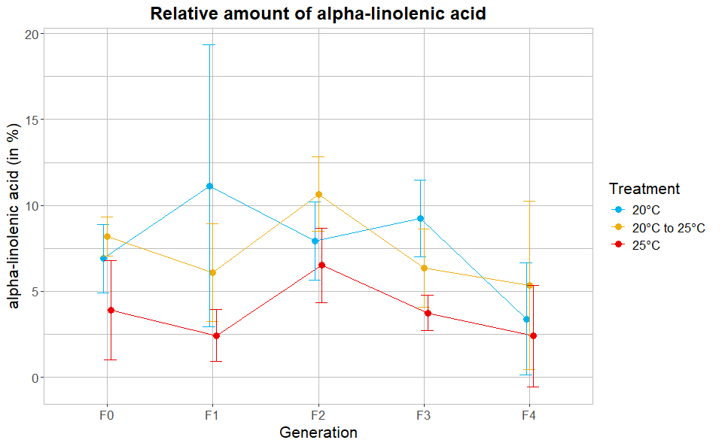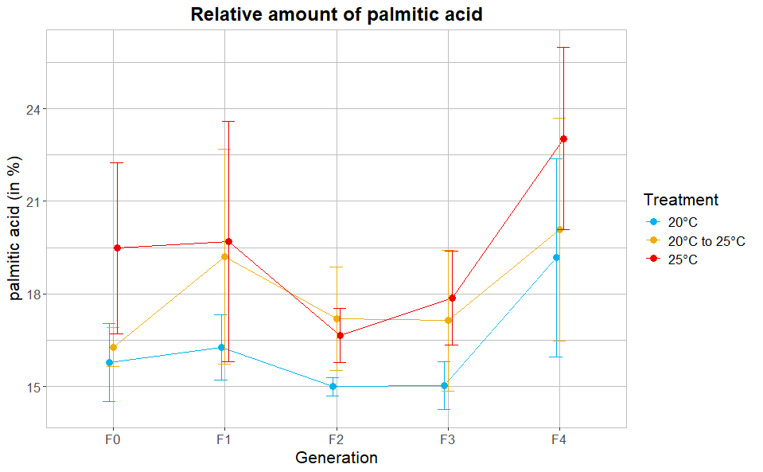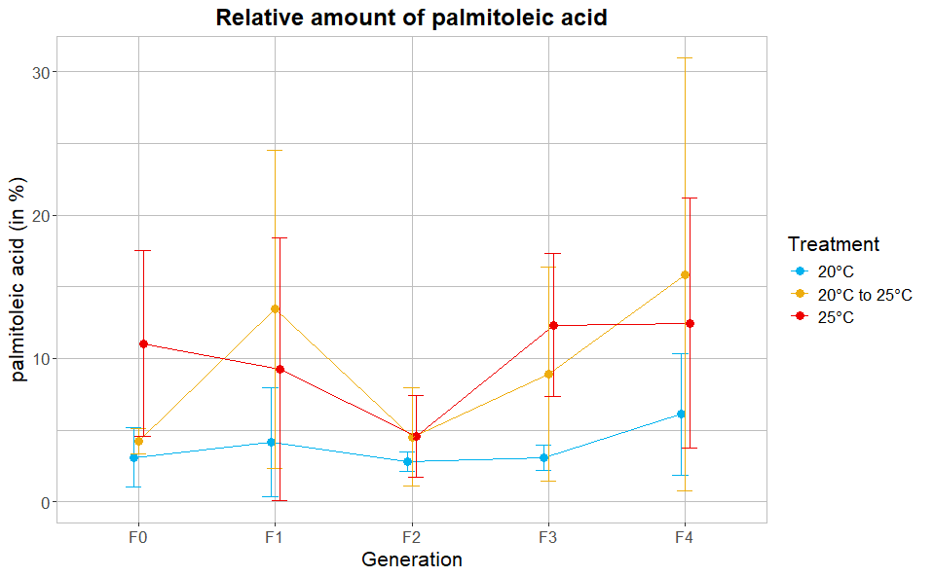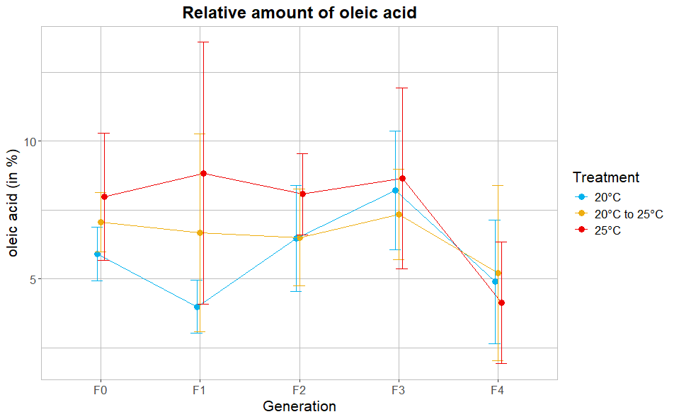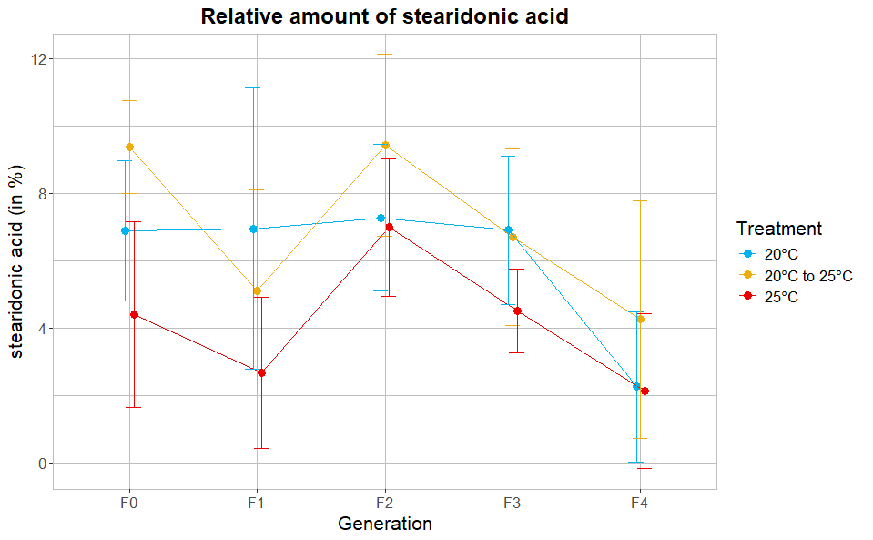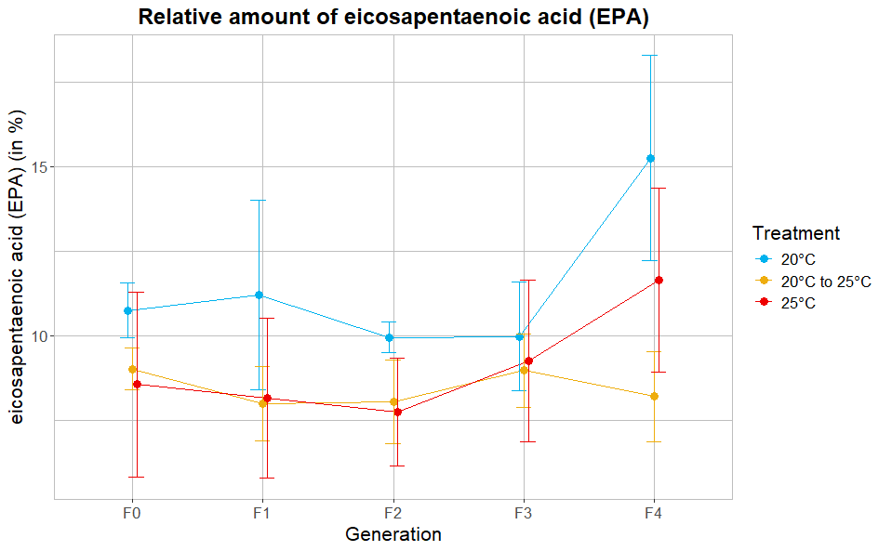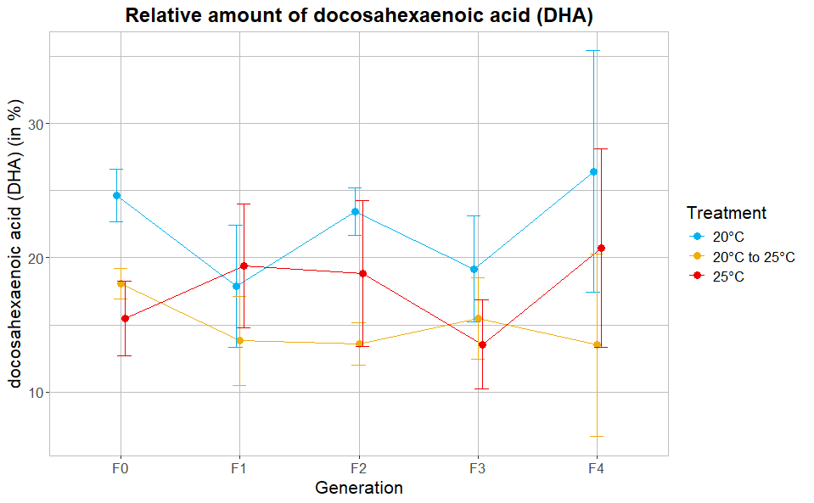

Supplementary table 1. Exposure times of each generation per treatment, in days.

|  |  |  |  |  |  |
| --- | --- | --- | --- | --- | --- |
|  | Exposure time F0 (in days) | Exposure time F1 (in days) | Exposure time F2 (in days) | Exposure time F3 (in days) | Exposure time F4 (in days) |
| Control | 8 (±1) | 16 (±2) | 17 (±2) | 15 (±2) | 14 (±2) |
| Increasing | 8 (±1) | 18 (±2) | 16 (±2) | 14 (±2) | 14 (±2) |
| Steady | 8 (±1) | 14 (±2) | 15 (±2) | 12 (±2) | 14 (±2) |

Supplementary table 2. Mean global methylation levels and their variance per generation, per treatment.

|  |  |  |  |
| --- | --- | --- | --- |
| Treatment | Generation | Mean global methylation level | Variance |
| Control | F0 | 0,8725793 | 0,048395981 |
| Control | F2 | 0,4894710 | 0,191173533 |
| Control | F3 | 0,2196916 | 0,010093342 |
| Control | F4 | 0,3737175 | 0,012145932 |
| Increasing | F0 | 0,6812342 | 0,217504614 |
| Increasing | F2 | 0,7598954 | 0,106023859 |
| Increasing | F3 | 0,1737125 | 0,008742272 |
| Increasing | F4 | 0,1846073 | 0,005727613 |
| Steady | F0 | 0,8496933 | 0,193080724 |
| Steady | F2 | 0,5830610 | 0,147287674 |
| Steady | F3 | 0,3896502 | 0,120764691 |
| Steady | F4 | 0,2734682 | 0,017380885 |