People’s Preferred Balance Between Politicians, Citizens, and Experts in
Policy-Making Decisions
Tessa Haesevoets¹, Bram Verschuere¹ & Arne Roets²
¹ Department of Public Governance and Management; Ghent University
² Department of Developmental, Personality and Social Psychology; Ghent University

Submission date: February 1, 2024

Word count (total): 10,950

Authors’ Note
Ethical approval: Ethical approval for the present research was obtained from the Ethics Committee of the Faculty of Economics and Business Administration at Ghent University (Ref: UG-EB 2022-A).
Data availability: The data and data analysis scripts of our studies are made publicly available and can be accessed through Open Science Framework (anonymized view-only link): https://osf.io/qsr6a/?view_only=ae513a6757a34c8aa7cb79df73f241ba
Disclosure statement: The authors declare that they have no competing interest.
Funding details: This research is part of the larger project “The changed face of local democracy? The impact of citizen participation on roles, relationships, and legitimacy perceptions of democratic institutional stakeholders” (funded by Ghent University Special Research Fund - BOF21/GOA/008). More information: https://participatievedemocratie.be.
Biographical note: Tessa Haesevoets is a postdoctoral researcher at the Department of Public Governance and Management of Ghent University. Bram Verschuere is a professor and the head of the Department of Public Governance and Management of Ghent University. Arne Roets is a professor at the Department of Developmental, Personality and Social Psychology of Ghent University.
Corresponding author: Tessa Haesevoets, Department of Public Governance and Management, Ghent University, Apotheekstraat 5, 9000 Gent, Belgium. Email: tessa.haesevoets@ugent.be.

Abstract
Most prior studies examining citizens’ preferences for ‘who should govern’ assume that people prefer either politicians, citizens, or experts to exclusively influence policy decisions. Our approach posits that individuals may actually prefer a mix of these actors. Across two studies, we discovered that people indeed favor the involvement of all three actors in policy decisions, but with specific relative importance assigned to each of them. Notably, our second study clarified that which actor should have the largest say depends on the specific issue at hand, with citizens outweighing experts and politicians for ideological issues and experts outweighing citizens and politicians for technical issues. These findings are particularly relevant, given that these two actors were found to outperform each other in a different legitimacy dimension. That is, citizens’ contribution is seen most in terms of input legitimacy, whereas experts are perceived as contributing most to output legitimacy, particularly for technical issues. In contrast, politicians are considered to contribute the least to all three legitimacy dimensions. To enhance the perceived legitimacy of policy decisions among the citizenry, it becomes crucial for policymakers to embrace a more ‘hybrid’ perspective, acknowledging the value of a more diverse collaboration between politicians, citizens, and experts.
Keywords: citizen participation; expert involvement; hybrid policy-making, decisional balance, relative weight, legitimacy dimensions; case variations

INTRODUCTION
In Western societies, democracy is commonly organized on the principle of representation: Elected politicians represent the people and are mandated to take policy decisions on their behalf. With the declining trust in politicians and political parties (Dalton & Weldon, 2005; Marien, 2011), a greater role of other actors (besides elected politicians) in the policy decision-making process is advocated. One direction is enhancing the participatory nature of democracy by giving citizens the opportunity to participate in policy decisions more directly (Cain et al., 2003; Dalton, 2004; Neblo et al., 2010), whereas others are calling for a greater use of expert opinions in shaping policy decisions (Hibbing & Theiss-Morse, 2002; Bertsou & Pastorella, 2017). Studies examining people’s support for altering the policy-making process by bringing in non-political decision-makers have been multiplying over the last decade. However, many of these studies asked people to declare which actor they prefer to make important policy decisions (e.g., Gherghina & Geissel, 2017; Rapeli, 2016), thereby treating people’s preferences for different decision-makers as being ‘mutually exclusive’, implying that they are incompatible and thus cannot coexist.
In the present research, we opt for a different approach by considering citizens and experts as two distinct actor types engaged in competition, alongside elected politicians, for influence in policy-making. To illuminate people’s preferred balance between politicians, citizens, and experts in the context of policy-making decisions, we conducted two empirical studies exploring which particular mixture of politician, citizen, and expert involvement respondents from the United Kingdom (UK) consider to be optimal. Our research objectives are threefold. First, in both studies, we examined how much say respondents desire politicians, citizens, and experts to have in policy decisions, relative to each other (RO1). Additionally, we explored in both studies how respondents assess the contribution of each of these three actors in terms of input, throughput, and output legitimacy of the policy-making process (RO2). In Study 2, we also delved into whether citizens’ relative support for and perceived contributions of these decision-makers depend on the specific issue under consideration (RO3). Such knowledge not only has theoretical relevance, but it may also offer valuable insights to practitioners who must ensure that policy-making decisions are perceived as acceptable and legitimate by the citizenry.
The Crisis of Representative Democracy
Over the last few decades, people’s confidence in and satisfaction with representative democracy has eroded (Dalton, 2004; Pharr & Putnam, 2000). A large-scale survey among more than 30,000 respondents from 27 different countries, for instance, illustrated that a mean of 51% of the respondents reported to be dissatisfied with how democracy is working in their country (Pew Research Center, 2019). Recent figures of the OECD similarly show that, across countries, people have low confidence in their national government (OECD, 2022). In the United States, there has been a steady decrease in public trust. Whereas in 1958, 73% of Americans trusted their government, this conviction has gradually declined, and in 2023, merely 16% of American citizens continue to trust their government (Pew Research Center, 2023). Such figures are exemplary for a trend that suggests a destabilizing of citizens’ relations with democratic institutions, which might stem from to the fact that many citizens have the perception that they are not being heard (low input legitimacy), that public institutions do not treat them fairly (low throughput legitimacy), and that political elites do not provide adequate solutions for the pressing problems of society (low output legitimacy).
This discontent with the current workings of democracy and democratic institutions has manifested itself in structurally low levels of trust in politicians, political parties, and public institutions (van der Meer, 2017), lower turnout in elections (Grönlund & Setälä, 2007; Kostelka et al., 2022), and the growing presence and success of populist anti-system parties (Norris & Inglehart, 2019; Rooduijn et al., 2019), which all suggest that traditional representative democracy is in crisis (see Flinders et al., 2019; Landemore, 2017; Tormey, 2014). Some have even claimed that people ‘hate’ politicians (Hay, 2007; Grossman & Sauger, 2017), the core actor of traditional representative democracy. Importantly, however, these observations do not necessarily mean that an increasing part of the population is turning its back to democracy as such; but rather that people are becoming more disenchanted with how democracy is organized, resulting in challenges to the legitimacy of the prime institutions of representative democracy: “people love democracy, but often despair at how it is practiced” (Escobar & Elstub 2019, p. 1).
Beyond Representative Democracy: Two Alternative Democracy Models
To remedy the overall malaise of representative democracy, several alternatives for representative democracy have been proposed in the literature, with the two most studied alternative models either advocating a more participatory type of democracy or a greater involvement of politically independent experts in policy-making (Bengtsson & Christensen, 2016; Bengtsson & Mattila, 2009; Coffé & Michels, 2014; Font et al., 2015; Gherghina & Geissel, 2019; Goldberg et al., 2020; Hibbing & Theiss-Morse, 2002; Webb, 2013).
A first alternative model in this regard is thus to introduce a more participatory type of democracy that increases the possibilities for citizens to have a more direct say in policy decisions. In the traditional representative model of democracy, apart from voting, citizens are rather passive subjects as recipients of public policies and services. In recent decades, many countries have started to complement this traditional form of representative democracy with various participatory mechanisms, which have been pooled under the term ‘participatory democracy’ (Patemen, 2012). Participation materializes in practices such as (binding or consultative) referenda, mini-publics, citizen panels, and participatory budgeting, which all have in common that they add a layer of direct citizen participation to representative democracy (Elstub & Escobar, 2019; Scarrow, 2001). Empirical evidence gleaned from public opinion polls demonstrates that most people are actually quite supportive of a more participatory version of democracy. Dalton et al. (2001, p. 145), for instance, state that: “most people in Western democracies favour reforms that would move toward a more participatory style of democratic government.” Along similar lines, Bowler et al. (2007, p. 351) noted that: “most people surveyed in affluent democracies appear to demand, or at least approve of, direct citizen influence over policy decisions.” A survey conducted by Pew Research Center among 41,953 respondents from 38 different countries confirmed these observations, by illustrating that direct democracy (in which citizens, rather than elected officials, vote on major issues) is supported by roughly two-third of the public (66%), with little difference in views between different countries (Pew Research Center, 2017).
While several studies have reported that citizens are generally supportive of a more participatory version of democracy (as illustrated by the above-presented figures), others have argued that people do not want more citizens participation, but rather more efficient and depoliticized decision-making (e.g., Hibbing & Theiss-Morse, 2002; Bertsou & Pastorella, 2017). Accordingly, a second often-studied alternative model has singled out a desire to give politically independent experts more power in shaping policy decisions, as they “would not be involved in competition driven by cravings for power or ideological rivalries” (Gherghina & Geissel, 2017, p .27). This type of ‘expert-based democracy’ is also commonly referred to as stealth democracy or evidence-informed policy making (see Christensen, 2021; Bundi & Pattyn, 2023; Rapeli, 2016). Regardless of the term used, the common denominator is that experts should be engaged more in the policy decision-making process. Support for such an expert-based model of democracy has been found among a broad group of citizens. Bengtsson and Mattila (2009), for instance, found that around one-third of the Finnish population is supportive of leaving policy decisions to non-elected experts. Similar findings have also been obtained among UK (Webb et al., 2013), Spanish (Font et al., 2015), and German citizens (Gherghina & Geissel, 2017, 2019). Moreover, in their study of public support for technocratic governments, Bertsou and Pastorella (2017) showed that the share of citizens being favorable of an expert-based model of democracy even reached over 50% in many European countries (for a recent and systematic comparison of citizens’ support for different experts among nine European countries, see Pilet et al., 2023).
Citizens’ Preferences for Hybrid Models of Democracy
From the above, it can be concluded that citizens’ support for citizens or experts as alternatives to elected politicians is quite high. However, most previous efforts exploring possibilities for changes to the decision-making model of representative democracy focused on either the role of citizens (e.g., Donovan & Karp, 2006) or the role of experts (e.g., Bertsou & Pastorella, 2017). Moreover, those studies that did incorporate all three actors (i.e., politicians, citizens, and experts) at once typically treated people’s preferences for the different decision-makers as being ‘mutually exclusive’, which means that they cannot occur together. Or, to say it in the words of Pilet et al. (2020, p. 2), “Most prior work evaluated the three actors separately and asked citizens to declare which actor they would like to play the central role in policy-making. And citizens had to pick up one.”
As a result of this, within the literature it is generally assumed that the citizenry is split along simple division lines regarding who should be in charge of policy decisions: they either prefer elected politicians, or citizens, or experts as core decision-makers (see Bengtsson & Christensen, 2016; Gherghina & Geissel, 2017). A critical shortcoming of such a categorical approach, however, is that it does not consider the fact that people may actually prefer a combination of different actors to simultaneously be involved in policy-making decisions. In light of this consideration, the recent work of Pilet and colleagues (2020) has demonstrated that most people indeed prefer a mixed model that combines several actors, above a model with only one single actor. Yet, based on this research it remains unclear what exact shape this mixed model should take, an issue the present study directly taps into.
Indeed, to provide deeper insights into which specific mixture of politician, citizen, and expert influence people consider to be optimal, as a first research objective (RO1), we examined how much influence lay citizens believe that each of these three actors should have in local policy-making decisions, relative to one another. In doing so, we rely on the attributed influence method (see Christensen, 2021; March,1955; Dür, 2008), which focusses on assessing perceptions of attributed influence. In the context of the present study, we particularly measure citizens’ own assessment of how much influence they believe citizens should have in policy-making decisions, as well as how much influence they prefer elected politicians and independent experts to have. We expect that most people will prefer a ‘hybrid’ model of democracy in which all three actors have a say in local policy decisions, but each with specific relative weights. In other words, we expect that most people do not want to radically reject politicians as a decision-maker, but rather that they want to complement and enrich traditional representative democracy with elements of both greater citizen participation and more expert involvement.
Citizens’ Perceived Contributions of the Different Actors
Not only do we lack a clear understanding about people’s preferences regarding the relative impact of various actors in policy-making decisions, we also do not know much about their reasons for these preferences. Indeed, based on the current state of the literature it is not always clear why people would favor one specific actor – or a combination of actors – over others. In this regard, Pilet et al. (2020) recently mentioned that “one final element for future studies could also be to fine-graine the dimensions on which citizens are evaluating elected politicians, experts and citizens as policymakers” (p. 16, italic added). We advance that perceptions of legitimacy may play a crucial role here. By legitimacy, we refer to the extent to which policy decision-making processes and outcomes “are acceptable to and accepted by the citizenry” (Schmidt, 2013, p. 9-10).
A consensus has grown that legitimacy is a concept that consists of three different dimensions, those being: input, throughput, and output legitimacy (see Haesevoets et al., 2023a; Hendriks, 2022; Schmidt, 2013). Therefore, as a second research objective (RO2), the present research sets out to examine the extent to which lay people believe that politicians, citizens, and experts contribute to each of these three dimensions in a democratic society and policy-making model. The input legitimacy dimension centers around values such as inclusiveness and representativeness (Scharpf, 1999; Schmidt, 2013). Here, the key questions are whether all parts of the population had the opportunity to be heard, and whether as many different interests and viewpoints as possible are represented (Hendriks, 2022). Legitimacy from the throughput dimension refers to the processes that happen in between inputs and outputs. Here, the focus lies on process values such transparency and the use of fair procedures (De Fine Licht et al., 2014; Schmidt, 2013; Van Meerkerk et al., 2015). Finally, the output dimension of legitimacy mainly focusses on the quality of policy outcomes. Here, the main question is whether policy decisions are effective and efficient (Scharpf, 1999; Strebel et al., 2019).
How then can the three actors (i.e., politicians, citizens, and experts) theoretically be expected to contribute to each of the three separate legitimacy dimensions (i.e., input, throughput, and output) in the perception of the public? In this light, it is crucial to note that there is an anticipated contribution from all three actors to each legitimacy dimension, although the strength of these contributions is expected to vary. Considering that the input dimension primarily involves providing opportunities for the entire population to be heard in policy decisions, we expect citizens to be seen as contributing more to this dimension than politicians and experts. Additionally, since politicians are presumed to ‘stand for’ the people they represent (Pitkin, 1967), they are, in turn, expected to presumably contribute more to the input dimension than experts. In the context of maintaining political power by the political elite, policy decision-making often occurs ‘behind closed doors’ (Jones et al., 2013). Therefore, for the throughput dimension, which focuses on the fairness and transparency of the decision-making process, we expect politicians to be perceived as contributing less compared to both citizens and experts. No specific distinctions are predicted between citizens and experts concerning their perceived contributions to the throughput legitimacy dimension. The output dimension, finally, underscores the efficiency and effectiveness of policy decisions. Given that the expert-based model “prioritizes output, efficiency, and optimal outcomes” (Bertsou & Caramani, 2022, p. 7), we expect experts to be perceived as contributing more to the output dimension than both citizens and politicians. Furthermore, as direct citizen participation is often deemed ‘inefficient’ and ‘time-consuming’ (see Roberts, 2004; Irvin & Stansbury, 2004), citizens are expected to be perceived as contributing less to the output dimension than politicians. The above-presented theoretical expectations regarding the perceived contributions of the different actors are summarized in Table 1.
TABLE 1. Overview of our theoretical expectations concerning people’s perceived actor contributions.
Legitimacy dimension | Theoretical predictions
Input | Citizens > Politicians > Experts
Throughput | Citizens = Experts > Politicians
Output | Experts > Politicians > Citizens
Case Variations: Technical and Ideological issues
Because policy issues vary in nature and in the way the public approaches them, people’s preferences for how these issues should be addressed, and by whom, are likely to vary as well. To further deepen our understanding of people’s relative support for and their perceived contributions of the different decision-makers (i.e., politicians, citizens, and experts), as a third research objective (RO3), we also examined if people’s preferences in this regard are dependent on the specific type of issue at hand. A distinction that may be particularly relevant in this regard is that between ‘technical’ and ‘ideological’ issues (see Wojcieszak, 2014; Vittori et al., 2023; also see the literature on ‘hard’ and ‘easy’ topics; Carmines & Stimson, 1980).
Technical issues are conceptualized as issues that deal with complex matters that require specialized knowledge for designing and adopting effective policies. Technical issues are typically associated with the application of knowledge, skills, and tools within a specific domain. As such, for this particular type of issues it can reasonably be expected that people will prefer experts to have a greater say in policy decisions than citizens and politicians. Ideological issues, on the other hand, are conceptualized as issues that touch upon (subjective) moral values and worldviews. Ideological issues often involve subjective opinions and can be deeply rooted in personal or group identity. As such, when it comes to dealing with issues that are morally-driven or ideologically-charged, we expect that people will prefer citizens to have a greater say in policy decisions than politicians and experts.
Taken together, in light of people’s preferred actor weights (our first dependent variable), we thus expect that people will prefer experts to outweigh citizens and politicians for technical issues, and citizens to outweigh politicians and experts for ideological issues. Yet, concerning people’s perceived actor contributions (our second dependent variable), no specific predictions are formulated regarding how the two case types might impact people’s preferences in this regard.
Research Context: The UK Case
The three aforementioned research objectives were investigated using data from two empirical studies conducted online among respondents residing in the United Kingdom (UK). The UK is divided into geographical areas called constituencies, and each constituency elects one Member of Parliament to represent them in the House of Commons. The UK traditionally uses the First-Past-the-Post (FPTP) electoral system. In each constituency, voters cast a single vote for their preferred candidate. The candidate who receives the most votes in that constituency wins a seat in the House of Commons. This electoral system is also often referred to as ‘winner-takes-all’ or ‘one-person-takes-all’ system because only the candidate with the highest number of votes in a constituency is elected, while all other votes in that constituency do not contribute to the election of a Member of Parliament (which may lead to the perception of ‘lost votes’). Critics argue that this system tends to favor larger parties and can lead to a two-party system. In fact, although the UK has a multi-party system, the country has traditionally been dominated by two major political parties: the Conservative Party and the Labour Party (for more details, see Curtice, 2009; Moran, 2017).
We believe that the UK is a highly appropriate context for the purpose of our research because, in this country, representative forms of democracy are already being supplemented by more participatory as well as more expert-based forms (see Fernández-Martínez & Font, 2018; Gherghina & Geissel, 2020). Indeed, in the last decade, various forms of direct citizen participation have been used by UK governments, especially at the local level. Examples of local citizen participation initiatives include The Edinburgh Road Tolls Referendum and the Leeds Climate Change Citizens’ Jury. Besides citizens, experts have also increasingly been involved in UK policy-making. Probably the most notable example of this at the national level concerns the use of expert advice, such as the Scientific Advisory Group for Emergencies (SAGE), during the COVID-19 pandemic.
The Present Studies
Our first study focusses on identifying general patterns for power balance preferences at a rather abstract level. To unravel how exactly people want this balance in the decisional power of politicians, citizens, and experts to look like, we employed a constant-sum approach, that (unlike previous studies) allows us to directly compare the relative importance that people ascribe to each of these three decision-makers. More in particular, we asked respondents to allocate 100 points among elected politicians, lay citizens, and politically independent experts, based on the relative amount of say they generally prefer each actor to have in the policy decision-making process. In this first study, we additionally also investigated the extent to which respondents consider each of these three actors to individually contribute to the input, throughput, and output legitimacy dimension.
Our second study aimed to replicate and extend the findings of our first study in the context of two specific cases. As such, an experimental study was conducted in which we included a more ‘technical’ and a more ‘ideological’ case. Our technical case concerned the road infrastructure of a city center, whereas our ideological case concerned the construction of a new mosque (see Methods and Materials for details). In this second study, we employed a similar constant-sum approach as we used in Study 1 to unravel the relative amount of say that respondents prefer politicians, citizens, and experts to have in each of the two case types. Moreover, for both case types, we also explored how each particular combination of actors (instead of each individual actor in isolation) is considered to contribute to the three legitimacy dimensions. Note that such a combination of different actors actually better represents the contemporary political reality: elected politicians and representative institutions still form the core of the political system, but citizens and/or experts are to some (increasing) extent allowed an increased say in the policy decision-making process. For example, in many democracies, citizens are offered the opportunity to voice their opinion through referenda and/or citizens panels, whereas experts are regularly invited to parliamentary committees and hearings. Such instances can be considered as forms of collaboration between politicians and citizens or experts.
Both our studies specifically focus on the local government level because this level is often considered to be an important learning school for democracy. For both studies, a gender-balanced sample of adult participants living in the UK was recruited through Prolific (www.prolific.co), an online platform for recruiting survey participants from a large panel (see Palan & Schitter, 2018, for more information on this platform). Several recent studies on data quality have shown that Prolific provides higher data quality than popular alternative web-based recruitment platforms (Peer et al., 2017), and performed well relative to widely used panels maintained by commercial survey firms and in-person research with undergraduate students (Douglas et al., 2023; Peer et al., 2023). Ethical approval as part of a larger project was obtained from the Ethics Committee at the university where the authors are affiliated (Ref: UG-EB 2022-A). Informed consent was obtained from every participant. We did not preregister our design prior to conducting the studies. The datasets, data analysis scripts, and Supplementary Materials file are publicly available, and can be accessed through Open Science Framework (anonymized view-only link): https://osf.io/qsr6a/?view_only=ae513a6757a34c8aa7cb79df73f241ba.
METHODS AND MATERIALS
Study 1
Sample
We recruited 201 UK respondents through Prolific. All respondents passed our attention check (i.e., they correctly answered an item stating: “please select the first response option for this question”). In order to determine the representativeness of our sample, we compared the characteristics of our respondents (mean age = 37.99 years [SD = 12.61], 48.3% female, and 59.7% Bachelor’s degree or higher) with those from the general UK population according to the Office for National Statistics 2021 Census data (median age = 40 years; 51.0% female; 33.8% Bachelor’s degree or higher). From these comparisons, it can be concluded that our sample approximates representativeness in terms of respondents’ age and gender. In our sample there is an overrepresentation of highly educated individuals, but robustness analyses showed that this did not affect the main results.
Procedure and measures
At the beginning of the study, respondents were asked to carefully read the following introduction text:
Citizen participation refers to the direct involvement of the public in decision-making by the (local) government. In recent years, governments have increasingly allowed citizens to participate in policy decisions. However, besides citizens, politically independent experts (such as scientific experts) have also been given an increasing say in policy-making processes. Importantly, elected politicians, ordinary citizens, and independent experts can have different weights in (local) policy decisions.
Preferred actor weights. We subsequently employed a constant-sum scale to assess the relative amount of say that respondents prefer each of the three actors to have. To this end, respondents were asked how much decisional weight they prefer elected politicians, how much decisional weight they prefer citizens, and how much decisional weight they prefer experts to have in (local) policy decisions. For each of these three actors, they were asked to fill in a number between 0 and 100 (with 0 indicating no say at all and 100 indicating absolute say), requiring that the sum of the three actors had to equal 100 (for more details on this method, see Dudek & Baker, 1956; for a recent application of this method; see Haesevoets et al., 2023b).
Perceived actor contributions. Next, the recently developed six-item legitimacy scale of Haesevoets et al. (2023a) was administered to measure the perceived contributions of the three actors in terms of input, throughput, and output legitimacy. More specifically, for each of the three actors (i.e., politicians, citizens, and experts), respondents were asked: In your opinion, to what extent can the involvement of [actor] in (local) policy decisions contribute to: (1) “taking into account as many points of view and interests as possible,” (2) “giving people from all walks of life the opportunity to be heard,” (3) “a transparent decision-making process,” (4) “a fair decision-making process,” (5) “an outcome that will work,” and (6) “an efficient outcome.” These items were all rated on a ten-point Likert scale (1 = not at all, 10 = very much so). Using this scale, we thus attempt to probe the extent to which people believe that the involvement of each of these three actors contributes to the input (items 1 and 2), throughput (items 3 and 4), and output (items 5 and 6) legitimacy dimension.
Study 2
Sample and design
For our second study, a sample of 538 adult respondents from the UK were recruited through Prolific. We only allowed respondents who had not participated in Study 1. Nineteen respondents (3.5%) were excluded from the analyses because they failed our comprehension checks (see below for details). The remaining 519 respondents did not differ markedly in terms of age (mean age = 38.96 years [SD = 12.85]) and gender (48.7% female) from the general UK population according to the Office for National Statistics 2021 Census data (median age = 40 years; 51.0% female). However, in our sample 66.7% of the participants obtained a Bachelor’s degree or higher, which is considerably higher than the adult UK population (2021 Census data: 33.8% Bachelor’s degree or higher). As in Study 1, robustness analyses showed that this did not affect the main results. As a between-subjects manipulation, in the present study we included two different case types, namely: a ‘technical’ case and an ‘ideological’ case. These cases had been pretested in a separate sample (N = 198).
Procedure and measures
At the beginning of the study, were confronted with the same introduction text as in Study 1 (see above). Afterwards, respondents in the technical case condition (n = 259) read the following case description:
An example of such a (local) policy decision could concern the road infrastructure in the city center. Imagine, for instance, that the roads are in bad shape and there are several dangerous intersections, which have caused some severe accidents. Therefore, the infrastructure in the city center has to be redesigned and reconstructed. Importantly, elected politicians, ordinary citizens, and independent experts can – in various combinations – be involved in deciding how the road infrastructure should be redesigned.
In the ideological case condition, respondents (n = 260) subsequently read the following case description:
An example of such a (local) policy issue could concern the construction of a new mosque. Imagine, for instance, that the old mosque will be torn down so that a nearby school can be further expanded. Therefore, a new mosque has to be built somewhere in the city center. Importantly, elected politicians, ordinary citizens, and independent experts can – in various combinations – be involved in deciding where to build this new mosque.
Preferred actor weights. In both the technical case and the ideological case condition, respondents were first asked to indicate how much decisional weight they prefer elected politicians, citizens, and experts to have in the respective case. For each actor, they had to fill in a number between 0 and 100; their sum had to equal 100.
Perceived actor contributions. Next, respondents in both conditions were presented with four different actor combinations. The first three combinations included two of the three actors and were presented in a randomized order. A first combination consisted of politicians and citizens making the decision, without the direct involvement of experts (‘Politicians & Citizens’). According to a second combination, politicians and experts would make the decision, without the direct involvement of citizens (‘Politicians & Experts’). A third combination comprised of citizens and experts making the decision, without the direct involvement of politicians (‘Citizens & Experts’). Additionally, we also included a fourth combination in which all three actors would make the decision together (‘Politicians & Citizens & Experts’). This latter combination was always displayed last to participants.
For each of these four combinations, respondents were asked to what extent they think that such a ‘decision-making coalition’ contributes to the input, throughput, and output dimension of legitimacy. These dimensions were measured with the same six legitimacy items as we used in Study 1. For the first three actor combinations, we additionally also asked respondents, as a comprehension check, to indicate which actor was not involved in the decision-making process. We always provided the three actors as response options. Nineteen respondents answered at least one of these three check questions incorrectly and were therefore removed from the analyses.

RESULTS
Study 1
We first examined the correlations between the included demographics (i.e., age, gender, and education level) and participants’ preferred actor weights and their perceived actor contributions. As shown in Table 2, a significant and positive correlation was observed between participants’ age and their preferred politician weight, indicating that older participants generally assigned more weight to politicians compared to younger participants. Additionally, a significant and positive relation emerged between participants’ gender and their perceived expert legitimacy, indicating that female participants tend to perceive experts as contributing more to perceived legitimacy (average of input, throughput, and output) than their male counterparts. No other correlations reached statistical significance.
TABLE 2. Correlations between the demographics and participants’ preferred actor weights and perceived actor contributions (Study 1).
 | Age | Gender | Education
Preferred politician weight | .17* | -.02 | .01
Preferred citizen weight | -.06 | -.02 | -.08
Preferred expert weight | -.12 | .05 | .08
Perceived politician legitimacy | .07 | .04 | .01
Perceived citizen legitimacy | .02 | .10 | .00
Perceived expert legitimacy | -.11 | .16* | .12
Note. N = 201. Gender: coded 1 = male, 2 = female. The perceived legitimacy scores reflect the average of the six legitimacy items. * p < .05.
Preferred actor weights
We then examined how much weight participants preferred the different actors to have. As shown in Figure 1, the preferred decisional weight of citizens (M = 36.14, SD = 17.97) and that of experts (M = 36.23, SD = 15.53) in policy decisions was significantly higher (both ps < .001) than that of politicians (M = 27.63, SD = 17.80). The difference between preferred decisional weight of citizens and experts did not reach statistical significance (p = .964).
FIGURE 1. Preferred actor weights (Study 1).
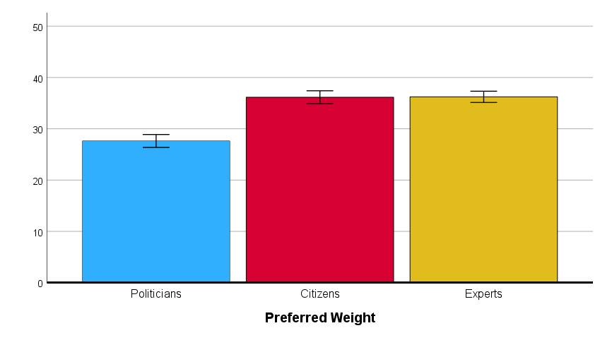
Note. N = 201. The error bars reflect the standard errors.
Perceived actor contributions
We subsequently conducted a repeated measure ANOVA in which the three actors (politicians, citizens, experts) and the three legitimacy dimensions (input, throughput, output) were included as within-subject factors. The results of this analysis, which are displayed in Table 3, show that the significant main effects of Actor and Legitimacy Dimension were qualified by a significant two-way interaction. This significant two-way interaction (see Figure 2) was further analyzed using simple effects tests (see Table 4).

TABLE 3. Results of the repeated measure ANOVA with Actor and Legitimacy Dimension as within-subjects variables (Study 1).
 | F | df | p | η²_{p}
Actor | 76.18 | 2, 199 | < .001 | .434
Legitimacy Dimension | 5.06 | 2, 199 | .007 | .048
Actor × Legitimacy Dimension | 54.10 | 4, 197 | < .001 | .523
Note. N = 201.
TABLE 4. Mean legitimacy scores (and standard deviations) as a function of Actor and Legitimacy Dimension (Study 1).
 |  | Actor
 |  | Politicians | Citizens | Experts
Legitimacy  Dimension | Input | 5.12 (2.41)_{a} | 7.75 (2.00)_{b} | 6.09 (2.40)_{c}
 | Throughput | 4.51 (2.63)_{a} | 7.02 (2.06)_{b} | 6.87 (2.72)_{b}
 | Output | 4.80 (2.38)_{a} | 6.05 (2.16)_{b} | 7.77 (1.96)_{c}
Note. N = 201. Means with different subscripts in the same row are significantly different at p < .05.
As visualized in Figure 2, the involvement of citizens is considered to contribute the most to the input dimension, followed by that of experts, and the lowest score for politicians (all ps < .001; see Table 4). Involvement of citizens and experts is considered to equally contribute to the throughput dimension (p = .383), and both significantly more than politicians (both ps < .001). Whereas involvement of experts is considered to contribute the most to the output dimension, followed by citizens, and the lowest score for politicians (all ps < .001). Of the three actors, politicians are thus clearly the ones who are believed to contribute the least to all three legitimacy dimensions.

FIGURE 2. Perceived actor contributions: Two-way interaction between Actor and Legitimacy Dimension (Study 1).
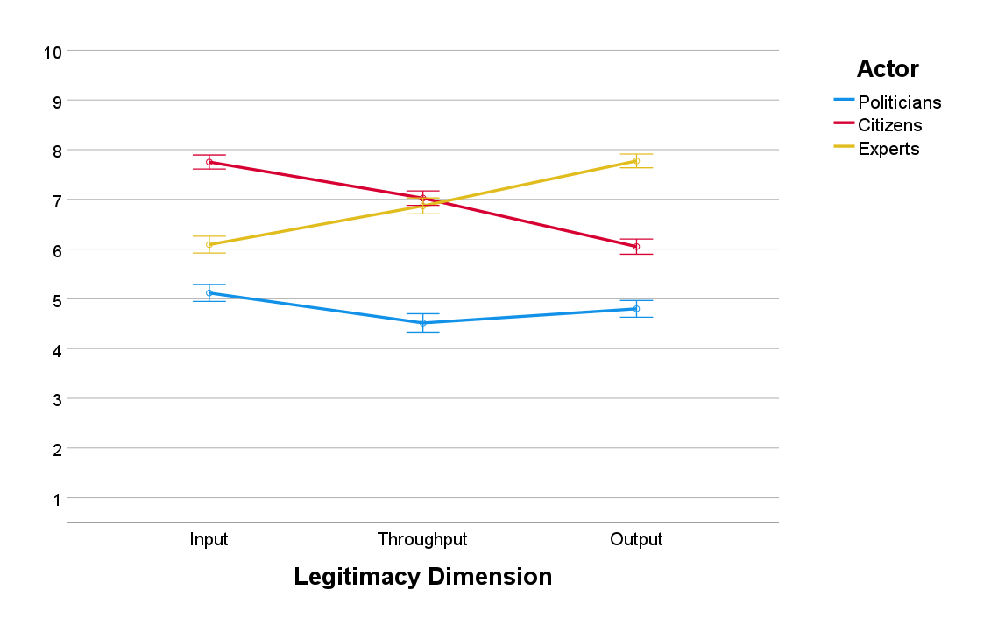
Note. N = 201. The error bars reflect the standard errors.
Study 2
Preferred actor weights
For our second study, we first examined if participants’ preferred actor weights are dependent on the case type. Our results show that, in the technical case condition (see Panel A of Figure 3), respondents preferred experts (M = 47.22, SD = 15.19) to have a significantly higher weight than citizens (M = 34.63, SD = 12.99), and citizens to have a significantly higher weight than politicians (M = 18.15, SD = 11.30) in deciding how to redesign the road infrastructure (all ps < .001). Conversely, in the ideological case condition (see Panel B of Figure 3), respondents preferred citizens (M = 43.07, SD = 16.24) to have a significantly higher weight than experts (M = 37.98, SD = 14.29), and experts to have a significantly higher weight than politicians (M = 18.96 SD = 13.27) in deciding where to build a new mosque (all ps < .002).
FIGURE 3. Preferred actor weights in function of the two different case types (Study 2).
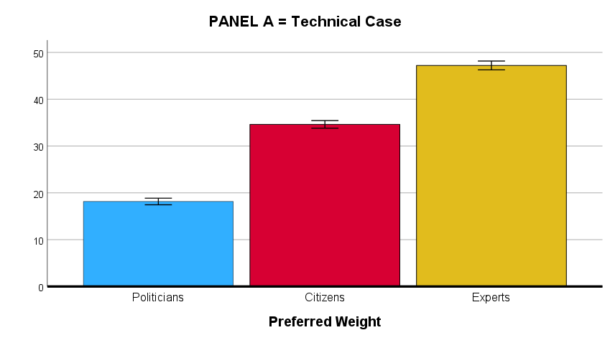
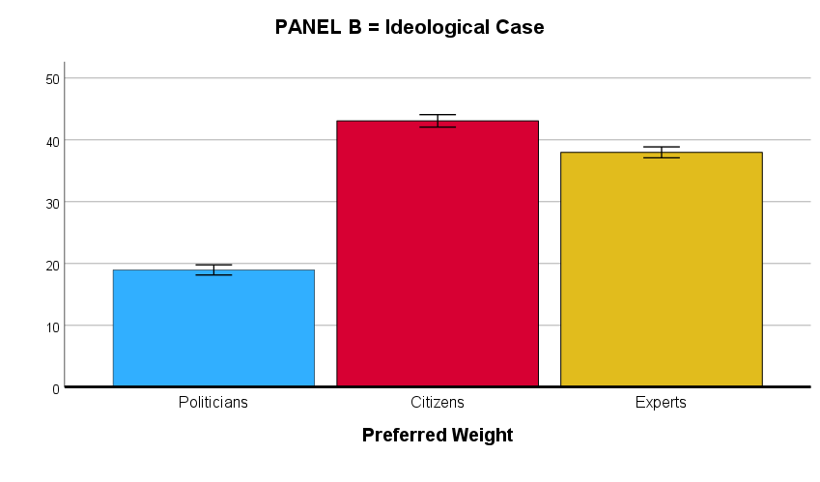
Note. Panel A: N = 259; Panel B: N = 260. The error bars reflect the standard errors.
Perceived actor contributions
We next conducted a repeated measure ANOVA in which the four actor combinations (Politicians & Citizens, Politicians & Experts, Citizens & Experts, Politicians & Citizens & Experts) and the three legitimacy dimensions (input, throughput, output) were included as within-subject factors and the two case types (technical vs. ideological) as the between-subject factor. As shown in Table 5, this analysis revealed a significant main effect of Actor Combination and Legitimacy Dimension, as well as a significant two-way interaction between Actor Combination and Legitimacy Dimension and between Actor Combination and Case Type. However, these effects were all qualified by a significant three-way interaction between Actor Combination, Legitimacy Dimension, and Case Type (see Figure 4), which was further analyzed using simple effect tests (see Table 6).
TABLE 5. Results of the repeated measure ANOVA with Actor Combination and Legitimacy Dimension as within-subjects variables and Case Type as between-subjects variable (Study 2).
 | F | df | p | η²_{p}
Actor Combination | 609.01 | 3, 515 | < .001 | .780
Legitimacy Dimension | 26.77 | 2, 516 | < .001 | .094
Case Type | 0.10 | 1, 517 | .750 | .000
Actor Combination × Legitimacy Dimension | 91.09 | 6, 512 | < .001 | .516
Actor Combination × Case Type | 7.09 | 3, 515 | < .001 | .040
Legitimacy dimension × Case Type | 2.88 | 2, 516 | .057 | .011
Actor Combination × Legitimacy Dimension × Case Type | 4.28 | 6, 512 | < .001 | .048
Note. N = 519.
TABLE 6. Mean legitimacy scores (and standard deviations) as a function of Actor Combination, Legitimacy Dimension, and Case Type (Study 2).
 |  | Actor Combination
 |  | Pol & Cit | Pol & Exp | Cit & Exp | Pol & Cit & Exp
Technical case condition (n = 259)
Legitimacy  Dimension | Input | 5.98 (2.24)_{a} | 3.58 (2.19)_{b} | 7.81 (1.84)_{c} | 8.91 (1.35)_{d}
 | Throughput | 5.68 (2.28)_{a} | 4.10 (2.26)_{b} | 7.69 (1.81)_{c} | 8.31 (1.64)_{d}  4)
 | Output | 4.46 (2.22)_{a} | 5.39 (2.20)_{b} | 7.55 (1.83)_{c} | 8.05 (1.63)_{d}
Ideological case condition (n = 260)
Legitimacy  Dimension | Input | 6.52 (2.22)_{a} | 3.58 (2.37)_{b} | 8.01 (1.56)_{c} | 8.71 (1.47)_{d}
 | Throughput | 5.94 (2.19)_{a} | 3.89 (2.40)_{b} | 7.76 (1.64)_{c} | 8.11 (1.76)_{d}
 | Output | 5.28 (2.26)_{a} | 4.98 (2.24)_{a} | 7.43 (1.71)_{b} | 7.71 (2.00)_{c}
Note. N = 519. Pol = politicians, Cit = citizens, Exp = experts. Means with different subscripts in the same row are significantly different at p < .05.
Figure 4 illustrates that the technical case (Panel A) and the ideological case (Panel B) were rated almost identical by the participants, with one notable exception (see below). First and foremost, for both case types, we found that the combination in which all three actors are involved is considered to contribute significantly more to all three legitimacy dimensions than any of the other combinations which combined two of the three actors (all ps < .001; see Table 6). When subsequently comparing the different two-actor combinations with each other, for both case types, it was found that the combination of Citizens & Experts is considered to contribute significantly more to all three legitimacy dimensions than the Politicians & Citizens combination and the Politicians & Experts combination (all ps < .001). A further comparison of these latter two combinations revealed that, for both case types, the combination of Politicians & Citizens is considered to contribute significantly more to both the input and the throughput dimension than the combination of Politicians & Experts (all ps < .001). However, for the output dimension, a small difference was found between the two case conditions in terms of how participants rated the Politicians & Citizens combination versus the Politicians & Expert combination. That is, in the technical case condition (see Figure 4; Panel A), the Politicians & Experts combination is considered to contribute significantly more to the output dimension than the Politicians & Citizens combination (p < .001); whereas in the ideological case condition (see Figure 4; Panel B), no significant differences were found between these two combinations in terms of perceived output legitimacy (p = .086).
This latter finding clarifies that the significant three-way interaction is actually driven by the difference between two specific combinations (i.e., the Politicians & Citizens combination and the Politicians & Experts combination) on only the output legitimacy dimension for the technical vs. ideological case condition, with the rest of the pattern being virtually identical in the two case type conditions.
FIGURE 4. Perceived actor contributions: Three-way interaction between Actor Combination, Legitimacy Dimension, and Case Type (Study 2).
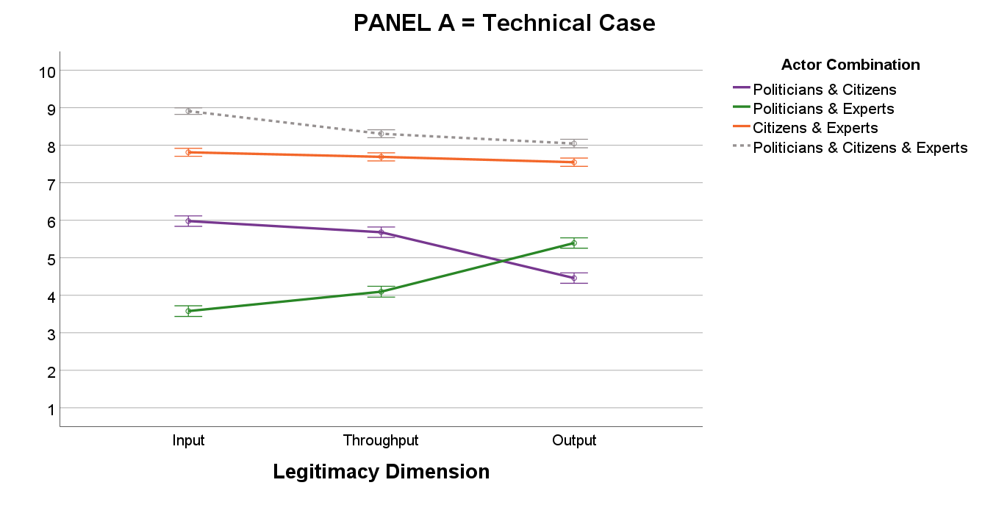

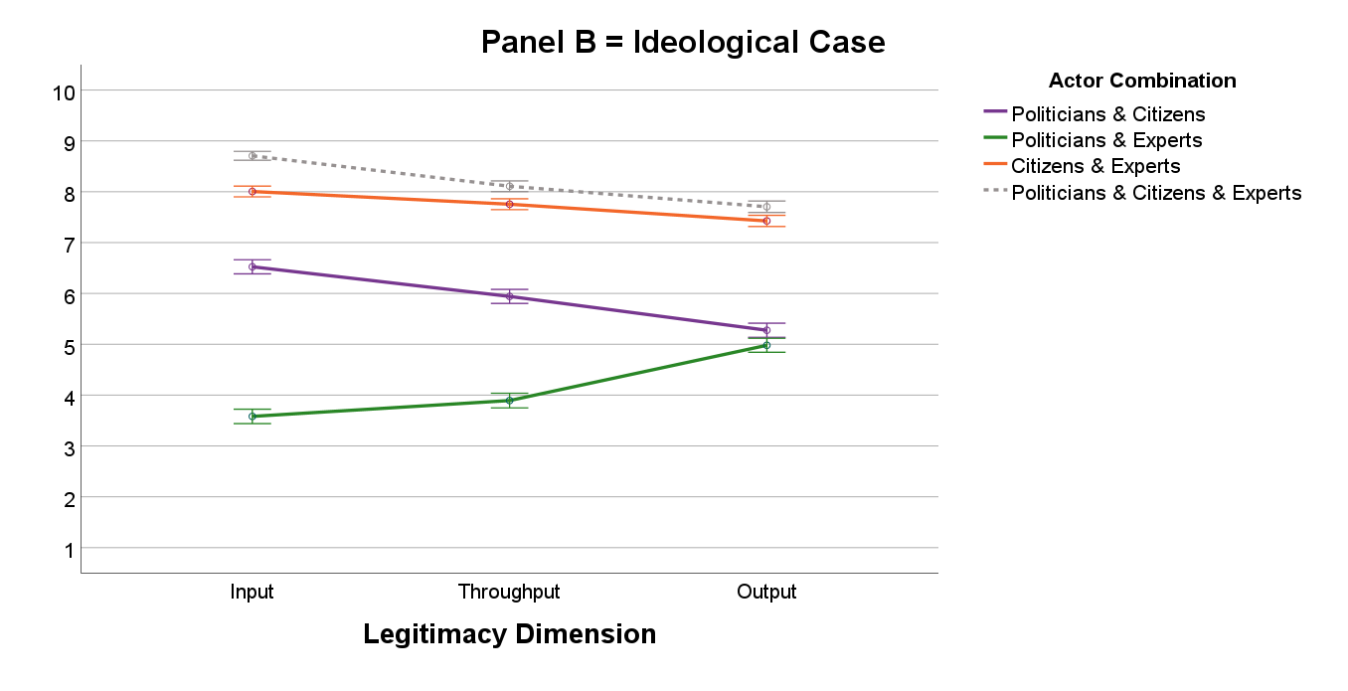
Note. Panel A: N = 259; Panel B: N = 260. The error bars reflect the standard errors.
Additional analysis based on the difference scores
As an additional robustness test, we also explored the contribution of each individual actor, by subtracting each two-actor combination from the three-actor combination. The resulting difference scores, which are visualized in Figure 5, largely echo the data pattern that we found in Study 1 (comparison between Figure 2 and Figure 5). In this vein, the most apparent difference between the two case types is that in the technical case condition experts are considered to contribute significantly more to the output dimension than citizens and experts (both ps < .001). Whereas in the ideological case condition, experts and citizens were found to contribute equally to the output dimension (p = .086), and both significantly more than politicians (both ps < .001).
FIGURE 5. Perceived actor contributions (based on the calculated difference scores): Three-way interaction between Actor, Legitimacy Dimension, and Case Type (Study 2).
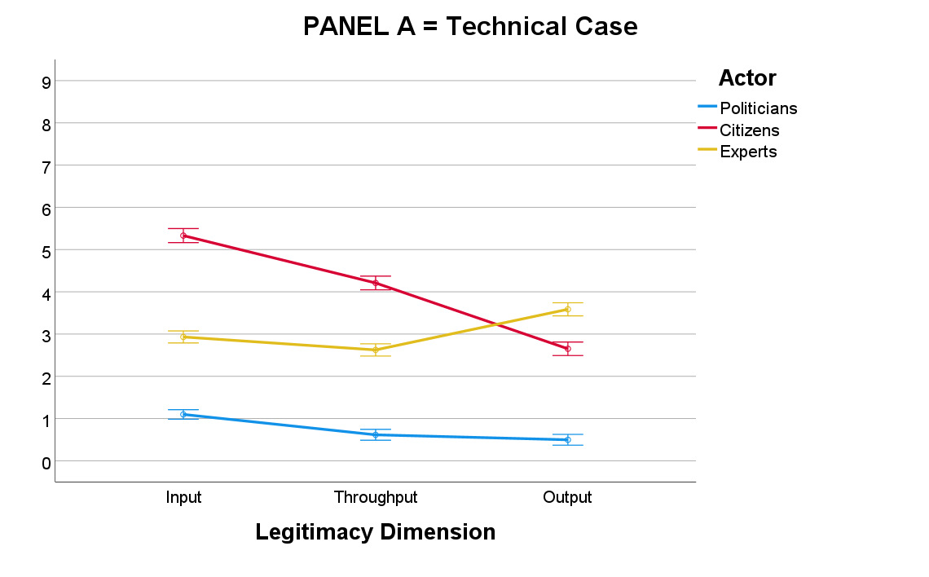

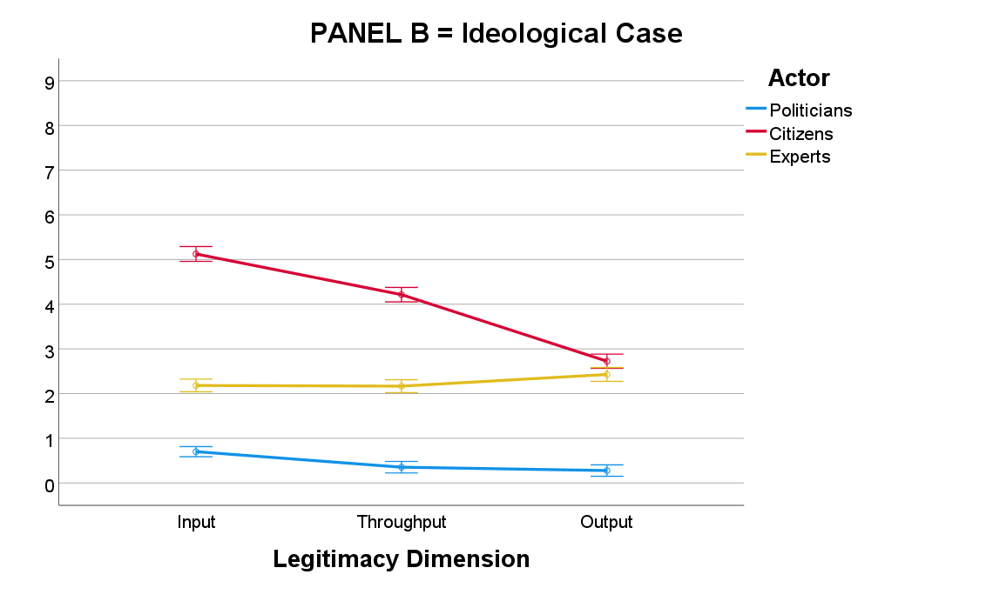
Note. Panel A: N = 259; Panel B: N = 260. The error bars reflect the standard errors. Politicians = [Politicians & Citizens & Experts] minus [Citizens & Experts]. Citizens = [Politicians & Citizens & Experts] minus [Politicians & Experts]. Experts = [Politicians & Citizens & Experts] minus [Politicians & Citizens].
DISCUSSION
It is often said that traditional representative democracy is in decline or even in crisis (Dalton, 2014; Flinders et al., 2019). In reaction to this, we are increasingly seeing calls for a more participatory version of democracy (see Cain et al., 2003; Scarrow, 2001), or for greater involvement of independent expertise in the policy decision-making process (see Bertsou, 2022; Hibbing & Theiss-Morse, 2002). However, how the balance in such ‘multi-actor involvements’ should look like according to the public remains unclear. Moreover, we also do not know how people evaluate the contribution of each of these different actors in terms of input, throughput, and output legitimacy (Hendriks, 2022; Schmidt, 2013), and whether people’s preferences in this regard depend on the issue at hand. The present study examined these three issues among UK respondents.
Theoretical Contributions
Given that different actors can be expected to compete with each other for influence, our first research objective (RO1) was to unravel how UK respondents want decisional power to be balanced between politicians, citizens, and experts. A first interesting finding in this regard is that our respondents generally prefer that all three actors have a considerable say in policy decisions. This observation is in line with recent calls for more ‘hybrid’ forms of democracy (see Goldberg et al., 2020; Pilet et al., 2020; also see Font et al., 2015; Hendriks, 2010), in which different democratic actors are simultaneously engaged in the policy-making process. What is new, however, is that, by employing a constant-sum approach, we were able to directly compare the relative importance that people ascribe to each of these three actors. When comparing the preferred relative weight of politicians, citizens, and experts, in both our studies, we found that respondents consistently preferred citizens and experts to have a significantly higher decisional weight than politicians.
Because the legitimacy concept has increasingly been conceptualized as consisting of an input, throughput, and output dimension (see Haggart & Keller, 2021; Hendriks, 2022; Starke & Lünich, 2020), as a second research objective (RO2), we set out to investigate to what extent the involvement of politicians, citizens, and experts is perceived by UK respondents as contributing to each of these three dimensions. As expected, both our studies clearly demonstrated that, of the three actors, citizens are considered to contribute most to input legitimacy (i.e., inclusiveness of people and viewpoints). Yet, experts were seen as contributing more to the input dimension than politicians. For the throughput dimension (i.e., transparency and fairness), the results show that citizens and experts were seen as contributing more than politicians. No differences were found between citizens’ and experts’ perceived contributions to the throughput dimension in Study 1, while in Study 2 citizens were seen as contributing more to throughput than experts. Finally, of the three actors, experts are considered to contribute most in terms of output legitimacy (i.e., effectiveness and efficiency of policy decisions), especially for technical issues. Yet, citizens were consistently seen as contributing more to output legitimacy than politicians. Table 7 outlines how our theoretical predictions concerning people’s perceived actor contributions align with our empirical findings.

TABLE 7. Overview of how our theoretical predictions concerning people’s perceived actor contributions align with our empirical findings.
Legitimacy dimension | Theoretical predictions | Empirical findings
Input | Citizens > Politicians > Experts | Citizens > Experts > Politicians
Throughput | Citizens = Experts > Politicians | Citizens ≥ Experts > Politicians
Output | Experts > Politicians > Citizens | Experts ≥ Citizens > Politicians

As a third research objective (RO3), in our second study we also examined if citizens’ relative support for and perceived contributions of the different decision-makers depend on the specific issue at hand. In line with our predictions, regarding people’s preferred actor weights (our first dependent variable), we indeed found that people generally prefer experts to outweigh citizens and politicians for more technical issues and citizens to outweigh experts and politicians for more ideological issues. These observations also corroborate prior research of Wojcieszak (2014), which has shown that preferences for different decision-makers are indeed issue-specific (also see Bertsou, 2022; Vittori et al., 2023, for similar findings). Furthermore, in terms of people’s perceived actor contributions (our second dependent variable), no pronounced differences were found between the technical and ideological issues, with exception of the perceived contribution of experts to the output dimensions (which was considerably larger in the technical case condition than in the ideological case condition).
Importantly, however, although we consistently found that citizens assign the least decisional weight to politicians and perceive them as making the smallest contributions to all three legitimacy dimensions, this does not imply that people want to exclude politicians entirely from the policy decision-making process. In fact, the most important finding of our research is that, in our second study – in which we explored how different actor combinations contribute to the three legitimacy dimensions – it was found that the three-actor combination (in which politicians, citizens, and experts are all three involved in the policy decision-making process) was rated significantly more positive than all possible two-actor combinations. Interestingly, this finding occurred for all three legitimacy dimensions and for both the technical and ideological case, attesting to the robustness of this important finding.
Implications for Practitioners
Besides these theoretical implications, the results of our studies also offer some valuable insights to practitioners. In fact, if policymakers want to be able to react responsively to people’s preferences and wishes, it is crucial that they know what the general public actually wants. In this vein, our findings indicate that, in general, people still see a role for elected politicians, but, in order for the decision-making process to be perceived as legitimate, it is important that citizens and experts are both also explicitly involved in the policy-making process. Indeed, our findings indicate that such a ‘hybrid’ mixture of politician, citizen, and expert involvement is perceived as the most legitimate by the UK citizens in our samples.
Although our findings indicate that, overall, people seem to prefer a ‘hybrid’ model of governance that combines these three actors in shaping policy decisions, it is important to note that prior studies have shown that that not all citizens are in favor of giving a greater role to citizens and/or experts, at the expense of politicians (e.g., Pilet et al., 2020). A closer look at our data concerning people’s preferred actor weights (our first dependent variable) shows that in both our studies a small minority of participants (less than 10%) preferred politicians to have an absolute say in the policy decisions (i.e., 100% politician weight). As such, policymakers should be made aware there is also some diversity in how people want the balance in the decisional power of politicians, citizens, and experts to look like.
Finally, our results illustrate that the extent in which people prefer the different actors to be involved in policy decisions also depends on the specific issue at hand, with people generally preferring experts to have most say for more technical issues and citizens to have most say for more ideological issues. This makes it a difficult exercise for policymakers to find the right balance between politician, citizen, and expert involvement. A such, in order to maximize perceived legitimacy of policy decisions by the citizenry, it is important that the decision-making process (and the communication thereof) is tailored in such a way that it corresponds with citizens’ issue-specific preferences and wishes.

Strengths, Limitations, and Directions for Future Research
Of course, the present study is not without its limitations. A first limitation of our work is that both our studies were conducted among respondents from one single country: the United Kingdom. As such, an important avenue for future research might be to examine whether country-specific factors may underlie the presently obtained findings, and whether these findings can also be generalized to other countries. One factor that might be particularly relevant in this regard concerns the amount of general trust that people have in the differ actors. Across our two studies, participants consistently assigned the least decisional weight to politicians and perceived them as making the smallest contributions across all three legitimacy dimensions. These findings might, at least in part, be explained by UK citizens’ current low overall trust in politicians, juxtaposed with their relatively high trust in fellow citizens. Indeed, according to the Office for National Statistics data (Trust in Government, UK, 2022), only 35% of the UK population stated that they trusted their national government, which is lower than the OECD average of 41%. In contrast, 75% of the UK population reported trusting other people, surpassing the OECD average of 67%.
Another important consideration in this regard concerns the specific nature of the UK’s electoral system. The UK uses the First-Past-the-Post (FPTP) system (Curtice, 2009) for the election of Members of Parliament to the House of Commons as well as for some local government elections. In contrast, most European countries (e.g., Sweden, Spain, Netherlands, Belgium, etc.) use proportional representation (PR) systems (see Palese, 2018), which aim to ensure that the distribution of parliamentary seats reflects the proportion of votes each party receives, thereby resulting in more diverse party landscapes and coalition governments. The UK’s reliance on the FPTP system (in which only the candidate with the most votes secures representation while all other candidates, regardless of how close their vote counts are, receive no representation) might be part of the explanation why politicians’ contribution to the input dimension of legitimacy were rated so low in our study. In light of these considerations, we believe that it is warranted to also conduct similar studies in other national contexts and/or by means of cross-country comparisons in order to verify if the present findings also extend beyond the UK case.
Another limitation is that our research focused only on decision-making by local governments, as it is possible that peoples’ preferences for different decision-makers may change depending on the level of government. Future research is therefore encouraged to examine if the presently obtained findings can also be generalized to other governmental levels, such as the regional/state level and/or the national/federal level. Moreover, in the present research we only examined policy decisions that were either more technical or more ideological in nature, whereas in reality policy issues can also be both (or neither). Indeed, many policy issues that deal with highly technical matters can, at least to some extent, also be ideologically-charged. We therefore encourage future research to also examine how such a ‘blend’ of technical and ideological aspects may impact people’s preference patterns.
A particular strength of our research, however, is that, by asking respondents to assign specific percentages to politicians, citizens, and experts (based on their preferred involvement in policy decisions), we were able to directly compare the relative amount of decisional weight that people prefer these three actors to have in the policy decision-making process. To our knowledge, no prior studies in this domain have undertaken such an endeavor. Yet, a drawback of this rather ‘abstract approach’ is that it remains unclear how these percentages may translate into concrete operationalizations in policy-making. Future research is needed to investigate in which particular role and/or through which specific means citizens and experts can best be integrated in the policy-making process. For instance, should citizens and experts be given a consultative or a decisional role in policy decisions? And do people prefer all citizens to voice their opinion in a referendum, or do they prefer a group of citizens to deliberate in a citizen panel? Similarly, do people prefer experts to be employed as cabinet advisers of government ministers, or do they prefer experts to be occasionally solicited by government ministers? These are the types of questions future research may focus on.
A final issue that we would like to be mentioned here is that in our study we only examined preferences for different decision-makers from the citizen perspective. How politicians and experts think about the present issues remains unclear. In this vein, we believe that an interesting avenue for future research is to investigate how much decisional weight the three actors should have according to politicians and experts, as well as how they see the contributions of the three actors in terms of the different legitimacy dimensions.
CONCLUSION
The main goal of our studies was to gain a better insight in the debate on the extent to which politicians, citizens, and experts should be involved in policy-making decisions. In their recent paper, Hibbings and colleagues (2023, p. 4) noted that “much of this debate is quite detached from information concerning what the people themselves actually want” (p. 4). Our findings illustrate that most of our UK respondents clearly want these three actors to simultaneously be involved in the policy decision-making process, but each with a different relative weight. As such, it can be concluded that a more ‘hybrid’ form of democracy, in which participatory mechanisms and expert opinions exist alongside representative democracy, is what most respondents in our samples seem to desire. Future studies are, however, needed to verify if (and to what extent) the present findings can be transferred to other countries as well.

Declaration of Interest
The authors declare that they have no competing interest.

REFERENCES
Barceló, J., Sheen, G. C. H., Tung, H. H., & Wu, W. C. (2023). Experts or politicians? Citizen responses to vaccine endorsements across five OECD countries. Public Opinion Quarterly, 87: 142-155.
Bengtsson, Å., & Christensen, H. (2016). Ideals and actions: Do citizens’ patterns of political participation correspond to their conceptions of democracy? Government and Opposition, 51: 234-260.
Bengtsson, Å., & Mattila, M. (2009). Direct democracy and its critics: Support for direct democracy and ‘stealth’ democracy in Finland. West European Politics, 32: 1031-1048.
Bertsou, E. (2022). Bring in the experts? Citizen preferences for independent experts in political decision‐making processes. European Journal of Political Research, 61: 255-267.
Bertsou, E., & Caramani, D. (2022). People haven't had enough of experts: Technocratic attitudes among citizens in nine European democracies. American Journal of Political Science, 66: 5-23.
Bertsou, E., & Pastorella, G. (2017). Technocratic attitudes: A citizens’ perspective of expert decision-making. West European Politics, 40: 430-458.
Bowler, S., Donovan, T., & Karp, J. A. (2007). Enraged or engaged? Preferences for direct citizen participation in affluent democracies. Political Research Quarterly, 60: 351-362.
Bundi, P., & Pattyn, V. (2023). Trust, but verify? Understanding citizen attitudes toward evidence‐informed policy making. Public Administration (online first).
Cain, B. E., Dalton, R. J., Cain, B., Scarrow, S. E., and Scarrow, S. E. (2003). Democracy Transformed? Expanding Political Opportunities in Advanced Industrial Democracies. Oxford: Oxford University Press.
Carmines, E.G. & Stimson, J.A. (1980). The two faces of issue voting. American Political Science Review, 74: 78-91.
Christensen, J. (2021). Expert knowledge and policymaking: A multi-disciplinary research agenda. Policy & Politics, 49: 455-471.
Coffé, H., & Michels, A. (2014). Education and support for representative, direct and stealth democracy. Electoral Studies, 35: 1-11.
Curtice, J. (2009) Neither representative nor accountable: first-past-the-post in Britain. In Duverger’s Law of plurality voting. New York: Springer.
Dalton, R. (2004). Democratic Challenges, Democratic Choices: The Erosion of Political Support in Advanced Industrial Democracies. Oxford: Oxford University Press.
Dalton, R. J., Burklin, W. P., & Drummond, A. (2001). Public opinion and direct democracy. Journal of Democracy, 12: 141-153.
Dalton, R., & Weldon, S. (2005). Public images of political parties: a necessary evil? West European Politics, 28: 931-951.
De Fine Licht, J., Naurin, D., Esaiasson, P., & Gilljam, M. (2014). When Does Transparency Generate Legitimacy? Experimenting on a Context-Bound Relationship. Governance, 27: 111-134.
Donovan, T., & Karp, J. A. (2006). Popular support for direct democracy. Party Politics, 12: 671-688.
Douglas, B. D., Ewell, P. J., & Brauer, M. (2023). Data quality in online human-subjects research: Comparisons between MTurk, Prolific, CloudResearch, Qualtrics, and SONA. Plos one, 18(3), e0279720.
Dudek, F. J., & Baker, K. E. (1956). The constant-sum method applied to scaling subjective dimensions. The American Journal of Psychology, 69: 616-624.
Dür, A. (2008) Measuring interest group influence in the EU: a note on methodology, European Union Politics, 9: 559-576.
Elstub, S. & Escobar, O. (2019). Defining and Typologising Democratic Innovations. In: Elstub, S. & Escobar, O. (Eds). Handbook of Democratic Innovation and Governance. Cheltenham: Edward Elgar Publishing.
Escobar, O. & Elstub, S. (2019): Introduction to the Handbook of Democratic Innovation. In: Elstub, S. & Escobar, O. (Eds): Handbook of Democratic Innovation and Governance. Cheltenham: Edward Elgar Publishing.
Fernández-Martínez, J. L., & Font Fábregas, J. (2018). The devil is in the detail: What do citizens mean when they support stealth or participatory democracy? Politics, 38, 458-479.
Flinders, M., Wood, M., & Corbett, J. (2019). Anti-politics and democratic innovation. In: Elstub, S. & Escobar, O. (Eds). Handbook of Democratic Innovation and Governance. Cheltenham: Edward Elgar Publishing.
Font J., Wojcieszak, M., & Navarro, C. J. (2015). Participation, representation and expertise: Citizen preferences for political decision-making processes. Political Studies, 63: 153-172.
Gherghina, S., & Geissel, B. (2017). Linking democratic preferences and political participation: Evidence from Germany. Political Studies, 65: 24-42.
Gherghina, S., & Geissel, B. (2019). An alternative to representation: Explaining preferences for citizens as political decision-makers. Political Studies Review, 17: 224-238.
Gherghina, S., & Geissel, B. (2020). Support for direct and deliberative models of democracy in the UK: Understanding the difference. Political Research Exchange, 2, 1809474.
Goldberg, S., Wyss, D., & Bächtiger, A. (2020). Deliberating or thinking (twice) about democratic preferences: What German citizens want from democracy. Political Studies, 68: 311-331.
Grönlund, K., & Setälä, M. (2007). Political trust, satisfaction, and voter turnout. Comparative European Politics, 5: 400-422.
Grossman, E., and Sauger, N. (2017). Pourquoi Détestons-nous Autant nos Politiques? Paris: Presses de Sciences Po.
Haesevoets, T., Roets, A., Steyvers, K., Verschuere, B., & Wauters, B. (2023a). Towards a multifaceted measure of perceived legitimacy of participatory governance. Governance, 1-18.
Haesevoets, T., Roets, A., Van Severen, R., Dierckx, K. & Verschuere, B. (2023b). The public’s preferred level of involvement in local policy-making. Scientific Reports, 13(7146).
Haggart, B., & Keller, C. I. (2021). Democratic legitimacy in global platform governance. Telecommunications Policy, 45: 102152.
Hay, C. (2007).Why We Hate Politics. London: Polity Press.
Hendriks, F. (2010). Vital Democracy A Theory of Democracy in Action. Oxford University Press, USA.
Hendriks, F. (2022). Key values for democratic governance innovation: Two traditions and a synthesis. Public Administration, 100: 803-820.
Hibbing, J., & Theiss-Morse, E. (2002). Stealth Democracy. Americans’ Beliefs About How Government Should Work. Cambridge: Cambridge University Press.
Hibbing, J. R., Theiss-Morse, E., Hibbing, M. V., & Fortunato, D. (2023). Who do the people want to govern? Party Politics, 29: 3-15.
Irvin, R. A., & Stansbury, J. (2004). Citizen participation in decision making: is it worth the effort? Public Administration Review, 64: 55-65.
Jones, H., Jones, N., Shaxson, L., & Walker D. (2013). Knowledge, Policy and Power in International Development: A Practical Framework for Improving Policy. London: ODI.
Kostelka, F., Singh, S. P., & Blais, A. (2022). Is compulsory voting a solution to low and declining turnout? Cross-national evidence since 1945. Political Science Research and Methods, 1-18.
Landemore, H. (2017). Deliberative democracy as open, not (just) representative democracy. Daedalus, 146: 51-63.
March, J. G. (1955). An introduction to the theory and measurement of influence. American Political Science Review, 49: 431-451.
Marien, S. (2011). Measuring political trust across time and space. In S. Zmerli, and M. Hooghe (Eds) Political Trust. Why Context Matters (pp. 13-46). Colchester: ECPR Press.
Moran, M. (2017). Politics and Governance in the UK. Bloomsbury Publishing.
Neblo, M. A., Esterling, K. M., Kennedy, R. P., Lazer, D. M., & Sokhey, A. E. (2010). Who wants to deliberate - And why? American Political Science Review, 104: 566-583.
Norris, P., & Inglehart, R. (2019). Cultural backlash: Trump, Brexit, and authoritarian populism. Cambridge University Press.
OECD (2022). Building Trust to Reinforce Democracy. Available online: https://www.oecd.org/governance/trust-in-government/oecd-trust-survey-main-findings-en.pdf.
Office for National Statistics (2021). 2021 Census data. Available online: https://www.ons.gov.uk/.
Palan, S., & Schitter, C .(2018). Prolific. ac—A subject pool for online experiments. Journal of Behavioral and Experimental Finance, 17: 22-27.
Palese, M. (2018). Which European countries use proportional representation? Electoral Reform Society. Available online: https://www.electoral-reform.org.uk/which-european-countries-use-proportional-representation/.
Pateman, C. (2012). Participatory democracy revisited. Perspectives on Politics, 10: 7-19.
Peer, E., Brandimarte, L., Samat, S., & Acquisti, A. (2017). Beyond the Turk: Alternative platforms for crowdsourcing behavioral research. Journal of Experimental Social Psychology, 70, 153-163.
Peer, E., Rothschild, D., Gordon, A., Evernden, Z., & Damer, E. (2023). Data quality of platforms and panels for online behavioral research. Behavior Research Methods, 1.
Pew Research Center (2017). Globally, Broad Support for Representative and Direct Democracy. Available online: https://www.pewresearch.org/global/2017/10/16/
globally-broad-support-for-representative-and-direct-democracy/.
Pew Research Center (2019). Many Across the Globe Are Dissatisfied With How Democracy Is Working. Available online: https://www.pewresearch.org/global/2019/04/29/many-across-the-globe-are-dissatisfied-with-how-democracy-is-working/.
Pew Research Center (2023). Public Trust in Government: 1958-2023. Available online: https://www.pewresearch.org/politics/2023/09/19/public-trust-in-government-1958-2023/.
Pharr, S. J., & Putnam R. D. (2000). Disaffected Democracies: What’s Troubling the Trilateral Countries? Princeton, NJ: Princeton University Press.
Pilet, J. B., Talukder, D., Sanhueza, M. J., & Rangoni, S. (2020). Do citizens perceive elected politicians, experts and citizens as alternative or complementary policy-makers? A study of Belgian citizens. Frontiers in Political Science, 2: 567297.
Pilet, J.-B., Vittori, D., Rojon, S., & Paulis, E. (2023). Who do Europeans want to govern? Exploring the multiple dimensions of citizens’ preferences for political actors in nine European countries. Party Politics, 13540688231153932.
Pitkin, H. (1967). The Concept of Representation. Berkeley and Los Angeles: University of California Press.
Rapeli, L. (2016). Public support for expert decision-making: evidence from Finland. Politics, 36: 142-152.
Roberts, N. (2004). Public deliberation in an age of direct citizen participation. American Review of Public Administration, 34: 315-353
Rooduijn, M., van Kessel, S., Froio, C., Pirro, A., De Lange, S., Halikiopoulou, D., Lewis, P., Mudde, C., & Taggart, P. (2019). The PopuList: an overview of populist, far right, far left, and Eurosceptic parties in Europe. Available online: https://popu-list.org.
Scarrow, S., 2001. Direct democracy and institutional change. A comparative investigation. Comparative Political Studies, 34: 651-665.
Scharpf, F. (1999). Governing in Europe: Effective and Democratic? Oxford: Oxford University Press.
Schmidt, V. (2013). Democracy and legitimacy in the European union revisited: input, output and ‘throughput’. Political Studies, 61: 2-22.
Starke, C., & Lünich, M. (2020). Artificial intelligence for political decision-making in the European Union: Effects on citizens’ perceptions of input, throughput, and output legitimacy. Data & Policy, 2: e16.
Strebel, M., Kübler, D. & Marcinkowski, F. (:). The Importance of Input and Output Legitimacy in Democratic Governance: Evidence From a Population-Based Survey Experiment in Four West European Countries. European Journal of Political Research, 58, 488-513.
Tormey, S. (2014). The contemporary crisis of representative democracy. Democratic Theory, 1: 104-112
Trust in Government, UK (2022). Office for National statistics. Available online: https://www.ons.gov.uk/peoplepopulationandcommunity/wellbeing/bulletins/trustingovernmentuk/2022
Van der Meer, T. W. G. (2017). Political Trust and the “Crisis of Democracy”. In W. R. Thompson (Ed.), Oxford Research Encyclopedia of Politics. Oxford University Press
Van Meerkerk, I., Edelenbos, J., & Klijn, E.-H. (2015). Connective management and governance network performance: the mediating role of throughput legitimacy. Findings from survey research on complex water projects in the Netherlands. Environment and Planning C: Government and Policy, 33: 746-764.
Vittori, D., Paulis, E., Pilet, J. B., & Rojon, S. (2023). Do technocrats boost the acceptance of policy proposals among the citizenry? Evidence from a survey experiment in Italy. Electoral Studies, 81: 102566.
Webb, P. (2013). Who is willing to participate? Dissatisfied democrats, stealth democrats and populists in the United Kingdom. European Journal of Political Research, 52: 747-772.
Wojcieszak, M. (2014). Preferences for Political Decision-Making Processes and Issue Publics. Public Opinion Quarterly, 78: 917-939.

Note that, in both our studies, we specifically referred to elected politicians, as such excluding other (non-elected) governmental actors such as those in the public administration.
Because of the overrepresentation of highly educated individuals in our sample, we have conducted some additional robustness tests to verify if the main findings of Study 1 hold for both low educated (did not graduate or only high school degree) and high educated (Bachelor’s degree, Master’s degree, or PhD) individuals. The results of these additional robustness analyses are provided in the Supplementary Materials (see Figures A1 and A2 of Appendix A).
See Figures B1 and B2 of Appendix B of the Supplementary Materials for details.
A separate pretest (N = 198 UK respondents; mean age = 39.25 [SD = 14.12], 50.5% female, 65.2% Bachelor’s degree or higher) was conducted through Prolific to verify if our technical case (road infrastructure example) is indeed perceived as more technical and less ideological than our ideological case (mosque example). As expected, the results of this pretest showed that respondents perceived the technical case as being significantly more technical than the ideological case (M = 5.96, SD = 1.18 vs. M = 4.21, SD = 1.77; p < .001); whereas the ideological case was seen as significantly more ideologically charged than the technical case (M = 5.05, SD = 1.68 vs. M = 3.09, SD = 1.58; p < .001). From these findings, it can be concluded that our case type manipulation indeed works as we intended.

