***In vitro* characterization of the pyrazole-carrying synthetic cannabinoid receptor agonist 5F-3,5-AB-PFUPPYCA and its structural analogs**

M.H. Deventer1, C. Norman2, R. Reid2, C. McKenzie2,3, N. Nic Daéid2, C.P. Stove1*

1 Laboratory of Toxicology, Department of Bioanalysis, Faculty of Pharmaceutical Sciences, Ghent University, Ghent, Belgium

2 Leverhulme Research Centre for Forensic Science, School of Science and Engineering, University of Dundee, Dundee, UK

3 Chiron AS, Trondheim, Norway

*Corresponding author

Laboratory of Toxicology

Faculty of Pharmaceutical Sciences

Ottergemsesteenweg 460

9000 Ghent

Belgium

Tel.: +32 9 264 81 35

Fax: +32 9 264 81 83

E-mail: [Christophe.Stove@UGent.be](mailto:Christophe.Stove@UGent.be)

Declarations of interest: none

**Abstract**

The synthetic cannabinoid receptor agonist (SCRA) market is undergoing important changes since the enactment of the 2021 class-wide generic SCRA ban in China, one of the most important source countries for new psychoactive substances (NPS). Recently, various compounds with new structural features, synthesized to bypass this legislation, have entered the recreational drug market. Certain monocyclic pyrazole-carrying “FUPPYCA” SCRAs have been sporadically detected since 2015 without gaining further popularity. However, as evidenced by their recent detection in Scottish prisons, 5F-3,5-AB-PFUPPYCA and 3,5-ADB-4en-PFUPPYCA have re-emerged, potentially triggered by the new legislative ban. The aim of this study was to characterize the *in vitro* intrinsic CB1 and CB2 receptor activation potential of 5F-3,5-AB-PFUPPYCA and 3,5-ADB-4en-PFUPPYCA, as well as 4 analogs (5F-3,5-ADB-PFUPPYCA, 3,5-AB-CHMFUPPYCA, 5,3-AB-CHMFUPPYCA and 5,3-ADB-4en-PFUPPYCA) using live cell β-arrestin 2 recruitment assays. Most analogs were essentially inactive at either CB1 or CB2, with only 3,5-AB-CHMFUPPYCA, 5,3-AB-CHMFUPPYCA and 5,3-ADB-4en-PFUPPYCA showing a limited activation potential at CB1. Furthermore, the importance of the position of the tail structure was demonstrated, with 5,3-regioisomers being more active than their 3,5-analogs. Moreover, all compounds exhibited antagonistic behavior at both receptors, which may be associated with their structural resemblance to cannabinoid antagonists and inverse agonists. Although the 3,5-regioisomers of these “FUPPYCA” SCRAs circumvent the Chinese ban, it is unlikely that these SCRAs will pose a major threat to public health, given the lack of pronounced CB receptor activity.

**Highlights**

* Generic ban-evading pyrazole FUPPYCA SCRAs have been detected in Scottish prisons.
* Activity at CB1 and CB2 receptor of 6 analogs was found to be limited.
* All tested compounds show signs of antagonism.

**Key words**

Bioassay, FUPPYCA, CB1 cannabinoid receptor, new psychoactive substances, synthetic cannabinoid receptor agonists

**Introduction**

One of the largest and most structurally diverse classes of new psychoactive substances (NPS) are synthetic cannabinoid receptor agonists (SCRAs)[1]. Their mechanism of action primarily consists of interacting with cannabinoid receptors (CB). The cannabinoid 1 (CB1) receptor subtype, through which SCRAs mimic the sought-after effects of Δ9-tetrahydrocannabinol (THC), the main component of cannabis, is mainly responsible for the psychoactive effects and is widely distributed throughout the central nervous system[2]. On the other hand, the cannabinoid 2 (CB2) receptor is present on cells associated with the immune system, where it is involved in the regulation of processes such as inflammation[2–4]. While THC has been associated with a rather limited acute toxicity[5], there have been reports of cases of severe adverse effects after SCRA use, such as agitation, hallucinations, cardiovascular toxicity, seizures, rhabdomyolysis, coma and death, as well as mass intoxications with highly potent SCRAs [6–8].

Most NPS, including SCRAs, are manufactured in China and shipped to distributors, sellers and consumers all over the world[9,10]. To disrupt this pattern, a stricter and future-proof legal framework was necessary, which led to the generic ban on fentanyl analogs in 2019[11] and on SCRAs in 2021[12]. Since the approval and enactment of the Chinese class-wide ban on SCRAs[12], a number of new substances designed to bypass this measure have made their way onto the recreational drug market. As the new Chinese SCRA legislation covers seven common scaffolds[13], there has been an increase in newly emerging SCRAs carrying diverse, often unknown core structures, as opposed to the typical indole and indazole. Recent examples of these compounds include previously unknown oxoindolin-bearing SCRAs, such as BZO-HEXOXIZID (MDA-19), BZO-POXIZID, 5F-BZO-POXIZID and BZO-CHMOXIZID, notified for the first time in the US, China, and Brazil in late 2021 [14–19]. Furthermore, SCRAs with a modified linker (in this case an additional methylene group linking the core structure to the head group), such as ADB-FUBIATA[20,21], CH-PIATA[22,23] and CH-FUBIATA[24], and compounds carrying a brominated core (ADB-5Br-INACA[25], ADB-5’Br-BUTINACA[26] and MDMB-5Br-INACA[27]) have been detected. Although these compounds currently make up a relatively small share in the very extensive SCRA market, structural analogs of the aforementioned substances as well as other ban-evading compounds can be anticipated to appear on the market at some point.

Another rather small group of SCRAs with distinct structural features are monocyclic pyrazole core-carrying compounds, of which 5F-5,3-AB-PFUPPYCA (AZ-037, N-(1-amino-3-methyl-1-oxobutan-2-yl)-1-(5-fluoropentyl)-5-(4-fluorophenyl)-1*H*-pyrazole-3-carboxamide) was the first to be notified to the EU Early Warning System (EWS), operated by the European Monitoring Centre for Drugs and Drugs Addiction (EMCDDA), in France in June 2015[10,28]. That same year a similar compound, 3,5-AB-CHMFUPPYCA (N-(1-amino-3-methyl)1-oxobutan-2-yl)-1-(cyclohexylmethyl)-3-(4-fluorophenyl-1*H*-pyrazole-5-carboxamide) appeared in dried herbal material in Japan (named AB-CHFUPYCA)[29]. In October 2018, the Center for Forensic Science Research and Education (CFSRE) (Willow Grove, PA, US) reported on the seizure of 5F-3,5-AB-PFUPPYCA (N-(1-amino-3-methyl-1-oxobutan-2-yl)-1-(5-fluoropentyl)-3-(4-fluorophenyl)-1*H*-pyrazole-5-carboxamide), the regioisomer of 5F-5,3-AB-PFUPPYCA[30]. More recently, in 2021, the EU EWS reported on the seizure of 5,3-AB-CHMFUPPYCA (N-[(1S)-1-(aminocarbonyl)-2-methylpropyl]-1-(cyclohexylmethyl)-5-(4-fluorophenyl)-1*H*-pyrazole-3-carboxamide), the 5,3 regioisomer of AB-CHFUPYCA/3,5-AB-CHMFUPPYCA, in Germany[31]. In general, this class of SCRAs apparently gained little popularity on the recreational drug market, as both literature and further information on seizures is scarce. Of interest is that 3,5-regioisomers of these pyrazole SCRAs bypass the Chinese generic ban, while 5,3-analogs are covered by this legislation. The pharmacological characteristics of these SCRAs remain poorly studied to this day. Analytical characterization of some compounds has been published, for instance Girreser *et al.* identified another analog, 5F-3,5-ADB-PFUPPYCA (N-(1-amino-3,3-dimethyl-1-oxobutan-2-yl)-1-(5-fluoropentyl)-3-(4-fluorophenyl)-1*H*-pyrazole-5-carboxamide) in a Russian sample of which the origin is unclear[32]. Uchiyama *et al.* and McLaughlin *et al*. analyzed 3,5-AB-CHMFUPPYCA, the latter identifying the substance in a sample that was incorrectly advertised as 5F-5,3-AB-PFUPPYCA, while also showing the synthesis and characterization of the regioisomer 5,3-AB-CHMFUPPYCA[29,33]. Furthermore, metabolism of these compounds was investigated by Franz *et al.*[34]*,* who also looked at their thermal stability, and more recently by Wagmann *et al.*[35]*.*

This study was inspired by the detection, as reported here, of two pyrazole SCRAs in seized samples from Scottish prisons in 2021 and 2022: 5F-3,5-AB-PFUPPYCA and another analog, 3,5-ADB-4en-PFUPPYCA ((S)-N-(1-amino-3,3-dimethyl-1-oxobutan-2-yl)-3-(4-fluorophenyl)-1-(pent-4-en-1-yl)-1*H*-pyrazole-5-carboxamide). The (re-)emergence of these SCRAs suggests a possibly rising interest in these compounds, potentially driven by the Chinese ban. Given the poor understanding of the pharmacology of these compounds, this study focused on the pharmacological characterization of a set of pyrazole SCRAs (5F-3,5-AB-PFUPPYCA, 5F-3,5-ADB-PFUPPYCA, 3,5-AB-CHMFUPPYCA, 5,3-AB-CHMFUPPYCA, 3,5-ADB-4en-PFUPPYCA and 5,3-ADB-4en-PFUPPYCA; structures are shown in **Figure 1**), using live cell CB1 and CB2 β-arrestin2 (βarr2) recruitment bioassays.

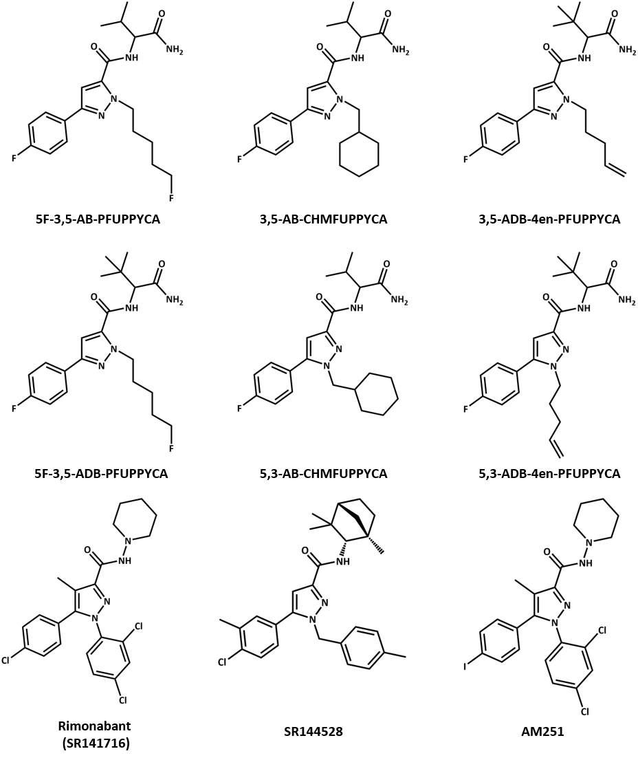

Figure 1: Chemical structures of the 6 SCRAs analyzed in this study and CB antagonists and/or inverse agonists rimonabant, SR144528 and AM251. Structures were made using ChemDraw 19 software.

**Materials and Methods**

*Materials and chemical reagents*

Dulbecco’s modified Eagle’s medium (DMEM) (GlutaMAXTM), Opti-MEM I Reduced Serum, penicillin, streptomycin and amphotericin B were procured from Thermo Fisher Scientific (Waltham, MA, USA). Fetal bovine serum (FBS), poly-D-lysine and dimethylsulfoxide (DMSO) were from Sigma-Aldrich (Darmstadt, Germany). The Nano-Glo® Live Cell reagent and the Nano-Glo® LCS Dilution buffer were purchased from Promega (Madison, WI, USA). Methanol was obtained from Chem-Lab NV (Zedelgem, Belgium). The reference standard CP55,940 was obtained from Sigma Aldrich, and JWH-018 was from LGC (Wesel, Germany). The reference standards for 5F-3,5-AB-PFUPPYCA (purity ≥98%) (N-[(1S)-1-(aminocarbonyl)-2-methylpropyl]-1-(5-fluoropentyl)-3-(4-fluorophenyl)-1*H*-pyrazole-5-carboxamide), 5F-3,5-ADB-PFUPPYCA (purity ≥98%) (N-[1-(aminocarbonyl)-2,2-dimethylpropyl]-1-(5-fluoropentyl)-3-(4-fluorophenyl)-1*H*-pyrazole-5-carboxamide), 3,5-ADB-4en-PFUPPYCA (purity ≥98%) ((S)-N-(1-amino-3,3-dimethyl-1-oxobutan-2-yl)-3-(4-fluorophenyl)-1-(pent-4-en-1-yl)-1*H*-pyrazole-5-carboxamide), 5,3-ADB-4en-PFUPPYCA (purity ≥98%) ((S)-N-(1-amino-3,3-dimethyl-1-oxobutan-2-yl)-5-(4-fluorophenyl)-1-(pent-4-en-1-yl)-1*H*-pyrazole-3-carboxamide), 3,5-AB-CHMFUPPYCA (purity ≥ 98%) ((S)-N-(1-amino-3-methyl-1-oxobutan-2-yl)-1-(cyclohexylmethyl)-3-(4-fluorophenyl)-1*H*-pyrazole-5-carboxamide) and 5,3-AB-CHMFUPPYCA (purity ≥98%) (N-[(1S)-1-(aminocarbonyl)-2-methylpropyl]-1-(cyclohexylmethyl)-5-(4-fluorophenyl)-1*H*-pyrazole-3-carboxamide) were kindly provided by Cayman Chemical (Ann Arbor, MI, USA).

Methanol, dichloromethane (high-performance liquid chromatography (HPLC) grade), and water (liquid chromatography-mass spectrometry (LC-MS) grade) were purchased from Fisher Scientific (Loughborough, UK). Bupivacaine and formic acid were obtained from Sigma Aldrich (Poole, UK). The reference standard for 5F-3,5-AB-PFUPPYCA (98.2% purity) used for seized sample analysis was obtained from Chiron (Trondheim, Norway). The reference standards for 3,5-ADB-4en-PFUPPYCA (purity ≥ 98%) and 5,3-ADB-4en-PFUPPYCA (purity ≥98%) were kindly provided by Cayman Chemical. The reference standard for ADB-BUTINACA (purity > 98%) (ADB-BINACA, N-[1-amino-3,3-dimethyl-1-oxobutan-2-yl]-1-butyl-1*H*-indazole-3-carboxamide) was synthesized and supplied by the Sutcliffe Group at Manchester Metropolitan University (Manchester, UK) as described previously[36].

*Detection in seized samples from prisons*

The extraction of SCRAs from infused papers, such as those commonly found within prison establishments, and analysis by gas chromatography-mass spectrometry (GC-MS) has been described previously[36,37]. In brief, paper samples were examined, photographed, and 2  1 cm2 samples were taken from opposite corners of the paper and extracted in 0.5 mL of 0.25 mg/mL bupivacaine in methanol by ultrasonication (5 min).

Sample extracts were qualitatively analyzed using GC-MS and compound identification required comparison of compound retention times and mass spectra in seized samples to a reference standard. If the compound identified was included in the SWGDRUG mass spectral library (version 3.11, released 1 June 2022), a (reverse) match factor was required to be greater than 850/1,000 for identification. If no reference standard was available for the compound, such as for new compound detections, orthogonal qualitative confirmation using ultra-performance liquid chromatography combined with a photodiode array detector, coupled to quadrupole-time-of-flight mass spectrometry (UPLC-PDA-QToF-MS) was required for compound identification.A more detailed description of the analytical method can be found in **Supplementary** **Material (S1)**.

*In vitro CB1 and CB2 β-Arrestin2 recruitment assays*

Pharmacological characterization was performed using live cell βarr2 recruitment assays, monitoring the intrinsic receptor activation potential of this set of pyrazole SCRAs at both CB1 and CB2. Details on the development of the assay have been previously described[38–40]. Human embryonic kidney (HEK) 293T cells with stable expression of either the CB1-βarr2 or CB2-βarr2 system were maintained at 37 °C, 5% CO2, under humidified atmosphere in DMEM (GlutaMAXTM), supplemented with 10% heat-inactivated FBS, 100 IU/mL penicillin, 100 µg/mL streptromycin and 0.25 µg/mL amphotericin B. Experiments were performed according to a two-day protocol. The day prior to the assay, cells were seeded in white opaque-walled poly-D-lysine coated 96-well plates at 5 x 104 cells/well. Stock solutions were prepared in Opti-MEM I Reduced Serum containing a total of 50% solvent (MeOH/DMSO) and used within 24 h. The next day, cells were rinsed with Opti-MEM and 100 µL of this medium was added to each well. The substrate was prepared by 20-fold dilution of the Nano-Glo® Live Cell reagent in Nano-Glo® LCS Dilution buffer. After this, 25 µL of the substrate mix was added to each well and luminescence was measured using a TriStar2 LB 942 Multimode Microplate Reader (Berthold Technologies GmbH & Co., Germany). After 10-15 min, allowing the signal to stabilize, 10 µL of a 13.5x concentrated stock solution was added. A concentration range of CP55,940, included as the reference standard, was taken along for normalization of the data. Luminescence was then monitored for 2 h. To evaluate potential antagonism, cells were pre-incubated for 5-6 min with 10 µM of the test SCRAs (10 µL, 13.5x concentrated), after which 10 nM (CB1-βarr2 assay) or 1 µM (CB2-βarr2 assay) of JWH-018 (10 µL, 14.5x concentrated) was added. For both experiments, appropriate solvent controls were included on each plate.

*Data analysis*

Initial data processing was performed using Microsoft Excel 2019. Raw luminescence values were corrected for *inter-well* variability and area under the curve (AUC) values were calculated for each concentration of each test compound. A blank correction was performed by subtracting the AUC values of the solvent controls. Data was then normalized to the Emax of CP55,940, arbitrarily set at 100%. Potency (EC50) and efficacy (Emax) parameters were determined via curve-fitting of the concentration-response curves (nonlinear regression, three-parameter logistic fit), using the GraphPad Prism Software (Version 9.3.0). Each datapoint represents the AUC ± standard error of the mean (SEM), derived from at least 3 independent experiments, run in duplicate. Normalized AUC values from the highest concentrations were excluded in case of a reduction of minimally 20% in comparison with the closest lower dilution. Possible outliers were detected using the Grubbs test, leading to exclusion from the dataset (applicable for 6 out of 994 data points (0.60 %), *p* value < 0.05). To assess the antagonistic behavior of the test compounds, JWH-018 activity data from solvent-treated cells was compared to the data from the pyrazole SCRA-treated cells. Using the GraphPad Prism Software, Kruskal-Wallis was used, followed by Dunnett’s multiple comparison post hoc test, to determine statistical significance (p-value < 0.05).

**Results**

*Detection in seized samples from prisons*

The authors received samples from the Scottish Prison Service (SPS) seized following either cell and prisoner searches or *in situ* detection in incoming mail using ion mobility spectrometry screening[37,41].

5F-3,5-AB-PFUPPYCA and 3,5-ADB-4en-PFUPPYCA were first detected in the Scottish prisons on 19th July 2021 in an infused paper sample. In comparison, 3,5-ADB-4en-PFUPPYCA was notified by the EU EWS on 14th December 2021 following detection in yellow powder seized by Hungarian Police on 30th September 2021[42]. As regioisomers, 3,5-ADB-4en-PFUPPYCA and 5,3-ADB-4en-PFUPPYCA co-elute on the GC-MS but they have different mass spectra obtained using electron ionization (EI); however, when both compounds are present, the resulting mass spectrum changes, becoming essentially a combination of the spectra of the two compounds (see **Supplementary Material (S2)** for more information).

Since their first detection in the SPS estate, 5F-3,5-AB-PFUPPYCA and 3,5-ADB-4en-PFUPPYCA have been detected 9 times to date in two Scottish prisons, with the last detection on March 3rd 2022. These compounds were always detected in infused papers as a mixture of the two compounds, along with low, almost trace levels of ADB-BUTINACA. The purpose (if any) behind the mixture of these compounds is unknown. An overview of the sample details can be found in **Supplementary Material (S2)**.

*Determination of potency and efficacy at CB1 and CB2*

Intrinsic receptor activation potential was assessed using two *in vitro* βarr2 recruitment assays, monitoring the interaction between the recruited βarr2 protein to the ligand-activated CB1 or CB2 receptor. **Figure 2** shows the activation profiles, obtained for the 6 pyrazole SCRAs, as well as for JWH-018 and the reference CP55,940. Potency (EC50) and efficacy (Emax) values are provided in **Table 1**.

Table 1: Potency (EC50) and efficacy (Emax) values for pyrazole SCRAs and JWH-018, relative to CP55,940 obtained using the CB1-βarr2 and CB2-βarr2 bioassay. The SCRAs that were identified in the Scottish prison samples are underlined. ND: not determinable.

|  |  |  |  |  |
| --- | --- | --- | --- | --- |
| **Compound** | **CB1** | | **CB2** | |
| EC50 (nM) (95% CI) | Emax (%) (95% CI) | EC50 (nM) (95% CI) | Emax (%) (95% CI) |
| **5F-3,5-AB-PFUPPYCA** | ND | < 5a | ND | < 5a |
| **5F-3,5-ADB-PFUPPYCA** | ND | 8b | ND | < 5a |
| **3,5-AB-CHMFUPPYCA** | ND | 57c | ND | 6c |
| **5,3-AB-CHMFUPPYCA** | 17.4 (1.05 – 27.1) | 20.6 (13.1 – 31.7) | ND | < 5d |
| **3,5-ADB-4en-PFUPPYCA** | ND | < 5b | ND | < 5a |
| **5,3-ADB-4en-PFUPPYCA** | 30.5 (8.98 – 103) | 23.3 (18.6 – 28.8) | ND | < 5b |
| **JWH-018** | 36.6 (13.7 – 94.4) | 313 (270 – 358) | 9.80 (4.52 – 21.2) | 57.0 (51.1 – 63.1) |
| **CP55,940** | 0.53 (0.18 - 1.45) | 99.5 (85.8 – 114) | 0.39 (0.19 - 0.78) | 101 (90.8 - 111) |

aMaximal activation seen at a concentration of 1 µM. Accompanying EC50 values could not be calculated.

bMaximal activation seen at a concentration of 10 µM. Accompanying EC50 values could not be calculated.

cMaximal activation seen at a concentration of 25 µM. Accompanying EC50 values could not be calculated

dMaximal activation seen at a concentration of 100 nM. Accompanying EC50 values could not be calculated

In line with earlier findings, CP55,940 activated both receptors with high potency, with EC50 values of 0.53 nM and 0.39 nM at CB1 and CB2, respectively[43,44]. By including JWH-018, which has previously been used as a reference agonist in the used assays, activity data obtained for these pyrazole analogs can be compared to earlier data on other common SCRAs. At CB1, JWH-018 showed a potency of 36.6 nM, with an efficacy of 313%, compared to the maximum effect of CP55,940. At CB2, we found an EC50 of 9.80 nM with a relative Emax of 57.0%. In general, all pyrazole-bearing SCRAs were either weakly active at CB1 or failed to activate it. None of the tested pyrazole SCRAs activated CB2. At CB1, 5,3-AB-CHMFUPPYCA had a potency of 17.4 nM, while its calculated efficacy was only 20.6% compared to the Emax of CP55,940 (**Figure 2, Panel B**). Its regioisomer 3,5-AB-CHMFUPPYCA showed a maximum CB1 activation of 57% at a concentration of 25 µM, however a plateau of maximum receptor activation could not be reached, which hampered accurate EC50 value calculation. Based on the pronounced shift of the concentration-response curve towards the right compared to that of 5,3-AB-CHMFUPPYCA, a lower potency can be deduced. For 5,3-ADB-4en-PFUPPYCA, we observed a potency of 30.5 nM at CB1, with an efficacy of 23.2% compared to CP55,940 (**Figure 2, Panel C**). No CB1 activity could be detected for its regioisomer 3,5-ADB-4en-PFUPPYCA. Both evaluated fluorinated analogs (5F-3,5-AB-PFUPPYCA and 5F-3,5-ADB-PFUPPYCA) were essentially inactive at both CB receptors (**Figure 2, Panel A**).

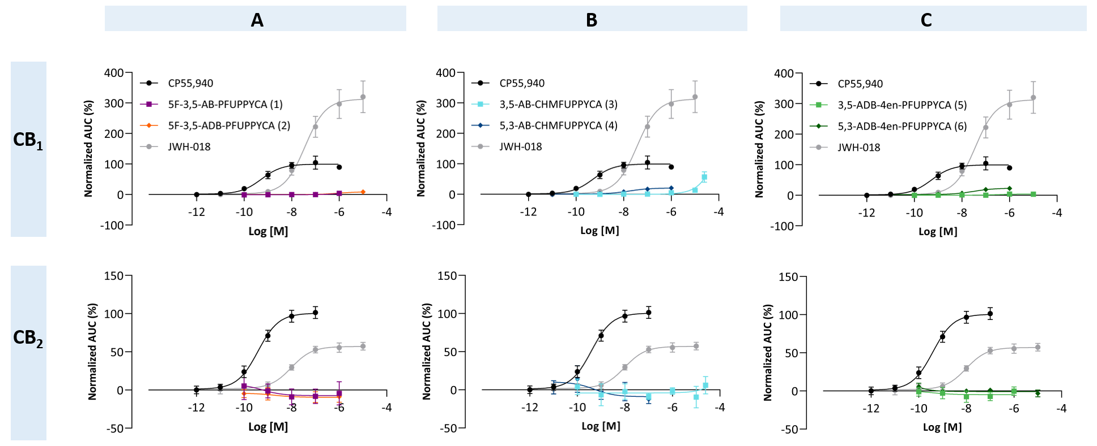

Figure 2: CB1 (upper panel) and CB2 (lower panel) receptor activation profiles for (A) 5F-3,5-AB-PFUPPYCA and 5F-3,5-ADB-PFUPPYCA; (B) 3,5-AB-CHMFUPPYCA and 5,3-AB-CHMFUPPYCA; (C) 3,5-ADB-4en-PFUPPYCA and 5,3-ADB-4en-PFUPPYCA. JWH-018 was included as a comparison. Data points represent the mean receptor activation ± standard error of the mean (SEM), obtained in 3 or more independent experiments, run in duplicate and are normalized to the maximum response of CP55,940.

*Evaluation of antagonistic potential*

To investigate the potential antagonistic behavior of these pyrazole SCRAs, cells expressing the CB1-and CB2-βarr2 systems were pretreated for 5-6 min with 10 µM of the pyrazole test compounds, after which JWH-018 was added. Based on the obtained profiles, all 6 SCRAs were able to inhibit CB1 and CB2 activation by 10 nM and 1 µM JWH-018, respectively, with different degrees of antagonism exerted by different analogs (see **Figure 3**). Activation profiles at both CB1 and CB2 can be found in **Supplementary Material (S3)**.

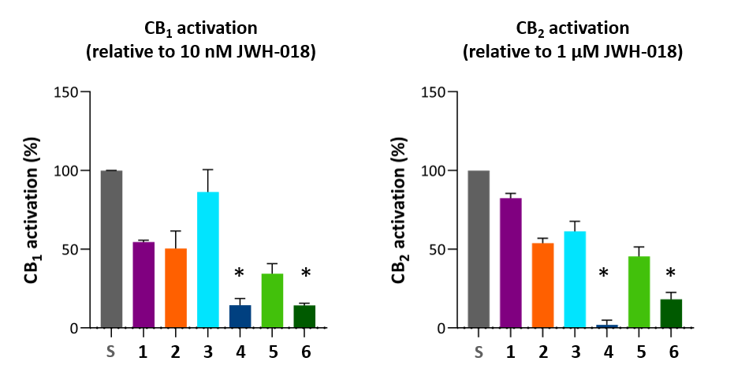

Figure 3: Activation of CB1 (left panel) and CB2 (right panel) by JWH-018 (10 nM and 1 µM, respectively) in cells pretreated with solvent (grey, **S**) or 10 µM of the indicated pyrazole SCRAs (5F-3,5-AB-PFUPPYCA (**1**); 5F-3,5-ADB-PFUPPYCA (**2**); 3,5-AB-CHMFUPPYCA (**3**); 5,3-AB-CHMFUPPYCA (**4**); 3,5-ADB-4en-PFUPPYCA (**5**); 5,3-ADB-4en-PFUPPYCA (**6**)) Data are given as % receptor activation (in comparison to receptor activation in solvent-pretreated cells) ± SEM (n = 3). Bars assigned with a (*) are significantly different from solvent-pretreated controls (p-value < 0.05).

**Discussion**

In the present study, we characterized the pharmacological behavior of the recently (re-)emerging pyrazole SCRAs 5F-3,5-AB-PFUPPYCA and 3,5-ADB-4en-PFUPPYCA, along with structural analogs, at CB1 and CB2 by means of *in vitro* activity-based bioassays. Given the overall low CB activation potential of these compounds, major trends regarding structure-activity relationship could not be identified. It is unclear whether the low potency and efficacy of these SCRAs, as determined here, contributed to the rather short-term appearance of compounds such as 3,5-AB-CHMFUPPYCA and 5F-3,5-AB-PFUPPYCA on the recreational drug market, potentially caused by consumers quickly losing interest in substances with limited or possibly even no psychotropic effect. One plausible explanation for the absence of relevant CB1 and CB2 activation potential may be found in the structural similarity of these pyrazole SCRAs with compounds with inverse agonistic or antagonistic properties, such as rimonabant (SR141716), SR144528 and AM251 (**Figure 1**)[45], as suggested earlier by Franz *et al.*[34] and Brandt *et al.*[46]. The SCRAs discussed here share both a pyrazole core and an amide linker structure with these compounds, whereas the substituted (chloro-, iodo-) phenyl groups also bear resemblance to the fluorophenyl moiety, present in these SCRAs. In this context, Wiley *et al.* synthesized a large set of rimonabant structural analogs, and found that some compounds could partially induce CB1 associated effects in mice, whereas others only showed antagonistic properties[47]. Based on this, we investigated potential antagonism by these SCRAs. Pre-treatment with 10 µM of pyrazole SCRA resulted in a substantial decrease in signal (caused by JWH-018 administration) compared to solvent control, demonstrating a clear antagonistic effect at CB1. The 5,3 regioisomers of the tested panel, 5,3-AB-CHMFUPPYCA and 5,3-ADB-4en-PFUPPYCA, exerted the most pronounced CB1 antagonism, reducing the JWH-018 signal to the level of the blank signal, indicating an almost complete blocking of the receptor. Interestingly, these two compounds show the closest structural similarity with the inverse agonists and antagonists mentioned before. Similarly, at CB2, these two SCRAs showed the most outspoken antagonistic potential, substantially reducing the signal of 1 µM JWH-018. Based on our *in vitro* activity data and these antagonist experiments, the behavior of these pyrazole SCRAs seems to be predominantly antagonistic. It is therefore somewhat surprising that some of these compounds have been detected in plant material or seized in prisons, which clearly demonstrates that these substances were intended to be used for their alleged (SCRA-like) psychoactive effects[10,28–30,48]. However, there is no information on the effects of these substances in humans or animals.

Our study included two pairs of regioisomers, in which the functional group was switched between the nitrogen atoms of the pyrazole core. Regioisomerism is a possible strategy to generate a variety of new analogs of already existing (and potentially controlled) substances, although isomers may also be unintended byproducts formed during synthesis[32,49,50]. We investigated the 3,5 regioisomers (3,5-AB-CHMFUPPYCA; 3,5-ADB-4en-PFUPPYCA) and their 5,3 analogs (5,3-AB-CHMFUPPYCA; 5,3-ADB-4en-PFUPPYCA), with the functional group switching from position 1 (N1) to position 2 (N2) of the pyrazole ring. Here, we found that both 5,3 analogs were more active at CB1 than their very weakly active 3,5 counterparts. This indicates that proper tail placement is required to achieve activity at CB1, as all 3,5 regioisomers were hardly capable of activating this receptor (3,5-AB-CHMFUPPYCA only showed CB1 activation at a very high concentration of 25 µM). This is in line with findings reported by Longworth *et al.,* who demonstrated that for a panel of indazole SCRAs, their *2H-*indazoleanalogs, carrying the functional group on the corresponding nitrogen atom as the 3,5 pyrazole SCRAs, showed a pronounced decrease in potency at both CB1 and CB2[49]. Of particular interest here is that only compounds with a functional group on N2 of the pyrazole core, in this case the 5,3 analogs, are covered by the Chinese generic ban. Compounds such as 5F-3,5-AB-PFUPPYCA, 3,5-AB-CHMFUPPYCA and 3,5-ADB-4en-PFUPPYCA therefore bypass current legal restrictions, which may have triggered a renewed on illicit SCRA markets and may explain the detection of 5F-3,5-AB-PFUPPYCA and 3,5-ADB-4en-PFUPPYCA in Scottish prisons in 2021 and 2022. Taking into account their lack of intrinsic CB1 and CB2 activation potential, these 3,5 SCRAs, although not scheduled, are not expected to have a pronounced abuse potential or cause major cannabinoid-associated toxicity. Obviously, we cannot exclude other (non-CB-mediated) effects or toxicity of these compounds at this point.

**Conclusions**

Between July 2021 and March 2022, two (re-)emerging Chinese ban-evading pyrazole SCRAs, 5F-3,5-AB-PFUPPYCA and 3,5-ADB-4en-PFUPPYCA, have been detected in Scottish prisons. This study is the first to characterize the intrinsic CB1 and CB2 receptor activation potential of a panel of 6 pyrazole SCRA analogs (5F-3,5-AB-PFUPPYCA and 5F-3,5-ADB-PFUPPYCA; 3,5-AB-CHMFUPPYCA and 5,3-AB-CHMFUPPYCA; 3,5-ADB-4en-PFUPPYCA and 5,3-ADB-4en-PFUPPYCA), including four 3,5-regioisomers which evade the 2021 Chinese generic SCRA ban. We found that most of these substances failed to activate either CB1 or CB2, with only 3,5-AB-CHMFUPPYCA, 5,3-AB-CHMFUPPYCA and 5,3-ADB-4en-PFUPPYCA being weakly active at CB1. 5,3-regioisomers were more active than their 3,5-analogs, matching structure-activity relationship trends previously observed for indazole SCRAs[49]. All tested compounds also showed antagonistic properties at both receptors, potentially linked to their structural resemblance to well-known inverse cannabinoid agonists and antagonists. Overall, despite the ability of some analogs to bypass legal restrictions, the immediate threat to public health is expected to be limited, due to their particularly low potency and efficacy at both CB receptors. This lack of cannabinoid activity may also explain the absence of new detections in Scottish prisons after March 2022.

**Declaration of competing interest.**

The authors declare no conflict of interest.

**References**

[1] European Monitoring Centre for Drugs and Drug Addiction. *European Drug Report: Trends and Developments*, Publications Office Of The European Union, Luxembourg, **2022**.

[2] R. G. Pertwee. Pharmacology of cannabinoid CB1 and CB2 receptors. *Pharmacology & Therapeutics*, **1997**, *74*, 129–180.

[3] A. C. Howlett, F. Barth, T. I. Bonner, G. Cabral, P. Casellas, W. A. Devane, C. C. Felder, M. Herkenham, K. Mackie, B. R. Martin, R. Mechoulam, R. G. Pertwee. International Union of Pharmacology. XXVII. Classification of Cannabinoid Receptors. *Pharmacol Rev*, **2002**, *54*, 161–202.

[4] Z. M. Whiting, J. Yin, S. M. de la Harpe, A. J. Vernall, N. L. Grimsey. Developing the Cannabinoid Receptor 2 (CB2) pharmacopoeia: past, present, and future. *Trends in Pharmacological Sciences*, **2022**, *43*, 754–771.

[5] O. H. Drummer, D. Gerostamoulos, N. W. Woodford. Cannabis as a cause of death: A review. *Forensic Science International*, **2019**, *298*, 298–306.

[6] R. Abouchedid, S. Hudson, N. Thurtle, T. Yamamoto, J. H. Ho, G. Bailey, M. Wood, N. Sadones, C. P. Stove, A. Dines, J. R. H. Archer, D. M. Wood, P. I. Dargan. Analytical confirmation of synthetic cannabinoids in a cohort of 179 presentations with acute recreational drug toxicity to an Emergency Department in London, UK in the first half of 2015. *Clinical Toxicology*, **2017**, *55*, 338–345.

[7] A. J. Adams, S. D. Banister, L. Irizarry, J. Trecki, M. Schwartz, R. Gerona. “Zombie” outbreak caused by the synthetic cannabinoid AMB-FUBINACA in New York. *New England Journal of Medicine*, **2017**, *376*, 235–242.

[8] L. M. Labay, J. L. Caruso, T. P. Gilson, R. J. Phipps, L. D. Knight, N. P. Lemos, I. M. McIntyre, R. Stoppacher, L. M. Tormos, A. L. Wiens, E. Williams, B. K. Logan. Synthetic cannabinoid drug use as a cause or contributory cause of death. *Forensic Science International*, **2016**, *260*, 31–39.

[9] European Monitoring Centre for Drugs and Drug Addiction and Europol. *EU Drug Markets Report 2019*, Publications Office Of The European Union, Luxembourg, **2019**.

[10] European Monitoring Centre for Drugs and Drug Addiction. *Synthetic Cannabinoids in Europe - a Review*, Publications Office Of The European Union, Luxembourg, **2021**.

[11] United Nations Office on Drugs and Crime. “News: April 2019 – China: Announcement to place all fentanyl-related substances under national control,” Available at: https://www.unodc.org/LSS/Announcement/Details/f2adea68-fbed-4292-a4cc-63771c943318, **2019**.

[12] United Nations Office on Drugs and Crime. “News: May 2021– China: Announcement to place synthetic cannabinoids under generic control,” Available at: https://www.unodc.org/LSS/Announcement/Details/ff032a29-2e14-4dab-b7d8-ab86d355c809, **2021**.

[13] Office of China National Narcotics Control Commission. Announcement on the inclusion of 18 substances including synthetic cannabinoids and fluamine in the Supplementary List of Controlled Narcotic Drugs and Psychotropic Substances with Non-medical Use. **2021**.

[14] The Center for Forensic Science Research & Education. *BZO-HEXOXIZID Chemistry Report*, **2021**.

[15] The Center for Forensic Science Research & Education. *BZO-POXIZID Chemistry Report*, **2021**.

[16] The Center for Forensic Science Research & Education. *5F-BZO-POXIZID Chemistry Report*, **2021**.

[17] The Center for Forensic Science Research & Education. *BZO-CHMOXIZID Chemistry Report*, **2021**.

[18] K. R. G. de Araujo, A. L. Fabris, L. F. Neves Júnior, J. de Carvalho Ponce, A. L. Soares, J. L. Costa, M. Yonamine. The mystery behind the apprehensions of the selective cannabinoid receptor type-2 agonist BZO-HEXOXIZID (MDA-19) as a drug of abuse. *Forensic Toxicol*, **2022**, DOI 10.1007/s11419-022-00646-6.

[19] C.-M. Liu, Z.-D. Hua, W. Jia, T. Li. Identification of AD-18, 5F-MDA-19, and pentyl MDA-19 in seized materials after the class-wide ban of synthetic cannabinoids in China. *Drug Testing and Analysis*, **2022**, *14*, 307–316.

[20] The Center for Forensic Science Research & Education. *ADB-FUBIATA Chemistry Report*, **2021**.

[21] M. H. Deventer, K. Van Uytfanghe, I. M. J. Vinckier, F. Reniero, C. Guillou, C. P. Stove. A new cannabinoid receptor 1 selective agonist evading the 2021 “China ban”: ADB-FUBIATA. *Drug Testing and Analysis*, **2022**, *14*, 1639–1644.

[22] The Center for Forensic Science Research & Education. *CH-PIATA Chemistry Report*, **2022**.

[23] D. Pasin, M. Nedahl, C. B. Mollerup, C. Tortzen, L. A. Reitzel, P. W. Dalsgaard. Identification of the synthetic cannabinoid-type new psychoactive substance, CH-PIACA, in seized material. *Drug Testing and Analysis*, **2022**, *14*, 1645–1651.

[24] The Center for Forensic Science Research & Education. *CH-FUBIATA Chemistry Report*, **2022**.

[25] The Center for Forensic Science Research & Education. *ADB-5Br-INACA Chemistry Report*, **2022**.

[26] The Center for Forensic Science Research & Education. *ADB-5’Br-BINACA Chemistry Report*, **2022**.

[27] The Center for Forensic Science Research & Education. *MDMB-5Br-INACA Chemistry Report*, **2022**.

[28] European Monitoring Centre for Drugs and Drug Addiction. *EMCDDA–Europol 2015 Annual Report on the Implementation of Council Decision 2005/387/JHA*, Publications Office Of The European Union, Luxembourg, **2015**.

[29] N. Uchiyama, K. Asakawa, R. Kikura-Hanajiri, T. Tsutsumi, T. Hakamatsuka. A new pyrazole-carboxamide type synthetic cannabinoid AB-CHFUPYCA [N-(1-amino-3-methyl-1-oxobutan-2-yl)-1-(cyclohexylmethyl)-3-(4-fluorophenyl)-1H-pyrazole-5-carboxamide] identified in illegal products. *Forensic Toxicol*, **2015**, *33*, 367–373.

[30] The Center for Forensic Science Research & Education. *5F-AB-PFUPPYCA Chemistry Report*, **2018**.

[31] European Monitoring Centre for Drugs and Drug Addiction. EU Early Warning System Formal Notification: EU-EWS-RCS-FN-2021-0046 (5,3-AB-CHMFUPPYCA). **2021**.

[32] U. Girreser, P. Rösner, A. Vasilev. Structure elucidation of the designer drug N-(1-amino-3,3-dimethyl-1-oxobutan-2-yl)-1-(5-fluoropentyl)-3-(4-fluorophenyl)-pyrazole-5-carboxamide and the relevance of predicted 13C NMR shifts – a case study. *Drug Testing and Analysis*, **2016**, *8*, 668–675.

[33] G. McLaughlin, N. Morris, P. V. Kavanagh, J. D. Power, B. Twamley, J. O’Brien, B. Talbot, G. Dowling, S. D. Brandt. The synthesis and characterization of the ‘research chemical’ N-(1-amino-3-methyl-1-oxobutan-2-yl)-1-(cyclohexylmethyl)-3-(4-fluorophenyl)-1H-pyrazole-5-carboxamide (3,5-AB-CHMFUPPYCA) and differentiation from its 5,3-regioisomer. *Drug Testing and Analysis*, **2016**, *8*, 920–929.

[34] F. Franz, V. Angerer, S. D. Brandt, G. McLaughlin, P. V. Kavanagh, B. Moosmann, V. Auwärter. In vitro metabolism of the synthetic cannabinoid 3,5-AB-CHMFUPPYCA and its 5,3-regioisomer and investigation of their thermal stability. *Drug Testing and Analysis*, **2017**, *9*, 311–316.

[35] L. Wagmann, R. G. Stiller, S. Fischmann, F. Westphal, M. R. Meyer. Going deeper into the toxicokinetics of synthetic cannabinoids: in vitro contribution of human carboxylesterases. *Arch Toxicol*, **2022**, *96*, 2755–2766.

[36] R. Kronstrand, C. Norman, S. Vikingsson, A. Biemans, B. Valencia Crespo, D. Edwards, D. Fletcher, N. Gilbert, M. Persson, R. Reid, O. Semenova, F. Al Teneiji, X. Wu, J. Dahlén, N. NicDaéid, F. Tarbah, O. B. Sutcliffe, C. McKenzie, H. Gréen. The metabolism of the synthetic cannabinoids ADB-BUTINACA and ADB-4en-PINACA and their detection in forensic toxicology casework and infused papers seized in prisons. *Drug Testing and Analysis*, **2022**, *14*, 634–652.

[37] C. Norman, G. Walker, B. McKirdy, C. McDonald, D. Fletcher, L. H. Antonides, O. B. Sutcliffe, N. Nic Daéid, C. McKenzie. Detection and quantitation of synthetic cannabinoid receptor agonists in infused papers from prisons in a constantly evolving illicit market. *Drug Testing and Analysis*, **2020**, *12*, 538–554.

[38] A. Cannaert, J. Storme, F. Franz, V. Auwärter, C. P. Stove. Detection and activity profiling of synthetic cannabinoids and their metabolites with a newly developed bioassay. *Anal. Chem.*, **2016**, *88*, 11476–11485.

[39] A. Cannaert, F. Franz, V. Auwärter, C. P. Stove. Activity-based detection of consumption of synthetic cannabinoids in authentic urine samples using a stable cannabinoid reporter system. *Anal. Chem.*, **2017**, *89*, 9527–9536.

[40] A. Cannaert, J. Storme, C. Hess, V. Auwärter, S. M. R. Wille, C. P. Stove. Activity-based detection of cannabinoids in serum and plasma samples. *Clin Chem*, **2018**, *64*, 918–926.

[41] C. Norman, B. McKirdy, G. Walker, P. Dugard, N. NicDaéid, C. McKenzie. Large-scale evaluation of ion mobility spectrometry for the rapid detection of synthetic cannabinoid receptor agonists in infused papers in prisons. *Drug Testing and Analysis*, **2021**, *13*, 644–663.

[42] European Monitoring Centre for Drugs and Drug Addiction. EU Early Warning System Formal Notification: EU-EWS-RCS-FN-2021-0047 (3,5-ADB-4en-PFUPPYCA). **2021**.

[43] M. H. Deventer, K. Van Uytfanghe, I. M. J. Vinckier, C. P. Stove. Cannabinoid receptor activation potential of the next generation, generic ban evading OXIZID synthetic cannabinoid receptor agonists. *Drug Test Anal*, **2022**.

[44] A. Ametovski, E. A. Cairns, K. E. Grafinger, A. Cannaert, M. H. Deventer, S. Chen, X. Wu, C. E. Shepperson, F. Lai, R. Ellison, R. Gerona, K. Blakey, R. Kevin, I. S. McGregor, D. E. Hibbs, M. Glass, C. Stove, V. Auwärter, S. D. Banister. NNL-3: A synthetic intermediate or a new class of hydroxybenzotriazole esters with cannabinoid receptor activity? *ACS Chem. Neurosci.*, **2021**, *12*, 4020–4036.

[45] R. G. Pertwee. Inverse agonism and neutral antagonism at cannabinoid CB1 receptors. *Life Sciences*, **2005**, *76*, 1307–1324.

[46] S. D. Brandt, P. V. Kavanagh, F. Westphal, W. Dreiseitel, G. Dowling, M. J. Bowden, J. P. B. Williamson. Synthetic cannabinoid receptor agonists: Analytical profiles and development of QMPSB, QMMSB, QMPCB, 2F-QMPSB, QMiPSB, and SGT-233. *Drug Testing and Analysis*, **2021**, *13*, 175–196.

[47] J. L. Wiley, D. R. Compton, D. Dai, J. A. H. Lainton, M. Phillips, J. W. Huffman, B. R. Martin. Structure-Activity Relationships of Indole- and Pyrrole-Derived Cannabinoids. *J Pharmacol Exp Ther*, **1998**, *285*, 995–1004.

[48] European Monitoring Centre for Drugs and Drug Addiction. *EMCDDA–Europol 2017 Annual Report on the Implementation of Council Decision 2005/387/JHA*, Publications Office Of The European Union, Luxembourg, **2017**.

[49] M. Longworth, S. D. Banister, J. B. C. Mack, M. Glass, M. Connor, M. Kassiou. The 2-alkyl-2H-indazole regioisomers of synthetic cannabinoids AB-CHMINACA, AB-FUBINACA, AB-PINACA, and 5F-AB-PINACA are possible manufacturing impurities with cannabimimetic activities. *Forensic Toxicol*, **2016**, *34*, 286–303.

[50] V. Shevyrin, V. Melkozerov, A. Nevero, O. Eltsov, Y. Morzherin, Y. Shafran. 3-Naphthoylindazoles and 2-naphthoylbenzoimidazoles as novel chemical groups of synthetic cannabinoids: Chemical structure elucidation, analytical characteristics and identification of the first representatives in smoke mixtures. *Forensic Science International*, **2014**, *242*, 72–80.